Portfolio Assignment

Computer Architecture and Networks
ACCD001

By Geraint Hill
9900497



Contents
Lab1: Building a Simple Network. 4
Lab Questions: 4
Lab Review: 4
Lab2: Building a Switch and Router Network. 5
Lab Questions: 5
Q1. Why were the pings not successful? 5
Q2. Were the pings successful? Why? 5
Q3, Step1. Retrieve hardware and software information from the network devices? Use the show version command to answer the following questions about the router: 5
Q3, Step2. Display the routing table on the router. Use the show ip route command on the router to answer the following questions: 5
Q3, Step3. Display interface information on the router. Use the show interface g0/1 to answer the following questions. 6
Q3, Step4. Display a summary list of the interfaces on the router and switch. 6
Lab Review: 6
Lab3: IPv4, Subnetting, VLSM and IPv6 Addressing. 7
Lab Questions: 7
Lab Review: 7
Features of IPv6. 7
Expanded Addressing Capabilities. 7
Header Format Simplification. 8
Improved Support For Extension and Options. 9
Conclusion. 10
Lab4: Securing Network devices for remote access. 11
Lab Questions: 11
Q1. What does the 2 within 120 mean in the above command? 11
Q2. What does the block-for 30 mean in the above command? 11
Q3. 11
Lab Review: 12
Write a research report comparing various Encryption standards, e.g AES, SHA, DES, RSA. 12
Lab5: Understanding Ethernet cable types. 13
Lab Questions: 13
Q1.Which part of making cables did you find the most difficult? 13
Q2.Why do you have to learn how to make a cable if you can easily buy pre made cables? 13
Lab Review: 14
Conclusion. 15
References 16

Lab1: Building a Simple Network.

Lab Questions:

Q1. Why are some Fast Ethernet ports on the switches are up and others are down?

If any interfaces are not connected to an end device, then they will be down. Consequently, if administratively down appears, then this interface is shut down by user input who has used the shut command on the interface, to bring an administratively down interface back up, issue the no shut command. The VLAN (Virtual Local Area Network) interface is a Switched Virtual Interface(SVI). When a switch is unboxed and connected to the network, all ports are up as soon as devices are connected into the interfaces. All switch ports, by default are members of native Vlan 1. If a device is connected to a switch interface with default configuration, the VLAN 1 will always show as up.

Q2. What could prevent a ping from being sent between the PCs?

Layer 1 – A cable / interface being damaged, physical interface shut on a port.
Layer 2 – VLAN shut administratively, misconfiguration on the interfaces connecting the
switches,
Layer 3 – IP / Subnet mask incorrect.

Lab Review:

The author used two Switches that operate on Layer2(L2). The switches were connected with a cross over cable, which enables two devices of the same type to be connected. Two PC’s were connected via their Layer 3 Network Interface Cards(L3), one in each switch.
The author understands that in this scenario, no default gateway is used, as there is no Router in the network. If PCA and PCB were in different subnets then a L3 Switch or a Router would need to be installed, and a default gateway IP for each sub network placed on a router interface and hosts IPV4 configuration. The network used is a flat network.
A switch needs to be secured to prevent any unauthorized access. The banner deters unauthorized users accessing the equipment, passwords to prevent easy access, and password encryption to prevent over the shoulder views of clear text or packet sniffers capturing in flow, especially when using telnet.
When PCA wants to communicate with PCB, a broadcast is sent, any device connected to the switch and in the same broadcast domain (subnet) will receive the broadcast, however only PCB will respond. PCA will populate his ARP table with IP and Mac Address binding. The Switch will also map the mac address of PCA and B to the interface it received the frame on.

Lab2: Building a Switch and Router Network.

Lab Questions:

Q1. Why were the pings not successful?
Because the router interfaces (default gateway for the hosts) have not been configured yet so the PDU does not know how to egress the network.

Q2. Were the pings successful? Why?
Yes. The IP default gateway configuration on the hosts Network Interface Card (NIC) Layer 3 (L3) interface sends the packet to the routers interface (default gateway) after the Address Resolution Protocol(ARP) has been conducted for the default gateway. The router is directly connected to the networks via respective interfaces configured by the administrator. A show IP route on the router shows a route to both networks and therefore is able to route the PDU’s to each network (Broadcast Domain).

Q3, Step1. Retrieve hardware and software information from the network devices? Use the show version command to answer the following questions about the router:

- What is the name of the IOS image that the router is running?
c2800nm-advipservicesk9-mz.124-15.T1.bin
- How much DRAM memory does the router have?
60416k / 5120k bytes
- How much NVRAM memory does the router have?
239K bytes
- What is the name of the IOS image that the switch is running?
WS-C2960-24TT SW version 12.2
- How much nonvolatile random-access memory (NVRAM) does the switch have?
Switch doesn’t show information on Packet Tracer
- What is the model number of the switch?
WS-C2960-24TT

Q3, Step2. Display the routing table on the router. Use the show ip route command on the router to answer the following questions:

- What code is used in the routing table to indicate a directly connected network?
C
- How many route entries are coded with a C code in the routing table?
2
- What interface types are associated to the C coded routes?
Directly connected interfaces –Fa0/0 and Fa0/1 (physical)

Q3, Step3. Display interface information on the router. Use the show interface g0/1 to answer the following questions.

- What is the operational status of the G0/1 interface?
UP
- What is the Media Access Control (MAC) address of the G0/1 interface?
0002.16e0.2702
- How is the Internet address displayed in this command?
192.168.1.1/24

Q3, Step4. Display a summary list of the interfaces on the router and switch.

- If the G0/1 interface showed administratively down, what interface configuration command would you use to turn the interface up?
No shut
- What would happen if you had incorrectly configured interface G0/1 on the router with an IP address of 192.168.1.2?
It would take the address however the default gateway for the hosts is configured as .1. The gateway for the hosts would therefore not be reachable.
- Explain the operation of a Router and a Switch.
A router is a Layer 3 device that acts as a gateway for hosts to reach other networks. It manages a routing table and routes traffic based on this. Routers create broadcast domains. Routers terminate Broadcast traffic. A router understands Internet Protocol (IP).
A Switch is a Layer 2 device and forwards frames at high speed. It provides network access for large number of hosts. Switches can segregate the network further by using Virtual LAN (VLAN). Each interface on a Switch is its own collision domain. If a switch states it is a 1Gb switch, each switchport is capable of 1Gb throughput full duplex. There are L3 switches that understand IP, however this is beyond the scope for this assignment.

Lab Review:

The author introduced a Router (L3) device into the lab. A router creates broadcast domains (networks). A router does not allow Broadcast traffic to leave the network. The router deals with an important protocol named Address Resolution Protocol (ARP). This Maps IP addresses to Mac addresses in a table. This reduces broadcast traffic on a network which is a good thing. A router also holds a routing table, and acts as a default gateway to connected networks. A router can perform static routing or autonomous routing. A router will check the destination address in an IP header against its routing table and will send it out of the correct interface. If a route is not in a routing table, then the router will simply drop the packets.
We explored basic show commands to get valuable information from the devices. This information is key for effective troubleshooting. We assigned descriptions to interfaces, making it clear what interfaces are connected to, we can confirm this with CDP (Cisco Discovery Protocol). Time was configured manually, this is good practice so that logs are easily read and a clear time can be given against each event to ensure effective troubleshooting can be made. However best practice would be to use a Network Timing Protocol Server to configure accurately have the same time on each device.

Lab3: IPv4, Subnetting, VLSM and IPv6 Addressing.

Lab Questions:

**The question required the author to subnet using 172.16.2.0/24 , in this case the user started the sub netting at 172.16.2.0 and then segmented from there, /24 does not allow for subnets over 254 addresses.
Subnet | Network Address | Subnet mask | First Address | Last Address | Broadcast Address
A | 172.16.13.64 | 255.255.255.224(/27) | 172.16.13.65 | 172.16.13.94 | 172.16.13.95
B | 172.16.2.0 | 255.255.248.0 (/21) | 172.16.2.1 | 172.16.9.254 | 172.16.9.255
C | 172.16.13.96 | 255.255.255.248 (/29) | 172.16.13.97 | 172.16.9.102 | 172.16.13.103
D | 172.16.10.0 | 255.255.254.0 (/23) | 172.16.10.1 | 172.16.11.254 | 172.16.11.255
E | 172.16.13.0 | 255.255.255.192 (/26) | 172.16.13.1 | 172.16.13.62 | 172.16.13.63
F | 172.16.12.0 | 255.255.255.0 (/24) | 172.16.12.1 | 172.16.12.254 | 172.16.12.255
Se1 | 172.16.13.104 | 255.255.255.252(/30) | 172.16.13.105 | 172.16.13.103 | 172.16.13.107
Se2 | 172.16.13.108 | 255.255.255.252 (/30) | 172.16.13.109 | 172.16.13.110 | 172.16.13.111

Lab Review:

Features of IPv6.

RFC2460[1] sets out five principal categories that Internet Protocol version 6 (IPv6) improves over its predecessor IPv4.
- Expanded Addressing Capabilities;
- Header Format Simplification;
- Improved Support for Extension and Options;
- Flow Labelling Capability;
- Authentication and Privacy Capabilities.

Expanded Addressing Capabilities.

In order to understand the size difference of IPv6 compared to IPv4, Reseaux IP Europeens (RIPE) [2], the internet registry for Europe, provides us the total number of IP addresses available in each protocol.
IPv4 = 4,294,967,296 – 32 bit in size.
IPv6 = 340,282,366,920,938,463,463,463,374,607,431,768,211,456 – 128 bit in size.
IPv4 format = 123.45.67.89
Ipv6 format = 2001:db8::ff00:42:8329
With the rapid development in the Internet of Things (IoT), the current IPv4 address scheme is not sufficient to support the need in accommodating a single IP for every device. In an IPv4 environment, as not all of IPv4 are routable over the internet, providers use Network Address Translation to preserve the IPv4 ranges, in this scenario a number of private IP addresses can share a common public address using Port Address Translation or NAT Overload[3]. Internet observers Akamai, in their report, “State of the Internet”[4], report that:
“ The number of unique IPv4 addresses worldwide connectiong to Akamai increased by nearly 7.6 million om the first quarter of 2017”. However, as noted previously, we expect that the unique global IPv4 Addresses seen by Akamai will decline somewhat in the future as carriers increase the availability of native IPv6 connectivity for subscribers and implement Carrier-Grade Network Address Translation (CGNAT) solutions more broadly to conserve limited IPv4 address space” – D Belson 2017.
Although NAT is used to preserve IPv4 public addresses, IPv6 negates the need of NAT, since it can assign a unique IP address per device due to its extensive availability. Interestingly, networks are able to dual-stack IP traffic, so that IPv4 and IPv6 can coincide on the same network, making the eventual transition from IPv4 to IPv6 easier[5].

Header Format Simplification.

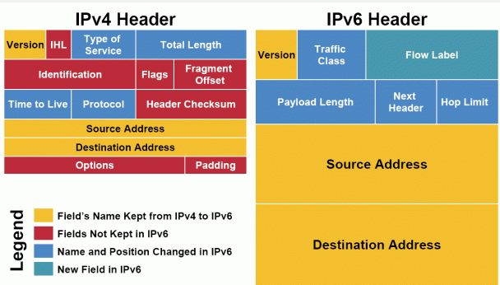
Figure1[6]: Image showing the difference between an IPv4 header and IPv6 header.
There are many different fields in the IPv6 Header[7]:
- Version – Ipv4 or IPv6.
- Traffic Class – traffic class for prioritisation.
- Flow Label – identifies separate packets meant to be in a flow.
- Payload Length – Size of the packet.
- Next Header – TCP or UDP.
- Hop Limit – how many hops the packet is allowed to make before being discarded.
- Source Address – IP of the originator.
- Destination Address – IP of intended recipient.
As we can see in figure 1, there is less information for the router to disseminate when analysing an IPv6 packet, making router processing of packets more efficient and faster when using IPv6.

Improved Support For Extension and Options.

Extension Headers (EH) are an essential part of IPv6. EH assist by providing additional information to the packet so that Routers, switches and hosts decide how to manage the packet. This makes the transit process more flexible and efficient than IPv4. The EH sits between L3 and Layer4 (L4). There are predefined options that can be selected, and in time additional added[8]:
- Basic IPv6 Header,
- Hop-by-hop options,
- Destination Options (with routing options),
- Routing Header,
- Fragment Header,
- Authentication Header,
- Encapsulation Security Payload Header,
- Destination Options,
- Mobility header.

Flow Labelling Capability.

When we discuss “Flow” in networking, we discuss the sequence of packets from a source to a destination. It is a way for the network to learn by looking in the IPv6 Header Source and Destination fields what flow a packet belongs to. This is a very useful mechanism as it arranges packets and seamlessly delivers them from and to end to end hosts[9].

Authentication and Privacy Capabilities.

Internet Protocol Security (IPsec) is a mandatory field in IPv6. It provides extra security measures to the packet. Cisco[10] highlight the benefits of this feature in IPv6:

Data Confidentiality- encrypt packets before transmission,
Data Integrity – ensure packet has been received as intended,
Data origin authentication – if sender is authenticated,
Antireplay – stops duplicate packets.

With minimal configuration, even the routing protocols can be encrypted.

Conclusion.
The author has discussed the key elements of IPv6 as set out by the RFC that governs it. We have discussed the key features of IPv6 and how it differs from IPv4 and explained the depletion of IPv4 and the need to implement IPv6.
The IPv6 header has been explained, we have explored how it differs from an IPv4 header, and demonstrating the efficiency of IPv6.
EH were explained and how they inject new headers into the packet so that the routing process can run more efficiently by looking in the headers and deciding what to do with the packet next before passing it on to the Transport Layer.
Finally we explored protecting the IPv6 packets, and ensuring Confidentiality, Integrity and Availability (CIA) concepts.
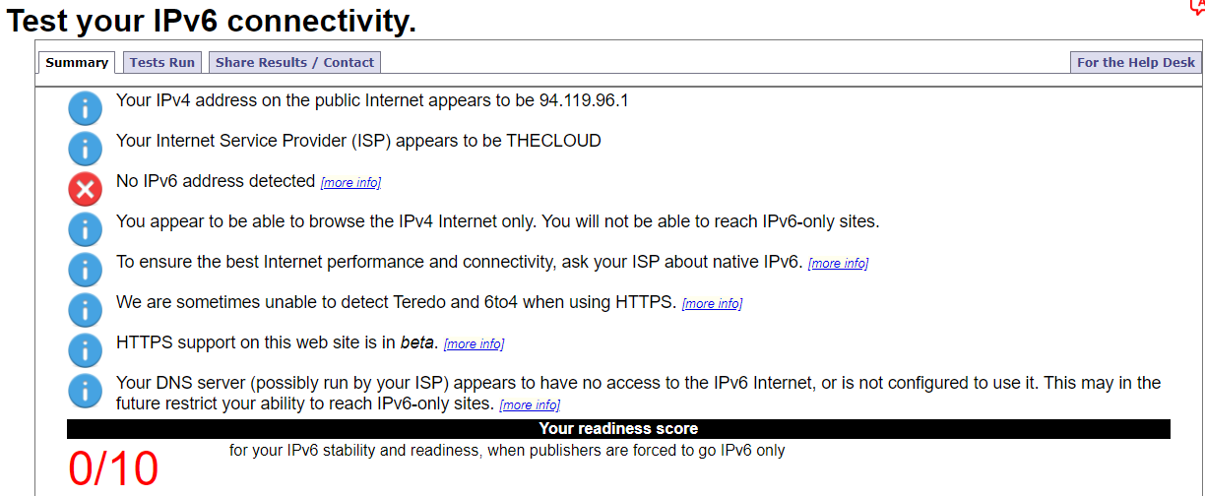
Figure2[11]: A snip from the authors IPv6 Test from a public network.
If IPv6 as not been enabled on a network, then users will not be able to reach IPv6 only sites.
Figure 2 shows a test the user made from a Public Network to see the readiness of IPv6 on the network. The ISP in question was not IPv6 ready, but the site does advise on action.
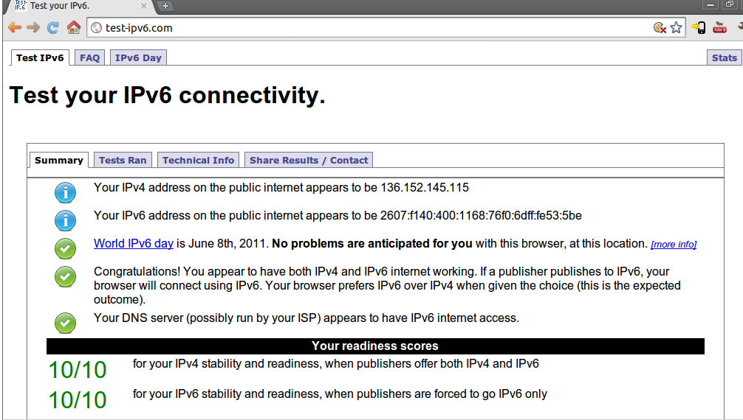
Figure3[12]: A snip from an image search for iptest result in Google.
Figure 3 displays a fully ready IPv6 network. Note that IPv4 AND IPv6 has been recognised!
The advantages of today’s technology is that whilst IPv4 addresses are depleting, networks can dual stack IPv4 and IPv6. This means that both protocols can be processed by the routers if required. This gives administrators the flexibility to slowly introduce IPv6 on their network. IPv6 is slowly being introduced by Internet Service Providers and other networks. There are still many IPv4 addresses in circulation, but there is a big drive to promote IPv6.
This report has provided a brief review of the features of IPv6.

Lab4: Securing Network devices for remote access.

Lab Questions:

Q1. What does the 2 within 120 mean in the above command?

If two failed attempts have been made in 2 minutes, login access will be refused.

Q2. What does the block-for 30 mean in the above command?

Login block will be in place for 30 seconds, after that users will be able to attempt again.

Q3.

- Does R1 accept the Telnet connection? Explain.

We enabled Telnet on line vty 0 4 with the command transport input telnet ssh. This means, telnet is available.
- Does R1 accept the SSH connection?
Yes, SSH is enabled on vty 0 4. We have also created a hostname, domain, generated RSA Keys and issued a username and password for authentication.
- What happened after you failed to login the second time?
It booted me out of the login prompt and wouldn’t let me reconnect for another 30 seconds.
- After you successfully logged in, what is displayed?
Router presently in Normal-Mode
- Enter privileged EXEC mode and use Enablep@55 for the password.
An option to enter the password a third time is given.
- Are you able to establish an SSH session with the switch?
Yes
- What versions of SSH are supported from the CLI?
SSHv1 and SSH v2
- How would you provide multiple users, each with their own username, access to a network device?
Either via a local database or an Authentication, Authorisation and Accounting server.

Lab Review:

Write a research report comparing various Encryption standards, e.g AES, SHA, DES, RSA.

Advanced Encryption Standard (AES)
RFC 3565 sets out the guidelines for AES protocol. AES replaced the Data Encryption Standard (DES) and it is widely used. AES is a symmetric algorithm using the same key[13].
AES works by encrypting the plaintext in rounds. The hexadecimal(hex) values in each round are looked at in a table with hex values and then the data is given random values. Each hex value in the data fields are encrypted per round. Once the data has been encrypted the encrypted data shifts rows and therefore “shuffles up”. Once the rows have been shuffled, the columns are then shuffled and given an different encrypted value. Finally a round key is generated and added to each column, providing a different encrypted value. This is done up to 14 rounds so the data is securely encrypted providing an encrypted output. The hash of the data is determined by its values through the whole process of encryption. AES use key lengths of 128, 192 and 256 bits[13].

Secure Hash Algorithm (SHA)
RFC 6234 sets out the guidelines for SHA.
The purpose of a SHA algorithm is to hash the data (not encrypt). A block of data is received by the SHA protocol. The SHA protocol then places them in H (hash) values (H0 – H7). Once the message is received the message is compressed and mixed up with another bit of the message to produce another set of H0 – H7 values. Once the new H values have been calculated, they are used to hash the next part of the message. By adding a bit of the message into the hash algorithm, the randomness of the hash is greater. If the message exceeds the size of the 512 bit hashing limit, then padding occurs[14].
There have been differences in the SHA world since SHA1 was compromised in 2017, the later versions of SHA (SHA2 and SHA3) are run higher level algorithms (H0 – H7). SHA is used to ensure integrity of data. If the hash is different from when it was generated to when it was received it would highlight an error[15].

Data Encryption Standard (DES)
RFC 1821 sets out the guidelines for DES.
DES is an encryption method that uses keys to encrypt data at each communicating host. DES is a symmetric algorithm using the same key.
The keys are 56bit[16]. A newer version of DES is currently used, known as Triple DES (3DES) and is considered more secure as it uses 3 sets of 56bit keys (168bit). RFC 1851 sets out the guidelines for 3DES[17].
DES uses the same key to encrypt / decrypt the messages. In DES (obsolete), a 56bit key was generated, making it susceptible to a brute force attack. 3DES was later introduced, expanding the key size of its predecessor. Whether an administrator uses 3DES or AES depends on their needs[18]. AES is preferred over DES / 3DES as it is more secure, quicker to process and is widely used[19].

Rivest-Shamir-Adleman (RSA)
The latest RSAv2 specification is set out in RFC 8017.
RSA is an asymmetric algorithm meaning it uses a public key and a private key to encrypt messages[20].
Each host send a copy of their public keys to encrypt the sending data with, the private key (only held by the receiving host) is used to decrypt the message with its public key attached. This method is deemed as the most secure encryption as the Private Key is only held by the originating host[21]. The key size of RSA can go upto 4096bits, however, the more bits used impacts the speed of the Computer Processing Unit (CPU) and the time it takes to encrypt / decrypt the messages[22].
RSA is used in conjunction with the Secure Sockets Layer SSL. Whenever we visit a webpage that has https:// in the address, we are certain that the traffic between our device and the visiting site is encrypted using RSA keys and SSL encryption[21].

Lab5: Understanding Ethernet cable types.

Lab Questions:

Q1.Which part of making cables did you find the most difficult?

Separating the twisted pairs and getting them in order, placing them in the glass head.

Q2.Why do you have to learn how to make a cable if you can easily buy pre made cables?

You can buy a reel of Cat5e or Cat6 and cut as per the length of run that you need. You don’t want a 10m cable to patch in to a meter distance.

Lab Review:

Write a research report (Max word count 600) on Cat 5e and 6 Ethernet cable standards.

Cat 5e and Cat6 standards have been developed by the Telecommunications Industry Association (TIA) and the Electronic Industries Alliance (EIA). TIA/EIA 568.C.0 address commercial building cabling for telecommunication products and services[23].
Cat6 cable has become the industry standard to replace cat5e. Although very similar aesthetically, there are many differences. We will begin this report with the similarities. Within the cat5e and cat6 are 4 pairs of cable twisted together, this is often referred to as the twisted pair. The twisted pair cables are colour coded:
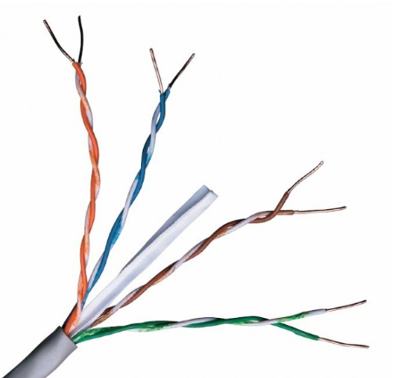
Orange
Orange/White
Green
Green/White
Blue
Blue/White
Brown
Brown./White
Figure1[24]: A cat6 cable stripped

The connector type that is used to connect these cables is a Registered Jack 45 (RJ45). This connector is the standard for the cat5e and 6 cable and most common network interfaces are also be made to the RJ45 standard, however, higher speed interfaces (fibre) are available.
There are two variants of Ethernet cable pinouts in networking. Pinouts is the arrangement of cable within the RJ45 connector prior to being crimped.
- Straight Through – to connect different devices of a kind (Switch -> Router, Switch->,Switch -> Personal Computer (PC).
- Cross over – to connect same devices of a kind (Switch -> Switch, PC -> PC).

Straight Through Cross Over
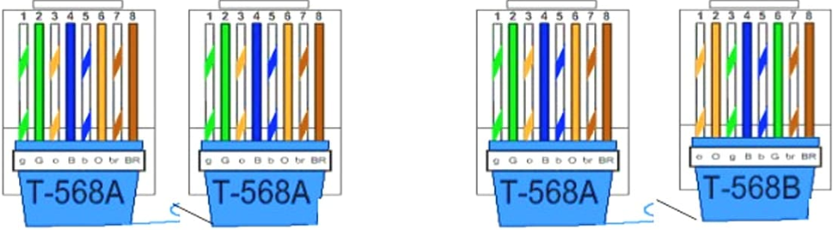
Figure 2[25]:Straight Through and Crossover cable pin out.

Differences between the cables include lower crosstalk, higher signal to noise ratio (SNR) and speed. Cat5e supports 1000Base-T(1Gb) and Cat 6 supports 10Gb Base T. These speeds are not guaranteed as different factors can present themselves to affect quality. Generally over distance the signal deteriorates, meaning the speeds are affected.
- Cat5e – there are less twists in the pairs, meaning it is more susceptible to interference. The copper in the Cat5e sheathing is slightly thinner, meaning the overall cable is smaller. The difference in thickness in copper also means that Cat6 is capable of providing more data throughput.

- Cat5e and Cat6 are backwards compatible, meaning that you could use them in the same environment. Bottlenecks will occur if transferring from Cat5e to Cat6 due to the throughput capabilities.

- The price of Cat6 is more costly. Cable Monkey ( A leading UK cable distributer) prices a 305m real of Cat5e at £62.85, whilst cat 6 would cost £97.35.If you are considering installing an enterprise building, you will notice a significant price difference[26].

Conclusion.

In this review we have explored the Cat5e and Cat6 standards.
We have discovered that Cat6 is 10x faster than Cat5e, and that it is the preferred standard to be installed in networks today, especially as Cat5e and Cat6 are backwards compatible.
The only drawback in using Cat6 is that it is more expensive and could prove costly to purchase and install. Other than the cost, the benefits of using Cat6 cabling exceeds the use of Cat5e.
Cat6 cable is more robust, with extra protected layers, it offers faster speeds and less cross talk (interference), meaning more reliable delivery of end to end data. Cat5e is heavily used in networks today. Traditionally Cat6 cabling was used in the server room due to its ability to send and receive large quantities of data, and Cat5 was then used to access ports for PC’s / Phones that did not utilise as much data. However, with the introduction of Cat7 that offers 40Gb[27] transfer capabilities, these will be used in the server room and cat6 will replace legacy cat5e[28].

References
[1] “RFC 2460 - Internet Protocol, Version 6 (IPv6) Specification.” [Online]. Available: https://tools.ietf.org/html/rfc2460. [Accessed: 30-Oct-2019].
[2] “Understanding IP Addressing and CIDR Charts — RIPE Network Coordination Centre.” [Online]. Available: https://www.ripe.net/about-us/press-centre/understanding-ip-addressing. [Accessed: 30-Oct-2019].
[3] “IP Addressing: NAT Configuration Guide, Cisco IOS Release 15M&T - Configuring NAT for IP Address Conservation [Support & Downloads] - Cisco.” [Online]. Available: https://www.cisco.com/c/en/us/td/docs/ios-xml/ios/ipaddr_nat/configuration/15-mt/nat-15-mt-book/iadnat-addr-consv.html. [Accessed: 30-Oct-2019].
[4] D. Belson, “akamai’s [state of the internet],” vol. 10, no. 1, p. 6, 2017.
[5] “Understanding Dual Stacking of IPv4 and IPv6 Unicast Addresses - TechLibrary - Juniper Networks.” [Online]. Available: https://www.juniper.net/documentation/en_US/junos/topics/concept/ipv6-dual-stack-understanding.html. [Accessed: 30-Oct-2019].
[6] “What’s wrong with IPv4 and Why we are moving to IPv6.” [Online]. Available: https://www.tecmint.com/ipv4-and-ipv6-comparison/. [Accessed: 31-Oct-2019].
[7] “IPv6 Header Deconstructed | Header Format of IPv6 | IPv6.com.” [Online]. Available: https://www.ipv6.com/general/ipv6-header-deconstructed/. [Accessed: 31-Oct-2019].
[8] “IPv6 Extension Headers Review and Considerations [IP Version 6 (IPv6)] - Cisco Systems.” [Online]. Available: https://www.cisco.com/en/US/technologies/tk648/tk872/technologies_white_paper0900aecd8054d37d.html. [Accessed: 31-Oct-2019].
[9] “RFC 6437 - IPv6 Flow Label Specification.” [Online]. Available: https://tools.ietf.org/html/rfc6437. [Accessed: 31-Oct-2019].
[10] “IPv6 Implementation Guide, Cisco IOS Release 15.2S - Implementing IPsec in IPv6 Security [Cisco IOS 15.2S] - Cisco.” [Online]. Available: https://www.cisco.com/c/en/us/td/docs/ios-xml/ios/ipv6/configuration/15-2s/ipv6-15-2s-book/ip6-ipsec.html. [Accessed: 31-Oct-2019].
[11] “Test your IPv6.” [Online]. Available: https://test-ipv6.com/. [Accessed: 31-Oct-2019].
[12] “Check for IPv6 Connectivity – scottlinux.com | Linux Blog.” [Online]. Available: https://scottlinux.com/2011/01/26/check-for-ipv6-connectivity/. [Accessed: 31-Oct-2019].
[13] “RFC 3565 - Use of the Advanced Encryption Standard (AES) Encryption Algorithm in Cryptographic Message Syntax (CMS).” [Online]. Available: https://tools.ietf.org/html/rfc3565. [Accessed: 06-Nov-2019].
[14] “RFC 6234 - US Secure Hash Algorithms (SHA and SHA-based HMAC and HKDF).” [Online]. Available: https://tools.ietf.org/html/rfc6234. [Accessed: 06-Nov-2019].
[15] “The Difference Between SHA-1, SHA-2 and SHA-256 Hash Algorithms.” [Online]. Available: https://www.thesslstore.com/blog/difference-sha-1-sha-2-sha-256-hash-algorithms/. [Accessed: 06-Nov-2019].
[16] “RFC 1829 - The ESP DES-CBC Transform.” [Online]. Available: https://tools.ietf.org/html/rfc1829. [Accessed: 12-Nov-2019].
[17] “RFC 1851 - The ESP Triple DES Transform.” [Online]. Available: https://tools.ietf.org/html/rfc1851. [Accessed: 12-Nov-2019].
[18] H. O. Alanazi, B. B. Zaidan, A. A. Zaidan, H. A. Jalab, M. Shabbir, and Y. Al-Nabhani, “New Comparative Study Between DES, 3DES and AES within Nine Factors,” vol. 2, no. 3, pp. 152–157, 2010.
[19] A. Taqa, A. . Zaidan, and B. . Zaidan, “New Framework for High Secure Data Hidden in the MPEG Using AES Encryption Algorithm,” Int. J. Comput. Electr. Eng., vol. 1, no. 5, pp. 566–571, 2009.
[20] “RFC 8017 - PKCS #1: RSA Cryptography Specifications Version 2.2.” [Online]. Available: https://tools.ietf.org/html/rfc8017. [Accessed: 12-Nov-2019].
[21] S. Nisha and M. Farik, “RSA Public Key Cryptography Algorithm A Review,” Int. J. Sci. Technol. Res., vol. 06, no. 07, p. 187-188, 2017.
[22] “RSA key lengths.” [Online]. Available: https://www.javamex.com/tutorials/cryptography/rsa_key_length.shtml. [Accessed: 12-Nov-2019].
[23] “Fiber and Cabling - TIA Online.” [Online]. Available: https://www.tiaonline.org/industry-priorities/transforming-infrastructure/fiber-cabling/. [Accessed: 31-Oct-2019].
[24] “Cat6 UTP PVC Solid Cable (Reel) | Cat6 Cable.” [Online]. Available: https://www.cablemonkey.co.uk/cat6-cable/21-excel-cat6-utp-cable.html. [Accessed: 31-Oct-2019].
[25] “Color coding of straight and crossover cable - Network Kings.” [Online]. Available: https://www.networkkings.org/color-coding-of-straight-and-crossover-cable/. [Accessed: 31-Oct-2019].
[26] “Cable Monkey.” [Online]. Available: https://www.cablemonkey.co.uk/. [Accessed: 04-Nov-2019].
[27] “Everything You Need To Know About Cat 7 Cable | RS Components.” [Online]. Available: https://uk.rs-online.com/web/generalDisplay.html?id=ideas-and-advice/cat7-cable-guide. [Accessed: 04-Nov-2019].
[28] A. Nielsen, “AMP NETCONNECT Guide to ISO/IEC 11801 2nd Edition Including Amendment 1,” no. February, pp. 1–26, 2008.

