The Exploration of Online Implicit Stratified Teaching (IST) of Higher Vocational General English Course of China From Teachers’ Perspective

Context and purpose:

As the large class size of General English Course in higher vocational colleges of China can not meet the needs of individuals, the online Implicit Stratified Teaching (IST) which conducts online teaching by confidentially dividing students into groups according to their learning abilities has been developed. However, the online IST of China is still on the stage of exploration with limited research about theoretical and practical resources of General English Course. Thus, this research aims to investigate possible factors that influence students’ learning through the online IST in higher vocational General English Course of China by collecting data of interviews from teachers’ perspective. The responses of the General English Course teachers who have experience in the online IST will help to provide suggestions and instructions to the conduction of the online IST and to achieve the goal of meeting students’ learning needs.

Research questions:

- What is the relationship between online IST and the higher vocational colleges students’ English academic outcomes from teachers’ perspective?
- What factors affect students’ English learning when conducting the online IST from teachers’ perspective?

Aims:
- To investigate the relationship between the students’ General English Course outcomes and online IST in higher vocational colleges.
- To explore the factors affect students’ English abilities when conducting the online IST from teachers’ perspectives.
To find out ways to improve students’ English learning through the online IST.

Objectives:
- To find out the relationship between students’ General English Course academic outcomes and the online IST in higher vocational colleges by qualitative data collecting through teachers’ interviews.

- To investigate the related factors that affect the students’ performance when conducting online IST by qualitative data collecting through the interviews with teachers.

My presentation

I’d like to briefly introduce the processes i used when i was undertaking my literature
review in the last module：

First, I chose the area I’m interested “IST”, reasons that i have introduced last class is about policy, personal experience and the feature of higher vocational colleges.

I’d like to know how effective it affects on students’ English ability’s improving.

Second, I use key words including “stratified teaching”, “higher vocational education” and “China” are used for the first round of literature research to set the boundary, as they help to clarify the scale of my research area.
Then, “implicit stratified teaching” and “General English Course” are chosen for the second round of research based on the resources collected already to refine the focus of this topic.
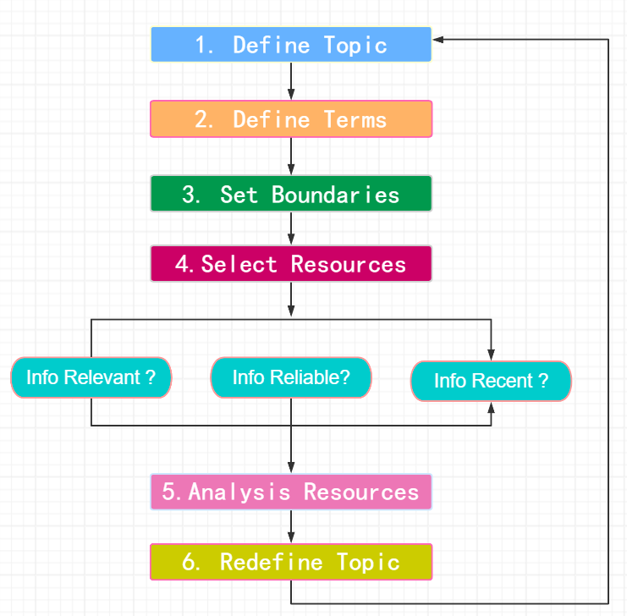
After the articles are chosen, I did the reading and took notes at the same time, try to summarise what had been explored and what are still unknown or unsure, then try to figure out the gaps which can be my focus. This process is kind of like “swimming pool approach”, the notes from reading includes strengthens and statistics also are used in the “critical” part to evaluate their research values.

According to the notes, i found that recources about “online IST” are very limited. Additionally, most of the resources are surface with theoretical researches and lacks of practical research, especialy in general English course. Most of the reseaches are comparing the examing the scores without deep analysis about the possible factors related to the scores. Thus, i plan to focus on “online, deep analysis with experienced (participants) teachers”. this module i will focus on teachers.

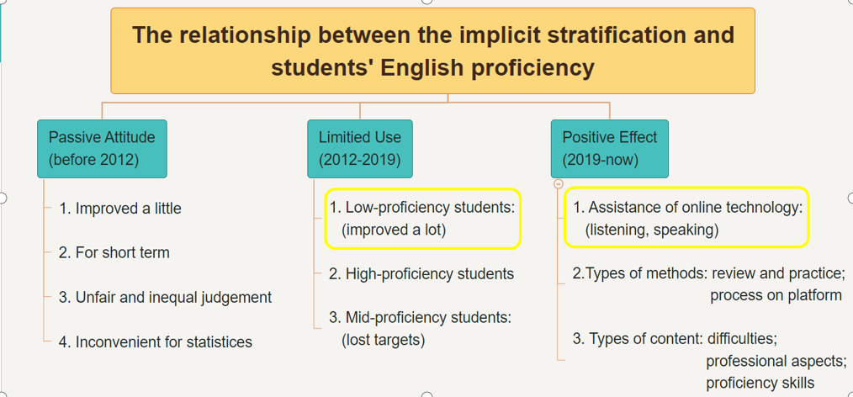

Thus, I refined my topic to “The Exploration of Online Implicit Stratified Teaching (IST) of Higher Vocational General English Course of China From Teachers’ Perspective” for this module.

In terms of the LR writing, according to the comments and suggestions from 7016, my literature review needs to be improved by closely relating the resources to my research topic, which means that they are not that directly related- at the moment . That is one of my confusion, due to the limited resources, how can i make them coherent for my research.

I plan to: After reading the tips, i found that i have

