

Assessment 1 – Reading Task Template
PART 1: Upload your photo of your A3 in-class notes here:
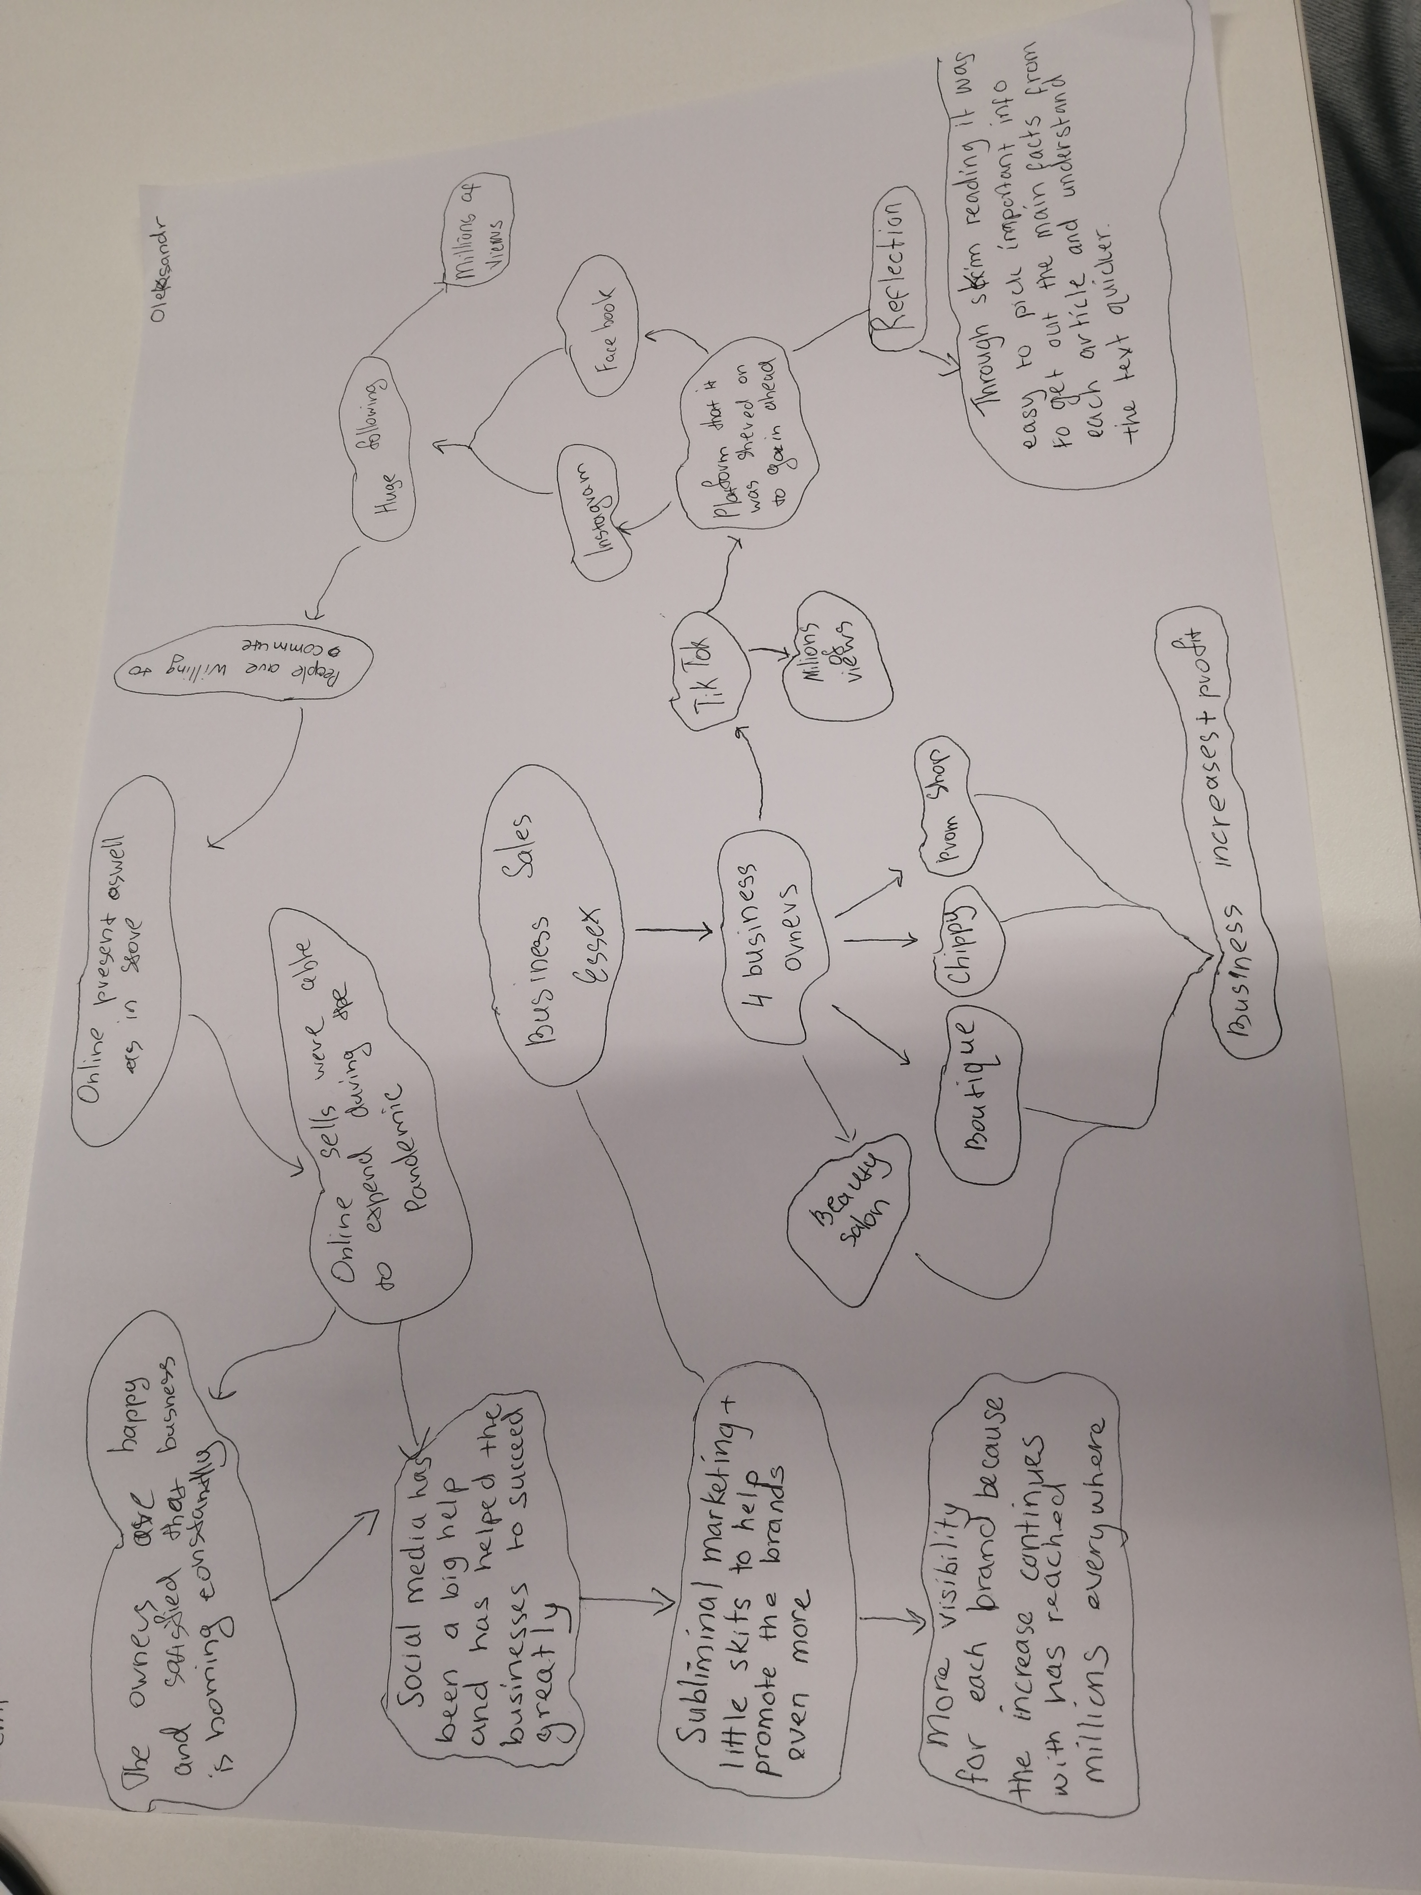

PART 2:
- Answer every question below in 1-3 full sentences.
- Use your own words. Do not use generative AI to answer these questions.
- Include a specific detail from the text when asked.
REMINDER
- The main idea is the overall message of the whole text.
- A key point helps to explain the main idea.
- A specific detail or example from the text shows that the key point is true.

- What is the main idea of the whole text?
The main idea was about how the 4 businesses were able to grow them individually through “Tik-Tok” and other platforms of social media like Facebook and Instagram.

- What is one key point that supports the main idea, and which specific example from the text shows this?
Social media had a big influence on helping the businesses develop and grow successfully online and as well as instore.

- What is a different key point that supports the main idea, and which specific example from the text shows this?
They were all able to stay open even during the pandemic and people were travelling far and wide to get to the businesses constantly.

- Which part of the text do you think is most important, and why?
How all the business received millions of followers and all the business did well and made big profits during a tough time (the pandemic)

Reflection:
- What did you find difficult in this task (including in-class components), and why was it difficult? Nothing.

- What helped you with this difficulty, and how did it help you?
Through skim reading it was easy to pick important info to get out the main facts from each article and understand the text quicker.

