

LEVEL 7 ASSESSMENT SPECIFICATION

Student name: | Seto chi shing | Student ID number: | 1812207
Programme: | MBA
Module: | Financial Management
Module code: | SBMA7100 | Contribution to Overall Module Assessment (%): | 100%
Lecturer: | Dr Katherine Mo | Internal Verifier:
Assignment Title: | Assignment 1 | Word count (or equivalent): | 5,000 words
Submission deadline: | 19 August 2019 | Return date of provisional marks & written feedback: | Within 20 days after submission
Submission method: | All written assessments, where practical and possible, must be submitted via Turnitin unless otherwise instructed by the Lecturer. (Please DO NOT put this assessment specification into Turnitin or it will match many similarities with other students’ submissions.)  Alternative submission method (if applicable):  Late submission of the assessment will result in a late penalty mark. Penalties for late submission: Up to one week late, maximum mark of 50%. Over one week late, 0%. Only the Extenuating Circumstances Panel may approve a change to submission dates.
Academic honesty / referencing: | Academic honesty is required. In the main body of your submission you must give credit to authors on whose research and ideas your work is based. Append to your submission a reference list that indicates the books, articles, etc. that you have used, cited or quoted in order to complete this assessment.

Executive summary

During 2018, Honeywell net sales is 3% to USD 41802 million dollars. Honeywell commit the financial commitments to create long-term shareowner value. And the income before taxes is 8% to USD 7887 million. The income before taxes is improved by Honeywell executive and management teams.
We are careful to monitor and control the short term financial account and can commit the investment planning and strategy planning to be a world leading product and service international company.

Chapter 1 is on Honeywell Limited's background and its business conditions, and introduce 2 types of companies with Bosch and Siemens as the comparison and analysis counterparts.

Chapter 2 through the various financial ratio, from different dimension analysis Honeywell Limited while in the financial structure and debt-servicing capacity through performed better than the other listed companies and insolvency index tests, but its operating capacity, profitability and growth capacity has been a recession behind counterparts and water. Although the investors' point of view its shares still able to give dividend rate of return stability, but Honeywell Limited necessary improvement programs to keep its operations.

Chapter 3 mentioned Honeywell Limited 's corporate governance issues: the study shows that they must be at its core team, internal control, trading position transparency and credit risk management in for a change, to the multi overall operating performance and improve the operational capability and competitiveness.

Chapter 4 is assessed this year Jinan shop item the effectiveness and investment value. Calculated through cash flow, net present value, and return more than the rate of investment returns and found that new projects on Honeywell Limited's business and financial position better financial benefits, it is proposed public Division project development and utilize its internal resources to pay for their liquidity needs.

The chapter 5 is to study to the Jinan shop has invested funds the feasibility financing analysis and to make the enterprises financial situation of the best recommendation. Analysed by 5 different Financing Program, the report recommendations Honeywell Limited adopt the bank 5- year loan program for Jinan shop the RMB378 million for funding.

Table of Contents

1. Introduction
1.1 Company Background
1.2 Operating Business Overview (products and services and the sales market)
1.3 Today's business environment
1.4 Company structure
1.5 Research comparison company information

2. Honeywell International, Inc.'s financial analysis
2.1 Listed company bankruptcy index Z-Score analysis
2.2 Financial structure
2.3 Paying debt ability
2.4 Operating capacity
2.5 Profitability
2.6 Growth capacity
2.7 Stock Market prospects analysis

3. Honeywell International, Inc.'s Corporate Governance assessment
3.1 Suggestions for improvement

4. Investment project appraisal
4.1 Compute tax cost
4.2 cash flow calculation
4.3 ARR and NPV calculation
4.4 payback period and IRR

5. Financing and capital management
5.1 Financing methods for analysing
5.2 Financing method proposed

6. Recommendations and Audit plan

7. References

8. Appendix

1. Introduction

  - Company Background

Honeywell International, Inc. is company, which have new product design, product development and have manufacturing line and factories in many countries. Honeywell International, Inc. group have electronic materials, plastics, fibre, chemical, power generation systems, control technologies, aerospace products.

Honeywell International, Inc. provides so many kind of service, it includes energy efficient products for transportation, business and homes. It also includes automotive products for example advanced material, chemicals, electronic and advanced materials. It also includes buildings, turbochargers and industry security technology. And it includes aerospace control sensing, product and services.

The business segmentation of Honeywell International, Inc. are material and technologies, transportation systems, control solutions, automation and aerospace.

For the aerospace segmentation which includes airport operations, space, military and general aviation. And technology service support for aircraft manufacturers, aircraft airlines operation, integrated avionics and engines.

For the Automation and Control Solutions segmentation which includes industrial facilities, buildings and homes service. And it also includes process automation, building solutions, mobility device, scanning, sensing controls, combustion and environmental controls, and life safety products.

For the Performance Materials and Technologies segmentation which includes chemicals, electronic materials, specialty chemicals, intermediates, composites and advanced fibres, specialty films and additives, fluorine products, equipment and services, adsorbents, catalysts, and hydrocarbon processing technologies.

For The Transportation Systems segmentation which includes braking products, provides automotive care, commercial vehicles, and engine boosting systems for passenger cars.

Honeywell International, Inc. was founded in 1885 by Albert M. Butz and is headquartered in Morristown, NJ.“

  - Operating Business Overview (products and services and the sales market)

The products and services list of Honeywell International, Inc.

Aerospace
Aerospace products include cockpit displays, flight management services, navigation & radios and integrated avionics systems, engines.
The major aerospace products are Wagtail (missile)- Discontinued early 1960s., Variable-geometry turbochargers, Turbocharged petrol engines, Turbochargers, SmartRunway and SmartLanding, RUR-5 ASROC, Radio Management Unit (RMU), Primus II Radio System, Primus Epic Radio System, Honeywell HTS900, Honeywell HTF7000, Honeywell RQ-16 T-Hawk, HG1120 IMU, GPS and Global Navigation System Sensor Units, GoDirect Services, Garrett TPE331, BendixKing, Auxiliary Power Units (APUs), Automatic Identification System (AIS) / RF Receivers, Aspire 200 Satellite Communications System and Actuation Systems.

Home and Building Technologies

Home and Building Technologies products include a wide variety of sensors, Inncom hotel management systems and burglar alarms.

The major Home and Building Technologies products are Wiring Device, Wireless intrusion alarm systems - ARMOR 300, WIN-PAK software suite, Water Purifiers, Warehouse Automation, Variable Frequency Drive (VFD), Variable Air Volume (VAV) Controller, Wall Module and Box, Honeywell T87, its classic "Round" thermostat, Thermostats, Standalone Fire Alarm, Specialty Detection – Flame, Beam, CO, Thermal Sensing Cable, Smoke detectors, Sensors (Temperature, Humidity, T/H, CO, CO2, DPS, Flow), Pro-Watch Security Management System, Pneumatic Control Valve, Performance Lite IP camera series, Outcome Based Service, ONYX® Series Intelligent Fire Systems, Notifications – Horn, Strobe, Speaker, Network Video Recorders, Mechanical Pressure Independent Control Valve, Mechanical Balancing Valve, MAXPRO Video Management System, MAXPRO Cloud Alarm Monitor, Integrated Utility Tunnel Platform (IUT), LobbyWorks Visitor Management Suite, Integrated Utility Tunnel Platform (IUT), HVAC Controls, HUS (Honeywell Universal Surveillance), Honeywell WEBs-EXP (Energy Expert), Honeywell WEBs N4 – Niagara, Honeywell Vector Occupant App, Honeywell SymmetrE, Honeywell Pulse for Connected Buildings, Honeywell Public Address and Voice Alarm (PAVA) products, Honeywell Guest Room Control, Honeywell's Smart Home Security Starter Kit, Honeywell Excel Series, Globe Valve & Actuator, Gas leak detectors, Fire Sprinkler Monitoring, Fire Protection Gas Suppression System, Fire IOT Platform, Fire Alarm Aspiration Sensing Technology™ (FAAST™), eVance Facility Manager, ESPCs (energy service performance contracting), Enterprise Buildings Integrator, Emergency Lighting, Electrical Sub-meter, Electrical Balancing Valve - Kombi Series, equIP Camera Series, Digital Video Manager, Damper Actuator (or DCA), Command and Control Suite, Comfort Point Open, Circuit Protection, Cable Management, Butterfly Valve & Actuator and Building Operation Expert (BOE).

Safety and Productivity Solutions

Safety and Productivity Solutions products include ruggedized handheld computers, voice-directed software solutions and Xtratuf footwear.

The major Safety and Productivity Solutions products are XtraTuf footwear, Voice-directed software solutions, Test and measurement products, Switches, Sensors, Industrial handheld computers, Respiratory systems, RFID technology, Professional Footwear, Print media, Oliver safety boots, Muck Boots, Lockout-Tagout, Intermec Products, Industrial printers, Head Protection, Electrical safety products, Howard Leight hearing protection, Honeywell Voice Maintenance & Inspection, Honeywell Integrated, Honeywell AIDC products, Head Protection, Hand Protection, Gas detection, Gas detection systems, First Responder Gear, First Aid, Fall Protection, Eye, face and hearing protection, Controls and monitors, Barcode scanners and readers and Automated material handling solutions.

Performance Materials and Technologies
Performance Materials and Technologies products are the Honeywell Connected Plant, Solstice refrigerants and Spectra Shield.

  - Today's business environment

Honeywell International, Inc. are bound by a variety of foreign government, local and state requirements to protect the environment and human health.

Honeywell International, Inc. believe that in connect with their business should properly designed to environmental damage friendly. It is so important policies, practices and procedure.

  - Company structure

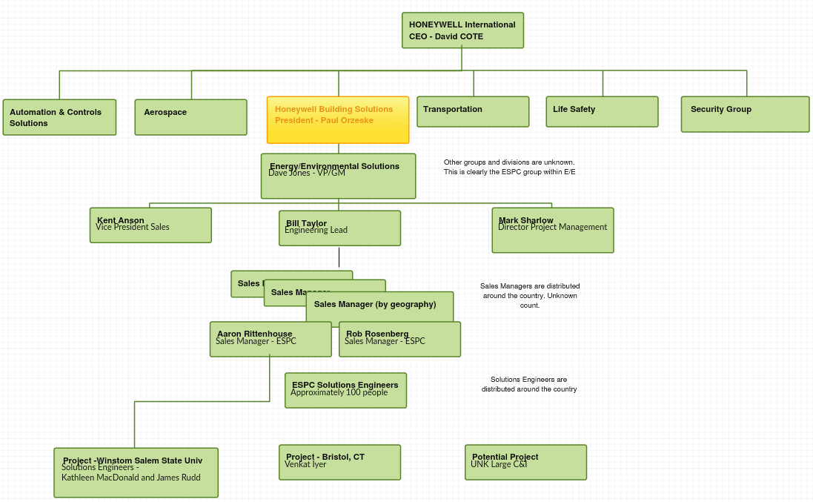

The chief executive of Honeywell international company limited is Mr. David COTE. The chief executive has six major product or service departments, they are automation & control solutions, aerospace, transportation, life safety, security group and Honeywell building solutions. The building solution department president is Mr. Pual Orzeske.

  - Research comparison company information

This study is used of three comparison of Honeywell international incorporation, Bosch group and Siemens Company limited. The Bosch group and Siemens Company limited company businesses have same nature of Honeywell international incorporation. They are also doing manufacturing business. The size of enterprise and market share are very close to each other.

Company name | Honeywell | Bosch | Siemens
Business nature | Industrial products | Industrial products | Industrial products
Market value | USD 124,468,000,000 | USD 6,295,256,200 | USD 96,189,772,700
PE | 20.59 | 28.81 | 15.71
Market area | worldwide | worldwide | worldwide

The market area of the Honeywell international incorporation, Bosch group and Siemens Company limited are worldwide.
The business nature of the Honeywell international incorporation, Bosch group and Siemens Company limited are industrial products.

Honeywell International, Inc. PE ratio is the price-to-earnings ratio. It is used for valuing the Honeywell International, Inc.
P/E Ratio=Earnings per share / Market value per share​

The PE ratio of Bosch group is higher than Honeywell international incorporation and Siemens Company. It indicates positive expectations for the future of the company. It means the Bosch stock is more expensive relative to earnings. And it typically represents a successful and fast-growing company.

The PE ratio of Siemens Company Limited is lower than Honeywell international incorporation and Bosch group. It indicates negative expectations for the future of the company. It means may suggest that the Siemens Company Limited stock is a better value or buy.

2. Honeywell's financial analysis

2.1 Listed company bankruptcy index Z-Score analysis

Z-Score mainly used to examine bankruptcy rate, when Z-Score greater value, insolvency of the less likely, Financial Ratios more sound. The Altman (1968), the when Z < 1.8 , are located in bankruptcy; when 1.8= Z <2.99, are located in gray area; when Z.2.99 is located at the Security Zone. Four companies the Z-Score values are as follows:

Honeywell, Bosch, Siemens (USD)
Company name | Honey-well | Honey-well | Honey-well | Bosch | Siemens
 | 2018 | 2017 | 2016 | 2018 | 2018
Net current assets | 5438 | 7141 | 6727 | 16503.65 | 18866.48
Total assets | 57773 | 59470 | 54146 | 94529.02 | 156973.95
Retained earnings | 33978 | 27481 | 28046 | 35254.87 | 46376.33
EBIT | 7854 | 7266 | 6790 | 6217.26 | 10467.19
Stock value (USD) | 130.76 | 151.65 | 114.56 | 288.36 | 110.04
Number of stock | 2.5m | 2.8m | 7.5m | 70.06m | 35.84m
Total liability | 39415 | 42805 | 34599 | 50260.14 | 102681.97
Sales | 41802 | 40534 | 39302 | 88665.45 | 93839.72

Company name | Honey-well | Honey-well | Honey-well | Bosch | Bosch | Bosch | Siemens | Siemens | Siemens
 | 2018 | 2017 | 2016 | 2018 | 2017 | 2016 | 2018 | 2017 | 2016
Net current assets | 5438 | 7141 | 6727 | 16503.65 | 16207.59 | 15262.91 | 18866.48 | 16580.49 | 13808.6
Total assets | 57773 | 59470 | 54146 | 94529.02 | 92513.1 | 92518.75 | 156973.95 | 153805.43 | 144554.12
Retained earnings | 33978 | 27481 | 28046 | 35254.87 | 33648.01 | 32250.2 | 46376.33 | 40447.22 | 31230.94
EBIT | 7854 | 7266 | 6790 | 6217.26 | 5586.72 | 3768.55 | 10467.19 | 10501.09 | 9696.53
Stock value (USD) | 130.76 | 151.65 | 114.56 | 288.36 | 296.2295 | 309.2245 | 110.04 | 131.2495 | 188.484
Number of stock | 2.5m | 2.8m | 7.5m | 70.06m | 70.06 | 70.06 | 35.84m | 38.3861 | 22.8147
Total liability | 39415 | 42805 | 34599 | 50260.14 | 50079.34 | 51743.83 | 102681.97 | 103385.96 | 105005.25
Sales | 41802 | 40534 | 39302 | 88665.45 | 88214.58 | 82635.77 | 93839.72 | 93635.19 | 89997.72

Z-score, Z = 1.2A + 1.4B + 3.3C + 0.6D + 0.999E
A= working capital / total assets
B = retained earnings / total assets
C = EBIT / total assets
D = stock value x total number of stock / total liability
E = sales / total assets

Company name | Honeywell | Honeywell | Honeywell | Bosch | Siemens
USD in million | 2018 | 2017 | 2016 | 2018,17,16 | 2018,17,16
A | 0.094 | 0.12 | 0.124 | 0.174 | 0.12
B | 0.588 | 0.462 | 0.518 | 0.373 | 0.295
C | 0.136 | 0.122 | 0.125 | 0.066 | 0.067
D | 0.008 | 0.0099 | 0.025 | 0.356 | 0.034
E | 0.704 | 0.6816 | 0.726 | 0.9.8 | 0.598
Z score | 2.11 | 1.88 | 2.03 | 2.1, ,2.36,2.19 | 1.4,1.53,1.45

Typically, a score below 1.8 indicates that a company is likely heading for or is under the weight of bankruptcy. Conversely, companies that score above 3 are less likely to experience bankruptcy.

The Siemens Company limited during year 2018, the Z- score is 1.4, so it indicates that a company is likely heading for or is under the weight of bankruptcy.
Honeywell international incorporation and Bosch group, the Z scores are not above 3, they are not less likely to experience bankruptcy.

2.2 Financial structure

Company name | Honeywell | Honeywell | Honeywell | Bosch | Siemens
year | 2018 | 2017 | 2016 | 2018 | 2018
Fixed assets to long term liabilities ratio | 0.188 | 0.203 | 0.183 | 0.052 | 0.36
Current liabilities to net assets ratio | 1.031 | 1.132 | 0.835 | 0.055 | 0.996
Current liabilities to stock ratio | 4.374 | 4.089 | 3.74 | 1.96 | 3.448

Fixed Assets to Long-Term Liabilities

Fixed Assets to Long-Term Liabilities = fixed assets / long term liability

Current liabilities to net assets ratio
Current liabilities to net assets ratio = Current liabilities / net assets

Current liabilities to stock ratio
Current liabilities to stock ratio = Current liabilities / stock

Fixed Asset to Long term Liability Ratio
For Fixed Asset to Long term Liability Ratio as an example, fixed assets are for the long-term finance source. If the rate is lower, source of funds is more stable; and that "Fixed Asset to Long term Liability Ratio" has lower value, the company financial crises in the lower chances.
Fixed Asset to Long term Liability Ratio of Siemens is higher than other companies, so its source of funds is more unstable.
Fixed Asset to Long term Liability Ratio of Bosch is lower than other companies, so its source of funds is more stable.
Honeywell’s long-term funds are very stable to show their strong competitive edge.

Current Liabilities to Net Asset Ratio
Current Liabilities to Net Asset Ratio indicates reliance on the equity for payment of debt. It is one of the measures of the solvency of a firm and, the ratio should not exceed 60 percent; higher percentages mean significant pressure on future cash flows. Current Liabilities to Net Asset Ratio is equal to Current liabilities x 100 / net assets ratio.
Honeywell has significant pressure on future cash flows.
Bosch has insignificant pressure on future cash flows.

Current Liabilities to Stock Ratio
Honeywell, Bosch and Siemens are at a reasonable level.

2.3 Paying debt ability

Company name | Honeywell | Honeywell | Honeywell | Bosch | Siemens
year | 2018 | 2017 | 2016 | 2018 | 2018
Current ratio % | 1.287 | 1.379 | 1.412 | 1.677 | 1.35
Quick ratio % | 1.059 | 1.134 | 1.145 | 1.166 | 1.059
Stock credit index | -0.257 | -0.548 | -0.541 | -0.326 | -0.202
Cash ratio % | 0.491 | 0.374 | 0.48 | 0.219 | 0.231
Total debt / equity ratio % | 0.682 | 0.719 | 0.639 | 0.532 | 0.654
Debt / equity ratio % | 0.531 | 0.754 | 0.623 | 0.013 | 0.564
Long term debt ratio | 0.307 | 0.268 | 0.264 | 0.686 | 0.339
Total debt / fixed ratio | 7.442 | 7.223 | 5.972 | 2.15 | 3.356
Time interest cover ratio | 21.4 | 22.99 | 20.09 | 2.95 | 5.426
Cash coverage | 24.44 | 26.52 | 23.13 | 5.22 | 7.43

Current ratio % = current assets / fixed assets
Quick ratio % = (current assets – inventory) / current liability
Stock credit index = (current liability – (current assets – inventory)) / inventory)
Cash ratio % = cash / current liability
Total debt / equity ratio % = total liability / total assets
Debt / equity ratio % = long term liability / net assets
Long term debt ratio = inventory / (inventory + long term liability)
Total debt / fixed ratio = total liability / fixed assets
Time interest cover ratio = EBIT / interest
Cash coverage = (EBIT + depreciation + amortization) / interest

2.4 Operating capacity

Company name | Honeywell | Honeywell | Honeywell | Bosch | Siemens
year | 2018 | 2017 | 2016 | 2018 | 2018
Employee cost | 1469 | 1420 | 1489 | 431 | 25316
Depreciation and amortization | 1116 | 1115 | 1030 | 4253 | 3419
Rental expenses | 0 | 0 | 0 | 0 | 1249
Other expenses | 1149 | 963 | 739 | 28 | 368
Depreciation and amortization = Depreciation + amortization

Company name | Honeywell | Honeywell | Honeywell | Bosch | Siemens
year | 2018 | 2017 | 2016 | 2018 | 2018
Total assets turnover | 7.893 | 6.84 | 6.78 | 3.79 | 3.07
Average collection period | 65.56 | 79.83 | 81.89 | 69.12 | 78.75
Sales in inventory | 54.36 | 59.82 | 57.92 | 77.77 | 87.75
Payment period | 70.46 | 58.39 | 75.49 | 53.85 | 67.23

Total assets turnover = sales / fixed assets
Average Collection Period (days) = 365 * account receivable / sales
Sales in Inventory (days) = average inventory / cost of goods sold * 365days
Payment period (days) = average account payable / cost of goods sold * 365

2.5 Profitability

Company name | Honeywell | Honeywell | Honeywell | Bosch | Siemens
year | 2018 | 2017 | 2016 | 2018 | 2018
Net profit | 6828 | 12390 | 11792 | 26769 | 24863
Net profit growth | 0.03 | 0.051 |  | -0.034 | -0.051
Gross profit margin | 30.5% | 30.57% | 30% | 34.1% | 29.9%
Net profit margin | 16.33% | 30.57% | 30% | 34.1% | 29.9%

Net profit = EBIT – cash - tax
Net profit growth = current net profit - previous net profit
Gross profit margin = gross profit / sales
Net profit margin = Net Profit / sales

Company name | Honeywell | Honeywell | Honeywell | Bosch | Siemens
year | 2018 | 2017 | 2016 | 2018 | 2018
Total assets turnover | 72.4% | 68.16% | 72.6% | 93.8% | 59.7%
Leverage ratio | 0.035 | 0.32 | 0.08 | 0.004 | 0.04
Return on equity (after tax) % | 33.6% | 42.2% | 52.1% | 64.5% | 47.5%

Total assets turnover = sales / total assets
Leverage ratio = tax / net assets
Return on equity (after tax) % = (Net Profit – tax) / net assets

2.6 Growth capacity

Company name | Honeywell | Honeywell | Honeywell | Bosch | Siemens
year | 2018 | 2017 | 2016 | 2018 | 2018
Retained yield | 5.51 | 3.9 | 2.75 | 1.23 | 1.8
Self-sustainable growth ratio % | 185 | 164.9 | 143.5 | 79.6 | 85.4

Retained yield = retained earnings / (Net Profit – tax)
Self-sustainable growth ratio % = retained earnings / net assets * 100

2.7 Stock Market prospects analysis

Company name | Honeywell | Honeywell | Honeywell | Bosch | Siemens
year | 2018 | 2017 | 2016 | 2018 | 2018
Earnings per share USD | 0.71 | 0.15 | 0.16 | 0.1 | 0.28
Price earning ration | 18.3 | 10.05 | 10.55 | 21.7 | 3.4
Dividend yield % | 33.3 | 17.1 | 16.24 | 19.7 | 12.6

Market Capitalization = market price per share x total number
Market-to-book ratio = market value per share / book value per share
Enterprise Value (EV) = Market capitalization + Market value of interest bearing debt – cash
EV Multiple = EV / EBITDA
Earnings per share EPS (HK$) = Net profit / Total number issued common shares
Price-earnings Ratio (Times)= market price/EPS
Dividen yield (+%) (payout ratio)=Dividend/net profit
EBITDA = EBIT + DEP + amort

Earnings per share EPS (HK$) = Net profit / Total number issued common shares
Price-earnings Ratio (Times) = market price/EPS
Dividen yield (%) (payout ratio) = Dividend/net profit

3. Corporate Governance assessment

Company name | Honeywell | Honeywell | Honeywell | Bosch | Siemens
year | 2018 | 2017 | 2016 | 2018,17,16 | 2018,17,16
ROA after tax % | 11.8 | 20.8 | 21.7 | 36.2,38.2,35.1 | 20.2,20.8,21
ROE after tax % | 37.2 | 74.3 | 60.3 | 7.7,83,3,79.6 | 58.4,63.4,76.9
EBITDA margin % | 21.45 | 20.68 | 19.9 | 14.05,13.37,11.7 | 17.26,17.05,16.1

ROA after tax % = Net Profit / total assets
ROE after tax % = Net Profit / net assets
EBITDA = EBIT + DEP + amort
EBITDA margin (%) = EBITDA / sales *100

From chapter 2 the Honeywell financial assessment analysis, we understand that Honeywell appearance growth negative in 2018, and it direct affect for its enterprise development in the future and the shareholders’ interests.

3.1 Suggestions for improvement

We recommend that Honeywell pay attention to these issues, further consider the following suggestions for improvements:

Reorganize the management team members and directors. Honeywell managers can be separated from director board under the supervision and appointment.

Honeywell managers, directors can perform tight internal control and response any unclear management matters.

Honeywell directors, managers can open more with the connected up to small shareholders in public.

Honeywell managers, auditors and perform internal self-credit rating assessment, and they can improve Honeywell financial cost and credit risk management of company.

4. Investment project Appraisal

4.1 Compute tax cost

EBITADA % 20.68
Sales 41802
Sales growth rate 3.13%

Operating rate 10 years

 | Year 0 | Year 1 | Year 2 | Year 3 | Year 4 | Year 5 | Year 6 | Year 7 | Year 8
Sales = last year sales x (1+growth rate) | 41802 | 43110 | 44459.7 | 45851.3 | 47286.5 | 48766.5 | 50292.9 | 51867.1 | 53490.5
EBITDA | 8644.65 | 8915.2 | 9194.27 | 9482.05 | 9778.84 | 10084.9 | 10400.5 | 10726.1 | 11061.8
Dep = (Building cost/9) | -80.111 | -80.111 | -80.1111 | -80.1111 | -80.1111 | -80.1111 | -80.1111 | -80.1111 | -80.1111
EBIT | 8564.54 | 8835.1 | 9114.16 | 9401.94 | 9698.73 | 10004.8 | 10320.4 | 10646.0 | 10981.7
Tax cost (standard rate 25%) | -2141.14 | -2208 | -2278.5 | -2350.49 | -2424.68 | -2501.2 | -2580.12 | -2661.5 | -2745.43
Profit | 6423.4 | 6626 | 6835.6 | 7051.46 | 7274.052 | 7503.611 | 7740.354 | 7984.508 | 8236.304

4.2 cash flow calculation

 | Year 0 | Year 1 | Year 2 | Year 3 | Year 4 | Year 5 | Year 6 | Year 7 | Year 8
EBITA | 8644.65 | 8915.2 | 9194.3 | 9482.1 | 9778.8 | 10084.9 | 10400.6 | 10726.1 | 11061.9
Expendi-ture | 0 | 0 | 0 | 0 | 0 | 0 | 0 | 0 | 0
Expendi-ture | 0 | 0 | 0 | 0 | 0 | 0 | 0 | 0 | 0
Tax expense | 0 | 0 | 0 | 0 | 0 | 0 | 0 | 0 | 0
Cash flow 60000 | 8644.65 | 8915.2 | 9194.3 | 9482.1 | 9778.8 | 10084.9 | 10400.6 | 10726.1 | 11061.9
Working capital the first year calculation => annual direct sales x operating cash-flow period/365
Working capital for the rest calculation => the previous year working capital x (1+sales growth rate)
Cash-flow after 10 years, using the assumption the ultimate growth

4.3 ARR and NPV calculation

Total income for 9 years 8000
Average ARR (A) 889
Initial cost (B) 8644.65
ARR (A/B) 10.28%

year | Cash flow | PV | PV total
Initial cost | 60000
1 | 8644.654 | 8382.288 | 8382.288
2 | 8915.231 | 8382.288 | 16764.58
3 | 9194.278 | 8382.288 | 25146.86
4 | 9482.059 | 8382.288 | 33529.15
5 | 9778.847 | 8382.288 | 41911.44
6 | 10084.93 | 8382.288 | 50293.73
7 | 10400.58 | 8382.288 | 58676.02
8 | 10726.12 | 8382.288 | 67058.3
9 | 11061.85 | 8382.288 | 75440.59

NPV = all cash flow 9 years – initial cost

4.4 payback period and IRR

1-8 profit (A) 67058.3
Initial cost (B) 60000
Payback period 8 year 2 months
IRR 25%

5. Financing and capital management

5.1 Financing methods for analysing

Company name | Honeywell | Honeywell | Honeywell | Bosch | Siemens
 | 2018 | 2017 | 2016 | 2018 | 2018
Cash and equivalents | 9287 | 7059 | 7843 | 4716 | 11066
Bank loans | 0 | 0 | 0 | 0 | 0
Cash ratio = cash / current liability | 0.49 | 0.37 | 0.48 | 0.22 | 0.23
Retained profit = retained earnings / net-income | 4.97 | 17.3 | 5.92 | 1.16 | 1.65
Net debt ratio = (bank loan – cash) / equity | -0.51 | -0.43 | -0.4 | -0.12 | -0.23
Net interest expense = interest payments – interest income | -367 | -316 | -338 | -1868 | -1707
Net interest expense / turnover | 46.5 | 46.2 | 49.9 | 492.9 | 556

Net debt ratio = (bank loans –cash) / Equity
Net interest expense = interest payments – interest income

i. cash payments– internal retained earnings/cash as sources of funding. Honeywell financial status is stable, in the past four years are all at net cash status, the net debt ratio is negative. But its cash ratio has been industry than 20 percent higher on the domestic financing after 2090 million its cash ratio is as high as 49 percent. Although retained earnings ratio would drop to 4.79, believe the enterprises little impact on future development.

ii. Commercial credit financing - mainly in the line on the line of business partners and the money received in advance and money credit too easily. But because it is directly to customers charge a fee and therefore to cope with the line partners for accounts payable to credit transactions. The main partners Honeywell for the counters’ customers now meet money working capital to 66 days for the industry also average. But the department store industry use this method of financing, where the individual counters customers to its fund-raising Limited, to raise 2090 million USD will need to negotiate with great deal of customers, therefore, not feasible.

iii. Issued share capital fund-raising - such as raise 2090 million USD, its distribution costs have reached 8-12% than the general bank loan for high interest rates. The new shares fund-raising will reduce shareholders' equity ratio, and shareholders to creditors to more than often return high, and therefore the liabilities rate is not high, was not proposing shares fund-raising.

5.2 Financing method proposed

Fixed assets to LTL ratio = long term liability / fixed assets
= 18924/5296=3.57

Debt / equity ratio = (short term debt + long term debt + other fixed payments) / shareholder’s equity
= (9756+1713+344+2269+6402)/18180=1.13

Interest expense to sales = interest / sales
=367/41802=0.00878

Debt ratio= liability / total assets
= (18924+(9756+1713+344+2269+6402))/57773=0.682

Financial items | 2018 actual | 2019 budget | 8 year average | Assessment
Fixed assets to LTL ratio | 3.57 | 3.68 | 7.76 | Negative
Debt / equity ratio | 1.13 | 1.23 | 1.13 | Not healthy
Interest expense to sales | 0.878% | 0.91% | 0.339 | Healthy
Debt ratio= | 68.2% | 62.5% | 38.2% | Healthy

6. Recommendations and Audit plan

After this data analysis, we have proposed Honeywell operational audit of the following points:

Honeywell can plan to use around ten years to buy new machines, equipment to develop new products to increase market share, based on past business data and marketing environment.

Change improve company business operating procedures. Honeywell can generate more sales while reducing expenses. To increase the Honeywell sales, can try cross-selling-offering new services and products that current offerings. Switch to a relationship-based sales model then gets customers coming back.

To maximize the Honeywell cash flow, it is the best ways to obtain stable cash flow.

Honeywell can also improve its some top financial accounting ratios such as the following list:
1. Debt-to-Equity Ratio
2. Current Ratio
3. Quick Ratio
4. Return on Equity (ROE)
5. Net Profit Margin

8. References

Honeywell-annual-report-2016
http://investor.honeywell.com/Cache/1500096766.PDF?O=PDF&T=&Y=&D=&FID=1500096766&iid=4121346

Honeywell-annual-report-2017
http://investor.honeywell.com/Cache/1001233343.PDF?O=PDF&T=&Y=&D=&FID=1001233343&iid=4121346

Honeywell-annual-report-2018
http://investor.honeywell.com/Cache/1500118299.PDF?O=PDF&T=&Y=&D=&FID=1500118299&iid=4121346

Bosch-annual-report-2016
https://assets.bosch.com/media/en/global/bosch_group/our_figures/publication_archive/pdf_1/GB2016.pdf

Bosch-annual-report-2017
https://www.bosch.in/media/our_company/shareholder_information/2017_2/annual_report_2016-17.pdf

Bosch-annual-report-2018
https://www.bosch.com/company/annual-report/

Siemens-annual-report-2016
https://www.siemens.com/investor/pool/en/investor_relations/Siemens_AR2016.pdf

Siemens-annual-report-2017
https://www.siemens.com/investor/pool/en/investor_relations/Siemens_AR2017.pdf

Siemens-annual-report-2018
https://assets.new.siemens.com/siemens/assets/public.1552038192.4bfbab10-00d6-4a22-aad2-b50f3f232bfb.siemens-annual-report-2018.pdf

Edward I. Altman, “Predicting financial distress of companies: revisiting the z-score and zeta models, Journal of Banking and Finance 2000

Al - Manaseer, Sufian Radwan ,International journal of economics and finance, 2018, Vol.10(8), pp. 181-189
Available from 2009 volume: 1

Schmidt, Ally (30 January 2015). "Analyzing how Honeywell makes money". marketrealist.com. Retrieved 23 July 2018.
"Honeywell's JetWave Hardware Chosen by ExecuJet South Africa". NASDAQ.com. 10 July 2018. Retrieved 23 July 2018.
"Acutation Solutions". aerospace.honeywell.com. Honeywell. Retrieved 24 September 2018.
"Honeywell to provide Lockheed Martin with new control actuation system to increase Rocket accuracy". armadainternational.com. Armada International. Retrieved 24 September 2018.
Huber, Mark (17 September 2018). "Honeywell Readies Aspire 200 Satcom for Bell 407". AINonline. AIN Publications. Retrieved 19 September 2018.
"Automatic Identification System (AIS) / RF Receivers". aerospace.honeywell.com. 17 September 2018. Retrieved 17 September 2018.
"Auxiliary Power Units". aerospace.honeywell.com. Honeywell. Retrieved 24 September 2018.
"GoDirect Services". Retrieved 15 September 2018.
"Honeywell Presents 24th Annual Aerospace and Defense Conference Slideshow". seekingalpha.com. Retrieved 15 September 2018.

9. Appendix

Honeywell international Inc. annual report 2018
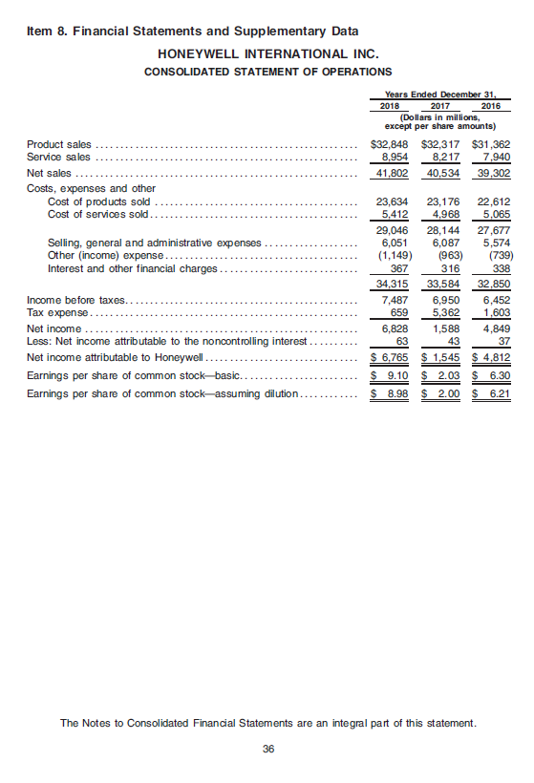
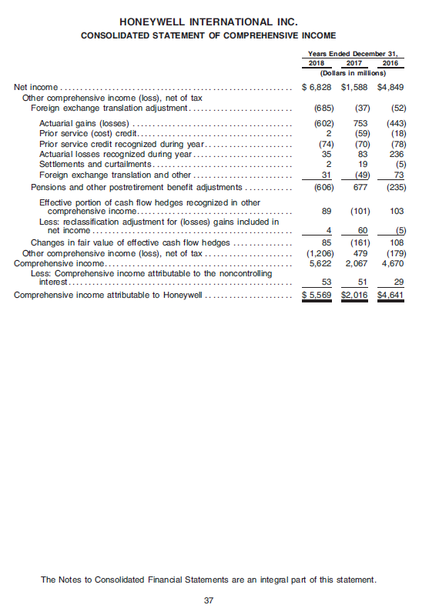
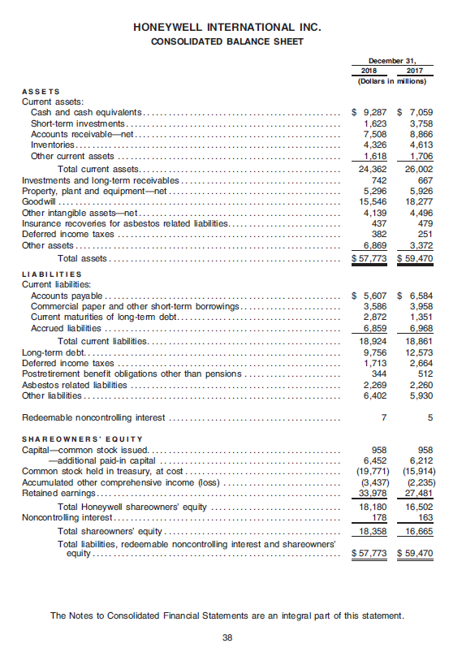
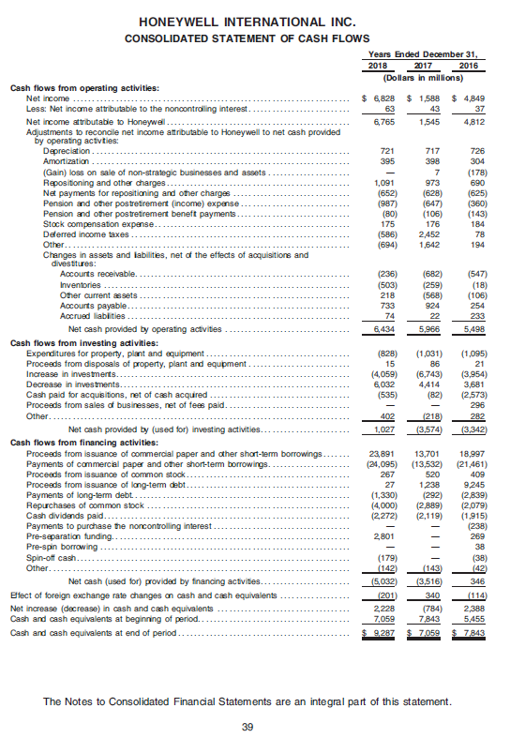
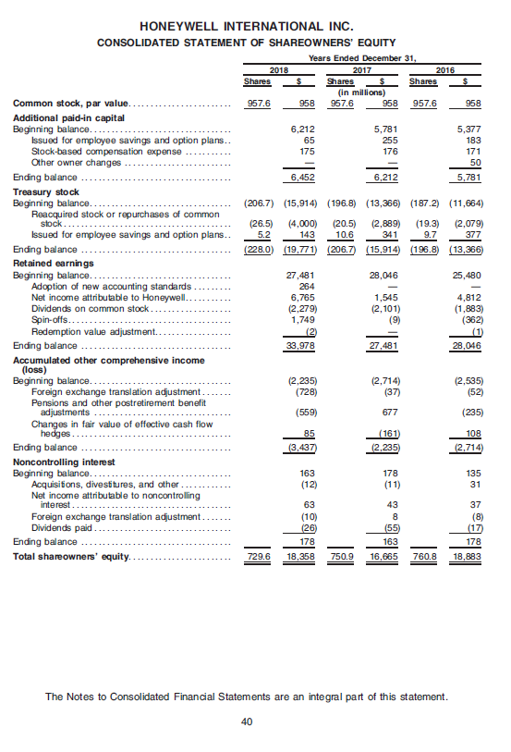

Honeywell international Inc. annual report 2016

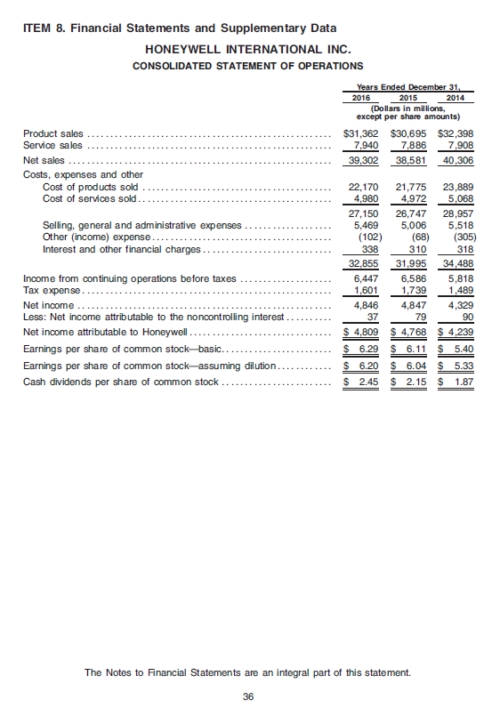
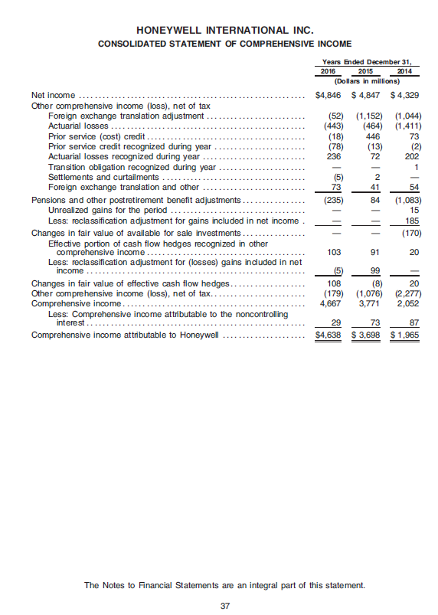
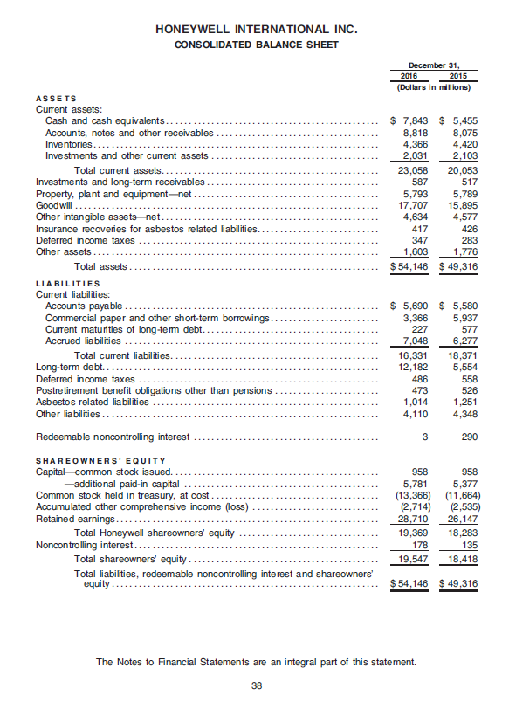

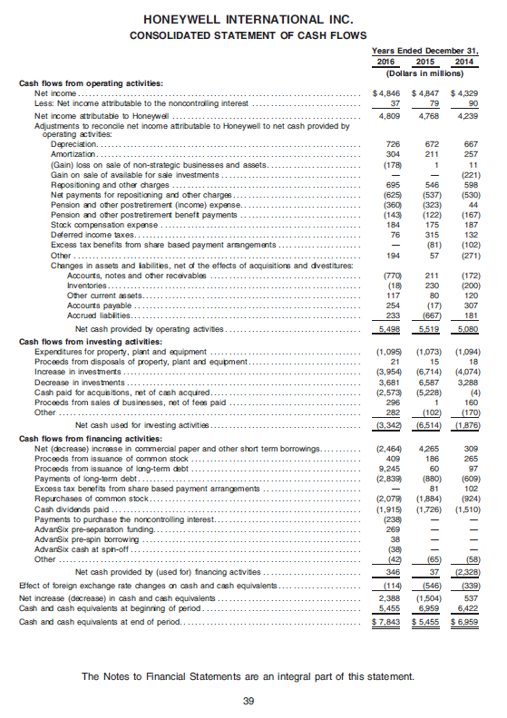
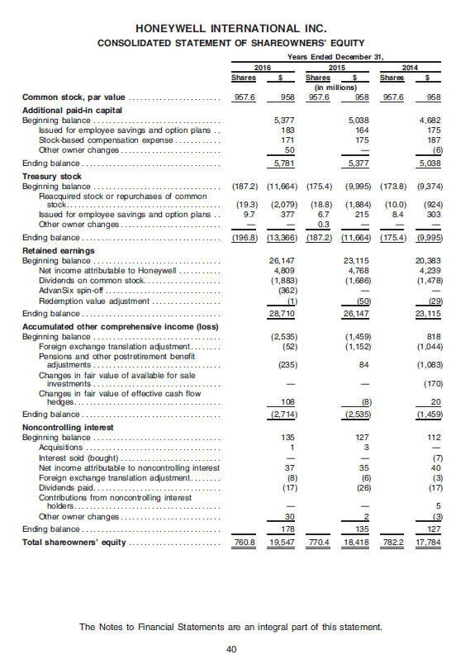

Bosch annual report 2018

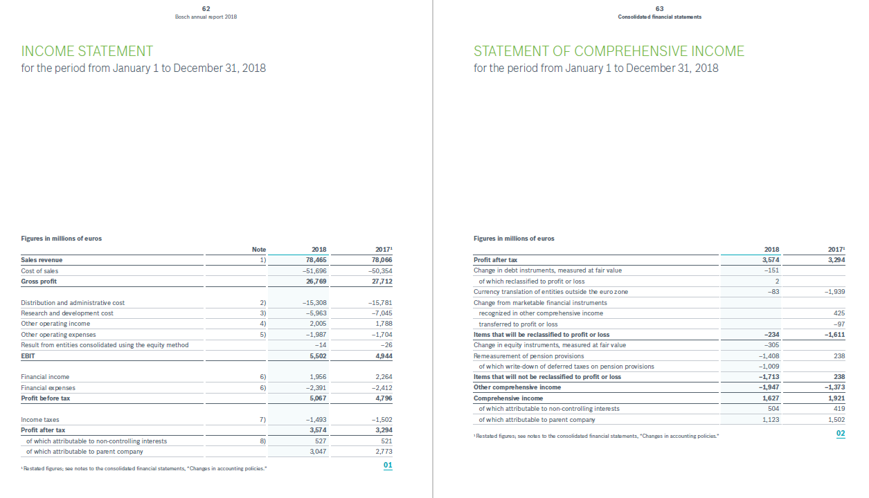
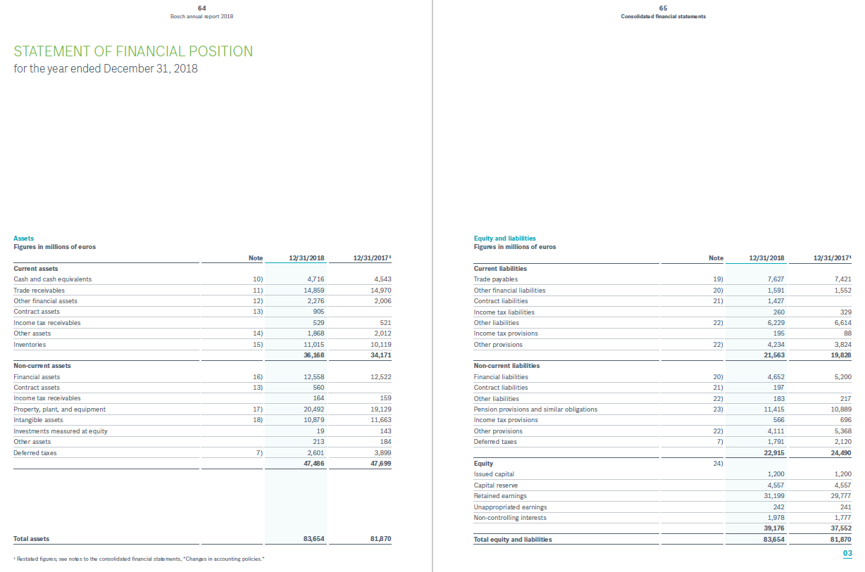
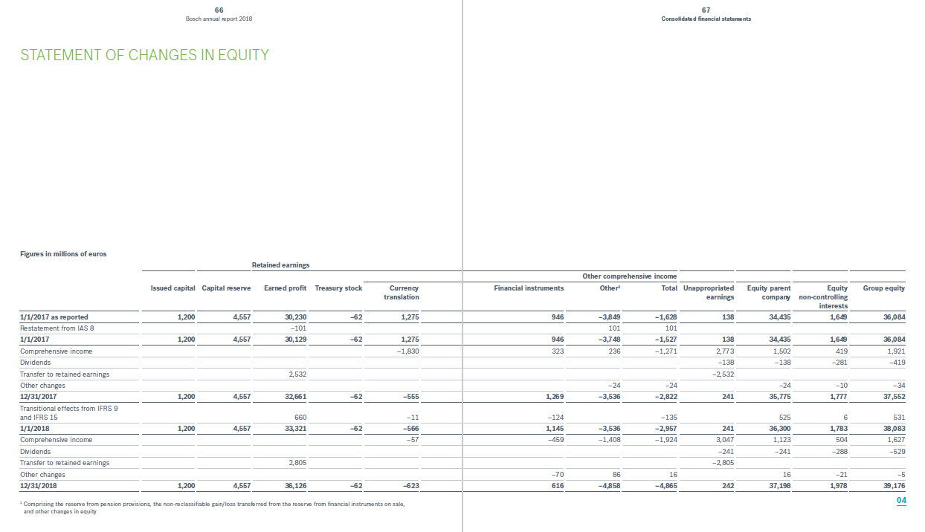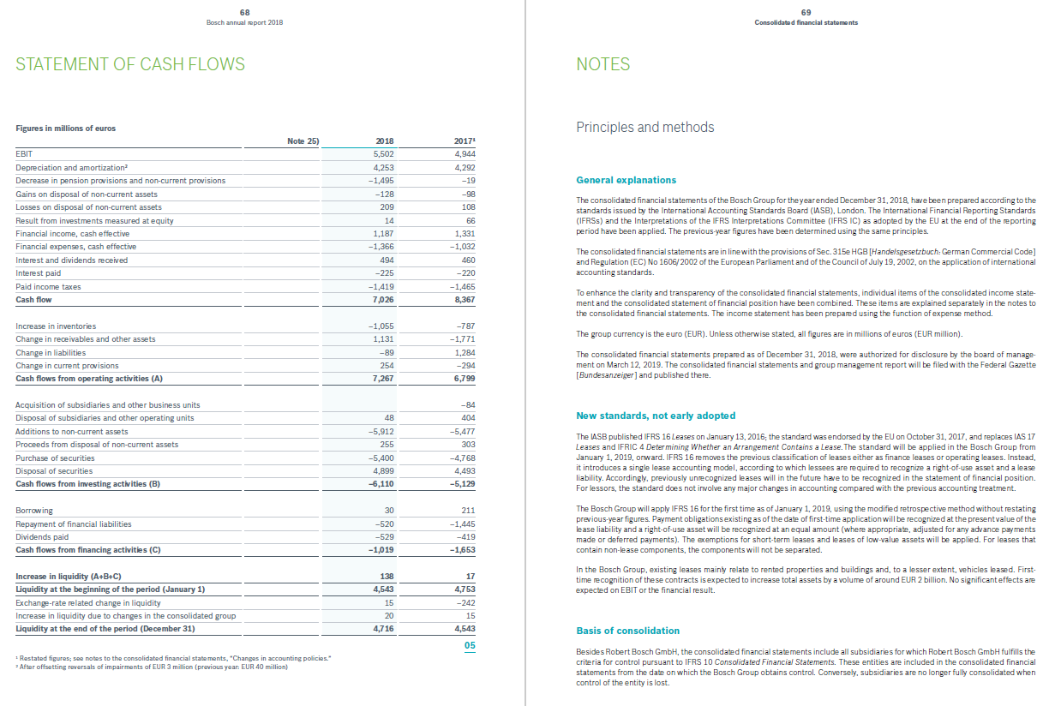

Bosch annual report 2016
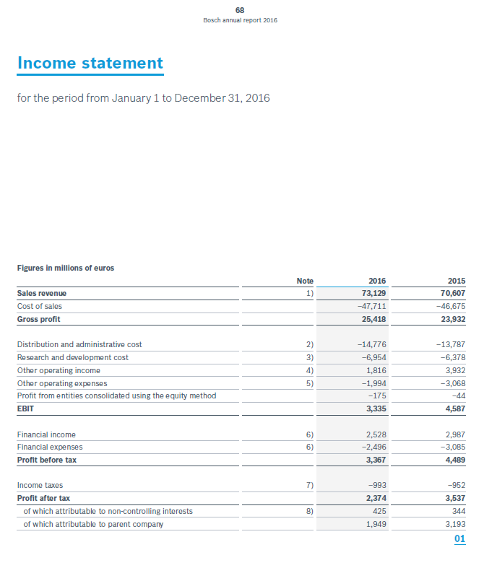
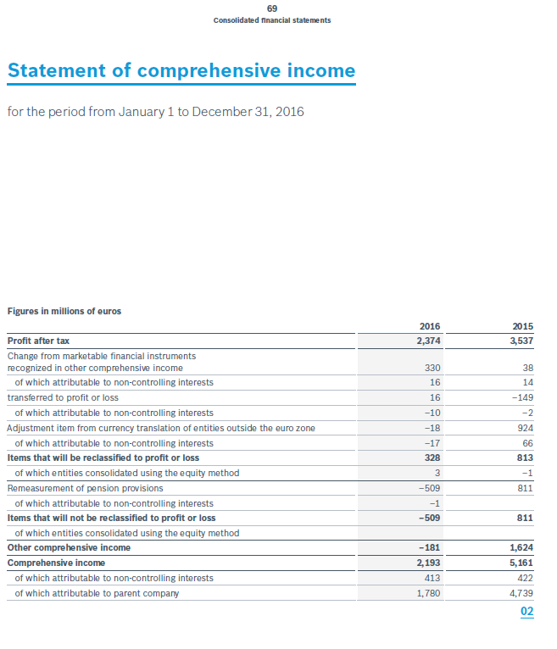
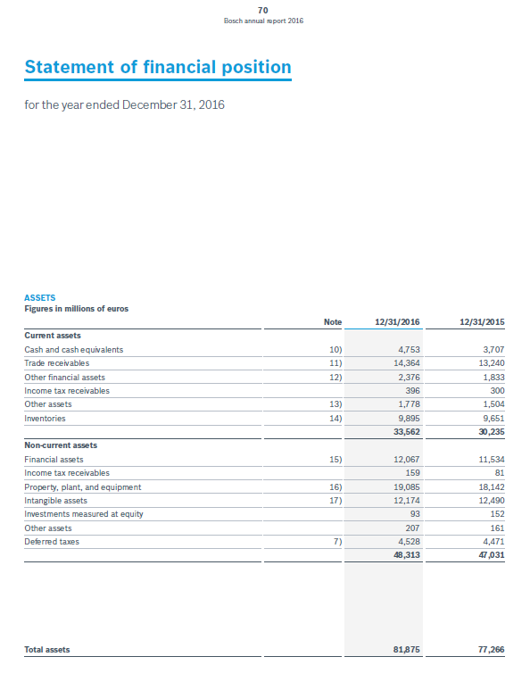
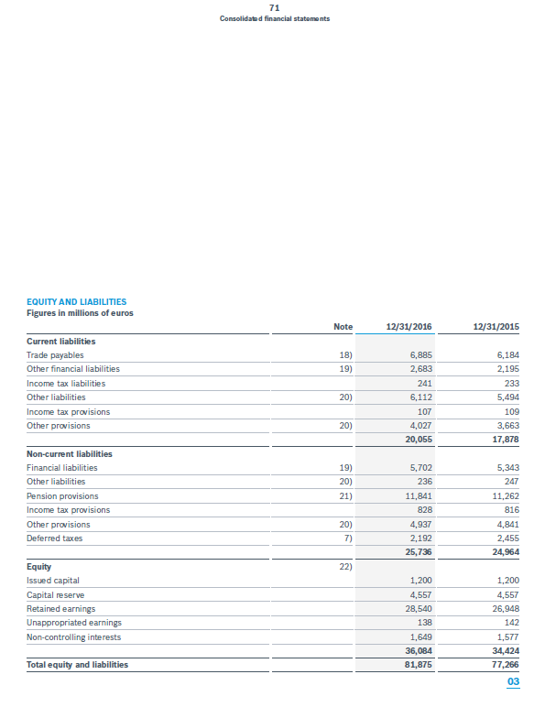
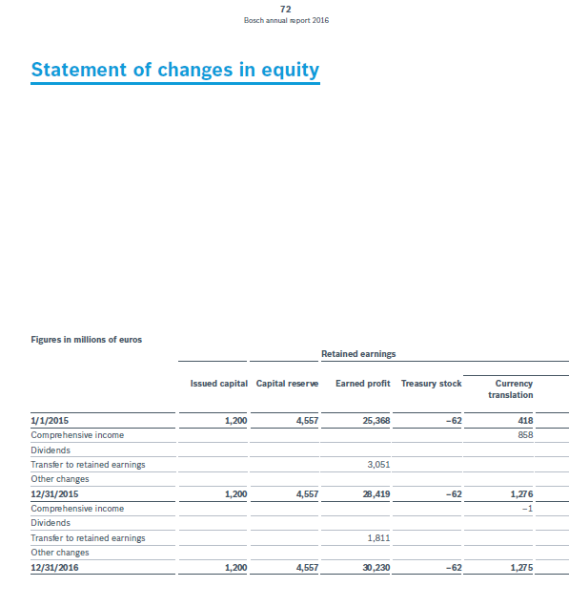
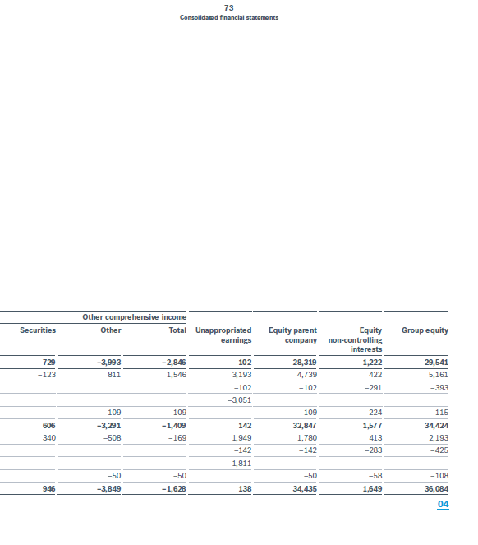
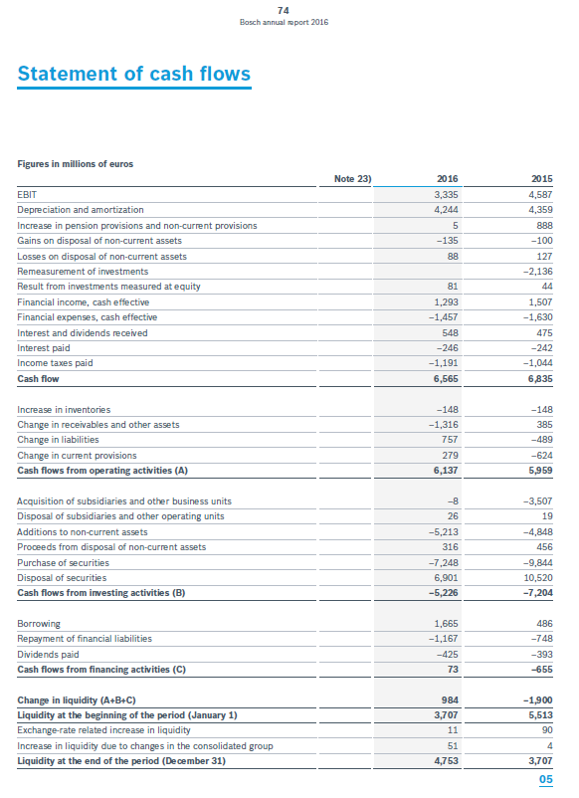

Siemens annual report 2018

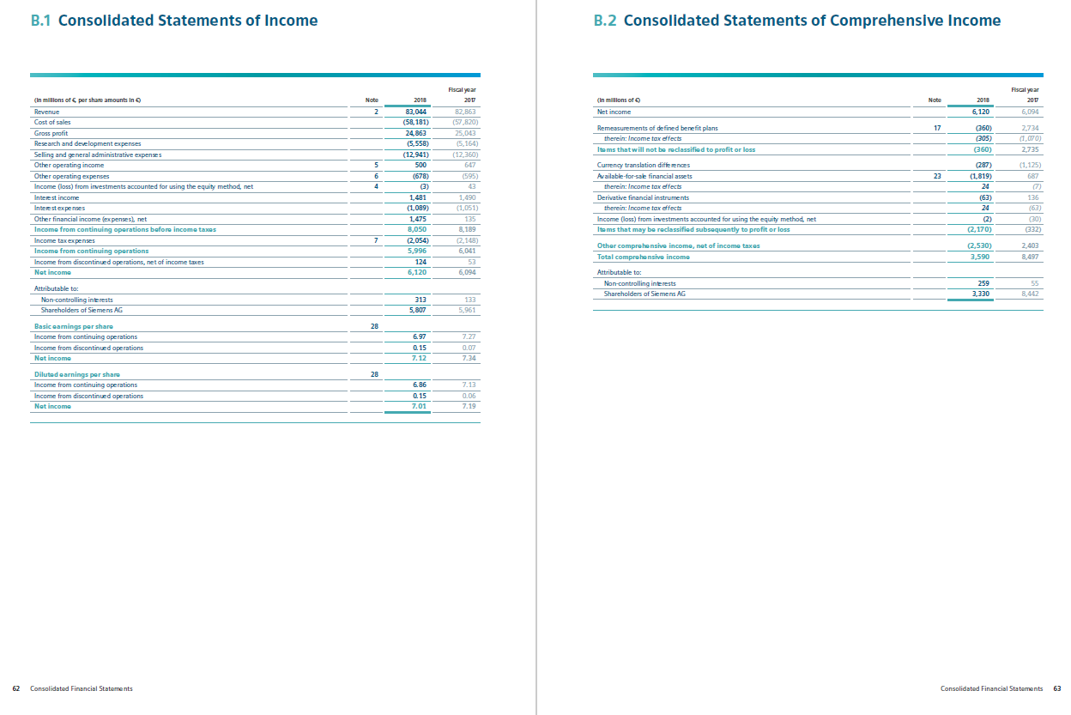
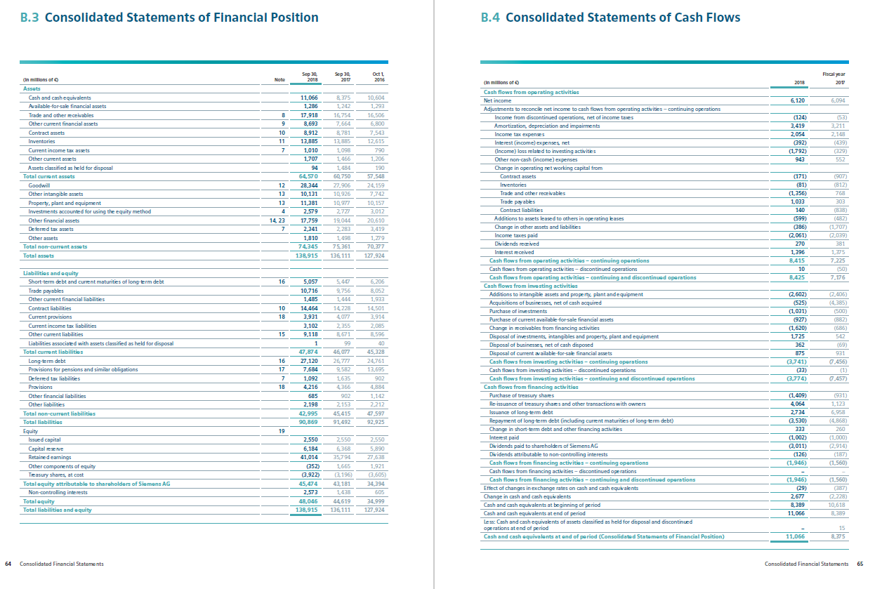
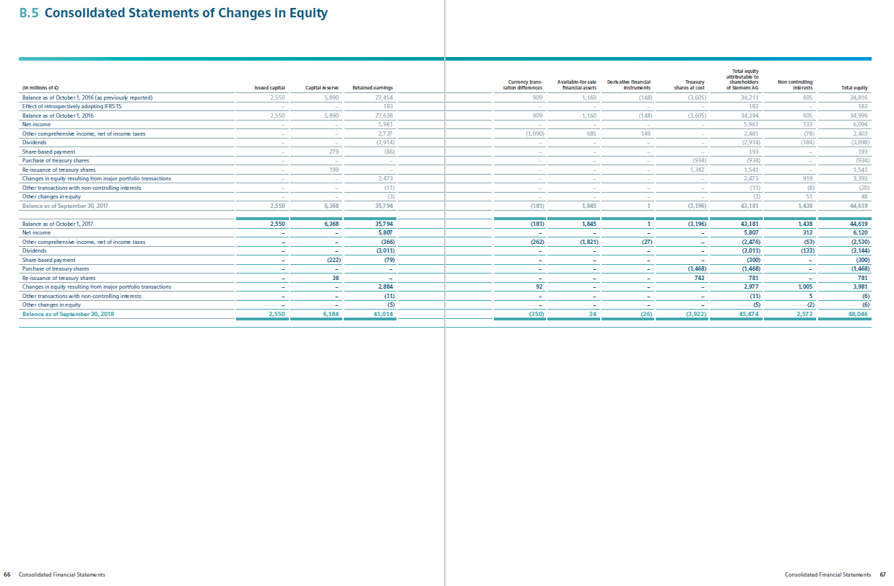
Siemens annual report 2017
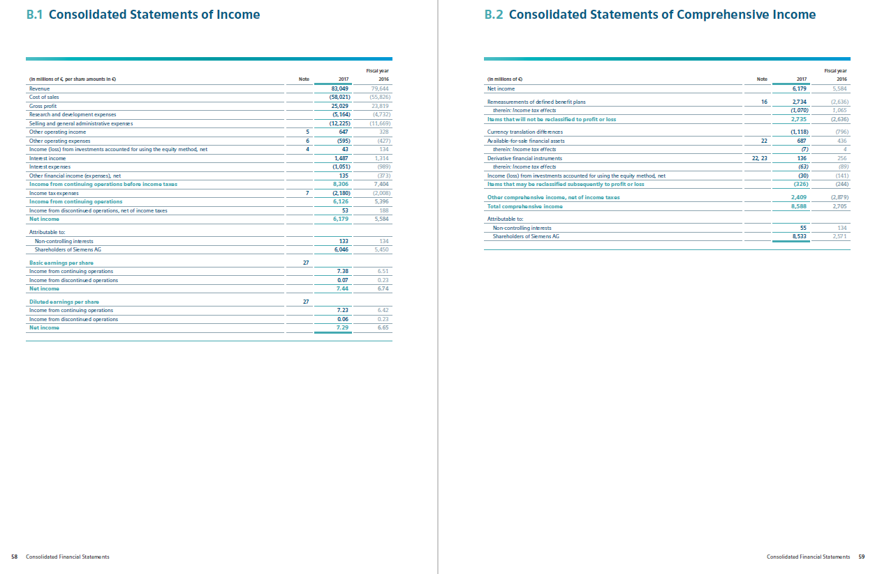
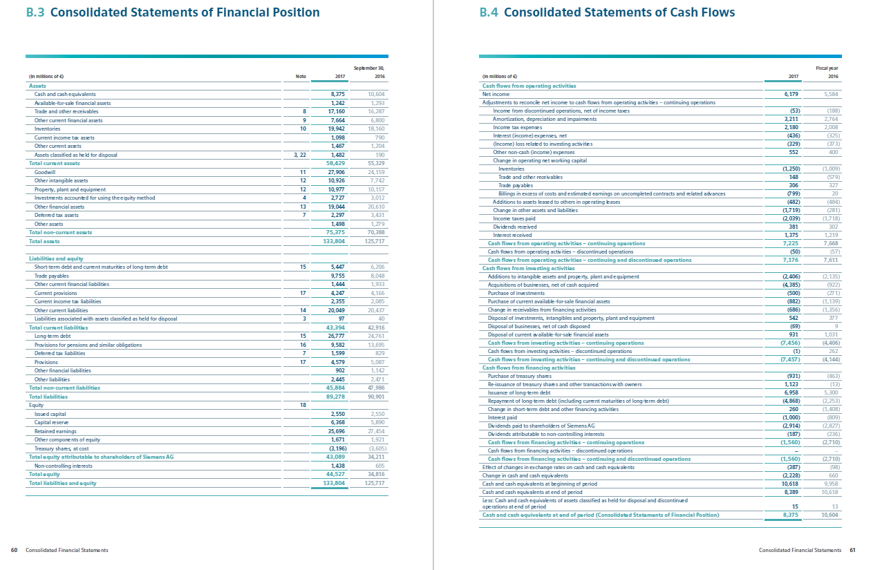
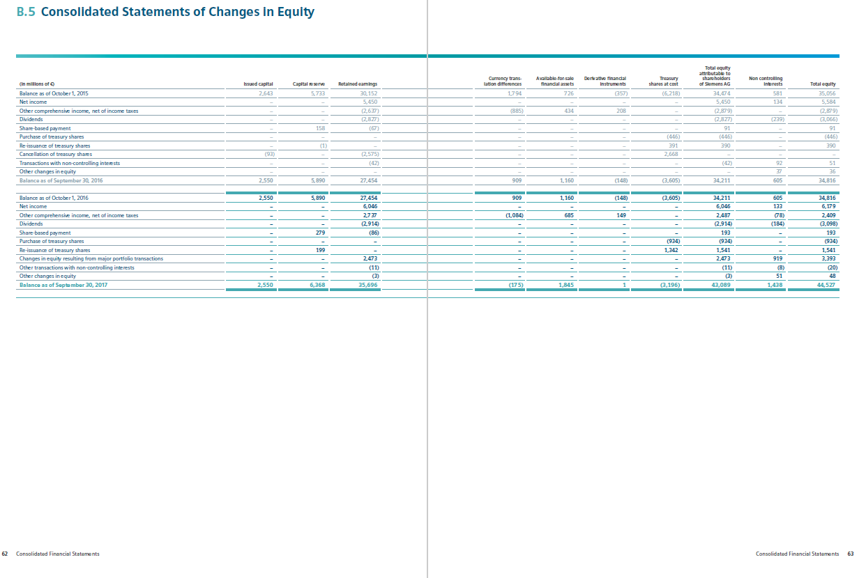

Honeywell, Bosch, Siemens



