2204714
Learning in the Digital Era ECGE4005P/C

https://uowtsd.sharepoint.com/teams/DysguynyrOesDdigidolLearningintheDigitalEraECGE4005PC_GRP-JessJames/Shared%20Documents/Recordings/Meeting%20in%20_Jess%20James_-20221107_201131-Meeting%20Recording.mp4?web=1

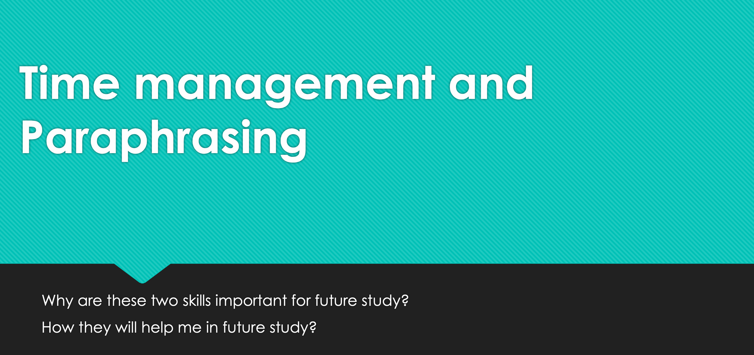

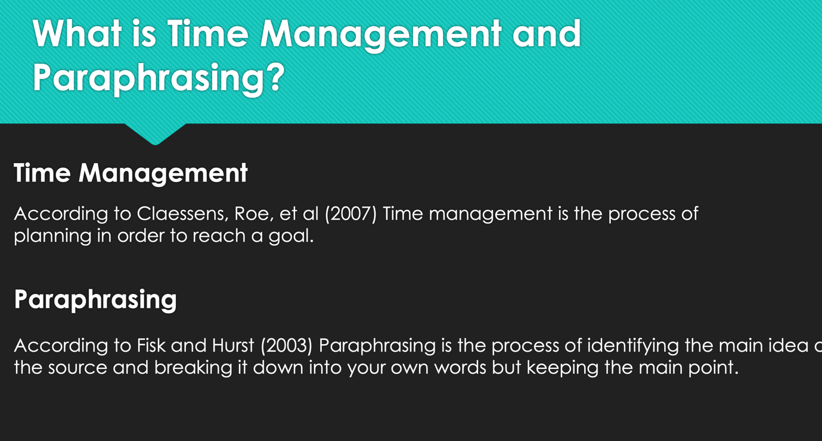

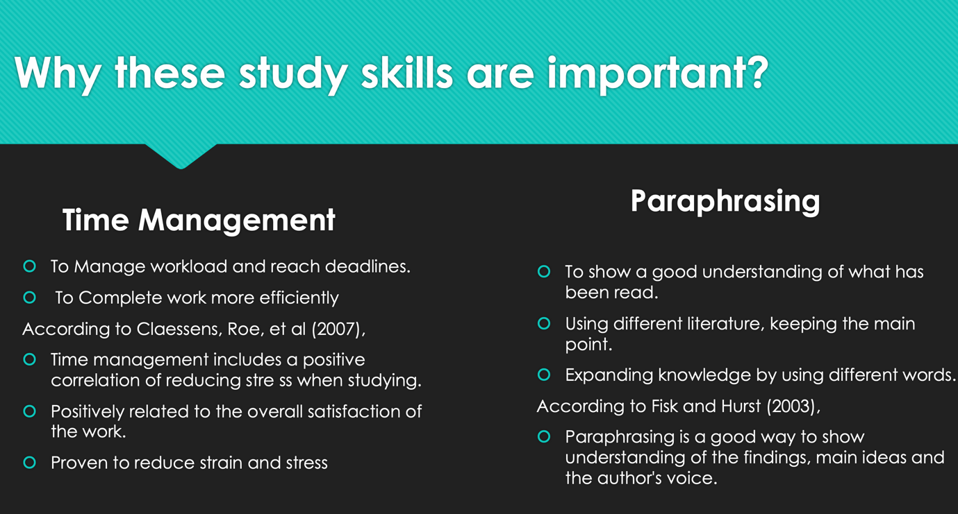

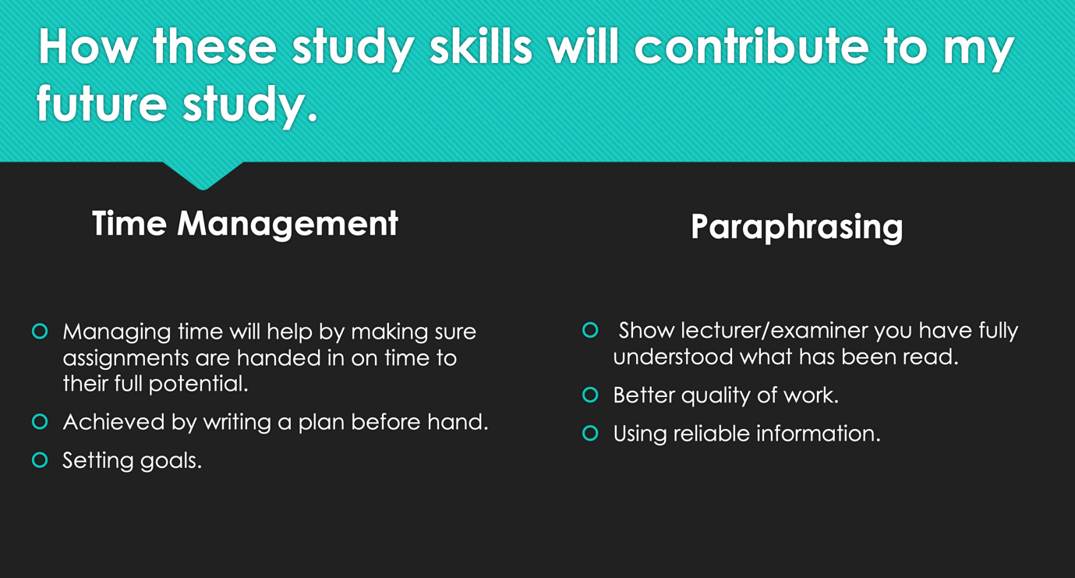

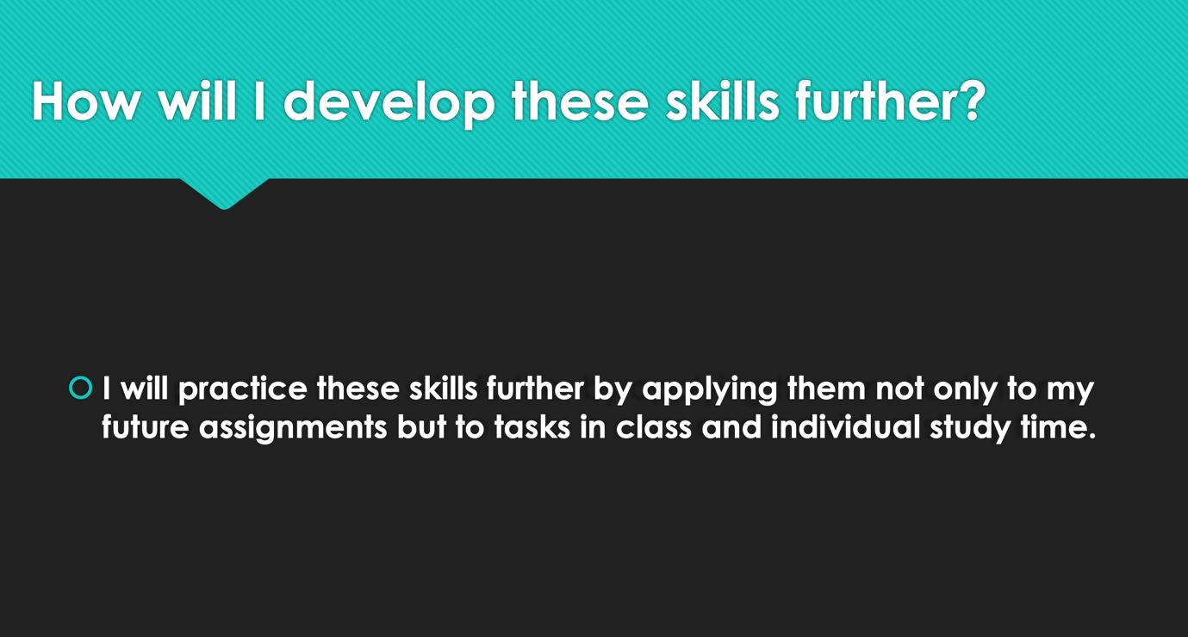

Reference list
Claessens, B.J., Van Eerde, W., Rutte, C.G. and Roe, R.A., 2007. A review of the time management literature. Personnel review.

Fisk, C. and Hurst, B., 2003. Paraphrasing for comprehension. The Reading Teacher, 57(2), pp.182-185.

