Investigation into the Chinese Balloons over North America

Contents
Background 2
Issue 2
Recommendation 2
Timing 2
Discussion 3
Current Capabilities 3
High altitude Balloons 3
Current military use of balloons 3
Power 4
Payloads 4
Gamma rays 5
X-rays 5
Ultraviolet (UV) 5
Visual Surveillance 6
Infrared 6
Radio Waves 6
Microwaves 7
Radar Transmission 7
Radar Tracking 8
References 9
Appendix A 11
Apprentix B 11
Appendix C 12
Appendix D 12

Table of Figures
Figure 1- A diagram of a weather balloon [4] 3
Figure 2-An image of the alleged weather balloon seen flying over America [7] 4
Figure 3- The electromagnetic spectrum [10] 5

Background
From the 28th January to the 4th February 2023, a Chinese-owned high-altitude balloon illegally entered North American aerospace, travelling at an altitude between 18-19.3 km. According to republican Mike Turner, the balloons flight path appears to directly match some sensitive missile defence sites, nuclear weapon sites and infrastructure, causing widespread concern [1] On the 4th February, the balloon was shot down by a United States (US) fighter jet on the coast of South Carolina, under the orders of President Joe Biden. In the weeks since, the wreckage has been recovered, and sent to a FBI laboratory for analysis [2]

Issue
The function of this balloon remains unknown. Chinese authorities claim it to be a civilian meteorological airship that was blown off course. However, both the US and Canada believe it was used for surveillance [2]. This report aims to discover the truth behind this incident, and provide insight into the balloons intentions.

Recommendation
The use of weather balloons as a malicious technology is a new and emerging concept. As detailed below, pre-existing technologies can be utilised to help survey, record and capture valuable data. Their low detectability and cost makes them rival the more traditional spy satellites as an effective intelligence gathering methodology. Therefore, it is clear that more research needs to be conducted into analysing, tracking and capturing these novel vessels, as well as producing viable countermeasure solutions for their use.

Timing
These balloons are believed to be a viable threat both currently and in the future, so research and testing should begin as soon as possible so that the UK can remain at an advantage.

Discussion

Current Capabilities

High Altitude Balloons
Figure 1 shows a typical weather balloon. The balloon itself is made from latex, and is filled with either hydrogen or helium. When released, the balloon increases in diameter as its altitude increases. A radiosonde is an instrumentation package tethered below the balloon which can measure dynamic weather processes such as pressure, temperature and relative humidity. These sensors are linked to a battery powered radio transmitter which sends any data to a ground receiver. The radiosondes position can be tracked via Global Positioning System (GPS). This allows wind speed to be calculated. Overall, its flight typically lasts over two hours, ascending up to 35km, and drifting more than 200km from the release point. Once it ascends past a certain altitude, the balloon pops, and the radiosonde returns to Earth using a parachute [3].
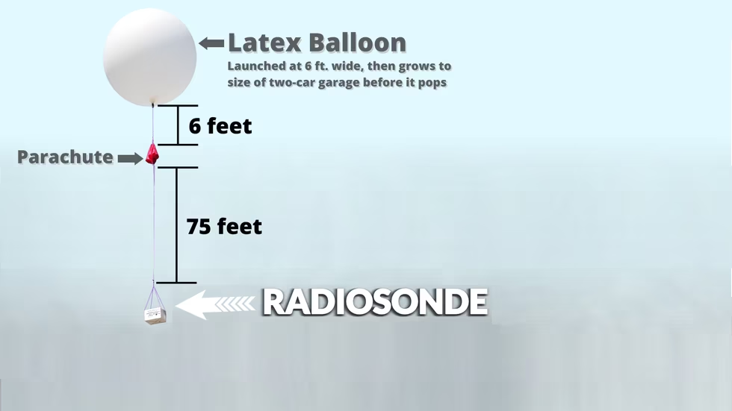
Figure 1- A diagram of a weather balloon [4]

Current military use of balloons
In 2019, the US military conducted a wide area surveillance test across six midwestern states, using 25 experimental solar powered high altitude balloons. These were capable of simultaneously tracking individual vehicles day or night, through all local weather conditions.
The balloons featured sophisticated sensors including Synthetic Aperture Radar (SAR). This utilises the motion of the antenna over the target region to create two dimensional images or three dimensional reconstructions of objects. Weather balloons can be “steered” by changing altitudes, using computers to use winds travelling in different directions to move around the different layers of the atmosphere. This manoeuvrability could allow balloons to move closer and at different angles to collect the required data. As it does not rely on the visible area of the spectrum, this technique can collect information regardless of the time and weather conditions [5].
According to the US military, their balloons are capable of using this radar, and other technologies, to follow multiple cars and boats for extended periods of time. Using SAR, the balloon is able to detect every car or boat in motion within a 25 mile radius beneath it. Additionally, they utilise mesh working technologies, allowing them to communicate with each other, share data and pass it onto ground receivers [6]. Consequently, it is of no surprise that these balloons have been viewed as a threat, given the US militaries current capability.

Power
Understanding the balloons power capabilities will provide an idea on potential payloads. Figure 2 clearly shows the balloon had 16 solar panels. Using the calculations shown in Appendix A, these panels are predicted to provide any instrumentation roughly 4.5 kW per hour. Together, the panels weigh around 288 kg.
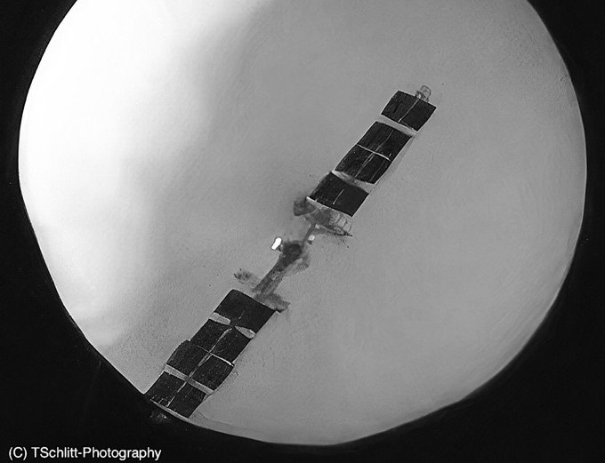
Figure 2-An image of the alleged weather balloon seen flying over America [7]

Payloads
The balloon was reported to be carrying a 900kg payload. Therefore, all the instrumentation and steering devices must have weighed a maximum of 612 kg [8]. Several news articles have suggested the balloon utilised different parts of the electromagnetic spectrum in order to collect data [5] [9]. This spectrum features the entire range of electromagnetic radiation according to their frequency or wavelength, as shown in figure 3. As seen, it is divided into seven sections, which offer their own distinctive characteristics. The sections below detail the military and meteorological uses of each area of the spectrum, as well as their feasibility of use within this balloon.
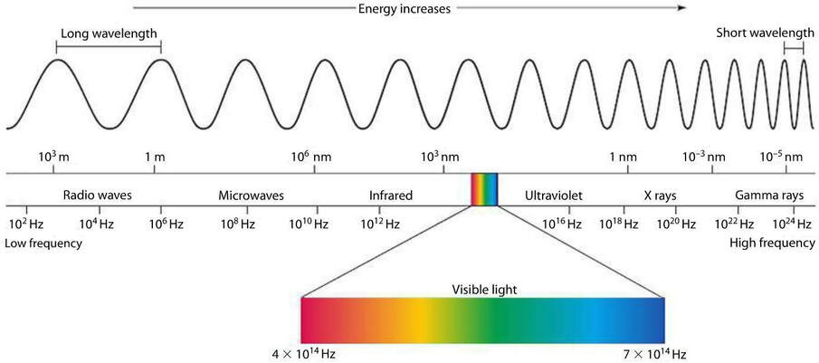
Figure 3- The electromagnetic spectrum [10]

Gamma rays
Gamma rays are emitted during radioactive decay, for example during a nuclear explosion. Despite most countries signing the Nuclear Ban Treaty, including the US and China, there is still little assurance that all countries have completely stopped testing [11]. By adding a gamma wave detector onto the balloon, China could ensure that no testing was occurring at the nuclear weapon sites the balloon transited over. However, these waves can become absorbed by interactions with air molecules 16 km above the Earth’s surface, which sheds doubt upon the detectors practicality at the balloons 18km altitude [12].

X-rays
X-rays are not traditionally used in weather balloons, as they do not contribute to meteorological understanding. Their most common use in military environments is x-raying vehicles and items for potential threats. These machines are incredibly large, and require high voltages to work, making them unfeasible when considering the weight and power limitations of the balloon. They also follow the inverse square law, meaning that the strength of the x-ray beam is inversely proportional to the square of the distance from the source. Consequently, for a beam to become effective at the balloons altitude of 18 km, the source has to be incredibly strong and would not be remotely practical for use in a balloon of this type.

Ultraviolet (UV)
Despite being invisible to the human eye, all objects emit a certain amount of UV light. This could provide the user with valuable information about the item or scene in view.
Modern battlefield surveillance devices often work in multiple wavebands, including the UV regions. Objects believed to be completely camouflaged in the visible region can be easily seen within this region, preventing obscuration. Additionally, chemical weapon plumes show in the UV spectrum, as the agents absorb UV light, making it easy to spot foul play [13]. To utilise these wavebands, the balloon could have used a UV camera, or had a UV bandpass filter attached to a camera [14].

Visual Surveillance
One speculation is the balloon was carrying cameras, and taking photographs of sensitive US sites. For this to occur, the balloon must be capable of carrying and powering a camera capable of photographing at sufficient resolution to be deemed useful. The Ground Sampling Distance (GSD) is the geometrical separation of consecutive pixels on the Earth’s surface. The further the distance between the earth and the satellite, and the larger the pixel size, the bigger the GSD [15]. As an example, the Simera Sense Hyperscape 100 - a high resolution camera used on satellites - has a GSD of 0.17m, at the 18km altitude the balloon was travelling at. This offers an incredibly detailed view of the ground. Additionally, the camera weighs only 1.2kg, well within the weight limits. The camera takes pictures in 32 bands of the Visible and Near-Infrared (VNIR) spectrum, allowing the user to fully understand the scene below. It only requires 6 W of power, making it viable when considering the solar energy available [16].

Infrared
Thermal imaging is widely used by the military due to its ability to operate day and night, regardless of the weather conditions. Detectors capture the infrared (IR) radiation emitted by all objects above absolute zero temperature. Variations in temperature within the scene are represented by a thermogram [17]. Use of an IR camera allows the user to locate and potentially target enemy forces from their heat signatures. Or, it can capture the specific wavebands emitted from enemy vehicles or weapons, allowing them to be targeted more effectively.
Alternatively, IR radiation can also be used within meteorology to provide a temperature map of countries. IR radiation is constantly emitted by the land, sea and clouds, and larger emitters (warm environments) emit significantly more than colder environments (high altitude clouds). This provides the user with valuable data on current and future weather patterns [18].
Due to this, the existence of a thermal imaging device could support either sides argument on the balloons function. However, using an IR detector for determining the IR emissions from a tank will require significantly more resolution than knowing the temperature of a cloudy sky. With companies such as Albedo offering a 2 m thermal resolution from their satellites, this high resolution data is definitely plausible [19].

Radio Waves
According to the US, 9-12 m of the balloons antennas have been found amongst the debris [20]. To communicate long distances, the antennae uses skywave propagation. In this, radio waves are directed at an angle in the sky, and refracted back to earth from layers of ionised atoms in the ionosphere.
Calculations in Appendix B approximate the balloon to be transmitting a maximum of 12.5 MHz, and thus communicating in the High Frequency (HF) domain of the radio wave spectrum. This area of the spectrum is often used for military communications. Therefore, if created for spying, the balloon could have intercepted these communications for malicious use.
As mentioned previously, it is viable that the balloon could be collecting photographic data. Within the HF region, this photographic data could only be sent using Slow Scan Television (SSTV). This allows the user to send images – either monochromatic or colour- using a voice channel, typically a single sideband modulator transmitter on the HF bands. The resultant images, however are low resolution, making them unfeasible to be used in surveillance operations [21].
Alternatively, if the balloon was collecting weather information, it will be transmitting data from its radiosonde to a ground station. However, due to the high amount of data required to be sent, the frequency of most radiosondes lies around 403 MHz, putting it in the ultrahigh frequency section of the radio range- not the HF [22]. Therefore, there is still uncertain on the exact nature of these transmissions.
The maximum distance the balloon could transmit using this antenna through skywave propagation is called the radio service range [23]. Using calculations in Appendix C, this distance was 557.34 km. This is significantly smaller than the distance from the US to China, meaning if the balloon had malicious intentions, it would require a receiver positioned much closer to, or within the US to receive the signal. Alternatively, it would have to store all its data to either be transmitted when within range, or kept until descent to the ground. Current spy satellites can transmit up to a 5725 km radio horizon surface range, with an altitude of 1200 km [24]. The fact this technology has not been utilised by the balloon could signal its harmless nature.

Microwaves

Radar Transmission
Radars transmit a focused pulse of microwave energy at objects in the atmosphere. As they strike some objects, the energy is scattered in all directions, including the direction of the radar. The larger the object, the greater the amount of energy received by the radar. Additionally, the time taken for the signal to be transmitted then received also provides information on its distance. By measuring any shift between the transmitted and received wavelengths, the radar can also determine if the object is moving, and if so, its velocity and direction. A positive phase shift implies the object is moving towards the radar, and negative shows it is moving away [25] [26].
According to leaked Pentagon documents, the balloon utilised SAR. As mentioned previously, this is capable of providing valuable military reconnaissance, detecting and tracking vehicles regardless of the time or weather conditions. Alternatively, this technique is also used for environmental mapping, monitoring forests and crops, as well as assisting with disaster relief [27]. Therefore its purpose is still uncertain.
As discussed previously, the balloon had an antenna capable of transmitting 12.5 MHz . If used for radar, instead of communication, it could have a radar resolution range of 12 m according to the calculations in Appendix D. This makes it capable of distinguishing between targets 12 m away from each other. In comparison, the commercially available Capella Space satellite has a radar range of just 0.5 m. Any finer resolution has been bound by US law, suggesting that spy satellites could have an even finer range [28]. Based upon this, it is unlikely the SAR has been used for spying, as it will need a much greater resolution to differentiate between vehicles, buildings and other items of interest. Instead, this radar range is similar in size to the Earth Resources Satellite. The 25m range allows this satellite to track oil spills and map the ocean floor, This supports the argument that the intentions of the balloon were indeed honest [29].

Radar Tracking
The Radar Cross Section (RCS) is a measure of how detectable an object is by radar. The larger the RCS value, the easier the object is to track. The RCS is influenced by:
- The target material- high amounts of metal cause an object to be electrically conductive due to its dielectric properties. This causes them to reflect radar far better than non-metals [30]
- The size of the target relative to the wavelength of the illuminating radar signal
- The absolute size of the target
- The incident angle of which the radar hits a particular portion of the target
- The reflected angle upon hitting the target- a smooth surface will typically reflect the microwave energy away from the sensor, whereas rough surfaces scatter the radiation in all directions. This increases the likelihood of the microwaves being directed towards the sensor. [31]
- The polarization of the transmitted and the received radiation with respect to the target orientation [32]
The weather balloon had a low RCS value, making it hard to track initially. Despite its large size, it contained low amounts of metal, causing minimal radar reflection. Additionally, a majority of the vessel has a smooth surface, so less energy was reflected back towards the sensor. This will be beneficial if the balloon was used for spying, as it makes it harder to detect.
The radar system itself must also be considered. Filters are employed within systems to remove unwanted noise, to ensure only the relevant information is sent onwards. The balloons high altitude, low speed combination were likely filtered out in initial searches by the military [33]. Only now, are past radar and tracking data are being analysed with new filters to discover more balloons, such as the ones over Japan in 2019 and 2021 [34]. With this new filtering knowledge, it should make these balloons significantly easier to track. This could eliminate any possible advantage on these balloons being used for reconnaissance in the future.

References

[1] | P. McCausland, “Map: Here's how close the Chinese spy balloon flew to the U.S. nuclear arsenal,” NBC, 7 2 2023.
[2] | C. Yilek, “What we know so far about the Chinese spy balloon and the other objects the U.S. shot down,” CBS News, 20 2 2023.
[3] | NOAA, “Radiosondes,” NOAA, 28 04 2023. [Online]. Available: https://www.noaa.gov/jetstream/upperair/radiosondes. [Accessed 8 5 2023].
[4] | J. Morse, “Morse Code of Weather: how weather balloons are launched and the importance of the data they collect,” KFYRTV, 28 6 2022.
[5] | H. Getahun, “Leaked Pentagon docs show the shot-down Chinese spy balloon may have had a feature known as 'synthetic aperture radar' that can see through certain materials, WaPo reports,” Buisness Insider, 16 4 2023.
[6] | N. Harris, “Pentagon Testing Mass Surveillance Balloons Across the US,” The Guardian, 2 8 2019.
[7] | TSchlitt-Photography, “Chinese Weather Balloon,” TSchlitt-Photography, Missouri, 2023.
[8] | M. Sparkes, “Chinese spy balloon: Everything we know after US recovers wreckage,” New Scientist, 10 2 2023.
[9] | M. Wendling, “Spy balloon sent data to China in real time - report,” BBC News, 3 4 2023.
[10] | Elvise, “​P6 F) Electromagnetic Spectrum – Part 1,” Elkvise , [Online]. Available: https://www.elevise.co.uk/gap6f.html . [Accessed 5 5 2023].
[11] | United States Environmental Protection Agency, “Radioactive Fallout From Nuclear Weapons Testing,” United States Environmental Protection Agency, 2 2023. [Online]. Available: https://www.epa.gov/radtown/radioactive-fallout-nuclear-weapons-testing#:~:text=These%20rays%20pose%20a%20higher,beta%20particles%20during%20radioactive%20decay.. [Accessed 8 5 2023].
[12] | Veritas, “Gamma Rays- what are they?,” Veritas, 4 9 2006. [Online]. Available: https://veritas.sao.arizona.edu/the-science-of-veritas/17-science/introduction/15-gamma-rays-what-are-they. [Accessed 8 5 2023].
[13] | H. B. D. E. e. a. McKone TE, “Appendix D Detecting and Monitoring Chemical Agents,” in Strategies to Protect the Heath of Deployed US Forces: Detecting, Characterising and Documenting Exposures, Washington, National Academies Press (US), 2000.
[14] | R. Uppal, “Military Applications of the Ultraviolet Spectrum becoming feasible with technology breakthroughs,” International Defence Security and Technology, 28 7 2022.
[15] | S. Sense, “GSD Calculator - Mastering Spatial Resolution for Earth Observation Satellites,” Simera Sense , 11 6 2020. [Online]. Available: https://simera-sense.com/gsd-calculator-mastering-spatial-resolution-for-satellites/. [Accessed 8 5 2023].
[16] | Simera Sense , “xScape100 Product Range,” Simera Sense , [Online]. Available: https://simera-sense.com/products/xscape100-2/. [Accessed 8 5 2023].
[17] | A. Akula, R. Ghosh and H. K. Sardana, “Thermal Imaging And Its Application In Defence Systems,” in OPTICS 2011: International Conference on Light. , 2011.
[18] | A. S. U. o. Washingston, “Interpreting IR Satellite Images,” University of Washingston, [Online]. Available: https://atmos.uw.edu/weather/aboutir.shtml. [Accessed 8 5 2023].
[19] | Albedo, “Aerial quality imagery -from space.,” Albedo, 2023. [Online]. Available: https://albedo.com/. [Accessed 8 5 2023].
[20] | M. Matza, “Chinese balloon sensors recovered from ocean, says US,” BBC News, 14 2 2023.
[21] | Electronics Notes, “SSTV - Slow Scan Television,” Electronics Notes, [Online]. Available: https://www.electronics-notes.com/articles/ham_radio/sstv/slow-scan-television-tv.php. [Accessed 29 3 2023].
[22] | National Weather Service , “Radiosonde Observation,” National Weather Service , [Online]. Available: https://www.weather.gov/upperair/factsheet#:~:text=These%20sensors%20are%20linked%20to,MHz%20or%20around%20403%20MHz.. [Accessed 29 3 2023].
[23] | Government of India , “INFORMATION COMMUNICATION & INSTRUMENTATION TRAINING CENTER, NEW DELHI,” [Online]. Available: https://imdpune.gov.in/training/lecture_icitc_commu.php. [Accessed 29 3 2023].
[24] | Satbytes, “How High Do Satellites Fly?,” SatBytes, 2001. [Online]. Available: http://www.spacetoday.org/Satellites/SatBytes/SatAltitudes.html#:~:text=Spysats%20and%20military%20communications%20satellites,and%20radar%20intelligence%20(RADINT).. [Accessed 23 3 2023].
[25] | National Weather Service, “How Does Radar Work,” National Weather Service, [Online]. Available: https://www.weather.gov/jetstream/how. [Accessed 4 5 2023].
[26] | Australian government, “Australian government department of meterology,” Australian government, [Online]. Available: http://www.bom.gov.au/australia/radar/about/what_is_radar.shtml#:~:text=Radars%20send%20out%20electromagnetic%20waves,scattered%20back%20to%20the%20radar. [Accessed 4 5 2023].
[27] | M. Ball, “Military Synthetic Aperture Radar (SAR),” Defence Advancement, 14 2 2023.
[28] | A. Nelson, “Capella Space Releases the Highest Resolution Commercial SAR Imagery in the World,” Cision , 2020.
[29] | University of California , “Synthetic Aperture Radar Study,” University of California , San Diego.
[30] | Raju, “Effect of Factors on radar operation,” in Radar Engineering, London, I.K. International Publishing House Pvt. Limited, 2013, p. 140.
[31] | Humboldt State University , “Radar Images,” Humboldt State University , California, 2019.
[32] | A. Modi, “Lecture_18: Radar Cross Section, Optical Theorem, Physical Optics Approx, Radiation by Line Sources,” YouTube, 2020.
[33] | M. Beinart, “Radar Enhancements May Explain Uptick In Detection Of Objects In U.S. Airspace, Officials Say,” Defence Daily , 13 2 2023.
[34] | T. Siripala, “Japan Suspects Chinese Spy Balloons Violated Its Airspace,” The Diplomat, 17 2 2023.
[35] | B. Howell, “Solar Panel Output: How Much Electricity Do They Produce?,” EE , 2 24 2023. [Online]. Available: https://www.theecoexperts.co.uk/solar-panels/electricity-power-output. [Accessed 24 3 2023].
[36] | SouthWest Antennas, “SouthWest Antennas,” [Online]. Available: https://www.southwestantennas.com/calculator/line-of-sight. [Accessed 23 3 2023].
[37] | Everything RF, “Radar Range Resolution Calculator,” Everything RF, [Online]. Available: https://www.everythingrf.com/rf-calculators/radar-range-resolution-calculator. [Accessed 5 5 2023].
[38] | NASA, “Gamma Rays,” NASA, [Online]. Available: https://science.nasa.gov/ems/12_gammarays#:~:text=SOURCES%20OF%20GAMMA%20RAYS&text=They%20are%20produced%20by%20the,dramatic%20activity%20of%20radioactive%20decay.. [Accessed 5 5 2023].

Appendix A
The average solar panel produces 350W. Therefore, all 16 will produce 61.6 kWh, assuming 11 hours of sunlight. Then, assuming non-ideal weather conditions, this can be reduced again to 50 kWh. This provides any instrumentation roughly 4.5 Kw per hour [35].

Apprentix B
Assuming the antenna is a half wavelength antenna:
$$0.5×12=24 m$$
$$\frac{3×{10}^{8}}{24}=1.25 MHz$$

Appendix C
Assuming the height of the balloon was 18.3km, using equation 1, the radio service range was 557.34 km.

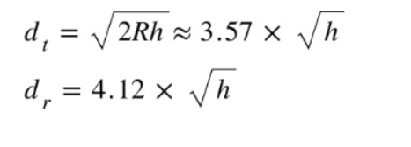

Equation 1- The line of sight and radio service range equation [36]

Appendix D
Using the equation 2, with a bandwidth of 12.5 MHz, the radar range resolution was 12m.
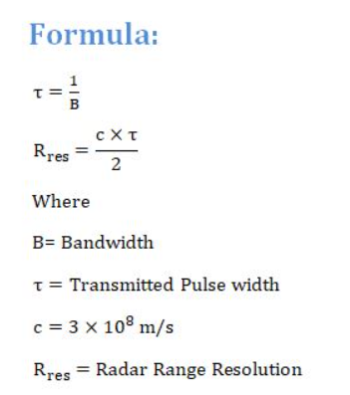
Equation 2- The radar range resolution equation [37]

