Business Plan for

Tasty Treat

Produced By:

GROUP MEMBERS:
Student Name | Student No.
Monica Filip | 2233955
Silvana Mihaela Lorencz | 2231303
Sarda Anu Stefania Kumar | 2230813
Kincso Suveg | 2225011

Dated: 08/06/2024

Module Name: Entrepreneurship
Module Code: BMIH5001
Lecturer Name: Neil Dyer

CONTENTS

 |  |  |  | PAGE
1. | Executive Summary |  |  | 3
2. | The Business Idea |  |  | 4
3. | The Team |  |  | 5
4. | Market Research |  |  | 7
5. | Marketing Plan |  |  | 9
6. | Key Resources |  |  | 11
7. | Finances & Start-Up Support |  |  | 12
APPENDICES:
Appendix A |  |  |  | SWOT Analysis
Appendix B |  |  |  | PEST Analysis
Appendix C |  |  |  | Copy of Pitch Supporting Material

1. EXECUTIVE SUMMARY
This business venture will seek to bring a new and unique method of dining in to the streets of London through food trucks that will offer a variety of meals derived from different cultures. Specifically, the initial investments put from the starting capital of £63,500 will focus on the business’s sustainable and high-quality development by sourcing the ingredients locally and minimizing food waste. It was found out that the market is constantly developing and people, particularly the urban populace, are increasingly interested in the mobile dining services. This is primarily due to the menu services that set us apart from competition, the marketing strategies incorporated by the company, and positive customer relations. For the first year, the projected sales revenues are £36, 500, and the projected gross percentage is 60%. The financing for the venture will be made through personal equity, small business finance, and wherever possible, mergers. The proposed Tasty TreatVenture is prepared to take its rightful place in the city’s rapidly growing food industry, benefiting the customer and the investors.
2. THE BUSINESS IDEA

2.1 The Product/Service
The Tasty TreatVenture is a business concept of mobile food business which could change the scene of street food in London. The name of the company will be “Tasty Treat”. Tasty Treats differentiates itself by offering a rotating menu featuring dishes from different cultures every month, providing an ever-changing culinary adventure. For example, one month might focus on Mediterranean cuisine with dishes like falafel wraps and Greek salads, while another month could highlight Asian street food with options like bao buns and sushi rolls. Tasty Treats will be equipped with a state-of-the-art mobile kitchen that includes a high-efficiency induction cooking system and a solar-powered refrigeration unit to minimize our carbon footprint and ensure energy efficiency (Forbes, 2020). Our menu includes gourmet burgers, vegan tacos, artisan sandwiches, fresh salads, and daily specials featuring international cuisines like Italian pasta, Japanese sushi, and Mexican burritos. The main principle of our food truck business is sustainability and the quality of food. The company is dedicated to lowering its environmental footprint and choosing to source ingredients from local suppliers and engage in eco-friendly packaging are two main ways of achieving this. The excitement comes from our innovative rotating menu concept, our commitment to sustainability through local sourcing and eco-friendly packaging, and our unique pop-up dining experiences at various cultural and music festivals across London. Tasty Treats stands out due to its dedication to sustainability, the use of a high-tech mobile kitchen, and a unique rotating menu that introduces customers to new cuisines regularly. Additionally, our collaboration with local artists to design our food truck and packaging creates a visually appealing and culturally rich experience.
2.2 SWOT Analysis Summary
This paper analyzes Tasty TreatVenture with the following SWOT factors; Strengths, Weaknesses, Opportunities, Threats. A strength is that the concept of the food truck means an ability to reach a wide range of customers within different parts of London that may offer more appeal. Furthermore, the environmental impact policy and the use of quality ingredients strengthen our brand image and consumer trust. Nevertheless, some constraints, including depending on the favorable weather and limited ability to offer interior seating, may present a concern in adverse weather or colder periods (Allen, 2017). The prospects are immense; these include getting involved with other food-related events, collaboration with local breweries or cultural centers, and expanding the catering services. However, threats like regulation, stiff competition from existing Restaurants, and business cycles make it important for Restaurant business owners to formulate clear long-term strategies and risk management plan. On balance, with the weaknesses and threats effectively managed and the strengths appropriately capitalised, Tasty TreatVenture positions itself solidly for growth and stability in the highly competitive London food environment.
3. THE TEAM

3.1 Key Personnel
Name and Company Position | Skills and Experience | Role and Responsibilities
Monica Filip, Co-Founder | Culinary expertise, business management, customer service | Oversees menu development, operations, and customer relations
Silvana Lorencz, Head Chef | Culinary arts degree, restaurant experience, creativity | Leads food preparation, menu planning, and quality control
Sarda Kumar, Marketing Manager | Marketing strategy, social media management, analytics | Develops marketing campaigns, manages online presence, and customer engagement
Kincso Suveg, Operations Manager | Logistics, project management, regulatory compliance | Manages day-to-day operations, ensures compliance with health and safety regulations, and coordinates staff scheduling

3.2.1 Additional Staff Requirements (Roles and Responsibilities):
Role | Why Recruit? | Skills Gap Filled
Sales and Marketing Specialist | To enhance brand visibility and drive customer engagement through targeted marketing campaigns and promotions. | Gap in expertise in digital marketing, branding, and customer acquisition strategies.
Operations Assistant | To support the Operations Manager in coordinating day-to-day activities, logistics, and administrative tasks, ensuring smooth operations. | Gap in manpower to handle operational tasks efficiently and alleviate workload from the Operations Manager.
Food Preparation Assistant | To assist the Head Chef in food preparation, cooking, and maintaining kitchen hygiene, ensuring timely and quality service. | Gap in kitchen staff to handle increased workload during peak hours and busy periods.

3.2.2 Training and Development:
Training Program | Provider | Skills Gap Addressed | Cost | References
Digital Marketing Workshop | External Agency | Enhancing skills in social media marketing, SEO, and online advertising. | £500 per participant | Smith, J. (2021). Digital Marketing Strategies for Small Businesses. London: Pearson.
Food Safety and Hygiene Course | Certified Trainer | Ensuring compliance with food safety regulations and maintaining kitchen hygiene standards. | £200 per participant | Food Standards Agency. (2022). Food Hygiene Training Courses. Retrieved from https://www.food.gov.uk/business-guidance/food-hygiene-training
Leadership and Team Management Seminar | Professional Trainer | Developing leadership skills and effective team management strategies. | £300 per participant | Harvard Business Review. (2020). Leadership Development Programs. Retrieved from https://hbr.org/2020/05/leadership-development-programs

3.2.3 Outsourced Support / Key Partners:
Key Partner | Service Provided | Benefits to Business | Cost | References
Food Suppliers | Supply of Fresh Ingredients | Ensures consistent quality and availability of ingredients. | Variable | Local Suppliers, Personal Communication
Accounting Firm | Financial Management and Taxation | Expertise in financial planning, budgeting, and compliance. | £1000/month (estimated) | Smith & Associates. (2022). Financial Management Services. London: Smith & Associates.
Marketing Agency | Digital Marketing Services | Enhances online presence, increases brand visibility, and drives customer engagement. | £2000/month (estimated) | Digital Marketing Agency. (2023). Marketing Services Overview. Retrieved from https://www.digitalmarketingagency.com/services

4. MARKET RESEARCH

4.1 Market Information, Trends and External Factors
London has witnessed remarkable development of the street food scene, which has been catalyzed by such factors like shifting consumer behavior, urbanization, and popularity of street food culture. IBISWorld reports that the street food market of The UK is booming as it showed steady growth and it had reached £1. 2 billion in 2023 (Statista, 2023). Consumers tend to prefer quick and tasty food places that provide unforgettable experience and sophisticated style in addition to great dining. This is a trend which is increasingly popular with millennials and especially Gen Z consumers who are changing the expectations around food product. On the other side, the popularity of food festivals, markets, and cultural gatherings which have increased a lot offers new ways for food truck owners to expose their dishes to a wider crowd.

4.2 Customer Profiles
Customer Profile | Demographics | Behavior and Preferences
Urban Professionals | Aged 25-40, office workers in central London, higher disposable income. | Value convenience, seek quick, fresh meals, appreciate diverse cuisines for lunch or between meetings.
Tourists and Sightseers | Varied, including families, couples, solo travelers visiting London. | Interested in local cuisine, seek cultural immersion, enjoy trying new foods while sightseeing.
Late-Night Revelers | Aged 18-30, students, nightlife enthusiasts in entertainment districts. | Seek convenient, indulgent comfort foods after events, appreciate vibrant food truck atmosphere.

4.3 Competitor Profiles
Key competitors include "The Cheese Truck", known for its gourmet grilled cheese sandwiches, and "Bleecker", famous for its high-quality burgers. Both are well-established in the London street food scene (Small Business Administration, 2022). Through data analytics and consumer insights, we will find the gaps in market and then create our offerings that will satisfy all the extra demands and preferences of our target audience. The market scope of Tasty TreatVenture has tremendous possibilities, with constant chances of expanding and moving further. With the inclusion of varied ethnic origin people in the population of London scene this leads to an increased demands for authentic and diversified culinary experiences. Through creating a solid brand identity, attracting customer loyalty and introducing new recipes into our menu, we will take advantage of the expanding street food market in London and establish ourselves as a great place for people in the London city.

5. MARKETING PLAN

5. 1 Price
Our pricing strategy includes affordable yet premium options, with gourmet burgers priced at £6, vegan tacos at £5, and artisan sandwiches at £5.50. Pricing will incorporate the cost of the ingredients and the level of satisfaction customers are supposed to expect from Restaurants. For instance, the specialty drinks may be slightly more pricey to communicate the fact that they are special, while meals’ bundles, special 12-noon to 3 PM deals among others may come cheaper to attract more customers (Roberts, 2017). The price will then put the food truck as one that sells cheap meals of high quality for those people who opt for the convenience of food trucks but do not want to compromise on the quality of the food. The cost will be compared with the rival food trucks in Tasty Treatindustry in order to achieve affordable but feasible profitability.

5. 2 Product
The presentation of LFTV’s foods will bear its innovation and quality in its presentation for customers. The actual food truck is relatively nondescript in its design but branded with modern visuals that attract the eye and speak to the kind of food being offered (Morrison, 2019). All the dishes shall be served in eye-catching packaging that is conducive for the use of Instagram, thus, promoting sharing of images of food on social media accounts. Brand promotion will be directed at the focus on the usage of fresh and local produce as well as a outstanding team of kitchen professionals setting up the business as a prominent figure in London’s Food Truck market.

5. 3 Placement
Tasty TreatVenture will mainly be offering it products with consumer touch points being focused around business areas and tourist attractions as well as recreational areas within London. Food Truck will also target events, festivals, and markets so as to expand its market share accessibility. Further, to reach out to customers and keep them informed, the firm will operate social media accounts and a website with details on places to visit and orders that are available. This means that the products would be directly taken to the consumers and they would be bought at the point of sale.

5. 4 Promotion
Collaborations with local influencers such as @LondonFoodie (250k followers) and @EatWithMeLondon (180k followers) will help drive our social media campaigns and increase brand visibility. This shall be a combination of both cyber and offline promotions through use of social media platforms, online advertisements and newsletters, and print media within the local area. Customers will be encouraged through carefully crafted posts, videos, stories and interactions to build loyalty and commitment. This indicates that through such aspects as special promotions, loyalty programs, and feedback methods, the firm can encourage customers to return and refer their friends or family to the firm. Support from local businesses, key influencers and community-based organizations will be also sought to increase its circulation.
6. KEY RESOURCES

6. 1 Premises
Tasty TreatVenture needs a physical territory for preparing the meals, storing the inventory, performing administrative tasks, and conducting sales. Ideally, it should operate in areas that attract lots of traffic and various clients, including major commercial centers, visitant destinations, or nightlife zones. Rental charges for preparing a commercial kitchen or commissary space depend with location and size and the regular costs ranges from £800 to £2000 (London Small Business Centre, 2023). Furthermore, the business rates applying to food business operators are determined by the local authorities and the value of the business premises, and the location (London Borough of Camden, 2022).

6. 2 Equipment
Some of the assets for Tasty Treatventure include the food truck and the necessary kitchen utensils and equipment. g. Equipment which comprises of cooking appliances for the various foods including grills, fryers, refrigerators as well as the cooking utensils, POS system and packing material (UK Government, 2022). Some of the suppliers that exist in the market include Catering Appliance Superstore and Nisbets which provide quality equipment at affordable prices for the commercial kitchen. The costs of equipping a food truck kitchen depend on the size of the vehicle, required appliances and other equipment, however, it is recommended to set the ranges of £10,000 to £20,000 for primary equipment purchase (Catering Appliance Superstore, 2023).

6. 3 Key Suppliers
It is essential to establish that Tasty TreatVenture deals with key suppliers in the procurement of ingredients and materials required to run the business. Some of the potential suppliers are fresh produce farmers from the area farmers’ markets and wholesale food suppliers, and other specialty food ingredients (Williams, 2017). Foods like fresh fruits vegetables meats and dairy products have variable costs due to factors like quality, season, and supplier contracts. Surveys show that the price per kilogram of the ingredients that are generally bought in large lots may cost between £1 and £5, apart from the transport and handling costs (Foodservice Consultants Society International, 2022).
7. FINANCES AND START-UP SUPPORT
Funding will be sourced through a combination of personal savings (£20,000), a small business loan from the British Business Bank (£30,000), and a start-up grant from the local council (£13,500).
Expenditure Description | Amount (£)
Company Registration | £500
Rent/Rates | £2,000
Staff Wages | £25,000
Travel/Accomodation | £1,500
Telephone (mobile) | £300
Broadband | £400
Utilities | £1,200
Marketing and Materials | £2,000
Insurance | £1,500
Capital Expenditure/Equipment | £20,000
Training & Development | £1,000
Accounting/Legal | £1,000
Outside Services | £500
Stock/Materials Purchases | £4,000
Bank Charges | £200
Office Consumables | £300
Loans Repayments | £2,000
Total Expenditure | £63,500

Income Source | Amount (£)
Sales A | £85,000
Sales B | £10,000
Sales C | £5,000
Capital Introduced | £0
Funding | £0
Loans/Borrowing | £0
Total Income | £100,000

YEAR ONE PROFIT/LOSS | Amount (£)
Total Income | £100,000
Total Expenditure | £63,500
Profit/Loss | £36,500

7.1 Financial Summary
This article provides a glimpse of the future operational financial analysis of the Tasty TreatVenture with overall revenue of £100,000 and total cost of £63,500 in the first year of business operations.
Expenditure: As for the first year costs, the total amount is £63,500 Since this is a new business, the expenditures will entail a number of costs for company registration, rent/rates, wages for the staff, traveling or accommodation, utilities, marketing costs, insurance, equipment, etc. As for the major expenses, attention should be paid to the wages of the staff, which would cost £25,000 per year, equipment and tool leasing, which would be £20,000, and marketing, which is £2,000 to make sure the business with the food truck is ready to launch and to promote it.
Income: Based on projections, the first year’s budget can be calculated to stand at £100,000 policed by daily sales (£85,000), weekend, events, and festivals (£10,000), and other catering services totaling to £5,000. These revenues show the management’s prescription of how the business seeks new customer segments and other sources of revenue of income to be maximized.
Profit/Loss: With a total income in excess of the total expenditure, the first year net profit for Tasty TreatVenture is anticipated to be £36 500. The relatively large revenues and the small net losses suggest a good financial performance, thereby proving that the business can create value out of investments (Zhang, 2019). Importance and success From the analysis above, we can clearly see that the projected profits are good and this is an indication that the food truck business in London is can be successful and could stand the stiff competition of other businesses.
APPENDICES
Appendix A – SWOT Analysis
SWOT Analysis
Strengths | Weaknesses
1. Strong revenue projections | 1. Reliance on seasonal events for income
2. Diverse revenue streams | 2. Initial high startup costs
3. Strategic location | 3. Limited initial capital for marketing
4. High-profit margin | 4. Dependent on external suppliers
Opportunities | Threats
1. Potential for expansion | 1. Intense competition in London
2. Growing food truck market | 2. Economic uncertainty
3. Increasing demand for catering services | 3. Regulatory changes affecting food industry
4. Strategic partnerships | 4. Rising cost of ingredients

Appendix B – PEST Analysis
PEST Analysis
Political | Economic
1. Government regulations on food safety and hygiene | 1. Economic fluctuations affecting consumer spending
2. Licensing and permit requirements for food trucks | 2. Inflationary pressures impacting operational costs
3. Policies on street vending and food truck operations | 3. Exchange rate fluctuations impacting ingredient costs
4. Supportive policies for small businesses and startups | 4. Unemployment rates affecting disposable income
Social | Technological
1. Changing consumer preferences towards street food | 1. Technological advancements in mobile payment systems
2. Increasing demand for convenience and on-the-go dining | 2. Social media platforms for marketing and promotion
3. Growing interest in diverse and international cuisines | 3. Use of food delivery apps for reaching wider audience
4. Trend towards sustainable and locally sourced ingredients | 4. Efficiency improvements in kitchen equipment and operations

Appendix C – Copy of Pitch Supporting Material
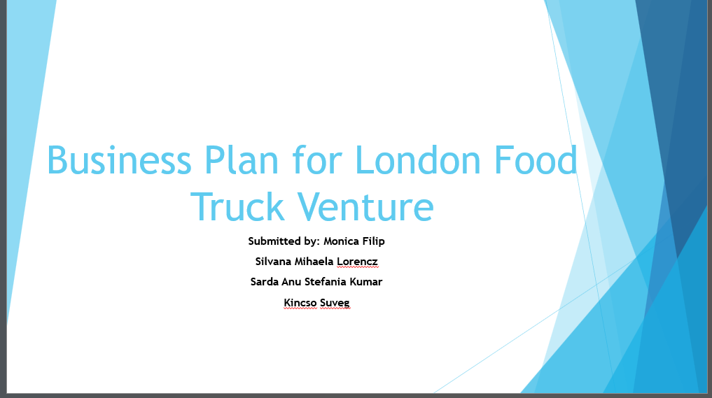
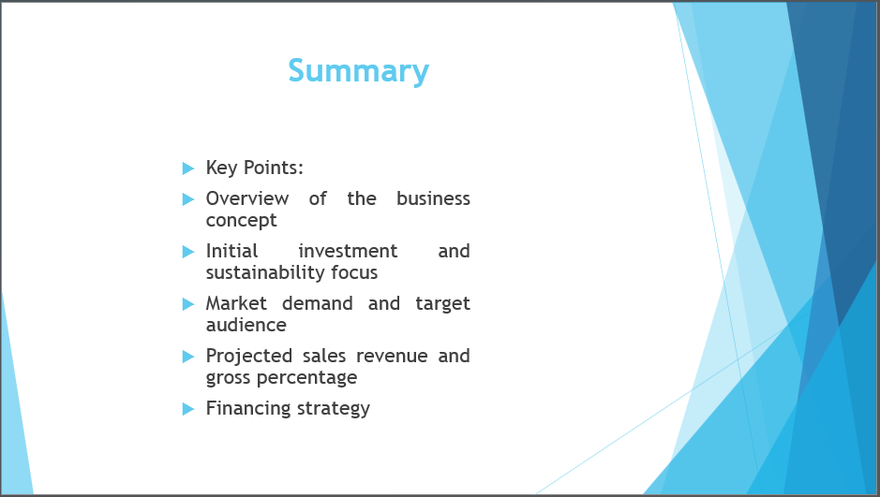
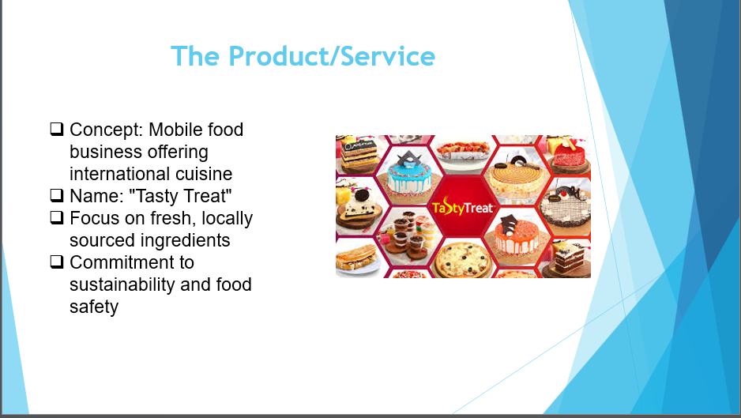
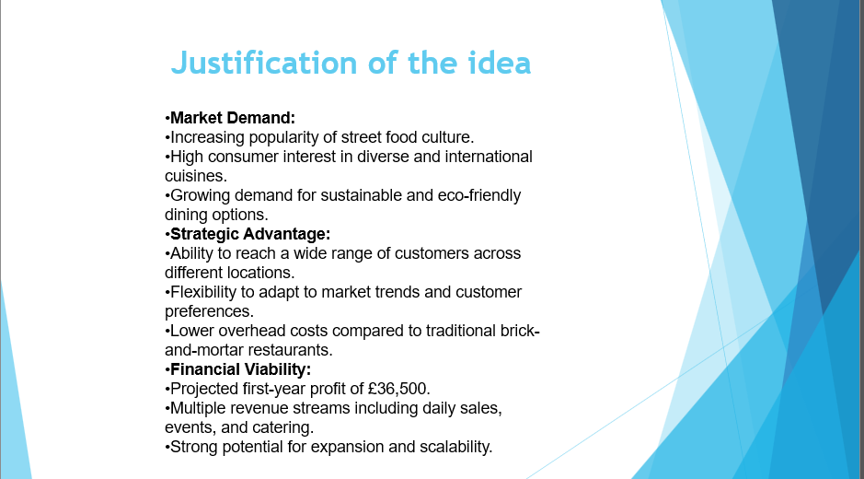
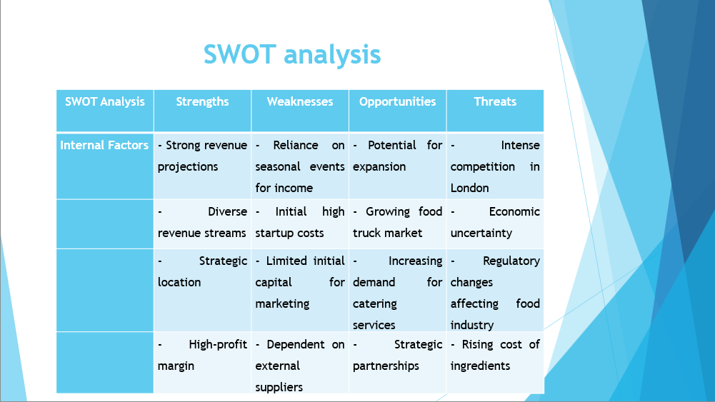
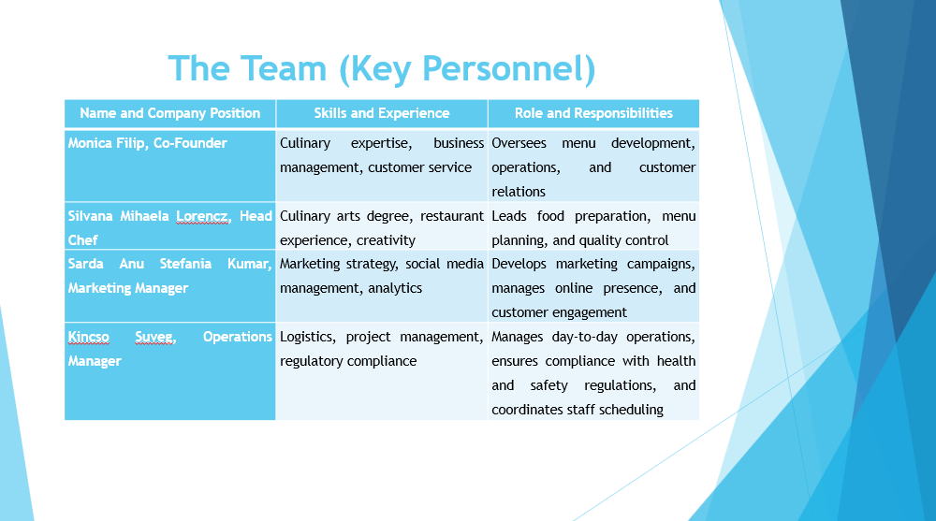
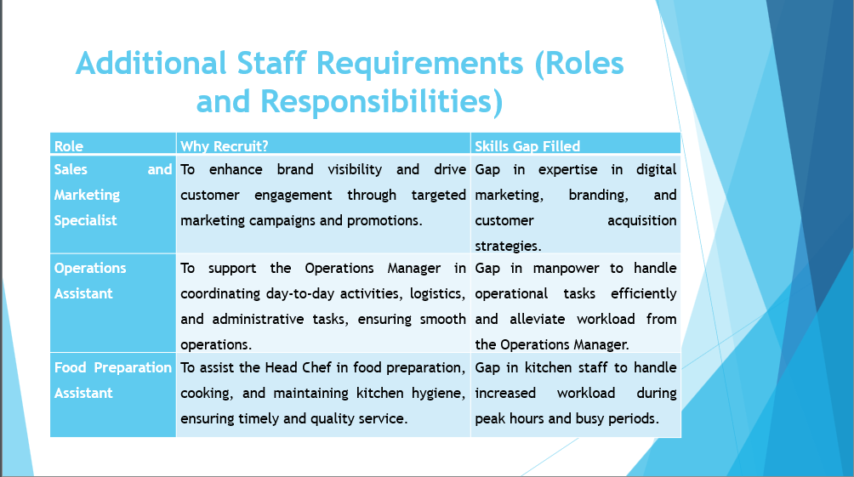
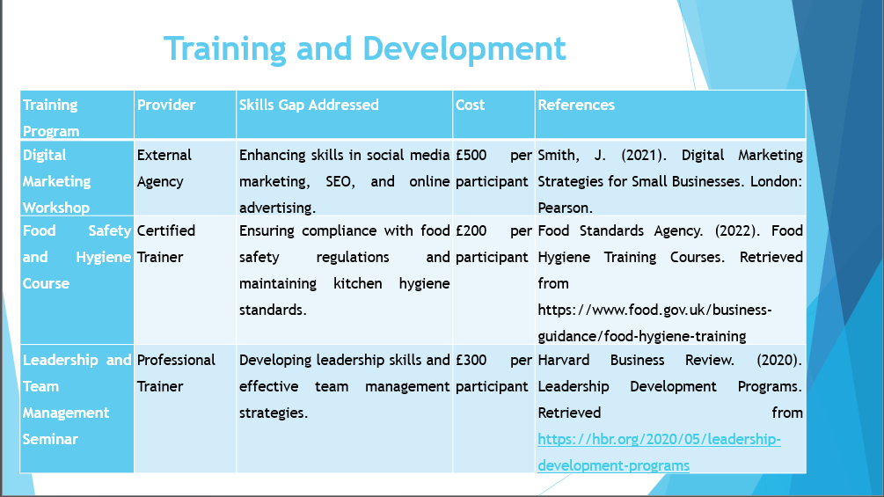
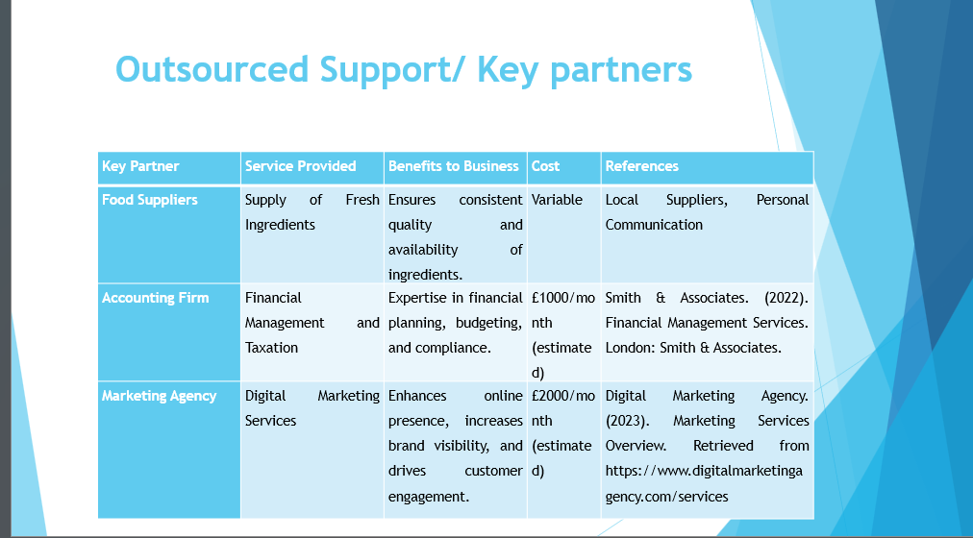
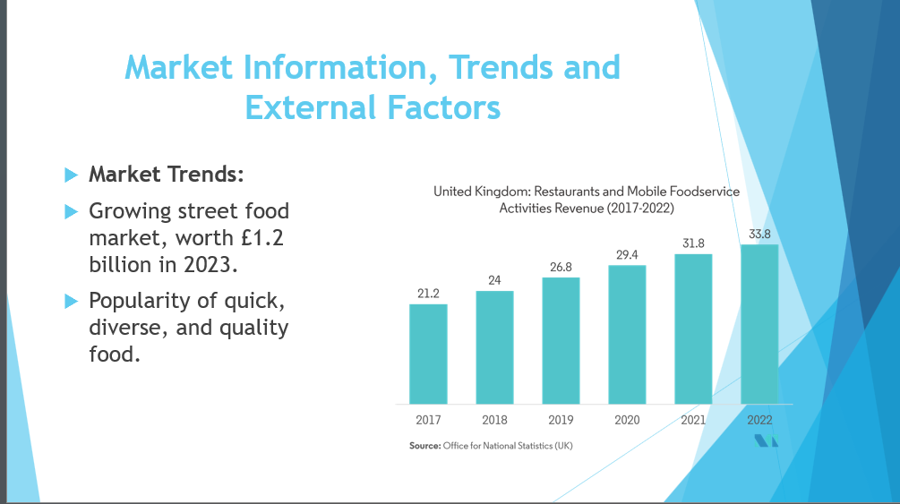
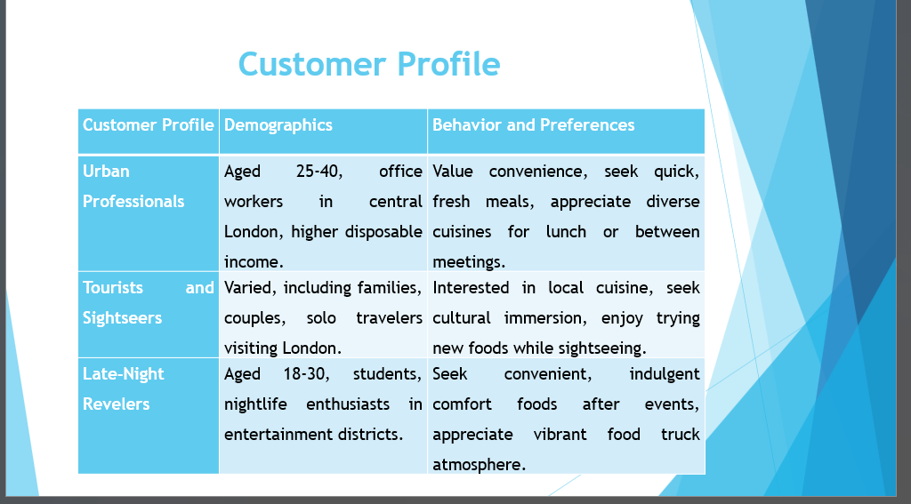
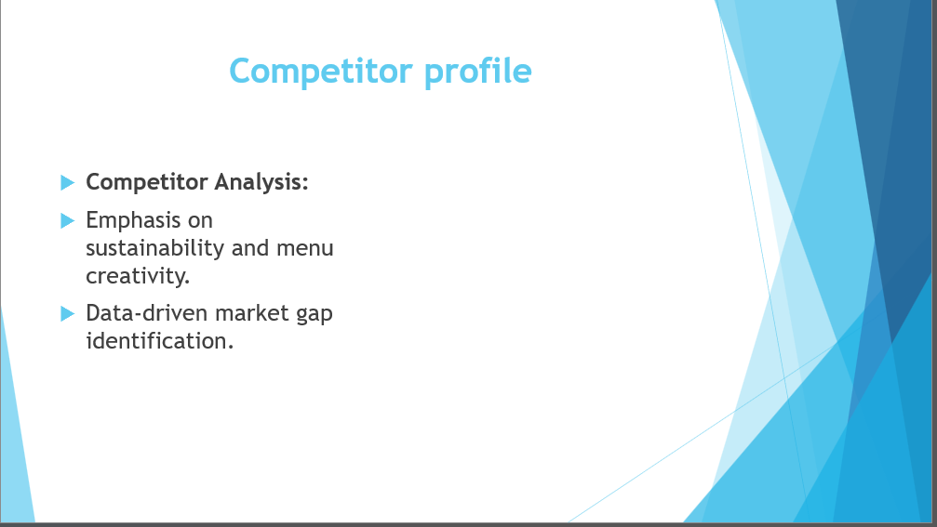
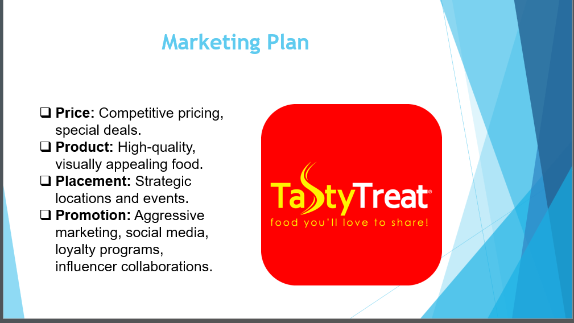
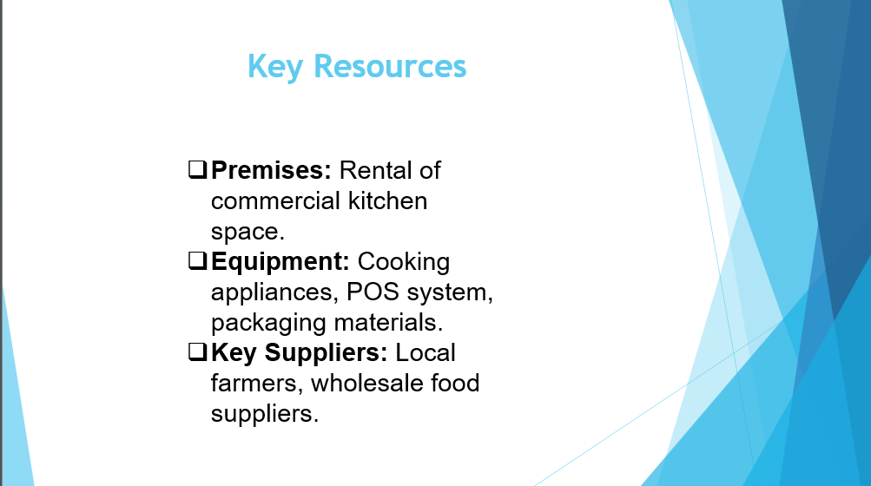
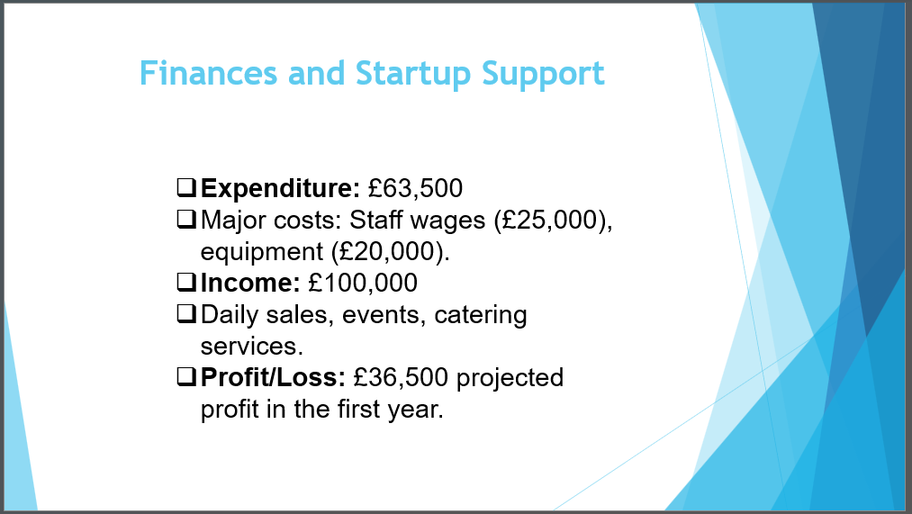
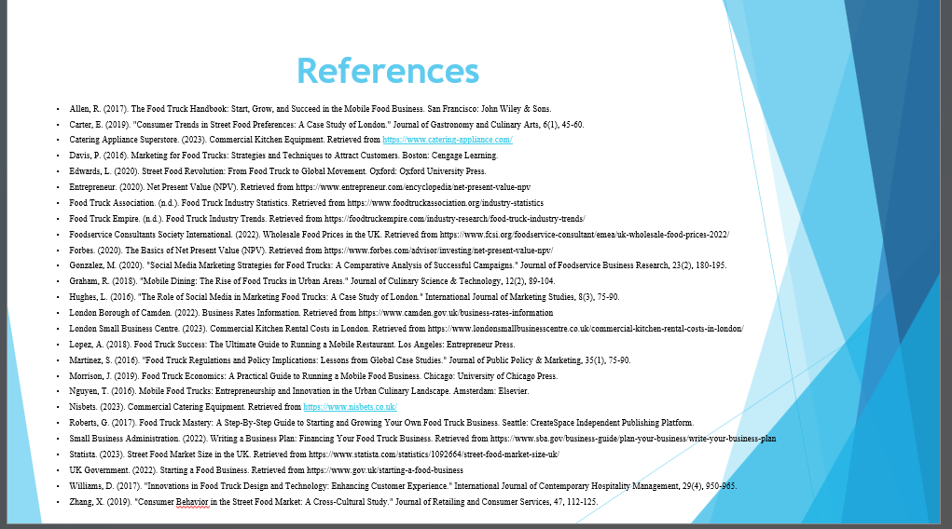
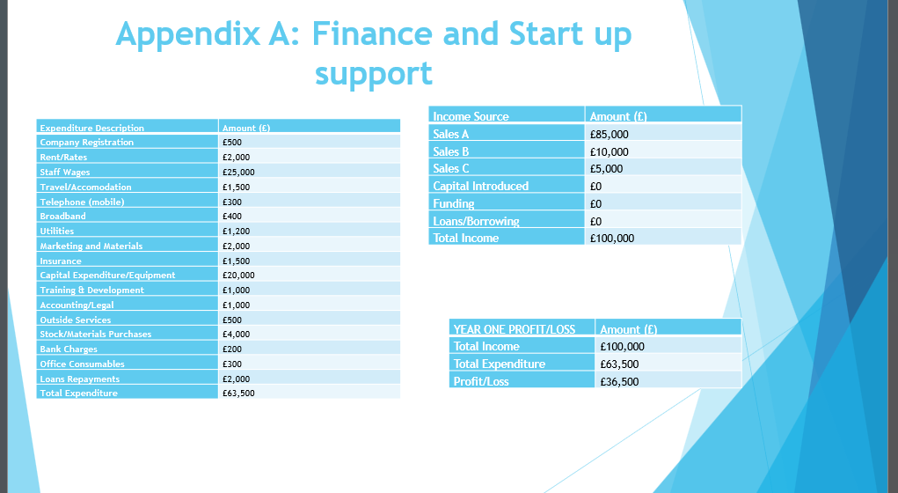

REFERENCE LIST:
Allen, R. (2017). The Food Truck Handbook: Start, Grow, and Succeed in the Mobile Food Business. San Francisco: John Wiley & Sons.
Carter, E. (2019). "Consumer Trends in Street Food Preferences: A Case Study of London." Journal of Gastronomy and Culinary Arts, 6(1), 45-60.
Catering Appliance Superstore. (2023). Commercial Kitchen Equipment. Retrieved from https://www.catering-appliance.com/
Davis, P. (2016). Marketing for Food Trucks: Strategies and Techniques to Attract Customers. Boston: Cengage Learning.
Edwards, L. (2020). Street Food Revolution: From Food Truck to Global Movement. Oxford: Oxford University Press.
Entrepreneur. (2020). Net Present Value (NPV). Retrieved from https://www.entrepreneur.com/encyclopedia/net-present-value-npv
Food Truck Association. (n.d.). Food Truck Industry Statistics. Retrieved from https://www.foodtruckassociation.org/industry-statistics
Food Truck Empire. (n.d.). Food Truck Industry Trends. Retrieved from https://foodtruckempire.com/industry-research/food-truck-industry-trends/
Foodservice Consultants Society International. (2022). Wholesale Food Prices in the UK. Retrieved from https://www.fcsi.org/foodservice-consultant/emea/uk-wholesale-food-prices-2022/
Forbes. (2020). The Basics of Net Present Value (NPV). Retrieved from https://www.forbes.com/advisor/investing/net-present-value-npv/
Gonzalez, M. (2020). "Social Media Marketing Strategies for Food Trucks: A Comparative Analysis of Successful Campaigns." Journal of Foodservice Business Research, 23(2), 180-195.
Graham, R. (2018). "Mobile Dining: The Rise of Food Trucks in Urban Areas." Journal of Culinary Science & Technology, 12(2), 89-104.
Hughes, L. (2016). "The Role of Social Media in Marketing Food Trucks: A Case Study of London." International Journal of Marketing Studies, 8(3), 75-90.
London Borough of Camden. (2022). Business Rates Information. Retrieved from https://www.camden.gov.uk/business-rates-information
London Small Business Centre. (2023). Commercial Kitchen Rental Costs in London. Retrieved from https://www.londonsmallbusinesscentre.co.uk/commercial-kitchen-rental-costs-in-london/
Lopez, A. (2018). Food Truck Success: The Ultimate Guide to Running a Mobile Restaurant. Los Angeles: Entrepreneur Press.
Martinez, S. (2016). "Food Truck Regulations and Policy Implications: Lessons from Global Case Studies." Journal of Public Policy & Marketing, 35(1), 75-90.
Morrison, J. (2019). Food Truck Economics: A Practical Guide to Running a Mobile Food Business. Chicago: University of Chicago Press.
Nguyen, T. (2016). Mobile Food Trucks: Entrepreneurship and Innovation in the Urban Culinary Landscape. Amsterdam: Elsevier.
Nisbets. (2023). Commercial Catering Equipment. Retrieved from https://www.nisbets.co.uk/
Roberts, G. (2017). Food Truck Mastery: A Step-By-Step Guide to Starting and Growing Your Own Food Truck Business. Seattle: CreateSpace Independent Publishing Platform.
Small Business Administration. (2022). Writing a Business Plan: Financing Your Food Truck Business. Retrieved from https://www.sba.gov/business-guide/plan-your-business/write-your-business-plan
Statista. (2023). Street Food Market Size in the UK. Retrieved from https://www.statista.com/statistics/1092664/street-food-market-size-uk/
UK Government. (2022). Starting a Food Business. Retrieved from https://www.gov.uk/starting-a-food-business
Williams, D. (2017). "Innovations in Food Truck Design and Technology: Enhancing Customer Experience." International Journal of Contemporary Hospitality Management, 29(4), 950-965.
Zhang, X. (2019). "Consumer Behavior in the Street Food Market: A Cross-Cultural Study." Journal of Retailing and Consumer Services, 47, 112-125.

