Website Assignment
Joshua Preece – 1807463
Internet Technology and Security (ACCA4018)
May 1st

Contents
Website Assignment 1
Introduction 2
Requirements 2
Implementation 2
Evaluation 6
References 6

Introduction
This report will include an introduction to the author’s website, a description of the website, the requirements for the website, the implementation of the website and an evaluation of the website.

Requirements
The author decided to make their website based around the Gundam franchise, more specifically the beginning of it. The purpose of the website is to provide facts about the franchise to anyone who is interested in getting into it. The author decided that the target audience for his website will be people new to the franchise and people who want to look at some facts about it. The website is relevant as it describes the details of the origin of the franchise which is where everyone should start with it as all entries to the franchise a should be watched or read in order.

Implementation
Screenshots in this section were taken with the Full Page Screen Capture Chrome extension to take a picture of the full webpage and GreenShot for area screenshots.
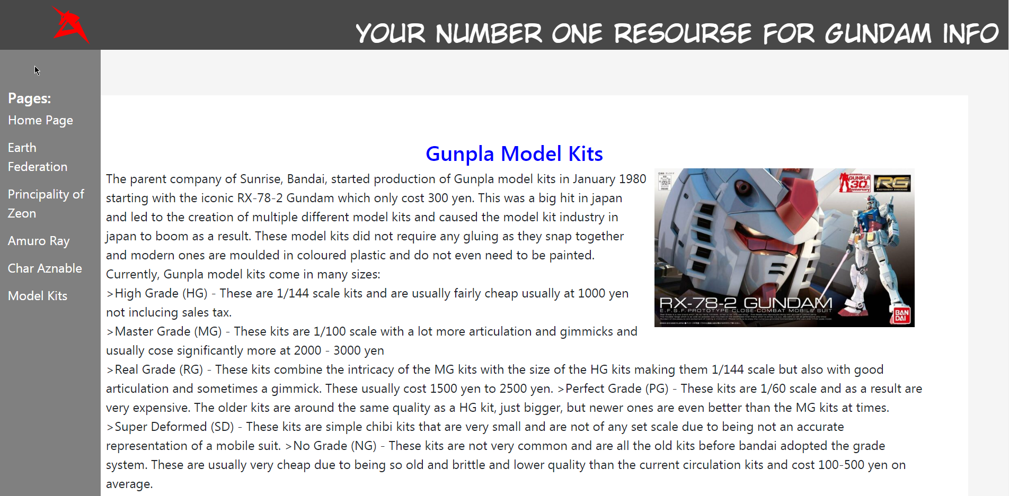
Upon hovering over the side bar, it expands to reveal all of the page links. This was done in order to save space on the top of the page and to have room for each page link.
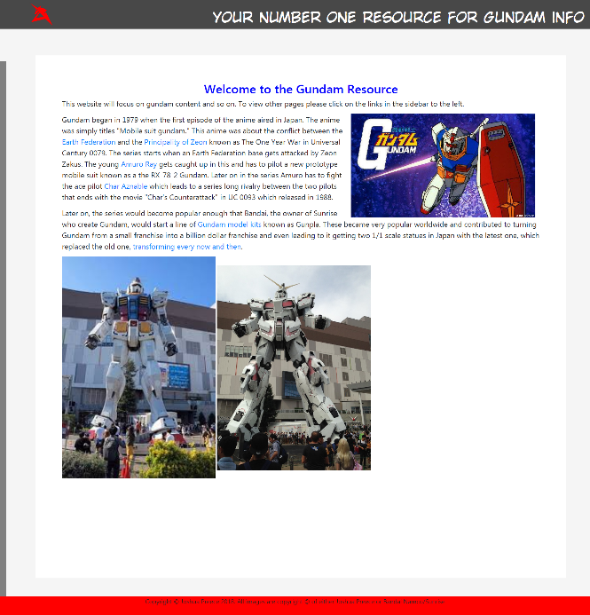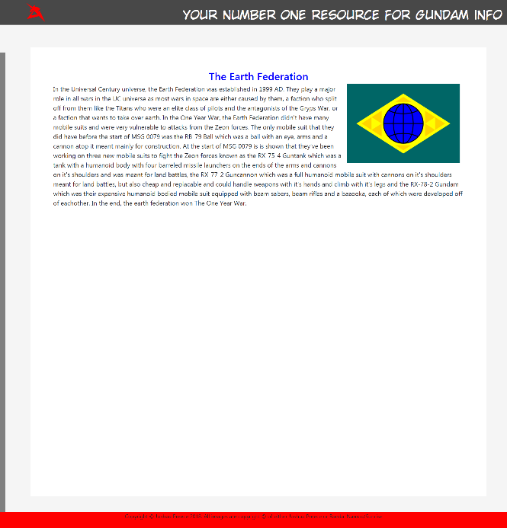
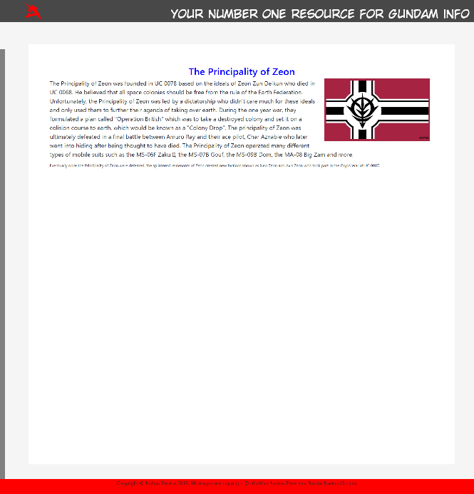
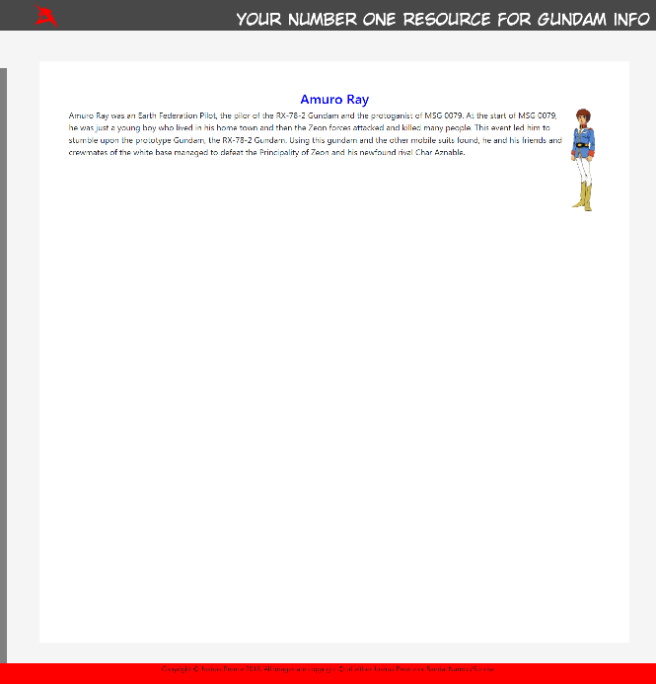
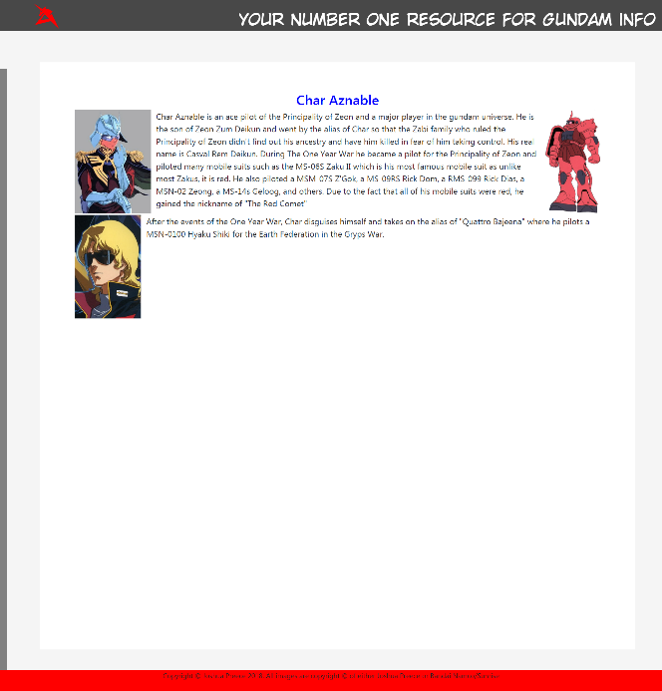
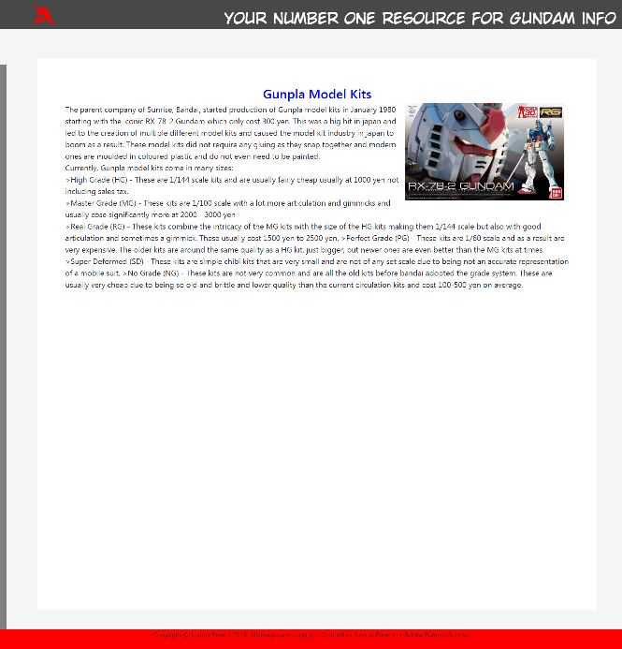
Upon validating the HTML of each page, the author found that there was an error in which it was recommended to add a language descriptor to each page. The author fixed this issue by adding lang=”en” to the HTML tag of each webpage. Other than that there were no errors.
Upon validating the CSS the author found no errors.

Evaluation
Upon evaluation of the website, the author used contrastchecker.com and found that the website achieved a contrast ratio of 21.
The website’s design is easy to use and work as the only abnormal part is the sidebar which the author designed it so that moving the mouse over it, will get the sidebar to expand making it easy to use. The menu bar and side bar also scrolls with the screen so that you have access to the links at all times.
Future improvements that could be made would be to make the sidebar expand via a button next to the logo and making the slogan at the top of the page an image instead of a <p> tag.
More improvements would be to expand the contents of the website by

References

Bibliography

[1] | "W3 Markup Validation Service," [Online]. Available: https://validator.w3.org/. [Accessed 1 5 2019].
[2] | "W3 Schools," [Online]. Available: https://www.w3schools.com. [Accessed 1 5 2019].
[3] | "Contrast Checker," [Online]. Available: https://contrastchecker.com/. [Accessed 1 5 2019].
[4] | "W3 CSS Validation Service," [Online]. Available: http://jigsaw.w3.org/css-validator/. [Accessed 1 5 2019].

