DESTINATION MANAGEMENT

2111632@student.uwtsd.ac.uk
Sustainable Hospitality & Tourism Management BMIH5006
Ruth Taylor-Davies

Contest page

Executive Summary

- Introduction
- Background
- Objectives
- Development
- Destination Management Plan.
- Application of Butler’s Life Cycle Model and Doxey Irridex Model.
- Recommendations for Future Development.
- Conclusion

Introduction
This report critically evaluates the principles of sustainable tourism within the development of Disney Orlando Destination. The analysis focuses on the economic, socio-cultural, and environmental pillars of sustainability and explores their association with general principles of development. Evidence is collated from a case study of the Walt Disney World Resort, utilizing data and statistics to support the findings. Additionally, the report examines the relationship between the traveling aspect of the industry and sustainable tourism. Butler's life cycle model and Doxey's Irridex model are employed to determine the current stage of Disney Orlando Destination's development. Based on the evaluation, recommendations are provided to guide future development while prioritizing sustainability.

Background
The Walt Disney World Resort in Orlando encompasses a vast area of around 25,000 acres and comprises a diverse range of attractions and amenities. The resort is comprised of four theme parks: the iconic Magic Kingdom, Epcot, Disney's Hollywood Studios, and Disney's Animal Kingdom. Alongside the theme parks, the resort also offers a variety of accommodations including hotels and vacation club properties. Additionally, Disney Springs serves as a vibrant hub for shopping, dining, and entertainment experiences. The resort further boasts a sports complex, conference centers, campgrounds, golf courses, and water parks, creating a comprehensive and immersive destination designed to entice visitors for extended stays (Disney's Contemporary Resort 2023).

Objectives

This evaluation aims to assess the extent to which sustainable tourism principles are incorporated into the development of Disney Orlando Destination. To maintain a competitive edge and ensure the long-term viability of the destination, it is crucial to consistently develop and differentiate the tourism product. This entails creating a distinctive offering that sets the destination apart from its competitors. By continuously enhancing and diversifying the tourism product, the destination can establish a more favorable position in the market and promote sustainability in the long run (M. van Niekerk & W. J. L. Coetzee 2011). The tourism industry plays a significant role in shaping natural, socio-cultural, and economic environments, with the potential to enhance and degrade the landscapes and communities that attract visitors. Recognizing the importance of preserving these environments and promoting long-term sustainability, it is imperative to steer the tourism industry toward a sustainable trajectory (Lesat et al,2020).

Development
The application of development management principles to the tourism sector enables destinations to unlock the potential of tourism as a catalyst for economic growth, cultural exchange, and environmental conservation. By adopting these principles, destinations can ensure that tourism activities yield positive outcomes while minimizing negative impacts and maximizing long-term benefits for all stakeholders involved (Ferguson,2007).
The development management plan for the Disney theme park complex in Orlando reflects the three pillars of sustainability: economic, socio-cultural, and environmental (South African Institution of Civil Engineering (SAICE),2016). Here's how the plan aligns with each pillar:

Economic Sustainability:

The Walt Disney Company has demonstrated a firm dedication to the implementation of impactful and measurable initiatives that aim to support the preservation and betterment of our planet for the benefit of future generations. As the company operates and expands its business, it upholds a strong commitment to sustainability and recognizes the importance of taking concrete actions to mitigate environmental impacts (ESG Reporting Center,2022).
Supporting local businesses and suppliers: By prioritizing sourcing from within the region, Disney stimulates the local economy, promotes job creation, and generates economic opportunities for residents (Environmental Sustainability,2022). By providing employment opportunities to residents, the resort plays a significant role in contributing to the economic community’s economic well-being emphasizes fair wages, comprehensive training programs, and avenues for career advancement, ensuring that employees are equipped with the necessary skills and resources for professional growth (Built-in,2023). Furthermore, the plan recognizes the economic impact of visitor spending and seeks to enhance visitor experiences to attract a larger volume of tourists. Increased visitor numbers translate into higher spending in the local economy, benefiting various businesses and stimulating economic growth within the region. This emphasis on visitor spending as an economic driver aligns with sustainable tourism principles, as it contributes to the overall economic sustainability of the destination (Keller,2020).

Socio-cultural Sustainability:
Community engagement: Disney fosters strong relationships with local communities through dialogue, collaboration, and partnerships. This involvement ensures that local voices are heard, cultural heritage is respected, and the needs and aspirations of the community are considered in decision-making processes (Diversity &Inclusion,2023).
Supporting local culture: By incorporating diverse cultural elements and traditions in the park's attractions, Disney celebrates and promotes cultural diversity, contributing to the preservation and appreciation of local culture.
Philanthropic activities and community outreach: Disney engages in community outreach programs, including educational initiatives and philanthropic activities, which enhance socio-cultural development and support the well-being of the community (Disney parks blog,2023).

Environmental Sustainability:

Sustainable infrastructure: The plan prioritizes the use of renewable energy sources, water conservation measures, green building practices, and sustainable landscaping, all of which minimize environmental impacts and contribute to resource efficiency.
Environmental stewardship: Disney focuses on preserving natural habitats, implementing waste management strategies, promoting recycling, and educating visitors about environmental conservation. These initiatives minimize negative impacts on the environment and promote sustainability.
Sustainable transportation: By developing transportation systems that prioritize public transportation, walking, and cycling, Disney reduces reliance on private vehicles, decreases carbon emissions, and promotes sustainable mobility options.
By incorporating economic, sociocultural, and environmental considerations into its development management plan, Disney demonstrates a commitment to sustainability and strives to create a balanced and harmonious destination that benefits the economy, local communities, and the environment (Environmental Stewardship,2023).

Development Management Plan

The Business Insights Luncheon & Economic Forum held at Hilton Orlando was a successful event, with over 400 attendees present. The event served as a platform to unveil Visit Orlando's new three-year strategic plan, which was developed through extensive research and feedback from key stakeholders. The plan highlights a new set of core values, including innovation, trust, and a focus on creating memorable experiences. The vision is to become the most visited, welcoming, and inclusive travel destination in the world, while the mission is to inspire, promote, and grow global travel to Orlando for economic and community benefit. The plan sets targets to achieve 80 million annual visitors and generate 40 million room nights by the end of 2024. The strategic goals of Visit Orlando are centered around sales and marketing, destination management, destination alignment, and organizational sustainability. Additionally, Visit Orlando's 16th annual Magical Dining program has started, offering three-course meals at discounted prices in over 90 restaurants, with proceeds benefitting local charities. The leisure and hospitality sector in the Orlando metro statistical market showed positive signs of recovery, with 6,900 jobs added in July and significant growth in accommodations, arts, entertainment, recreation, and food services (Visit Orlando,2021).

Application of Butlers Life Cycle Model and Doxey Irridex Model

Butler's Life Cycle Model:
This model suggests that tourist destinations go through several stages of development: exploration, involvement, development, consolidation, stagnation, and decline/rejuvenation. It assesses the maturity and evolution of a destination over time.
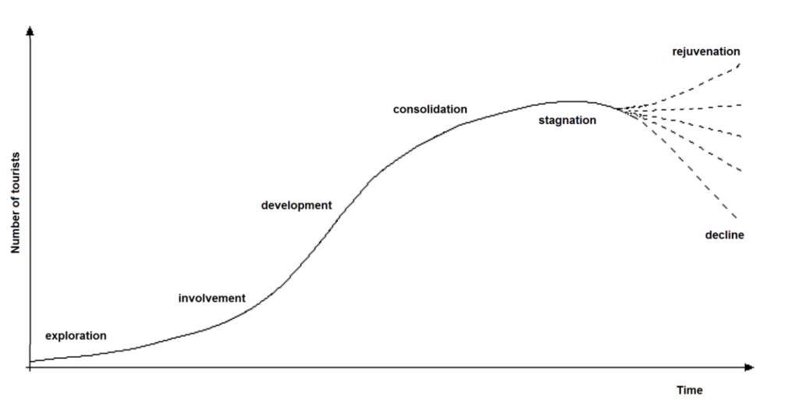

Professor Richard Butler proposed a model known as Butler's life cycle model to depict the evolution of a tourist destination over time. This model aims to simplify and enhance our understanding of the development trajectory of destinations.
It's important to note that Butler's life cycle model is a theoretical framework that provides a general understanding of the stages a destination may go through. Each destination's reality may differ, and the length and characteristics of each stage can vary. The model serves as a useful tool for tourism planners, policymakers, and researchers to analyze the developmental dynamics of tourist destinations (BBC,2023).

In the case of Disney Orlando, it can be argued that it is in the consolidation stage or possibly the early stages of stagnation. Disney Orlando has established itself as a well-known and popular destination, attracting millions of visitors each year. It has a strong infrastructure, diverse offerings (theme parks, resorts, entertainment), and a significant market presence. However, the pace of new developments and expansions may have slowed down, and the destination is focused on maintaining its position and improving visitor experiences.

Doxey Irridex Model

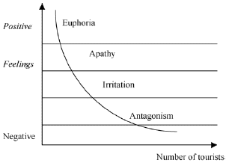

This model examines tourist sentiment and the potential negative impacts of tourism on host communities. It suggests that as tourism develops, host-guest interactions can lead to annoyance, hostility, apathy, and eventually, adaptation (Fan et al,2019)
In the context of Disney Orlando, it can be assumed that the destination is currently in the adaptation stage. Over time, the local community and infrastructure have likely adjusted to the presence of a large-scale tourism operation like Disney. The initial annoyances and host-guest tensions that may have arisen during the earlier stages of development have likely been addressed through improved planning, visitor management, and community engagement efforts.

Recommendations for Future Development

Environmental Conservation:

Implement solar panels and energy-efficient technologies across theme parks, resorts, and facilities to reduce energy consumption and carbon emissions.
Expand water conservation efforts by using smart irrigation systems, installing water-saving fixtures, and implementing rainwater harvesting techniques.
Enhance waste management practices by increasing recycling infrastructure, implementing composting programs, and reducing single-use plastics through alternative packaging solutions.

Community Engagement:

Establish partnerships with local organizations and community groups to support environmental and social initiatives, such as habitat restoration projects and educational programs.
Collaborate with local suppliers and businesses, prioritizing procurement of locally sourced products and services to stimulate the local economy.
Provide training and employment opportunities for residents, particularly in areas of sustainable practices, conservation, and guest services.

Cultural Preservation:

Incorporate authentic local cultural elements, such as architecture, art, and performances, throughout the resort to showcase and preserve the unique cultural heritage of the Orlando region.
Engage with local communities and cultural experts to ensure accurate representation and interpretation of local traditions and customs.
Offer interactive experiences and educational programs that celebrate and educate visitors about the region’s rich cultural diversity.

Visitor Education:

Develop comprehensive sustainability education programs for visitors, including interactive exhibits, guided tours, and informational materials, to raise environmental and cultural conservation awareness.
Encourage responsible visitor behavior through signage, digital platforms, and mobile applications that provide tips and guidance on sustainable practices, waste reduction, and local community support.
Offer incentives and rewards programs for visitors who actively participate in sustainable activities and initiatives.

Innovation and Technology:

Invest in research and development of sustainable technologies, such as advanced waste-to-energy systems, smart grid solutions, and energy-efficient transportation options.
Incorporate sustainable design principles into new construction and renovation projects, utilizing eco-friendly materials, green building techniques, and energy management systems.
Explore the use of digital platforms, virtual reality experiences, and augmented reality applications to enhance guest experiences while reducing environmental impacts.

Continuous Improvement:

Establish key performance indicators and regularly track progress towards sustainability goals, providing transparent environmental and social performance reporting.
Conduct regular sustainability audits and assessments to identify areas for improvement and implement innovative solutions.
Foster a culture of sustainability throughout the organization by engaging employees, suppliers, and partners in sustainability initiatives through training, recognition programs, and collaboration (National Environmental Health Association,2012).
By engaging stakeholders and fostering collaboration, Disney Orlando can benefit from diverse perspectives, expertise, and resources to drive long-term sustainability. The involvement of various stakeholders ensures a holistic approach to sustainable development and increases the chances of success in achieving shared goals.

Conclusion:

The Walt Disney World Resort demonstrates a comprehensive commitment to sustainable development across its economic, socio-cultural, and environmental dimensions. Through partnerships with local businesses, cultural diversity promotion, and sustainable infrastructure and transportation initiatives, the resort strives to create a harmonious destination that benefits the regional economy, respects local culture, and minimizes environmental impact. Continuous monitoring, evaluation, and adaptation of sustainable practices will be crucial for the resort's long-term success in achieving its sustainability goals (Sustainable development goals,2023).

Executive Summary:

This report evaluates the principles of sustainable tourism in the development of Disney Orlando Destination. It examines the economic, socio-cultural, and environmental aspects of sustainability and their integration into the destination. The analysis is based on a case study of Walt Disney World Resort, using data and statistics to support the findings. The report also explores the relationship between sustainable tourism and the travel aspect of the industry. Butler's Life Cycle Model and Doxey's Irridex Model are applied to assess the current stage of development. Based on the evaluation, recommendations are provided to guide future development while prioritizing sustainability. Disney Orlando demonstrates a commitment to sustainability through economic support for local businesses, socio-cultural engagement with communities, and environmental initiatives. However, continuous improvement, community engagement, and technological innovation are essential for long-term sustainability. By incorporating these recommendations, Disney Orlando can maintain its position as a sustainable destination that benefits the economy, culture, and environment.

References

BBC, (2023), Changing pattern and nature of tourism, Available on; https://www.bbc.co.uk/bitesize/guides/z2nnqty/revision/2.

Built-in, (2023), The Wall Disney Company, Available on: https://builtin.com/company/walt-disney-company/benefits.

Disney's Contemporary Resort (2023), Available at: ui.co.uk/destinations/the-americas/united-states-of-america/florida/walt-disney-world-resort/hotels/disneys-contemporary-resort.html?utm_medium=paidsearch&&msclkid=02bcd51241dc19f9bd41b167ba23682d&gclid=02bcd51241dc19f9bd41b167ba23682d&gclsrc=3.

Diversity & Inclusion, (2023), Community Making a Meaningful, Measurable Difference, Available: https://impact.disney.com/diversity-inclusion/community/.

Environmental Sustainability (2022), Available: https://impact.disney.com/environment/environmental-sustainability/.

Environmental Stewardship, (2021), The Walt Disney Company, Retrieved from https://www.thewaltdisneycompany.eu/environmental-stewardship/.

Environmental, Social, and Governance (ESG) Report., (2021), The Walt Disney Company, Retrieved from https://thewaltdisneycompany.com/esg-report/.

Fan, D XF, Liu, A, Qiu, R, (2019), ‘Revisiting the relationship between host attitudes and tourism development: A utility maximization approach’, Vol.25 (2), p.171-188,
London, England: SAGE Publications.

Ferguson, L (2007), ‘The United Nations World Tourism Organisation’, New political economy, Vol.12 (4), p.557-568, Abingdon: Routledge.

Keller, C, P, (2020), ‘Geography of tourism and recreation: environment, place, and space’, Vol.37 (1), p.62, North York: University of Toronto Press.

Niekerk, M & W. J. L. Coetzee (2011), ‘Utilizing the VICE Model for the Sustainable Development of the Innibos Arts Festival’, Journal of Hospitality Marketing & Management, 20:3-4, 347-365.

South African Institution of Civil Engineering (SAICE), (2016) ‘Civil Engineering (Johannesburg, South Africa),’, Transforming our world: the 2030 agenda for sustainable development: international, Vol.2016 (1), South African Institution Of Civil Engineering (SAICE).

Sustainable development goals, (2023), Available on: https://www.un.org/sustainabledevelopment/sustainable-development-goals/.

The Sustainability Handbook: The Complete Management Guide to Achieving Social, Economic, and Environmental Responsibility, (2017), Journal of Environmental Health, Vol.74 (8), p.42, National Environmental Health Association.

Visit Orlando, (2021), INTRODUCING OUR NEW 3-YEAR STRATEGIC PLAN, https://www.visitorlando.com/about-us/corporate-blog/post/introducing-our-new-3-year-strategic-plan/.

