Report Academic report
To: UWTSD
From: Yasmeen Begum (2119725)
Date: 1st February 2022
Subject: Academic and Employability skills BMSW4001 BIRMINGHAM
Lecturer: Abdi Rahman

Table of content

Introduction 3

Motivations 4

Respect 5

Recognition Praise 6

Communication 7

Supportive 8

Opportunities 9

Encouragement. 10

Salary 11

Conclusion 12

References 13

Bibliography 14

INTRODUCTION

The aim of this report is to explore the most effective ways to motivate staff. To do this, I would be understanding the definitions of motivations and will highlight it in my discussion. Before exploring motivations, it is important to understand what the meaning or definition of motivations are.

Motivation involves in everyday usage. Motivation is all about keeping a positive attitude and the goal you want to achieve. The main aspect about being motivated is being confident in yourself. It’s about striving for what you want. Being enthusiastic and productive. Motivation means you must train your own mindset. To think positive. You need to block out any negativity. It will help you to go in the direction of success and to achieve the best in life. And for you to push yourself for the best in life is you got to be MOTIVATED.

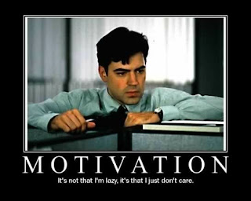
This Photo by Unknown Author is licensed under CC BY

MOTIVATION
So, what is the most effective way to motivate staff.
Motivating staff is an everyday challenge for every employer. It’s never easy. Work motivation is necessary for staff to complete their day-to-day task.
Key Facts:

1.Facilitate respectful relationship.
2.Reconigtion, praise of the work. 3.Communication.
4.Supportive.
5. Opportunities to progress.
6.Encouragment.
7.pay
Employers face a challenge every day to motivate their staff. No one says it’s easy, but it must be done. Not only by themselves but also by others. Motivation is not easy sometimes but can be done. What motivates employees according to over 40 years of motivation surveys. “Carolyn Wiley (1997) over years surveys have been conducted.1. explores past and present attitudes of employees concerning work-related motivational factors. 2.Understanding the factors that employees consider motivating lends to rewards, to which they more positively respond. Present surveys prove that over time motivational preferences vary over time. Unlike surveys conducted in 1946,1980,1986.
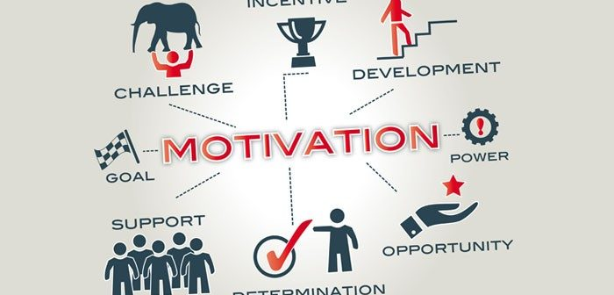
This Photo by Unknown Author is licensed under CC BY

1, RESPECT
Respect is a big aspect in every sector. Weather its professional, personal, or anywhere, the employer should respect his staff, as with the help of them his business grows and succeeds. Where employees need to do the same as having the respect for the employer.as they are the ones who is providing them with an income and giving them an opportunity with a job.by respecting employees it encourages them to focus and aim high, employers should encourage the staff to respect one another as it shows professionalism with in the job. Having respect will a positive impact on one another, respect is a fantastic skill with or without having a job.it is a day to day basis skill.to elaborate on this, then the staff will work together and progress successfully without any complications made within the job. This will leave a conclusive mood on staff. So according to (Victoria Masterson February 11, 2022, pp 51.) that respect for one and other at work means to adopt diversity practices.it has been studied that a few years ago the issue of gender was seen as a binary issue of males and females.to secure equal rights and conditions for women at work. The work place should make changes with some discernment and tact so all workers are treated fairly.

1.RESPECT INCREASES PRODUCTIVITY AND COLLABORTION. 2.RESPECT GIVES EMPLOYESS SATISFACTION. 3.RESPECT CREATES A FAIR ENVIRONMENT.
https://youtu.be/muoM-Fst2fA



2, RECONIGTION, PRAISE

1: I really appreciate your work and help.
2: written and verbal praise. 3: Rewards staff.
Sometimes a simple well done or thank you means a lot.as sometimes a person just needs that well down to make there day good if there are having a bad day. Feeling appreciated or being recognised is a big part in a workplace.it gives you the drive to do your job and to perform much better. Helping an employee helps their performance and gives them motivation to work. individually and part as a team, giving them bonus, increases salary.
Reward staff; is important as well as praise. Giving them an objective to perform well.
Armstrong and brown (2019)
Introduction
The meaning of this is to give basic information about the organizations rewarding people. This will benefit them financially and non-financially. Each achievement has its own rewards process. The values is also discussed to give a better understanding. The reward management compromises with the reward process, which is therefore rewarded to staff.

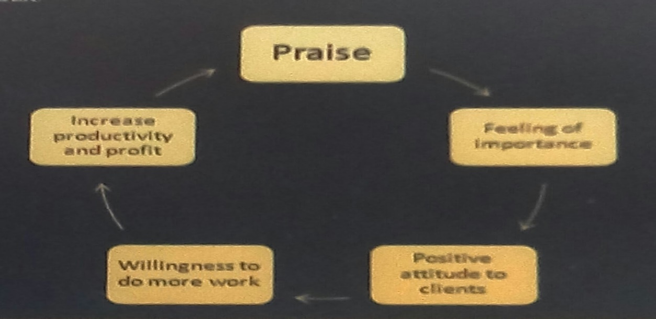
This Photo by Unknown Author is licensed under CC BY-SA

3, COMMUNICATION
communication is a big part in a work force. You need to be able to communicate with each other to progress and to do your daily tasks or job at work. Lack of communication does make an impact on an employee. Where you then do not feel motivated.as doing the same thing and not getting appraisal which is a part of communication.
Communication also ability to communicate effectively plays a huge role in teamwork. Those who can’t remain on the same page and express their needs, thoughts, and feelings will find it hard to succeed as a team.
Performance management processes define individual performance and contribution expectations, assess performance against those expectations, provide for regular constructive feedback, and result in agreed plans for performance
So according to (murray,2021) an excellent communication has a big impact on employees feeling respected and motivated.it makes them more demotivated. Some employees say that their employer are sometimes nonvisible and not easy to talk to and as employers do not frequently talk to their employees that often. If employers encourage and communicate well with their employees. Then employees pick up speed, sharing information, such as working as a team. Employees then can accept successes and failures if need to. Being a good communicator is most valued by employees.
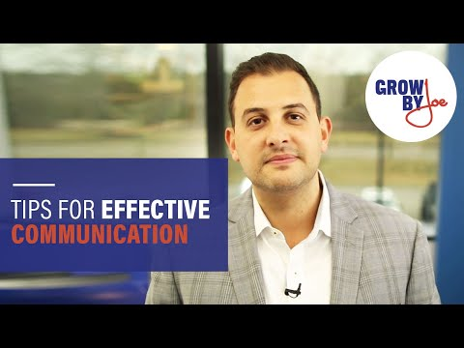
https://youtu.be/1FlsLxFRwN84
4. Supportive
Support is vital as well. every employee needs a good employer who would support them daily. Sometimes support is not just about work. It’s also about outside workplace.it can personal, such as health, family, financial. Employees should be able to feel free and comfortable to approach their employer if there need support.as maybe communicating about it will help and resolve the issue or how you feel.

Mental health
- Today, after the stresses and traumas of the pandemic, managers also need to learn to communicate with a great deal more empathy, and to develop their listening skills. They need to learn how to seek first to understand, before being understood. Only by doing this do they stand a chance of being even remotely persuasive.

- Family .2 Demonstrate sincere caring and interest in their individuality by asking how things are going with their ill family member, their child’s first day of school, or moving into their first house.
(Cohen, 2006)
- Financial. with today’s situation with pandemic. everyone is struggling with their finances. With everyday essentials, food, electric, gas, petrol and etc.so employers should understand and be supportive as everyone struggles financially.


This Photo by Unknown Author is licensed under CC BY

This Photo by Unknown Author is licensed under CC BY-NC-ND
5.Opportunities to progress.
Every employee has a right to progress in their employment. that’s where employees or management should encourage them. If there are opportunities in the workplace or in the job, it will also give them a strive to be motivated, equal opportunities should be given to everyone.it shouldn’t matter what’s your gender, age, religion, disability, salary. by law everyone now has equal rights. There are loads off ways to progress in your employment. you should have driven to step up the ladder yourself as well as your employer motivating you to or even think that you do deserve it.
According to McKay (2008) three-quarters of workers in Britain have more employees that have a formal equal rights policy. Employers' policies sometimes amount to general statements on equality but also by monitoring through data on the composition of the workforce.it has suggested from research by impact equal policies. (e.g., Hoque and Noon (2004) 3 and Dickens (2000) 4), that policies do not address discrimination in the workplace. Policies may worsen employee attitudes and motivation. There are different polices received by disabled employees and minority ethnic workers. Who view policies positively.


This Photo by Unknown Author is licensed under CC BY-SA-NC

6. Encouragement.

Encouragement is to support, inspire, to become successful in the career you chosen to pursue. encouragement is a big part of motivation.to motivate your staff employers should encourage them, as sometimes some employees need a bit of a push in the right direction. encouragement does not necessarily only mean to be work related it also can help with personal affairs as well. encouragement can be done in different forms, such as praises, support, talking.by giving someone a little bit of encouragement can push them far.as getting out of bed is a big encouragement these days for staff.
According to the (11 Tips for Leaders Who Want to Encourage Positive Workplace Relationships, 2022) for most employee’s work takes up their waking hours.so whether you’re working 9-to 5 or have your own business. Your professional life sometimes blends in with your personal life. Especially when it comes to a friendship at work, as its normal and natural for employees to form a strong bond.so its important for employers to encourage their employees to appropriate and productive bonding. If not then it will may let close personal relationship with co-workers cloud judgment or a reason for them to play favourites when it comes working a part of a team

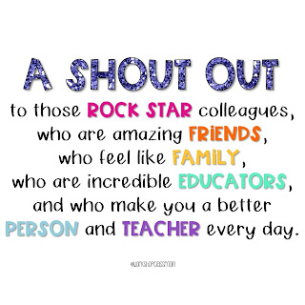
This Photo by Unknown Author is licensed under CC BY-NC-ND

7.salary
Salary is a big part of being motivated as well if employees think there are working long hours but not being paid the right salary. And still need to work due to personal reason will only go in and just do what there need to do, and then just go home, employees do not feel encouraged or motivated as well feel valued. nor are employees then interested in the tasks given or work as a team. if the salary is right then employees are motivated more. Willing more to complete tasks. Willing to work as a team and would want to progress employees as well should not be treated different by salary due to gender, age, religion.
according to romo,2022 women had worked only 74 hours extra to catch up in 2022 than 2021 to equalize with men in order to pay and compensation fairness. And he also referred the occasion took place where the vice president of America attended and encouraged the women on winning court case on equal working condition and equal compensations as men at work places.

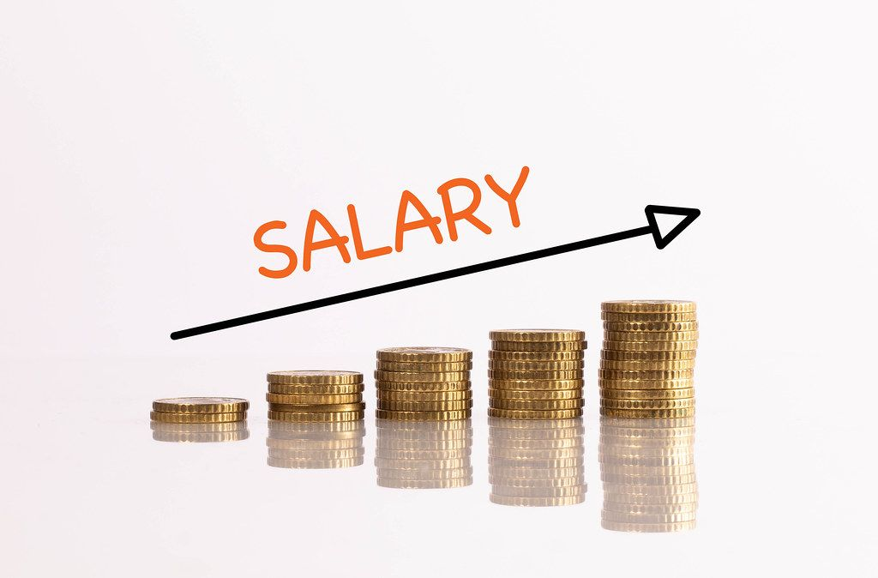
This Photo by Unknown Author is licensed under CC BY

8.Conclusion
It shows these are the main key factors of encouraging to motivate your staff. Alongside much more but these are the main important factors. Motivation does come in many forms but main is encouraging. Giving Respect. And praising when necessary. Employers need to have motivated staff so that’s how their business will progress. Motivation works both ways like as mentioned above. As then Motivation will help staff with there day to day activities.



References

1. (Armstrong and brown, 2019)
2. Cohen, S. (2006). Compliment your staff with nonmonetary rewards. Nursing Management (Springhouse), 37(12), pp.10, 14.
3. McKay. (2008). Making Equal Opportunities Work: Equal Opportunities, Employee Attitudes and Workplace Performance: Findings from WERS 1998. Industrial Law Journal (London), 37(4), 394–396. https://doi.org/10.1093/indlaw/dwn023
4. Murray (2006). Eight ways bad managers kill conversations – and motivation. cmi 2021.
5. Romo, V. (2022). On Equal Pay Day, women are trying to make a dollar out of 83 cents. Northcountrypublicradio.org. [online] 16 Mar. Available at: https://www.northcountrypublicradio.org/news/npr/1086732450/on-equal-pay-day-women-are-trying-to-make-a-dollar-out-of-83-cents [Accessed 22 Mar. 2022].
6. Victoria Masterson (2022 Feb 11) pp 51. Respect for one another at work means adopting diversity best practices.:

7. Wiley, C. (1997). What motivates employees according to over 40 years of motivation surveys. International Journal of Manpower, 18(3), pp.263–280.
8. 11 Tips for Leaders Who Want to Encourage Positive Workplace Relationships. (2022). Newsweek. [online] 27 Feb. Available at: https://www.newsweek.com/11-tips-leaders-who-want-encourage-positive-workplace-relationships-1681943 [Accessed 22 Mar. 2022].
9. https://youtu.be/muoM-Fst2fA
10. https://youtu.be/1FlsLxFRwN8

Bibliography.

1.RYAN, R.M., 2012. Motivation and the Organization of Human Behaviour: Three Reasons for the Re-emergence of a Field. The Oxford Handbook of Human Motivation. Oxford University Press, .

