Effective Communication in the Workplace
Swan Event Department.

Diana Czanasz

Effective Teamworking and Communication

BMSK4002

Group 3

Term 1

Lecturer: Gregory Cowan

30th December 2018.

CONTENTS

Introduction 3

1 Definition of communication 4

2 Transmission Medium 6

2.1 Examples of situations, where oral and 7
non-verbal channels are used

2.1.1 First scenario 7
2.1.2 Second scenario 8

2.2 Examples of the written forms of 9 communication

2.2.1 Using email as written form of 9
communication

2.2.2 Other way of written communication 13

3 Barriers to communication 14

Conclusion 15

References 16

INTRODUCTION

This report will analyse different ways of communication, used by employees of the Swan Event Department. Therefor giving the adequate workplace examples, different strategies which leads to effective communication will be examined.

When working for hospitality industry such as Events, communication plays important role. A successful employee is expected to have outstanding communication skills in order to cooperate with other colleagues and guests in a professional and friendly manners. The acknowledgement of effective communication takes time and require a lot of practise. In order to run event smoothly, the employees must show genuine knowledge on how to cooperate. Hospitality is a very busy industry. In Swan case, on average it event venue host around 350 events annually. Swan events department is composed of 25 members of staff, this includes: sales team, planners, managers, supervisors, chefs, bartenders and waiting staff. Considering such busy venue , it is very likely that communication issues might occur among employees. This is usually caused by stress related to factors such as high demands, lack of experience, lack of time. However effective communication could lead to minimising of misunderstanding among co-workers and smooth the overall experience.

- DEFINITION OF COMMUNICATION

Communication is known as the process of exchanging the information, thoughts and ideas between humans. For communication to take place two or more people are needed, at least one sender and one receiver. Processing information is otherwise known as encoding and decoding messages, outcome of this process varies from factors such as: channels used in order to communicate , non-verbal signals, words used, language. As well as speed, pitch, intonation and volume of speech (Maud, Schriek and Tinkler, 2017, p. 47).

The diagram shown below illustrates the process of sending and receiving messages.

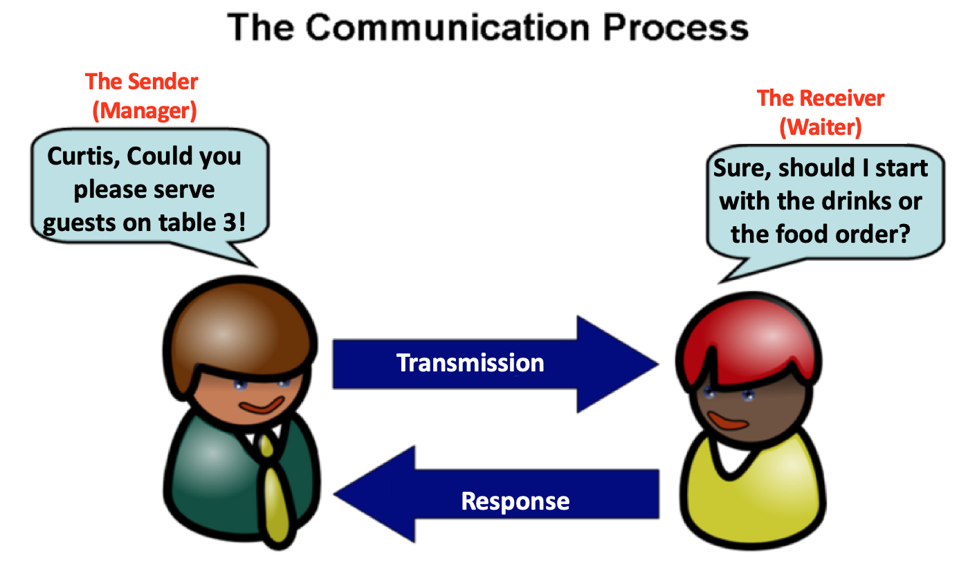

Sender: Person that begins the conversation, encoding his message in a way that will reflect the information he shares, using verbal or non-verbal form of communication (MTD Training. 2010).

Receiver: Person to whom information has been communicated. Receiver is the person that will decode message observing body language of sender and practising active listening in order to respond giving the feedback to the person he communicates with (MTD Training. 2018).

Message: Is an information, meaning or idea shared with the receiver. Message is encoded using verbal and non-verbal symbols. Message must be well structured, so it can be interpret by receiver, in the way that sender desires (topper. 2018).

Responding: Answer to the message received, done by either receiver or sender (topper. 2018).

Feedback: Response based on the meaning that receiver attached to the message received from sender. Feedback can be
shown in written, verbal or non-verbal way (topper. 2018).

- TRANSMISSION MEDIUM – different ways of communication.

According to Maud, Schriek and Tinkler (2017). People correspond through different types of transmission medium, such as:

- Oral

- Non – Verbal

- Written

- Electronic

Employees of Swan Event Department are using all of the mentioned above mediums in order to communicate with each-others and with customers.

2.1 Examples of situations, where oral and non-verbal channels of communication are used, by employees at Swan Event Department.

2.1.1 First Scenario – Briefing.

Events at Swan, starts usually with the briefing given by the Manager. Here is when all the team members including: managers, bartendes, waitress, chefs, and planner, are gathering together in order to acknowledge the strategy, tasks that must be accomplished and timing of the event which is due to take place.

In order to deliver information with desire effect, words should be chosen carefully and body language such as: posture and face expressions, should be in control.

Manager when giving a speech uses oral way of communication, however non- verbal: body language and face expressions takes significant part. While talking to the members of team, manager uses para-linguistic skills such as tone of voice and volume of speech in order to assure that everyone can hear the message transmitted. Speech is done clearly using appropriate language, and questions are asked in order to check if attention has been paid. The body posture of manager is relaxed and eyes are focused on audience in order to show the respect. (Morgan, 2017, p.252).

It would be very inappropriate if the manager while talking to employees, keeps his/hers hands in pockets and look away from the audience, talking quietly with monotone voice. Employees would easily loose the interest.

2.1.2 Second Scenario – Team Service.

When dinner is about to start, team leader comes to each waiting staff (waitress/ waiters) individually, and using oral communication through the form of whispering, saying that it is the time to serve the first course. Also, sometimes physical communication such as typing on the arm of waiter, is used as the way of gathering and signal attention.

Calling each staff member individually in this situation is better, rather than standing on the middle of the room, rising arms and shouting “ Guys, we must now serve the food!”.

When the team leader have delivered the message to the whole team (usually 5 members of staff). Every person grabs two plates with adequate dish given by chef, and follows the team leader to the room. Leading person goes to the specific table and stand at specific spot. Then members will follow previously agreed sequence. When standing around the table, waitress are looking at team leader and waiting for the sign, in order to place the plate in front of the guest. If the instructions are followed and team members are keeping an eye contact with team leader, even if one of the member stands in wrong position, team leader seeing it would be able to shake his head and direct waiter to correct guest. (Morgan, 2017, p.252).
However if the waiter is not maintaining eye contact with his leader in such occasion he will place the dish in front of the wrong person.

Those examples shows how important is the way we communicate and how easily our lack of communicating can affect the work outcomes.

2.2 Examples of the written forms of communication used at Swan Events Department:

2.2.1 Using Email as way of written communication.

Illustrated below is a daily report for an example of the electronic, written form of transmission. The purpose of writing such report at work is to share brief information about company achievements or issues which occur on the daily base. This could include: complains from customer, any fault log, accident that happened, inappropriate staff behaviour, as well as positive feedback received from client. Such report is written with the help of specific devises like laptop, tablet or computer. When completed, it is saved to the desktop and emailed to general manager and other relevant employees.

Daily Report
Date: 22nd September 2018 | Type of Event: Kat and Rob Wedding

Venue Space: Balcony room, Upper Foyer, Bar. | Client: Rob Smith.

Manager: Janita | Number of Guests: 104

Today, wedding of Katy and Rob Smith took place in the Balcony Room. Total of 104 guests attend. Ceremony began at 13:00PM and it lasted 20 minutes. At 13:30 guests moved down to Upper-Foyer for 45minutes of drink reception, in the meantime team was preparing room for the wedding breakfast.
Guests came back up at 14:45 where drinks were served prior to 3 course meal. Starter was served on time at 15:00PM, however main course was delayed for nearly 20 minutes (15:50PM), due to last minute dietary requirements and misunderstanding between chefs. Followed by main course, speeches took place, those were scheduled for approximate time of 10 minutes, but took longer than quarter-hour. Dessert was served afterwards (17:00PM). After 3 course as planned guests must have change the venue space as room has to be turned into dancing space. Due to previous delays we couldn’t longer use Upper-Foyer space for the second turn around, therefore guests has to be directed to piazza, bar. We had very short time to set up bar area, so by the time that guests came down, coffee station and other drinks weren’t ready. Luckily staff members from the bar helped out and took good care of our clients, while event team was setting up. Katy and Rob were a bit disappointed that we used deferent venue space for turnaround, as it was smaller so guests weren’t comfortable enough. After around one hour ( 18:30PM), everyone could return upstairs where dancefloor was set and first dance took place. Evening snacks were served at 20:00PM. During the party one of the guests was misbehaving towards bartender, but issue was quickly solved. Rest of the night passed successfully.
Bar closed at 00:45AM and guests departure was at 1:00AM.

According to Sara Left(2002), first email management program was written in 1972 by Larry Roberts. This program would enable users to send, and replay to messages.

Email is a very popular form of communication. However emails are easily misunderstood, this might cause confusion or conflict between sender and receiver (Masters, 2014).
According to David Masters (2014) it is very important before sending an email few factors need to be taken into consideration:
- The audience: depends on audience email can be formal or in-formal.
- Purpose: emails aren’t right for every occasion.
- Structure: use paragraphs, message sent via email shouldn’t be too long.
- Language: it is important to remember of using the words such as: “Thank you” or “Please”.
- Prof Reading: before sending the message, it is worth to check on mistakes such as spelling, especially when sending complaint, CV or resignation letter.

On over all, employees of the Swan Event Department sends hundreds of emails every day. This includes: reports, handovers, cash ups, weekly rota, function sheets, updates, etc.
Example: Email – Daily Report
Question: What if person send the attached file and forgets to mention it in the email?
Answer: Person that receives email could miss the important attachment.
Therefore, when sending the attachment such as daily report, it is necessary to mention it in the email itself.
See example below..
Dear All,
Please see the attached document for the daily report.
If you have any questions, do not hesitate to ask.
The best way to reach me would be at: Diana.Cz6@swan.co.uk.
Have a lovely weekend.
Best wishes,
Diana Czanasz.

Swan, as company is very organised when it comes to corresponding with clients or suppliers trough the electronical medium such as email. To make the job easier for its employees, each of the operational team have the access to the folder which includes email templates.
2.2.2 Other form of written communication.
In busy environment like hospitality, happens that accident might occur. Therefore, it is very important to report such unfortunate situation as soon as possible.
In case if one of the employees have been injured, first aid help should be provided by the employee who holds first aid certificate.
The aim of recording accident at work is to prevent future incidents. Also and most importantly it is used as proofs that such situation took place and that first aid was provided. When accident in the workplace took place, employer is obligated to inform Incident Contact Centre of the HSE. (Morris, 2018).
Accident must be recorded in the accident book. Person filling up the accident book must be very careful. Making sure that all the information are written clearly and in allocated box.

- Barriers to Communication

According to toppr (2018) there are few groups of barriers which might cause misunderstanding:
Sematic: Wrong interpretations, bad translations, usage of wrong words.
Example: If employees English is very poor and manager cannot speak in any other language than language would be the barrier.
To solve such problem, manage r could ask other member of staff who speaks same language as the other employee in order to translate the message.
Psychological: Emotional state of mind can have impact on how message is encoded and decoded. People under emotions such as anger, cannot focus and communicate properly.
Example : If employer sees that his employee is not acting in usual way and shows some signs of sadness or anger, it is worth to ask question “ How are you?”, “ Is everything alright?”
Personal: Luck of confidence, some people are shy to ask the questions, fear that conversation can affect persons authority.
Example: Supervisor might be afraid to ask for the advice to his manager, as he does not want to be seen as uncapable of accomplishing the task given.

CONCLUSION
Communication in the work place is proven to be an important skill to master. The report have looked at the Swan Event Department and the scenarios of where communication played a major role and a determine factor between frailer and success. The report also looked at the transmission medium and the methods of communications in the work place of Swans. Furthermore, the report highlighted the barrier of communication and its impact in the work place. Overall, communication in any industry, especially the hospitality, is an install aspect of the work mechanise and it can differentiate between a good and bad employees.
.

References:

Left, S. (2002)‘Email timeline’, The Guardian, 13th March. Available at:
https://www.theguardian.com/technology/2002/mar/13/internetnews(Accessed: 28th December 2018).

Masters, D. (2014)’How to write clear and professional emails’, Tutsplus, 19th May. Available at:
https://business.tutsplus.com/articles/how-to-write-clear-and-professional-emails--cms-20939
(Accessed: 28th December 2018).

Maud, A; Schriek, M and Tinkler, K.P. (2017) Certificate in higher education: skills for the workplace student yearbook. London: SAGE Publication Ltd.

Morgan, P. (2017) The business student’s guide to study and
Employability. London: SAGE Publication Ltd.

Morris, I. (2018)’ The importance of reporting an accident in the workplace’ Ian Morris [blog]. 4 December. Available at:
https://direct2compensation.co.uk/blog/the-importance-of-reporting-an-accident-in-the-workplace
(Accessed: 28th December 2018).

MTD Training (2010) Effective communication skills. Available at:
http://promeng.eu/downloads/training-materials/ebooks/soft-skills/effective-communication-skills.pdf
(Accessed: 28th December 2018).

Toppr (2018) Communication. Available at:
https://www.toppr.com/guides/business-studies/directing/communication/
(Accessed: 28th December 2018).

