Game Theory and Design
ACCA5040
Iain Martin
2311038
2024
Contents
Alien Colony Survival 2
Platform and Audience 2
Competitors/Similar Products 4
Game Outline 5
Story 5
Game Flow 5
Game World 6
Colonists/Traitors (The Players) 6
Creatures 7
Level Design 10
Gameplay 13
Colonist Loop 13
Traitor Loop 13
Control Systems 14
Hud 15
Game Experience 16
Game Experience 16
Menus 16
Gameplay Mechanics 17
Mechanics 17
Hazards 18
Tasks 18
Cutscenes 19
Bad Ending 19
Good Ending 19
Additional 21
Bonus/Replay 21
Future Content 21
Bibliography 22

Alien Colony Survival

Platform and Audience
Platforms    Fig. 21. Windows [12]    Fig. 22. MacOS [13] | Windows/MAC Desktop and Laptop.  We do not want to dilute the control scheme or graphics for consoles until the PC version is fully complete and staff can be directed to the console port through rigorous testing with console hardware.

PEGI Rating [1]    Fig. 23. Pegi 18 [1] | PEGI 18 – This game is aiming for realism including blood gore and profanity, this is similar rating to other titles with similar themes.  - Alien: Isolation [2]  - CoD:MW3 [3]

Target Demographic | We are aiming at 18+ due to the nature of the games themes and realistic nature.  We are also hoping to pull in those who have an interest in the Aliens [4], Life [5] and A Quiet Place [6] film series, in addition to those who have enjoyed games like Alien: Isolation, Rimworld [7]and Among Us [8].  We also hope that the survival light RPG and rogue-like elements will attract a large number of players who are interested in these style of games.  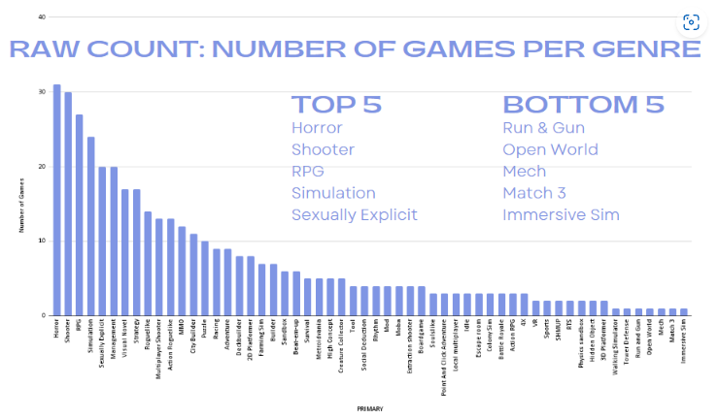  Fig. 24. Genre popularity [14]  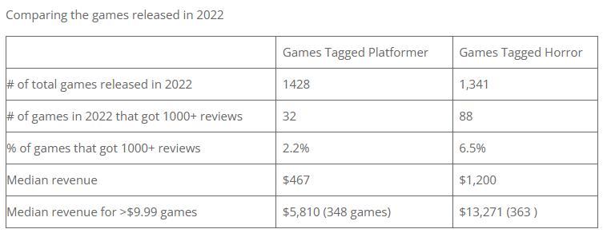  Fig. 25. Genre Popularity [14]  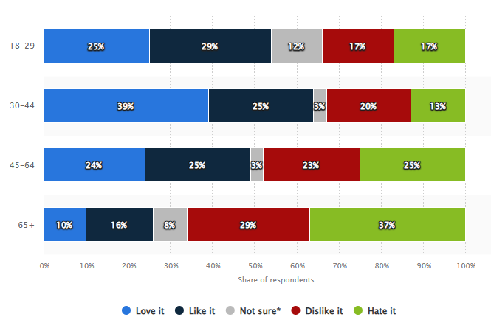  Fig. 26. Horror Movie Genre Popularity [15]

Competitors/Similar Products
We will only have some areas of similarity between some current and soon to come titles.
Alien: Isolation 2 [9]  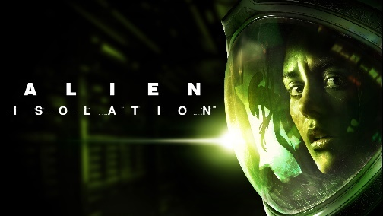  Fig. 1. Alien Isolation [2] | It has been announced recently by Creative Assembly that they are looking to release a sequel.  This has themes similar to those we are looking to exploit, with alien-type creatures and survival aspects, but ours will be in a multiplayer fashion.
Rimworld [7]  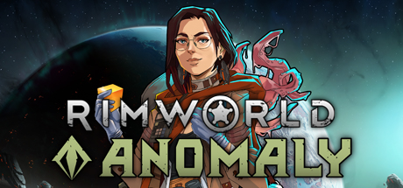  Fig. 2. Rimworld [7] | It is a colony survival game, with colonists with random stats and traits.  We are looking to implement traits within the characters, which will be randomly generated. Rimwold is top down where we are going for FPS.
Among Us [8]  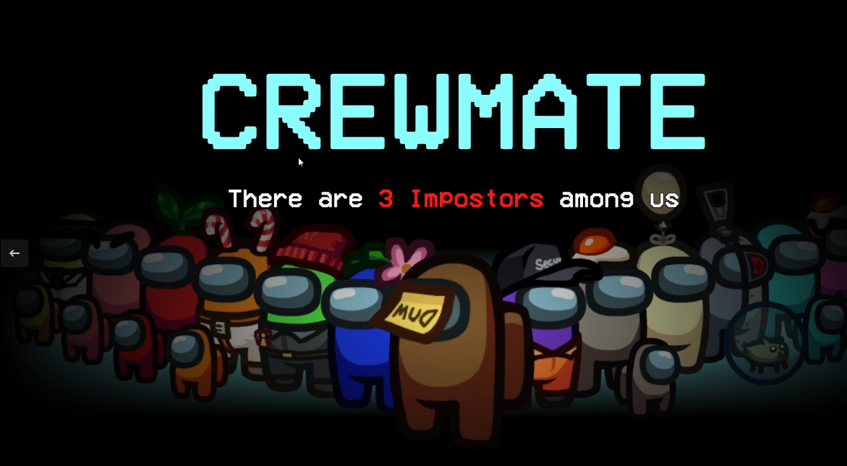  Fig. 3. Among Us [8] | Multiplayer with imposters among the crewmen, all must complete tasks and try to find the imposter in their midst.  We are going to leverage the mini-games and the imposter, who will play a more important role than just killing other players.
Sim Ant [10]  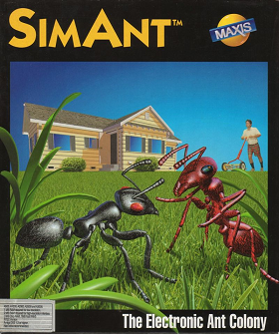  Fig. 4. Sim Ant [10] | Colony of ants that use pheromones to navigate the world and direct other ants to do specific tasks.  We are going to use the pheromone system that each of the scout creatures will lay for, prey found, search here, attack here, etc.

Game Outline

Story
Colonists will find their colony invaded by creatures hell-bent on using the colonists for food to expand their hive.

Traitors who have hidden themselves within the colony population are known to be getting paid for information on what the creatures can do, the traitors know they can’t fight the colonists direct but are confident in their ability to arrange “Accidents”.

The colonists are desperate and will need to find a way to survive and escape or arrange a rescue.

Game Flow
This is a Multiplayer first-person survival horror with some light RPG elements. It will be based in a colony or starship, where colonists find themselves under attack by creatures and random acts of sabotage.

The colonists (players) are trying to survive a creature infestation. They will be tasked with completing different tasks that will help them survive and eventually escape from the Colony/Starship.

Among the colonists, there will be some traitors who will be trying to complete their own tasks, which, in addition to stopping the colonists in any way possible without outright killing them with weapons, be these accidental deaths or luring creatures into areas to capture the colonists.

The creatures will be based around a hive and send out scouts to locate where colonists are held up before attacking with larger types of creatures. Colonists will feed the hive, allowing the Breeder to create more creatures.

Game World

Colonists/Traitors (The Players)
The look of the colonists and traitors will be similar so as they do not stand out from one another.

They will be dressed in futuristic civilian engineering-style garb, as they are all workers. This is a working colony/ship, not a pristine, fully functional and built colony with regular colonists.

Colonists and traitors will have random traits that are either positive or negative, and they will also be randomly assigned equipment based on their role in the colony.

Only security colonists, if assigned, will have light weapons, like pistols.

Other weapons will only be available if a colonist has been given a specific skill, and these will be very defensive and not designed to go out hunting the creatures.


Fig. 5. Colonist [11]


Fig. 6. Colonist [11]

Creatures
The creatures will come in 4 flavours.

Scout – Small nimble, although still slightly larger than a pre-teen human, can easily hide when required and is strong enough to capture a colonist if they are on their own and un-aware. Can leave a pheromone trail for Warriors and other Scouts to follow depending on trail left.
- Navigation Trail
  - Allows the Scout to retrace steps to the hive.
- Search Trail
  - Alerts the hive that there is possible activity and sends more Scouts and possibly Warriors to do an intensive search of the area.
- Attack Trail
  - Contact with a food source (Colonists) will draw several Warriors from the hive to actively attack and capture colonists in an area.
- Defend Trail
  - Released by the Breeder to defend the area they are in.

Defender - Large, twice the size of a colonist, heavily armoured and fast even though they don’t look it, they will stay near the hive and will protect the breeder as a priority.

Warrior – Slightly larger than a colonist, fast and strong with light armour scales, small arms would need to be used at point blank to even put a dent in this creature, it will normally remain new the hive until the scouts have a location so that they save their strength.

Breeder – Large, about the size of a t-rex, will not leave the hive and will only defend itself if directly attacked, its primary focus is eating biomatter, eg colonists, and using this for energy to birth more creatures.

All of the creatures will be in a dark grey colouring, deep recessed eyes as they have evolved to use pheromones for tracking; armour takes the form of chitin, almost beatle-like, if a beetle could grow this large.

There will be an overall AI director similar to Left 4 Dead [ 16]
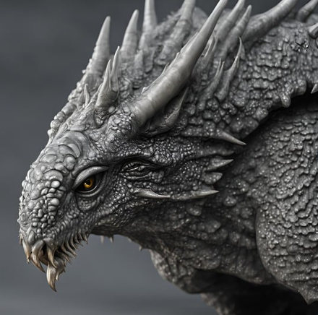
Fig. 7. Creature [11]
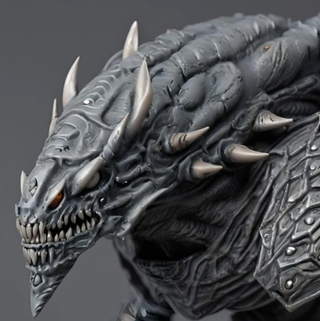
Fig. 8. Creature [11]
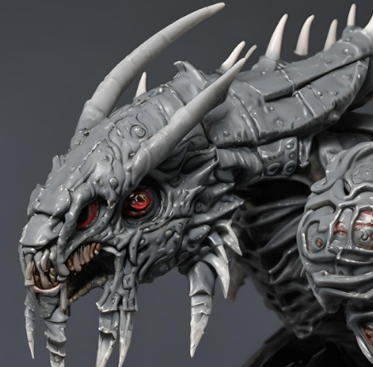
Fig. 9. Creature [11]

Level Design
Colonies will be randomly generated at the start of each game, with specific areas included by default. These are required in all colonies and allow all tasks to be available. They will never appear directly connected, and the Hive will be set to spawn as far from the main colony section as possible.
- Creature Hive (can only be one per colony)
- Operations Centre (can only be one per colony)
- Colony Living areas
- Power Room (can only be one per colony)
- Engineering (can only be one per colony)
- Medical Bay (can only be one per colony)
- Communications relay (can only be one per colony)
- Landing pad/bay (can only be one per colony)
Other areas that may spawn.
- Armoury (can only be one per colony)
- Security Office (can only be one per colony)
- Research Offices (can only be one per colony)
- Bar (can only be one per colony)
Connection points allow sections to be connected.
- Single Corridors
- T-Junctions
- Ventilation Ducts (Can be traversed via crouch/crawl up to Warrior creature sze)
- Corner Junctions
- Cross Junctions
- Double Width of above

The area's look will be run down, dark, and dingy; in some areas, lighting will be very limited. If the power goes out, there will only be dark red emergency lighting.

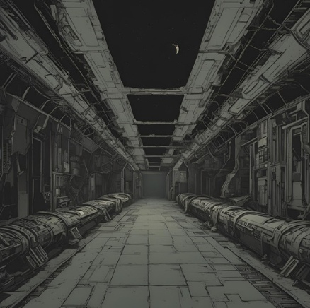
Fig. 10. Colony [11]

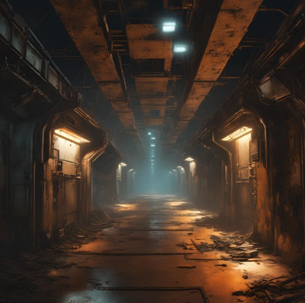
Fig. 11. Colony [11]

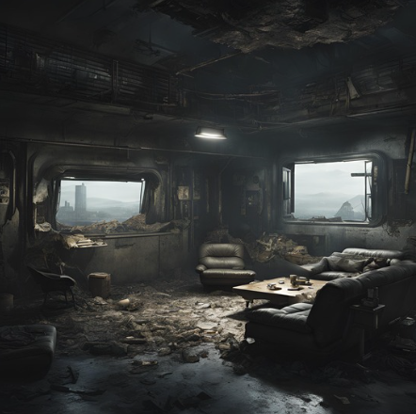
Fig. 12. Colony [11]

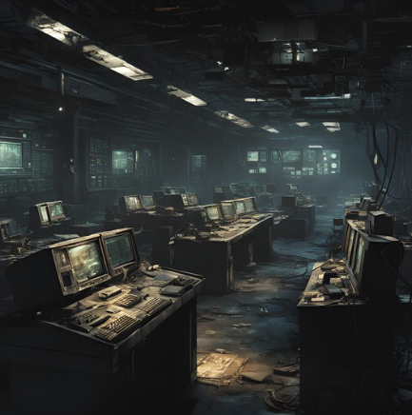
Fig. 13. Colony [11]

Gameplay

Colonist Loop
The loop for the colonists is simple: It’s all about surviving to try and carry your character onto the next colony, there is the addition of trying to rescue other colonists.

The main tasks will involve trying to contact rescue teams or escape shuttles.

Other tasks include collecting items to craft weapons and other items to help try and set up a safe zone, which can still be breached, it’s just a little harder for the creatures to do.

Surviving involves completing the tasks but also avoiding the creatures at all costs.
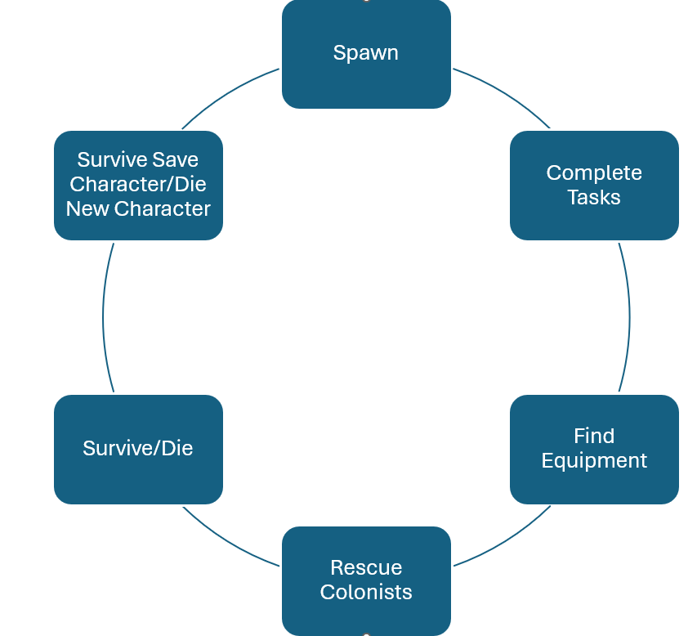
Fig. 14. Colonist Core Loop

Traitor Loop
Traitors have the addition of trying to cause issues with the colonists' escape.

Tasks will range from sabotaging colonists' work and activating systems to help the traitor escape.
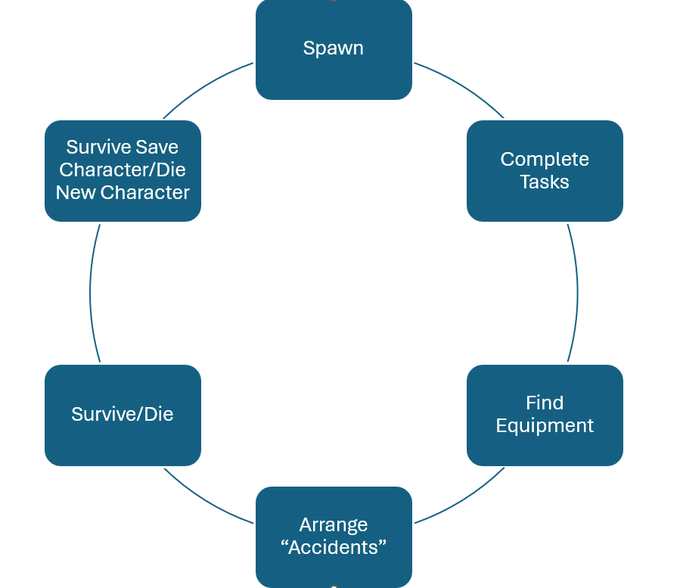
Fig. 15. Colonist Core Loop

Control Systems
Controls will primarily be mouse and keyboard.

Mouse 1 – Primary Equipped/interact with tasks
Mouse 2 – Zoom
Mouse 3 – Reload
Scroll – Change Equipment Slot
WASD – Movement
QE – Leaning
R – Interact
F – Throw
T – In-game Chat
LCtrl – Crouch
Z – Prone
LShift – Sprint
V – Local in-game VOIP
1234 – Equipment slots
Caps Lock – Walk/Run

Fig. 16. Mouse & Keyboard [11]

Hud
The HUD will be realistic with very little onscreen information out with a simple centre point acting as a reference for interactions/aiming.

- Health
  - Pulsing red border at the edge of the screen getting larger as health pool drops.
  - Blood drops running down the screen as health gets into a critical state.
- Stamina
  - Breathing gets heavier and louder
  - Not only signifying stamina is getting lower, the louder breathing can be picked up on by creatures if the player is attempting to hide.

Game Experience

Game Experience
The game will present as a survival horror where winning is not the norm for most players, players are going to experience fear from the outset from the main menu having dark orchestral music and the background showing a wrecked room with several dead colonists and if looked at closely players will see dark red eyes in the darkest area.

Upon entering the game players will realise this isn’t something that will be easy to survive with limited resources not a lot of light and the constant fear of any creatures looking for them and no way to defend themselves.

Menus
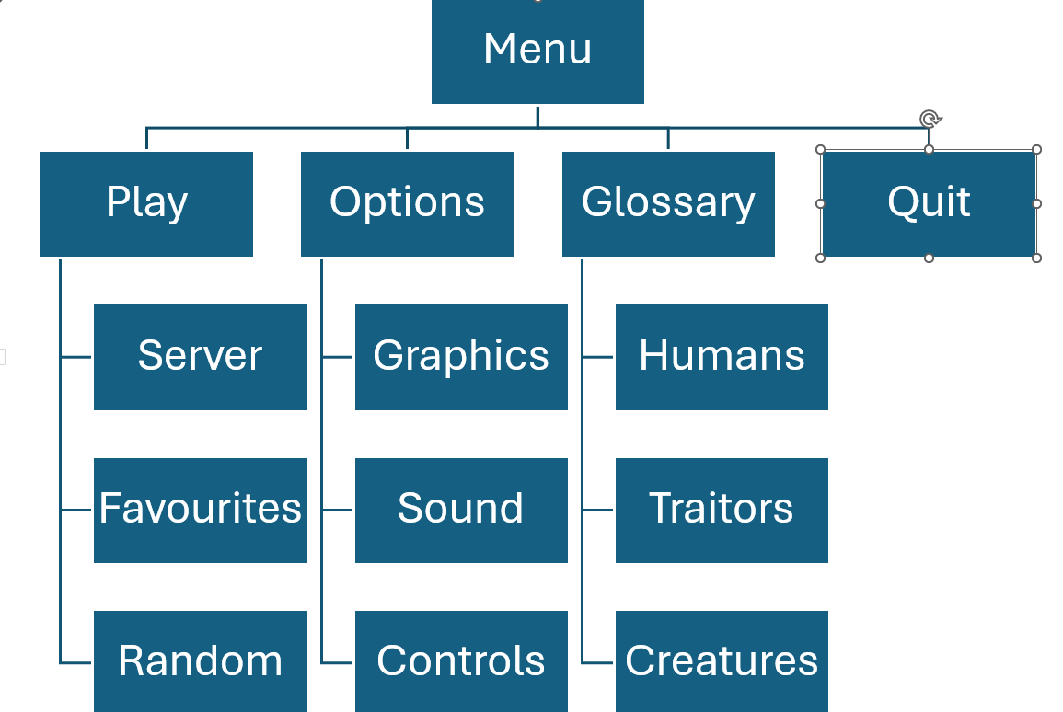
Fig. 17. Menu

Gameplay Mechanics

Mechanics
Name | Look | Effect | Availability
Fuel | Jerry Cans  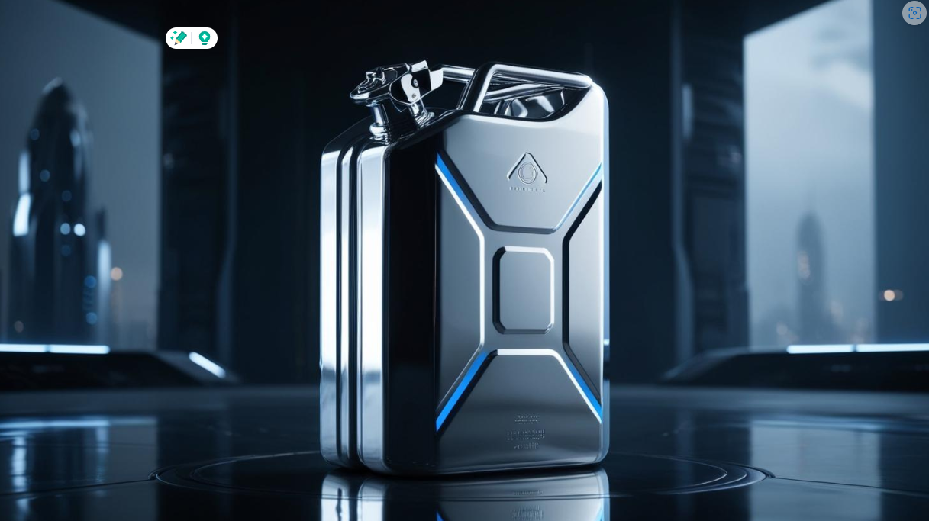  Fig. 27. Jerry Can [11] | Can be used to fuel different items, Power generators, Flame throwers etc | Can be found randomly throughout the colony, higher percentage in areas they would be found, garage, power room etc
Weapon Parts | Different parts of weapons, grips, barrels etc  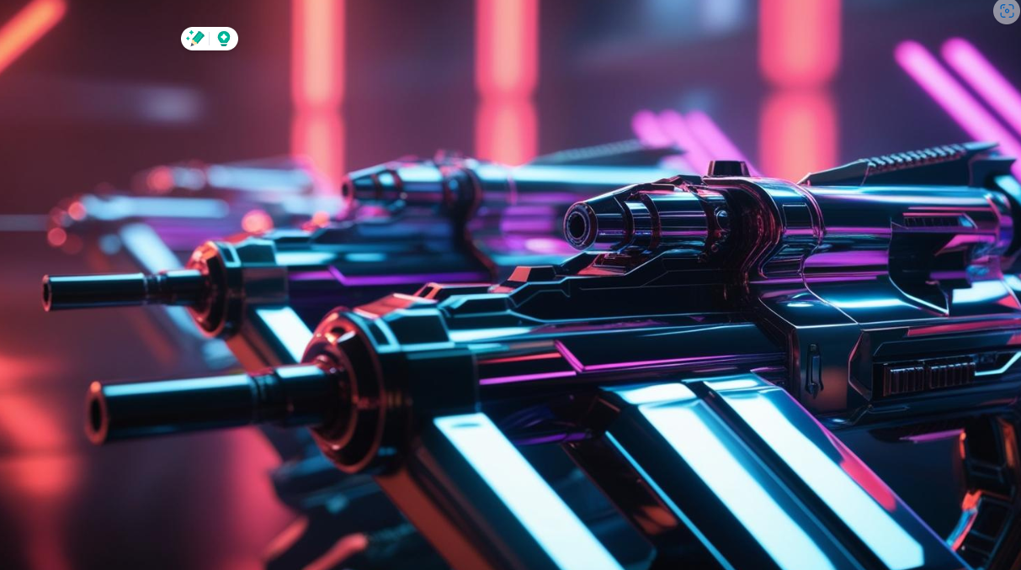  Fig. 28. Weapon Parts [11] | Can be used to craft diy weapons for defence | Can be found randomly throughout the colony, higher percentage in areas they would be found, armoury, security office.
Aid Kits | 1st Aid kits  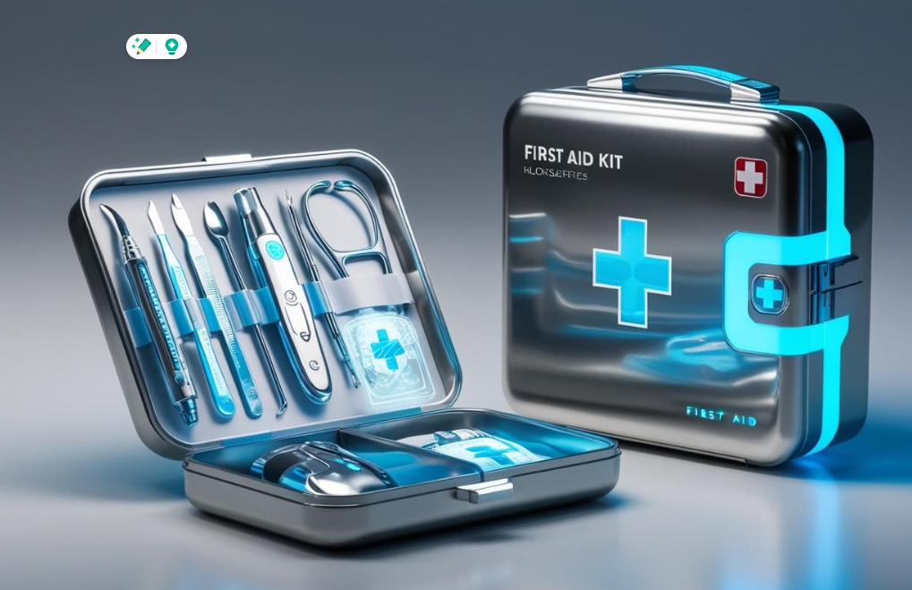  Fig. 29. First Aid Kits [11] | Can be used to heal colonists/traitors if they have suffered and injury. | Can be found randomly throughout the colony, higher percentage in areas they would be found, medical bay.
Tool Kits | Tool Kit    Fig. 30. Engineer Toolkit [11] | Can be used for various tasks that require tools, sealing doors repairing hardware(non electrical) | Can be found randomly throughout the colony, higher percentage in areas they would be found, engineering bay, garage.
Electrical Kits | Tool Kit with more electrical gubbins attached  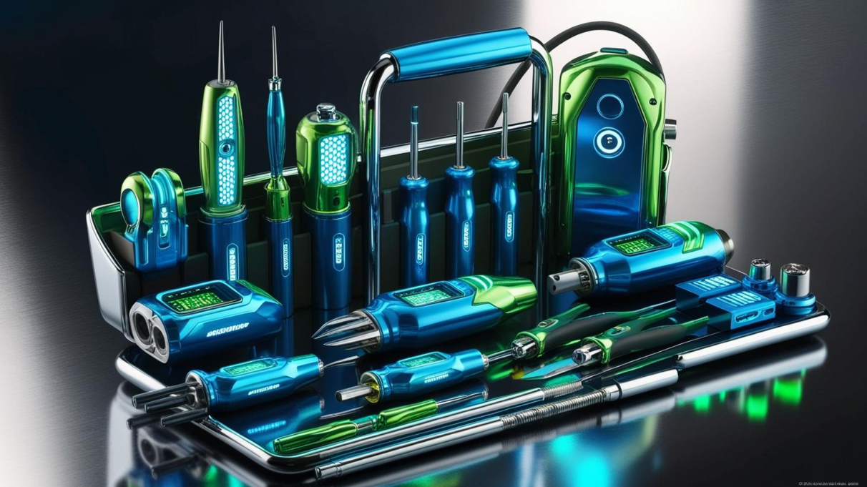  Fig. 31. Electrical ToolKit [11] | Can be used for various tasks that require electrical kits, fixing door panels, repairing light controls etc | Can be found randomly throughout the colony, higher percentage in areas they would be found, engineering bay,
Ammunition | Boxes of ammo  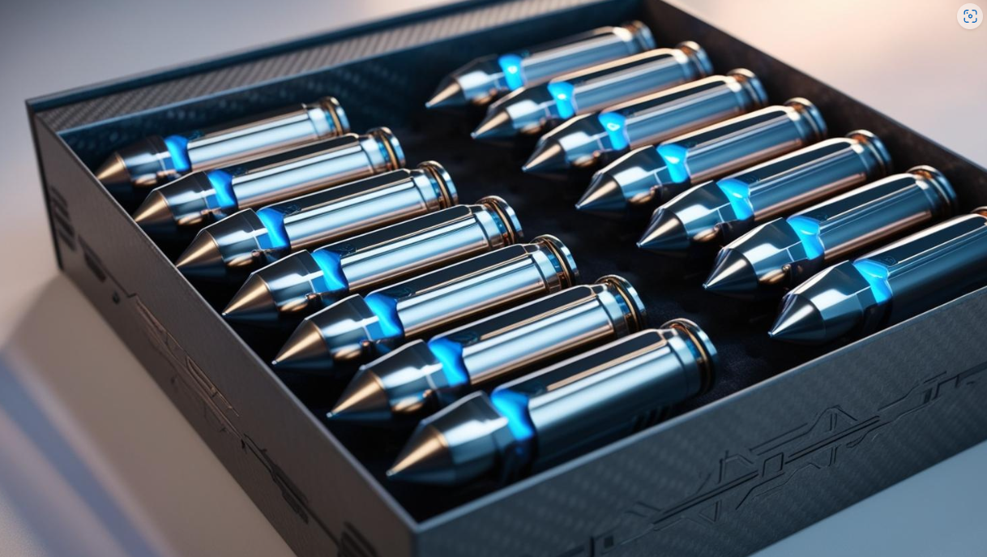  Fig. 32. Ammo Box [11] | Can be used to reload certain weapons | Can be found randomly throughout the colony, higher percentage in areas they would be found, armoury, security office.

Hazards
Name | Look | Effect | Availabilty
Exploding panels | Burst of electricity from different panels | Cause damage or death of player | Usually caused by a traitor tampering with panels
Creatures | As Described previously | Capture and kill players | When players are spotted
Gas | Green haze | Causes damage to players, players will cough which could attract creatures | Usually caused by traitor tampering with the generators or O2 generators

Tasks
Task | Requirement | Outcome
Seal Door Electrically | Electrical Tool Kit | Mini-game connecting cables correctly to seal the door from the panel, can still be forced open.
Weld Door | Welder | Mini-game setting welder settings and adjusting speed to weld the door correctly as an incorrect weld will not leave the door sealed for long.
Sabotage door panel | Electrical Tool Kit | Mini-game traitor cuts wires which will cause an overload when interacted with.

Cutscenes
There are only 2 endings and depending on whether the player survives or dies depends on what is played out.

Bad Ending
Camera slowly pans around the interior of the creature hive, showing several colonists lying dead.
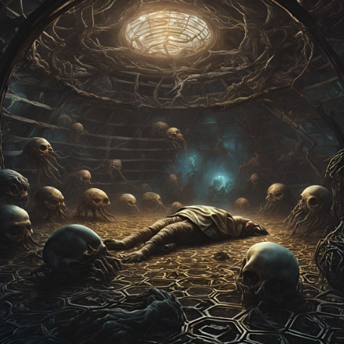
Fig. 18. Ending Bad [11]

Good Ending
Good ending is rare for most players so this should be something special, a starship escaping from the world cut to inside the colonists celebrating, cut to a creature on the outside of the ship slipping in through a plate of armour…. It’s never a win….

Fig. 19. Ending Good [11]


Fig. 20. Ending Good [11]

Additional

Bonus/Replay
Players will be incentivised to do the best they can to survive. If a player survives, they will get to add that colonist/traitor to a pool of saved characters that they can choose to use again.

They will be allowed, once they have saved a character, to change their look. They will also get a bonus selection of traits they can choose from, which will benefit the character in the next playthrough.

This is a massive incentive to try and survive each playthrough as players like to make characters their own and with the difficulty of surviving they will feel every win and loss and want to survive and feel invested in each character.

Future Content
We are not looking to divide the community with paid for DLC, additional creature hives with different variations on creatures, new rooms/level content/tasks, we also would like to add “The Rescue Party” DLC for those who are more interested in a more FPS action orientated experience, with the rescue party showing up after the events of a colony action, colony states will be saved and these will be uploaded for the rescue team to enter and complete their own tasks with the colony in the same state it was in when the colony players finished.,

Bibliography
[1] PEGI, “PEGI age ratings | Pegi Public Site,” Pegi.info, 2017. https://pegi.info/page/pegi-age-ratings (accessed Nov. 14, 2024).
[2] Alien: Isolation, [Software], Creative Assembly, Horsham, England, 2014.
[3] Call of Duty Modern Warfare 3, [Software], Infinity Ward, Woodland Hills, California, 2011.
[4] J. Cameron, Director, Aliens, [DVD], United States, Brandywine Productions, 1986.
[5] D. Espinosa, Director, Life, [DVD], California, Culver City, Columbia Pictures, 2017.
[6] J.Krasinski, Director, A Quiet Place, [DVD], California, Los Angeles, Platinum Dunes, 2018.
[7] Rimworld, [Software], Ludeon Studios, 2018.
[8] Among Us, [Software], Innersloth, 2018.
[9] C. Director, “Creative Assembly,” Creative-assembly.com, Sep. 07, 2024. https://www.creative-assembly.com/blog/were-continuing-journey-we-started-10-years-ago (accessed Nov. 12, 2024).
[10] SimAnt, [Software], Maxis, 1993.
[11] Canva, “Canva,” Canva, 2024. https://www.canva.com (accessed Dec. 07, 2024).
- Engineer colonist in the future dark dirty clothing with tools
- Creature grey armoured in grey chitin deep set eyes
- Run down colony corridor dark future
- Colony living area dark dirty future
- Colony main operations room dark future run down
- gaming Keyboard top down with mouse
- Human colonist lying dead in a hive in the future with creatures in the background lurking in the dark
- Future Spaceship leaving cloud covered planet
- Future colonists celebrating in a spaceship in space dark colours
- electricians toolkit future
- engineer toolkit future
- Future Jerry Can
- Weapon parts future
- Future First Aid Kit
- Box of future ammunition

[12] Windows, [Software], Microsoft, New Mexico, Albuquerque, 1975.
[13] MacOS, [Software], Apple, California, Cupertino, 1976.
[14] zukalous, “14 Reasons why every indie game developer should make at least one horror game – How To Market A Game,” Howtomarketagame.com, Oct. 02, 2023. https://howtomarketagame.com/2023/10/02/every-indie-game-developer-should-make-a-horror-game (accessed Dec. 09, 2024).
[15] Statista, “U.S.: horror film genre’s popularity by generation 2022 | Statista,” Statista, 2022. https://www.statista.com/statistics/1346792/popularity-horror-movie-genre-age-group-united-states (accessed Dec. 10, 2024).
[16] Left 4 Dead, [Software], Valve South, California, Lake Forest, 2008

