Potential benefits to the organization and individuals of developing individuals in workplace.

- Introduction
- Main findings
2.1Training and development
2.2motivetion
2.3Employees engagement

- Conclusion
- Personal development plan

1.0 Introduction
This report will critically evaluate benefits of development to the organization and individuals. It is important to invest in workforce development to sustain and improve the talents, knowledge and skills of both individual workers and the company as a whole.(Kuvaas & Dysvik,2009). One of today's most important issues facing companies is motivating the employees. The selection of suitable human resource practices is important as different claims have been made that the human resources of the organization are vital to the success of an organization. Amongst the most important roles of human resources management is employee development. Latest evidence indicates that high dedication to human resources policies, such as the growth of employees, influence organizational performance by influencing employee behaviors and attitudes. A main assumption in perceived investment in employee development is that it generates environments in which workers feel their organizations value their commitment and care for their career progression. (Lee and Bruvold, 2010) Performance management is the key to success of the employees and organization. In order to foster and grow the values, ideals, and competencies required to maintain their optimum results, high-performing organizations need efficient employee performance management systems. Performance management can be seen as a systemic mechanism by which an organization's overall performance can be enhanced by enhancing individuals' performance within a team setting. Via efforts to encourage high-performing staff, successful management of individual performance is a source of sustainable competitive advantage. The performance management framework must be used not only as an appraisal and measurement tool, but also as a strategic tool for an organization to accomplish this. In this way, for individual happiness, engagement and objective achievement, there will be a systematic review of success at operational processes and individual levels. (Sahoo, Mishra, 2012). To measure how business is performing useful tools like KPI’s Key performance indicators can be use to help solving operational problems of organization. Nowadays, most organizations are spending a lot of money in the training and development of workers in order to stay competitive and effective in the organisation. The value of employee training is increasing quickly and companies are using this method to compete with their industry rivals. Training and development builds employees motivation to work thought personal growth witch benefits both sides workers and employers.( Jehanzeb, Bashir,2013).

2.0 Literature Review

2.2 Training and development
Training exercises have reported evidence that they have a significant influence on people and teams' results. Training can also benefit from other findings at both individual and organization level like attitudes, rewards and empowerment, for example( Aguinis, Kraiger,2009). Mel Kleiman (2000) identified the key components of a quality employee training program as being built on the orientation, management strategies and leadership skills of employees. These concepts provided the foundation of any staff development programme. Janet Kottke (1999) pointed to the need for employee development programs It encompasses, along with the domains of knowledge, an effective framework within which companies develop their businesses on a business level. The principle of the idea is intelligence, teamwork, creative thinking and problem solving. Jehanzeb, Bashir 2013 says that there's no structured process for the development of employee training, however important the particular methods that would evaluate it. The combination of knowledge, career growth and goal-setting will be the ideal employee training and development programme. These methods would help the system, which will make it more beneficial for workers and the company. Information and knowledge systems are fast moving forward, and these witch companies cannot provide their employees with up-to-date information technology knowledge that they will struggle to survive. Employees must be granted new job training in order to be able to deal with the new task quickly. It should be the duty of the company to ensure that workers have expertise, skills and capabilities, and that these skills must be in line with the level of work needed. Moreover, when workers need the required skills and knowledge, which must be given to them in a timely manner without delay. As a result, companies have made a commitment to make sure that employees can learn whenever they need it. Organizations required Internet and machine learning segments to achieve this aim. The primary reason for career development as a number of the employee training program isn't really to encourage employees to think that their companies are funding their careers, but also to consider the fact that they help employees manage the unique attributes of their lives and provide a clear path of promotion. Organizations can not make promises to workers about their job security, but they provide them with opportunity to expand their knowledge and skills so that they can stay on the job market. (Moses 1999).
Workers surely benefit from the employee training and development plan. They study the soft and technical skills needed for their work. For the past 30 years, unemployment has been at its lowest rate, which is not advantageous for employees to start new jobs if growth prospects are limited. (Dobbs 2000). New graduate students are often interested in a company that offers rigorous training services to its employees, but can bring some risk to company as my loos the new recruits after providing them opportunity of training because as they trained they will be looking for a better options on the market. (Feldman 2000).To make sure that training and development benefit both parties the employees and employers and is essential to achieving organizational goals, it needs to be pursued carefully, in the early twenty-first century human resource managers argued that one of the key issues they face was training concerns and development. (Stavrou, Brewster and Charalambous 2004)
According to Jehanzeb, Bashirm the main benefits from training and development for organization is Organizational Performance, Employee Retention and market growth.

Sung and Choi says that by creating a comprehensive environment that encourages and promotes learning, training and development investments provide the basis for the preparation and initiation of learning and knowledge management within organizations. Such an operational context allows workers to partake in a range of organizational educational process, such as information suggestion systems and cross-functional task forces, to discuss pressing organizational challenges. These performance standards are wider in nature than interpersonal learning at the dyad or small group level, further promoting the exchange of information across roles and hierarchical levels within an organisation. Such information exchange significantly improves the capacity of workers to reach and learn applicable knowledge across different parts of the enterprise, which can promote corporate creativity. Such information sharing significantly improves the ability of workers to access and learn applicable knowledge across a wide variety of subjects.
Organizational segments that can promote organizational creativity. In fact, professional development strategies allow workers to do so.
Take an active part in the product development by encouraging them to consider training and knowledge generation as part of the employment obligations and to change the status quo rather than automatically acknowledge it.(Sung& Choi,2014)

2.3Motivation
Motivation has big impact on how employees engage at work. Maslow hierarchy of needs applied to employee engagement theory shows that there is a very clear picture indicates how the motivation has impacting on the way how employees are working. Survival and security is not enough for employees, hight tears need to be achieve belonging where works an almost engaged, importance where employee shows engagement and the hights part self-actualisation where employees show hight engagement in to his organization and where the productivity is reaching the hights part, where the loyalty is build. According to (Jehanzeb, Bashir 2013) loyalty to a company can not always be measured, but it is essential for employees to feel rewarded personally. The employee feels relaxed and wants to stay in the business when he feels his commitment and expertise are put into the profits of the company. Employees who are pleased about their job believes that their job has a meaning and is vital to their business. Wagner says that typically, those who leave the job are not the best employees, for those witch are usually stay the finance part is not always most important. While salary and bonuses play an very important role in employee selection and retention, workers often see chances for professional development, face diverse roles, and explore personal and professional growth, and opportunities. Increase among workers in self-confidence self-esteem and work satisfaction is for them more important then just earning money. (Wagner 2000).

Solomon Markos in his article is referring to Penna,2007 , that purpose at workplace has the prove to be a great way of getting employers and workers closely together to help both where employees feel a sense of belonging, the ability to express themselves freely, the ability to make a contribution, they find meaning. Employees are motivated in organisations where they can find enjoyment at work. Researcher have also come up with some new concept called "Hierarchy of Engagement" that illustrates Maslow's use for a hierarchy model of engagement . There are basic needs for wages and benefits in the bottom line. When the employee meets these needs, the employee looks at growth prospects, the likelihood of advancement and then the style of leadership can be incorporated into the model mix. Finally, after all of the above-mentioned lower-level expectations have been fulfilled, the employee looks at the balance of the value-meaning, which is illustrated by a true sense of relation, a mutual purpose and a shared sense of meaning at work(Markos, Sridevi,2010)
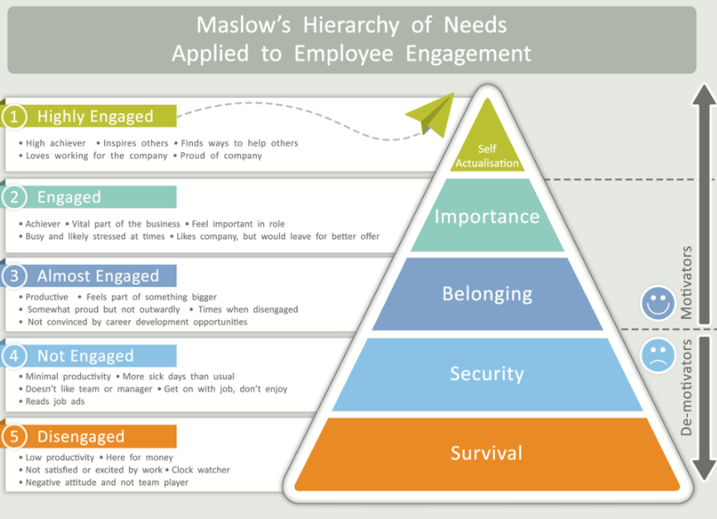

2.3 Employee engagement
“A workplace approach designed to ensure that employees are committed to their organisation’s goals and values, motivated to contribute to organisational success, and are able at the same time to enhance their own sense of well-being.” (MacLeod and Clarke, 2009, 9) Robinson et al. (2004) define employee engagement as “a positive attitude held by the employee towards the organization and its value. An engaged employee is aware of business context, and works with colleagues to improve performance within the job for the benefit of the organization. The organization must work to develop and nurture engagement, which requires a two-way relationship between employer and employee.”
The pinion and description submitted by the Institute of Employment Studies, it is evident that employee engagement is the product of a two-way partnership involving employer and employee, which points out why there are questions to be answered from both parties. According to

3.0 Conclusion
Happiness of employees seems to be the secret to any company's success. If the workers are happy, the clients will be satisfied and the organisational level performance will improve. (Bhatti, Awan, Razaq 2013)

4.0 Task 2
Personal development plan for logistic company supervisor
Objective/Area Of Development | Measures/methods | Priority | Support/ Development | Review Date | Other Comments
Time manging | -scheduling ahead  -Making task agenda | mediun | -Supervision form line manger | 20.12.2020
Operation System training | -learning how to operate delivery system,  -managing drivers routs  - | hight | -training provided by company  -support form line manager, open line regarding any problems. | 14.12.2020
Expanding company | -creating recruitment adverts  -scheduling interviews  -helping line manager with recruiting candidates | medium | -access to recruitment website  - HR support  -Training on recruitment system | 20.01.2021
Problem solving | -making sure that daily issues which will have impact on delivery operations are solved | hight | -Training  -support form line manger  -support from operation team | 14.12.2020
The supervisor needs to learn how to use operation system, this is a high priority as is necessary toot to work, the operations based on it and without knowledge, the supervisor can not do this job. The company will provide training of how to operate this system.

- Aguinis and Kurt Kraiger 2009, Benefits of Training and Development for Individuals and Teams, Organizations, and Society Herman
- Mel Kleiman (2000, January). What happens if you don’t train them and they stay? Occupational Health and Safety, 69 (1), pp. 18, 70
- Wagner, S. (2000, August). Retention: Finders, keepers. Training and Development, 54 (8), 64.
- Kottke, J. L. (1999). Corporate universities: Lessons in building a world-class work force (revised). Personnel Psychology, 52, 530-533.320.
- . Stavrou, E., Brewster, C., and Charalambous, C. (2004), ‘Human Resource Management as a Competitive Tool in Europe,’ working paper, London: Henley College
- Moses, B. (1999, February 1). Career planning mirrors social change. The Globe and Mail [On-Line]. Retrieved January 18, 2001 from the World Wide Web: http://www.bbmcareerdev.com/careerplan.html
- Feldman, D. (2000, May). The Dilbert syndrome: How employee cynicism about ineffective management is changing the nature of careers in organizations. American Behavioral Scientist, 43, 1286-1301.
- Sun Young Sung And Jin Nam Choi, Do Organizations Spend Wisely On Employees? Effects Of Training And Development Investments On Learning And Innovation In Organizations. Journal Of Organizational Behavior, J. Organiz. Behav. 35, 393–412 (2014)
- M. Ishaq Bhatti · H. M. Awan · Z. Razaq, 23 November 2013, The key performance indicators (KPIs) and their impact on overall organizational performance
- Robinson D., Perryman S., and Hayday S. (2004). The Drivers of Employee Engagement Report 408, Institute for Employment Studies, UK
- Solomon Markos, M. Sandhya Sridevi International Journal of Business and Management Vol. 5, No. 12; December 20107

- Chay Hoon Lee &Norman T. Bruvold, 17 May 2010, Creating value for employees: investment in employee development, Pages 981-1000
- Khawaja Jehanzeb, Dr. Nadeem Ahmed Bashir, Training and Development Program and its Benefits to Employee and Organization: A Conceptual Study, European Journal of Business and Management, Vol.5, No.2, 2013
- C.K. Sahoo, Sukanta Mishra, (2012),"Performance management benefits organizations and their employees", Human Resource Management International Digest, Vol. 20 Iss: 6 pp. 3 - 5

