Task 1: Locating Sources
Identify and locate three different sources (a report, a journal article, and a website) related to the question
“What employability skills do business graduates need to succeed in the modern workplace?”
Show how you used keywords, search terms, and Boolean operators to find them, and explain how you know which type of source each one is and why it is appropriate for the research question.

Source Type & Why It Is Appropriate | URL/DOI | What search engine did you use? Google/Online Library/Library AI Assistant | Keywords/Boolean Operators Used
Article. This article is relevant cause it talks about whether the skills we learn are useful | https://librarysearch.uwtsd.ac.uk/permalink/44WHELF_UWTSD/oc9jb5/cdi_doaj_primary_oai_doaj_org_article_9bebbaa8320d4ae484fbf17794b3a7e5 | Online library | Employability skills, success, and business
Book. Useful guide book regarding skills for business students and employment | https://librarysearch.uwtsd.ac.uk/permalink/44WHELF_UWTSD/18o90jg/alma99100433101902421 | Online library | Business skills, employability

Task 2: Evaluating Information (CRAAP Test)
Your colleague has forwarded you a source from a peer reviewed journal, and they are not sure whether it is appropriate to use and has asked for your help. Your task is to evaluate the source by using the CRAAP Test to assess its appropriateness.
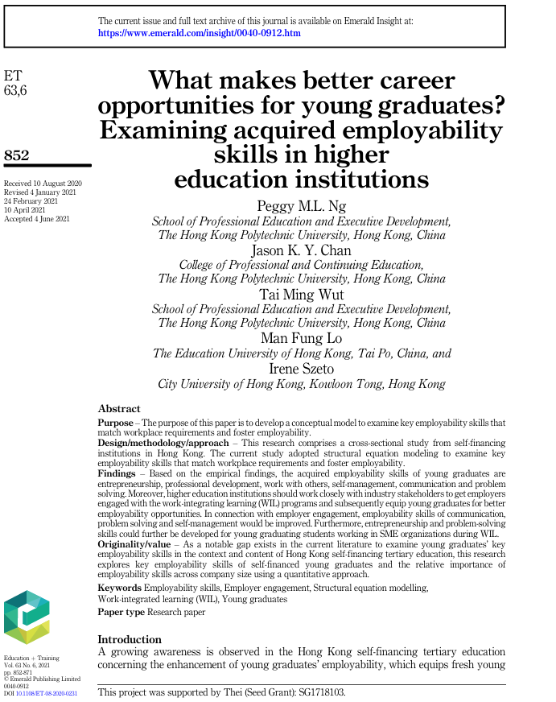

CRAAP Test
Currency | I deem this article current because it was made in 2023, only 3 years ago
Relevance | This article tries to talk about whether the skills pre-graduates learn will actually help them with employment in their field, the field being business
Authority | This article has been written by Rubio-Andrés, Mercedes ; Ramos-González, María del Mar ; Molina-López, Manuel M. ; Sastre-Castillo, Miguel Ángel
Accuracy | The article talks about how the competitiveness when it comes to the skills a students has accumulated actually aids in finding the right candidate for a position, and it affirms worries that acquiring the skills might be a waste of time. A student who has learned many different skills find it easier to successfully in a competitive and difficult labour market
Purpose | The purpose of the article is to try to inform students about their skills and education being worth it when it comes to pursuing a role in business

Task 3: Source Analysis
Your manager has provided you with a short extract from a source and has asked you to analyse the source by Identifying one strength, one weakness, and providing a brief explanation of the strength and weakness identified.
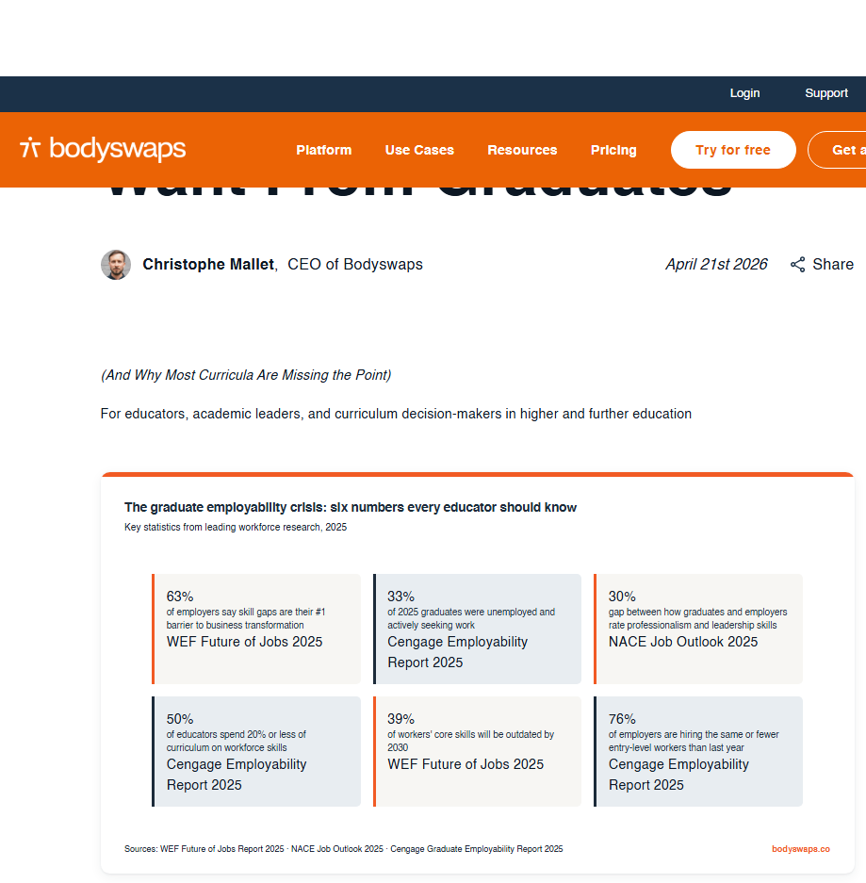
.

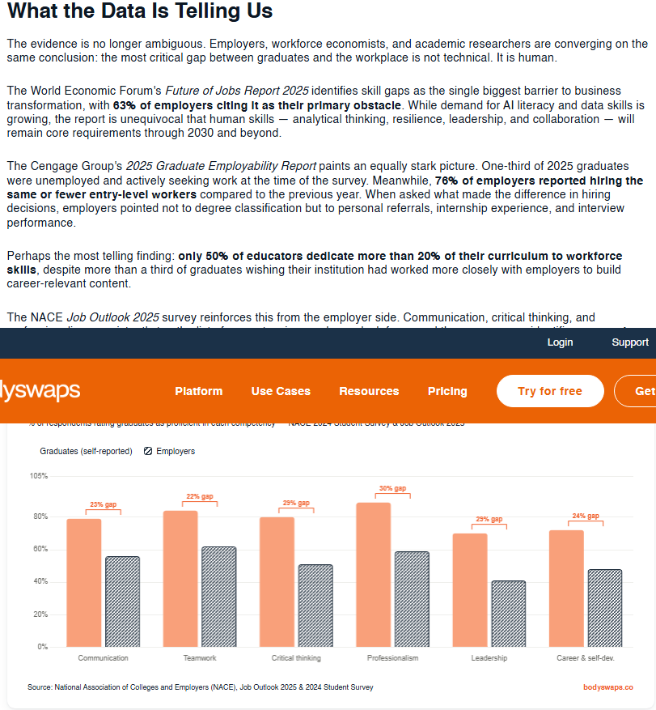

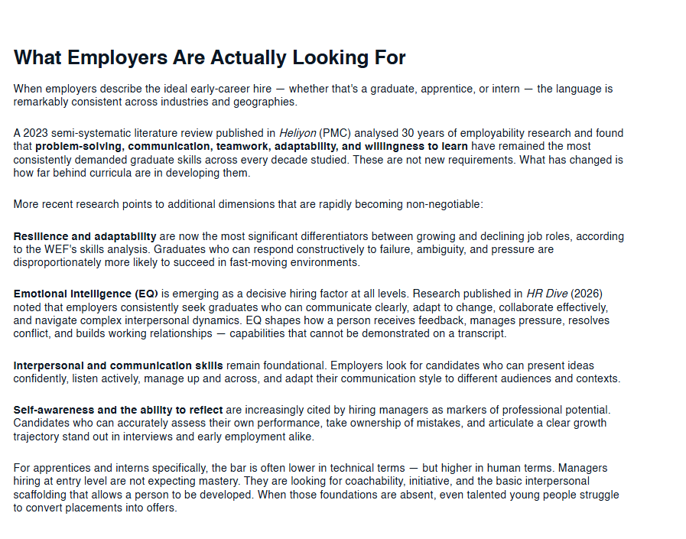

Please click the link, if you wish to read the article online.
What Employers Actually Want From Graduates

Strength of the Source:

The source is quite good at calming a student’s, like myself, worries about the time theyre spending these skills and whether it will lead to a desired outcome. I personally enjoy how it talks about how it drives people to be more competitive and acquire more skills because it only makes things easier

Weakness of the Source:

I do feel as though the article is quite short and that is for me a weakness even it does have a good effect on the reader and their doubts regarding what they’re spending so much time on in education

