

Construction Management
Assignment 1
Programme Control

By Benjamin Davies (2012775)
Submitted on 26/01/24

Table of Contents Page Number

1.0 Introduction 3

2.0 Kingsway Construction 4

3.0 Gantt Chart 5

4.0 Cost, Time and Resources 6-9

5.0 Performance and Incentivisation 10

6.0 Delay 11-12

7.0 Reference List 13

1.0 Introduction
Construction management is an important discipline that ensures successful execution of construction projects. At its core, construction management involves a strategic orchestration of various elements, from project planning and budgeting to quality control and safety compliance. The role of construction managers is harmonizing the efforts of architects, engineers, contractors, and other stakeholders to ensure efficient construction processes. With a focus on time management, resource allocation, and risk mitigation, construction managers navigate the complexities of the construction landscape. (Gausch, K, 2022)
Their expertise is instrumental in transforming blueprints into tangible structures, all while adhering to regulatory standards and client expectations, construction management is the adhesive that binds vision to reality in the dynamic world of construction projects.
Gantt charts are invaluable tools in construction management due to their ability to visually represent tasks, timescales, and interdependencies. These charts offer a comprehensive overview of project schedules, aiding in effective planning and resource allocation. (Mind Tools Content Team,2022)
By assigning durations to tasks and monitoring progress, project managers can track project timelines and identify potential delays promptly.
Gantt charts also enhance communication and collaboration among team members, stakeholders, and clients, as they provide a clear visual representation of project milestones. Additionally, these charts facilitate risk management by highlighting critical paths and potential bottlenecks, allowing project managers to proactively address issues and ensure the smooth progression of the project.

2.0 Kingsway Construction
You are to assume that UWTSD has received planning consent for a new mixed use / office development in The Kingsway, Swansea.
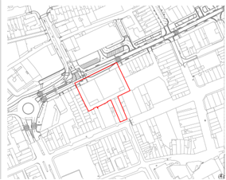
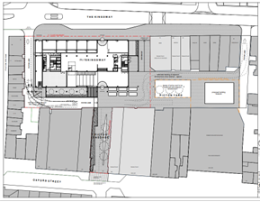
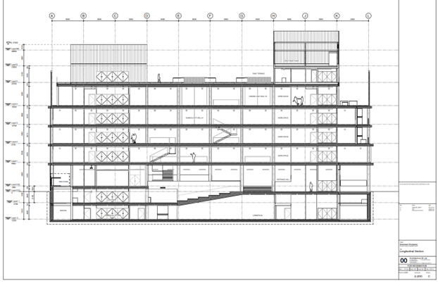

2.0 Gantt Chart
The Gantt chart shows the general construction of the building from the planning stage to project completion. The Gantt chart was created using MS project which starts with the contracts stage and ends with project handover and completion. The specific element that has been chosen is the site preparation phase which is shown below.
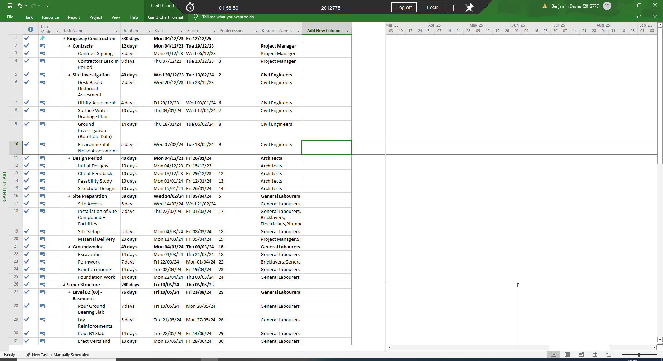

Different types of workers have been assigned tasks on the project which in this case specifically are the Project Manager, Site Managers, General labourers, Bricklayers, Electricians, and Plumbers.
Overall, the site preparation phase takes 38 days to complete starting with site access which is done by the labourers and organised by the site manager, followed by the installation of the site compound and facilities which uses labourers, bricklayers, electricians and plumbers, followed by site setup which is done by the labourers and finishing with the material delivery phase in which the project manager and site manager arrange for the materials to arrive, this stage takes the longest with 20 days due to the amount of materials needed for the project.
These tasks also show a critical path, the critical path is the sequence of tasks or activities that must be completed on time for the entire project to finish on schedule. It is the longest path through the project network diagram, where the duration of each task is summed up to determine the total project duration. For the site Preparation phase the critical path is as shown below.
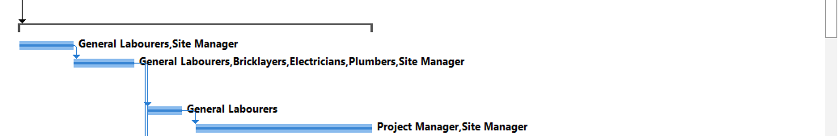

3.0 Time, Cost and Resources

Time
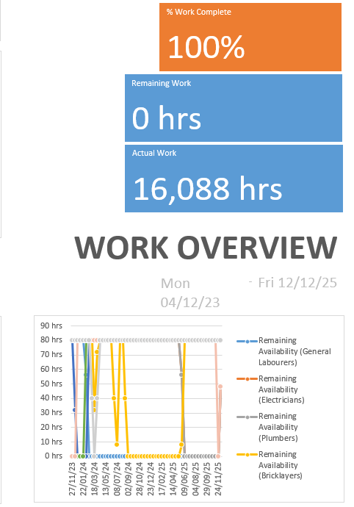
This Graph Shows the proposed work running from 04/12/23 to 12/12/2025, which is 530 days and requires 16,088 hours of work from the different workers on the projects. It also shows the availability of each worker which is very useful and must be accounted for.

Cost
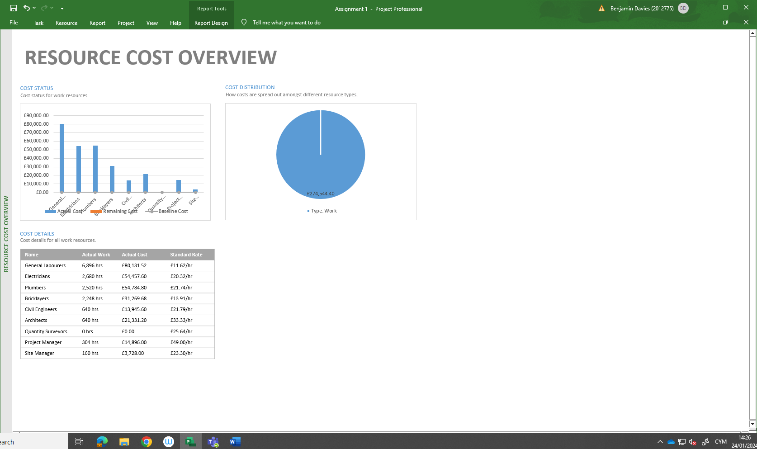
The resource cost report is based on the hourly rate of each worker, these figures will go towards calculating the final cost of the project, the hourly rates were calculated using the average hourly salary of each profession in 2023.

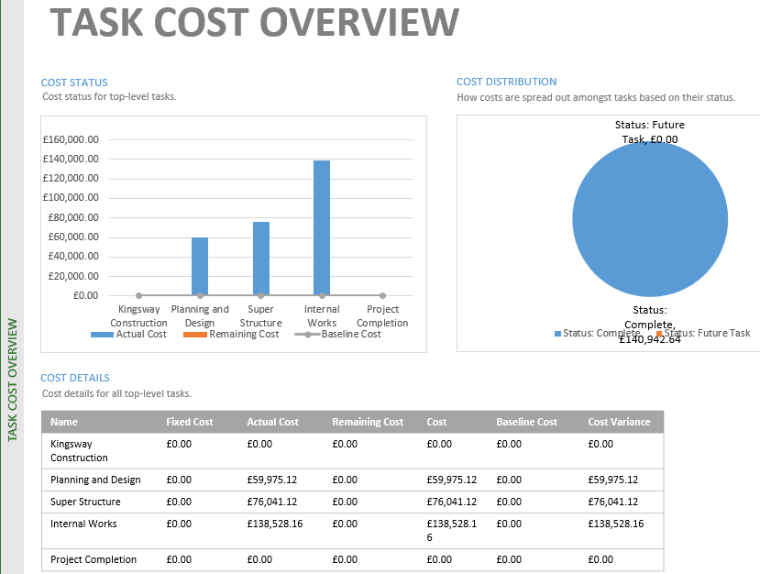

This Report shows the costs per task, the highest costing sector is the internal works which costs £138,528.16, this is due to the number of different resources needed on the task. This overview is important when designing and constructing a building, as you need accurate cost estimations, these estimations are based on a forecast of the resources and associated costs that are needed to complete the project, this ensures all project objectives are completed within budget and within the timescales.

Resources
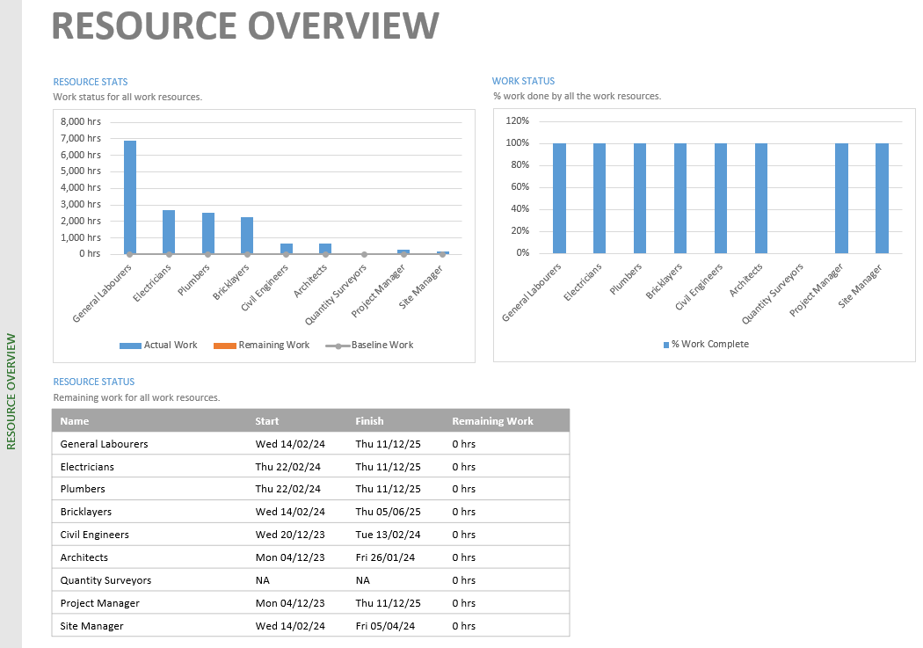
This table is the resource overview which is a table on the working hours of each profession involved in the project. Understanding the availability and allocation of resources is important for successful project execution. A detailed overview of the workforce enables project managers to assess the skills, expertise, and availability of team members.

4.0 Performance and Incentivisation
Good workforce performance is key in completing a construction project and incentivization is vital in empowering a workforce. Incentives act as motivators, serving to channel the efforts of individuals and teams towards heightened performances. By rewarding exemplary work, organisations create a sense of recognition for individual accomplishments that inspires others to strive for excellence in their work. (Utilities One,n.d.)
Incentives contribute to goals, ensuring that employees understand the connection between their contributions and company objectives. This alignment creates a sense of purpose and commitment within the workforce, driving them to work collaboratively and with increased dedication.
Incentives serve as effective tools for employee morale, as employees are more likely to stay engaged and satisfied when their efforts are acknowledged and rewarded. (Anon, 2023)
Ways of doing this is regular performance feedback and coaching sessions that can be implemented to provide constructive insights and guidance to team members, creating an environment of continuous improvement.
Incentives can be financial or non-financial, we could create friendly competition, some example incentives we can set are being on time to site, helpfulness towards colleagues, completing work on time and solving problems. (Construction Business Owner Magazine, 2023)
Additionally, targeted training and skill development programs can address specific competency gaps identified through performance assessments, ensuring that the team is equipped with the necessary tools for success.
By combining these strategies, companies can create a positive and proactive work culture that not only addresses performance issues but also cultivates an environment conducive to sustained productivity and success.

5.0 There is a strike by the local concrete company which is set to begin on the first day you require concrete. The strike is due to last 5 weeks. Show how this affects the project within the report addressed to the client and how is it generally dealt with from a contractual point of view.
In most construction contracts, you are provided with additional time for delays which are attributed to the owner. If the delay is caused by the contractor, then the owner is entitled to receive liquidated damages which are stipulated under the contract, the contractor is then entitled to receive a time extension without any additional compensation.
In general, Contracts don’t cover all types of delays, however most will contain clauses based on timely completion of work under contract, it is regarded that time is of the essence which indicates that the contractor is obligated to complete work in a timely manner.(Waters, J, 2022)
The New Engineering Contract, including NEC3 and NEC4, incorporates a comprehensive approach to delays within construction management. They include an Early Warning System encouraging proactive communication of potential issues, a system of Compensation Events for addressing delays caused by specified events, time extensions for affected project completion dates, fair risk allocation between parties, and dispute resolution mechanisms like adjudication. Specific clauses related to delays may vary based on the form of the NEC contract and options selected within it, emphasizing the need for careful review and legal consideration to understand how delays are managed in each contractual arrangement. (A Lamb Associates, 2021)
In this situation the concrete company has gone on strike which has affected timescales within the project starting with pouring of the ground bearing slab. To work around this issue, we had to wait out the strike but when we start the super structure, we needed to have more workforce to recover time and to ensure no more delays. The concrete company and contractor will need to liase to discuss compensation as this is a compensation event as the concrete company are at fault.
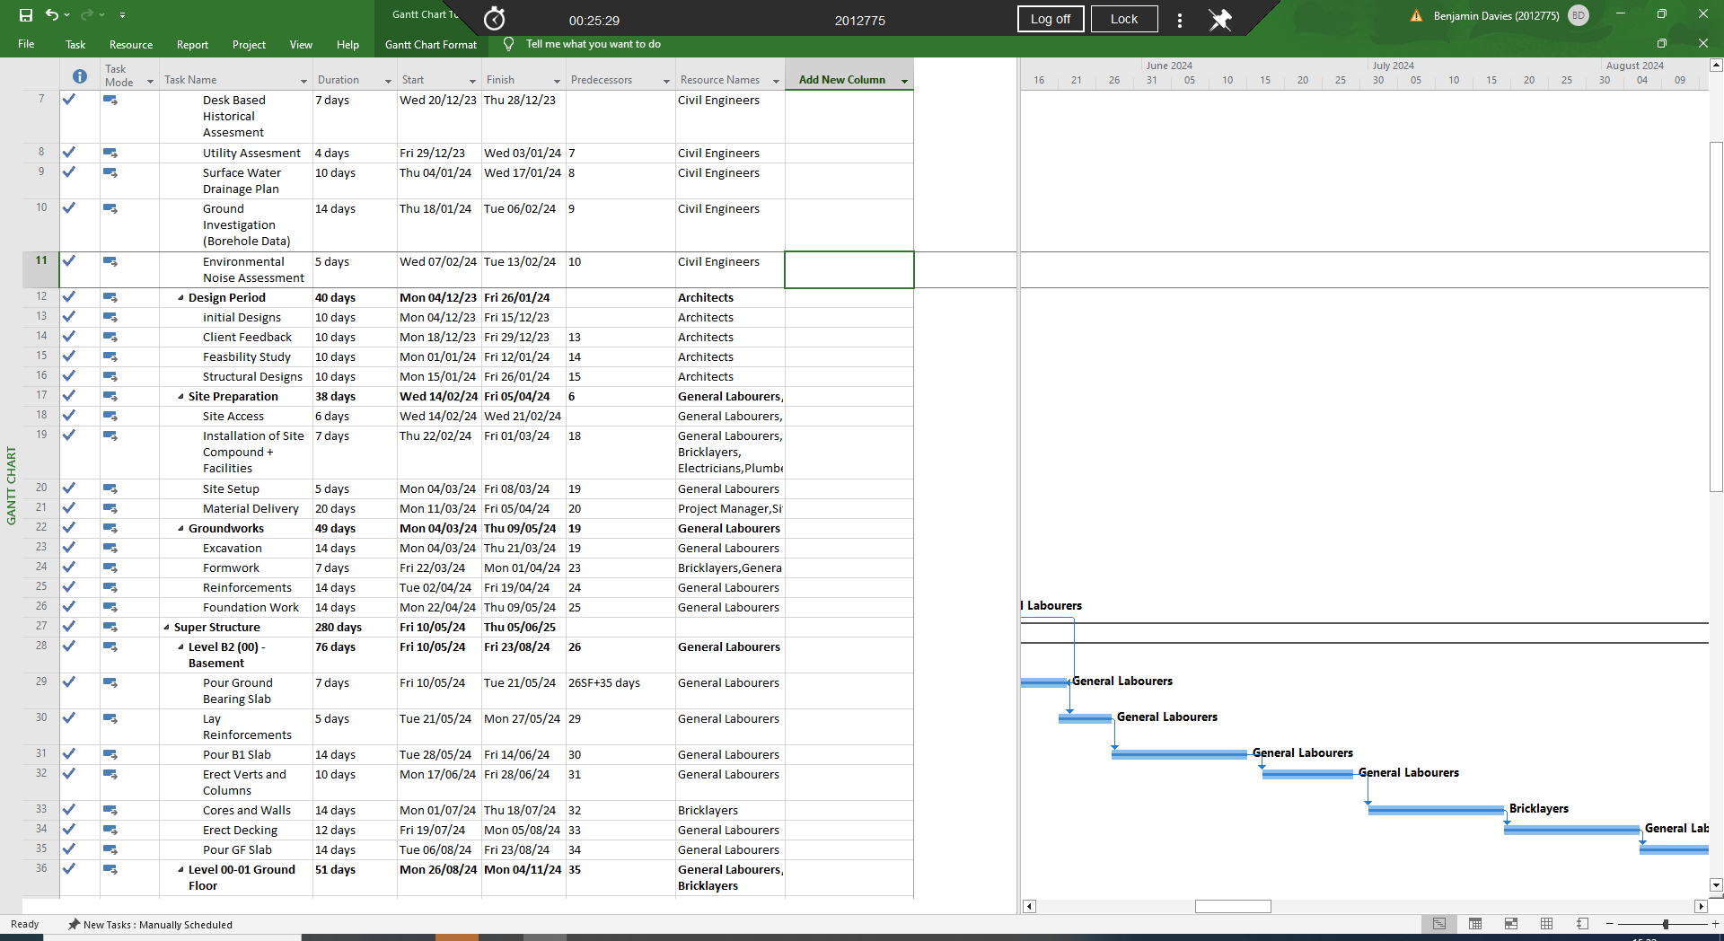

6.0 Reference List

Gausch, K. (2022). Construction Management: Benefits and Functions. [online] SafetyCulture. Available at: https://safetyculture.com/topics/construction-management/

Mind Tools Content Team (2022). MindTools | Home. [online] www.mindtools.com. Available at: https://www.mindtools.com/aktsij3/gantt-chart

Utilities One. (n.d.). The Benefits of Safety Incentive Programs on Construction Sites. [online] Available at: https://utilitiesone.com/the-benefits-of-safety-incentive-programs-on-construction-sites

Anon, (2023). How to create a successful incentive plan for construction workers. [online] Available at: https://ourlinq.com/blog/how-to-create-a-successful-incentive-plan-for-construction-workers

Construction Business Owner Magazine. (2023). Pay & Performance Incentives That Work. [online] Available at: https://www.constructionbusinessowner.com/business-management/pay-performance-incentives-work.

Waters, J. (2022). Delay Claims In Construction: A Quick Overview Guide. [online] Helix Law. Available at: https://helix-law.co.uk/construction-delay-claims/#:~:text=Types%20of%20Construction%20Delay&text=How%20the%20delay%20is%20classified

(A Lamb Associates, 2021)
https://www.alambassociates.com/nec3-vs-nec4-whats-changed/#:~:text=Under%20the%20NEC3%2C%20the%20contractor,payment%20application%20to%20the%20Client.

