
Amazon Knowledge Management System AWS Leader on the Market
[Document subtitle]
Verginica Caracas (1906795) | 7/2/21 | Knowledge and Information Skills for the Workplace (BMSW5106_SWAN)

Table of contents

- Introduction………………………………………… 2
- Organisational Profile Of Amazon………………. 3
- SWOT Analysis of Amazon`s Knowledge Management System………………………………. 4
- Critical Evaluation of Amazon`s Knowledge
Management System…………………………. 7
- Conclusion………………………………………….12
- Recommendations………….………………………12
- References………………………………………… 13

- Introduction
This report aims to analyse and evaluate the Knowledge Management System at Amazon.
Knowledge is a term that was theoretically studied by philosophers millennia ago. Aristotle (348-322 BC): “Knowledge is the source of power and development…” It was not until the 13th century, with the advent of craft guilds, that knowledge became more practice (Wiig,1999)
1970s: Information and knowledge were seen as organisational resources. 1980s: Knowledge is addressed in articles and journals as a competitive factor that helps one organization differentiate itself from others.
1990s: The International Knowledge Management Network (IKMN) went online (1994)
Knowledge Management became a business.

Starting from the previous definitions:
"the coordination and exploitation of organizational knowledge resources, in order to create benefit and competitive advantage" (Drucker, 1999).
"is managing the corporation's knowledge through a systematically and organizationally specified process for acquiring, organizing, sustaining, applying, sharing and renewing both the tacit and explicit knowledge of employees to enhance organizational performance and create value." (Davenport & Prusak, 2000)
KM Tools defines "Knowledge Management is the systematic management of an organization's knowledge assets for the purpose of creating value and meeting tactical & strategic requirements; it consists of the initiatives, processes, strategies, and systems that sustain and enhance the storage, assessment, sharing, refinement, and creation of knowledge. " (2018)

Data represents facts, simple observations, raw numbers, or words without context. data becomes Information after 5 C`s process: contextualized, categorized, calculated, corrected, and condensed. Information represents the Data transposed in a significant context having a few characteristics: availability, accuracy, relevance, and completeness. Knowledge means the conscious and understood information acquired through experience. Knowledge is not transmitted but requires learning because it is based on individual values, perceptions and experiences.

Nowadays, capitalizing on knowledge in an organization is fundamental in today's economy. Knowledge management leads to the performance of the organization, as well as to the prosperity of the clients, it helps to communicate and collaborate between all the stakeholders of an organisation.

- Organisational Profile of Amazon
Amazon.com is one of the world’s most successful eCommerce companies. Amazon started in 1994 in Jeff Bezos 'garage as an online bookstore, with Bezos' desire to create an online community, "a whole store." (Stone, 2018) Bezos had "a vision for the company's explosive growth and dominance of e-commerce." (Hartmans, 2021)
The company went public in 1997. From day one, Amazon's shares rose from $ 18 / share to $ 24 at the end of the day. In the same year, Bezos added movies and music to its sales offer. (Armstrong, 2009)
In 1998, Amazon became an international company, opening the first two sites outside the United States, in the UK and Germany. Due to the avalanche of orders, Amazon has expanded its business by opening four new order fulfilment centres in the USA.
Amazon has grown tremendously, reaching today "one of the largest online retail sites in the world." (Armstrong, 2009) “Today, Amazon shoppers can find what they`re looking for online and in person.” (Amazon, What we do)
The main activities that Amazon operates are:
Amazon Store
Devices and Services (Alexa, Echo, etc.)
Amazon Web Services-AWS is a cloud platform that offers over 175 services.
Delivery & Logistics
Entertainment (Amazon Studios, Amazon Prime, Amazon Music)
Amazon owns and operates several sites and applications for the Amazon Demand-Side Platform advertising platform, such as: Amazon devices (Kindle e-readers, Tablet Fire and Fire TV), Internet Movie Database (IMDb), Woot - site which offers low prices for customers, Shopbop, Reviewing digital photography, Zappos, Goodreads - online community of book readers, Twitch - a popular live video streaming service. (Johnson, 2020)
Amazon has the Headquarters in Seattle, Washington USA, and has offices in all countries where it operates: the United States, United Kingdom, Germany, France, Spain, Ireland, Italy, Canada, Australia, Japan, China, India and Mexico. (Algopix, 2018)
From a geographical point of view, Amazon has divided its activity into three segments:
North America, this area generating 60% of revenue, International area with a sales contribution of 30%, and Amazon Web Services (AWS) 15%.
Around the world number of Amazon`s employees in 2020 was 1,298,000, an increase of 62.66% compared to 2019. They stated that in 2021 will employ 1.3 million people around the world, and more than 55,000 people across the UK. (Macro Trends, 2021)
At Amazon, the hierarchical structure of employees is very simple compared to other companies, it is organized on 12 levels of hierarchy.
Levels 1-3 are for FC workers, support staff.
Level 4 is for recent graduates.
Levels 5-6 are positions for MBA graduates, and from level 7 up are senior managers, 8 for directors, 9-10 are reserved VP levels, level 11 includes executives, and finally level 12 is Bezos, the CEO. (Objective Outlook, 2017)
A structure of the workforce according to gender, race or ethnicity is presented on the website aboutamazon.com: globally in 2020 /: 44.6% women, and 55.4% men. Regarding race or ethnicity, the data are for the United States: 1.5% Native Americans,
3.6% multiracial,
22.8% Latin,
26.5% black people,
13.6% Asian,
32.1% white people.
Amazon's revenue in 2020 was $ 386,064B, up 37.62% from 2019. Gross profit in 2020 $ 152,757B, with an increase of 32.85% compared to 2019. (Macro Trends, 2021)

- SWOT Analysis of Amazon`s Knowledge Management System
SWOT Analysis is a simple and powerful tool that helps an organization's management develop new business strategies. This analysis highlights the Strengths, Weaknesses, Opportunities, and Threats of an organization.
This report aims to present a SWOT analysis for the Knowledge Management system that Amazon uses.
Amazon uses its own AWS cloud platform as a knowledge management system. AWS is in the form of building blocks that are used to create and deploy any type of application in the cloud. (Sharma, 2021) This system is a performance-centred system showing a clear way to action for all the tasks customers need to accomplish. (Rosenberg, 2014)

Strengths of AWS
1.Amazon adopts Resource-based View (RBV) RBV advocates say that for an organization to use existing resources by exploiting external opportunities is more advantageous than looking for new resources. RBV is a model that appeared in the years 1980-1990, approaching the resources and business capabilities of an organization as a way to performance. Jay Barney (1991) argues that RBV brings a competitive advantage to an organization if the resources (tangible or intangible) are heterogeneous and immobile, while having VRIO attributes (value, rarity, inimitability and organized)
Tangible resources are physical objects: buildings, equipment, vehicles, etc. These kinds of resources can be bought by any business.
Intangible resources represent what a company owed, except physical things such as: intellectual property, brand reputation. These resources are built over time, which rivals could not get from the market, is customized by each company.
Resource heterogeneity refers to the fact that each company uses different resource packages. To exemplify this Jurevicius (2013) compares Apple Inc. with Samsung Electronics showing how two companies in the same field achieve different performances. Apple has a reputation that allows it to sell its products at high prices, making significantly higher profits than its competitor Samsung, which does not have an equal reputation.
The immobility of resources means that they do not move from one company to another. Tangible assets in an organization (intellectual property or branding) are usually immovable. There are also regulations regarding trademark registration, intellectual property.
VRIO Framework (Rothaermel`s, 2013)
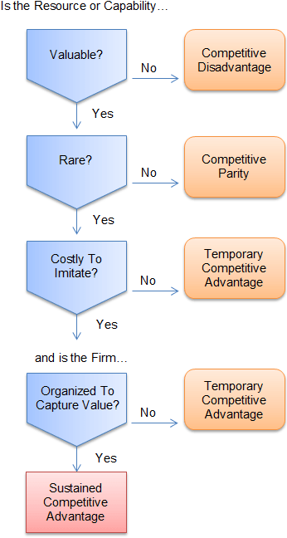
Valuable resources increase the value for customers and decrease the costs of the production.
Rare resources are those resources that can only be purchased / acquired by very few organizations. When a resource loses its rarity (it is acquired by several organizations) the competitive advantage disappears, resulting in a competitive parity.
Imitability. To meet this criterion, organizations must pay high fees to protect their resources that offer them competitive advantages over their rivals.
In order to give organizations a competitive advantage, resources must be organized and stored to add value.
There are four VRIO resources that bring competitive advantages to Amazon can be mentioned:
- High brand capital
- International affiliate network
- Artificial intelligence capability
- High market share
Other skills such as professionalism and expertise in online commerce or distribution hubs are valuable and rare but can be imitated (there are many other online retail companies) and are not uncommon.
The VRIO model helps Amazon`s management make optimal decisions to gain competitive advantage: Walmart, Google, Microsoft, Apple.

A detail analyses of how VRIO are resources at Amazon is presented in Appendix, p…)
2. Through Knowledge Management System, Amazon has the advantage of feedback from their customers. Amazon sells AWS to other companies and governmental organisations. With feedback from customers, they can permanently improve their own knowledge system without requiring additional payments.
3. Easy access for customers - an interface, a portal. It becomes familiar to both customers and Amazon employees at Customer Service.
4. It is a system that ensures data security and online payment security, which means a lot to customers.
Weaknesses of AWS
1. It's too complex. AWS has many applications and mistakes can be made.
2. Requires staff training, this involves time and financial resources.
3. In Kartman's opinion (2018) "AWS is not perfect. Some of its weakest spots are hybrid solutions and legacy systems."

Opportunities of AWS
1. Amazon's pioneering spirit has led to a continuous development of the business through innovation and creativity, as well as AWS appeared in the portfolio.
2. Small Business Accelerator. Because "AWS is more SME-oriented" as feedback from a customer sounds (David Roberts, 2018) Amazon can help small companies with logistics.
Threats
1. A serious threat to Amazon is political change. For example, the Indian government has banned the sale of non-essential goods on Amazon since the first months of the Covid-19 pandemic.
2. A permanent threat to any computer system is hackers. And customers are worried about identity theft, they believe their personal data could be exposed.
3. Anti-trust investigations are a real threat because the company's reputation is declining.
- Critical Evaluation of Amazon`s Knowledge
Management System
Knowledge Management Value Chain (KMC) is a powerful tool focused on how to develop, store, transmit and share and finally to apply knowledge in an organization.
This model was developed by Mathieu Weggeman in 1997.

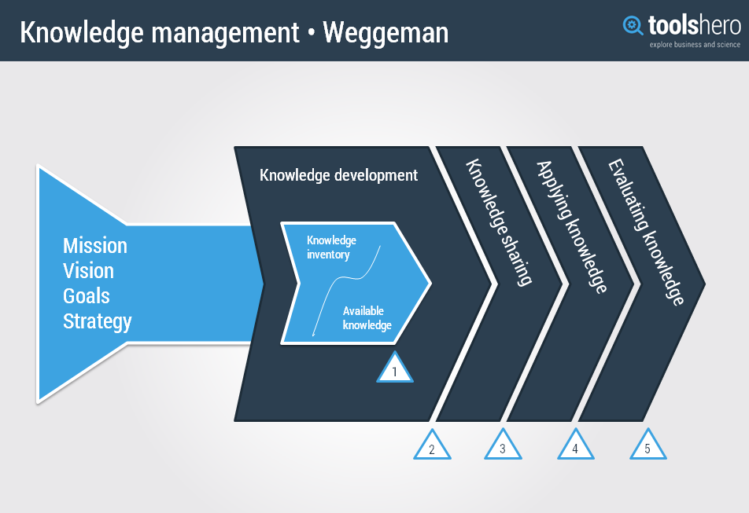

1.Acquisition
Amazon uses Big Data from customers while they browse the site. In this way they find out the customers' preferences, as well as many other useful data to make perfect recommendations based on collaborative filtering. This large amount of data helps Amazon build a "360-degree view" of each individual. (Marr, 2021)
They also have a good application for feedback from employees and can thus improve their commitment and determination to perform.
Amazon patents any innovation necessary for the business, thus adding uniqueness to their resources, making the resources VRIO, increasing the competitive competence for the company.
2. Storage
Amazon started with a simple objective and goal: to offer their customers what they want, when they want it, quickly and easily.
The key to their success was using one portal/one interface, consistent presentation, and great online help. This brings comfort and familiarity, and less anxiety for their customers. It is easy and familiar for customers and for employees as well. That means to store knowledge Amazon uses a user-friendly, modern/outdated, and providing a right amount of knowledge platform.
To store and retrieve unlimited data on the Internet they use Simple Storage Service S3 their own web service, which is like Google Drive. This is mainly used for static web content and media, and it best suited to AWS. AWE is another Amazon IT infrastructure cloud service in the form of building blocks that are used to create and implement any type of application in the cloud. (Sharma, 2021) It is one of the most reliable platforms in the IT industry. What makes AWS unique is the low cost of infrastructure and the fact that it can connect countless business worldwide. This system is a performance-centred system showing a clear way to action for all the tasks customers need to accomplish. (Rosenberg, 2014)
This will be beneficial to employees as they want to perform their jobs more effectively. For that the workers are trained to use AWS.
Comparing Amazon with another eCommerce company, eBay has the advantage of auctioning as its main activity. Here Amazon offers Prime customers free shipping for any order.
Paraphrasing Dan Hunter Wharton’s professor, eBay wastes a lot of time in controversies and disputes to maintain the reputation of sellers.

3. Dissemination
Dissemination of knowledge, also known as sharing and knowledge transfer is the exchange of information, expertise or knowledge between company members (Bartol and Srivastava, 2002; Li, 2007).
Dissemination of what has been learned well means the widespread exchange of knowledge that will generate new solutions. Examples of approaches to knowledge dissemination: knowledge brokers (between researchers and users), Networks (connect researchers and users)
Within its platform Amazon has several applications that facilitate interaction and communication within the company. This communication is according to SECI more socialization, i.e., tacit to tacit.
SECI model was introduced by Nonaka and Takeuchi in 1996 and is a model for knowledge conversion. They also contributed to the theory of knowledge creation and transfer.
"Consistent, honest, and open communication with our employees" is Amazon's statement for Employee Engagement.
4. Application
Knowledge management applications have become a "must have" due to the unlimited amount of information nowadays. This can only be managed by a new, semantic technology to perceive all the nuances of communication. (Expert Ai, 2016)
The AWS -cloud platform that Amazon developed for its own company, (now AWS sold to customers) is high-performance and contains applications for all departments within the company. Because the knowledge that has been stored and disseminated is hosted by their own platform can be easily accessed by all employees.
In comparison, Mountain Equipment Co-op (MEC), which sells equipment and clothing only to its members, uses explicit Knowledge type and has also developed its own platform with a more collaborative and two-way style to which it adds new procedures whenever needed.
The Human Resources Department is important in any business. It provides the entire workforce in an organization. The activities of this department are recruitment and selection, Training and development, surveys, payroll, compensation and benefits.
HR holds the personal files of the employees and therefore personal data, that is why it is very important what KM system the company uses. Amazon uses AWS, which is currently the sales leader with 34% of the cloud infrastructure market, seconded by Azure from Microsoft which owns 18%. (Kartman, 2018) which proves commitment to the company, employees and the planet.
AWS provides access control based on roles and permissions. Employees have access to the information they need without asking for help.
The integration of new employees is essential in terms of its subsequent productivity. Amazon has an integration package to inform the new employee about the company's policy, ranking, promotion conditions, professional development, etc.

Advantages of AWS:
- AWS is suitable for any organisation, delivering enormous amount of value for
the clients.
- It is user-friendly,
- Permanent updates
- Focus on security -AWS shared responsibility model.
- Rapid deployment
- Highly flexibility
AWS, as everything on this Planet is not perfect.
- One disadvantage is that it is too complex to fit government organizations, and small and medium businesses.
- There still are hybrid options.
Here are some AWS clients: GE, Major League Baseball, Ferrari, Tata Motors.
A quick comparison with Microsoft Azure has the following advantages:
- Scalable and secure
- many cost-effective business
- Focus options on Iaas and PaaS
- Open-source support

On the other hand, there are disadvantages:
- Pay-as-you-go is not free,
- Weak DevOps support
- steep learning curve
- Extensive (compared to AWS and Google Cloud Platform)
Amazon has grown tremendously since 1994 when it began, under Bezos. Jeff Bezos has been very creative is innovative for Amazon over 26 years of running the business. He had a personal style of running the company, often making surprising decisions, such as: The customers had his email address to complain about any problem. Through this initiative he solved all customers complains in record time because, he directed them to the responsible staff. They had to solve the problem in half an hour. Or the decision for work teams to communicate less with each other to be more productive.
On 5 July, the new CEO at Amazon will be Andy Jassy (Jeans, 2021). Jassy is the current leader of Amazon Cloud Services, Amazon Web Services. He will lead Amazon after a very good period after the year when the Covid-19 pandemic created the opportunity to increase sales and unexpected profit.
"Andy will never let the universe make us typical." Bezos said of the future CEO of Amazon.
After a period of changes and news with products (Alexa, AWS System) and new activities (acquisition of Whole Foods), plus a new CEO, Amazon will enter a new period, and as Stone said “Alexa, the cloud business AWS, and the acquisition of Whole Foods are the initiatives that will make or break Amazon in its third decade of existence.” (Stone, 2018)

- Conclusion
In conclusion, Amazon will enter the third period of life with a new CEO, new products and new activities.
What Amazon has accomplished in recent years is a huge step in meeting its goals and objectives to reach the most powerful and high-performance cloud platform to form a solid network of loyal customers. As nothing is perfect, but everything is perfectible, Amazon still has to focus on profitability, not only on expanding activities and increasing volumes. Maintaining a reputation and position in the market is sometimes (if not always) more intense than fighting with competitors to reach that position. So, to succeed and perform in Amazon, Jassy, the new CEO, must aware the importance of Knowledge Management.

- Recommendations
A first recommendation would be to focus on profitability rather than sales to add value to existing resources and no longer operate with zero business trends.
It must also follow the actions of their competitors and be competitive in the future.
Amazon needs to pay close attention to anti-trust investigations that pose a real threat to the company's reputation.
Expansion and diversification can lead to the loss of the company's identity. A balance should be maintained so that loyal customers do not lose confidence in Amazon.

- References
- Armstrong, (2009) The History of Amazon.com Available at: http://www.techwalla.com (Accessed: 25 May 2021)
- Algopix, (2018) Q&A 11 December. Available at: http://www.algopix.com (Accessed: 7 June 2021)
- Amazon Our workforce data Available at: http://www.aboutamazon.com (Accessed: 8 June 2021)
- Amazon What we do Available at: http://www.aboutamazon.com (Accessed: 8 June 2021)
- Barney, J. (1991) Firm Resources and Sustained Competitive Advantage Available at: http://www.ftms.edu.my (Accessed:26 June 2021)
- Bartol, K.M. & Srivastava, A. (2002). Encouraging the exchange of knowledge: the role organizational reward systems. Journal of Leadership and Organization Studies
- Davenport, T., Prusak, L. (2000). Working Knowledge: how organisations manage what they know? Harvard, USA: Harvard Business School Press.
- Drucker, P. F. (1999) ‘Knowledge-Worker Productivity: The Biggest Challenge’, California Management Review Available at: http://www.journals.sagepub.com (Accessed: 12 June 2021)
- Hartmans, A. (2021) `Amazon` wasn`t the original name of Jeff Bezos` company, and 14 other little-known facts about the early days of Amazon. Available at: http://www.businessinsider.com (Accessed: 24 May 2021)
- Hunter, D., (2005) In eBay`s Success May Lie Hints of Trouble Ahead 9 March. Available at: http://www.knowledgewharton.upenn.edu (Accessed;4th June 2021)
- Jeans, D. (2021) Amazon`s New CEO Will Wake Up On 5 Fighting Wars On Multiple Fronts 27 May. Available at: http://www.forbes.com (Accessed: 28 June 2021)
- Johnson, T. (2020) What are Amazon`s Owned and Operated Sites for DPS? 17 November Available at: http://tinuiti.com/blog (Accessed: 10 June 2021)
- Jurevicius, O. (2013) Resources Based View 14 October. Available at: http://www.strategicmanagementinsight.com (Accessed:26 June 2021)
- Kartman, N. (2018) AWS vs Azure: Pros & Cons for Your Business 12 October. Available at: http://www.squadex.com (Accessed: 25 June 2021)
- Knowledge Management Tools, (2018) What is Knowledge Management? Available at: http://www.knowledge-management-tools.net )Accessed:10 June 2021)
- Macro Trends, (2021) Amazon Revenue 2006-2021 | AMZN Available at: http://www.macrotrends.net (Accessed: 22 May 2021)
- Marr, B. (2021) How Amazon Is Using Artificial Intelligence (AI) Available at: http://www.youtube.com (Accessed: 28 June 2021)
- Objective Outlook, (2017) Amazon works because of its org structure 5 September. Available at: http://www.medium.com (Accessed: 9 June 2021)
- Robert, D. (2018) Feedback on “AWS vs Azure: Pros & Cons for Your Business 12 October Available at: http://www.squadex.com (Accessed: 26 June 2021)
- Rosenberg, M., (2014) The Knowledge Management Genius of Amazon.com 29 July. Available at: http://www.learningsolutionsmag.com (Accessed: 3rd June 2021)
- Sharma, H., (2021) What is AWS? – Amazon Web Services (AWS) updated 28 May. Available at: http://www.edureka.co/blog (Accessed: 3rd June 2021)
- Stone, B. (2018) The Everything Store: Jeff Bezos and the Age of Amazon-Preface Available at: http://www.amazon.in (Accessed: 12 June 2021)
- Wiig, K.M., (1999) Knowledge Management: An Emerging Discipline Rooted in a Long History. Available at: http://www.krii.com (Accessed: 10 June 2021)

- Appendix

