f | 2016
Liam Coome/P146896

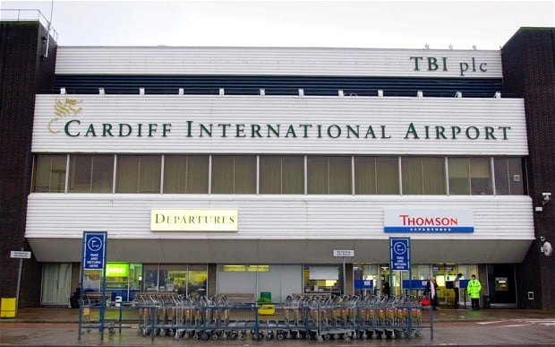

The Public Perception received from Cardiff Airport since it has been under the Welsh Government ownership.

Contents
- Research Question
- Hypothesis or Aim
- Objectives of Research
- Research Rationale
- Literature Review/Contextual Analysis
- Proposed Research Methodology, including justification for
  - strategy chosen
  - data collection methods
  - sampling framework and selection criteria
- Research Ethics and Risks
- Research Plan
  - resources required
  - Timings
- Resources and Planning

Introduction
The aim of this research proposal is an investigation into the factors of why Cardiff Airport is a disappointment since the new government ownership and to demonstrate an aspect of area it can improve upon.

Objectives of research
- To analyse evidence of the support Cardiff has with its current customers within wales
This will be done to gain an understanding of information circulating around Cardiff airport with its mixed opinions of how Cardiff airport is managed and support by the welsh government and acceptance by the populace.
- To observe the government’s strategy and evaluate their successiveness
This will be achieved through surveys and gathering responses from consumers with importance to the study to see how the government has planned and prepared to continue its regrowth programme for the upcoming years.
- To demonstrate clear ideas as to how increased visitor numbers and funding can improve Cardiff Airport. Cardiff airport will be examined to learn any reasons as to why improvement progress has been halted as well as to the reasons it has suffered shortcomings. This will be achievable through secondary research of looking at statistics and customer statements about their experience through the establishment.

Research rationale
Through the welsh government bought Cardiff Airport off the Spanish company TBI (BBC News, 2016), by public opinion, it is still not of a high standard. “Cardiff Airport has been named the worst terminal for passenger experience in a new survey of the UK’s small airports”. (Law, 2016) The previous ownership did not put in the financial support to upgrade or maintain the standard for an international airport as falling visitor numbers dwindled “between 2007 and 2011, while at Cardiff numbers fell from 632,953 to 276,212 over the same period”.(Miller, 2016) even though the government has been trying to improve facilities at Cardiff, so why is it still not meeting up to standards even with a £10million loan in 2013(ITV News, 2016) a part of Cardiff’s vision when the welsh government purchased the airport was to create an airport which could represent wales “Together with our investment in refurbishment and the new shuttle bus service, this programme of improved facilities and modernisation is part of our vision to create a high-quality airport of which Wales can be proud.”(ITV News, 2016) Through these means, the government of wales was aiming for the improvements to be more appealing to airline operators. (ITV News, 2016) this was later proven a success as Flybe became one of the first larger airlines to join a partnership with Cardiff Airport, “Flybe, Europe's largest regional airline, today announces it is to open a new base at Cardiff Airport. The airline will serve 11 destinations in the UK and Europe this summer and base two of its existing Embraer E195 aircraft at the Airport.”(Flybe.com, 2016) With 1.2m welsh travellers crossing the border to use Bristol airport Cardiff airport is suffering to it competitor, with Cardiff’s current average of 1.4ml, the two markets together would be near the target mark of the chairman of Cardiff airport Roger Lewis prediction by 2025 of three million. To meet such a demand Cardiff airport would need to invest £100m to create a new larger terminal. (Barry. S,2017)

Contextual analysis
It is believed that the research is worth carrying out as the outcome of this topic is unclear and is worth investing time to have a clear outlook; As Cardiff Airport is a large aspect of Cardiff being largely influenced by visitor numbers and the economy, Cardiff Airport is a major topic at times amongst the welsh government for the justification of £52 million. (The Wave, 2016) plus it brings work to the economy and visitors. The discussion of Cardiff Airport can be controversial at times in relation to the amount of funding required and the environment, Cardiff Airport applies to a new context as the future for the industry is still unclear and the plans and strategy are still lacking in results, but due to recent ownership there is recent information available for the present investigation, as Cardiff Airport is currently the fastest growing. “Cardiff Airport is the fastest growing airport in the UK that regularly handles over one million passengers.”(Cardiff Airport, 2016) with the new introduction of Qatar airways Cardiff is expecting a boost of 150,000 passengers flying in and out of wales. (Barry. Sion ,2017)

Research Methodology
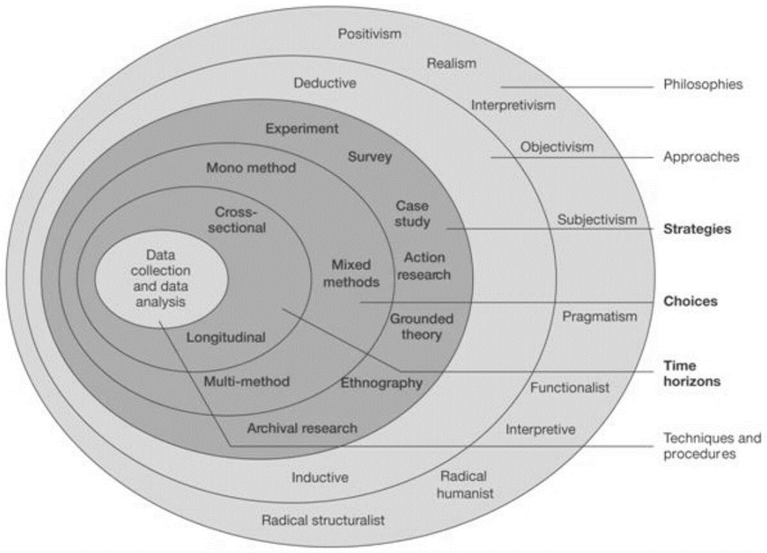
(The Research Onion,Saunders,et,al,2009,p. 138)
The chosen method of research is through the Interpretivist research philosophy as it allows more creativity and open research that follows the path of Idealism, “Interpretivism is “associated with the philosophical position of idealism, and is used to group together diverse approaches.” (Interpretivism, Research Methodology, 2016). Compared to the linear path of positivism which is limited to data collection and observation. “In positivism studies the role of the researcher is limited to data collection and interpretation through objective approach and the research findings are usually observable and quantifiable”(Positivism, Research Methodology, 2016)., however the use of data collection and interpretation is useful in regards to data being easily accessible and a different point of view given by multiple interpretations.
Of the two induction and deduction, the deduction methods follow a simpler and more approachable method beginning with the theory that gets narrowed down to the hypothesis and then further down to collect observations to justify the hypothesis and confirm the theory. (Socialresearchmethods.net, 2016) opposed to induction which seems to follow a more SMART approach “In inductive reasoning, we begin with specific observations and measures, begin to detect patterns and regularities” (Socialresearchmethods.net, 2016)
The information will include both qualitative and quantitative data both useful to this study as a collection of public opinion is gathered through surveys and reviews on trip advisor add up to support the numbers. While qualitative interviews will be fewer but will provide a more detailed piece of evidence which can be analysed further. The qualitative is more focused individually to get more quality than quantity when gathering information. “Qualitative research is a research strategy that usually emphasises words rather than quantification in the collection and analysis of data.”(Bryman, 2008)
The research will include both secondary and primary research with multiple case study sources, surveys, website reviews, interviews; the study population will include friends, family, university students, and general public with an age restriction of over 18’s along with online resources. Access to all these areas is available as primary and secondary research.
Data will be collected from a multiple of sources the online reviews can be found at online at (Airlinequality.com, 2016), (Tripadvisor.co.uk, 2016) and (yelp, 2016). Secondary information relating to the topic will mostly be gathered through news articles. Primary research will be gathered from interviews and questionnaires with survey monkey and talks with relevant individuals who can provide evidence and answers for the topic. Questionnaires will be mainly focused with responses from travellers who have ventured through Cardiff airport.
The reliability and validity of resources, the majority of online resources validity can be questioned such as the news articles and information from unofficial sources. While the online resources from official resources such as information from the Cardiff Airport website are official and are reliable, the primary research including the interviews and questioners are believed to be reliable and valid as much as possible but there will be different interpretations for each answer.

Research ethics and risk/Research plan
Risks involve time management when gathering responses and answers to interviews and questionnaires, to composite results and collect data. Time management will be monitored and followed up by a time schedule to keep up with deadlines. Regarding the topic there are not many risks or limitations that might cause or prevent an analysis of the topic which leads to how it is not affected by any legal, ethical or other risks and limitations to progress. The data will be evaluated through a content analysis, survey money and SPSS the data evaluated will be kept to a time plan on a Gantt chart, the results will be compared and contrasted to the information gathered and assorted on an excel spread sheet with other data containing facts and figures.

Resources and planning
Resources will include computer systems, Microsoft application packages, and access to news articles, E-books, online services, journals, documents, articles, pen and paper.
No | The Public Perception received from Cardiff Airport since it has been under the Welsh Government ownership. | Oct | Nov | Dec | Jan | Feb | Mar | Apr | May
1 | Proposal
 | Define research aims, objectives and methodology
2 | Literature review
 | Carry out extensive research
3 | methodology
 | Decide on – write up research methodologies/ devise questionnaire/ interviews
4 | Findings and analysis
Conduct research
Analyse questionnaire results
 | Arrange interviews for gaps in research
 | Collate and analyse feedback
 | conclusion
5 | Submission preparation
 | Consultation with supervisor
 | Proof – read and editing
 | Binding
 | submission

The above Gantt chart outlines the plan for the amount of time set to carry out each task

Bibliography
BBC News. (2016). Cardiff Airport: Welsh government plan to buy from TBI - BBC News. [Online] Available at: http://www.bbc.co.uk/news/uk-wales-20769091 [Accessed 4 Dec. 2016].
Law, P. (2016). Cardiff Airport ranked bottom in which? Passenger satisfaction poll of small airports. [online] walesonline. Available at: http://www.walesonline.co.uk/news/wales-news/cardiff-airport-ranked-bottom-which-5742886 [Accessed 4 Dec. 2016].
Miller, C. (2016). Cardiff Airport loses half its passengers on key routes to sunny Spain. [online] walesonline. Available at: http://www.walesonline.co.uk/news/wales-news/cardiff-airport-loses-half-passengers-2031764 [Accessed 4 Dec. 2016].
ITV News. (2016). £10m loan for improvements at Cardiff Airport. [online] Available at: http://www.itv.com/news/wales/story/2013-12-11/improvements-to-be-made-at-cardiff-airport/ [Accessed 4 Dec. 2016].
Flybe.com. (2016). Flybe | Corporate | Media | News archive | FLYBE TO USE TWO EMBRAER 195 JETS IN NEW CARDIFF BASE 150305. [online] Available at: http://www.flybe.com/corporate/media/news/1503/05.htm [Accessed 4 Dec. 2016].
The Wave. (2016). Cardiff Airport: Payment Questioned. [online] Available at: http://www.thewave.co.uk/news/local/cardiff-airport-payment-value-questioned/ [Accessed 4 Dec. 2016].
Cardiff Airport, (2016). [online] Available at: https://www.cardiff-airport.com/news/2016/07/12/cardiff-named-uks-fastest-growing-airport/ [Accessed 4 Dec. 2016].
Research Methodology. (2016). Interpretivism (interpretivist) Research Philosophy - Research Methodology. [online] Available at: http://research-methodology.net/research-philosophy/interpretivism/ [Accessed 4 Dec. 2016].
Research Methodology. (2016). Positivism - Research Methodology. [online] Available at: http://research-methodology.net/research-philosophy/positivism/ [Accessed 4 Dec. 2016].
Socialresearchmethods.net. (2016). Deduction & Induction. [online] Available at: http://www.socialresearchmethods.net/kb/dedind.php [Accessed 4 Dec. 2016].
Airlinequality.com. (2016) Cardiff airport. [online] Available at: http://www.airlinequality.com/airport-reviews/cardiff-airport/ [Accessed 5 Dec. 2016].
Bryman, A. (2008) Social Research Methods, Third edition, Oxford, Oxford University Press.
Tripadvisor.co.uk. (2016). Cardiff airport. - Cardiff Message Board - TripAdvisor. [online] Available at: https://www.tripadvisor.co.uk/ShowTopic-g186460-i309-k6966668-Cardiff_airport-Cardiff_South_Wales_Wales.html [Accessed 5 Dec. 2016].
Yelp. (2016). Cardiff Airport - CWL - Barry, Cardiff. [online] Available at: https://www.yelp.co.uk/biz/cardiff-airport-cwl-barry [Accessed 5 Dec. 2016].
Cardiff Airport entrance, (2016). [image] Available at: http://i.telegraph.co.uk/multimedia/archive/02227/cardiff_2227865b.jpg [Accessed 5 Dec. 2016].
Cardiff Airport Logo, (2016). [image] Available at: https://www.cardiff-airport.com/images/logo-en.jpg [Accessed 5 Dec. 2016].
Barry, Sion. "What Cardiff Airport Needs To Do To Make A Success Of Its Qatar Airways Service." walesonline. N.p., 2017. Web. 20 Nov. 2017. http://www.walesonline.co.uk/business/business-news/what-cardiff-airport-needs-make-12979291
Saunders, M., Lewis, P & Thornhil, A., 2009 Research Methods for Business Students. 5th Edition. London: Pearson Education Limited.
Barry, S. (2017). This is what Cardiff Airport's biggest rival is planning. [online] walesonline. Available at: http://www.walesonline.co.uk/business/business-news/what-cardiff-airports-biggest-rival-13942046 [Accessed 27 Nov. 2017].

