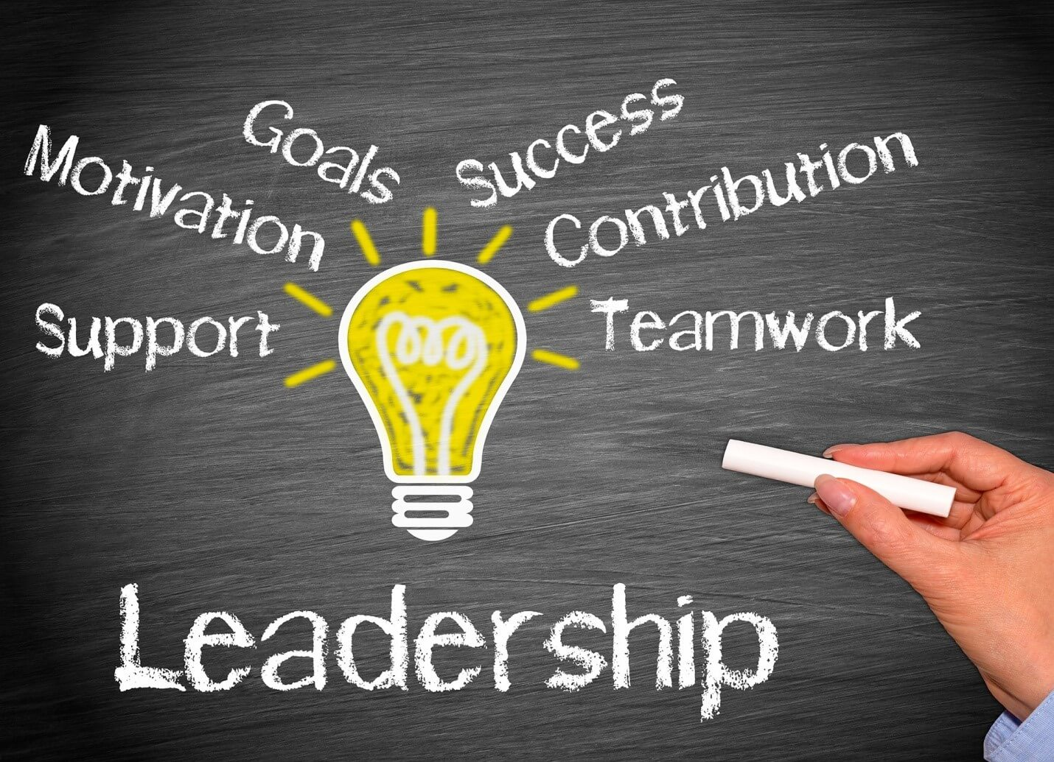

A critical analysis of Employee and Leadership Development

Madalina Blaglosov 2207678

In today's changing world, businesses recognise the importance of employee and leadership development for their organizations. It is considered an important route to derive leadership development to establish the long-term success rate of any company. There is also a continuous need to develop the skills and knowledge of the organizational demands (Alameeri et al., 2021, p. 668). Many employee development skills are required to meet specific organizational goals and needs. It is also aligned as an essential approach for individual growth. Furthermore, it can enhance effectiveness in raising competitiveness and fostering leadership growth. These steps are necessary to develop organizational culture and motivate leaders to guide the teams for uncertainty and change throughout the present skills to comprehend a better approach with enhancing employee skills and leadership programs.
In this essay will be evaluated the significance of leadership and strategic development for employees and leaders. It can further explore the need to raise the competitive edge for broader business strategies. This study will present the challenges and benefits of aligning with various business strategies. The role of technology is further essential for facilitating the complexities involved in dealing with diverse environments.
The relationship between leadership and employee development through relevant theories, models, and real-world examples will be analysed. It further focuses on how organizational leadership and culture need to foster employee growth in the current competitive landscape to derive the skills that can ensure effective certainty and change for shaping the critical role in organizational culture (Chatterjee et al., 2021, p. 12134). It further fosters the effectiveness of a broad range of business strategies to enhance the role of technology in the facilitation of the current environments.

Strategic employee development or staff development is essential for upskilling employees by teaching them newer methods to meet specific business goals. In this case, employee development is vital, where training is required to track certain key metrics for associating directly with the program's ROIs (Ichsan et al., 2021, p. 259). There are different ways through which formal training can be beneficial, such as webinars, online courses, and in-person classes. These schemes can focus on various types of training in multiple roles. Businesses currently need skilled employees to reach different goals and use different motivational techniques in the same manner.
Employees further believe in development for fostering a sense of collaboration and teamwork, which can help promote a culture of learning and growth in the same manner. It is demonstrated that a company's commitment helps invest in its employees. This idea can further boost morale and increase loyalty by associating directly with workplace culture by improving employee experiences (Hajiali et al., 2022, p. 57). Through continuous improvement, professional development can acquire skills and knowledge to develop work processes with increased productivity. Improved productivity is a significant result, as per data provided by Deloitte. The study explored that learning culture has increased employee productivity by 52% in 2022.
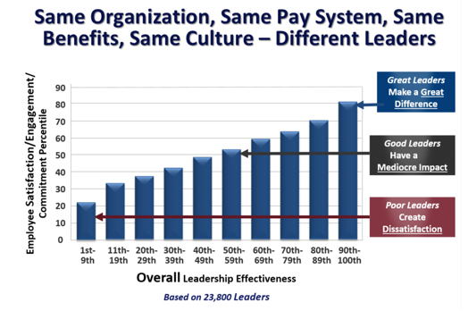
Figure 1: Leadership Effectiveness (Arthur, 2016)
Also, it can further enhance mentoring opportunities. With different experiences, employees can gain one-on-one insights about fostering a culture for high performers. These ideas are present in coaching skills through knowledge and teaching in the best manner. Mentorship can further promote a knowledge-sharing model in the organization. These are further important by providing further expertise for building collaborative work environments. High employee retention is also seen where the pay raise has been increased by 31% with an enhanced business role of an employee through fostering different levels of collaboration (Meuser & Smallfield, 2023, p. 251). In addition, hiring costs are reduced if companies use the methodologies for training employees correctly. Employee referrals are hired through employee networks at a 55% faster rate.
These trends are essential for providing a better idea for enhancing the brand and its value. These trends are followed for high-quality talent for the business. These companies will be fundamentally essential to reach complete potential and profitability similarly (Rasheed et al., 2023, p. 1). Businesses can also utilise the same money to provide training opportunities to their current employees similarly. Career development is also one of the more straightforward ways employees can develop themselves within the company to enhance their roles.
Enhanced job security is also useful for filling the knowledge gap and adapting to the change of jobs per the allocated requirements regarding economic challenges and industry shifts. When specific companies invest in employee development, it is a sign that the businesses are willing to invest in the employees' future. These trends help raise employee loyalty (Sorn et al., 2023, p. 1). These factors are directly in line with leadership development for guiding specific abilities in enhancing the role of future leaders. These leadership skills are focused on soft skills with decision-making and problem-solving abilities.
Likewise, leaders who understand the industry will likely emerge as the technological tools for handling a comprehensive experience to offer problem-solving, creativity, and critical thinking in leaders (Rasheed et al., 2023, p. 1). The objectives of this idea may be further supported and encouraged by these trends. Employee engagement and retention further serve as an essential engagement tool where employees can feel valued and supported to raise the bar for career development and mentorship for their betterment.
Effective leaders also recognize the significance of providing constructive feedback to raise the bar for greater job satisfaction and reduce turnover rates.
Providing training programs can further benefit the leaders by engaging the learning behaviour for creating a ripple effect. Communication skills are also essential for career development for building different competencies while raising the relationships between clients and customers (Udin et al., 2023, p. 1). Employee development programs are specifically structured to motivate employees to perform better with certain job satisfaction standards and contribute to company success by aligning with training initiatives and human resources and setting similar business goals and strategic objectives.

Leadership development plays a vital role in developing and driving the industry. Additionally, leaders who understand the industry will likely emerge as the technological tools for handling a comprehensive experience to offer problem-solving, creativity, and critical thinking in leaders (Zeeshan et al., 2021, p. 1963029). These trends can further encourage and embrace the goals of this idea. Employee engagement and retention further serve as an essential engagement tool where employees can feel valued and supported to raise the bar for career development and mentorship for their betterment.
Effective leaders further understand the importance of providing constructive feedback to raise the bar for higher job satisfaction and reduce turnover rates. Cultivating high-performance teams can further be equipped to build high-performing teams. These leaders automatically possess the skills that allow them to leverage their strengths. These tasks are handled with inclusive trends to enable collaborative work environments. These leaders can also empower their teams and excel in raising organizational success.
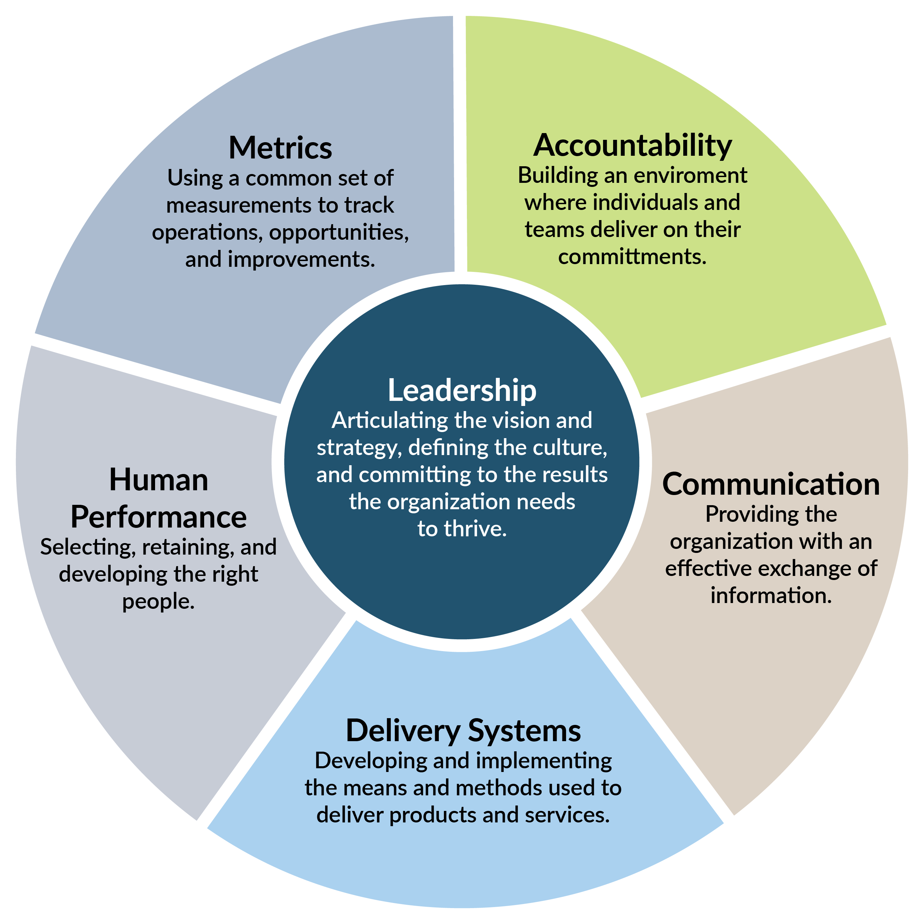
Figure 2: Six Systems of Organizational Effectiveness (Dell, 2025)
Adapting to change is also an essential tool for leaders to allow further flexibility. Leadership development programs are focused on enhancing the raised flexibility and resilience. For building an effective leadership development program, different steps need to be followed (Żywiołek et al., 2022, p. 11607). First, it is essential to identify the leadership competencies with core competencies and skills that align with values and goals. These trends are also focused on decision-making, strategic thinking and conflict-resolution skills.
Assessment and feedback can further be enhanced by learning the existing strengths for focusing on different areas of improvement. These performance evaluation tools can help leaders understand specific business development needs and preferences (Alameeri et al., 2021, p. 668). Mentorship and coaching can further enhance goals by providing valuable insights and helping leaders refine their skills in developing ideas. Real-world application is also vital to address the challenges of allowing the practice of leadership techniques.
These experiences help allocate trends that can be used to conduct assessments and focus on thorough skills for ideas to achieve organizational goals. Continuous learning abilities can be critical. For example, companies like IBM and Google are focused on creating a culture that can help with the knowledge transfer of employees and raise job satisfaction levels (Chatterjee et al., 2021, p. 12134). These companies are invested in the professional growth of the employees, where change is constant. Such ideas focus on technically proficient trends to shift with consumer preferences.

Implementing leadership and employee programs also have different challenges, and the organizations have to make sure that the trends being used are developed to drive organisational resistance and focus on idealizing cultural barriers. As well, there are still complexities involved with executing development programs to hinder the impact and sustainability to raise the growth and focus areas for the programs.
Providing training programs can further benefit the leaders by engaging the learning behaviour for creating a ripple effect. Communication skills are also essential for career development for building different competencies while raising the relationships between clients and customers (Ichsan et al., 2021, p. 259). Employee development programs are specifically structured to motivate employees to perform better with certain job satisfaction standards and contribute to company success by aligning with training initiatives and human resources and setting similar business goals and strategic objectives. Leadership development plays a vital role in developing and driving the industry.
One of the significant challenges companies face is the problem of leadership programs. Specific investment is required to develop solutions to fund the infrastructure and resources (Hajiali et al., 2022, p. 57). The time needed to devote to significant development away from daily tasks is vital to address the challenges in formulating limited or poorly executed programs. There are still documented benefits of leadership development and employees.
Organizations struggle to buy in from leadership and are focused on return on investment through raising development initiatives. There is a need to provide clear communication methods which cannot pose essential challenges to focus on rigid structures for specific environments. In such cases, engaging in development opportunities with hierarchical and rigid structures is necessary.

Technology is an important aspect that can be focused on improving employee and leadership development conditions. These trends can enhance the learning experiences by improving the effectiveness of the development programs (Hajiali et al., 2022, p. 57). Aditionally there is a need to provide flexible and scalable techniques to focus on improving the trends for organizational growth and individuals. The primary way through which technology has been focused is Learning Management Systems (LMS).
The platform provides a centralized location for employees and leaders to access specific training material to further engage in assessments and certification programs. Notable examples of LMS include Moodle, Talent LMS and BlackBoard (Zeeshan et al., 2021, p. 1963029). These aspects are vital to allocating technical skills results to the actual trends to improve the conditions in the relevant case. E-learning platforms have become essential to focus on providing multiple opportunities, such as Udemy, LinkedIn Learning and Udemy.
These courses can provide different certifications to align with balancing roles and responsibilities with development opportunities. E-learning allows diverse content with consistent development across various organizations (Rasheed et al., 2023, p. 1). These are becoming important for delivering results in different geographical locations and skills that can benefit similarly.

In conclusion, strategic employees can be focused on enhancing organizational effectiveness to foster innovative trends. It can further help maintain adaptable and motivated trends by the current workforce. Challenges are still present, with resistance to allocating the technology to play its role through personalized advertising development. Technology is also essential here to deliver different courses and metrics to individuals who can focus on the development of the people to further navigate the challenges and achieve long-term success. It has further increased to be developed as a complex global issue.
Cultivating high-performance teams can further be equipped to build high-performing teams. These leaders automatically possess the skills that allow them to leverage their strengths. These tasks are handled inclusively to facilitate collaborative work environments. Additionally, these leaders are adept at empowering their teams and enhancing organizational success.

References
Alameeri, K., Alshurideh, M., Al Kurdi, B. and Salloum, S.A., 2021. The effect of work environment happiness on employee leadership. In Proceedings of the International Conference on Advanced Intelligent Systems and Informatics 2020 (pp. 668-680). Springer International Publishing.
Arthur, L 2016, The Impact of Leadership on Employee Engagement - The Clemmer Group, The Clemmer Group.
Chatterjee, S., Chaudhuri, R., Sakka, G., Grandhi, B., Galati, A., Siachou, E. and Vrontis, D., 2021. Adoption of social media marketing for sustainable business growth of SMEs in emerging economies: the moderating role of leadership support. Sustainability, 13(21), p.12134.
Dell, F 2025, Leadership and data - Circle-spoke diagram | Circle Diagrams | Cost Leadership Diagrams, https://www.conceptdraw.com, viewed 9 April 2025, <https://www.conceptdraw.com/examples/cost-leadership-diagrams>.
Ichsan, R.N., Nasution, L., Sinaga, S. and Marwan, D., 2021. The influence of leadership styles and organizational changes on employee performance with an environment work as an intervening variable at pt. Bank sumut binjai branch. Journal of Contemporary Issues in Business and Government| Vol, 27(2), p.259.
Hajiali, I., Kessi, A.M.F., Budiandriani, B., Prihatin, E. and Sufri, M.M., 2022. Determination of work motivation, leadership style, and employee competence on job satisfaction and performance. Golden Ratio of Human Resource Management, 2(1), pp.57-69.
Meuser, J.D. and Smallfield, J., 2023. Servant leadership: The missing community component. Business Horizons, 66(2), pp.251-264.
Rasheed, R., Rashid, A., Amirah, N.A. and Afthanorhan, A., 2023. Quantifying the moderating effect of servant leadership between occupational stress and employee in-role and extra-role performance.
Sorn, M.K., Fienena, A.R., Ali, Y., Rafay, M. and Fu, G., 2023. The effectiveness of compensation in maintaining employee retention. Open Access Library Journal, 10(7), pp.1-14.
Udin, U., Dharma, R.D., Dananjoyo, R. and Shaikh, M., 2023. The Role of Transformational Leadership on Employee Performance Through Organizational Learning Culture and Intrinsic Work Motivation. International Journal of Sustainable Development & Planning, 18(1).
Zeeshan, S., Ng, S.I., Ho, J.A. and Jantan, A.H., 2021. The impact of servant leadership on employee engagement is assessed through the mediating role of self-efficacy in the Pakistani banking sector—Cogent Business & Management, 8(1), p.1963029.
Żywiołek, J., Tucmeanu, E.R., Tucmeanu, A.I., Isac, N. and Yousaf, Z., 2022. Nexus of transformational leadership, employee adaptiveness, knowledge sharing, and employee creativity. Sustainability, 14(18), p.11607.

