Name Chaman
Student ID 2214619
Programme MBA Master of Business Administration
Module Human Resource Management
Module Code LCMB7000
Assignment Title Assisgnment-1 (Human Resource Management)
Word Counts 2500 words

Human Resource Management

Table of Contents
Execution Summary | 3
Introduction | 3
1.0 Labour Market | 4
1.1 Labour Work in developing and developed countries | 4
1.2 Labour Work in UK | 6
1.3 Current Status of Labour Market in UK | 6
2.0 Human Resource Management Strategies | 7
2.1 Human Resourcing Strategy in the post Brexit external environment. | 7
2.2 Human Resourcing Strategy in the post Covid external environment. | 8
2.3 Motivation Theory of HRM strategies | 8
3.0 PESTLE analysis for Human Resource Management | 9
4.0 Conclusion | 10

Execution Summary:-
This report is mainly based on the Human Resource Management strategy in labour market of UK which is beneficial for both management and individuals as well as for nation economics to remove the sense from the employee’s arisen due to Covid-19 pandemic. All the organization required human resources for providing the ideas and manpower to the business as such recruitment of professional and skilled manpower, there is requirement of many more peoples so that skilled/experienced person could be selected (Torrington, Taylor and Atkinson, 2017). The report have covered the concept of work labour in United Kingdom which defines the labour work conditions, environment, remunerations, labour laws and other laws related to the labour in UK and how the Human Resource Management play role in UK environment as the work of HRM also depends on the polices of the counties which vary country to country according to their polices, positions, connection with other countries, laws, political standard, social responsibilities etc. The report covered that the situations deal by the Human Resource Management in the post Covid external environment and the also covers the environment which faced post brexit. Study of this assignment also explain the Labour market which is define the labour market as a means a communication between seller and buyer in which they informed to each other about what they have, what they required and negotiation regarding price before the end of their communication according to Serena (2016, p.201). Human Resources Management is on the one side on behalf of organization in labour market concept and the other hand person. This reports consists the present crisis in labour work which is being faced by the developing countries and which is also giving the threatening regarding the present less policy space during the recent crises. How the developing counties balancing in third major factor of country economics i.e. Labor market in post Covid-19 pandemic.

Introduction:-
The object of the report to describe overview of strategy of HRM in the post Covid and Brexit. HRM has broad and disciplined approach for employment of people and their development. HRM can be defined as a philosopher because of their nature of job that in what ways the management of people should be carried out which is interlinked by a number of theories in connection with the behaviour of people and organization. HRM connected with the policies and practices in the area of organization design and development, deployments of people, Training & Development, evaluation of performance and rewarded (Armstorng and Taylor, 2014). HR specialist can setup the strategies remove the negative thoughts amongst the people which affected the people due to Covid pandemic. The HRM work mainly depends on the goals as per organization polices and HRM work are to make efforts for achieving the decided objectives of the organization by proper developing and applying the human resource strategies. Give the development of high performance culture and satisfy with the strategy that the talented, skilled, qualified people are engaged in accordance with the requirement of organization. The HRM provide a faithful relationship between management and employees and encourage the people to use their best in the organization (Armstorng and Taylor, 2014)

1.0 Labour Market
On study of the journal of Serena (2016, p.201) it is cleared that the labour market in very simple ways that the labour market is the point where supply and demand connected, agree to work on the determine price and quantity of the work performed as defined by the (Bosworth, Dawkins and Stromback, 1996) . Further some authors also define the labour market in simple words as a means a communication between seller and buyer in which they informed to each other about what they have, what they required and negotiation regarding price before the end of their communication (Serena, 2016).
The labour market works on the principle of competition in which all persons for getting or retaining a particular position, competing with each others. Further, the employer also compete to attract and retain the employee in their organization who well efficient and have expertness for making profit. It is mentioned here that the labour market is one of the main element of market economy along with goods and capital market (Serena, 2016).

1.1 Labour Work in developing and developed countries
On perusal of the report (International Labour Organization, 2022) it reveals that while most of the countries has come out in the safe zone from Covid-19, but multiple and overlying economics and political crises are warning the labour market recovery in the world. Due to these crises, labour market inequalities are increasing and effect o the same are being faced by the some group of workers and firms. The developing countries were getting recovery from the Covid-19 pandemic very slowly but now they are facing the problems from the present less policy space during the recent crises. As per analyzing of developing countries, the informal job increased during 2021 and recovered the loss of 2020 which was faced due to Covid-19 pandemic but on the other hand formal employment did not increased during this period. It was the expectation of the IOL that the informal job will grow at the same speed of formal employment which indicates the jeopardizing. No improvement has been noticed at the starting of 2022 regarding encouraging recovery of hours worked although difference has been stayed between regions and income groups. It is also noticed that the hours worked during the 3rd quarter of 2022 were below as comparison from the 4th quarter of 2019. According to ILO report (2022, p.1) during the Covid-19 pandemic, 94 percent workers were residing in that countries in which lockdown have been announced to control the spread of Covid-19. Presently, all the countries have withdrawn the instructions issued regarding lockdown. Accordingly, the economical activities successful returned on the track during starting of 2021 and 2022 and the favourable differences in labour market trends and within the countries have been noticed. According to ILO report (2022, p.3) trends in global GDP growth and consumer prices showing through chart:
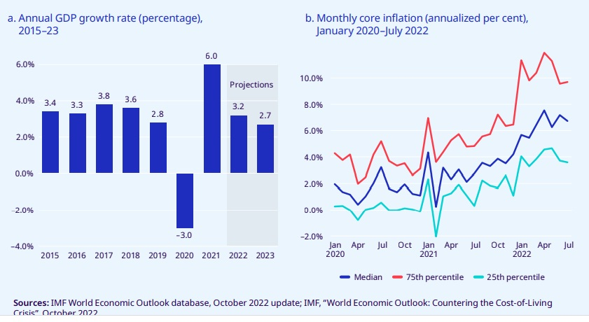

In addition, on 24.02.2022, the Russian attacks on the Ukraine which majorly affected the labour market of Ukraine. Due to this Ukraine’s employment is noticed lower than the previous years and it is expected that the labour market will be fall down in future years. The effect of the crisis of Russian and Ukraine attacks should be assessed by the neighboring countries as this crisis can be danger for the labour market specially when the conflict become deeply. Due to the effect of Russian and Ukraine attacks prices of the foods and energy have increased which significantly impacted to the labour market (ILO, 2022).

1.2 Labour Work in UK
According to Russell through (a guild to UK employment by law) there are three type traditional categories of workers in UK which Self Employed, Agency Worker and Employees and each category have different employment protection right. Before few years forth category namely Workers also established in UK. Brief description of these four categories:
- Self Employment— Any person who run their business responsible for making their own decision for their business / job work and relationship between employer and individual has more advantages due to as the employer is free from the statutory employment protections laws.
- Agency Workers— Workers employed or engaged by any employment agency who supplied the services of employment. These workers category certain statutory responsibilities i.e. Labour laws, Health and safety laws etc. However agency workers engaged temporary basis and not for even years.
- Employees— Most of the workers in UK are employees of any company to give their services. There is no other difference between blue collar worker, while collar workers and senior directors except legally agreement written with regard to their employment contract.
- Workers—This forth category ‘workers’ established in new in UK law and this concept born from European law. In a describe form we can define this category as a worker working under an employment contract or some other applicable contract under which they agree to provide their services individually.
According to Russell through (a guild to UK employment by law) in UK, there are three forums regarding labour market to resolve the dispute between worker and employers i.e. Employment Tribunals, Common Law Court and Advisory Conciliation & Arbitration Service. In addition, all foreign workers required a valid work permit to do the work in the UK alongwith a visa. All the persons who are entering for stay for more than 6 months in UK is required prior entry clearance after obtaining the work permit.

1.3 Current Status of Labour Market in UK
On perusal of the Labour Market Overview, UK (2022, p.2) it noticed that during the period from July 2022 to September 2022, the employment rate in UK was 75.5% which was unchanged as comparison to previous quarter. The rate was below 1.1% in comparison the rate recorded just before the Covid-19 pandemic. Presently it has been noticed that the number of employees decreased while the self employed worker increased in UK. In addition to above, as per research on UK labour market statistic report of Powell (2022) during the period of August to October 2022, the employment of above sixteen year was 32.77 in UK and the employment rate of age group 16-64 recorded 75.6% in comparison to previous year rate which was 75.4%. Employment rate is increased in fourth quarter but still below in comparison with pre-Covide-19 pandemic figure recorded.

2.0 Human Resource Management Strategies
According to (Armstrong and Taylor, 2017, p.25) Strategic HRM is an approach which explain that how can objectives an organization can be achieved with the help of people through HR strategy and HR policies and practices. Strategic HRM can be considered as a philosophy instead of a set of techniques. It provides the base for reviewing the strategy which includes the analysis of organization context and decision on the HR polices. It is most important for integrating of business and HR strategies for achieving the prescribed objectives of the business (Armstrong and Taylor 2017, p.18). This is a challenge for HRM department to remove the negative effect of the any health disasters like Covid pandemic on the employees and earlier it was argued by the authors that HRM should be the part of crisis management. HRM should be ready to attend any problem and issued caused by Covid-19 pandemic in employer whether related to work place or home as HRM main task during crises/disaster is to remove the negative effects among the people (Bieńkowska, Koszela, Sałamacha, and Tworek, 2022).

2.1 Human Resourcing Strategy in the post Brexit external environment.
It was always expected that the Brexit will affect the labour market in UK. AT the end of 2021 i.e. at the end of the full departure from the European Union, other things hide the full affect of Brexit on the employment such as Covid pandemic. As per official government figure, there are 828,000 fewer workers in the UK between February 2020 to December 2020. There were unemployment rate was 0.6% in the last quarter which was increased in comparison the previous quarter and in the other figure we can say a loss of 202,000 employments was noticed and this behalf it can be believed that UK unemployment rate was 5% at that time while it was 3.8% in October 2019 (Edwards, 2021). As such, this was a challenge before the Human Resource Management to recover this loss with their HRM strategies. Accordingly, HRM specialist play lead role with HRM strategies to recover the labour market affects.

2.2 Human Resourcing Strategy in the post Covid external environment.
Some recovery has been noticed in number of people engaged in part time work but this was the lesser as per the level of pre pandemic. 551,000 fewer people were engaged in part time work during January to March, 2022 and 734,000 fewer people were engaged in self employment. The numbers of people in assigned for full time employment were decreased however the percentage of women assigned in full time employment noticed as increased. Laobur market has defined as who are either in work or who are looking for work. From the start of Covid pandemic there are 400,000 fewer people noticed in this two years. It has been noticed that during January to March 2020, 8.45 million people of age group 16-64 were economically inactive while during January to March 2022 they were 8.86 million (Powell, Devine, and Clark, 2022). This was a challenge the front of organization to give shape and keeping the job performance during Covid Pandemic as there were negative impacts of people due to their stress ad lack of job security. Accordingly, HRM role is growing for contribution their HRM strategies as they can give a positive shape or thought to the people job and enhance performance during a critical time (Bieńkowska, Koszela, Sałamacha, and Tworek, 2022).

2.3 Motivation Theory of HRM strategies in post Covid pandemic
The main aim of HRM is to initiate organizational ability by ensuring that skilled, engaged, qualified, experienced people are working in the organization to achieving the objectives of the organization. The strategic HMR that how the relationship can be managed for all employees in proper manner to achieve the goals/objectives of organization as defined by Alvesson (2009 p.52) . This is the fact that properly selected the HRM strategies give the strength to the people job performance. Here work motivation can be define as to motive the employee to perform the job work by removing the. The people can be motivated with external factors such as organizational environment and culture. This is a type of cure for motivating employees to select the HRM practices in terms of knowledge, attitude and way of acting. HRM strategy also gives the surety of security and satisfaction such as providing place for rest in the work place, provides the facility for work from home, taking care about the wellness, relation with the employees which will cover the negative effect of Covid pandemic (Bieńkowska, Koszela, Sałamacha, and Tworek, 2022).

3.0 PESTLE analysis for Human Resource Management
According to study of FME Team (PESTLE Analysis strategy skills) all the organizations should notify their external factors which impacted on their organization’s functions. In these notified factors many are the beyond the control of organization on which no control parameter can be fixed but implication of these must be in knowledge. According to Armstrong and Taylor (2017, p.159) HRM role is the main factor for the business management which focused on the proper management of employments. HRM provides the route structure to the organization for management of people within the organization. The PESTLE analysis define as a environment scanning tool which covers factors of political, economic, social, technological, legal and environmental. According to Armstrong and Taylor (2017, p.219) a framework of assessment of the environment changes which can be effected the organization so that proper planning could be made for future to deal the situations. The framework is best which is based on the scanning of environment by using the PESTLE analyzing. With the help of this analysis proper planning for future can be made for dealing the issues of human resource and impact of these factors on the labour market of the organization according to Armstrong and Taylor (2017, p.219). Factors of PESTLE analysis showing though a chart:-
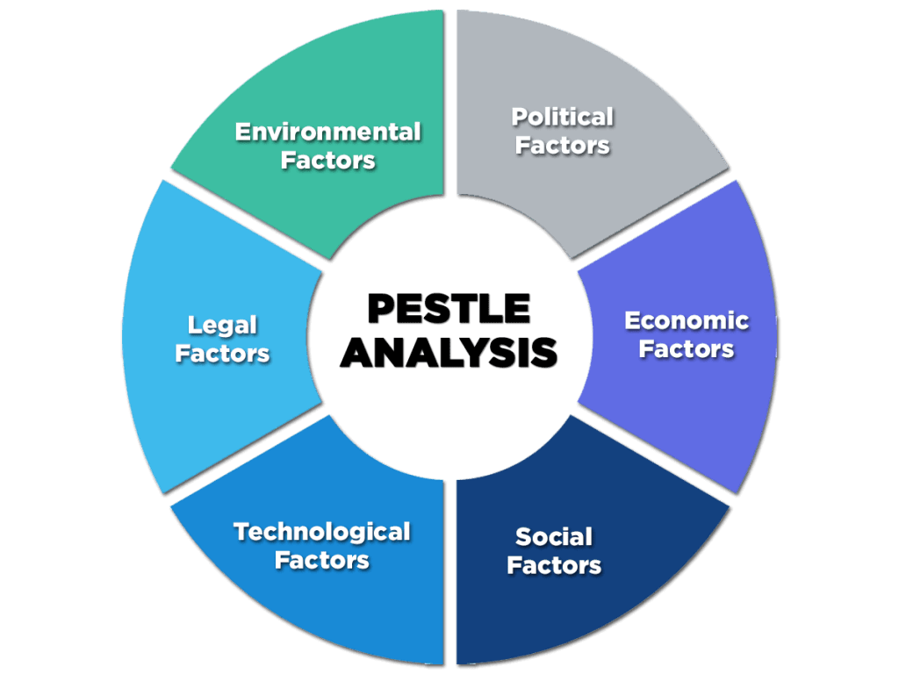
(Source: https://enterslice.com/learning/pestle-analysis-a-mechanism-for-analysis-of-businesses/)

4.0 Conclusion
The conclusion of report is that the Houman Resource Management Department have specialties to remove the negative sense amongst the employees during the Covid Pandemic. It has been analysed that HRM has objectives for the organization to Achieve Integration to prepare vertical alignment of the HRM strategy alongwith business strategies as well as prepare horizontal integration of HR strategies and to provide a meaning at the time of unfavourable environment so that need of organization and peoples can be completed with the help of HR strategies and also to provide the contribution in business strategy by giving attention on the ways from which, the organization can take advantages of their human resources. The report consist the evaluation report of labour work in developed and developing countries as well as UK alongwith the discussion of HMR strategy on it. Strategies of HRM in the post Covid and Braxit have also been play a key role to recover the labour market or any other external situations.

References:
Alvesson, M (2009, pp 52–67) The Routledge Companion to Strategic Human Resource Management:Critical perspectives on strategic HRM, in (eds) J Storey, P M Wright and D Ulrich, Abingdon:Routledge.

Armstrong, M. and Taylor, S. (2014) Armstrong’s Handbook of Human Resource Management Practice. Thirteenth Edition. UK: Ashford Colour press Ltd.

Becker, B. and Huselid, M. (1998, p.53-101) Research on Personnel and Human Resource Management: High Performance Work Systems and Firm Performance: A Synthesis of Research and Managerial Implications. Jai Press Inc.

Bieńkowska, A., Koszela, A., Sałamacha, A. and Tworek, K. (2022) COVID-19 oriented HRM strategies influence on job and organizational performance through job-related attitudes. Available at: https://journals.plos.org/plosone/article?id=10.1371/journal.pone.0266364 (Accessed: 15 December 2022)

Bosworth, D., Dawkins, P. and Stromback, T. (1996) The Economics of the Labour Market. Harlow:Addison Wesley Longman Ltd.

Edwards, D. (2021) Brexit and Jobs: What Does the UK Job Market Look like after Leaving EU. Available at: https://www.lexology.com/library/detail.aspx?g=24a77f96-5df8-4577-8781-d3eb139b5ef1 (Accessed: 25 December 2022)

International Labour Organisation (2022) ILO Monitor on the world of work. Tenth Edition. Multiple crises threaten the global labour market recovery

Office for National Statistics (2022) Labour Market Overview, UK. Available at https://www.ons.gov.uk/employmentandlabourmarket/peopleinwork/employmentandemployeetypes/bulletins/uklabourmarket/november2022/pdf (Accessed: 25 December 2022)

Powell, A., Devine, B. and Clark, H. (2022) Coronavirus Impact on the labour market. House of Common Library

Russell, T. (no date) A guide to Employment UK by law. Available at https://www.tim-russell.co.uk/upimages/Employment%20Guide.pdf (Accessed: 23 December 2022).

Serena, P. (2016, p.201-209) Labour Market- Concept, Function, Features, Patterns: Management Strategic Journal. Available at: http://www.strategiimanageriale.ro/papers/160429.pdf (Accessed: 25 December 2022)

Team FME (no date) PESTLE Analysis Strategy Skill. Available at: https://dl.icdst.org/pdfs/files3/30970b3e91cb4ab7175dd807e39c5134.pdf (Accessed: 25 December 2022)

Torrington, D., Taylor, L. and Atkinson, C. (2018) Human Resource Management. Tenth Edition. Harlow, United Kingdom: Pearson Education Limited.

Whitley, R. (1999) Divergent Capitalisms: The Social Structuring and Change of National Business Systems. Oxford: Oxford University Press.

