Coursework Title
Module Name: Computer Architecture & OS
Module Code: ACCA 4022
Student Name: SEYDINA NDOME
Student ID: 2504569
Lecturer Name: Md Shantanu Islam

Submission date: 27 Mars 2026

Contents
Introduction 4
Key functions of general Operating Systems 4
Task Management: 4
Application/Program Management: 4
File/Directory Management: 5
Device Management: 5
Security Management: 6
Use of Windows OS CLI commands 7
Example 1: 7
Example 2: 7
Example 3: 8
Example 4: 8
Example 5: 8
Example 6: 9
Example 7: 9
Example 8: 10
Example 9: 10
Example 10: 11
Use of Linux OS CLI commands 11
Example 1: 11
Example 2: 12
Example 3: 12
Example 4: 13
Example 5: 13
Example 6: 14
Example 7: 14
Example 8: 15
Example 9: 15
Example 10: 16
Use of Windows OS scripts 16
Example 1: 16
Example 2: 17
Use of Linux OS scripts 18
Example 1: 18
Example 2: 19
Conclusion 20
References 20
Appendices 21

Introduction
This course offers a thorough examination of fundamental operating system features, particularly contrasting Windows and Linux environments via their Command Line Interfaces (CLI). The first section of the study outlines the fundamental OS functions, including task, application, file, device, and security management. The report's main focus is on real-world applications, with 10 distinct CLI command examples for Linux and Windows to illustrate system administration and troubleshooting. It also looks at automation through scripting, examining Batch scripts in Windows and Bash scripts in Linux that carry out conditional logic, arithmetic operations, and repeated loops.
(100 words)

Key functions of general Operating Systems
Since its 1985 release, Microsoft Windows has grown to become the most popular graphical operating system worldwide. It is essential for offering an intuitive interface that controls hardware, runs programs, and protects data. In order to ensure effective system performance, its fundamental tasks include peripheral control, memory management, and CPU scheduling . [1] [2] (50 words)

Task Management:
The Task Manager tool, which enables users to keep an eye on and manage running processes, is the main tool used for task management in Windows. It helps discover applications that affect system performance by providing real-time data on hardware resource use, such as CPU, memory, and disk usage. This tool allows users to monitor network activity, control launch applications to speed up boot times, and "End Task" sluggish programs. When a personal computer is multitasking, effective task management guarantees that the operating system distributes resources appropriately, preserving overall system stability and responsiveness. [3] (100 words)
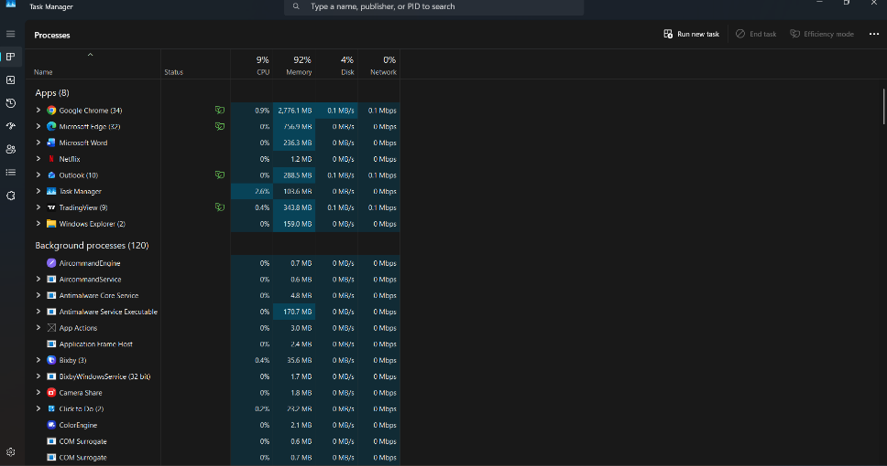
Figure 1: Task Management

Application/Program Management:
The complete process of managing software during its whole existence, including installation, upkeep, and optimization, is known as application management in Windows. To guarantee that apps are installed safely and continue to work with system updates, the operating system makes use of specialized tools like the Microsoft Store and the Windows Installer (MSI). Because the OS controls how programs utilize CPU, memory, and disk space to prevent system failure, this management is essential for resource efficiency. Windows guarantees that software stays dependable, safe, and in line with user needs by centralizing these functions. [4]
(100 words)
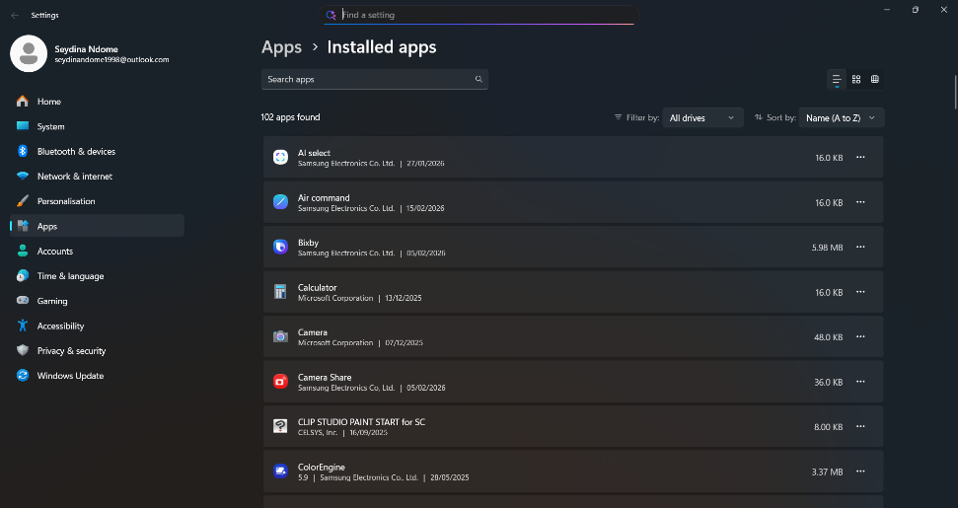
Figure 2: Application/Program Management

File/Directory Management:
The process of arranging, storing, and retrieving data utilizing a hierarchical system of drives, folders, and files is known as file/directory management in Windows. The NTFS (New Technology File System) is used by this system, which is mostly controlled by File Explorer, to monitor file locations, permissions, and attributes. Effective administration guarantees that information is easily available while enabling users to carry out necessary tasks including producing, renaming, relocating, and deleting data. Additionally, the operating system protects sensitive data from unwanted access by enforcing security through Access Control Lists (ACLs) and managing "metadata"—information about the file, such as its size and creation date. [5](100 words)

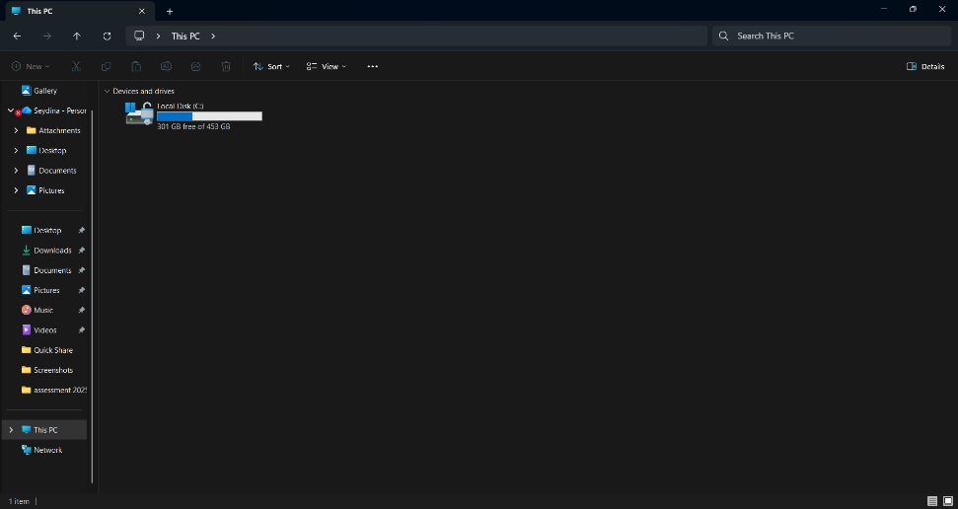
Figure 3: File/Directory Management

Device Management:
In Windows, device management refers to the process of managing and coordinating hardware that is connected to the computer, including keyboards, printers, and disk drives. Device drivers are used by the operating system to provide effective communication between the hardware and the software. The Device Manager tool, which enables users to examine status, update driver software, or disable malfunctioning hardware, is essential to this. Windows maintains system stability and avoids hardware conflicts by controlling these physical and virtual devices, enabling the CPU to effortlessly communicate with different peripherals to carry out essential input and output tasks. [6](100 words)
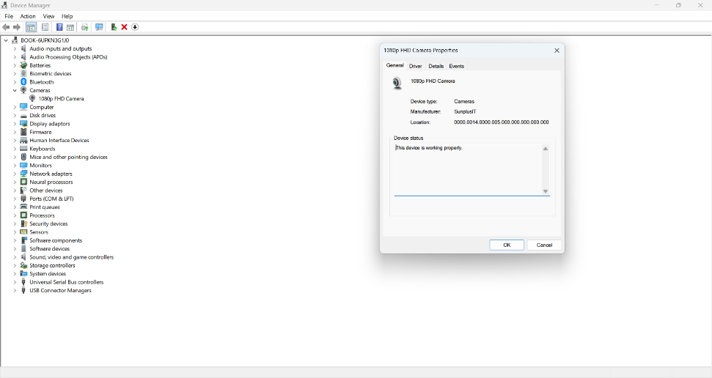
Figure 4: Device Management

Security Management:
Security management in Windows is a multi-layered process designed to protect the system’s integrity, confidentiality, and availability. It primarily utilizes Windows Security (formerly Windows Defender), which provides real-time protection against viruses, ransomware, and phishing attacks. The system also employs User Account Control (UAC) to prevent unauthorized changes by requiring administrative approval for high-level tasks. Additionally, Windows uses the NTFS file system to manage specific user permissions through Access Control Lists (ACLs). According to Microsoft (2024), these integrated security features work together to create a secure environment by monitoring network traffic via the Windows Firewall and ensuring that only trusted software can execute on the device. [7] (100 words)

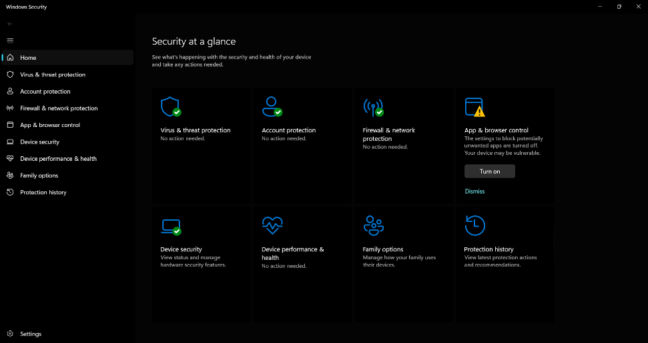
Figure 5: Security Management

Use of Windows OS CLI commands
A potent substitute for the graphical user interface, the Windows Command Line Interface (CLI) enables users to communicate with the operating system via text-based commands. It is crucial for carrying out sophisticated system troubleshooting, effectively administering distant servers, and automating repetitive activities using scripting. [8](40 words)

Example 1:
DIR . To list every file and subdirectory inside a given directory, use the dir command. It offers information such as file size, the total number of files, and the date of last modification.
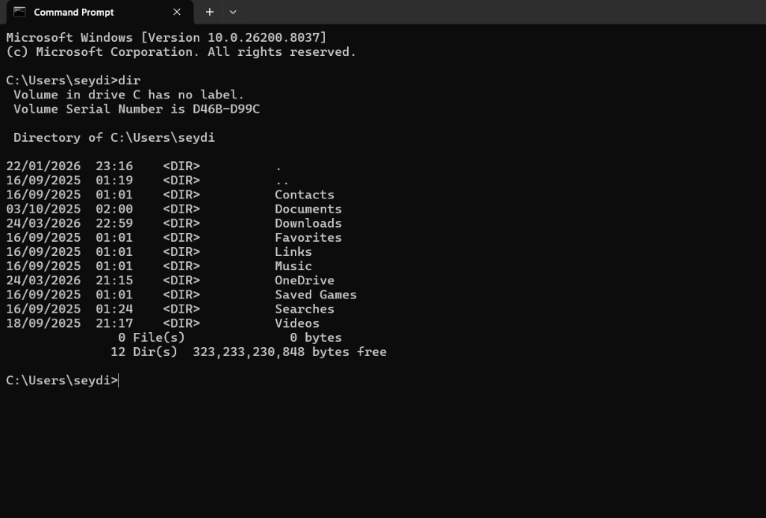
Figure 6: DIR

Example 2:
CD. The user can move between folders by using the cd (Change Directory) command. For example, the command cd.. advances the user to the parent directory by one level.
(30 words)
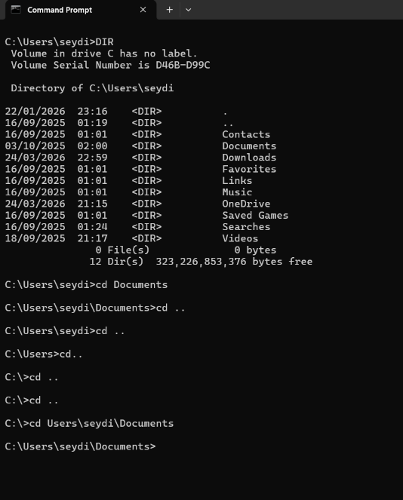
Figure 7: CD

Example 3:
MKDIR. This command, also called md, helps with orderly file management by creating a new directory or folder at the given path.
(30 words)
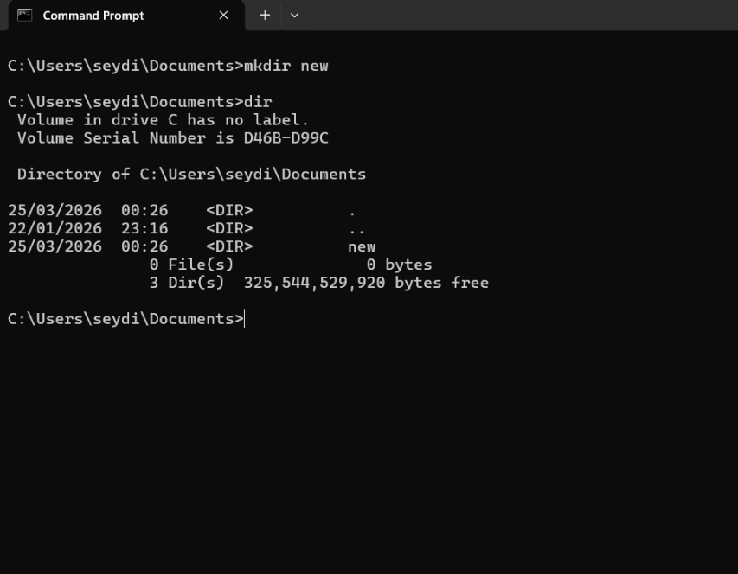
Figure 8: MKDIR

Example 4:
RMDIR. To delete an empty directory from the system, use the rmdir (or rd) command. Directories that still contain files cannot be deleted. (30 words)
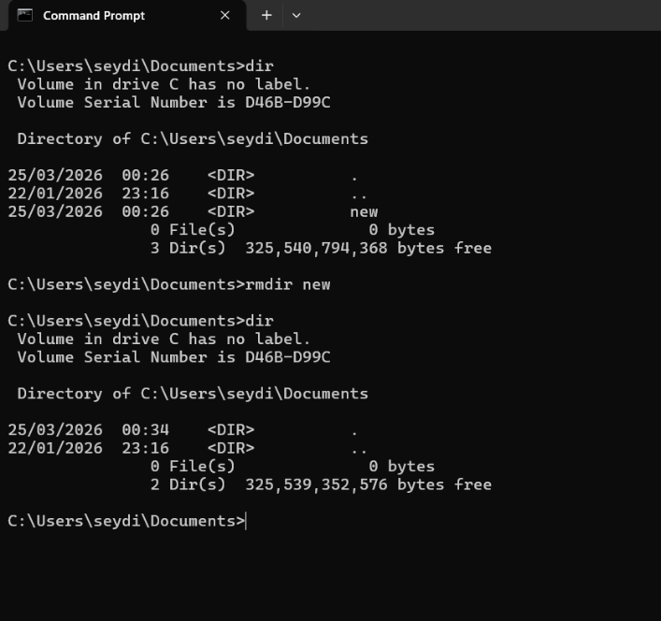
Figure 9: RMDIR

Example 5:
The echo command in Windows CLI is used to display messages or turn command echoing on/off. It is frequently used in batch scripts to provide user feedback or create text files. (30 words)
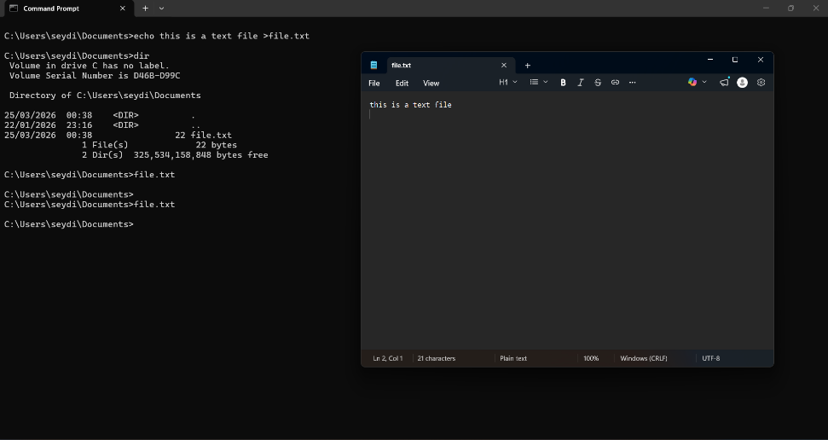
Figure 10: echo

Example 6:
The tasklist command displays a comprehensive list of all currently running processes on a local or remote computer. It provides essential details like Process ID (PID) and memory usage for troubleshooting. (30 words)
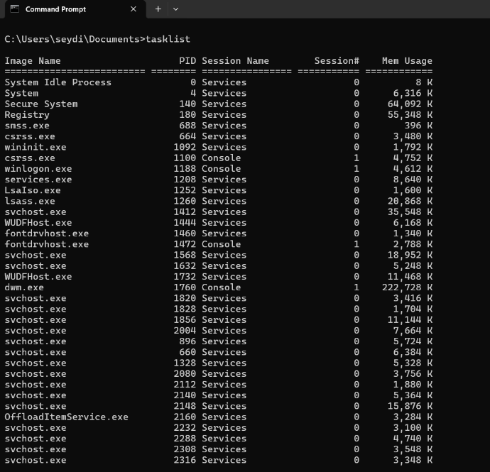
Figure 11: tasklist

Example 7:
A useful tool for displaying comprehensive configuration data about the computer and its operating system is the systeminfo command. The OS version, BIOS information, memory capacity, network adapter settings, and installed hotfixes are examples of important hardware and software data. (30 words)
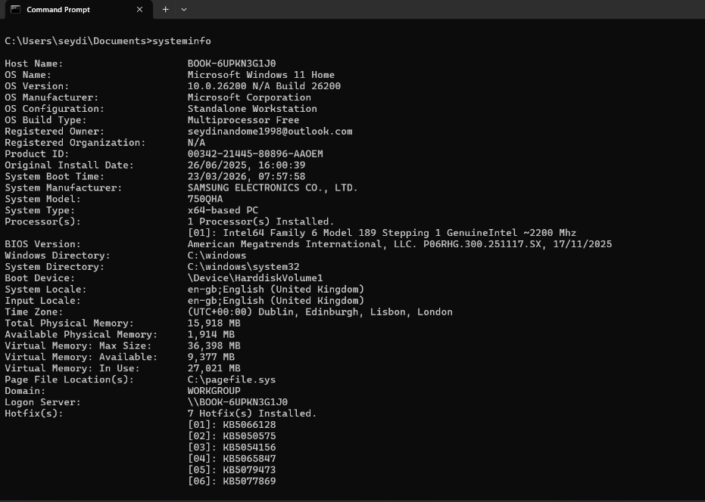
Figure 12: Systeminfo

Example 8:
The ipconfig /all command displays a detailed summary of all network adapters. It provides essential data like MAC addresses, DHCP status, and DNS servers, which is crucial for advanced network troubleshooting.
(30 words)
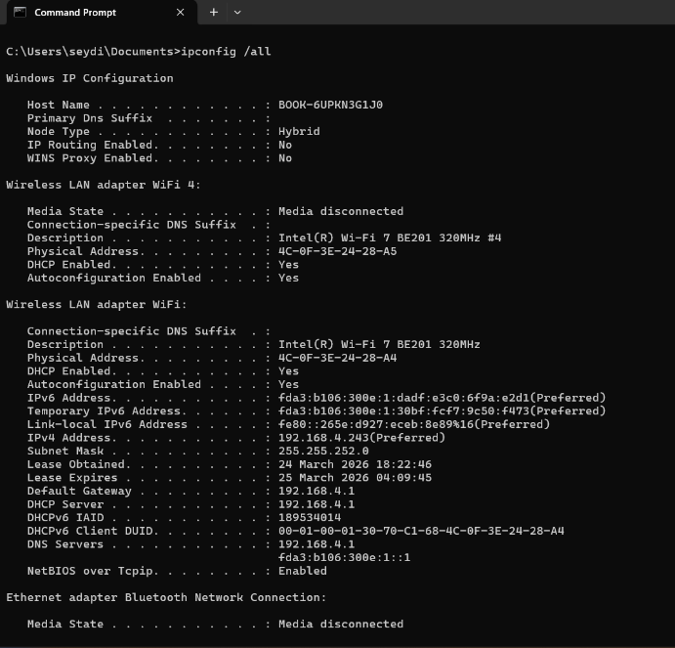
Figure 13: Ipconfig /all.

Example 9:
The ping command tests network connectivity by sending ICMP packets to a specific IP or domain. The output shows response time and packet loss, helping diagnose if a host is reachable. (30 words)
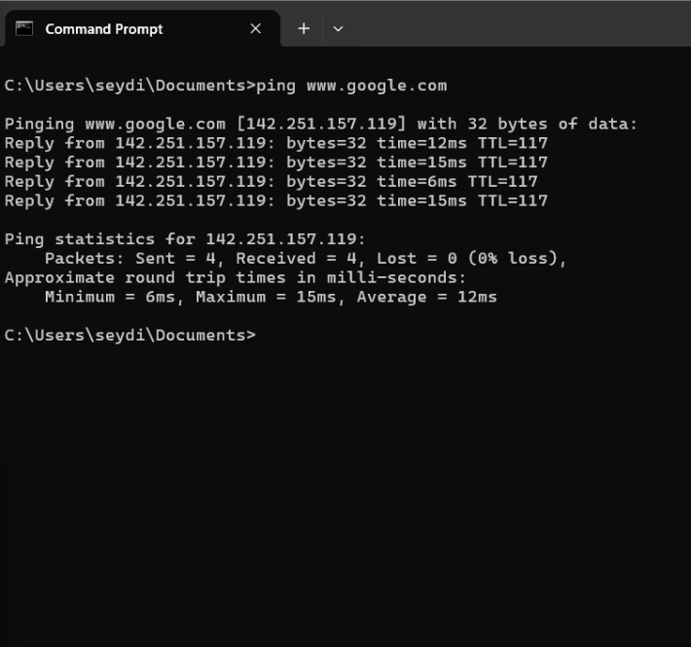
Figure 14: Ping.

Example 10:
The tracert command tracks the path a packet takes to a destination, listing every router (hop) passed. It is used to identify where network delays or connection failures occur. (30 words)
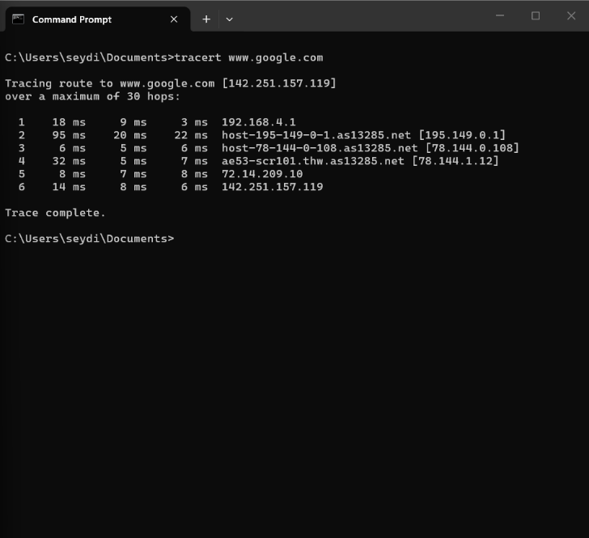
Figure 15: Tracert

Use of Linux OS CLI commands
Direct communication with the system kernel is possible using the text-based Linux Command Line Interface (CLI). It provides fine-grained control over file systems and network configurations through effective shell commands, making it indispensable for server management, automation, and development. [9](40 words)

Example 1:
The su command allows a user to switch to another user account, typically the root superuser, during a terminal session. The output requests a password to grant administrative privileges. (30 words)
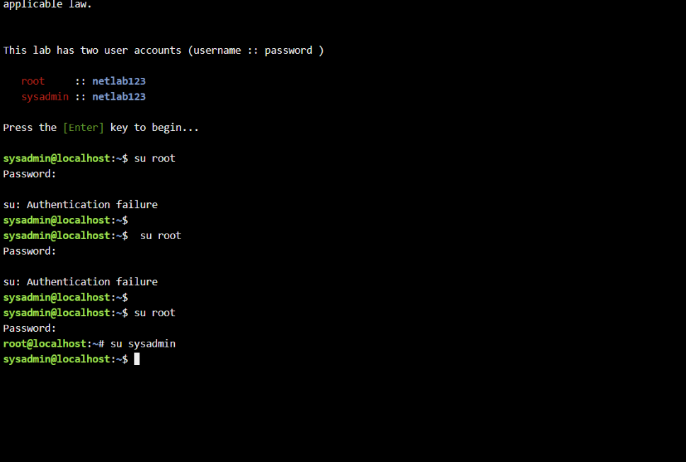
Figure 16: su

Example 2:
This command, which stands for "Print Working Directory," shows the user's current directory's complete absolute path. (30 words)
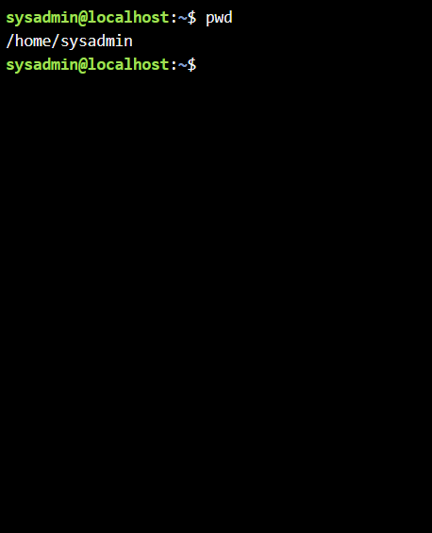
Figure 17: pwd

Example 3:
Used to enumerate a directory's contents. Frequently used flags, such as -l, display specific file ownership, rights, and sizes. (30 words)
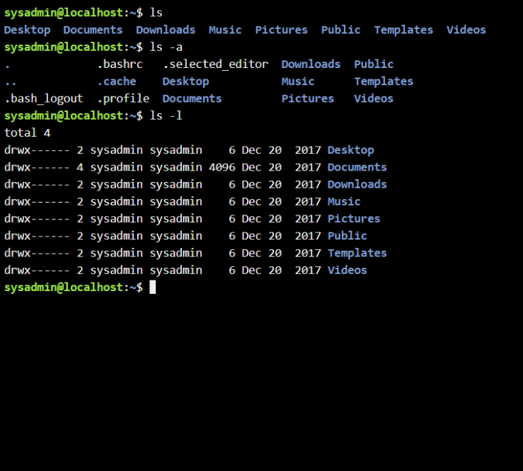
Figure 18: ls

Example 4:
Similar to Windows, cd is used to change the current workspace to a different directory using forward slashes (/) as separators. (30 words)
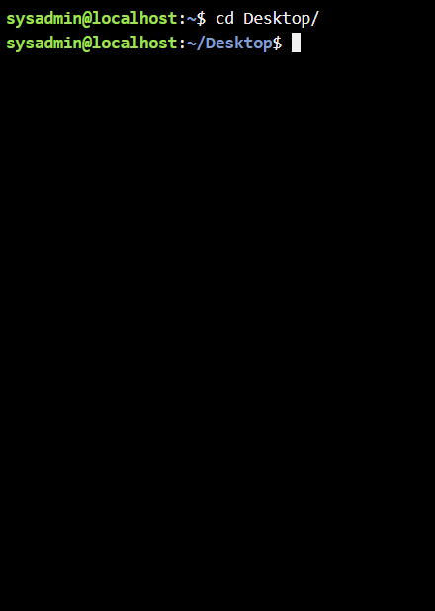
Figure 19: cd

Example 5:
This command creates a new directory. Using the -p flag allows the creation of parent directories simultaneously if they do not exist. (30 words)
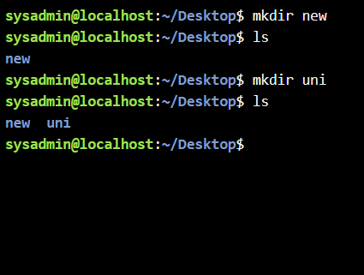
Figure 20: mkdir

Example 6:
Removes empty directories. For directories with content, the rm -r command is typically used instead. (30 words)
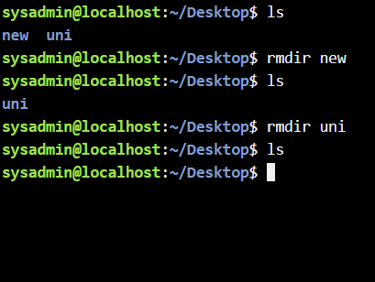
Figure 21: rmdir

Example 7:
A quick way to create a new, empty file or update the timestamp of an existing file. (30 words)
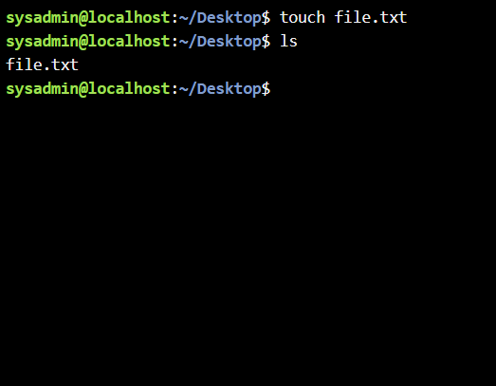
Figure 22: touch

Example 8:
Echo generates text, cat shows it on the terminal, and rm removes the file. The output displays the file's creation, content verification, and eventual removal. (30 words)
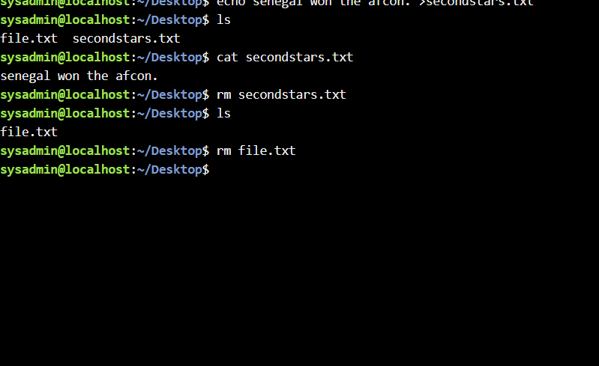
Figure 23: echo,cat,rm

Example 9:
Used to configure or display information about network interfaces. It shows IP addresses, MAC addresses, and data packet statistics. (30 words)
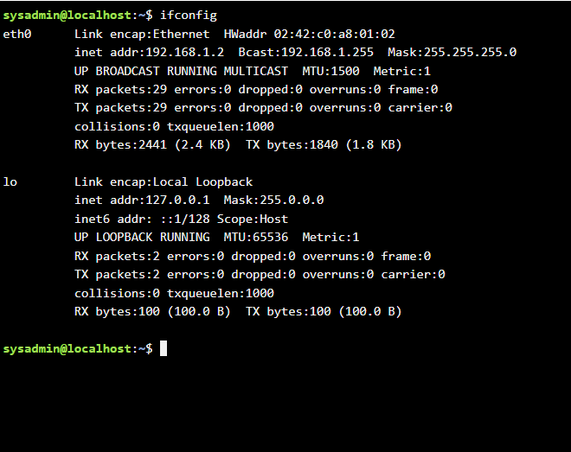
Figure 24: ifconfig

Example 10:
whoami displays the username of the current effective user, while date shows the current system time and date. (30 words)
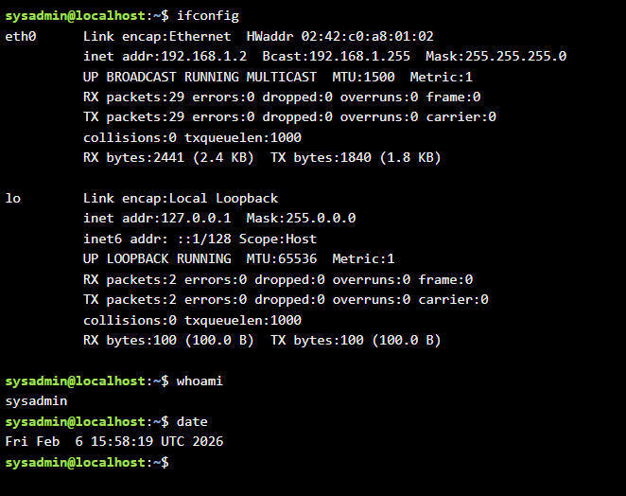
Figure 25: whoami, date

Use of Windows OS scripts
Batch scripting involves creating a .bat or .cmd file containing a sequence of commands executed by the cmd.exe interpreter. It is primarily used for automating repetitive tasks like file backups, software installations, and system configuration. [10] (50 words)

Example 1:
Explain the script and output. This Windows Batch script shows how to automate a basic calculation using variables and arithmetic operations. To make sure the terminal only shows the results and not the code itself, the script starts with @echo off. It makes use of the set /a command, which is the particular syntax needed to carry out numerical computations in the Windows CLI. In this case, the values of 46 and 46 are given to two variables, and their sum is stored in a third variable.
The final result, "The sum is 92," is then output using the echo command, giving the user unambiguous feedback. In administrative settings, this kind of scripting is essential for activities like maintaining IP ranges, calculating disk space, and automating financial data logging. The accompanying output demonstrates the effectiveness of CLI-based automation for simple logic operations by confirming that the Windows command processor correctly interpreted the variables and carried out the addition without error.
(150 words)
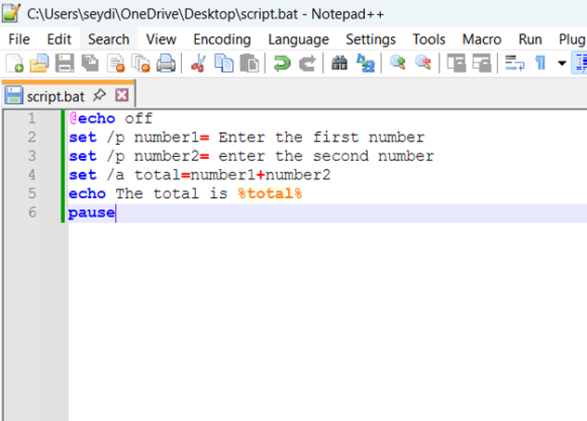
Figure 26: Description
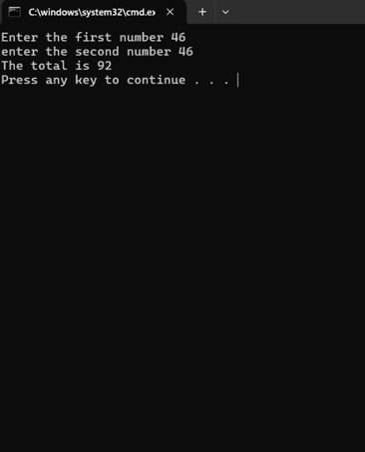
Figure 27: Description

Example 2:
This Windows Batch script uses conditional logic and human interaction to establish age-based eligibility. To keep the interface tidy, it starts with @echo off. The set /p command, which pauses the script's execution to let the user enter data—in this case, their age—is used by the script to assign that input to the variable %age%. In order to create dynamic scripts that react to various user data instead than depending on hardcoded values, this method is essential.
The IF/ELSE statement is the primary component of the script. It determines whether the entered age is 18 years of age or older using the comparison operator geq (Greater Than or Equal To). A celebratory message is echoed if the condition is satisfied; if not, the otherwise block is triggered to notify the user that they are unable to cast a ballot. Two scenarios are shown in the accompanying output images: one in which entering "12" yields a negative response, and another in which entering "27" verifies voting eligibility. Administrative scripts that must execute distinct tasks depending on system status or user rights require this logic. (150 words)
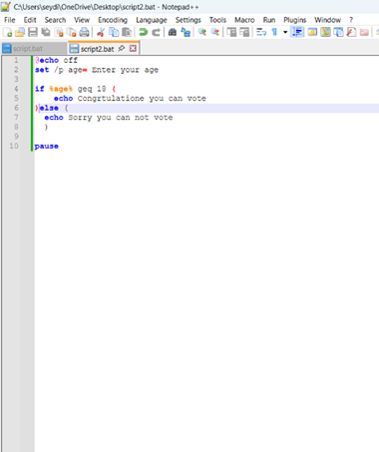
Figure 28: Batch stript adding number
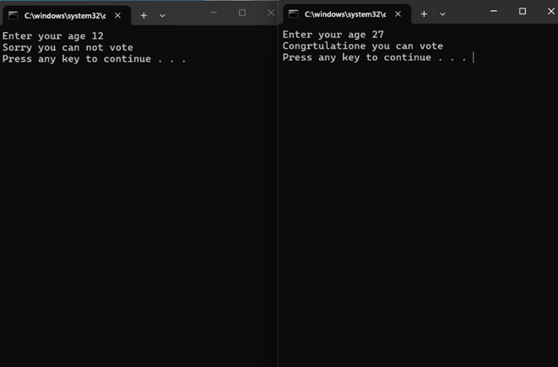
Figure 29: Batch stript adding number

Use of Linux OS scripts
Creating a.bat or.cmd file with a series of commands that are run by the cmd.exe interpreter is known as batch scripting. Automating repetitious operations like software installations, file backups, and system configuration is its main usage. [11] [12](50 words)

Example 1:
This Linux Bash script illustrates the basic procedure of obtaining user input to carry out dynamic computations. It was written using the Nano text editor. It uses the read command, which pauses execution to collect numerical input from the user and store it in variables num1 and num2, in contrast to a static script. A key component of shell scripting is its interactivity, which enables flexible tools that can instantly process various data sets.
The total=$((num1+num2)) syntax is used to handle the mathematical operation through arithmetic expansion. This instructs the Bash shell to evaluate the expression enclosed in double parenthesis as a sum. The final outcome is then shown to the terminal with the echo command. The output image's main detail initially displays a "Permission denied" error, which is a typical Linux scenario that happens when a script doesn't have executable permissions. Usually, the user needs to use chmod +x to fix this before the script can output "the sum is 92." This process emphasizes how crucial file system security and proper reasoning are in Linux systems.
(150 words)
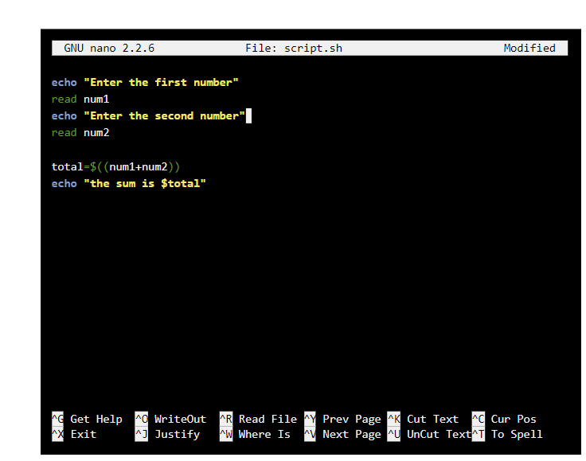
Figure 30: Bash script adding number
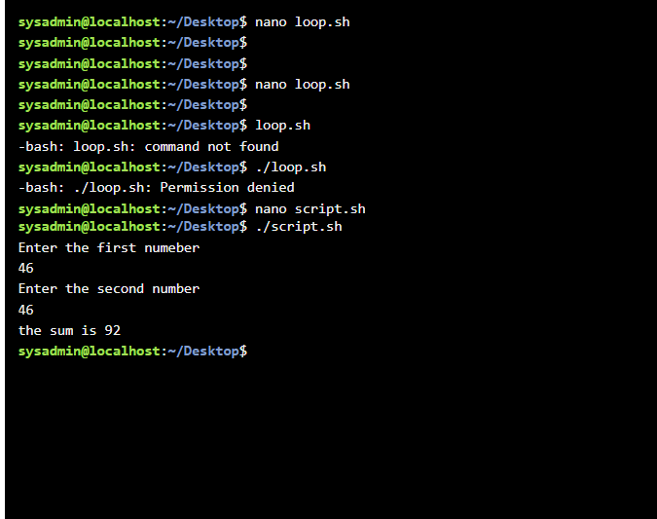
Figure 31: Bash script adding number

Example 2:
This Linux Bash script, loop.sh, shows how to automate repeated activities using a for loop. The Nano text editor is used to write the script, which uses the conventional C-style loop syntax for ((i=0; i<10; i=i+1)). The variable i is initialized at 0 by this instruction, and it keeps increasing by 1 as long as the value is less than 10. The echo command outputs the variable's current value to the terminal on each run.
The script's lifespan is verified by the terminal output. The user applies chmod +x loop.sh to grant the required executable rights after using the cp (copy) command to move the file to the Desktop. The terminal successfully shows a vertical succession of numbers from 0 to 9 after executing ./loop.sh. This experiment demonstrates how the Linux file system necessitates specific permission management for script execution and how shell scripting may effectively handle iterative logic.

(150 words)
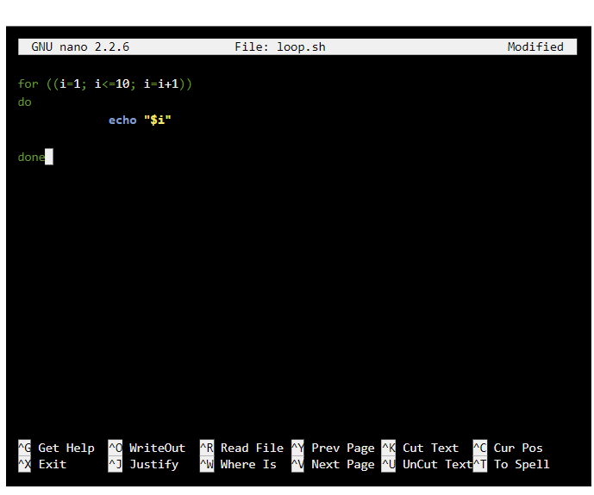
Figure 32: Description
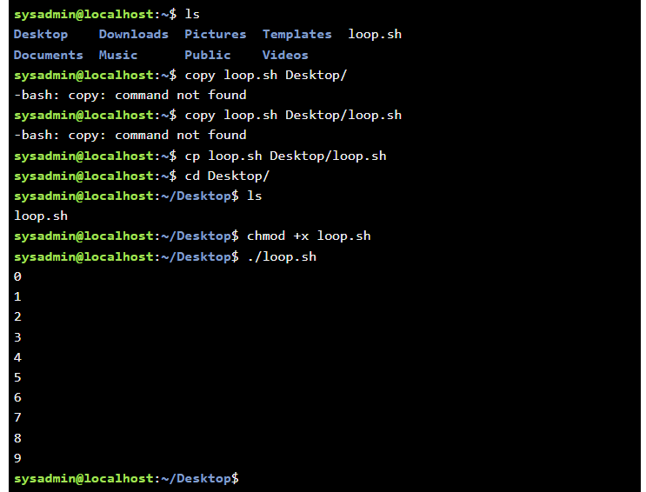
Figure 33: Description

Conclusion
This study successfully compared the Linux and Windows operating systems using scripting and CLI commands. I now understand how both platforms manage files, tasks, and automation in a useful way. Running arithmetic and conditional scripts taught me the importance of exact syntax and file permissions in professional system management.(50 words)

[13]References

[1] | D. C. a. B. P. A. Tsichritzis, Operating systems, 2014.
[2] | synchronet, synchronet. [Online]. [Accessed 11 02 2026].
[3] | S. a. P. J. Khanista and Karnbunjong, 2019 IEEE Asia Pacific Conference on Circuits and Systems, 2019.
[4] | K. a. W. M. a. C. R. a. B. K. P. Marzullo, Tools for distributed application management, 1990.
[5] | A. Ayshwariya, to Mobile Using File Directory, 2023.
[6] | Microsoft, “What does device management mean for organizations?,” [Online]. Available: https://learn.microsoft.com/en-us/intune/intune-service/fundamentals/what-is-device-management#:~:text=Microsoft%20Intune%20is%20a%20device%20management%20solution,corporate%20network%20and%20data%20from%20unauthorized%20access. [Accessed 22 03 2026].
[7] | Microsoft, “What is Microsoft Security Exposure Management?,” Microsoft, [Online]. Available: https://learn.microsoft.com/en-us/security-exposure-management/microsoft-security-exposure-management. [Accessed 22 03 2026].
[8] | R. a. G. A. K. Banoth, The Windows Operating System, Linux Overview}, 2026.
[9] | ubuntu, “The Linux command line for beginners,” ubuntu, [Online]. Available: https://ubuntu.com/tutorials/command-line-for-beginners#1-overview. [Accessed 22 03 2026].
[10] | .tutorialspoint. [Online]. Available: https://www.tutorialspoint.com/batch_script/index.htm. [Accessed 23 03 2026].
[11] | L. L. TV, “How To Write Bash Scripts In Linux,” [Online]. Available: https://www.youtube.com/watch?v=2733cRPudvI. [Accessed 20 03 2026].
[12] | freecodecamp., “Bash Scripting Tutorial – Linux Shell Script and Command Line for Beginners,” 20 03 2023. [Online]. Available: https://www.freecodecamp.org/news/bash-scripting-tutorial-linux-shell-script-and-command-line-for-beginners/. [Accessed 20 03 2026].
[13] | [Online].
[14] | [Online].

Appendices
Online Course name: Linux Unhatched
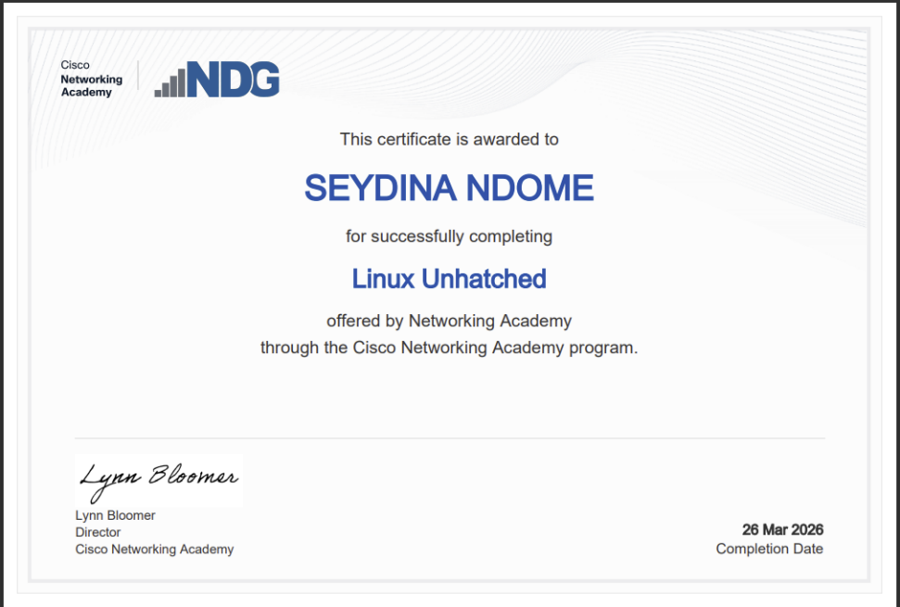
Figure 34: Certificate of completion

