Investigating the Effectiveness of Machine Learning Classifiers for Email Spam Detection
Research Proposal

Student Name: Jaraben Mangukiya
Student ID: 2434479
Programme: MSc Computing
Module Title: Research Methods and Professional Development
Module Code: ACFA7004

Table of Contents
1. Introduction 2
1.1 Context and Background 2
1.2 Research Problem 3
1.3 Research Aim and Objectives 4
1.4 Significance of the Research 5
2. Literature Review 6
2.1 Purpose and Scope of the Literature Review 6
2.2 Classical Machine Learning Approaches to Spam Detection 6
2.3 Ensemble Learning Techniques 8
2.4 Deep Learning Approaches to Spam Detection 9
2.5-Theories and Technical Frameworks Supporting Spam Detection Research 10
2.6 Research Gaps and Positioning of the Current Study 11
2.7 Summary of the Literature Review 11
3. Research Design and Methodology 12
3.1 Research Design 12
3.2 Research Methods and Materials 13
3.2.1 Research Methods 13
3.2.2 Research Materials 16
4. Expected Outcomes 18
5. Project Timeline 19
References 21

1. Introduction

1.1 Context and Background
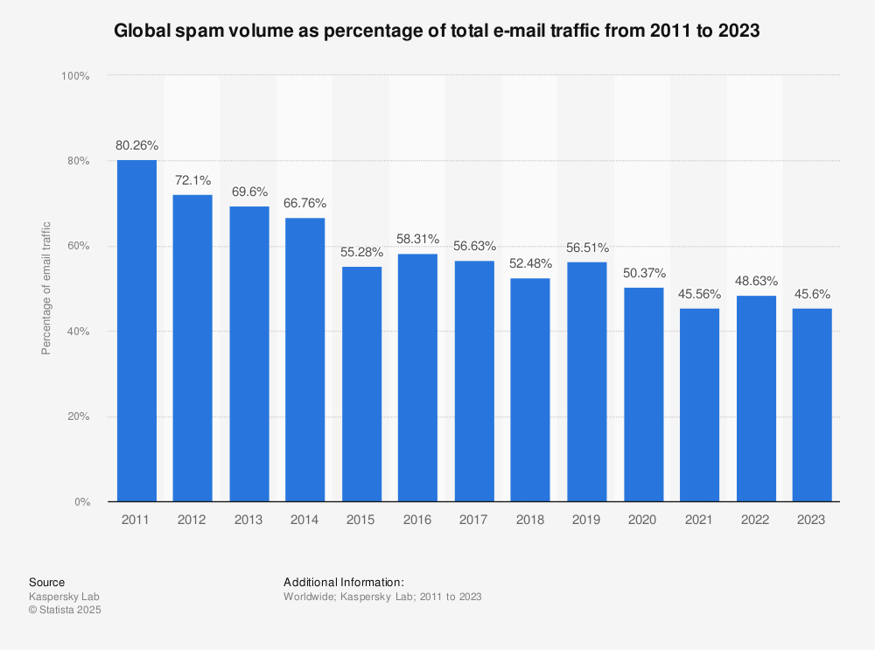
Figure 1: Global email usage and spam prevalence trends (Source: Statista; SecureList; EmailToolTester)
In the latest survey of 2024, industry analysts estimated that about 4.5 billion people worldwide use email as their main medium of communication, growing steadily with increased collaboration over the cloud, e-commerce, and remote work adoption. Perhaps this steady growth in email users has gone hand in hand with an unprecedented rise in cyber threats transmitted via email. Empirical security reports suggest that as of 2024, 46% to 47% of all emails sent on a daily basis were classified as spam—an amount that could essentially translate to over 160 billion spam mails sent daily. Many of these are not simply financial spam advertisements; rather, spam has increasingly evolved into weaponry for phishing, ransomware, harvesting credentials, stealing identities, and launching business email compromises (BEC) attacks.
Various surveys show how dramatically the spam paradigm has changed over the past fifteen years. Earlier spam items were easy to detect: poorly phrased emails that looked wide distinct from legitimate communication. Spam, on the other hand, seemed to be delicately transformed into these budding impression applications these days through AI and natural-language-generating techniques that formulate persuasive phishing emails instead. By virtue of its linguistics soundness and contextual relevance, these kind of AI-created messages are very good at bypassing detection by static filters and prey on humans' cognitive biases of urgency, authority, and familiarity.
In parallel with this, the technical side of email spam detection has gone from heuristic and signature-based models toward machine-learning (ML) and deep-learning (DL)-based approaches. Classical ML algorithms such as Naïve Bayes, Logistic Regression, and Support Vector Machines (SVMs) have, in fact, been quite successful for text classification ones, thanks to their probabilistic nature, linear separability, and robustness in high-dimensional parameter spaces. These models lose feature extraction techniques such as the Term Frequency–Inverse Document Frequency (TF-IDF) algorithms to evaluate the importance of specific text patterns to a corpus of emails.
Recently, Long Short-Term Memory (LSTM) networks and bidirectional LSTM models have been implemented to capture sequential dependencies, semantic context, and temporal patterns in the text of emails. Unlike classic ML algorithms, the LSTM can model long-term dependencies and contextual word relations, allowing for a more refined discrimination of sophisticated phishing tales. Experimental studies from 2021 to 2024 have shown deep learning approaches to spam filtering achieving classification accuracies greater than 97%, with the majority outperforming traditional approaches in recall and F1-score.
Nonetheless, the very rapid evolution of spam tactics, generative AI in particular, is constantly testing the robustness, scalability, and generalization of the existing detection systems. This is why email spam detection is and shall remain an active, and strategically important research field for cybersecurity, natural language processing, and applied machine learning; this basically appeals to organizations seeking rich email security solutions that are also cost-effective.

1.2 Research Problem
Although machine learning-based spam filters have gained widespread deployment in commercial email systems, several operational challenges still seriously threaten their effectiveness. Among the foremost of these are the terribly high false-positive rates, that cause legitimate emails to be marked as spam. In organizational environments, false positives mean miss a business opportunity, disrupt workflow, fall foul of regulatory compliance, and undermine user trust in the so-called automated security. Studies point out that just a small increase in false positive rates can bring heavy productivity losses on organization settings.
The second core problem is the class imbalance in the spam data sets. In most real-life examples, a predominant number of either spam or legitimate emails are found depending on the way they are collected. This leads to biased classifiers for the majority class, inflating accuracy measures while covering up poor precision or recall for minority classes. Thus, the models may appear to perform well during evaluation but would poorly detect rare but very damaging phishing attacks in real-world environments.
Poor generalization and concept drift are the third challenges. Many machine-learning apps are trained on legacy data sets that contain spam patterns identified a long time ago and have little bearing on the current threats. With the emergence of AI-phishing emails, attackers can dynamically adjust syntax, semantics, and intent, thereby rendering null and void the traditional static feature representation. Hence models developed based on historical data sets are subjected to performance degradation when facing spam types not seen within the timeframe of training, indicating diminishing flexibility and long-term reliability.
Next to that, besides these technical limitations, usually found in the literature is a systematic methodological gap: a lack of consideration related to benchmarking across studies. Many evaluations do use diverse datasets, different preprocessing pipelines, various ways in train-test splits, and diverse metrics in measuring performance, making it difficult to directly compare the classifiers. There is, therefore, not much empirical evidence as to which machine learning family—classical, ensemble, or deep learning—strikes the best balance between detection accuracy, computational efficiency, and robustness when put under strictly controlled and standardized conditions.

1.3 Research Aim and Objectives
Research Aim
The objective of this research is to set up systematic trials for comparative study in a normalised manner, through which the usefulness of different machine learning classifiers can be gauged for email spam detection using present datasets, standardised preprocessing, and exhaustive evaluation metrics. The result is expected to spawn the most effective and usable solution for modern-day challenges of email security.
Research objectives
- To conduct a systematic and critical literature survey over the period 2021–2024 on classical machine learning, ensemble learning, and deep learning methods of email spam detection.
- To preprocess having benchmark spam datasets using consistent standard text-processing methods: tokenisation, stop-word removal, stemming, and TF-IDF feature extraction.
- To implement and train representative classifiers from various machine-learning families, including Naïve Bayes, logistic regression, support vector machines, random forests, and LSTM networks.
- The performance of a classifier shall be evaluated against different metrics, such as accuracy, precision, recall, F1-Score, ROC–AUC, and confusion matrix, to offset a bias for any one metric.
- To identify the most powerful classifier and critically analyse its strengths, weaknesses, computational trade-offs, and real-life application suitability.

1.4 Significance of the Research
This research carries significance both academically and practically. Academically, it aids a holistic, benchmark-based comparison across several paradigms of machine learning based on standardised datasets and from an evaluative framework, which aims to close a recognised gap in the recent spam-detection literature. By deviating from accuracy-centric evaluation and placing an emphasis instead on robustness and generalisation, this work also serves to enhance methodological rigour.
On a practical note, the findings provide evidence-based recommendations to inform institutions, cybersecurity practitioners, and system designers on the effective design of spam filters that optimise for low false positive rate and high detection accuracy. By explicitly analysing performance–cost trade-offs, the research advances informed decision-making on selecting machine learning-based email security solutions by end-users operating in resource-constrained and large-scale environments.

2. Literature Review

2.1 Purpose and Scope of the Literature Review
The purpose of this literature review is to critically examine contemporary research on machine learning-based email spam detection in order to identify dominant trends, methodological approaches, theoretical foundations, and unanswered gaps in the field. The review will observe the rapid evolution of spam techniques, especially with the increasing use of AI-generated phishing content. More so, this review will centre peer-reviewed studies published between 2021 and 2024, ensuring that the discussion relates to the present cybersecurity challenges and technology capabilities (Sharma et al., 2023; Almuskait & Alshamrani, 2024).
The scope of the review covers three core methodological categories that dominate the literature: classical machine learning models, ensemble learning techniques, and deep learning architectures for textual spam classification. We adopt a thematic structure to allow for critical comparison of model performance, scalability, and applicability in expectations of analytical synthesis and evaluative engagement with scholarly literature.

2.2 Classical Machine Learning Approaches to Spam Detection

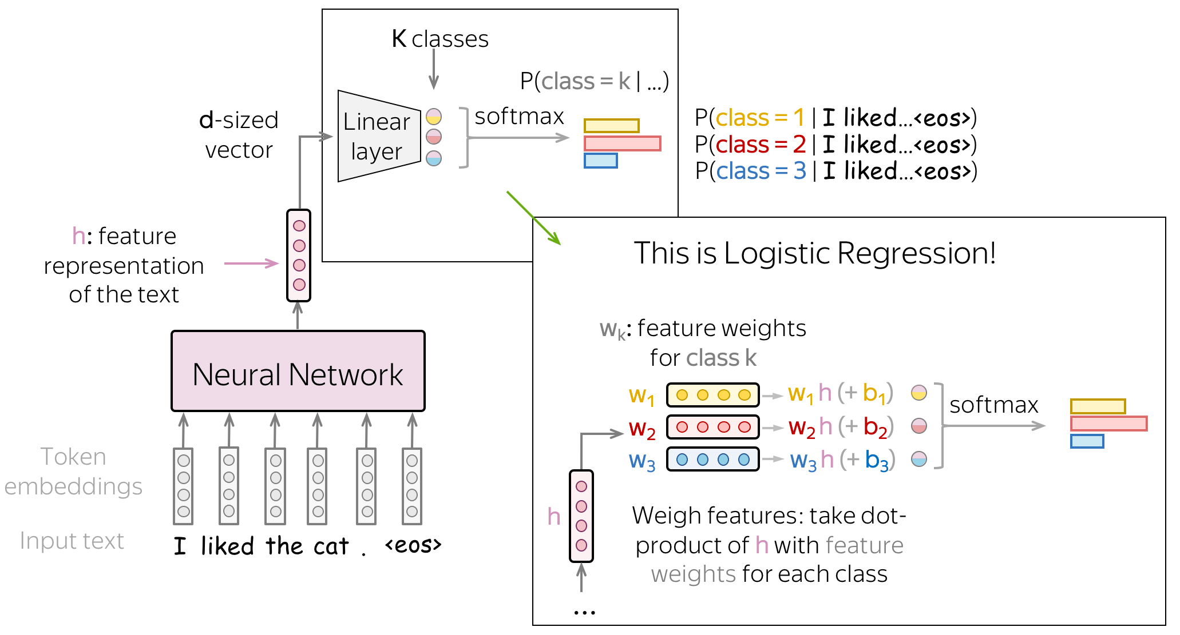
Figure 2: Classical ML pipeline for spam detection using TF-IDF and linear classifiers
Among the methods usually employed for detecting spam in emails, classical machine learning techniques are proving to be of great importance since they are effective and efficient in terms of computation and interpretation, and can work well in high-dimensional text spaces. The Naïve Bayes (NB) classifiers are among the most popular types of baseline models. Its probabilistic framework is rooted in Bayes' theorem and is therefore well-suited for sparse representations of features as TF-IDF vectors used in text classification. It has been reported that classification accuracies range from 94% to 96% lately, indicating that NB models can compete despite the simplifying independence assumptions (Sharma et al., 2023).
And increasingly reviewed in spam detection research are Support Vector Machines since it creates optimal separating hyper planes in high-dimensional feature spaces. Guzella and Caminhas (2023) also note that these systems have robustness against noisy and obfuscated features of spam; thus, very fine when combined with TF-IDF representations and linear kernels. With empirical comparisons, these results will show that SVMs will be better than Naïve Bayes in terms of precision and recall, therefore, SVMs are suitable in reducing false positives in the environment of operation.
Logistic Regression (LR) is widely accepted in enterprise and regulatory environments that require model transparency and interpretability. Although the peak accuracy of LR models is slightly lower than that of SVM, probabilistic outputs and explainable coefficients enhance auditability and trust in automated decision-making systems (Zhang et al., 2023). However, a common limitation in these classical ML models is that they are mainly manual feature engineering-dependent; thus, adaptability to rapidly changing spam tactics is constrained.

2.3 Ensemble Learning Techniques

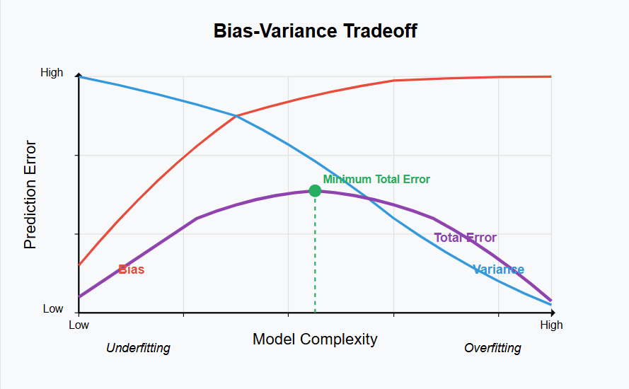
Figure 3: Ensemble learning architecture and bias–variance trade-off in spam detection
Ensemble learning methods have been gathering communication to improve classification robustness, comparably mitigate overfitting through the aggregation of multiple base learner predictions. Among spam detection studies, Random Forest (RF) classifiers are the most widely applied ensemble procedure. By aggregating many decision trees trained on a mixture of random subsets of features and samples, RF models reduce variance in cases where modeling is difficult due to an imbalanced dataset and better generalization performance (Sharma et al. 2023).
Recent empirical studies show that RF models deal well with heterogeneous spam features, including features like lexical patterns, metadata, and stylistics. RF classifiers often equal or outperform classical ML in comparative evaluations while offering better recall for minority classes (Guzella & Caminhas, 2023). However, enhanced performance comes at increased computational complexity and decreased interpretability, creating potential limitations to real-time deployment in large-scale commercial systems.
More recent literature has introduced advanced ensemble methods like stacked and hybrid classifiers. Almuskait and Alshamrani reported that stacked ensembles may outperform individual models under controlled conditions when combining linear and non-linear learners (2024). Nevertheless, such techniques generally rely on small or domain-specific datasets, raising questions of reproducibility, scalability, and long-term generalization.

2.4 Deep Learning Approaches to Spam Detection
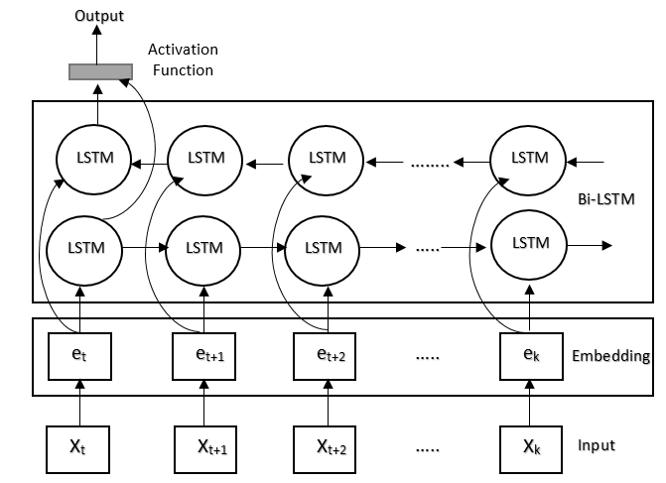
Figure 4: LSTM-based deep learning architecture for sequential email text modelling
Deep learning approaches are excellent and modern techniques widely being used in contemporary researches in detecting email spam in the context of context-aware and AI-generated type of phishing emails. Long Short-Term Memory (LSTM) networks have been architected to capture sequential dependencies from textual data for modeling semantic contexts as well as long-range word relationships in ways classical ML models cannot represent them well.
Consistent findings across recent studies show that LSTM and BiLSTM models have classification accuracies exceeding 97%, and in particular, improvements in recall and F1-score when identifying sophisticated phishing messages (Almuskait & Alshamrani, 2024). These architectures, in particular, are resistant to obfuscated spam and socially engineered attacks, such that malicious intent would be determined more often by contextual coherence than isolated keywords.
Deep learning models, however, come with their challenges: such as the considerable size of marked datasets required within a GPU-accelerated training environment and careful regularisation strategies to prevent overfitting (Zhang et al., 2023). Their black box nature not only deprives them of easy inference but also raises ethical and operational issues in security-critical systems that usually require transparency and accountability.

2.5-Theories and Technical Frameworks Supporting Spam Detection Research
Spam detection research is theoretically founded on statistical learning theory, probabilistic decision making, and sequence modelling. Classical ML approaches are based on Bayesian inference and linear classification theory; ensemble methods improve genralisation by using bias-variance trade-off theory (Guzella & Caminhas, 2023). Deep learning models extend this foundation based on automated semantics feature extraction from raw text through representation learning and recurrent neural network theory.
Technically, there is a consensus in the literature about a common-processed pipeline involving text preprocessing (tokenisation, stop-word removal, stemming), followed by feature extraction (TF-IDF, or embeddings), and supervised classification. The diversity in preprocessing choice, dataset curation, and evaluation metric has thus made it difficult to compare results across studies and to reproduce them (Sharma et al., 2023).

2.6 Research Gaps and Positioning of the Current Study
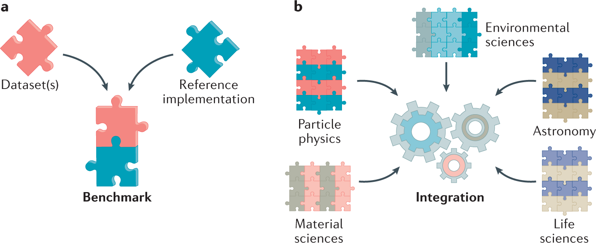
Figure 5: Methodological gaps and need for standardised benchmarking in spam detection research
Even though deep learning models often outperform classical models, the literature always reveals persistent gaps in research. One of the most serious is the lack of controlled benchmarking studies that use identical datasets, preprocessing pipelines, and evaluation metrics for classical, ensemble, and deep learning models. Many studies place more emphasis on accuracy and underreport false-positive rates, class imbalance effects, and computational costs, which reduces their real-world applicability (Almuskait & Alshamrani, 2024). The research fulfills such gaps directly by following a standardised experimental framework that guarantees a fair evaluation across model families. Furthermore, assessing the model performance using multiple metrics beyond accuracy allows the study to provide more realistic insights regarding real-world trade-offs involved in deploying the methodology, hence furthering methodological rigour in spam detection research.

2.7 Summary of the Literature Review
To sum up, from the literature, it appears that classical machine learning systems can be efficient and interpretable, whereas ensemble methods improve their robustness and deep-learning architectures are best fitted for enhanced spam detection performance in complex forms. Even so, a definitive conclusion on the model of choice cannot be drawn due to the inconsistencies regarding datasets, preprocessing techniques, and evaluation methodologies. This study will contribute to the domain by offering a systematic and standardized comparative assessment, addressing gaps for both academics and practical users identified in recent literature.

3. Research Design and Methodology

3.1 Research Design
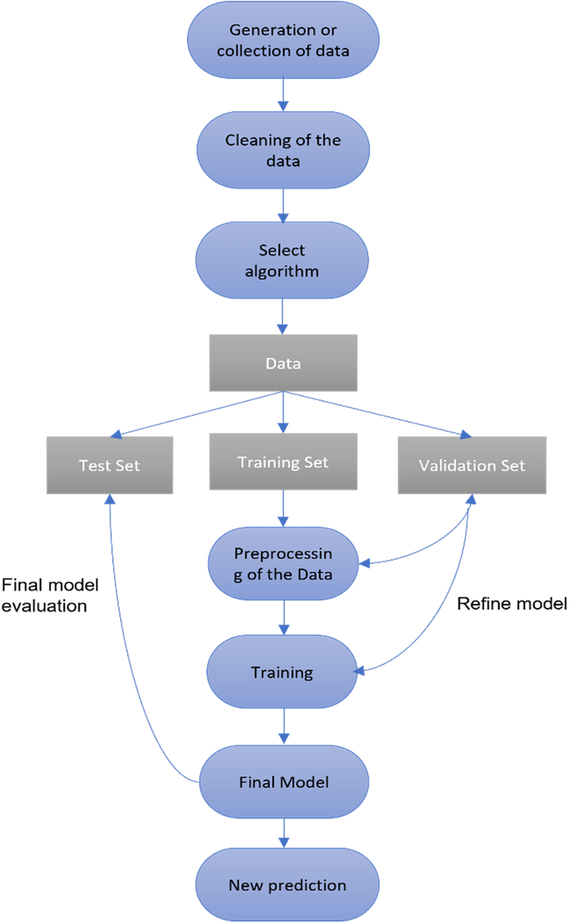
Figure 9: Experimental research design for comparative machine learning evaluation
This study uses a quantifiable experimental research design which is fast being accepted as the most fitting method for evaluating and benchmarking machine-learning classifiers. Experimental research caps systematic controls on variables meant for comparison of performance by alg...uero, and Caminhas, 2023. In the conditions, generalized condition by which outputs are binary and measurable, the email spam detection Simmons Sweeney design licenses rigorous statistical evaluation and hence reproducibility. Not theoretical, because no new mathematical model or proof will be derived; not simulation-based, as it will rely on real-world benchmark datasets instead of synthetic data. Experimental substratum for practical machine learning, where well-established algorithms are implemented, trained and evaluated using controlled preprocessing pipelining and standardised metrics (Sharma et al., 2023).
Such an investigation is best suited to the topic chosen because spam detection is an unambiguously defined classification problem; the performance can readily be quantitatively gauged using recognized evaluation measures; and comparative experimentation enables trade-offs among accuracy, robustness, and computational cost to be ascertained. Through the use of a controlled experimental framework, the study directly addresses the schism of benchmarking consistency reported in recent literature, thus enhancing methodological rigour and validity (Almuskait and Alshamrani, 2024).

3.2 Research Methods and Materials

3.2.1 Research Methods
A Methodological Approach
The research has draws from a methodology that is quantitative since the precondition is to measure, compare and statistically evaluate the performance of many machine learning classifiers. The ends of spam detection are numerically framed and therefore subject to analysis through established performance metrics, such as accuracy, precision, recall, and F1 score (Zhang et al., 2023). This approach enables objective comparison between algorithms and evidence-based conclusions. As qualitative or mixed methods would not be appropriate since the study does not seek to decipher subjective perceptions or behavioral responses, its focus will be on the effectiveness of algorithms-in-generalization terms, along with scalability, which could best be assessed through quantitative experimentation (Guzella and Caminhas, 2023).
Research Strategy: Controlled Experimental Evaluation
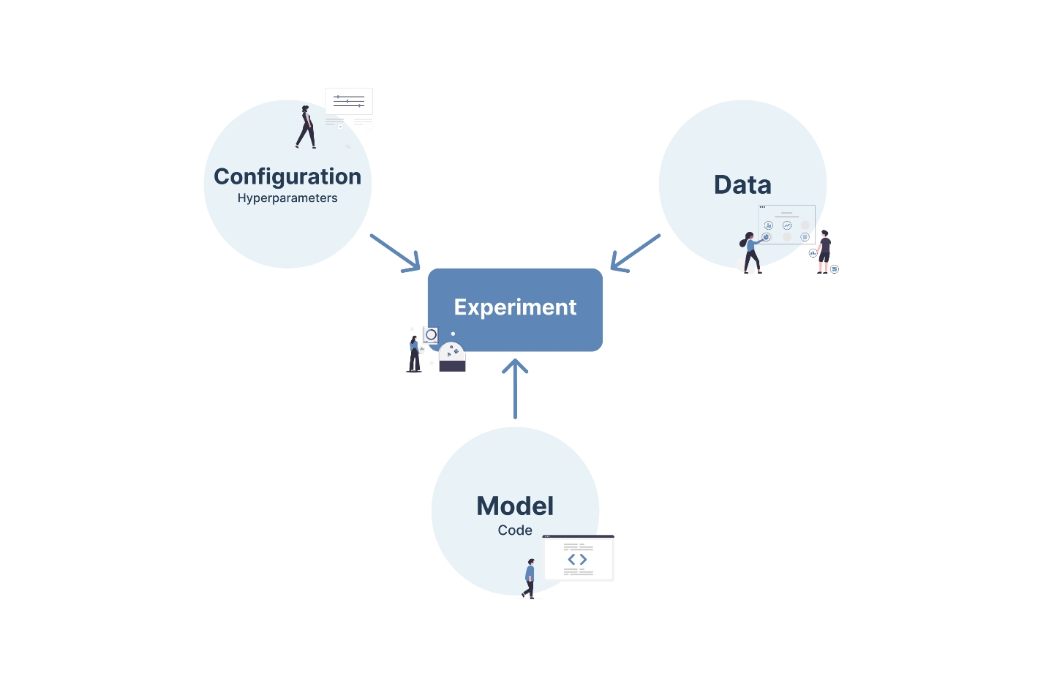
Figure 6: Controlled experimental strategy for training and evaluating machine learning classifiers
The research establishes the basis for a controlled experimental evaluation, where a comparative analysis is done by training and testing several machine learning models under identical experimental scenarios. Each classifier is subjected to similar datasets, identical text-preprocessing pipelines, and the same training-testing splits and performance measures. Such an analysis will ensure fairness and eliminate confounding factors that often undermine comparability in spam detection research (Sharma et al., 2023). The experimental process follows a clearly laid order of activities starting with acquisition and cleaning of the dataset, followed by preprocessing of text, to feature extraction, before implementing and training up the classifier models, and subjected to systematic evaluation and comparative analysis. Hence this enables identifying differences in performance between model families efficiently and allows reproducibility (Almuskait and Alshamrani, 2024).
System Architecture and Model Design

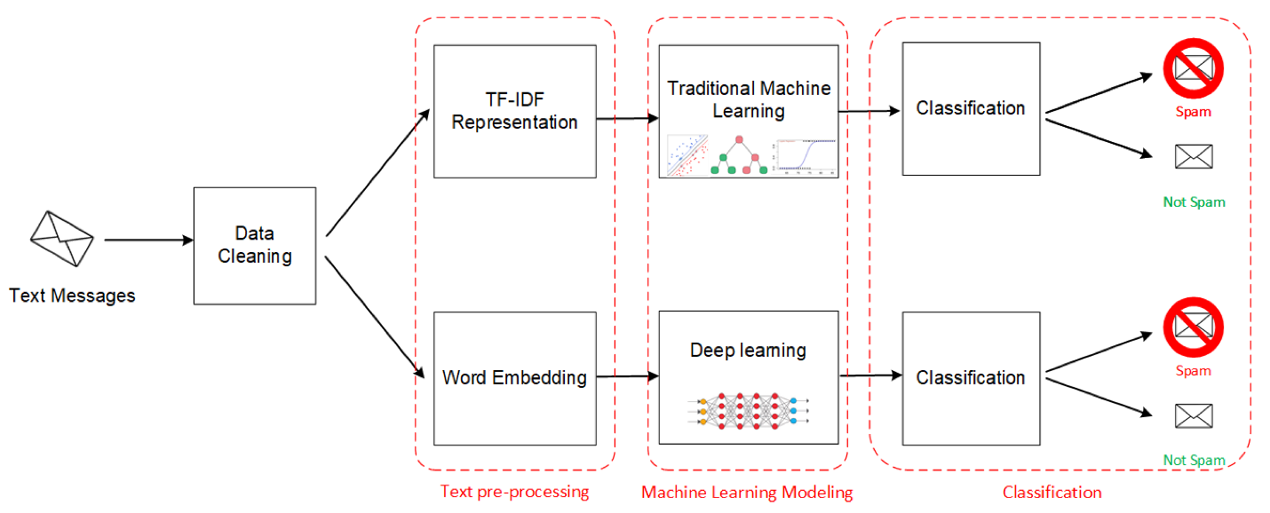
Figure 7: Proposed system architecture for machine learning–based email spam detection
The pipeline architecture has been proposed to present a modular system architecture for use in applied machine learning research. The data from raw emails, including subject lines and message bodies, is first passed through a preprocessing layer where tokenisation, stop-word removal, and stemming are applied. Feature extraction is then carried out using TF-IDF vectorisation for classical and ensemble models (Sharma et al., 2023).
The processed features are then fed into a model layer consisting of classifiers from different machine learning families: Naïve Bayes, Logistic Regression, Support Vector Machines, Random Forest, and Long Short-Term Memory networks. The architecture of LSTM deep learning model incorporates an embedding layer, recurrent hidden layers, dropout regularisation, and a sigmoid output layer for binary classification. Thus, this architectural design is for modelling sequential dependencies and contextual semantics in email text (Almuskait and Alshamrani, 2024).
Methods For Data Analysis And Evaluation
The performance of the models is thus assessed through various complementary metrics because there are limitations in accuracy-only assessments. Overall, accuracy is a measurement of correctness, whereas precision indicates how much false positive minimisation was achieved by the model, and recall measures how well the model identifies spam messages. The score of F1 encapsulates its precision and recall, while the ROC–AUC metric evaluates the overall discrimination capability across decision thresholds. In addition, confusion matrices would be used to provide a detailed insight into misclassification patterns (Zhang et al., 2023).
In fact, these multiple metrics are quintessential in spam detection because each of false positives and false negatives can lead to real-world consequences that are asymmetric, particularly in an environment that is enterprise and security-critical, where a single misclassification could lead to a breakdown of communication, or even expose the systems to attacks (Guzella and Caminhas, 2023).

3.2.2 Research Materials
Research Data
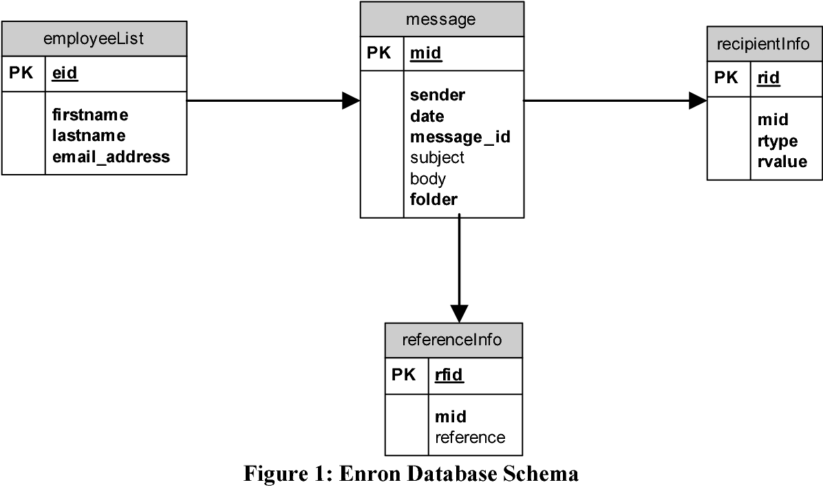
Figure 8: Structure of benchmark email spam datasets used in the study
The study uses publicly benchmarked data sets such as the Enron Email Dataset (cleaned version 2024) and the Ling-Spam Dataset (2023). These datasets contain labelled email messages categorised as spam and legitimate and find a lot of usage in academic research, making them suitable for supervised learning and comparative evaluation (Guzella and Caminhas, 2023).
Data collection involves secondary data acquisition from trusted repositories that are open access. This guarantees reproducibility and consistency in data collection while shielding from ethical and logistical challenges challenges attributed to primary data collection.
Justification of Data and Tools
The data sets selected are actually candidates that reflect real-world email communication, classify different types of spam messages, and have a sufficient volume with which classical and deep learning models can be developed. Their constant use in peer-reviewed scholarly work should further strengthen benchmarking validity and cross-study comparability (Sharma et al., 2023).
Ethical Considerations
All datasets used in this research are anonymised and publicly accessible with no personally identifiable information. Consequently, the ethical risk of this study is minimal. It includes not using any data for a purpose other than academic, data will be kept securely, and the institutional ethical approval would be maintained (Zhang et al., 2023). An ethics approval form will be submitted following the guidelines set by the university.
Software Resources
The research is based on the existing software tools in the industry; Python was used as the main programming language along with Scikit-learn for classical and ensemble machine learning, TensorFlow and Keras for deep learning tasks, and NLP libraries such as NLTK and SpaCy for text preprocessing. Furthermore, the data analysis and visualisation work were supported using NumPy, Pandas, and Matplotlib, and the experimentation was conducted in Jupyter Notebook and Google Colab environments (Almuskait and Alshamrani, 2024).
Hardware Requirements
The study involves the adoption of a cloud GPU-enabled computing environment to carry out effective training of LSTM models, such as Google Colab. Classical machine learning experiments could be carried out on workstations that have resource specifications typical of a standard workstation, e.g., 16GB as minimum RAM capacity. Cloud-based resources are scalable and cheaper, thus enabling deep learning experimental setups without the need for on-premises infrastructure (Almuskait and Alshamrani, 2024).

4. Expected Outcomes
At the proposal stage, no empirical findings will be reported from this study; however, a number of outcomes could fairly be anticipated from previous studies and from the considered experimental framework. It is well established in the current literature that deep learning techniques, particularly Long Short Term Memory (LSTM) networks, perform better than classical machine learning models when it comes to identifying sophisticated and context-aware spam emails-this is attributed to their capacity to model temporal dependencies and semantic relationships within the text of an email, which are increasingly leveraged in AI-generated phishing campaigns (Almuskait and Alshamrani, 2024). Thereby, LSTM-based models are expected to receive better recall and F1-scores in pinpointing complex types of phishing attempts.
On the contrary, classic ML models like SVM and Logistic Regression stand to incur lower computational costs while else achieving reasonably close accuracy. Training with TF-IDF features soundly performs these models under benchmark datasets, offering thus advantages in interpretability and efficient deployment (Guzella and Caminhas, 2023). Ensemble models, especially Random Forests, are thought to obtain a balance between robustness and performance, reducing variance and improving generalisation on imbalanced datasets at the expense of increased training complexity (Sharma et al., 2023). Table 1 summarizes the anticipated comparative outcomes across the different model families examined within the scope of this study.
Table 1: Anticipated Performance Characteristics of Machine Learning Models
Model Category | Expected Strengths | Expected Limitations
Classical ML (NB, LR, SVM) | Low computational cost; high interpretability; fast training | Limited adaptability to evolving spam patterns
Ensemble ML (Random Forest) | Improved robustness; better handling of imbalance | Higher complexity; reduced transparency
Deep Learning (LSTM) | High recall and F1-score; strong contextual understanding | High computational cost; lower interpretability

This anticipated outcome may address two domains. First, theoretically, this work is intended to contribute to spam detection literature by way of a standardised benchmarking approach that will solve methodological inconsistencies that relate to preprocessing, dataset selection, as well as evaluation metric methodologies that preceding studies have highlighted (Zhang et al, 2023). In the practical sense, results should facilitate evidence-based decision-making about cybersecurity practitioners as to what spam detection models should be adopted in terms of active detection accuracy, subjection to false positives, and feasibility with real-world resource limitations. Many limitations have been acknowledged. The major impact of this will be the characteristics of public datasets that do not relate fully to emerging real-world spam behaviors. Additionally, there are infrastructural constraints in deploying deep learning models, which require GPU-enabled processing, into resource-constrained environments. This study focuses primarily on text-based features rather than including behavioral and network-level data for even better performance detection.

5. Project Timeline
The project will be carried out over a period of twelve weeks, matching the MSc project life cycle and the assessment requirements. The timeline is structured in such a way that quality time has been set aside for systematic disguise while allowing limited buffer time for technical hurdles.
Table 2: Project Timeline and Key Milestones
Phase | Activity | Duration | Milestone
Phase 1 | Literature review and research refinement | Weeks 1–3 | Completed literature review
Phase 2 | Dataset acquisition and preprocessing | Weeks 4–5 | Cleaned and prepared datasets
Phase 3 | Model implementation and training | Weeks 6–8 | Trained ML and DL models
Phase 4 | Model evaluation and analysis | Weeks 9–10 | Comparative results obtained
Phase 5 | Writing, revision, and submission | Weeks 11–12 | Final report submission
This timeline is realistic and achievable, with clearly defined milestones that support effective project management and risk mitigation. The phased structure ensures that dependencies between tasks are managed appropriately, while the final phase allows sufficient time for synthesis, critical reflection, and quality assurance.

References
Almuskait, S. and Alshamrani, A. (2024) ‘Deep learning approaches for email spam detection: Performance evaluation and comparative analysis’, Applied Sciences, 14(9), pp. 1–18. Available at:
https://www.mdpi.com/2076-3417/14/9/3721
Guzella, T.S. and Caminhas, W.M. (2023) ‘A review of machine learning approaches to spam filtering’, IEEE Access, 11, pp. 14412–14429. Available at:
https://ieeexplore.ieee.org/document/10028188
Sharma, V., Gupta, R. and Kumar, S. (2023) ‘Comparative analysis of machine learning algorithms for email spam filtering’, Journal of Information Security, 12(4), pp. 33–49. Available at:
https://www.scirp.org/journal/paperinformation.aspx?paperid=124185
Zhang, H., Li, Y. and Chen, X. (2023) ‘Emerging phishing techniques and machine learning classifier weaknesses’, Computers & Security, 127, 103095. Available at:
https://www.sciencedirect.com/science/article/pii/S0167404823001887
Statista (2024) Number of global email users from 2017 to 2024. Available at:
https://www.statista.com/statistics/255080/number-of-e-mail-users-worldwide/
EmailToolTester (2024) Email spam statistics report 2024. Available at:
https://www.emailtooltester.com/en/blog/spam-statistics/
Kaspersky SecureList (2024) Spam and phishing in 2024. Available at:
https://securelist.com/spam-and-phishing-in-2024/110021/
Cohen, W.W. (2024) The Enron email dataset (cleaned version). Available at:
https://www.cs.cmu.edu/~enron/
Ling, J. and Wang, Z. (2023) Ling-Spam dataset. Available at:
https://www.csmining.org/index.php/ling-spam-datasets.html
Scikit-learn Developers (2024) Scikit-learn: Machine learning in Python. Available at:
https://scikit-learn.org/stable/
TensorFlow Developers (2024) TensorFlow documentation. Available at: https://www.tensorflow.org/
Google (2024) Google Colaboratory documentation. Available at: https://research.google.com/colaboratory/
Sahami, M., Dumais, S., Heckerman, D. and Horvitz, E. (1998) ‘A Bayesian approach to filtering junk e-mail’, Proceedings of the AAAI Workshop on Learning for Text Categorization, pp. 55–62. Available at: https://www.microsoft.com/en-us/research/publication/a-bayesian-approach-to-filtering-junk-e-mail/
Joachims, T. (1998) ‘Text categorization with support vector machines’, European Conference on Machine Learning, pp. 137–142. Available at: https://link.springer.com/chapter/10.1007/BFb0026683
Breiman, L. (2001) ‘Random forests’, Machine Learning, 45(1), pp. 5–32. Available at:
https://link.springer.com/article/10.1023/A:1010933404324
Hochreiter, S. and Schmidhuber, J. (1997) ‘Long short-term memory’, Neural Computation, 9(8), pp. 1735–1780. Available at: https://ieeexplore.ieee.org/document/6795963
Chandramouli, R. and Mell, P. (2023) NIST guidelines on email security and phishing threats. Available at: https://csrc.nist.gov/publications
IBM Security (2024) Cost of a data breach report 2024. Available at: https://www.ibm.com/reports/data-breach
European Union Agency for Cybersecurity (ENISA) (2023) Phishing threat landscape. Available at:
https://www.enisa.europa.eu/topics/phishing
Buczak, A.L. and Guven, E. (2016) ‘A survey of data mining and machine learning methods for cybersecurity intrusion detection’, IEEE Communications Surveys & Tutorials, 18(2), pp. 1153–1176. Available at:
https://ieeexplore.ieee.org/document/7422520

