University of Wales Trinity Saint David
Assignment name: Individual Marketing Report
The impact of the Covid19 pandemic on the organization
Chosen company: Superdrug PLC

Student ID: 2115611

Student name: Milena Andonova Andonova

I declare that this assignment is all my own work and that I have acknowledged all materials used from the published or unpublished works of other people. All references have been duly cited.

Executive summery

Covid19 pandemic have critical negative impact over the global and UK economic with decreasing the people incomes, rise the inflation, setting restrictions and limitations. All this lead to many companies struggling and fighting for survival as there is consistent cost with decreased sales or even no sales as many shops closed down during the lockdowns. It is very important to analyze and define the most serious challenges coming from the pandemic and based over the information to see how the company responds to this challenges. In our report below is chosen the UK beauty and cosmetic company named Superdrug PLC.

Contents
Executive summery 2
Introduction 3
Company Brief 3
Understand the processes and stages of marketing 4
Defining the mission 4
Conduct analysis 6
Marketing mix 6
Figure 2 7
Marketing campaign 7
Exercise control over the process 8
Marketing orientation 9
Learning the consumer behaviour 9
PESTEL Analysis Superdrug PLC 10
SWOT analysis – Superdrug PLC 12
Conclusion 13
Reference list 14

Introduction

Marketing is the method of establishing objectives through the planning and fundamental principle of pricing, moving, and delivering ideas, products, and services. It's the relationship between the company we've built and the market. Most of the time, this takes the form of some type of advertising. Specific marketing entails the development of products and marketing campaigns tailored to the wants and needs of specific customers.
Many businesses are attempting to return to this form of marketing today, due to advances in technology, because it is greater than anyone else because it makes customers feel special. In the below report there will be provided different analyze of the pandemic impact over the Superdrug PLC decisions, performance and operations.

Company Brief
Superdrug Stores plc (trading as Superdrug) is the second-largest health and beauty retailer in the United Kingdom, behind Boots UK. Since October 2002, the company has been a subsidiary of A.S. Watson Group, which is part of the Hong Kong conglomerate CK Hutchison Holdings.
Superdrug accepts exchanges from nearly 900 stores across the United Kingdom and Ireland, as well as Denmark, Finland, and Sweden. More than 14,000 people represent the company. Apart from offering wellness and greatness products on the web and in stores, there are more than 220 drug stores with conference rooms, and another 19 have nurture centers. It maintains ties with sister companies, Savers and The Perfume, which are also owned by A.S. Watson Group (Glied,2021).
Superdrug became a BUAV-endorsed retailer in February 2010, having joined a few other high-street chains in encouraging that its own image items would be free of animal testing. The jumping rabbit mercilessness free logo appears on all Superdrug own mark products. In any case, this does not apply to items sold in the shop that are produced by different brands. In 2010, Superdrug tested shop-in-shop concessions in collaboration with sister company The Perfume Shop.
Figure 1
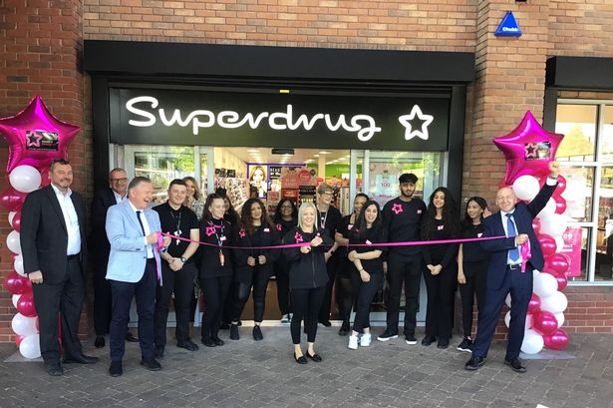

(Glied,2021).

Understand the processes and stages of marketing

Defining the mission

Each company's main goal, vision, objectives, and targets declare the critical orientation in its overall advancement. The vision paints a picture of a perfect organization that benefits human culture. The important ways for a successful turn of events in company are defined by vision. Each business organisation should have its own plan for the future that helps to preserve its clarity while also energizing progress.
The company's goals express the company's sustained objectives to achieve an outstanding public image. It reveals the commitments made to employees, providers, and clients, among other things. It takes note of the standards and procedures that the company uses to conduct its operations. The statement of purpose outlines the most important expectations for the future. Following the investigation, it was discovered that after a clearly stated statement of purpose, one's standing in the public arena improves (Lyons,2021).

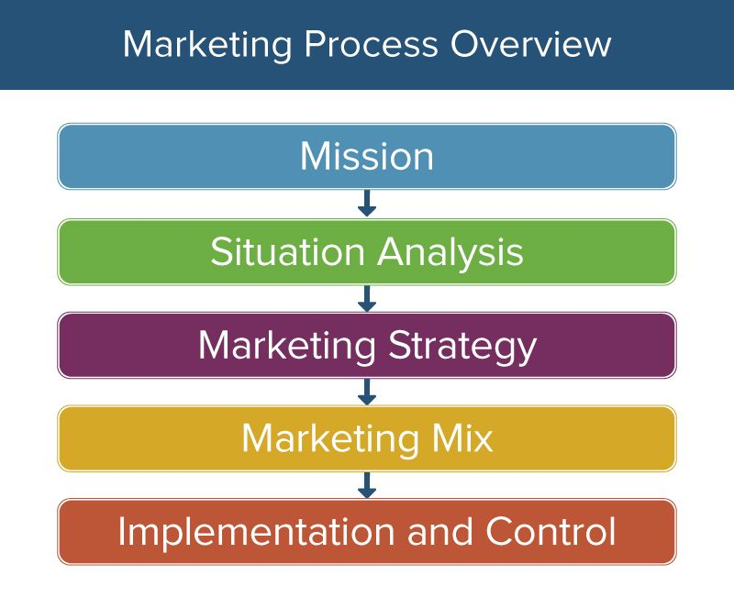
Figure 1: Stages of the marketing process (Lyons,2021).

Conduct analysis

In promoting, key tasks are responsibility assigned in which the real entertainers, typical outcomes, and set cut off point times are specified. Marketing managers must first plan key objectives, then devise dynamic strategies for achieving them. As if it were a real tree, the agreement of acknowledged objectives can be clarified one by one. There should be no cycles or separated elements in the objective tree after it has been worked through completely. There are two approaches to dealing with the choice tree. The first is that each lower level component is linked to a single component, and the second is that the lower level components are linked to a small number of components and a higher level of order (Rains,2021).

Marketing mix

Product - The primary tool of marketing is to create a product with such qualities that business efforts are no longer necessary. The item is used to adapt business actions to market demands. The idea of the item's promotion determines the amount of variability in creation. Sustained implementation is required for high company performance and, as a result, genuine autonomy to achieve the organization goals and objectives.
Price - It has a significant role in the marketing approach. The most important consideration in value development is not only production costs, but also buyer evaluation. Costs should be set so that the customer feels like he's getting a good deal on the quality of the item he's getting.

Promotion the promotion has main critical importance for the company success and the customer loyalty. Superdrug PLC use many different very productive offers like buy one get one free, buy one get second half price and all this setting the customer interest at high levels (Rains,2021).

Place in the current situation the online sales increased significantly due to the covid19 pandemics and this move the importance of the stores locations in the high streets. Still the company has very good located stores and focus to always open stores with best locations as this increased the sales and number of customers visited the store.

Figure 2

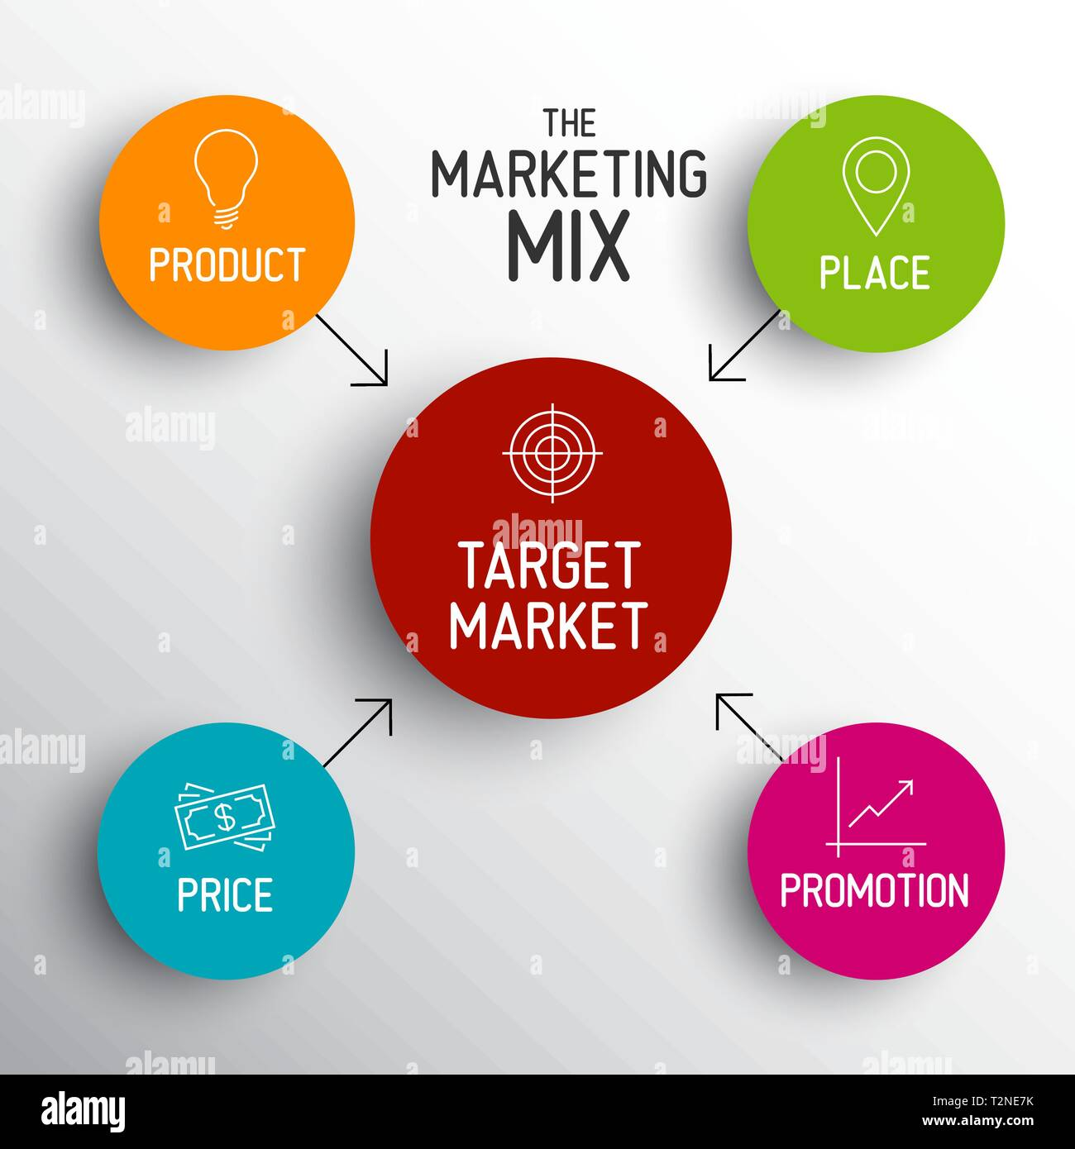

(Rains,2021).

Marketing campaign

Target marketing – Target marketing entails segmenting a market and then concentrating your marketing efforts on one or a few key segments, which are customers whose specifications and requires most closely match the products or services you provide. It tends to be the path to attracting new enterprise, broadening agreements, and achieving your company's goals (Lyons,2021).

Content marketing
Content marketing is a marketing strategy for creating and distributing interesting content to a specific target audience. The purpose of development is to get customers to take specific actions and remember them for their transition position. Data obtained from a potential buyer at the ideal setup is what content marketing is all about (Button,2021).

Product marketing
The main focus of getting items to promote is item promoting. Item advertising companies are the user's overall representative, informing achievers, deal-making empowering impacts. All at the same time Product promoters are among the most skilled plate spinners on the planet (Fusté,2021).

Email marketing

One of the most cost-effective aspects of running a web targeted advertisement campaign is through online marketing. Which is why a significant number of advertising companies find it to be a "appetizing bite." Nevertheless, if this instrument is used incorrectly, it can have dire implications.
Junk mail is one of the most irritating things we come across on a daily basis, and it irritates us when we go through our inboxes. Junk mail inundates our mailboxes on a regular basis, owing to a lack of adequate planning in online ads and reliance on irregular intervals, misinformed users to open the messages (Rains,2021).

Exercise control over the process

Showcasing control refers to the assessment of a company's marketing effectiveness in terms of revenue generated, market share captured, and profit earned. The genuine result is compared to the guidelines established in order to identify the difference and make the necessary changes.
Marketing is one of a company's most important functions. To make sure error-free outcomes, optimal resource consumption, and accomplishment of planned targets, leadership must workout effective control over marketing programs (Fusté,2021).

Marketing orientation
Marketing orientation often has three main aspects, which are:
Customer orientation: a company can operate in an economic system by manufacturing things that individuals need and can afford. As a result, determining customer demand is critical to the company´s effectiveness, if not its continued existence (Mills,2021).
Organizational orientation: In this context, the marketing team of a company is frequently regarded as being of prime significance at the physiological level. Knowledge from the company's marketing team will be used to direct the behavior of other departments within the company. A marketing function, for instance, may discover that customers want a new product in the market or a new application for a current products. With this in mind, the marketing function will notify R&D, who will develop a goods working model based on the new customer preferences (O’Connor,2021).

Learning the consumer behaviour

The primary question in shopping behavior is how customers consider approach for identifying, purchase execution, and consumer behaviours, as well as why they behave in the way they do. According to the hypotheses, the authorial tendency is to connect different extraordinary belief systems of the purchasing intention – the emotional and logical basis. To aid in the study of consumer behavior, a number of tools, structured as models, have been established (Button,2021).

Consumer behavior models are abstract and organizational in nature, and they represent the ideology about the nature of usage that has been accepted. The designs also depict the functional connection and significance of the numerous variables that affect consumer behavior (Mills,2021).

PESTEL Analysis Superdrug PLC

Political factors
Superdrug PLC is impacted from the political factors due to the Brexit and the covid19 decisions for lockdowns as this indirectly and directly impact consistent way the company performance and the net profit.
The increasing of the taxation percentage also has very negative impact over the company performance as this decrease the company profit and sustainability (Fusté,2021).
Economical
The current situation of the economic with the negative impact from the COVID19 has very negative impact over the Superdrug performance and sales. Despite the company is select to stay open in the form of key stores the restriction over the customers significantly drop the sales and the company profit. Thankfully to the online sales the company managed to keep some performance and customer loyalty (Button,2021).
Social
Here is included the population issues and challenges for example people start taking actions for refusing to purchase plastic bags and items, social distancing, animal free products and other social trends impacting the company decision and activities negative way as this increasing the company operational cost and decreasing the net profit (Mills,2021).

Technologic
Here is included the digital trends, increasing power of the social media, increasing customer expectations that the companies need to use the high technologies for better service and products. For example Superdrug PLC invest into the head sets which target to increase the customer loyalty and engagement (O’Connor,2021).

Legal
Nowadays there is many legislations legal ways related to covid19 and this set pressure to the company. There is legal expectation linked to Brexit and workers, there are passports and tests linked to the covid19 pandemic which ones again made complicate the company operations and performance (Button,2021).

Environmental factors
Here we must say the impact from the climate change, recycling and the issue with the plastic products, the population have issues with the incomes and safety and all this lead to decreased customer average shopping and from there the low company sales and profit (Mills,2021).

Figure 3
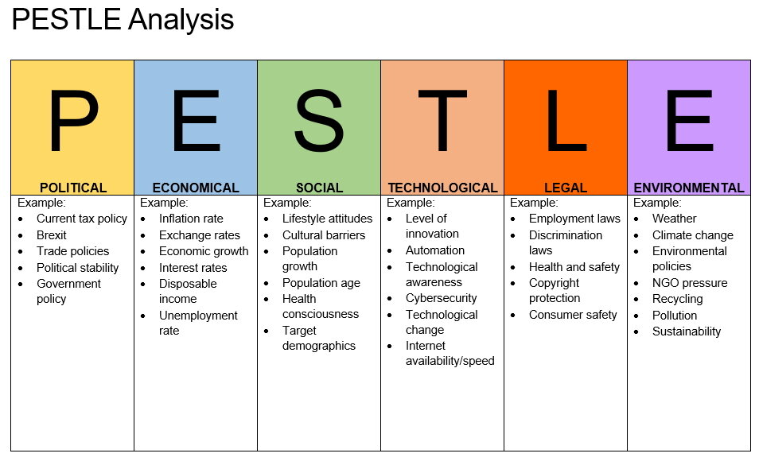
(O’Connor,2021).

SWOT analysis – Superdrug PLC

SWOT ANALYSE Superdurg PLC
Strenght | Weaknesses
Popular brand name, Strong market positions, Very good locations, Loyal clients, good assortment, good services. | Lack of management control, low quality of the customer service, decreasing customer service tandards due to staff turnover, low wages, lack of management skills and expertice (Button,2021).
Opportunities | Threats
Better focus and increasing of the market share, increasing of the clients and customer service levels, implementing talent programs and staff retention strategies. | Brexit implications, COVID19 restrictions, new competitors.

Conclusion

Marketing is a comprehensive managerial activity that entails creating and communicating messages that guarantee benefits to clients or communities. Marketing, media relations, and other types of public-facing corporate communications are all included. Market research, setting advertising objectives and vision, and constructing the message are all processes. Then there's the delivery. Marketing is an approach in corporate communications and product promotion that emphasizes consistency. It is founded on the belief that all communications a business sends out to the public must be constant, unrestricted, continuous, and organized. Whatever type of media exposure you pay for, the aim is to create the same branding and benefits for your target market. Consistency in the message and brand vision establishes a correct expectation of what customers can expect from you (Lyons,2021).

Reference list

Al-Ghunaim, T.A., Johnson, J., Biyani, C.S. and O’Connor, D., 2021. Psychological and occupational impact of the COVID-19 pandemic on UK surgeons: a qualitative investigation. BMJ open, 11(4), p.e045699.
Bauer-Staeb, C., Davis, A., Smith, T., Wilsher, W., Betts, D., Eldridge, C., Griffith, E., Faraway, J. and Button, K.S., 2021. The early impact of COVID-19 on primary care psychological therapy services: A descriptive time series of electronic healthcare records. EClinicalMedicine, p.100939.
Ferry, A.V., Wereski, R., Strachan, F.E. and Mills, N.L., 2021. Predictors of UK healthcare worker burnout during the COVID-19 pandemic. QJM: An International Journal of Medicine.
Gilleen, J., Santaolalla, A., Valdearenas, L., Salice, C. and Fusté, M., 2021. Impact of the COVID-19 pandemic on the mental health and well-being of UK healthcare workers. BJPsych open, 7(3).
Johnson, S., Dalton-Locke, C., San Juan, N.V., Foye, U., Oram, S., Papamichail, A., Landau, S., Olive, R.R., Jeynes, T., Shah, P. and Rains, L.S., 2021. Impact on mental health care and on mental health service users of the COVID-19 pandemic: a mixed methods survey of UK mental health care staff. Social psychiatry and psychiatric epidemiology, 56(1), pp.25-37.
Magner, C., Greenberg, N., Timmins, F., O'Doherty, V. and Lyons, B., 2021. The psychological impact of COVID‐19 on frontline healthcare workers ‘From Heartbreak to Hope’. Journal of Clinical Nursing, 30(13-14), p.e53.
Sattar, N. and Valabhji, J., 2021. Obesity as a Risk Factor for Severe COVID-19: Summary of the Best Evidence and Implications for Health Care. Current Obesity Reports, pp.1-8.
Waitzberg, R., Quentin, W., Webb, E. and Glied, S., 2021. The Structure and Financing of Health Care Systems Affected How Providers Coped With COVID‐19. The Milbank Quarterly, 99(2), p.542.

