

Name: Shreyaben Radhey Patel
Student ID: 2242222
Module: Digital Marketing
Module Code: LCMB7010
Lecturer: Amitave Banik
Submission Date: 18/12/2023

Table of Contents
Task 1 4
Part 1: Introduction 4
Company Background 4
Marketing Strategy 5
Overview of LVMH's Digital Marketing Strategy 5
Alignment with Overall Business Objectives 6
Internal and External Flows 6
Internal Communication and Workflow in Digital Marketing 6
Workflow in Digital Marketing 7
External Digital Communication Channels 7
Digital Asset 9
LVMH’s Digital Asset Portfolio 9
Utilization and Performance of Digital Assets 10
Marketing Information Systems 11
LVMH’s Marketing Information Systems Infrastructure 11
Data Management and Utilization for Marketing 12
Customer Relationship Management 12
CRM Strategies at LVMH 12
Integration with Digital Marketing Efforts 13
Segmentations, Targeting, and Positioning 13
Market Segmentation Approaches by LVMH 13
Targeting Strategies and Campaigns 14
Positioning of LVMH in the Digital Space 15
Positioning Map and Link with Marketing Mix 15
Visualizing LVMH’s Market Positioning 15
Correlation with Marketing Mix Elements 16
Competitive Advantage 16
LVMH’s Digital Competitive Advantages 16
Marketing Mix 17
Application of the 7Ps in LVMH’s Digital Marketing 17
Sweet Spot of Marketing 17
Identifying LVMH’s Marketing Sweet Spot 17
Online Marketing Model 18
Frameworks Used by LVMH for Digital Marketing 18
SOSTAC Model 19
Applying SOSTAC to LVMH’s Digital Marketing Plan 19
Recommendations and Examples of Artificial Intelligence 19
Part 2: Machine Learning and its Influence on Digital Marketing 20
Ways Machine Learning Influences Digital Marketing 20
Critical Analysis of the applications of Machine Learning in digital marketing to maximize ROI and ROS 21
Ways ML will help LVMH in digital marketing strategy 22
Conclusion 23
References 25

Task 1

Part 1: Introduction
When it comes to staying ahead of the competition in today's dynamic retail industry, digital marketing has become an absolute must. With the rise of mobile devices and the internet, customers' interactions with companies have changed dramatically, making digital marketing more important than ever for merchants. With its help, companies can have real-time conversations with consumers, providing them with tailored experiences that increase engagement and loyalty. By analyzing massive volumes of data, merchants may better understand customer behavior, tastes, and trends, which in turn helps with making strategic decisions (Olazo, 2022). Additionally, digital marketing allows retail enterprises to reach a wider audience, regardless of their location, which broadens their consumer base and access to international markets. Digital marketing is crucial to the profitability, expansion, and exposure of contemporary retail businesses and it is more than simply an element of these companies.

Company Background
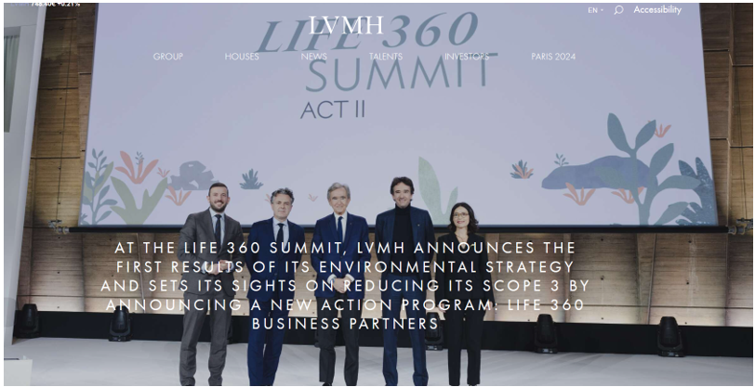
LVMH (2019).
The French luxury goods giant Louis Vuitton is based in Paris and goes by the acronym LVMH. With a wide portfolio of more than 70 esteemed brands, LVMH has evolved into a powerhouse since its founding in 1987 as a result of the combination of fashion firm Louis Vuitton and wines and drinks company Moët Hennessy. Several industries are serviced by the company. These include the following: selective retailing, watches and jewelry, fragrances and cosmetics, leather products, and fashion (Chen, 2021). Catering to an affluent customer and retaining a substantial position in the global luxury industry, LVMH exemplifies the essence of luxury with a strong focus on craftsmanship, legacy, and quality.

Marketing Strategy

Overview of LVMH's Digital Marketing Strategy
E-commerce and Online Presence: Recognizing the growing trend of online shopping, LVMH has significantly invested in enhancing its e-commerce platforms. Each brand under the LVMH umbrella maintains its unique digital identity while ensuring a seamless and luxurious online shopping experience (Park and Rhee, 2021). Websites and mobile apps are designed to be visually rich and user-friendly, mirroring the luxury experience of shopping in-store.
Social Media and Influencer Marketing: LVMH leverages social media to build brand awareness and engage with a younger demographic. Platforms like Instagram, Facebook, and WeChat are used to showcase products, brand stories, and lifestyle content (Park and Rhee, 2021). Influencer partnerships further extend the reach, with celebrities and fashion influencers embodying the brand ethos in their social media engagements.
Personalization and Customer Experience: Personalization is a key element of LVMH's digital strategy. Using data analytics and AI, LVMH gathers insights into customer preferences to offer personalized recommendations and bespoke services (Vanderhaeghen and Chevalier, 2020). This approach enhances customer loyalty and replicates the personalized attention offered in physical stores.
Digital Innovation and Collaboration: LVMH continuously explores innovative digital solutions. Initiatives like the LVMH Innovation Award encourage start-ups to develop novel technologies that enhance customer experience. Collaborations with tech giants and investment in AR and VR technologies also illustrate LVMH's commitment to digital innovation.
Sustainability and Online Engagement: Aligning with contemporary concerns, LVMH's digital platforms also focus on sustainability. Brands within the group use their digital presence to highlight sustainable practices and initiatives, resonating with environmentally conscious consumers.

Alignment with Overall Business Objectives
LVMH's digital marketing approach is carefully synchronized with its overall business goals, guaranteeing that the company's digital endeavors improve and supplement its conventional luxury philosophy. Keeping ahead of the curve in the luxury goods industry as customers' tastes change is one of LVMH's top priorities. To back this up, LVMH has a robust online presence and uses advanced e-commerce systems, which let it reach more people across the world and enter new areas. Attracting a younger generation while retaining the current client base is another important goal for the firm (Vanderhaeghen and Chevalier, 2020). That is why LVMH's plan to use influencer marketing and social media is so important.
LVMH markets its products as classic and modern by interacting with millennials on social media and other platforms where they spend a lot of time. This strategy not only attracts a wider range of customers but also revitalizes the brand's reputation, guaranteeing its continued viability and popularity. Additionally, as a foundational element of the luxury retail sector, LVMH prioritizes the customer experience. With this goal in mind, it has developed a digital marketing strategy that makes use of customization strategies, such as data analytics to provide personalized suggestions and great online experiences. The unique and customized experience that consumers anticipate at LVMH's brick-and-mortar shops is reflected in this tailored digital interaction. The company's larger dedication to environmental responsibility is in line with LVMH's emphasis on sustainability in its digital content (Sánchez Zaragozá, 2022). Fulfilling both its corporate social responsibility objectives and customer expectations, LVMH increases its brand value and appeals to more eco-conscious consumers by using its digital channels to showcase sustainable activities.

Internal and External Flows

Internal Communication and Workflow in Digital Marketing
A company's digital marketing strategy can't succeed without strong internal communication. All of the team members and departments will be on the same page, which will encourage them to work together and come up with creative solutions. To effectively discuss plans, share insights, and align objectives, it is essential to have regular interdepartmental meetings. To further simplify communication, it is essential to integrate project management software. To improve openness and responsibility, these technologies provide a single location to monitor project schedules, delegate work, and report on progress (BOUFIM and BARKA, 2021). A key component of efficient digital marketing internal communication is the establishment of distinct duties and responsibilities, with the goal of making sure that all team members understand their specific contributions to the overall marketing goals.
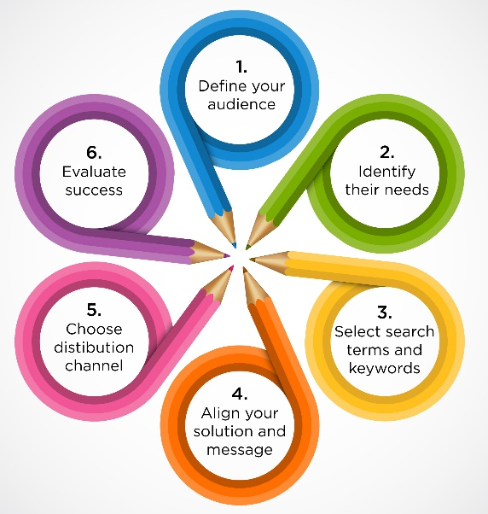
Figure 1: Internal Communication
Source: (Foster, 2017)

Workflow in Digital Marketing
Iterative, data-driven strategy is the norm in digital marketing workflows. First, there's planning, during which objectives are defined in light of data gathered from surveys of potential customers and other sources. At this point, you should be preparing the content for the campaign, coming up with ideas for creative concepts, and setting up key performance indicators (KPIs). Analytics and monitoring take center stage after the campaign is live and responding instantly to consumer actions and campaign efficacy is made possible by real-time monitoring of engagement data (BOUFIM and BARKA, 2021). Reviewing the campaign's performance against the KPIs and learning from both successes and failures is an important part of post-campaign analysis.

External Digital Communication Channels
A company's engagement with its audience is greatly influenced by external digital communication channels. These channels include various platforms that are used to reach, engage, and convert prospective consumers. The first is the indispensability of social networking sites such as LinkedIn, Instagram, Twitter, and Facebook. By allowing two-way contact between brands and their audience, they help create a feeling of community and loyalty to the company. From Instagram's visually-driven postings to LinkedIn's professional networking, each site serves a unique audience and encourages a distinct kind of content. Online blogs and websites act as virtual storefronts for companies, showcasing their wares in all their glory. Companies may connect with consumers on a more personal level by sending them personalized updates, emails, and special deals (Kovaitė et al., 2020). Video-sharing websites like YouTube provide a venue for interesting, informative, and amusing videos that tell stories about brands and products in an interactive and visually appealing manner. Finally, when it comes to digital communication with the outside world, internet advertising including sponsored content and pay-per-click (PPC) campaigns. To make sure that marketing campaigns reach the right people, these channels allow for customized advertising based on user preferences and behaviors.
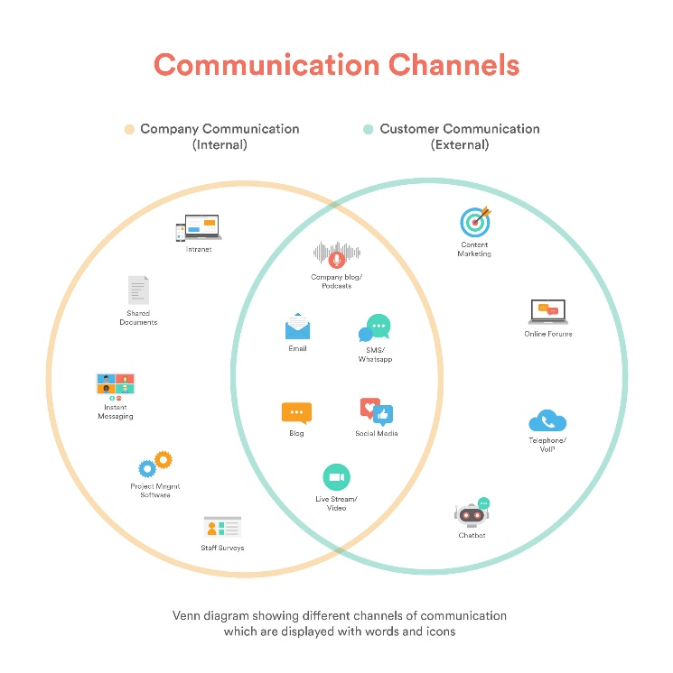
Figure 2: External Communication
Source: (Foster, 2017)

Digital Asset
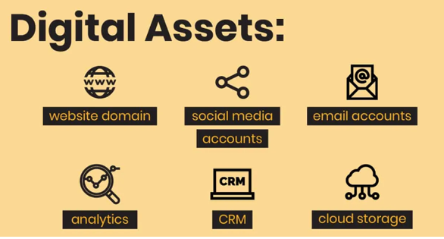
Fox, R.J. (2020).

LVMH’s Digital Asset Portfolio
The digital asset portfolio of LVMH exemplifies the inventive way the company combines digital expertise with luxury. The foundation of this system is a collection of LVMH brand-specific, beautifully designed websites and mobile apps. Louis Vuitton and Dior use their internet platforms as more than simply sales channels as they create immersive experiences that showcase the brands' legacy, workmanship, and exclusivity. Instagram, Facebook, and WeChat are just a few of the social media channels where the group has made a strong impression (Oliveira, 2020). Crafted with care, these social media platforms cater to affluent consumers by sharing stories, behind-the-scenes looks, and high-fashion material. In order to connect with younger generations and keep their brand relevant in the digital era, LVMH's social media strategy is crucial.
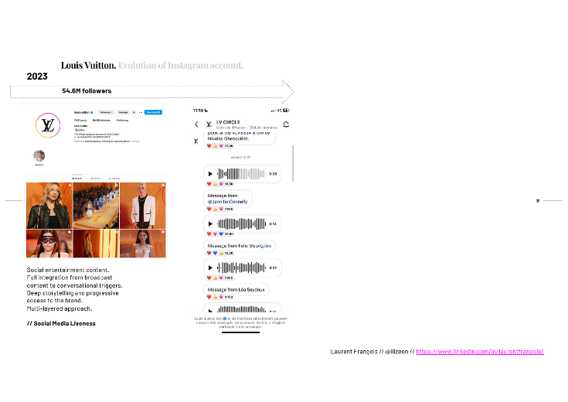
Figure 3: Instagram page of LVMH
Source: (Francois, 2023)
In the ever-changing world of online shopping, LVMH has created cutting-edge platforms that provide customers with the same smooth and opulent experience as when they visit one of its brick-and-mortar stores. By funding research into VR and AR, the company is enhancing this experience and giving consumers new ways to interact with its goods. Finally, LVMH has access to advanced data analytics capabilities in its digital asset portfolio (Oliveira, 2020). Understanding consumer behavior and preferences is essential for targeted marketing and improving customer relationships, and these technologies play a key role in this process. LVMH's digital asset portfolio strikes a nice balance between the old and the new, guaranteeing the group's place at the forefront of the luxury goods industry's digital transformation.
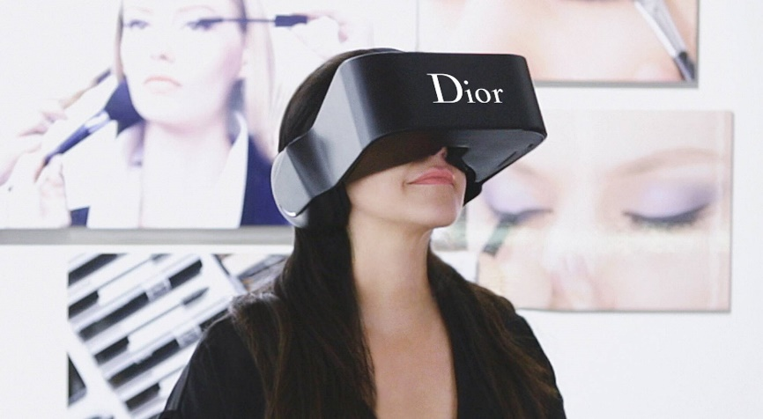
Figure 4: VR headset created by DIOR
Source: (lvmh.com, 2015)

Utilization and Performance of Digital Assets
LVMH is at the forefront of the luxury industry's digital revolution, and it uses its digital assets to its advantage to boost brand awareness, consumer engagement, and operational efficiency. The digital properties of the brand are the websites and apps that serve as more than just virtual marketplaces. Due to these platforms' high-quality images and comprehensive product descriptions, online shopping seems as exclusive and luxurious as going to a physical store. E-commerce features included in LVMH's digital platforms further facilitate hassle-free luxury buying for customers all over the world (Cao et al., 2023). The digital strategy of LVMH is heavily dependent on social media. With a focus on its personality and target demographic, each of LVMH's brands has its own social media presence.

Marketing Information Systems

LVMH’s Marketing Information Systems Infrastructure
Essential to the marketing success of the company, LVMH's Marketing Information Systems (MIS) infrastructure boasts a complex combination of innovative technology and strategic data management. Central to this infrastructure's architecture is the ability to gather, process, and use massive volumes of data in order to improve marketing tactics and drive decision-making for its varied portfolio of high-end brands. An advanced CRM system is the backbone of LVMH's management information system (MIS). In order to create thorough profiles of its customers, LVMH uses this system to gather precise information from a variety of touchpoints, including in-store encounters, internet purchases, and social media involvement (Treiblmaier, 2023). In order to increase customer loyalty and retention, these profiles are crucial for customizing marketing campaigns, creating more relevant promotions, and upgrading customer service. The sophisticated analytics techniques used by LVMH can handle both organized and unstructured data. Market trends, customer behavior, and campaign success may be better understood with the use of these technologies. Marketing campaigns at LVMH are both proactive and reactive due to data analysis that reveals new possibilities, helps with pricing strategies, and predicts how the market will evolve.
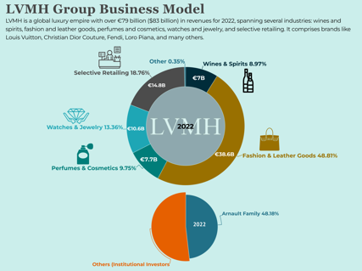
Figure 5: Marketing Information System
Source: (Cuofano, 2023)

Data Management and Utilization for Marketing
Modern marketing plans would be incomplete without proper data management and exploitation, which greatly affects client understanding and engagement. Data from many sources, like as interactions with customers, their online activities, sales transactions, and social media activity, must be collected, stored, and organized in order for data management to be effective. This data contains a wealth of valuable information about the marketing sector. When used correctly, it may show trends in customer preferences, behaviors, and purchases (Treiblmaier, 2023). With this information in hand, marketers may fine-tune their approaches, resulting in more relevant and targeted advertising. The ability to personalize messaging and offers is a major perk of data used in marketing. It helps companies provide a better experience for consumers and makes marketing more successful overall.

Customer Relationship Management
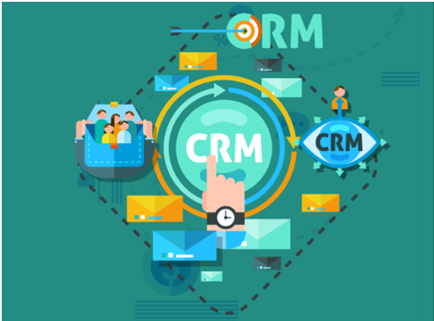
May 20, B.S.B.W.P. and 2020 (2020).

CRM Strategies at LVMH
LVMH's continued success in the luxury goods industry is its extensive CRM (Customer Relationship Management) strategy. Important principles of the premium consumer experience, such as exclusivity and customization, form the basis of this approach. From in-store encounters to online conduct, LVMH's CRM system gathers precise consumer data across many touchpoints, allowing for a thorough insight into client preferences and behaviors. In order to provide customers with highly relevant and individualized communication, offers, and services, this data is used to customize their experiences. Customers feel more connected to the company and more likely to buy from them when they get personalized suggestions and invites to special events. The CRM strategy at LVMH also includes teaching employees to provide each client the individualized attention they deserve, which contributes to the prestige and quality that consumers associate with the LVMH brand (Parnes, 2022). LVMH's CRM methods are vital for making lasting impressions on customers, fostering connections over time, and preserving the premium brand's reputation in the cutthroat industry.

Integration with Digital Marketing Efforts
LVMH's digital marketing and customer relationship management strategies work hand in hand to provide a comprehensive approach that boosts engagement and loyalty among LVMH's clients. This connection allows for the creation of cross-platform, tailored marketing campaigns by using data analytics to learn about consumer tastes and habits. When it comes to digital marketing, LVMH uses its CRM to send personalized emails, run social media campaigns, and publish targeted online content. The CRM system tracks and analyzes client interactions across many channels, which helps to enhance customer profiles (Parnes, 2022). Based on the customer's past purchases and web surfing behavior, personalized recommendations, specials, and new product notifications are sent to them. This integration allows LVMH to use the efficiency and reach of digital marketing while maintaining a consistent and tailored brand experience across all digital channels.

Segmentations, Targeting, and Positioning

Market Segmentation Approaches by LVMH
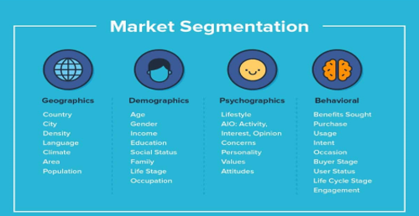
Monitor, C. (2019).
Affluent and varied, LVMH's customers are served by complex market segmentation strategies. Market segmentation according to demographic, psychographic, behavioral, and geographical characteristics is an important part of the company's strategy. In terms of demographics, LVMH aims for affluent people who can afford to buy luxury items. People in this demographic tend to be high-achieving entrepreneurs, famous people, and professionals who place a premium on uniqueness, exclusivity, and brand prestige. From a psychographic perspective, LVMH caters to customers who want to live a life that reflects their appreciation for tradition, the arts, and great workmanship. Purchase patterns and devotion to the brand are the cornerstones of LVMH's behavioral segmentation (Lai, 2022). Personalized services and special items are offered to the firm's devoted client base, whom the company seeks out and nurtures. As a last factor, geographic segmentation is considered; LVMH adjusts its products and services to meet the needs of certain regions and cultures throughout the globe.

Targeting Strategies and Campaigns
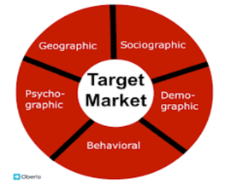
Bramesh (2020).
LVMH's targeting tactics are precise and exclusive, targeting certain audience groups with specialized messaging. The organization uses demographic targeting, lifestyle, and behavioral analytics. High-earners who respect luxury, quality, and brand legacy are the target market. LVMH also targets aspirational people who want premium goods but are not conventional luxury purchasers. Lifestyle campaigns emphasize the luxurious experience above the goods. On Instagram and Facebook, where adverts and content are tailored to user interests and behaviors, data analytics is used for precise targeting (Lai, 2022). LVMH's advertisements also use narrative to emphasize brand legacy and craftsmanship, which resonates with its target demographic and boosts brand esteem.

Positioning of LVMH in the Digital Space
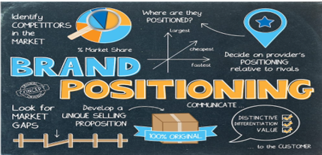
info@themmachine.com (2019).
When it comes to the internet, LVMH presents itself as the pinnacle of luxury, successfully fusing the old and the new. In addition to embracing innovation and modern trends, the firm uses digital channels to highlight the history, workmanship, and exclusivity of its brand. Luxury goods giant LVMH aims to recreate the opulence and sophistication of its brick-and-mortar stores online via its posh websites, advanced e-commerce systems, and engaging social media content (Chevalier and Mazzalovo, 2021). With the use of targeted marketing and tailored online services, LVMH is able to establish a strong online presence that appeals to both its wealthy customers and the next generation of luxury shoppers.

Positioning Map and Link with Marketing Mix

Visualizing LVMH’s Market Positioning
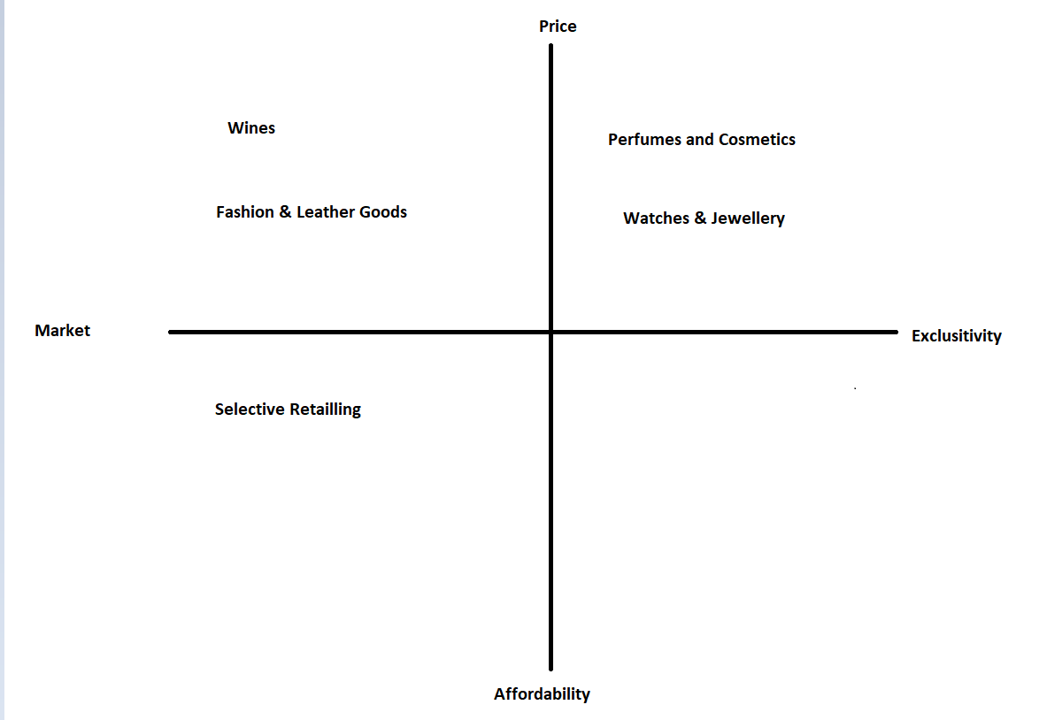
Figure 6: Positioning Map of LVMH
The varied LVMH portfolio is organized in this positioning map according to price and exclusivity. With a focus on fashion and leather goods and wines aimed squarely at the market, we can see that this luxury class offers somewhat more accessible prices. Products in the Perfumes cosmetics Watches and jewelry categories, on the other hand, are priced more and more exclusively to represent their premium nature and target market. Suggesting a middle ground between market accessibility and exclusivity, Selective Retailing acts as an entry point for a wider range of consumers to connect with LVMH's premium world.

Correlation with Marketing Mix Elements
Displaying the confluence of product, price, location, and promotion to establish the brand's stature, the LVMH positioning map exhibits significant correlations with the marketing mix factors. Premium pricing methods, unique distribution channels, and sophisticated promotional efforts that highlight rarity and luxury are in line with the high-end positioning of Watches and jewelry and Perfumes and cosmetics. Marketing efforts for wines and fashion and leather goods aim to appeal to a larger audience by maintaining a high level of quality but offering them at a somewhat more accessible price point and via greater distribution. One example of a balanced mix that strikes a good balance between exclusivity and reaching a larger audience is selective retailing.

Competitive Advantage

LVMH’s Digital Competitive Advantages
LVMH's ability to combine high-end design with modern technology gives it a leg up in the digital marketplace. Similar to the upscale service offered in-store, the company's internet platforms give a unique and tailored purchasing experience. By mastering omnichannel marketing, LVMH is able to keep its brand consistent across all digital touchpoints. Its strategic choices are driven by consumer data and tailored marketing efforts made possible by its investment in sophisticated analytics (Rangel and López, 2022). Moreover, compared to rivals in the luxury digital space, LVMH stands head and shoulders above the crowd thanks to its unique usage of AR and VR experiences, which boost consumer engagement and establish the brand as a leader in digital luxury.

Marketing Mix

Application of the 7Ps in LVMH’s Digital Marketing
Product: LVMH showcases its exquisite product range through high-resolution images and detailed descriptions online, emphasizing quality and craftsmanship.
Price: While maintaining premium pricing, LVMH's digital platforms often present exclusive deals and limited-time offers to incentivize purchases.
Place: LVMH products are available on sophisticated e-commerce sites, offering global accessibility while ensuring an experience akin to visiting their physical boutiques.
Promotion: The company employs targeted digital campaigns, influencer partnerships, and social media storytelling to promote its brands, focusing on exclusivity and heritage (Rangel and López, 2022).
People: LVMH invests in customer service excellence online, providing personalized assistance and after-sales support, reflecting the brand’s commitment to customer satisfaction.
Process: The purchase process is streamlined across digital channels, ensuring a seamless and luxurious transaction experience from browsing to delivery.
Physical Evidence: Even in the digital realm, LVMH creates a tangible sense of luxury through branded packaging and virtual experiences that mimic the ambiance of their physical stores.

Sweet Spot of Marketing

Identifying LVMH’s Marketing Sweet Spot
One of LVMH's strongest selling points is the impression of approachable exclusivity it may give off. The digital experience that the firm crafts is a work of art, appealing to the aspirations of a wide range of consumers while retaining the charm of premium luxury. Digital storytelling and smart branding allow LVMH to tap into customers' emotions and ambitions, creating a premium, personalized experience with every campaign and encounter (He, 2023). This strategic placement serves as the pinnacle of history meeting modernity and accessibility, captivating both the existing luxury market and the growing market of young, wealthy purchasers.
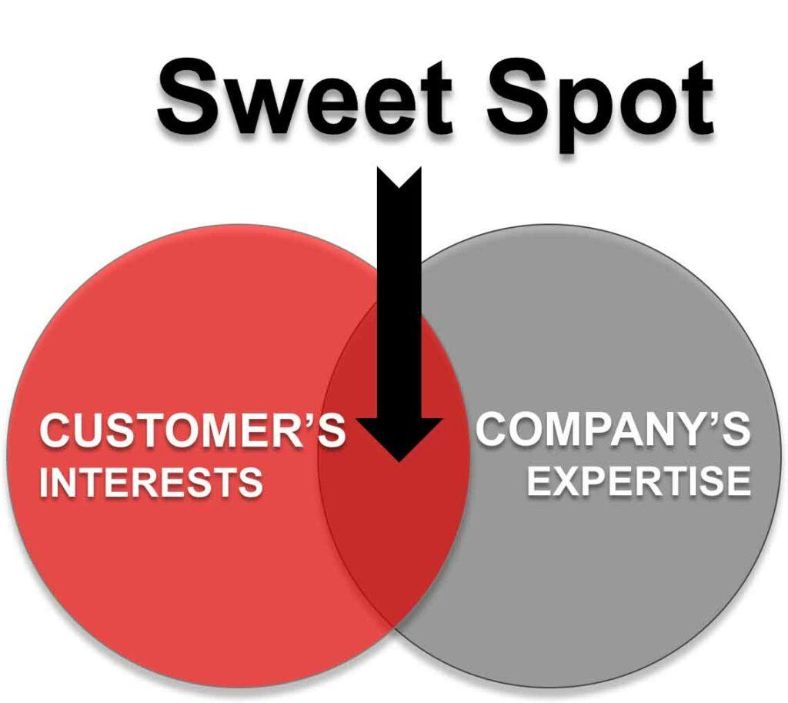
Figure 7: Sweet spot
Source: (He, 2023)

Online Marketing Model

Frameworks Used by LVMH for Digital Marketing
To keep its digital marketing campaigns innovative and successful, LVMH uses a variety of frameworks. From first awareness to purchase and beyond, LVMH utilizes the customer journey map as a framework to personalize digital experiences at every touchpoint. In addition, they use the AIDA model which stands for "attention, interest, desire, action" to build digital campaigns that do just that. Segmenting the market, targeting the proper people, and positioning the brands strategically in the digital domain are all parts of the STP model that the firm uses. LVMH's digital activities are built on data-driven frameworks (He, 2023). Analytics help with targeted marketing choices, and key performance indicators quantify the effectiveness of campaigns. To further solidify its position as industry leaders, LVMH uses the 7Ps of marketing: product, pricing, place, promotion, people, process, and physical evidence all of which are optimized for digital execution to provide customers with a consistent and opulent brand experience.

SOSTAC Model
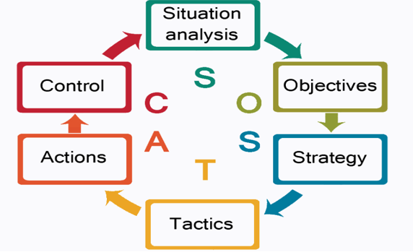
Smith, P. (1990).

Applying SOSTAC to LVMH’s Digital Marketing Plan
LVMH's digital marketing plan, analyzed through the SOSTAC framework, begins with a thorough Situation Analysis, where the company evaluates its online market presence, customer digital interactions, and competitive landscape. The Objectives are then defined with precision, focusing on enhancing e-commerce growth, increasing digital engagement, and maintaining brand prestige in the online sphere. The Strategy involves targeted communication and personalized customer experiences, capitalizing on the luxury appeal and heritage of the brand. Tactics include curated social media content, influencer collaborations, and exclusive online events, complemented by SEO and data-driven advertising to attract and retain a high-value audience. The Action phase sees the implementation of these tactics through a meticulous operational plan, leveraging LVMH's vast resources and expertise (Richards-Carpenter, 2020). Lastly, Control mechanisms are set in place to monitor performance against KPIs, using analytics to measure success and inform ongoing optimization, ensuring that LVMH's digital marketing remains agile and responsive to market dynamics.

Recommendations and Examples of Artificial Intelligence
LVMH can improve consumer experiences and simplify processes by using artificial intelligence (AI). One piece of advice is to add chatbots driven by artificial intelligence to their online properties. Some examples of chatbots that may give rapid help, individualized purchasing advice, and after-sales support include Sephora's "Virtual Artist" chatbot, which employs artificial intelligence to deliver cosmetic lessons and product suggestions. The use of AI for trend forecasting and inventory management predictive analytics is another field. Say, for example, Stitch Fix uses AI to personalize clothes choices for each client by analyzing purchase data and social media trends to forecast consumer behavior. Artificial Intelligence can help LVMH develop more targeted advertising strategies. Like Netflix's recommendation engine, machine learning can sift through user data to create highly targeted adverts, bringing viewers more material that suits their interests and increasing the likelihood that they will click through to buy.

Part 2: Machine Learning and its Influence on Digital Marketing

Ways Machine Learning Influences Digital Marketing
Personalization: Machine learning algorithms analyze vast amounts of data on user behavior, preferences, and engagement (Miklosik and Evans, 2020). By identifying patterns and predicting user interests, these algorithms enable marketers to personalize content, offers, and product recommendations at an individual level. Netflix's recommendation engine is a prime example, curating content for viewers based on their watching history.
Customer Segmentation and Targeting: Machine learning enhances customer segmentation by processing complex datasets to identify distinct customer groups. Marketers can then target these segments with tailored campaigns. Google's advertising platform uses machine learning to help marketers reach potential customers more effectively through targeted ads.
Predictive Analytics: Machine learning aids in forecasting future consumer behavior and market trends. It can predict which products will be popular, allowing businesses to adjust their inventory and marketing efforts accordingly (Miklosik and Evans, 2020). Amazon uses predictive analytics to anticipate user purchases and optimize its inventory management.
Optimization of Marketing Campaigns: Machine learning algorithms continuously analyze the performance of marketing campaigns, automatically adjusting them for optimal results. This real-time optimization leads to higher ROI. Tools like Adext AI utilize machine learning to manage and optimize ad spending across different platforms.
Chatbots and Customer Service: Machine learning-powered chatbots provide instant customer service and support, handling inquiries and guiding users through the sales funnel. These chatbots learn from each interaction, improving their ability to communicate effectively with customers over time.

Critical Analysis of the applications of Machine Learning in digital marketing to maximize ROI and ROS
Personalization and Customer Engagement: ML makes it possible to create hyper-personalized marketing campaigns through the examination of client data, which encompasses previous purchases, browsing activities, and preferences, machine learning algorithms have the capability to personalize marketing messages, product suggestions, and even website design for each unique user. This amount of customization raises the probability of conversions, which has a direct influence on the return on investment and return on sales (Martínez and Vega, 2022). As an example, Amazon's recommendation engine is responsible for a significant percentage of the company's revenue. It does this by recommending goods to consumers that they are more likely to ultimately buy.
Predictive Analytics for Demand Forecasting: The predictive capabilities of machine learning make it possible for organizations to have a more accurate understanding of future consumer behavior and market trends. This predictive ability is helpful in inventory management because it ensures that ideal stock levels are maintained, which is beneficial since it reduces holding costs and maximizes sales potential. This not only helps in discovering prospective market possibilities and client demands, but it also makes it possible to conduct marketing efforts that are both timely and smart.
Optimization of Marketing Campaigns: The success of a variety of marketing channels and campaigns is regularly analyzed by machine learning algorithms, which determine which ones are producing the best return on investment (ROI). They are able to reallocate resources in real-time in order to capitalize on the most productive techniques, whether it is pay-per-click (PPC) ads, email marketing, or interaction on social media (Martínez and Vega, 2022). This dynamic allocation of resources guarantees that marketing dollars are invested in areas that provide the best returns on investment.
Enhanced Customer Insights and Segmentation: Customers may be divided into more sophisticated categories using machine learning, which goes well beyond simple demographics and can be based on a range of criteria. This segmentation makes it possible to conduct marketing initiatives that are more focused and relevant. When marketing efforts are more targeted, there is a greater likelihood that they will connect with the audience, which ultimately results in improved sales and a higher return on investment.
Chatbots and Automated Customer Service: A wide variety of customer support inquiries may be effectively handled by chatbots and virtual assistants that are driven by machine learning. Not only does this enhance the entire client experience, but it also frees up human resources to concentrate on more difficult jobs, which in turn increases the overall efficiency of the organization and contributes to a greater return on investment.
Challenges and Considerations: There is a lot of promise for machine learning in digital marketing, but there are also a lot of problems. The amount and quality of the data that is accessible has a direct bearing on the quality of the insights that may be obtained via machine learning. In addition, the careful management of consumer data is required by data legislation such as the General Data Protection Regulation (GDPR). Furthermore, an excessive dependence on automated systems might result in a loss of human touch in contact with customers, which is essential in particular fields of business.

Ways ML will help LVMH in digital marketing strategy
Enhanced Customer Experience: LVMH can leverage ML to analyze customer data deeply, including purchase history, browsing patterns, and preferences, to offer highly personalized customer experiences. ML algorithms can tailor product recommendations, marketing messages, and even the digital interface for each user. For a luxury brand like LVMH, this bespoke approach can significantly enhance customer engagement and loyalty. Personalization, done correctly, can lead to increased sales and a higher customer lifetime value.
Predictive Analytics for Trend Forecasting and Inventory Management: In the fast-paced world of luxury fashion and goods, being ahead of trends is crucial. ML can process vast amounts of data from various sources to identify emerging trends, allowing LVMH to stay ahead of the curve in product development and marketing. Moreover, predictive analytics can optimize inventory levels, ensuring that popular items are well-stocked and reducing overproduction of less popular ones, thus maximizing sales and minimizing waste.
Optimizing Marketing Campaigns for Higher ROI: ML can dynamically analyze the performance of different marketing channels and campaigns, providing insights into what content works best on which platform and for which audience. By constantly learning and adapting, ML can help LVMH allocate its marketing budget more effectively, ensuring higher returns on investment. This could include optimizing email marketing campaigns, social media ads, or even influencer collaborations.
Enhanced Customer Insights and Segmentation: ML can process customer data to create detailed customer segments based on nuanced behavioral patterns, lifestyle preferences, and purchase history. This advanced segmentation allows LVMH to tailor its marketing efforts more effectively, ensuring that campaigns resonate with the intended audience.
Chatbots and AI-driven Customer Service: ML-powered chatbots can provide instant customer service, assisting with inquiries, recommendations, and after-sales service. For LVMH, this means offering a high level of customer service while freeing up human resources for more complex queries.
Content Optimization and Creation: ML can assist LVMH in content creation by analyzing what types of content (images, text, video) perform best across different digital platforms. It can also help optimize the timing and frequency of content posting.
Challenges and Ethical Considerations: While ML offers numerous benefits, LVMH must navigate challenges such as ensuring data privacy and security, particularly given stringent regulations like GDPR. There's also a need to balance the efficiency of automated systems with the human touch that is often crucial in luxury brand interactions.

Conclusion
This study demonstrates how important Machine Learning (ML) is for boosting LVMH's online advertising campaign. Important in the premium market, ML will allow LVMH to personalize and connect customers like never before. In order to stay ahead of the competition and quickly adapt to changing market conditions and consumer tastes, LVMH relies on ML's predictive analytics and trend forecasting capabilities. Marketing efforts may be optimized with the use of ML-driven insights, which can increase return on investment (ROI) and guarantee effective and smart resource allocation. However, data privacy and the human element of interactions with premium brands must be balanced when ML is used. The incorporation of ML into LVMH's digital strategy signifies a shift towards a data-driven, customer-centric approach, as well as the deployment of modern technologies. If LVMH handles this transition with care, it will be able to embrace the digital future while maintaining its position as a luxury market leader.

References
BOUFIM, M. and BARKA, H., 2021. Digital marketing: Five stages maturity model for digital marketing strategy implementation. IJBTSR International Journal of Business and Technology Studies and Research, 3(3), pp.15-pages.
Bramesh (2020). Aiming for the Right Target in Trading. [online] Bramesh’s Technical Analysis. Available at: https://brameshtechanalysis.com/2020/02/20/aiming-for-the-right-target-in-trading/ [Accessed 17 Dec. 2023].
Cao, Q., Yang, P. and Jing, K., 2023. A Review of Research on Classification, Ownership Confirmation and Value Evaluation of Enterprise Digital Assets——From the Perspective of Digital Asset Construction and Value Realization. In Proceedings of the 2nd International Conference on Public Management, Digital Economy and Internet Technology, ICPDI 2023, September 1–3, 2023, Chongqing, China.
Chen, R., 2021. Analysis on How LVMH Can Be the Leader of the Luxury Industry. In 2021 International Conference on Financial Management and Economic Transition (FMET 2021) (pp. 77-81). Atlantis Press.
Chevalier, M. and Mazzalovo, G., 2021. Luxury brand management in digital and sustainable times. John Wiley & Sons.
Cuofano, G., 2023. Bernard Arnault Empire: LVMH Group Business Model In A Nutshell. [Online]
Available at: https://fourweekmba.com/lvmh-group-business-model/
Foster, J., 2017. What internal communications lessons can we learn from PPC marketing?. [Online]
Available at: https://www.interactsoftware.com/blog/what-internal-communications-lessons-can-we-learn-from-ppc-marketing/
Fox, R.J. (2020). Digital assets management: 2020 how-to-guide - Mowgli Digital assets management a how to guide: best practices. [online] Mowgli. Available at: https://bemowgli.com/websites/digital-assets-management-2020-how-to-guide/ [Accessed 12 Dec. 2023].
Francois, L., 2023. Decoding Louis Vuitton’s Instagram Journey: A Masterclass in Brand Evolution. [Online]
Available at: https://medium.com/@lilzeon/decoding-louis-vuittons-instagram-journey-a-masterclass-in-brand-evolution-1675f7cfead0
He, T., 2023. Business Strategy and Market Attempt of Luxury Brands in the Post-epidemic Era–A Case Study of LVMH’s Leather Goods. In 3rd International Conference on Economic Development and Business Culture (ICEDBC 2023) (pp. 293-300). Atlantis Press.
info@themmachine.com (2019). How to Build a Brand Positioning Statement Effectively. [online] The Marketing Machine. Available at: https://www.themmachine.com/how-to-build-an-effective-brand-positioning-statement/ [Accessed 17 Dec. 2023].
Kovaitė, K., Šūmakaris, P. and Stankevičienė, J., 2020. Digital communication channels in Industry 4.0 implementation: The role of internal communication. Management: Journal of Contemporary Management Issues, 25(1), pp.171-191.
Lai, C.S., 2022. The Strategy and Competitor Analysis of LVMH. In 2022 2nd International Conference on Financial Management and Economic Transition (FMET 2022) (pp. 549-557). Atlantis Press.
lvmh.com, 2015. Dior creates its own virtual reality headset. [Online]
Available at: https://www.lvmh.com/news-documents/news/dior-creates-its-own-virtual-reality-headset/
LVMH (2019). LVMH. [online] LVMH. Available at: https://www.lvmh.com/ [Accessed 8 Dec. 2023].
Martínez, J. and Vega, J., 2022. ROS System Facial Emotion Detection Using Machine Learning for a Low-Cost Robot Based on Raspberry Pi. Electronics, 12(1), p.90.
May 20, B.S.B.W.P. and 2020 (2020). Top 5 Best CRM WordPress Plugins for 2023. [online] Compete Themes. Available at: https://www.competethemes.com/blog/crm-wordpress-plugins/ [Accessed 13 Dec. 2023].
Miklosik, A. and Evans, N., 2020. Impact of big data and machine learning on digital transformation in marketing: A literature review. Ieee Access, 8, pp.101284-101292.
Monitor, C. (2019). How You Can Use Interactive Content To Segment Your Leads. [online] Campaign Monitor. Available at: https://www.campaignmonitor.com/blog/email-marketing/how-you-can-use-interactive-content-to-segment-your-leads/ [Accessed 14 Dec. 2023].
Olazo, D.B., 2022. Measuring the level of Digital Marketing Capabilities, Digital Marketing Strategies and Challenges and Issues of SMEs in adopting Digital Marketing. J. Mark. Adv. Pract, 4, pp.79-96.
Oliveira, M.R.S., 2020. Equity Valuation: LVMH Moet Hennessy: Louis Vuitton SE (Doctoral dissertation).
Park, J. and Rhee, Y.J., 2021. Analysis of digital marketing strategies of luxury fashion brands. Journal of the Korea Fashion and Costume Design Association, 23(1), pp.87-102.
Parnes, P., 2022. Corporate venture capital: common practices and different approaches cases research of Arezzo&Co’s ZZ Ventures and LVMH’s LVMH Luxury Ventures (Doctoral dissertation).
Rangel, C. and López, B., 2022. 14 Digital transformation in luxury brands. Sustainable International Business Models in a Digitally Transforming World.
Richards-Carpenter, N.N., 2020. ‘A very useful text for any luxury brand management student, or luxury prac-titioner, interested in increasing their knowledge in contemporary luxury issues and the evolving luxury consumer.’–Debbie Pinder, University of Southampton ‘A good blend of practical and theoretical focus with new conceptual ideas to.
Sánchez Zaragozá, P., 2022. Louis Vuitton's digital strategy on Instagram. Proposal of an online campaign to promote the 2022 Fall-Winter Men Collection on Instagram (Doctoral dissertation, Universitat Politècnica de València).
Smith, P. (1990). SOSTAC® Planning. [online] PR Smith. Available at: https://prsmith.org/sostac/ [Accessed 8 Dec. 2023].
Treiblmaier, H., 2023. Beyond blockchain: How tokens trigger the internet of value and what marketing researchers need to know about them. Journal of Marketing Communications, 29(3), pp.238-250.
Vanderhaeghen, L. and Chevalier, L., 2020. How to implement digital marketing for a luxury fashion brand while respecting its components?.

