___________________________________
Design and Implementation of a Relational Database System
Eco-Ride Bikes
Louise Jay (1500828)

Contents
Introduction 3
Scenario 3
Entity Relationship Diagram 3
Table Design 4
Entities and Relationships 4
Normalisation 4
Data Integrity and Validation 5
Queries 6
Bikes In Use Query 6
Maintenance Cost By Month Query 7
Future Improvements 7
Conclusion 7
References 8

Introduction
This assignment presents a relational database design for Eco-Ride, a public electric bike rental scheme. It explains the rationale behind the chosen database design, how the design addresses current operational problems, and the validation and normalization strategies that ensure reliable record keeping. The aim is to replace paper forms and spreadsheets with a maintainable database that improves efficiency, prevents conflicts such as double bookings, and provides insights into business costs. The report covers practical choices such as tables, keys, lookups and constraints and outlines queries and future improvements that would help Eco-Ride scale.

Scenario
Eco-Ride currently manages hires and maintenance using paper forms and spreadsheets, which creates a range of operational issues. Paper databases can often contain inconsistent and incorrect and missing data, as there are no restrictions to limit user error [1]. Staff struggle with poor records of bike availability, duplicate rider entries and difficulty producing consistent usage or cost summaries. These weaknesses lead to inefficiencies because bikes can be double booked and repairs are hard to trace. Producing reliable reports has to be done manually which is time consuming and prone to error. A well structured relational database provides a single source of data for riders, bikes, rentals and maintenance, enabling staff to run accurate operational reports.

Entity Relationship Diagram
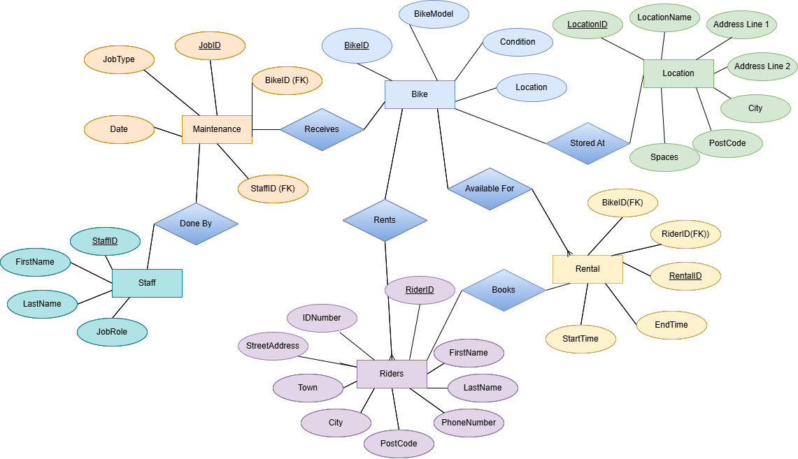

Table Design
The proposed database uses six focused tables: Bikes, Riders, Staff, Rentals, Maintenance, and Locations. Each table has an Autonumber primary key to provide stable identifiers—BikeID, RiderID, StaffID, RentalID, MaintenanceID, and LocationID this simplifies joins and queries. Field types are chosen to match the data, Short Text for names and categorical values, Date/Time for timestamps, and Currency for cost fields. Lookup fields or small lookup tables standardise values for attributes such as model, condition and maintenance type [2]. The Locations table holds station address and capacity information and helps avoid repeating address fields in the bike table. Unique constraints on rider contact fields such as email and phone number reduce the risk of duplicate registrations and maintain records so customers can be contacted [1].

Entities and Relationships
The entities in the model map directly to business activities e.g. riders hire the bikes. Relationships are simple and intuitive for example, a bike can have many rentals and many maintenance events and a rider can have many rentals. These one-to-many relationships are implemented with foreign keys that enforce referential integrity so rentals and maintenance cannot reference non-existent bikes, riders or staff. By entities being set up this way, the database makes it easy to create queries and ensures that records are correct.
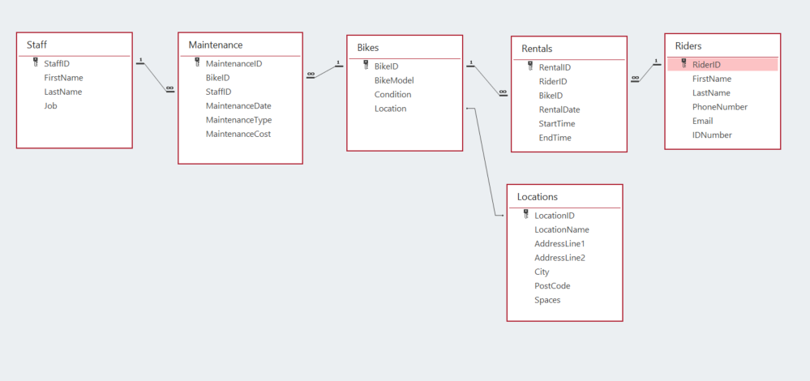

Normalisation
The database is normalised to reduce redundancy and prevent update, insert and delete anomalies. Normalisation is the process of designing the most optimal database possible, making it easy to use and less memory intensive [3]. Each table represents a single subject area; bikes, riders, staff, rentals, maintenance and locations and uses an autonumber primary key so rows are unique and easy to reference. In First Normal Form all fields are atomic and single-valued. Attributes such as model, condition and maintenance type are implemented as lookup fields or separate lookup tables to avoid multi-valued columns. In Second Normal Form non-key attributes depend on the whole primary key and repeating groups such as address and capacity are moved into the Locations table to prevent duplicated address data across bikes. In Third Normal Form no non-key attribute depends on a primary key, for example, bike location details live in Locations rather than in Bikes, and staff details live in Staff while maintenance stores only foreign keys plus maintenance attributes. Values such as rental duration or costs are stored as queries rather than stored in the tables, which keeps the table clean and avoids update anomalies.

Data Integrity and Validation
Data integrity is enforced through constraints and field validation. Table elements such as primary keys and foreign keys with enforced referential integrity prevent orphaned rows and ensure related records exist [2]. There are restrictions that ensure that rider email and phone numbers are unique to prevent duplicate registrations [1]. There are some important validation rules, such as requiring end time to be after the start time. There is also a validation rule that maintenance costs are non-negative. Lookup tables create standardised values for model, condition and maintenance type to avoid inconsistencies in phrasing and typographical errors. Together these measures prevent orphan records, duplicate registrations and operational errors such as double bookings while still allowing flexibility where necessary eg. null entries where appropriate.
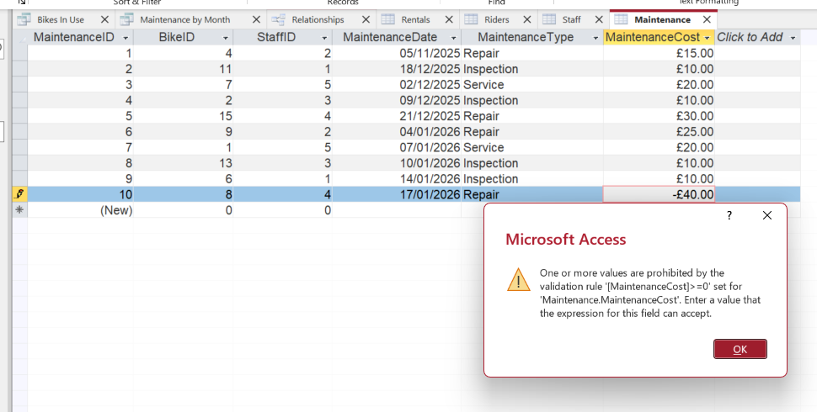
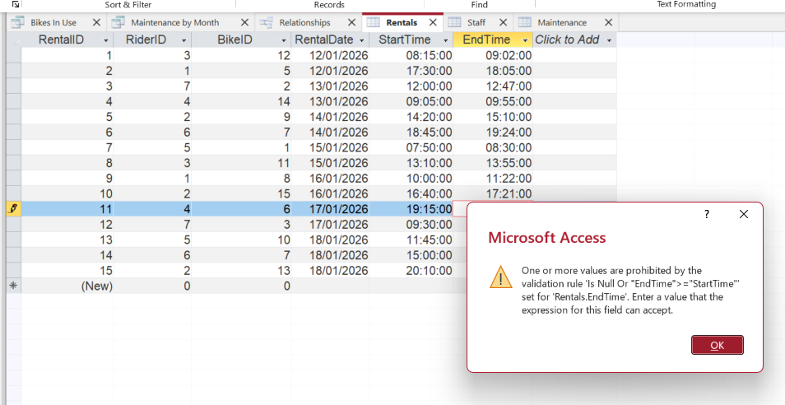

Queries
The normalized design and enforced relationships make it easy to build queries for operations and reporting. To check availability a query was made that returns rentals where EndTime IS NULL, this identifies bikes currently out on hire and is useful for preventing double bookings. There is also a maintenance query that groups by month and sums maintenance cost, producing a monthly summary of spending and workload, which helps budgeting. This could also help identify issues with bikes which cause the most expenses.

Bikes In Use Query
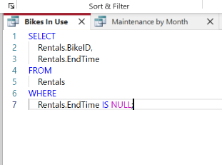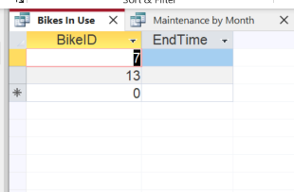

Maintenance Cost By Month Query
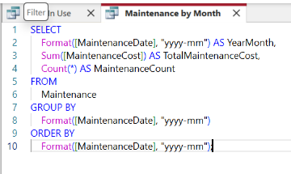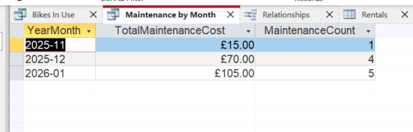

Future Improvements
Several future improvements to the database could increase reliability, usability and scalability. Standardising input formats with input masks for phone numbers and postcodes will reduce errors and help ensure customers are contactable. More could be done with the ability to detect active rentals. A dashboard could be created for staff which shows active bike rentals, and flags rentals that are overdue. Bikes that are currently in use could be flagged when forms are being completed. Using forms to enforce validation rules would provide user feedback and reduce errors. For record keeping, it may be useful to log who is adding to the database and when with fields like CreatedBy and CreatedAt, this would be most helpful in the maintenance and rentals tables.

Conclusion
The relational design replaces inefficient paper and spreadsheet processes with a robust database that supports daily operations and reporting for Eco-Ride. Relevant tables, Autonumber keys, lookup fields and a dedicated Locations table reduce redundancy and typographical errors, while referential integrity, unique indexes and validation prevent duplicates, orphaned records and inconsistencies such as double bookings. Normalisation keeps the database maintainable and predictable, and the example queries facilitate availability checks and maintenance cost analysis. Implementing the suggested future improvements will further enhance reliability and speed of use, enabling Eco-Ride to scale its service and deliver better experiences for riders and staff.

References
[1] M. J. Hernandez, Database design for mere mortals : a hands-on guide to relational database design. Boston: Addison-Wesley, 2021.
[2] P. Weverka and T. L. Warner, Office 365 all-in-one for dummies, 1st ed. in For dummies. Hoboken, NJ: John Wiley & Sons, Inc, 2019.
[3] T. M. Connolly and C. E. Begg, Database systems : a practical approach to design, implementation, and management. in Always learning. Boston: Pearson, 2015.

