

Module Title: | Dissertation
Module Code: | LCMB7020
Course: | MASTER OF BUSINESS ADMINISTRATION IN (GENERAL MANAGEMENT )
Dissertation Topic: | Analysis of the factors influencing the consumer purchase behaviour for fast fashion: A study of UK consumers and Zara’s fast fashion apparel
Lecturer: | Dr. Jaya Gopalkrishnan

Master’s Degrees by Examination and Dissertation
Declaration Form.
1. This work has not previously been accepted in substance for any degree and is not being concurrently submitted in candidature for any degree.
Signed : Rupalbahen Nikhilkumar Patel
Date : 14/10/2023

2. This dissertation is being submitted in partial fulfilment of the requirements for the degree of Master in Business Administration.
Signed : Rupalbahen Nikhilkumar Patel
Date : 14/10/2023
3. This dissertation is the result of my own independent work/investigation, except where otherwise stated.
Other sources are acknowledged by footnotes giving explicit references.
A bibliography is appended.
Signed candidate : Rupalbahen Nikhilkumar Patel
Date: 14/10/2023

4. I hereby give consent for my dissertation, if accepted, to be available for photocopying, inter- library loan, and for deposit in the University’s digital repository
Signed (candidate) : Rupalbahen Nikhilkumar Patel
Date : 14/10/2023

Supervisor’s Declaration.
I am satisfied that this work is the result of the student’s own efforts.
Signed : Dr Jaya Gopalkrishnan
Date: 14th Oct ,23

University of Wales: Trinity Saint David
E-Thesis Deposit Agreement

Details of the Work
I would like to deposit the following item in the digital repository maintained by the University, and/or in any other repository authorized for use by the University:

Title: Analysis of the factors influencing the consumer purchase behaviour for fast fashion: A study of UK consumers and Zara’s fast fashion apparel

This item is a product of my own research endeavours and is covered by the agreement below in which the item is referred to as “the Work”. It is identical in content to that deposited in the Learning Resources Centre, subject to point 4 below.
I agree that the University of Wales: Trinity Saint David may electronically store, copy or translate the Work to any approved medium or format for the purpose of future preservation and accessibility. The University is not under any obligation to reproduce or display the Work in the same formats or resolutions in which it was originally deposited.
UW: TSD Digital Repository
I understand that work deposited in the digital repository will be accessible to a wide variety of people and institutions, including automated agents and search engines via the World Wide Web.
I understand that once the Work is deposited, the item and its metadata may be incorporated into public access catalogues or services, such as national databases of electronic theses.

I agree as follows:
- That I am the author or have the authority of the author/s to make this agreement and do hereby give the University of Wales: Trinity Saint David the right to make available the Work in the way described above.
- That the electronic copy of the Work deposited in the digital repository and covered by this agreement, is identical in content to the paper copy of the Work.
- That I have exercised reasonable care to ensure that the Work is original, and to the best of my knowledge, does not breach any laws including those relating to defamation, libel and copyright.
- That I have, in instances where the intellectual property of other authors or copyright holders is included in the Work, gained explicit permission for the inclusion of that material in the Work, and in the electronic form of the Work as accessed through the open access digital repository, or that I have identified and removed that material for which adequate permission has not been obtained and which will be inaccessible via the digital repository
- That University of Wales: Trinity Saint David does not hold any obligation to take legal action on behalf of the Depositor, or other rights holders, in the event of a breach of intellectual property rights, or any other right, in the material deposited.
- That I undertake to indemnify the University of Wales: Trinity Saint David against all actions, suits, proceedings, claims, demands and costs occasioned by the University in consequence of any breach of this agreement

Signature: Rupalbahen Nikhilkumar Patel
Date: 14/10/2023

Abstract
This study was conducted to investigate the factors influencing the consumer purchase behaviour for fast fashion apparel of ZARA. It increasingly emphasised on psychological, social and personal factors impacting the purchase behaviour of the consumer.
The dissertation was segmented into theoretical and empirical sections. The former section had used past literature in relation to the topic and investigated different models and theories for clear justification. The empirical section consisted of a real-time survey that was performed online using a set of 15 questions. This multiple-choice questionnaire helped to collect topic-related data from work colleagues and university students. These participants were approached through WhatsApp, email, social media messages and text messages. Thus, using the quantitative methods, primary data was collected in this research, whereas past literature helped to gather secondary data from reliable and academically-accepted sources.
The study findings revealed that psychological factors (motivation, perception, learning and attitude and beliefs), social factors (family and friends, reference group, and roles and status) and personal factors (age, income, occupation and lifestyle) had a significant impact on the consumer purchase behaviour. Through literature review and survey, the study had successfully achieved research aims and objectives. In the concluding part, the researcher had suggested recommendations to Zara, had set future research direction and had examined this research limitations.

Acknowledgement
My supervisors, namely, Jayakumari Gopalkrishna and Hossein Shokri, had provided me with their extensive support and supervision throughout this research study and for that I offer my heartfelt gratitude to them. Further, their good research knowledge and skill had helped me to understand the know-how about conducting research.
I am also thankful to the University for giving us a dissertation module that helped me to gain good analytical and research skills.
I also appreciate all the research participants for giving their valuable time in completing the survey and helping me to successfully achieve the research aims and objectives.

Table of Contents
Abstract 6
Acknowledgement 7
Chapter 1: Introduction 12
1.1 Introduction 12
1.2 Background of the Research 12
1.3 Company Background 14
1.4 Research Aims and Objectives 14
1.5 Research Questions 15
1.6 Research Rationale 15
1.7 Significance of the Research 16
1.8 Dissertation Structure 17
Chapter 2: Literature Review 19
2.1 Introduction 19
2.2 Definitions of Consumer Purchase Behaviour (CPB)? 19
2.3 Evaluation of CPB in Apparel Industry 20
2.4 Psychological Factors and Impact on CPB 21
2.5.1 Motivation 22
2.5.2 Perception 24
2.5.3 Learning 25
2.5.4 Attitude and Belief 26
2.6 Social Factors and Consumer Purchase Behaviour 27
2.6.1 Family and Friends 28
2.6.2 Reference Group 30
2.6.3 Roles and Status 31
2.7 Personal Factors and Consumer Purchase Behaviour 33
2.7.1 Age 34
2.7.2 Income 35
2.7.3 Occupation 36
2.7.4 Lifestyle 37
2.4 Models of Consumer Behaviour 39
2.4.1 Engel-Kollat-Blackwell (EKB) Model of Consumer Behaviour 39
2.4.1 The Black Box Model 41
2.8 Summary 43
Chapter 3: Methodology 44
3.1 Introduction 44
3.2 Research Design 44
3.3 Philosophy 45
3.4 Approach 45
3.5 Methodological Choice 45
3.6 Strategies 46
3.7 Time Horizon 46
3.8 Data Collection 47
3.8.1 Size of the Sample 47
3.8.2 Sample Type 47
3.8.3 Sampling Technique 47
3.8.4 Data Type 48
3.8.5 Data Collection Method 48
3.9 Data Analysis 49
3.10 Ethical Considerations 49
Chapter 4 Data Analysis 51
4.1 Introduction 51
4.2 Data Analysis 51
4.2.1 Analysis of the Survey Questions 51
Chapter 5: Discussion 68
5.1 Introduction 68
5.2: Discussion on Survey Questionnaire Results 68
Chapter 6: Conclusion and Recommendations 72
6.1 Introduction 72
6.2 Conclusion 72
6.3 Recommendation 74
6.3.1. Recommendations to ZARA 74
6.3.2 Recommendations for Future Research 75
6.4 Research Limitations 76
References 78
Appendices 93
Appendix 1: Survey Questionnaire Sample 93

List of Figures
Figure 1: Deloitte consumer tracker for essential and discretionary purchase 12
Figure 2: Dissertation Structure 17
Figure 3: Consumer Buying Behaviour 20
Figure 4: Psychological Factors Impacting CPB 22
Figure 5: Motivational Psychological Process Model 22
Figure 6: Maslow Hierarchy of Needs 23
Figure 7: The Perceptual Map 25
Figure 8: Learning Model 26
Figure 9: Social Factors Impacting CPB 28
Figure 10: Pew Research Centre Report 29
Figure 11: Purchase Decision Phases 31
Figure 12: Average disposable household income in the UK by decile group 32
Figure 13: Weekly household spending on clothing in the UK by decile group 32
Figure 14: Personal Factors Impacting CPB 33
Figure 15: Fashion segment users in the UK by age 34
Figure 16: Gen Z sustainability preference 37
Figure 17: SRI Consulting VALS Model 38
Figure 18: EKB model of consumer behaviour 39
Figure 19: Global Consumer Insights Pulse Survey 40
Figure 20: The Black Box Model 42
Figure 21: Research Onion 44
Figure 22: Gender 52
Figure 23: Age 53
Figure 24: Occupation 54
Figure 25: Income 55
Figure 26: Frequency of purchase 56
Figure 27: Motivation to purchase apparel 57
Figure 28: Brand selection criteria 58
Figure 29: Purchasing clothes makes me happy. I do not care about others’ opinion 59
Figure 30: Purchasing clothes to create good impression 60
Figure 31: Group influencing purchase decision 61
Figure 32: Purchasing clothes according to personal and/or professional role 62
Figure 33: Purchasing clothes according to personal and/or professional status 63
Figure 34: Purchasing clothes worn by same age people 64
Figure 35: Purchasing clothes within the budget 65
Figure 36: Purchasing clothes that suits the personality 66
List of Tables
Table 1: Gender 51
Table 2: Age 52
Table 3: Occupation 53
Table 4: Income 54
Table 5: Frequency of purchase 55
Table 6: Motivation to purchase apparel 57
Table 7: Brand selection criteria 58
Table 8: Purchasing clothes makes me happy. I do not care about others’ opinion 59
Table 9: Purchasing clothes to create good impression 60
Table 10: Group influencing purchase decision 61
Table 11: Purchasing clothes according to personal and/or professional role 62
Table 12: Purchasing clothes according to personal and/or professional status 63
Table 13: Purchasing clothes worn by same age people 64
Table 14: Purchasing clothes within the budget 65
Table 15: Purchasing clothes that suits the personality 66

Chapter 1: Introduction

1.1 Introduction
This chapter provides a research overview and gives a broad idea about the themes that will be covered in the study. Firstly, it sets the scene by giving a brief research background. Through research rationale, a justification for conducting this study is specified. Next, the purpose and significance of this research, along with the research aims and objectives are also highlighted in this chapter. Finally, a structure of this dissertation is presented at the end of the chapter.

1.2 Background of the Research
Consumer buying behaviour is a widely researched concept in the academic field. It is the process which clarifies how, why, what and when a consumer selects or purchases a product or a brand (Kumar, et al., 2014). Chan (2001) stated that gaining complete knowledge about consumer buying behaviour is impossible as it is associated with the thoughts and consciousness of a person. However, Gupta and Ogden (2009) explained that predicting consumer behaviour in a buying situation is possible by referring to their previous buying decisions. For example, Deloitte uses consumer tracker to record the spending of the consumers and forecast their future purchase behaviour (as shown in Fig. 1).
Figure 1: Deloitte consumer tracker for essential and discretionary purchase
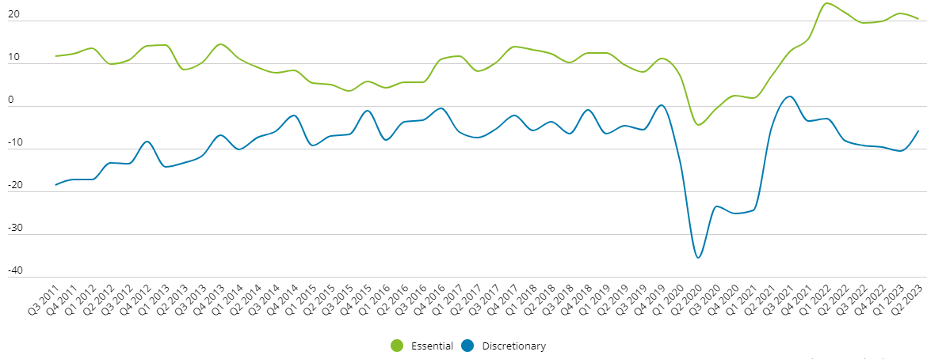
Source: Deloitte (2023)
Purchase decisions are taken by consumers on a regular basis and most of them are unaware of the factors that influence them to that decision (Kumar, 2016). For instance, buying clothes comes naturally to the human being as it is the basic need of an individual (Entwistle, 2023). However, there are certain characteristics responsible for purchase decisions that may arise from psychological, social, and personal factors (Ramya and Ali, 2016). From the perspective of the marketers, knowledge about these factors helps to better understand the consumers and their decisions. Moreover, this knowledge can help them to design effective marketing strategies, which can further influence their buying decision (Chou, et al., 2020). For example, if the marketers are targeting upper social class consumers, having considerable disposable income, the market offering should focus on quality, comfort and service to meet the expectations of those consumers. Therefore, marketers should integrate consumer purchase behaviour into every aspect of their strategic marketing plan.
In the apparel industry, constantly and significantly changing consumers’ needs, had led to the introduction of fast fashion concepts. Fast fashion is defined by Payson (2020) as an approach of quickly producing a high volume of inexpensive clothing that replicates trends from runway, big fashion designs and celebrity culture. Zara, H&M and Primark in the United Kingdom, operates on the fast fashion business model and focuses on quickly changing and producing the garments with the fast-changing fashion trends (PR News Wire, 2023). This has resulted in increased demand, creation of needs and compelling of customers to frequently visit fast fashion stores to stay on track with the latest trend (Business Research Insight, 2023).
Consumers’ increasing interest in fast fashion has lately influenced many researchers to study their buying behaviour for fast fashion (Caro and Martínez-de-Albéniz, 2015). Studies in the past have found that price, environmental factors and sustainability, supply-chain, distribution and production are the important factors that impact consumers’ decision with regards to fast-fashion (Cachon and Swinney, 2011; McNeill and Moore, 2015; Gabrielli, et al., 2013). However, this study looks beyond these factors and focuses more on psychological, personal and social factors in influencing the decision of consumers for purchasing fast fashion.

1.3 Company Background
The fast-fashion company selected for the purpose of this research is Zara. It is a leading retail brand and a flagship company of Inditex, the largest distribution and fashion group worldwide (Zara, n. d.). This Spain-based company was established in 1975 by Amanico Ortega and since then the brand has expanded in many countries across the globe, which includes China, Italy, United States, United Kingdom (UK), France and so on (Forbes, n. d.). At present, there are more than 2,000 stores of Zara, including Zara Kids, and 500 stores of Zara Home globally (Smith, 2022). In the UK, the first store of Zara was opened in 1998, and as of June 2023, there are 60 Zara stores in 60 locations and 41 cities in the UK (Inditex, n. d.; Scrape Hero, 2023).
Zara focuses on designing, producing, distributing and selling a wide range of apparel for men, women and children (Business of Fashion, n. d.). Its product-line also includes shoes, perfume, accessories, and cosmetic products. Further, the company also deals in home appliances and homeware through Zara Home (Retail Week, n. d.). For easy access and hassle-free purchase, Zara’s vast product-line is available on both ecommerce platforms and in its brick-and-mortar stores (Zara, n. d.). During the year 2022, the company had generated a worldwide revenue of more than 23 billion euros (Smith, 2023), through its offline as well as online stores.

1.4 Research Aims and Objectives
The broad aim of this study is to investigate the factors that influence the purchase behaviour of the consumers for Zara’s apparel products. This research will emphasise on factors – psychological, social and personal – that have a significant impact on the decisions of Zara’s consumers.
To achieve the broad research aim, the research objectives are:
- To identify if psychological factors that influences the purchase behaviour of consumers for Zara’s product
- To evaluate if social factors play an influential role in purchase behaviour of Zara’s consumers
- To identify if personal factors influences the consumers’ buying behaviour

1.5 Research Questions
Based on the research aims and objectives, the main question addressed in this research is –
What are the factors influencing the purchase behaviour of the consumers for Zara’s apparel products?
Following the main question, the investigating questions that will be answered through this research are:
- What psychological factors influence the purchase behaviour of consumers for Zara’s product?
- What social factors play an influential role in purchase behaviour of Zara’s consumers?
- What personal factors influence the consumers’ buying behaviour and how?

1.6 Research Rationale
Growing demand for fast fashion leads to increasing competition in the fashion industry (Mrad, et al., 2020). Therefore to gain a competitive edge, the fast fashion retailers are trying to develop a good brand image in the consumers’ mind to influence their buying behaviour (Shamsher, 2015).
Studying consumer buying behaviour is important for every entrepreneur in order to understand how consumers make decisions about what products or services to purchase and how they use their valuable resources, like time, money and energy, in getting the desired products and services (Hanaysha, 2017). A good understanding of consumers’ needs and characteristics plays a crucial role in determining their buying decision (Lukman and Vukasovic, 2020). Ramya and Ali (2016) stated that knowledge about the factors affecting consumers’ purchase decisions can help the businesses to increase the sales, boost customer satisfaction, gain competitive advantage and ensure long-term survival. However, a failure in understanding the consumer behaviour can lead to product, service as well as the overall business failure (Mirabi, et al., 2015).
Studies in the recent past have identified corporate social responsibilities and marketing strategies, especially social media, as major influential factors of consumer buying behaviour, and of their perception towards a brand and its offerings (Hanaysha, 2017; Jermsittiparsert, et al., 2019; Chou, et al., 2020). Other researchers have focused on brand-oriented factors, like brand name, brand value, product price and store environment as the key indicators of consumers’ choice and their purchase decision (Pardeshi and Khanna, 2021; Shridhar, 2023; Banik and Sinha, 2020). Although considerable research in the past has studied consumer buying behaviour in different industries, limited research has been conducted with regards to consumer purchase decisions in the fast fashion sector. Additionally, there has not been any mutual agreement on the most influential factors shaping consumers’ decisions. However, this research will focus on customer-oriented factors, such as personal, psychological and social, that influences consumers’ behaviour, especially in the fast fashion industry.

1.7 Significance of the Research
The findings of this research can be beneficial for Zara and other fast fashion brands in understanding their consumers’ buying preferences and the most influential factors that impact their buying decisions. This knowledge will help the fast fashion stores to bring necessary changes in their apparel products, services and overall business process that will further attract more consumers to the business (Kumar, 2016). Besides Zara and fast fashion brands, the entrants in the fast fashion world can also use the findings of this research to design their product-lines as well as their marketing and business strategies that will help them gain maximum consumers’ attention.

1.8 Dissertation Structure
Oliver (2013 explained that a dissertation structure is made up of 6 chapters as shown in Fig.2.

Figure 2: Dissertation Structure

Source: Modified from Oliver (2023)
Chapter 1: Introduction
Introduction chapter offers a brief background of the research and an overview of the company that focused on this research. The rationale and significance of the research are also thoroughly described in the introduction chapter. Additionally, the aims, objectives, and questions related to the research study are well described in this chapter.
Chapter 2: Literature Review
This chapter explores the existing literature and presents widespread discussion on various theoretical concepts and themes related to the research topic. The key terminologies, i.e. personal, social and psychological factors, which are also the focus of this study, are investigated in-depth to identify their influence on buying behaviour of the consumers of a fast fashion company, i.e. Zara.
Chapter 3: Methodology
This chapter specifies the methodological approach and techniques adopted by the researcher to conduct this study. It also provides a reason for selecting a specific research method and offers an explanation on its appropriateness with this research. Additionally, it illustrates the technique used to collect and analyse the data and the ethical consideration followed by the researcher when gathering data.
Chapter 4: Data Analysis
In this chapter, quantitative data collected from the research participants, using survey questionnaires, is further analysed using pie-charts and tables. A description on participants’ responses for each research question was presented in this chapter. When describing the responses, the researcher also made comparisons with the past study data described in the literature review. This helped to identify the similarity or differences of this study findings with the previous studies conducted by other researchers.
Chapter 5: Discussion
This chapter discussed the key findings derived after analysing primary data gathered from research participants. Further, the research questions, stated in the first chapter, are addressed and answered in this chapter.
Chapter 6: Conclusion and Recommendations
This is the final chapter of the dissertation which concludes the study on the basis of the key findings. The research aims and objectives, illustrated in the introduction chapter, were restated and justified to an extent to identify whether each research objectives were achieved.
Followed by the conclusion, the research suggests recommendations and limitations for this research and sets direction for future research on similar subject areas. Additionally, a brief recommendation is also offered to Zara with regards to the influential factors that they can consider to influence their consumers’ buying behaviour.

Chapter 2: Literature Review

2.1 Introduction
Grant and Osanloo (2014) stated that literature review explores key theories, philosophies and terminologies related to the specific research area. Further, it deconstructs the existing literature and critically assesses different perspectives of the past researchers on a given topic, field or discipline (Kucan, 2011).
In this chapter, existing academic literature, related to consumers and their purchase behaviour, is critically evaluated. Additionally, models and theories related to consumer behaviour are examined to understand how and why consumers make a purchase. Next, existing information on three influential factors, i.e. psychological, social and physical, is explored and their role in consumer buying behaviour is identified.

2.2 Definitions of Consumer Purchase Behaviour (CPB)?
Solomon, et al. (1995) defined CPB as the sum of actions which involves selecting, buying, utilising and discarding products or services by a person or a group of people to fulfil their needs and desires.
Batra and Kazmi (2004) explained that CPB consists of emotional and mental activities as well as noticeable behaviour responses of consumers occurring when search, purchase and post purchase use of products and services is done.
According to Darian, et al. (2015), CPB comprises individual or group’s preferences, choices, attitude and judgement concerning the purchase of any product or services.
Ramya and Ali (2016) defined CPB as decisions made by a prospective consumer with regards to purchasing (both online and offline) a specific product or service.
The current definition offered by Tao, et al. (2022) explains CPB as a task undertaken by a person from seeking information to making purchase intentions to experiencing purchase decision issues.
Although the above definitions give different viewpoints, they all explain a common perspective that CPB involves different actions and experiences of a consumer (as shown in Fig. 3) when making a purchase.
Figure 3: Consumer Buying Behaviour
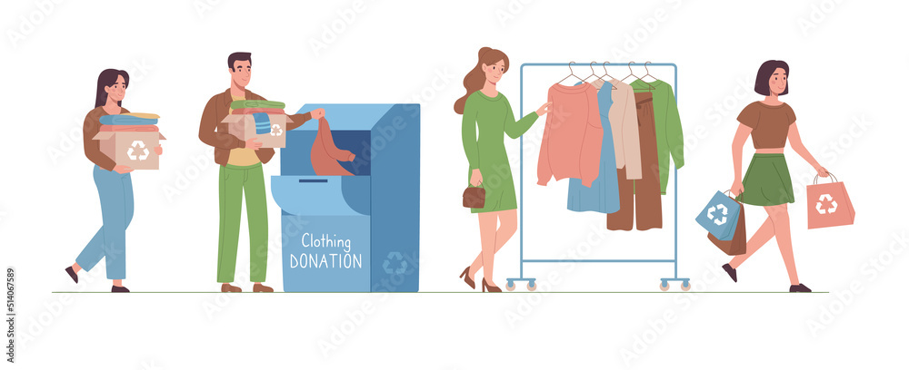
Source: (Siddiqua, 2016)

2.3 Evaluation of CPB in Apparel Industry
According to Cachon and Swinney (2011), CPB in the apparel industry is a complex and multifaceted process. It changes according to the self-perception and self-image, psychological perspective, buying habit, change in the trend, and choices offered by different brands (Tien, 2019).Therefore it is essential for Zara’s marketers to first get familiar with different types of consumption behaviour of the customers before understanding the factors influencing their purchase.
According to Park, et al. (2006), when buying clothes, some consumers indulge in impulse buying behaviour which refers to instant purchase of a product or a service without prior consideration or intention. Chen and Wang (2016) stated that consumers’ impulse purchases result from an immediate but strong urge to purchase a product without considering the consequences of making such a purchase. A study conducted by Gandhi (2020) found that male are more engaged in impulse shopping than females due to their personal characteristics of spending less time shopping. On the other hand, study by Chetioui and Bouzidi (2023) found female as the impulse shopper than male due to increased fear of missing out, emotional arousal on seeing the product, and fund and entertainment associated with the product.
Another buying behaviour, as stated by Sharma, et al. (2001) is variety seeking purchase behaviour wherein the consumer switches between the brands or products in search for variety or to avail something new. Variety seeking buying behaviour is more visible in the fast fashion industry wherein with the changing trends, consumers are interested to find new options available with different brands (Gabrielli, et al., 2013). According to the survey conducted by Statista, 60% of the UK consumers switch brands depending on the best offer offered by them (Wunsch, 2021).
Eriksson, et al. (2017) explained that consumers also engage in habitual-brand loyal buying behaviour in the apparel industry, which refers to purchase from the same brand over and again due to the loyalty with the brand. Recent research by Performance Marketing World revealed that 73% of the UK consumers are loyal to some brands or retailers (Dennis, 2022).
The above literature shows that consumers experience different buying behaviour when making an apparel purchase, however understanding the factors influencing these behaviour is important for Zara to attract more consumers to their business.

2.4 Psychological Factors and Impact on CPB
Psychological factors are directly associated with the mind and consciousness of an individual (Sharma, 2021). These factors shape consumers’ behaviour and have a strong impact on them (Singh, et al., 2018). They are very important yet difficult for the marketers to quantify due to their internal and subjective nature (Lichev, 2017). However, the salient feature is that they describe the specific quality of an individual and the way they perceive, interpret and respond in a purchase situation (Khaniwale, 2015).
According to Kotler (2005), there are 4 psychological factors (as shown in Fig. 4) that impacts the purchase behaviour of a consumer.

Figure 4: Psychological Factors Impacting CPB
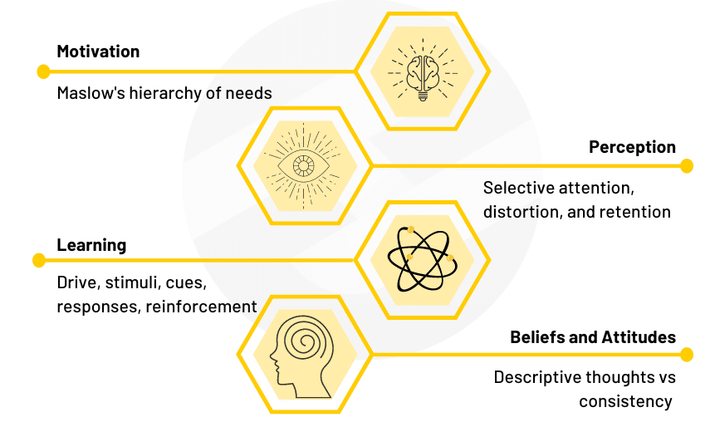
Source: Super Heuristics (2023)

2.5.1 Motivation
According to Kimmel (2013), motivation involves why a consumer behaves in a particular way. The motivational psychological process begins with evolution of purchase behaviour, the direction in which the behaviour moves and the way it is sustained (as shown in Fig. 5).
Figure 5: Motivational Psychological Process Model
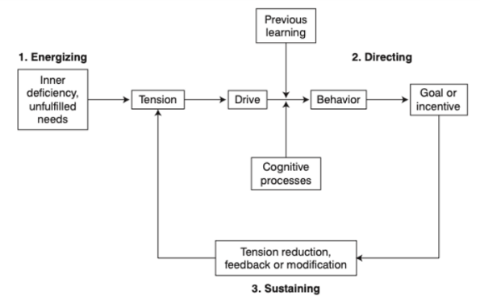
Source: Kimmel (2013)
As per the model, a consumer behaviour for apparel purchase can be triggered due to certain deficiency, like absence or need of specific garment, style, brand clothing, etc. This deficiency could be either physical or psychological. Psychological instincts motivate a consumer to further channelise the behaviour, based on the previous purchase experience or cognitive process (hereditary or social or cultural factors), to achieve the ultimate goal. After fulfilling the goal, the consumer learns from the feedback and decides if modification is required in the future purchase (Kimmel, 2013).
Kimmel (2013) claimed that several needs of consumers are closely linked and they together motivate purchase behaviour. For example, purchase needs for a branded garment can be motivated due to status symbol and/or emotional connection with a specific brand. Hence purchasing a single branded garment can help to satisfy both the needs. This theory of Kimmel opposes Maslow’s ‘Hierarchy of Need’ (as shown in Fig. 6) which states that there are different types of needs which influence the purchase behaviour in a set hierarchical pattern. According to Maslow’s theory, basic needs (physiological and safety) should be met first before moving to psychological or self-fulfilment needs.
Figure 6: Maslow Hierarchy of Needs
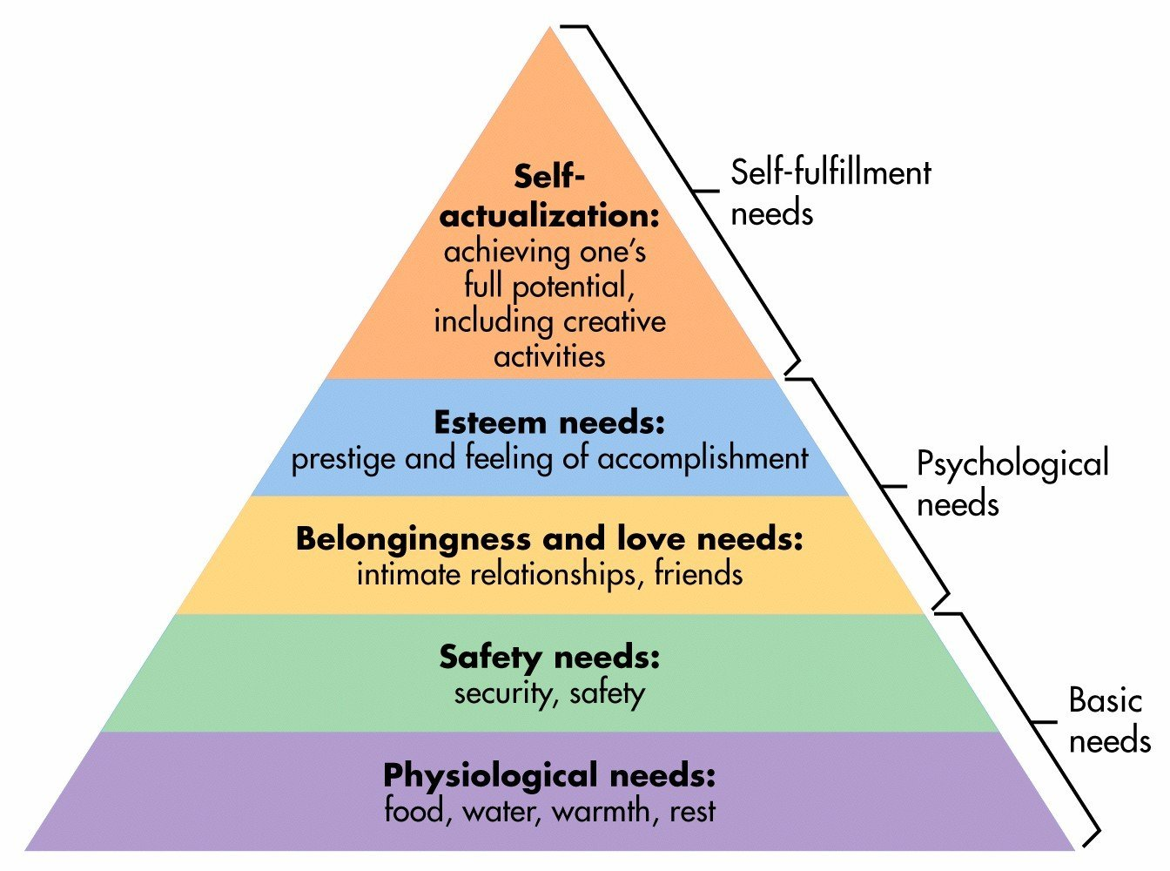
Source: McLeod (2023)
Overall, buying an apparel can be influenced by various factors, such as desire to impress others and reveal the status (Rajagopal, 2011), price and brand name (Wang, et al., 2022), style and trend (Morgan and Birtwistle, 2009; Rahman and Jamil, 216), advertising (Shrivastava and Bisen, 2014), and so on. Zara’s marketers need to have a good understanding about these motivational factors, resulting in specific purchase behaviour, to target their consumers effectively.

2.5.2 Perception
Cox and Shiffrin (2017) defined perception as how different people select, organise and interpret a given information in different ways to understand their surroundings. On the other hand, Luthand (2018) stated that it involves the opinion and understanding of a consumer about a product or a brand and their marketing, which significantly influence their purchase behaviour. A consumer may develop a positive or a negative perception about a product or a brand based on their interaction (Kimmel, 2013). For instance, a consumer may react negatively to a brand’s ‘price increase’ strategy as it may differ from the existing subjective perception of the brand being cost-effective. According to the Customer Loyalty Index (2022), 56% of the people in the UK will switch brands due to the price rise factor.
Cetine, et al. (2012) explained that when consumers are exposed to a Zara’s marketing message, different people may perceive the message in different ways based on selective attention, selective distortion, and selective retention, which further impacts CPB. According to the perceptual map (Ramya and Ali, 2016), as shown in Fig. 7, selective attention occurs when consumers focus on the specific product advertising and at the same time neglects others. For example, if a consumer wants to purchase from the Zara brand, he/she will pay attention to all promotions from Zara, while neglecting other brands, like H&M, Primark, etc., and their offerings. Selective distortion signifies that consumers will interpret Zara’s marketing in different ways based on their current thought and beliefs. For example, if Zara uses a celebrity to endorse its products, the purchase behaviour will be influenced based on the consumers’ feeling about that celebrity. Selective retention refers to how long the marketing message will be retained in the minds of the consumers. In order to ensure that marketing message is retained for a long time among consumers, Zara marketers can use drama, catchy tagline, and emotional aspects, when creating a campaign/advertisement. Overall, through effective marketing messages, Zara can not only influence CPB, but also enhance brand attitude and loyalty, boost sales, improve consumer preferences and decrease price sensitivity that can lead to positive WOM (word of mouth). (Fripp, 2023).
Figure 7: The Perceptual Map
Source: Adapted from Fripp (2023)

2.5.3 Learning
According to Sharma (2021), learning is the core aspect and significant determinant of CPB that occurs through previous purchase experience, observation and interaction with others. It signifies change in the behaviour resulting from previous experiences (Miravete and Palacios-Huerta, 2014). For instance, after using a brand’s product or service, a consumer may learn whether it generated satisfaction or dissatisfaction which further determines if the consumer will repeat the purchase or avoid it in future (Xue and Zhou, 2010).
Kotler, et al. (2009) described that learning process includes 4 elements – drives, cues, responses, and reinforcement (as shown in Fig. 8).

Figure 8: Learning Model
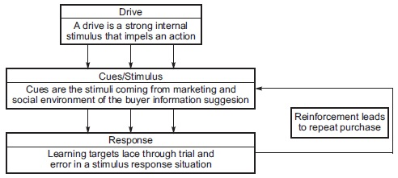
Source: Durmaz (2014)
Drives are the strong internal urge that motivates consumers to make a purchase; cues are the information gained by the consumers through advertising or social groups; responses are the perceptions or attitude of a consumer which occurs during or post purchase; and based on the learning consumers are reinforced to make future purchase (Kotler, et al., 2009).
Kushwaha, et al. (2015) claimed that learning can create either negative or positive experiences. For instance, a consumer who had a negative purchase experience is more likely to avoid future purchases because he/she remembers unpleasant past experiences. According to Lee Resource International (n. d.), 91% of the consumers will discontinue purchasing from a brand after a bad experience. Emplifi, a customer experience platform, reported that 86% of the consumers will switch to rivals after a poor customer experience (Business Wire, 2022). On the other hand, Zendesk (2023) reported that 75% consumers will purchase again from a company after a good experience.

2.5.4 Attitude and Belief
Attitude indicates consistent assessments, feelings and opinions about specific brands, products and services, and it is influenced by different factors, like past experience, social group, and marketing message (Furaiji, et al., 2012). Several research in the past have identified positive and significant correlation between attitude and CPB. For instance, a study by Rausch and Kopplin (2021) found that consumers’ attitudes have a positive relation with their buying power in relation to sustainable apparel purchase. However, Thogersen, et al. (2015) identified that a positive attitude towards marketing mix has a significant impact on consumer satisfaction and purchase. On the other hand, Lang (2018) found that there is a negative relation between consumers’ attitude and financial risk associated with purchase.
Beliefs are consumers’ descriptive assumptions about a product, service or brand that is shaped by personal judgement, factual information, religious or cultural beliefs and social groups (Raman, 2014). Gupta and Banerjee (2021) explained that both attitude and beliefs have a significant role in influencing CPB. For instance, if the consumers believe that a product is useless or less worthy for them, they may not make a purchase even if the product is of good quality and brand. Like attitude, a consumer may have positive, negative or neutral beliefs about a brand or a product and service. Kim and Zhang (2014) stated that consumer’s beliefs may change based on their existing condition and past experience. For example, a consumer may purchase fast fashion apparel due to the low-cost factor, but may choose other high fashion brands in need of quality and durability factor. Like attitude, several studies in the past have identified a link between consumer beliefs and purchase behaviour. Nora and Minarti (2016) studied Muslim fashion trends and found that religiosity or religious beliefs have a positive impact on purchase intention. However, Ashraf, et al. (2017) studied luxury fashion and found no relation between religiosity and beliefs or attitude towards purchasing apparel. Peña-García, et al. (2020) identified subjective norms and culture that have a significant relation with online CPB.

2.6 Social Factors and Consumer Purchase Behaviour
Consumers are social beings who belong to the society and therefore their behaviour, likes and dislikes, preferences, are largely influenced by other people in the social environment (Furaiji, et al., 2012). Likewise, Ramya and Ali (2016) stated that consumers look forwards to other people’s approval and opinion, and rarely acts in a way that is socially unacceptable. Therefore, within a society, CPB is influenced by social factors (as shown in Fig. 9), like family and friends, reference group, and role and status (Durmaz and Gunduz, 2021).
Figure 9: Social Factors Impacting CPB
Source: Super Heuristics (2023)

2.6.1 Family and Friends
Pandey and Verma (2015) family is the most significant social group wherein the members are connected through blood relation or marriage, whereas friends are closely connected social groups who communicate on a regular basis. Therefore, friends and family highly influences production consumption and disposal of a consumer (Kushwaha, et al., 2015). The Ad Mass (2021) identified that during a consumer’s purchase journey, family and friends have a huge influence during the awareness (78%) and purchase (79%) phases.
According to Gupta and Banerjee (2021), consumers engage in face-to-face communication with family and friends, which gives them an opportunity to gain information about the best brand or product in the market. Thus, family and friends are the first group, as per Raman (2014), which creates the initial impression about the brand and its offering. Pew Research Centre (2017) found that 72% of the consumers get information through word-of-mouth from family and friends (as shown in Fig. 10). Similarly, Nielsen (2012) reported that 92% trust WOM recommendation from family and friends. This indicates that Zara marketers can consider word-of-mouth marketing as the most cost-effective medium to influence their consumers’ purchase decision.
Figure 10: Pew Research Centre Report
Source: Pew Research Centre (2017)
Banerjee (2015) claimed that, based on the communication with family and friends, a consumer develops preference, attitude and belief, which further triggers his/her choice or decision. Additionally, Gupta and Banerjee (2021) stated that family and friends have a social and psychological influence on the apparel choice of a consumer. Similarly, Balasubramanian and Soman (2019) opined that the values, behaviours, habits, beliefs and conducts among the family members and the peers may impact consumers’ decision of whether or not to purchase a particular product or service. A study by Collado (2017) found that the attitude of a friend or a parent has a significant positive relation with the attitude of the consumer towards a product.
Sudhakar and Rani (2012) discussed that views of family and friends are more likely to eliminate the risk associated with a product decision or purchase. Additionally, they do not have any negative intention of influencing the consumer and hence their opinions are highly trusted by the consumers. A research conducted by ‘Because’ (creative experience agency), explored that on an average, family and friends have 4 to 5 times higher probability of influencing CPB than any other group (Green, 2017).

2.6.2 Reference Group
Xiurong and Chenglei (2010) described the reference group as all those people who have a direct or indirect impact on the attitude, lifestyle and self-image of a consumer, which may further affect his/her product or brand selection or purchase. Alternatively, Kumar (2022) explained that a reference group is the one with whom a person wants to be associated. This group includes people, like friends, family, celebrities, social media influencers, work colleagues, classmates, etc.
Cetina, et al. (2012) stated that reference groups are of two types – primary or informal group (friends and family) and secondary or formal group (professionals, religious groups, and trade association). According to Al-Azzam (2014), primary groups have a stronger influence on consumers, due to their close bond and regular association, than secondary groups, who are informally related. Conversely, Khan (2012) had identified that buying behaviour is highly influenced by formal sources, like advertising, than informal reference groups. Additionally, Ad Mass report (2021) found that during the consideration stage of purchase decision, consumers are highly influenced by social media contribution and reviews from anonymous friends (as shown in Fig. 11), whereas informal groups (friends and family) are highly influenced during awareness and purchase phase, as stated earlier. However, the findings from Carmen (2014) revealed that within the primary group, peers at work and social media influencers have an impact on CPB, however, their impact is slightly lower than that created by family and friends. A survey by Statista found that around 1/4th of the consumers in the UK are influenced by social media influencers to make a purchase decision (Chevalier, 2023).
Thus, Zara marketers should have a good understanding of different reference groups and their impact on CPB to create effective communication and marketing messages.

Figure 11: Purchase Decision Phases
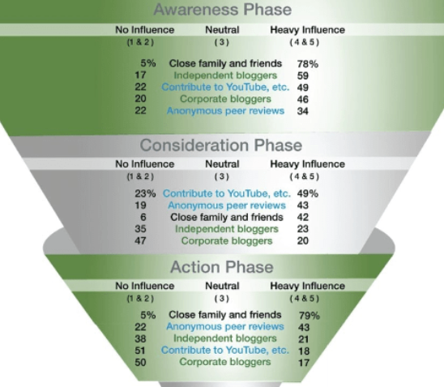
Source: Ad Mass (2021)

2.6.3 Roles and Status
Armstrong, et al. (2014) explained that role and status refers to social class or position of a consumer in the society that influences his/her purchase behaviour. For instance, if a person is working at a higher designation (like, Chief Executive Officer or CEO) may purchase clothes that would demonstrate his/her status.
Mirzaei and Ruzdar (2010) argued that a person plays different roles, like son/daughter, mother/father, professional worker, etc., which impacts purchase behaviour differently. For example, a consumer playing the role of a friend or a family member may purchase comfortable casual clothes, whereas in a professional role, the same consumer may purchase formal clothes that are professionally accepted.
Besides the role, the consumer's purchase decision is also based on the social class or status. For example, people belonging to the lower class may have low disposable income (as shown in Fig. 12) and therefore may spend less on clothing (as shown in Fig. 13) than those belonging to upper social class with high income.
Figure 12: Average disposable household income in the UK by decile group
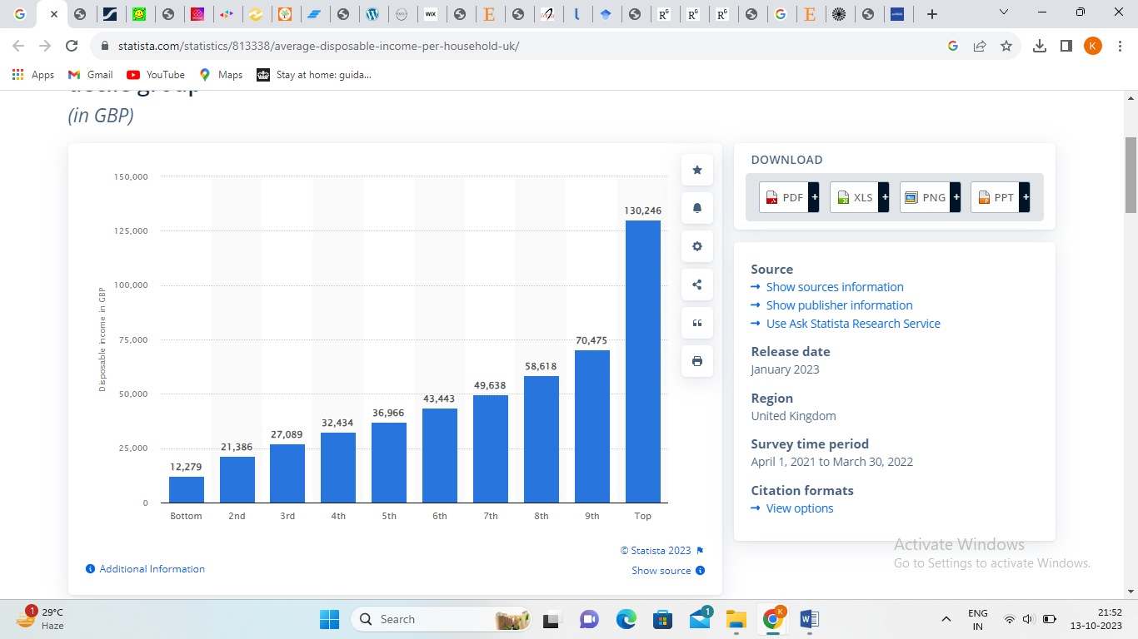
Source: Clark (2023)
Figure 13: Weekly household spending on clothing in the UK by decile group
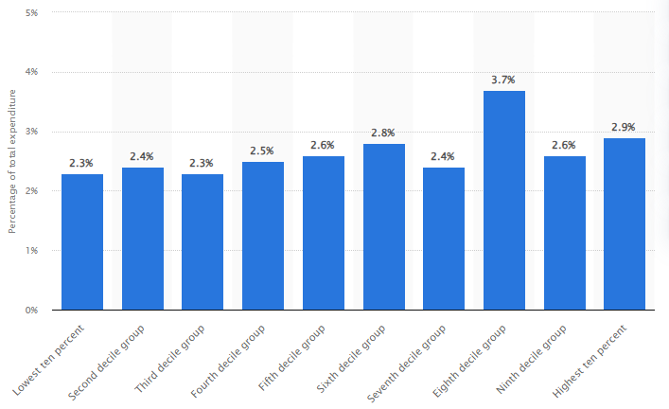
Source: Smith (2023)
To note, Fig. 12 shows disposable income of people in the UK as per their decile. Decile refers to segregation of people based on their income value (Gov.UK, n. d.). For example, the bottom decile indicates the lowest 10% of the people having the lowest income, whereas the top decile indicates the highest earning group.
Thus, previous studies have identified that role and status influence CPB and therefore Zara’s marketers should consider these social factors when targeting its consumers and when marketing its apparel product to them.

2.7 Personal Factors and Consumer Purchase Behaviour
Personal factors refers to individual characteristics that affect his/her purchase behaviour (Rehman, et al., 2017). Generally people differ from one another in terms of personality, attitude, beliefs, perception, experience, and so on (Ali, 2016). From a marketing perspective, understanding different characteristics of different consumers helps to know why they behave in different ways in a given purchase situation with the same experience (Anisha and Kalaivani, 2016). The most essential personal factors considered by marketers are age, occupation, income and lifestyle (as shown in Fig. 14).
Figure 14: Personal Factors Impacting CPB
Source: Super Heuristics (2023)

2.7.1 Age
Gandhi and Choudhry (2021) explained that the dynamics of CPB differs or changes at different ages and different life cycle stages. This means that the tastes and preferences of the consumers change with age. For instance, old people may be less interested in fashionable clothes and may choose clothes that are comfortable, whereas young adults or teenagers may be more inclined to fashionable and trendy clothes (Gazzola, 2020). Similar findings were derived by Mantilla (2018) that younger generations invest more energy, time and money on fashion trends than the older population as the former identify and socialise more with a peer group who follows trends and fashion. Statista Research Department (2023) also identified that In the UK, most consumers in the fashion segment belong to the age 25 to 34 years, especially for apparel purchase (as shown in Fig. 15). Therefore, it is essential for Zara marketers to have a good understanding about their target audiences and their preferences as it will aid them in market segmentation and in planning market strategies (Tien, 2019).
Figure 15: Fashion segment users in the UK by age
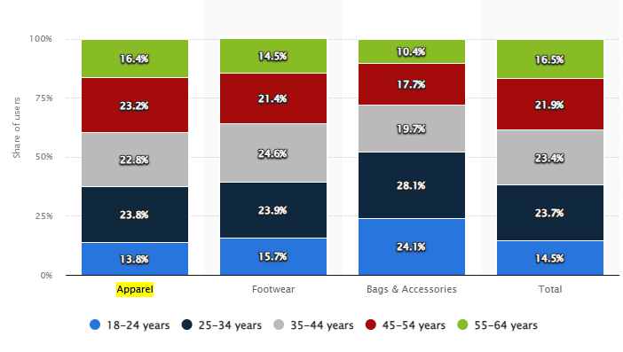
Source: Statista Research Department (2023)
Different studies in the past have identified contradicting results when age factor was measured against CPB. A vast number of studies identified significant positive impact of age on CPB towards fashion products (O’Cass, 2004; Scarpi, 2006; Ahuja, 2015; Zheng and Chang, 2020). On the contrary, Wee (2015) performed a study on shopping behaviour of people of different ages. The researcher found that age had no significant role in determining CPB and different people selected different clothes depending on their tastes and preferences. Nawi, et al. (2019) also found no significant impact of age on the online purchase behaviour of the consumers. Similar findings were suggested by Fekete-Farkas, et al. (2022) who stated that age is not a significant predictor of CPB for online purchase.

2.7.2 Income
Kumar, et al. (2014) stated that income increases the purchasing power and influences the buying pattern of a consumer. According to the researcher, a consumer determines what to purchase and how often to purchase based on his/her disposable income. Consumers with high disposable income has the power and ability to spend on expensive brand clothing, like Louis Vuitton, Chanel, Burberry, etc.; however, a consumer with low earning or income may spend on cheap or cost-effective brands, like Primary, Zara, H&M, or street side local clothing stores (Kumar, 2022). As shown in Fig. 13, the lowest decile group in the UK will spend 0.6% less than the highest decile group having considerable income (Smith, 2023).
Income influences the price-sensitivity in a consumer (Kumar, et al., 2014) and so price can also be regarded as the element influencing different buyers. Aribowo and Hadiprawiro (2013) stated that ‘price’ of the product is the most important factor for less affluent buyers, whereas more affluent buyers give high importance to the quality and variety of luxury products and services. In terms of the fast fashion industry, Williams (2022) stated that the industry offers cost-effective clothing to attract price-sensitive consumers and therefore a high number of lower income consumers and families are highly attracted to fast fashion clothing.
Most of the previous studies have identified a positive association between income and CPB. Mihic and Culina (2006) studied CPB and consumption with the emphasis on social class and income and found that both social class and income variables were significantly related to CPB. Husnian, et al. (2019) found that availability of money has a significant positive impact on impulse purchase behaviour of a consumer, whereas those with limited money availability indulge in thoughtful buying behaviour after making comparisons between different brands.
A study by Gartner (2017) found that consumers who have just begun their career, especially those in the age range 18-34, may have limited spending capacity and therefore may indulge in high impact – low cost apparel products and therefore fast fashion apparel are increasingly popular in this age group.

2.7.3 Occupation
Rehman, et al. (2017) explained that occupation is another personal factor that influences CPB. Consumers usually purchase apparel that suits or advocates their profession (Rahman and Jamil, 2016). For example, a student may purchase more casual trendy clothes than a corporate employee who purchases more formal clothing that fits the work environment (Wong, 2015). Likewise, a teacher may purchase decent-looking clothes whereas a low-income worker may be engaged in purchasing rugged work garments (Ali, 2016).
A study by Srinivasan et al. (2014) was conducted to identify the impact of occupation on frequency of purchase of luxury products and found that business professionals indulge in luxury product purchase due to high wages earning. However, a study by Edelson (2022) found that students are highly attracted to fast fashion clothing, due to their affordability element. Similarly, Mathews (2022) and YouGov (2021) revealed that students are more inclined to fast fashion and are the frequent buyers of this type of clothing. This shows that most studies have identified ‘students’ as the high indulgence demographic group in fast fashion and therefore Zara marketers can focus on this target group and their needs and preferences to influence their buying habits. However, contradicting results were revealed by ThredUP (2022) that 51% of the college students or Gen Z (generation Z) want to quit fast fashion clothing than 65% of them who plan to buy more sustainable clothes (as shown in Fig. 16). A varying result was also presented by Rahim et al. (2017) who studied the impact of demographic factors on sustainable purchase behaviour and found no significant impact of occupation on CPB.

Figure 16: Gen Z sustainability preference
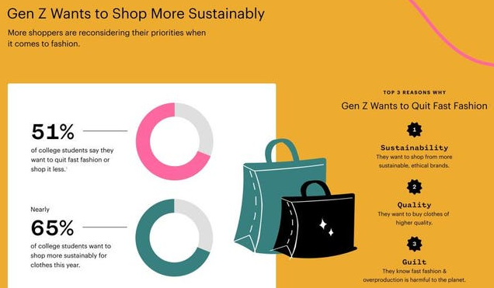
Source: ThredUP (2022)

2.7.4 Lifestyle
Lifestyle is an indication of the way an individual lives, behaves and interacts in the society that influences his/her activity, interest and opinion (AIO) (Rehman, et al., 2017). Anisha and Kalaivani (2016) explained that from a marketing perspective, lifestyle plays an important role in market segmentation wherein the marketers can segregate their target audiences based on their beliefs, disposable income and spending patterns. Further, it gives them knowledge about the difference in values among the same group of individuals that influences their CPB. For instance, a consumer who performs environment friendly activities in their day-to-day living, like reusing or recycling things, consuming a healthy diet, keeping the environment clean, and so on, may be more attracted to sustainable clothing.
The marketers of Zara can use ‘value and lifestyle’ (VALS) model (as shown in Fig. 17) designed by SRI International to segregated its consumers based on two dimensions, i.e. primary motivations (ideals, achievement and self-expression) and resources (innovativeness, income, education, skills, etc.). According to the model, consumer motivated by ideals are thinkers and believers who are motivated by knowledge and values; those in achievement section are achievers and strives who are motivated by hard work and success; whereas self-expression consumers indulge more in social and physical activities (SRI International, n. d.). For example, students can be categorised as ideals who have low monetary resources and are believers of WOM from family and friends.
Figure 17: SRI Consulting VALS Model
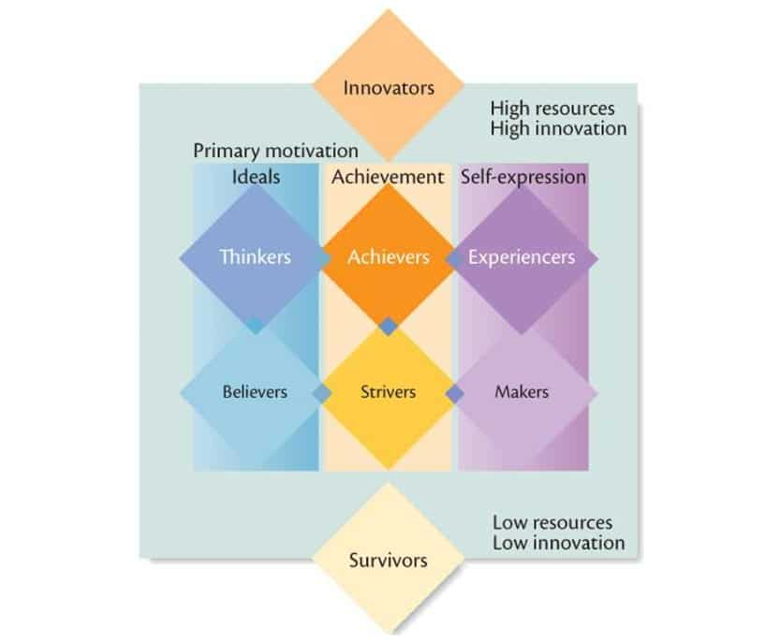
Source: Super Heuristics (2023)
Many studies have researched lifestyle to understand how it impacts CPB and have identified a positive link between these variables (Ahmad, et al. 2010; Krishnan, 2011; Maney and Mathews, 2021). As a result, the internationally operating ZARA brand should emphasise on the lifestyle of the consumers in different locations to meet their preferences and to influence their purchase.

2.4 Models of Consumer Behaviour
Consumer behaviour models are frameworks that emphasises on behaviour patterns of a consumer and aids in comprehending the way and the reason behind a consumer’s purchase decision (Wang, et al., 2023). Although there are different consumer behaviour models, however, with regards to Zara’s target consumers, this study will focus on two models to gain deeper insight into CPB.

2.4.1 Engel-Kollat-Blackwell (EKB) Model of Consumer Behaviour
Engel-Kollat-Blackwell model explains that consumers play a vital role in determining the success of an organisation and therefore Zara should focus on meeting the needs of their consumers (Jisana, 2014). This model also suggests that Zara has the responsibility to understand its consumers’ behaviour, as well as to be aware of their needs and wants (Zhang, et al., 2020). Thus, the EKB model was designed to understand consumer behaviour in relation to purchase decisions. On the other hand, Srivastava, et al. (2021) illustrated that the EKB model was designed to build strong connection with the consumers and to enhance company-consumer relationship.
According to Roy and Datta (2022), there are different stages (As shown in Fig. 18) in the EKB model that leads to a purchase decision among the consumers.
Figure 18: EKB model of consumer behaviour
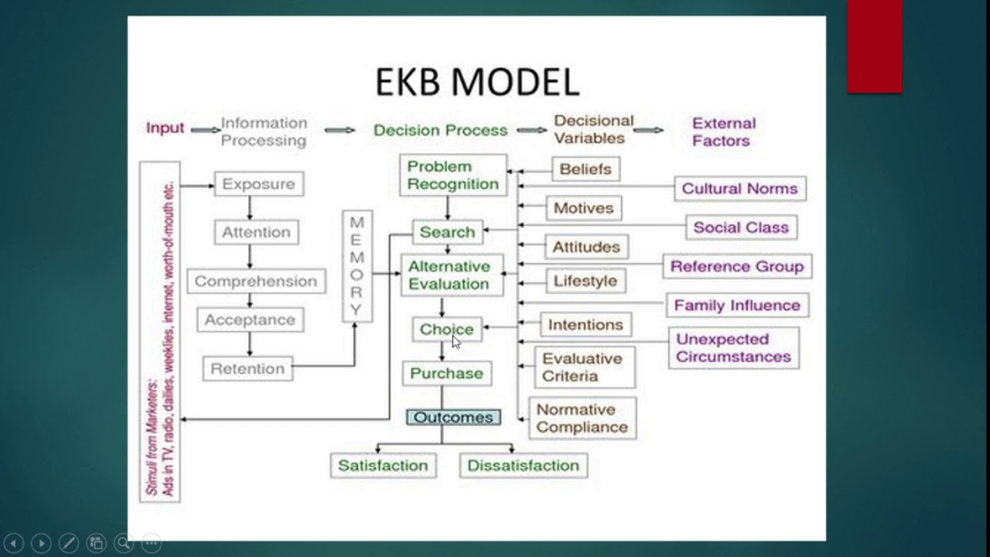
Source: Jangra (2021)
Input stage: At this stage, a consumer gains information regarding a specific product or service through informative and persuasive advertisements on television, radio, social media, etc. According to a PwC survey (2023), different ads on different channels influence purchase behaviour of consumers (as shown in Fig. 19).
Figure 19: Global Consumer Insights Pulse Survey
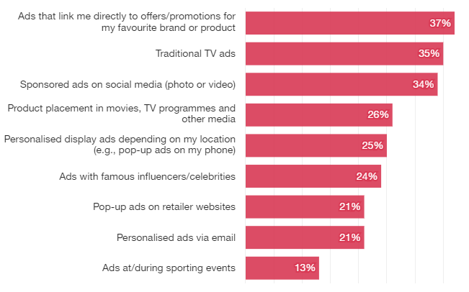
Source: PwC (2023)
When the consumers begin information search, for instance on a social media page of Zara, they acquire additional knowledge, like other products offered by the company, product price and features, reviews and comments of people who have used the product, and so on (Jisana, 2014). Based on this information, consumers can make their purchase decision. Gelder (2023) opined that 70% of the consumers read 6-7 reviews before making a buying decision.
Information processing stage: At this stage, the consumer first gets exposed to the information from various sources, gives attention to the information, makes interpretation based on the information and then retains the information by shifting the message to long-term memory (Wani, 2013). In other words, the purchase intention of the consumer at this stage is based on personal preference, past experience and ability to make decisions (Roy and Datta, 2022). PwC (2018) reported that 73% of the consumers believed that experience drives their purchase behaviour.
Decision processing stage: This is an important stage in the EKB model as it focuses on the all phases of decision-making process, i.e. recognition of need, searching information, evaluating alternatives, making choices and purchase and post purchase evaluation, as identified by Kotler (2012). In this stage, external factors, like culture, social status, family and reference group and unexpected circumstance, helps a consumer to recognise a need or a problem. The consumer then becomes involved in searching information (offline and/or online) to satisfy the need. Based on the previous experience, stored in the memory, and data obtained through search, the consumer evaluates the options available. This further leads to making choices and finally making a purchase. After the purchase, the consumer evaluates whether or not the need was satisfied (Jisana, 2014).
Variables enabling decision stage: Srivastava, et al. (2021) explained that when a consumer proceeds through the decision-making process, there are different variables, like lifestyle, beliefs, motivation, intention, etc., which can influence the purchase decision.
Thus, the EKB model explains that consumers’ purchase behaviour and decisions rely on influential factors, which are examined by rational insight (Tan, 2010).

2.4.1 The Black Box Model
Furaiji, et al. (2012) stated that ‘the black box model’ or ‘stimulus-response model’ is an effective model to examine CPB. It depicts the interrelation between the external factors or stimuli, consumer factors (beliefs, attitude, perception, etc.) and decision making process, as shown in Fig. 20, which influences the buyer’s response to whether to purchase a product or not (Wani, 2013).

Figure 20: The Black Box Model
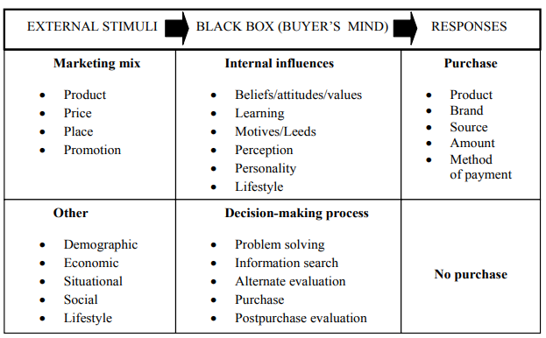
Source: Furaiji, et al. (2012)
The first component of the model, i.e. external stimuli, represents the external environment of a consumer that includes marketing mix activities (4Ps or product, price, place and promotion) of the firm, as well as other environmental factors like, demographic, economic, lifestyle, etc., which indirectly influences the consumers. For instance, through attractive promotional campaigns and effective product design and price, Zara markets can influence their consumers. However, apparel purchase intention can also be influenced by personal factors, consisting of demographic elements, as well as social groups. Further, these external factors also play a significant role in providing information to the consumer about specific products or brands (Tan, 2010).
Based on the indirect influence at the external stimuli phase, the ‘Black Box’ or consumer’s mind reacts (Roy and Datta, 2022). This is an important phase wherein a consumer makes the purchase intention based on the internal characteristics, like personal beliefs, attitude and perspective about the brand and its offerings. Further, the consumer passes through the decision making process, wherein he/she indulges into information search, evaluation of the alternatives and post purchase evaluation based on past experience to make future purchase decisions. Ramya and Ali (2016) suggested that the role of the Zara marketers at this stage is to understand how the consumer engages with external and internal stimuli, which produces future response. As identified in the EKB model, a good past experience may result in positive or repetitive purchase, whereas a negative experience may result in ‘no purchase’ in future (Ramya and Ali, 2016). However, Jisana (2014) explained that some consumers may experience negative feelings due to a wrong purchase and such consumers may indulge in future purchases to remove the negative factor and gain increasing satisfaction with the future purchase. For example, purchasing a wrong size may evoke negative feelings, however, ensuring to buy the correct size in future may lead to increased consumer satisfaction.

2.8 Summary
This chapter conducted an extensive review of the past literature in relation to the research topic. It also identified theories related to consumer behaviour to understand the psychological, personal and social factors influencing the CPB. It was observed that different researchers and scholars had derived different findings and these will help the study researcher to identify the relation and reliability of the previous study findings as real-time analysis of the research participants’ responses. The focus of this chapter was mainly on the psychological, social and personal factors and different elements of each of these factors that significantly impacted CPB. The following chapter will describe the methods used by the researcher to gather data for this study.

Chapter 3: Methodology

3.1 Introduction
In the methodology chapter, the researcher describes the philosophy, approach, strategies and methods used to perform the research effectively. Additionally, it mentions the data collection and data analysis techniques and procedures considered by the researcher. Further, it also highlights the research ethics that the researcher had complied with during this study.

3.2 Research Design
Research design refers to a strategic plan or a blueprint used to conduct a research study (Zikmund, et al., 2013). To design this study, the ‘research onion’ framework (as shown in Fig. 21), designed by Saunders, Lewis and Thornhill, was used as a reference. It mentioned different methods and choices made by the researcher in gathering data related to the research topic.
Figure 21: Research Onion
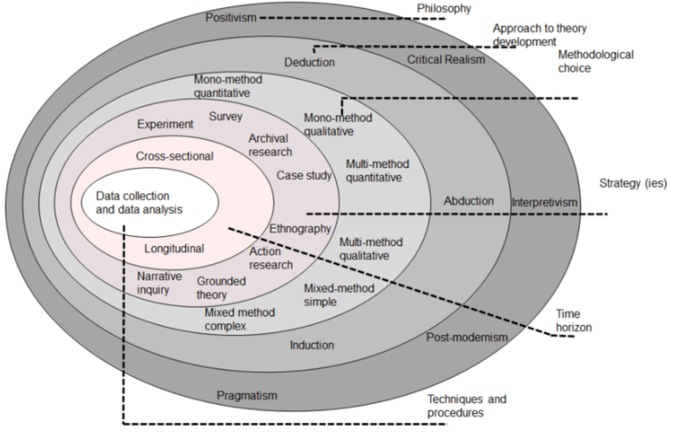
Source: Saunders, et al. (2019)

3.3 Philosophy
Research philosophy indicates views and assumptions regarding knowledge development in a specific area of research (Saunders, et al., 2019). Of all the research philosophies illustrated in Fig. 1, this research had adopted positivism philosophy as it focuses on gathering factual information through observation or numerical measurements to study the social world and nature of human behaviour (O’Gorman and Maclntosh, 2015). In other words, using positivism philosophy, the study can emphasise on collecting information about the factors influencing consumer purchase behaviour through quantitative analysis of participants’ responses and through existing knowledge, available in the past research, about the given topic to design research aims and objectives, and this actions relate with the positivism philosophy, so it was used in this study over other methods.

3.4 Approach
This indicates the reasoning approach selected by a researcher to test or build a theory (Beins, 2017). According to Saunders, et al. (2019), there are three research approaches used in a study. These are deductive approach (developing theory and later testing it using a research strategy), inductive approach (using strategy to build theory), and abductive approach (gathering data to form new or change existing theory and then again additional data to test the new or existing theory). This research begins with development of aims and objectives, based on the research topic and academic literature, and proceeds with collection and exploration of data to test or justify the research objectives. As a result, it can be said that a deductive approach was used to conduct this research. Using this approach, the researcher can easily identify the interrelation between study variables, like personal, social and psychological factors and consumer purchase behaviour, to derive better outcomes.

3.5 Methodological Choice
Bernard (2013) stated that methodological choice refers to the strategy used to justify the research problem and accomplish the research objectives. It includes quantitative, qualitative and mixed methods used to answer the research questions. As explained by Saunders, et al. (2019), quantitative methods involve the use of numeric data that can be graphically or statistically represented in the research. On the other hand, a qualitative method involves collecting non-numeric or descriptive data from various academic sources. Mixed method involves collection and analysis of both numeric as well as non-numeric data. To examine the influence of factors on consumer purchase behaviour, this research measures and analyses the responses of the participants numerically using graphs and tables. This resembles the quantitative research’s characteristics and therefore a quantitative method was used in this study.

3.6 Strategies
Research strategy refers to the plan or actions used by the researcher to achieve the research objectives and to answer the research questions (Saunders, et al., 2019). There are a range of strategies as described in Fig.1. However, this research had considered survey strategy, using questionnaire, to collect data from the participants on the research topic (Refer to Appendix for questionnaire copy). According to Crowther and Lancaster (2012), survey strategy implies quantitative methodology for gathering data from a large group of respondents by asking them various questions. The main reason for choosing survey strategy for this research was the time constraint and the key feature of the strategy, i.e., it is economical and easy to explain and understand.

3.7 Time Horizon
This layer in the research onion represents the time taken by the researcher to conduct the research. When a research is conducted or when data is collected within a specific time frame, it is termed as cross-sectional research. On the other hand, when a research is conducted over a long period of time and when data is repeatedly collected and compared, it is called longitudinal research (Melnikovas, 2018). Due to time constraint, this academic research is conducted for a specific time period. Therefore, this study uses a cross-sectional time horizon to investigate the topic.

3.8 Data Collection

3.8.1 Size of the Sample
Sample represents the portion of people selected from a larger group for the purpose of the study (Bernard, 2013). At the beginning, to study the influential factor for consumer buying behaviour, a small sample size of 100 respondents were considered due to limited time and resource constraint. However, when collecting the primary data, a total of 105 responses were derived. The researcher believed that considering a large sample size would have derived better outcomes, but on the other hand, involving a larger group and analysing a significant number of responses in a short span of time would have been a challenging task. Therefore, the selected size of sample was regarded as sufficient to gather information related to the topic.

3.8.2 Sample Type
This study had considered both male and female samples aged 15 and over to study the factors influencing consumer purchase behaviour, across different age groups and gender. The sample included friends, friends of friends, classmates and co-workers, specially residing in the United Kingdom.

3.8.3 Sampling Technique
According to Cohen, et al. (2018) sampling is the process of selecting a specific size of sample (respondents) that represents the larger population. Probability and non-probability sampling are the two main techniques used to select research samples. Probability sampling refers to the process of selecting random samples from the wider group to generalise the findings of a research, whereas non-probability sampling avoids random selecting and targets specific portions of a larger population as they may have more information than the rest of the population (Cohen, et al., 2018). This research involved a non-probability convenience sampling technique, using which the researcher had conveniently selected participants from among classmates, friends, friends of friends and co-workers. According to Taherdoost (2016), convenience sampling is a kind of non-probability sampling, which involves selection of the participants due to ease of accessing them and gathering information from them at a given point in time. Using this method, the researcher was able to easily send the online survey link to the participants through text message, social media message and emails. Even friends of friends were encouraged to take part in the survey due to which the targeted sample size was slightly exceeded. Thus, convenience sampling aided in quickly and easily reaching the desired sample size due to which this method was considered suitable for this study.

3.8.4 Data Type
Rabianski (2003) stated that primary and secondary are the two types of data used by the researchers in their study. Primary data refers to raw information collected directly for the time from the research participants. This data can be collected using surveys and questionnaires, experiments, observations, and interview methods (Rabianski, 2003). Alternatively, secondary data refers to existing data gathered by the individual/s other than those using the data. Such data can be collected from literary text published in various sources, like books, journals, newspapers, magazines, websites, etc. (Rabianski, 2003). In this research, secondary data was collected from verified academic publications, such as journal articles, research papers and books to gain distinctive insight of the work already published and to structure the literature review for this study. Additionally, legitimate websites and company websites (Zara and Inditex) were used to collect secondary data related to the research company. However, this research also collected primary data from the research sample, using survey questionnaire strategy, in order to gain deeper insight and gather factual information about the research topic.

3.8.5 Data Collection Method
Firstly, to collect the primary data, a survey questionnaire method was used. The researcher had targeted to conduct an online survey and therefore an online questionnaire was prepared using Google form. The questionnaire consisted of 15 questions, highlighting 4 demographic questions (like age, gender, occupation and monthly income, of the participants) and 11 questions in relation to the research aims and objectives. Demographic information was collected to analyse the influence of psychological, social and personal factors across different groups of consumers. Further, the questionnaire included multiple-choice and 5-point Likert scale questions. Additionally, a consent form was attached at the beginning of the questionnaire, which gave information related to participation criteria, benefits and risks of participation, and confidentiality factors considered by the researcher.
After preparing the questionnaire, the online survey link was sent to the participants through text message (on WhatsApp, social media and university platform) or via emails.

3.9 Data Analysis
Primary data, in the form of participants’ responses to the questionnaire, was analysed on the Microsoft Excel. The statistical outcome derived after the analysis was represented in the form of graphs and tables in this study.

3.10 Ethical Considerations
These are the guiding principles or rules of conduct practised by the researcher throughout the research study (Kuada, 2012). This research follows ethics related to respondents’ confidentiality, data collection and data storage aspects.
To maintain the confidentiality and anonymity of the respondents, the researcher ensured that their personal details, such as name, mobile number, address, and social media ID, are not obtained during the data collection process. To collect the data ethically, an online consent of the respondents was collected which was considered as a proof of their voluntary participation.
The non-confidential responses of the participants on Google Drive as well as the data analysed on the Excel sheet were safely and securely stored in the researchers’ laptop that was protected with a password known only to the researcher. As the data was only accessible to the researcher, it was not archived. Further, the data will be stored in the researchers’ laptop for the period of 1 year or until the researcher successfully completes her course. Post this time period, all the data will be deleted from the laptop as well as the Google Drive of the researcher.

Chapter 4 Data Analysis

4.1 Introduction
Data findings and analysis chapter, also referred to as results chapter, focuses on the primary data collected from the research participants through survey questionnaire and analysed in Microsoft Excel. It summarises and analyses the findings of each survey question using clear text narration supported by tables and graphs. Further, this chapter lays a foundation for the next chapter i.e., ‘Discussion Chapter’. In other words, the responses of the survey participants that are analysed in this chapter will form the basis for interpretation in the next chapter.

4.2 Data Analysis

4.2.1 Analysis of the Survey Questions
In this research, demographic information or socio-economic information, such as gender, age, occupation and income, of the participants were collected to evaluate their specific characteristics and to gain a deeper insight into their background.

Question 1: Gender
 | Frequency | Percentage
Male | 62 | 59%
Female | 43 | 41%
Total | 105 | 100%

Table 1: Gender

Figure 22: Gender
In terms of gender distribution, Table 1 shows that there were 62 male and 43 female participants who agreed to take part in this study. This shows that more than half of the participants (59%) were male as compared to female (41%). However, it is important to note that the participants were randomly selected among friends, university students, work colleagues and friends of friends, and no specific criteria were used for participants’ selection.

Question 2: Age
 | Frequency | Percentage
15-25 | 24 | 22.86%
26-35 | 49 | 46.67%
36-45 | 26 | 24.76%
46-55 | 4 | 3.81%
Above 55 | 2 | 1.9%
Total | 105 | 100%

Table 2: Age

Figure 23: Age
From Table 2 and Figure 23, it can be found that maximum participants were in the age group 26 to 35 years (46.67%). Additionally, there were near to equal participants in the age range 15-25 (22.86%) and 36-45 (24.76%) years. These three groups accounted for around 94.29% of the overall participants. The remaining 5.71% were distributed among 46-55 years (3.81%) and above 55 years of age (1.90%). The results indicate that most of the participants belonged to a younger age group than the older ones with a significant proportion of the sample being millennials, followed by Gen Z participants.

Question 3: Occupation
 | Frequency | Percentage
Full-time employed | 27 | 25.7%
Unemployed | 10 | 9.5%
Entrepreneur/ Self-employed | 11 | 10.5%
Student | 57 | 54.3%
Total | 105 | 100%
Table 3: Occupation

Figure 24: Occupation
According to the survey results, as depicted in Table 3, majority of the respondents (57) were students, followed by those in full-time employment (27), and the least number of participants in ‘unemployment’ (10) and ‘entrepreneur or self-employed’ (11) categories. The findings in Figure 24 suggest that more than half of the respondents (54.30%) in this study were students and a little more than a quarter were employed in an occupation (25.70%). The other 2 categories, i.e., ‘unemployed’ and ‘entrepreneur/self-employed’ had nearly equal percentage of participants, i.e., 9.50% and 10.50% respectively. The main reason for maximum student participants involved in this study could be that the researcher is a student and had contacted friends and university classmates to participate in the survey.

Question 4: Monthly income (in GBP)
 | Frequency | Percentage
Less than 500 | 30 | 9.5%
500-1000 | 22 | 28.6%
1001-1500 | 17 | 21%
1501-2000 | 10 | 16.2%
2001-5000 | 16 | 9.5%
Above 5000 | 10 | 15.2%
Total | 105 | 100%
Table 4: Income

Figure 25: Income
Table 4 and Figure 25 depicts that there were an equal number of participants with the monthly income less than 500 and in the range 2001-5000 (9.50%). Similarly, there were near to equal participants having income in the range 1501-2000 (16.20%) and above 5000 (15.20%). However, a majority of the participants had monthly income between 500 and 1000 (28.60%), and between 1001 and 1500 (21%). The main reason could be that most participants in this study were students in the UK whose income can range from 500 – 1500 depending on their age and occupation (Gov.UK, 2023).

Question 5: How frequently do you purchase clothes?
 | Frequency | Percentage
Once a week | 13 | 12.4%
Once a month | 45 | 42.9%
Once in 6 months | 39 | 37.1%
Once a year | 8 | 7.6%
Total | 105 | 100%
Table 5: Frequency of purchase

Figure 26: Frequency of purchase
As shown in Table 5 and Figure 26, the survey participants had experienced a diverse range of fast fashion buying frequency. It was found that 13 participants (12.40%) purchased fast fashion clothes once a week, 45 (42.90%) purchased once a month, 39 (37.10%) purchased once in 6 months and 8 (7.60%) once a year. The results implies that weekly and monthly frequency (55.30%) of fast fashion purchase was more than 6 months or yearly frequency (44.70%). Majority of the participants falling in weekly and monthly categories (58 of them) indicates their regular involvement with fast fashion clothes. The remaining 47 participants falling ‘once in 6 months’ and ‘once a year’ categories signifies that they invest in fast fashion clothes on an occasional basis.

Question 6: What motivates you to purchase apparel?
 | Frequency | Percentage
Advertising | 15 | 14.29%
Price | 24 | 22.86%
Trend | 23 | 21.9%
Brand name | 32 | 30.48%
None of the Above | 9 | 8.57%
Other | 2 | 1.9%
Total | 105 | 100%
Table 6: Motivation to purchase apparel

Figure 27: Motivation to purchase apparel
Table 6 and Fig. 27 depict various motivational factors that influenced participants’ apparel purchase. Among 105 participants, maximum (32 participants) reported ‘brand name’ as the top motivational factor. ‘Price’ and ‘trend’ followed with 24 and 23 responses respectively. Next, ‘advertising’ received 15 responses. However, there were 9 participants who opted for ‘none of the above’ which explains that neither brand name, price, trend, nor advertising motivated their purchase behaviour. Additionally, there were 2 respondents who selected ‘other’ option and specified ‘personal choice’ (1 participant), and ‘material and season’ (1 participant) as their motivational factor. Overall, the survey results indicated that there were diverse opinions with regards to purchase motivation implying that different people may be motivated by different factors.

Question 7: I select a brand based on following criteria
 | Frequency | Percentage
Brand name | 33 | 31.43%
Price it offers | 36 | 34.29%
Brand marketing | 6 | 5.71%
Past experience | 27 | 25.71%
None of the above | 3 | 2.86%
Other | 0 | 0
Total | 105 | 100%
Table 7: Brand selection criteria

Figure 28: Brand selection criteria
Although ‘brand name’ was found in the previous question as a highly motivational factor for apparel purchase among the participants, their brand selection criteria was more based on the ‘price it offers’ which was chosen by 36 participants or by 34.29% of the total participants. ‘Brand name’ was the second highest criteria on the list which was opted by 33 participants (31.43%). A quarter of the participants (25.71%) felt that past experience was also one of their brand selection criteria, while a small number of them (5.71%) selected ‘brand marketing’ criteria. However, there were 3 participants who did not have any brand selection criteria and also there were no responses recorded for ‘other’ option.

Question 8: I purchase clothes as it makes me happy. I do not care about the opinion of other people
 | Frequency | Percentage
Strongly agree | 59 | 56.19%
Agree | 40 | 38.1%
Neither agree nor disagree | 5 | 4.76%
Disagree | 0 | 0
Strongly disagree | 1 | 0.95
Total | 105 | 100%
Table 8: Purchasing clothes makes me happy. I do not care about others’ opinion

Figure 29: Purchasing clothes makes me happy. I do not care about others’ opinion
When participants were asked if they cared about other people’s opinion when purchasing clothes, more than half of them (56.19%) ‘strongly agreed’ to the statement. Additional 40 respondents (38.10%) also opted for ‘agreed’ which showed that a large portion of them opined that they did not care about others’ opinion when making an apparel purchase decision. A contrasting view to the statement was presented by only 1 participant who ‘strongly disagreed’ to the statement. Nevertheless, there were 5 participants (4.76%) who had a neutral opinion on the statement and had therefore opted for ‘neither agree nor disagree’.

Question 9: I purchase clothes that creates a good impression on others
 | Frequency | Percentage
Strongly agree | 42 | 40%
Agree | 35 | 33.33%
Neither agree nor disagree | 18 | 17.14%
Disagree | 7 | 6.67%
Strongly disagree | 3 | 2.86%
Total | 105 | 100%
Table 9: Purchasing clothes to create good impression

Figure 30: Purchasing clothes to create good impression
Participants had mixed opinions with regards to question 9 through which they were asked if they purchased apparel to create a good impression. As shown in Table 9 and Fig. 30, the majority of the respondents (40%) strongly agreed with the statement, whereas the least number of them (2.86%) strongly disagreed with it. Overall, a majority of the participants showed agreement with the statement, accounting for a total of 73.33%, while those who showed disagreement accounted for a total of 9.53%. The remaining 17.14% of the participants neither agree nor disagree with the statement.

Question 10: My apparel purchase decision is influenced by following group
 | Frequency | Percentage
Family | 28 | 26.67%
Friends | 39 | 37.14%
Work colleagues | 7 | 6.67%
Social media influencers | 26 | 24.76%
None of the above | 4 | 3.81%
Other | 1 | 0.95%
Total | 105 | 100%
Table 10: Group influencing purchase decision

Figure 31: Group influencing purchase decision
The data presented in Table 10 and Fig. 31 demonstrates that most of the respondents were highly influenced by their friends when making a purchase decision as this option had received 37.14% responses. Next to this group was ‘family’ that had received 26.67% responses. Social media influencers were categories as the third highest on the list that accounted for nearly a quarter (24.76%) responses. However, there were 7 participants who were influenced by ‘work colleagues’ (6.67%) and only 1 participant who was influenced by himself/herself (accounting for 0.95%). Rest of the 4 participants (3.81%) stated that none of the options listed influenced their purchase opinion.

Question 11: I purchase clothes according to my personal and/or professional role

 | Frequency | Percentage
Strongly agree | 51 | 48.57%
Agree | 45 | 42.86%
Neither agree nor disagree | 7 | 6.67%
Disagree | 2 | 1.9%
Strongly disagree | 0 | 0
Total | 105 | 100%
Table 11: Purchasing clothes according to personal and/or professional role

Figure 32: Purchasing clothes according to personal and/or professional role
The aim of the question was to identify whether the participants purchased their apparel based on their personal and/or professional role. The results shown on Table 11 and Fig. 32 indicates that a vast majority of the respondents (48.57%) strongly agreed with the question asked, whereas 42.86% agreed. Only 2 respondents (1.90%) had contradicting views and therefore had marked ‘disagree’ option. On the other hand, there were 7 respondents who had a neutral viewpoint on the statement. However, there were no responses recorded for the ‘strongly disagree’ option.

Question 12: I purchase clothes according to my personal and/or professional status
 | Frequency | Percentage
Strongly agree | 44 | 41.90%
Agree | 49 | 46.67%
Neither agree nor disagree | 8 | 7.62%
Disagree | 4 | 3.81%
Strongly disagree | 0 | 0
Total | 105 | 100%
Table 12: Purchasing clothes according to personal and/or professional status

Figure 33: Purchasing clothes according to personal and/or professional status
The results for this question more or less matched with the results of the previous questions. It can be seen in Table 12 and Fig. 33 that 93 respondents (88.57%) strongly agreed or agreed that they purchased apparel according to their personal and professional status. 8 respondents (762%) neither agree nor disagree, while 4 respondents (3.81%) stated they disagreed with the statement. ‘Strongly disagree’ option had received no responses, like the previous question.

Question 13: I purchase clothes that are worn by my age people
 | Frequency | Percentage
Strongly agree | 33 | 31.43%
Agree | 46 | 43.81%
Neither agree nor disagree | 12 | 11.43%
Disagree | 11 | 10.48%
Strongly disagree | 3 | 2.86%
Total | 105 | 100%
Table 13: Purchasing clothes worn by same age people

Figure 34: Purchasing clothes worn by same age people

The above results show that the majority of the participants either strongly agreed (31.43%) or agreed (43.81%) that they purchased clothes worn by people their age. However, there were a total of 14 participants who either disagreed (10.48%) or strongly disagreed (2.86%) that their age’s clothes influenced their purchase. Among all the participants, 12 of them (11.43%) neither agree nor disagree with the statement.

Question 14: I purchase clothes that is within my budget
 | Frequency | Percentage
Strongly agree | 48 | 45.71%
Agree | 49 | 46.67%
Neither agree nor disagree | 7 | 6.67%
Disagree | 1 | 0.95%
Strongly disagree | 0 | 0
Total | 105 | 100%
Table 14: Purchasing clothes within the budget

Figure 35: Purchasing clothes within the budget
To investigate if the participant’s budget played a role in their apparel purchase, the results in Table 14 and Fig. 35 illustrated that a nearly equal number of the participants opted for ‘strongly agree’ (48 participants - 45.17%) and ‘agree’ (49 participants- 46.67%) options. This shows that a significant portion of the participants purchased their clothes within their budget. Only for 1 person, budget was not an important factor and therefore had disagreed with the statement. Neutral opinion of 7 participants (6.67%) indicates the possibility that sometimes they purchased within their budget and sometimes they did not consider their budget when making apparel purchase decisions.

Question 15: I purchase clothes that suits my personality

 | Frequency | Percentage
Strongly agree | 61 | 58.1%
Agree | 38 | 36.19%
Neither agree nor disagree | 5 | 4.76%
Disagree | 1 | 0.95%
Strongly disagree | 0 | 0
Total | 105 | 100%
Table 15: Purchasing clothes that suits the personality

Figure 36: Purchasing clothes that suits the personality
To examine if personal factors influenced the purchased behaviour, participants were asked if their apparel purchase was based on their personality and the results depicted in Table 15 and Fig. 36 showed that more than half of them (58.10%) strongly agreed, while over 1/3rd of them (36.19%) agreed with the statement. Only 1 participant (0.95%) disagreed, whereas 5 of them (4.76%) had a neutral viewpoint. There were zero responses recorded for the ‘strongly disagree’ option.

Chapter 5: Discussion

5.1 Introduction
This chapter delves into the meaning, importance and relevance of the survey questionnaire results. It focuses on explaining and evaluating the study results and showing how it relates to the literature review. In other words, the data analysed in Chapter 4 is interpreted and discussed in detail to investigate if this study results were in line with the previous studies conducted by other researchers.

5.2: Discussion on Survey Questionnaire Results
The data analysis results showed that a total of 105 responses were received, which indicates that the number of responses had exceeded the targeted sample size of 100 participants. Analysis of the demographic and socio-economic information, related to age, gender, occupation and income, found that of 105 responses, 59% were from male and 41% were from females (59:41 ratio) and majority of these respondents were in the age group 26-35 (46.67%). As mentioned in the literature review, the current statistic shows that most of the consumers involved in fashion purchase in the UK fall into this age group (Statista Research Department, 2023), indicating that this study findings are related with the current statistic on the consumer segment in the fast fashion industry.
The survey results showed that most participants received a monthly wage between 500 and 1000 (28.60%) which is the average salary of a part-time employee in the UK who earns £10.42/hour (GOV.UK, n. d.). This increases the possibility that the majority of the participants were engaged in part-time employment. This possibility was confirmed by the question related to the occupation, which revealed that a maximum of the participants were students (54.30%) who are allowed to work only 20 hours/week in the UK (UK Council for International Student Affairs, 2023). This signifies that the final results were generalised from the perspective of students or millennials who are pursuing their studies and are involved in part-time employment. Additionally, literature review also mentioned that the ‘student’ group is highly attracted to fast fashion brands and there is increasing possibility of them purchasing new clothes frequently (Edelson, 2022; Mathews, 2022). In support of this, the survey questions in this study revealed that most of the respondents’ frequency of purchasing fast fashion apparel was ‘once a month’ (42.90%). Thus, this study results are related with the study by Edelson (2022) and Mathews (2022) who identified ‘students’ as the frequent and major consumers of the fast fashion sector. The study by Mathews (2020) stated 90% of the university students’ (9 in every 10 students) engagement with fast fashion whereas the study by Edelson (2020) identified 72% of the college students’ indulgence with fast fashion purchase. Further literature review showed that different people may have different motivation and attitudes when making apparel purchase decisions. This study identified ‘brand name as a highly motivational factor among the majority of the participants (30.48%). Similar findings were derived by Wang, et al. (2022) who identified brand name and price as the most influential factors, whereas contradicting findings were from Rahman and Jamil (2016) who emphasised on ‘trend’ as the highly motivational factor among the professional people that influenced their purchase behaviour. In this study only 21.90% of the participants were influenced by trends. Additionally, this study also showed different results than the study by Shrivastava and Bisen (2014) who identified ‘advertising’ as the most impactful factor for influencing consumer purchase, while in this study advertising motivated only 14.29% of the participants.
When the participants were asked if their purchase depended on their personal and/or professional role and status, high number of participants strongly agreed (48.57%) that they prioritised their personal and/or professional role in purchase decision-making, whereas maximum number of participants agreed (46.67%) that they purchased according to their personal and/or professional status. This study results partially resembled the study by Wong (2015) who identified that purchase behaviour of students significantly differs from that of the full time employers wherein the former group purchased more casual clothes whereas the latter prefers purchasing more formal clothes that advocates their profession.
Further analysis on the survey questions revealed that ‘price’ and ‘budget’ were the most important factors which played a significant role in brand selection and in fast fashion purchase respectively. Maximum participants in this study selected a brand based on the price it offered (34.39%) and also a vast majority of participants (92.38%) in this study made apparel purchases within their budget. This finding supports the previous research that has identified ‘price’ and ‘budget’ as the most influential factors of fast fashion purchase (Cachon and Swinney, 2011; McNeill and Moore, 2015; Gabrielli, et al., 2013). Nevertheless this study findings were supported by Garner (2017) also revealed that students who earn a relatively small amount of wages may have limited spending capacity and therefore may check the price of the apparel before purchasing and may opt for less expensive clothes that fits in their budget. In support of these findings, Aribowo and Hadiprawiro (2013) also quoted price as the significant factor for affluent buyers. Additionally Kumar, et al. (2014) stated that price-sensitivity arises out of income and therefore it is the most deciding factor in apparel purchase.
Besides price and budget, this study participants were most influenced by ‘friends’ (37.14%), followed by ‘family’ (26.67%) when making apparel purchase decisions. This finding is related with the studies mentioned in the literature review, which describes friends and family as the most influential group for consumers’ apparel choice (Pandey and Verma, 2015; Kushwaha, et al., 2015). Gupta and Banerjee (2021) stated that they create social and psychological influencers; Raman (2014) claimed they help the consumer to form first perception about the brand or a product; Banerjee (2015) found beliefs and preferences of friends play a significant role; and Sudhakar and Rani (2012) described them as risk eliminators. Further, green (2017) reported the influence of family and friends as 4 to 5 times higher; Ad Mass (2021) found their influence is higher at awareness (78%) and purchase (79%) stage of decision-making; and Pew Research Centre and Nielsen reported that they provide 72% and 92% WOM recommendations respectively. On the other hand, Carmen (2012) explained that work colleagues and social media influencers impacted the consumer purchase decision to some extent. Similarly, in this study ‘social media influencers’ was chosen by only a quarter of the participants (24.76%), whereas the influence of work colleagues was mentioned by just 6.67% participants. This proves that social media influencers and work colleagues have minimal influence in comparison to friends and family members.
When evaluating the personal factors influencing the purchase behaviour of the consumers, this study found that most participants (43.81%) agreed that they purchased clothes worn by their age group. Thus, this study showed that age influenced the purchase behaviour of the participants. Similarly, a study by Mantilla (2018) found that young people followed their friends and social group when choosing the clothes or trends. Besides, this study was not significant with the findings of Wee (2015) who identified no significant relation between age and consumer purchase behaviour. According to this study, people of different age groups selected different clothes based on their personal choice and preferences.

Chapter 6: Conclusion and Recommendations

6.1 Introduction
This chapter presents a conclusion to the study by restating the research aims and by answering the research questions. It will summarise the key findings and inform about the main contribution of the study. Further, it will discuss the research limitations and offer recommendations to ZARA and for future research in the similar field or topic area.

6.2 Conclusion
The main aim of the study was to investigate the factors that influence the purchase behaviour of the consumers for Zara’s apparel products. This research had specifically emphasised on personal, social and psychological factors influencing consumer behaviour. The broader aim of the research was successfully accomplished through the results of the survey as well as through review of the past literature. In line the study aims, the following research objectives were also achieved:
Objective 1: To identify if psychological factors that influences the purchase behaviour of consumers for Zara’s product
The literature review identified motivation, perception, learning, and attitude and beliefs as the main psychological factors influencing CPB. Similarly, the survey results revealed that participants were highly motivated by the brand name of the fast fashion company, they purchased the clothes that suited their personality, they were happy to make their own purchase decision, and they purchased clothes to make a good impression. In terms of motivation, different studies in the past found different motivational elements, like price, brand name, style, trends, advertising, etc. whereas the survey study revealed that the highest motivational factor was ‘brand name’. Regarding perception, the literature review revealed selective attention, distortion and retention of brand’s marketing shaped the CPB. However, survey results identified that advertising and brand marketing impacted only 14.29% and 5.71% of the participants respectively. In concern to learning, literature review suggested strong drive to purchase, cues from advertising and social groups, and individual’s perception and attitude responses reinforced the purchase behaviour. On the other hand, study results showed that although the participants were motivated by friends, they also made purchases based on their own attitude and perception and did not care about the opinion of others. Nevertheless, literature review also identified that religious beliefs, norms, values, feelings and opinion also played a role in influencing CPB.

Objective 2: To evaluate if social factors play an influential role in purchase behaviour of Zara’s consumers
On evaluating social factors impacting CPB, both survey results and literature review identified that friends and family, reference group and role and status had a significant impact on purchase behaviour. In terms of family and friends, literature review analysed that they have 4 to 5 time high influence than other groups. Additionally, it was revealed that WOM recommendation of friends and family were highly considered by consumers and they influenced during the awareness and purchase phase of decision-making. The survey results also established that friends, followed by family significantly influenced the apparel purchase decision of participants. In relation to reference group, literature review examined that there are primary and secondary group, wherein primary group are informal groups including family and friends, whereas secondary groups are more formal and covers professional and union groups. Past studies identified less impact of secondary reference group than primary group when making purchase decision. Besides, the studies also concluded that social media influencers and anonymous peer group played a significant role during the product or brand consideration stage of decision-making. Similarly, the questionnaire results also showed that social media influencers, followed by work colleagues had a lesser impact than friends and family. However, the participants also revealed that other people’s opinion were not considered when making a purchase. In reference to role and status, both survey results and literature review stated that people buy clothes based on their personal and professional role and status.

Objective 3: To identify if personal factors influence the consumers’ buying behaviour
This research identified that personal factors do have a significant influence on CPB. Through literature review, it was established that age, income, occupation and lifestyle played an influential role. Regarding age, the past studies found that people purchased clothes depending on their age. Also, the studies showed that students and teenagers are more attracted to fast fashion and trendy clothes and their purchase behaviour was also different from old age people who preferred comfortable clothing. The survey results demonstrated that most participants were students in the age range 26-35 earning less than 500 GBP per month. These groups of participants frequently visited fast fashion stores, indicating that students are highly attracted to fast fashion shopping. Also, the participants agreed that they purchased clothes worn by people of their age, implying that age influenced CPB. In terms of income, literature reviews identified that high earning groups purchased luxury clothing more than low earning people. Further, price-sensitive people, like teenagers and students with less earning capability were more concerned about the price of the apparel. Such findings identified in Chapter 2 was also supported by this study results which showed that participants selected the brand based on the price offered by them and they also purchased the clothes within their budget. When evaluating occupation factor, literature review proposed that people in professional occupation and higher positions purchased formal clothing whereas students preferred casual clothing. This findings was justified through survey results wherein participants strongly agreed that they purchased clothes based on their professional and personal role.

6.3 Recommendation

6.3.1. Recommendations to ZARA
This research is significant for ZARA as it will help the management and marketers of the company to understand the personal, social and psychological factors impacting their consumers’ purchase behaviour. The marketers of the company can accordingly design their marketing strategies to fulfil the needs and expectations of their consumer group. In line with this study, the following recommendations can be offered to ZARA:
- The study results showed that the young age group (25-34), mostly students with low earning, are highly attracted to fast fashion brands. Thus, ZARA can accordingly design their clothing that not only meets the taste and preference of this group but also offer clothes that fits in their budget.
- ZARA should focus on offering both trendy and formal apparel that attracts both working class and millennial groups or students.
- This study found that brand image is the significant factor in motivating the consumers to purchase and therefore ZARA should focus on creating a positive brand image among the consumer through effective promotional campaigns and by enhancing customer experiences.
- ZARA should also focus on constantly researching the market and observing the changing trends and attitudes of consumers as this study revealed that budget and low-priced clothes influences the purchase behaviour.
- Results of the study illustrated that friends, family and social media influencers are the 3 most influential groups that influence the purchase behaviour. ZARA should therefore focus on word-of-mouth advertising as well as leveraging the influencers on social media to achieve positive results.
- Zara and other clothing companies should consider using club cards or consumer’s loyalty cards wherein for bringing every new customer to the business and influencing them to buy specific products, they can win star points. This will help to influence the purchase behaviour as well as increase the sales of the company.

6.3.2 Recommendations for Future Research
- Cross-sectional time horizon was used in this study as the researcher was given a specific time period to complete the study. Therefore, future study can consider a longitudinal time horizon to investigate if change in time horizon reveals contradicting results.
- The United Kingdom was the location used to conduct this study. Future study can therefore choose cross-culture or cross-region investigation to compare if social, psychological and personal factors in different geographical locations influence CPB in different ways.
- This research had focused on only three main factors, i.e. personal, psychological and social factors impacting consumer purchase behaviour. However, for the future studies, the authors can consider various other factors, such as economic, cultural, environmental, situational, etc. that influences the purchase behaviour of consumers.
- Data in this study was analysed using Microsoft Excel and simple statistical and frequency tables and graphs. However, in future studies, the researchers can choose new analysis tools, like regression, ANOVA, correlation coefficient or statistical software to conduct an in-depth and meaningful analysis.
In this research, ZARA in the apparel industry was selected as a research company. However, future researchers can select different companies in different sectors or more companies from similar and different sectors to conduct company-wide and industry-wide analysis.

6.4 Research Limitations
The researcher had observed following limitation in this research:
- The selected sample size of (100-105) participants was very small to generalise the result for large industries, like fast fashion. Conversely, a bigger sample group of 500-600 participants could have probably shown different results.
- Time and lack of resources, like knowledge about using statistical software, was the biggest issue in completing the research study of 15,000 words.
- The researcher had selected friends, work colleagues and university classmates as the research participants. This could possibly lead to biases in the participants’ responses.
- Performing surveys online gives limited opportunity to the research to justify the validity and reliability of the responses as in the virtual scenario, participants are more likely to answer the questions randomly.

References
Ad Mass report (2021) Friends & Family Are the Key to Purchase Decisions. Available at: https://admass.io/blog/friends-and-family-are-key-to-purchase-decisions [Accessed 20th August 2023].
Ahuja, N. (2015) ‘Effect of branding on consumer buying behaviour: A study in relation to fashion industry’, International Journal of Research in Humanities & Social Sciences, 3(2), pp.32-37.
Al-Azzam, A.F.M. and Fattah, M. (2014) ‘Evaluating effect of social factors affecting. consumer behavior in purchasing home furnishing products in Jordan’, British Journal of Marketing Studies, 2(7), pp.80-94.
Ali, S.A. (2016) ‘Factors influencing consumer buying behavior: A review’, An International Journal of Interdisciplinary Studies, 1(1), pp.1-6.
Anisha, S. and Kalaivani, A. (2016) ‘Factors influencing buyers' behavior while purchasing’, Shanlax International Journal of Commerce, 4(3), pp.153-158.
Aribowo, H. and Hadiprawiro, M.J. (2013) ‘The Study of Factors Influencing Consumer Purchasing Decision of Zara Clothing’, Journal Executive, 10(2), pp.144-168.
Armstrong, G., Adam, S., Denize, S. and Kotler, P. (2014) Principles of marketing. 6th edition. Melbourne: Pearson Australia.
Ashraf, S., Hafeez, M.H., Yaseen, A. and Naqvi, A. (2017) ‘Do they care what they believe? Exploring the impact of religiosity on intention to purchase luxury products’, Pakistan Journal of Commerce and Social Sciences (PJCSS), 11(2), pp.428-447.
Balasubramanian, P. and Soman, S. (2019) ‘Awareness regarding fair trade concept and the factors influencing the fair trade apparel buying behaviour of consumers in Cochin City’, Journal of Strategic Marketing, 27(7), pp.612-629.
Banerjee, T. (2015) ‘Impact of energy efficiency on consumer purchase decision: a study on household products in India’, ASBM Journal of Management, 8(2), pp.68-77.
Banik, S. and Sinha, P. (2020) ‘Factors affecting customer retention in telecom sector: A systematic review in Indian perspective’, International Journal of Engineering Research and Technology (IJERT), 13 (9), pp. 2137-2152.
Batra Satish, K. and Kazmi, S.H.H. (2004) Consumer Behaviour-Text and Cases. 1st edition. New Delhi: Excel Books.
Beins, B.C. (2017) Research method: A tool for life. 3rd edition. New York: Cambridge University Press.
Bernard, H.R. (2013) Social research methods: Qualitative and quantitative approaches. 2nd edition. London: SAGE Publication Ltd.
Business of Fashion (n. d.) Zara. Available at: https://www.businessoffashion.com/organisations/zara [Accessed: 9th July 2023].
Business Research Insight (2023) Fast fashion market report overview. Available at: https://www.businessresearchinsights.com/market-reports/fast-fashion-market-100275 [Accessed: 7th July 2023].
Business Wire (2022) 86 Percent of Consumers Will Leave a Brand They Trusted After Only Two Poor Customer Experiences. Available at: https://www.businesswire.com/news/home/20220202005525/en/86-Percent-of-Consumers-Will-Leave-a-Brand-They-Trusted-After-Only-Two-Poor-Customer-Experiences [Accessed: 17th August 2023].
Cachon, G.P. and Swinney, R. (2011) ‘The value of fast fashion: Quick response, enhanced design, and strategic consumer behavior’, Management Science, 57(4), pp.778-795.
Caro, F. and Martínez-de-Albéniz, V. (2015) ‘Fast fashion: Business model overview and research opportunities’, Retail Supply Chain Management: Quantitative Models and Empirical Studies, pp.237-264.
Cetină, I., Munthiu, M.C. and Rădulescu, V. (2012) ‘Psychological and social factors that influence online consumer behavior’, Procedia-Social and Behavioral Sciences, 62, pp.184-188.
Cetină, I., Munthiu, M.C. and Rădulescu, V. (2012) ‘Psychological and social factors that influence online consumer behavior’, Procedia-Social and Behavioral Sciences, 62, pp.184-188.
Chan, R.Y., 2001. Determinants of Chinese consumers' green purchase behavior. Psychology & marketing, 18(4), pp.389-413.
Chen, Y.F. and Wang, R.Y. (2016) ‘Are humans rational? Exploring factors influencing impulse buying intention and continuous impulse buying intention’, Journal of Consumer Behaviour, 15(2), pp.186-197.
Chevalier, S. (2023) ‘Consumers influenced by social media influencers in the UK 2022, by generation’, Statista. Available at: https://www.statista.com/statistics/1395249/social-media-influence-purchase-uk-age/#:~:text=In%202022%2C%20approximately%20one%2Dfourth,content%20creators%2C%20followed%20by%20millennials. [Accessed: 27th August 2023].
Chou, S.F., Horng, J.S., Liu, C.H.S. and Lin, J.Y. (2020) ‘Identifying the critical factors of customer behavior: An integration perspective of marketing strategy and components of attitudes’, Journal of Retailing and Consumer Services, 55, pp.1-11.
Clark, D. (2023) ‘Average disposable income per household in the UK 2021/22, by decile’, Statista. Available at: https://www.statista.com/statistics/813338/average-disposable-income-per-household-uk/ [Accessed 24th August 2023].
Cohen, L., Manion, L. and Morrison, K. (2018) Research methods in education. 8th edition. London: Routledge.
Collado, S., Evans, G.W. and Sorrel, M.A. (2017) ‘The role of parents and best friends in children's pro-environmentalism: Differences according to age and gender’, Journal of Environmental Psychology, 54, pp.27-37.
Cox, G.E. and Shiffrin, R.M. (2017) ‘A dynamic approach to recognition memory’, Psychological Review, 124(6), pp.795-860.
Crowther, D. and Lancaster, G. (2012) Research methods. 2nd edition. Oxford: Elsevier, Ltd.
Customer Loyalty Index (2022) ‘A Review of UK Consumer Attributes Impacting Loyalty to Retailers, Brands, and Stores’, Emarsys. Available at: https://emarsys.com/learn/blog/emarsys-customer-loyalty-index-2022-united-kingdom/ [Accessed 16th August 2323].
Darian, J.C., Tucci, L., Newman, C.M. and Naylor, L. (2015) ‘An analysis of consumer motivations for purchasing fair trade coffee’, Journal of International Consumer Marketing, 27(4), pp.318-327.
Deloitte (2023) The Deloitte Consumer Tracker Q2 2023. Available at: https://www2.deloitte.com/uk/en/pages/consumer-business/articles/consumer-tracker.html [Accessed: 7th July 2023].
Dennis, S. (202) ‘One in five Brits can’t afford loyal brands’, Performance Marketing World. Available at: https://www.performancemarketingworld.com/article/1806212/one-five-brits-cant-afford-loyal-brands [Accessed: 12 August 2023].
Durmaz, Y. (2014) ‘The impact of psychological factors on consumer buying behavior and an empirical application in Turkey', Asian Social Science, 10 (6), pp. 194-204.
Durmaz, Y. and Gündüz, G. (2021) ‘A Theoretical Approach To Social Factors Influencing Consumer Behavior’, International Journal of Research- GRANTHAALAYAH, 9(11), pp.252-257.
Entwistle, J. (2023) The fashioned body: Fashion, dress and modern social theory. 3rd edition. Cambridge: Polity Press.
Eriksson, N., Rosenbröijer, C.J. and Fagerstrøm, A. (2017) ‘The relationship between young consumers’ decision-making styles and propensity to shop clothing online with a smartphone’, Procedia Computer Science, 121, pp.519-524.
Fekete-Farkas, M., Gholampour, A., Bouzari, P., Jarghooiyan, H. and Ebrahimi, P., (2021). ‘How gender and age can affect consumer purchase behavior? Evidence from A microeconomic perspective from Hungary’, AD-minister, (39), pp.25-46.
Forbes (n. d.) Zara. Available at: https://www.forbes.com/companies/zara/?sh=499249e97487 [Accessed: 9th July 2023].
Fripp, G. (2023) ‘What is Selective Attention?’ Perceptual Maps. Available at: https://www.perceptualmaps.com/what-is-selective-attention/ [Accessed 16th August 2323].
Furaiji, F., Łatuszyńska, M. and Wawrzyniak, A. (2012) ‘An empirical study of the factors influencing consumer behaviour in the electric appliances market’, Contemporary Economics, 6(3), pp.76-86.
Gabrielli, V., Baghi, I. and Codeluppi, V. (2013) ‘Consumption practices of fast fashion products: a consumer‐based approach’, Journal of Fashion Marketing and Management, 17 (2), pp. 206-224.
Gabrielli, V., Baghi, I. and Codeluppi, V. (2013) ‘Consumption practices of fast fashion products: a consumer‐based approach’, Journal of Fashion Marketing and Management: An International Journal, 17(2), pp.206-224.
Gandhi, R. and Choudhry, P., (2021). ‘A Conceptual Paper on Factors Influencing Consumer Buying Behaviour’, Webology, 18(1), pp.1125-1132.
Gandhi, S. (2020) ‘Analysis of impulsive buying behavior in fashion industry’, International Journal of Engineering and Management Research, 10 (1), pp.42-51.
Gazzola, P., Pavione, E., Pezzetti, R. and Grechi, D., (2020). ‘Trends in the fashion industry. The perception of sustainability and circular economy: A gender/generation quantitative approach’, Sustainability, 12(7), pp.1-19.
Gelder, K. V. (2023) ‘Number of reviews online shoppers read before making a purchasing decision 2019-2021’, Statista. Available at: https://www.statista.com/statistics/1020836/share-of-shoppers-reading-reviews-before-purchase/ [Accessed: 27 August 2023].
Gov.UK (n. d.) Glossary and definitions of concepts and technical terms. Available at: https://assets.publishing.service.gov.uk/government/uploads/system/uploads/attachment_data/file/200774/appendix_1_hbai12.pdf [Accessed 24th August 2023].
Green, V. (2017) ‘New research from Because explores the ‘Influence of Experience’, Because. Available at: https://www.becausexm.com/blog/new-research-from-because-explores-the-influence-of-experience [Accessed 21st August 2023].
Gupta, S. and Banerjee, S. (2021) ‘An Analytical study of the Affordable Luxury Apparel Market in India-Identification of the Key Factors Influencing the Consumer Buying Behaviour’, Turkish Online Journal of Qualitative Inquiry, 12(8), pp.1182-1204.
Gupta, S. and Ogden, D.T., 2009. To buy or not to buy? A social dilemma perspective on green buying. Journal of consumer marketing, 26(6), pp.376-391.
Hanaysha, J.R. (2018) ‘An examination of the factors affecting consumer’s purchase decision in the Malaysian retail market’, PSU Research Review, 2(1), pp.7-23.
Inditex (n. d.) People. Available at: https://static.inditex.com/annual_report_2016/en/our-priorities/people/ [Accessed: 9th July 2023].
Jangra, A. (2021) ‘Consumer psychology — The science of consumer behavior’, Medium. Available at: https://aamishajangra.medium.com/consumer-psychology-the-science-of-consumer-behavior-9b493d0b98f9 [Accessed: 27 August 2023].
Jermsittiparsert, K., Siam, M., Issa, M., Ahmed, U. and Pahi, M.J.U.S.C.M. (2019) ‘Do consumers expect companies to be socially responsible? The impact of corporate social responsibility on buying behavior’, Uncertain Supply Chain Management, 7(4), pp.741-752.
Jisana, T.K. (2014) ‘Consumer behaviour models: an overview’, Journal of Commerce and Management, 1(5), pp.34-43.
Joo Park, E., Young Kim, E. and Cardona Forney, J. (2006) ‘A structural model of fashion‐oriented impulse buying behavior’, Journal of Fashion Marketing and Management: An International Journal, 10(4), pp.433-446.
Khan, S. (2012) ‘The influence of formal and informal sources on consumer buying behavior’, Global Journal of Management and Business Research, 12(12), pp.1-5.
Khaniwale, M., (2015) ‘Consumer buying behavior’, International Journal of Innovation and Scientific Research, 14(2), pp.278-286.
Kim, Y. and Zhang, Y. (2014) ‘The impact of power-distance belief on consumers’ preference for status brands’, Journal of Global Marketing, 27(1), pp.13-29.
Kimmel, A.J., 2013). Psychological foundations of marketing. 1st edition. New York: Routledge.
Kotler, P., Armstrong, G., Ang, S.H., Leong, S.M., Tan, C.T. and YAU, O. (2009). Principles of marketing: An global perspective. New Jersey: Prentice Hall.
Kuada, J. (2012) Research Methodology: A Project Guide for University Students. 1st edition. Frederiksberg: Samfunds Litteratur
Kucan, L. (2011) ‘Approximating the practice of writing the dissertation literature review’, Literacy Research and Instruction, 50(3), pp.229-240.
Kumar, A.A. (2016) ‘Factors influencing customers buying behavior’, Journal of Marketing and Consumer Research, 27, pp.30-34.
Kumar, A.A., 2022) ‘Factors influencing customers buying behavior’, International Journal of Innovative Science and Research Technology, 7(11), pp. 41-44.
Kumar, H. H. A., John, F. S., and Senith, S. (2014). A Study on factors influencing consumer buying behavior in cosmetic products’, International Journal of Scientific and Research Publications, 4 (9), pp.1-6.
Kushwaha, B.P., Rao, N.S. and Ahmad, S.Y. (2015) ‘The factors influencing consumer buying decision of electronic products’, Management Dynamics, 15(1), pp.5-15.
Lang, C. (2018) ‘Perceived risks and enjoyment of access-based consumption: Identifying barriers and motivations to fashion renting’, Fashion and Textiles, 5(1), pp.1-18.
Lee Resource International (n. d.) Build Better Business. Available at: http://leeresources.com/ [Accessed: 17th August 2023].
Lichev, G.T., (2017) ‘Psychological factors in determining consumer behaviour’, Eastern Academic Journal, 1, pp.8-16.
Lukman, A. and Vukasovic, T. (2020) ‘The Factors Influencing the Buying Decision of Customers Behaviour’, Management, 15(3), pp.221-233.
Luthans, F., Luthans, B.C. and Luthans, K.W. (2021) Organizational behavior: An evidence-based approach. 14th edition. Caroline: Information Age Publishing, Inc.
Maney, K.L. and Mathews, S., (2021). ‘A Study of the Impact of Lifestyle on Consumer Purchase Decision of Young Indians’, AIMS International Journal of Management, 15(2), pp.34-45.
McLeod, S. (2018) Maslow’s hierarchy of needs. Available at: https://www.simplypsychology.org/maslow.html [Accessed: 15th August 2023].
McNeill, L. and Moore, R. (2015) ‘Sustainable fashion consumption and the fast fashion conundrum: fashionable consumers and attitudes to sustainability in clothing choice’, International Journal of Consumer Studies, 39(3), pp.212-222.
Melnikovas, A. (2018) ‘Towards an Explicit Research Methodology: Adapting Research Onion Model for Futures Studies’, Journal of Futures Studies, 23(2), pp. 29-44.
Mihic, M. and Culina, G. (2006) ‘Buying behavior and consumption: Social class versus income’, Management: Journal of Contemporary Management Issues, 11(2), pp.77-92.
Mirabi, V., Akbariyeh, H. and Tahmasebifard, H. (2015) ‘A study of factors affecting on customers purchase intention’, Journal of Multidisciplinary Engineering Science and Technology (JMEST), 2(1), pp.267-273.
Miravete, E.J. and Palacios-Huerta, I. (2014) ‘Consumer inertia, choice dependence, and learning from experience in a repeated decision problem’, Review of Economics and Statistics, 96(3), pp.524-537.
Mirzaei, H. and Ruzdar, M., (2010) ‘The impact of social factors affecting consumer behavior on selecting characteristics of purchased cars’, Journal of Payame Noor University, pp.1-11.
Morgan, L.R. and Birtwistle, G. (2009) ‘An investigation of young fashion consumers' disposal habits’, International Journal of Consumer Studies, 33(2), pp.190-198.
Mrad, M., Majdalani, J., Cui, C.C. and El Khansa, Z. (2020) ‘Brand addiction in the contexts of luxury and fast-fashion brands’, Journal of Retailing and Consumer Services, 55, pp.1-12.
Nawi, N.C., Al Mamun, A., Hamsani, N.H.B. and Muhayiddin, M.N.B. (2019) ‘Effect of consumer demographics and risk factors on online purchase behaviour in Malaysia’, Societies, 9(1), pp.1-11.
Nielsen (2012) Global Trust in Advertising and Brand Messages. Available at: https://www.nielsen.com/insights/2012/global-trust-in-advertising-and-brand-messages-2/#:~:text=Ninety%2Dtwo%20percent%20of%20consumers,of%20information%20and%20insights%20into [Accessed 20th August 2023].
Nora, L. and Minarti, N.S. (2017) ‘The role of religiosity, lifestyle, attitude asdeterminant purchase intention’, The 2th International Multidisciplinary Conference, Universitas Muhammadiyah Jakarta, Indonesia, 15 November, pp.135-148.
O'cass, A. (2004) ‘Fashion clothing consumption: antecedents and consequences of fashion clothing involvement’, European Journal of Marketing, 38(7), pp.869-882.
O'Gorman, K. and MacIntosh, R. (2015) Research methods for business and management: A guide to writing your dissertation. 2nd edition. Oxford: Goodfellow Publishers Ltd.
Oliver, P. (2013) Writing your thesis. 3rd edition. London: Sage Publication Ltd.
Osanloo, A. and Grant, C. (2016) ‘Understanding, selecting, and integrating a theoretical framework in dissertation research: Creating the blueprint for your “house”’, Administrative Issues Journal: Connecting Education, Practice, And Research, 4(2), pp.12-26.
Pandey, M. and Verma, R. (2015) ‘Factors influencing the buying behavior of consumers towards organized retail stores in Jalandhar, Punjab’, IUP Journal of Marketing Management, 14(1), pp.51-65.
Pardeshi, V.H. and Khanna, V. (2021) ‘Factors influencing online apparel shopping orientation among women in Mumbai’, Journal of Global Entrepreneurship Research, 11(1), pp.163-174.
Payson, T. (2020) ‘The Impacts of COVID-19 on Fast Fashion’, The Ontario Journal of Outdoor Education, 32 (4), pp. 8-11.
Peña-García, N., Gil-Saura, I., Rodríguez-Orejuela, A. and Siqueira-Junior, J.R. (2020) ‘Purchase intention and purchase behavior online: A cross-cultural approach’, Heliyon, 6, pp. 1-11
Pew Research Centre (2017) Word of Mouth Is the Most Common Way People Get News From Friends and Family. Available at: https://www.pewresearch.org/journalism/2013/03/17/friends-and-family-important-drivers-of-news/1-word-of-mouth-is-the-most-common-way-people-get-news-from-friends-and-family/ [Accessed 20th August 2023].
PR News Wire (2023) Fast Fashion Global Market Report 2023. Available at: https://www.prnewswire.com/news-releases/fast-fashion-global-market-report-2023-301749153.html [Accessed: 7th July 2023].
PwC (2018) Experience is everything: Here’s how to get it right. Available at: https://www.pwc.com/us/en/advisory-services/publications/consumer-intelligence-series/pwc-consumer-intelligence-series-customer-experience.pdf [Accessed: 27 August 2023].
PwC (2023) Decision points: Sharpening the pre-purchase consumer experience. Available at: https://www.pwc.com/gx/en/industries/consumer-markets/consumer-insights-survey.html [Accessed: 27 August 2023].
Rabianski, J.S. (2003) ‘Primary and secondary data: Concepts, concerns, errors, and issues’, The Appraisal Journal, 71(1), pp.43-55.
Rahim, R.A., Sulaiman, Z., Chin, T.A., Arif, M.S.M. and Hamid, M.H.A. (2017) ‘E-WOM review adoption: Consumers’ demographic profile influence on green purchase intention’, IOP Conference Series: Materials Science and Engineering, 215 (1), pp. 12-20.
Rajagopal (2011) ‘Consumer culture and purchase intentions toward fashion apparel in Mexico’, Journal of Database Marketing & Customer Strategy Management, 18, pp.286-307.
Raman, P. (2014) ‘Factors Influencing Women Consumers' buying Behavior towards Online Shopping in India’, Journal of Contemporary Management Research, 8(2), pp.23-56.
Ramya, N.A.S.A.M. and Ali, S.M. (2016) ‘Factors affecting consumer buying behavior’, International Journal of Applied Research, 2(10), pp.76-80.
Rausch, T.M. and Kopplin, C.S. (2021) ‘Bridge the gap: Consumers’ purchase intention and behavior regarding sustainable clothing’, Journal of Cleaner Production, 278, pp. 1-15.
Rehman, F.U., Bin Md Yusoff, R., Bin Mohamed Zabri, S. and Binti Ismail, F. (2017) ‘Determinants of personal factors in influencing the buying behavior of consumers in sales promotion: a case of fashion industry’, Young Consumers, 18(4), pp.408-424.
Retail Week (n. d.) Zara. Available at: https://www.retail-week.com/companies/zara [Accessed: 9th July 2023].
Roy, P. and Datta, D. (2022) ‘Theory and Models of Consumer Buying Behaviour: A Descriptive Study’, Parishodh Journal, 11(3), pp.206-217.
Saunders, M., Lewis, P. and Thornhill, A. (2019) Research Methods for Business Students. 8th edition. Harlow: Pearson Education Ltd.
Scarpi, D. (2006) ‘Fashion stores between fun and usefulness’, Journal of Fashion Marketing and Management: An International Journal, 10(1), pp.7-24.
Scrape Hero (2023) How many Zara stores are there in the United Kingdom? Available at: https://www.scrapehero.com/location-reports/Zara-UK/#:~:text=How%20many%20Zara%20stores%20are,Zara%20stores%20in%20the%20UK. [Accessed: 9th July 2023].
Shamsher, R. (2016) ‘Store image and its impact on consumer behaviour’, Elk Asia Pacific Journal of Marketing and Retail Management, 7(2), pp.1-27.
Sharma, P. (2021) Role of psychological factors in determining consumer behaviour’, International Journal of Innovations & Research Analysis (IJIRA), 1(2), pp.51-54.
Sharma, P., Sivakumaran, B. and Marshall, R. (2010) ‘Exploring impulse buying and variety seeking by retail shoppers: towards a common conceptual framework’, Journal of Marketing Management, 26(5-6), pp.473-494.
Shridhar, R. (2023) ‘Study on purchase behavior of the customer in retail’, European Chemical Bulletin, 12 (5), pp. 528-536.
Siddiqua, M. (2016) ‘Consumer Buying Behavior – Digital Vs the Real World’, ZD Blog. Available at: https://www.zilliondesigns.com/blog/consumer-buying-behavior-digital-vs-real/ [Accessed: 10th August 2023].
Singh, V., Chaudhuri, R. and Verma, S. (2018) ‘Psychological antecedents of apparel-buying intention for young Indian online shoppers: Scale development and validation’, Journal of Modelling in Management, 14(2), pp.286-311.
Smith, P. (2022) ‘Number of Zara and Zara Home stores worldwide in January 2022, by region’, Statista. Available at: https://www.statista.com/statistics/674434/number-of-zara-stores-worldwide-by-region/#:~:text=As%20of%20January%202022%2C%20there,the%20planet%20as%20of%202021. [Accessed: 9th July 2023].
Smith, P. (2023) ‘Clothing share of household spending in the United Kingdom (UK) 2022, by income group’, Statista. Available at: https://www.statista.com/statistics/284881/clothing-share-of-household-spending-in-the-united-kingdom-uk-by-income-group/#:~:text=This%20statistic%20shows%20the%20percentage,expenditure%20on%20clothing%20in%202022. [Accessed 24th August 2023].
Smith, P. (2023) ‘Net sales of the Inditex Group worldwide from 2013 to 2022, by brand’, Statista. Available at: https://www.statista.com/statistics/456505/sales-inditex-group-worldwide-by-format/ [Accessed: 9th July 2023].
Solomon, M. (1995) Consumer Behaviour. 3rd edition. New Jersey: Prentice Hall.
SRI International (n. d.) VALS™ market research. Available at: https://www.sri.com/hoi/vals-market-research/ [Accessed: 27th August 2023].
Srinivasan, R., Srivastava, R.K. and Bhanot, S. (2014) ‘Impact of occupation on purchase behaviour of luxury brands’, International Journal of Advances in Engineering and Management (IJAEM), 1(5), pp.33-44.
Srivastava, R., Rathore, J.S. and Singh, H. (2021) ‘An empirical study on channel attributes of online and offline channels based on Engel-Kollat-Blackwell (EKB) model’, World Review of Entrepreneurship, Management and Sustainable Development, 17(6), pp.864-882.
Statista Research Department (2023) ‘Fashion segment e-commerce users UK 2021, by age group’, Statista. Available at: https://www.statista.com/forecasts/480940/clothes-and-accessories-e-commerce-users-by-age-digital-market-outlook-uk [Accessed: 27th August 2023].
Sudhakar, A. and Rani, T.S. (2012) ‘Social Factors Influence on the Buying Behavior of Personal Care Products’, SIES Journal of Management, 8(2), pp. 54-62.
Super Heuristics (2023) Chapter 4 – What are the Social Factors Affecting Consumer Behavior? Available at: https://www.superheuristics.com/learnmarketing/what-are-the-social-factors-affecting-consumer-behavior/ [Accessed 20th August 2023].
Super Heuristics (2023) Chapter 5 – What are the Personal Factors Affecting Consumer Behavior? Available at: https://www.superheuristics.com/learnmarketing/what-are-the-personal-factors-affecting-consumer-behavior/ [Accessed 24th August 2023].
Super Heuristics (2023) Chapter 5 – What are the Personal Factors Affecting Consumer Behavior? Available at: https://www.superheuristics.com/learnmarketing/what-are-the-personal-factors-affecting-consumer-behavior/ [Accessed: 27th August 2023].
Super Heuristics (2023) Chapter 6 – What are the Psychological Influences on Consumer Behavior? Available at: https://www.superheuristics.com/learnmarketing/what-are-the-psychological-influences-on-consumer-behavior/ [Accessed 12th August 2023].
Taherdoost, H. (2016) ‘Sampling methods in research methodology; how to choose a sampling technique for research’, SSRN Electronic Journal, 5(2), pp.18-23.
Tan, C. S. (2010) ‘Understanding consumer purchase behavior in the Japanese personal grooming sector’, Journal of Yasar University, 5(17), pp.2821-2831.
Tao, H., Sun, X., Liu, X., Tian, J. and Zhang, D. (2022) ‘The impact of consumer purchase behavior changes on the business model design of consumer services companies over the course of COVID-19’, Frontiers in Psychology, 13, pp. 1-14.
Thogersen, J., De Barcellos, M.D., Perin, M.G. and Zhou, Y. (2015) ‘Consumer buying motives and attitudes towards organic food in two emerging markets: China and Brazil’, International Marketing Review, 32(3/4), pp.389-413.
ThreadUP (2022) thredUP and Stranger Things star Priah Ferguson launch a ‘Fast Fashion Confessional’ Hotline. Available at: https://newsroom.thredup.com/news/thredup-teams-up-with-stranger-things-star-priah-ferguson-to-launch-an-fast-fashion-confessional-hotline-p7la4#:~:text=Many%20Gen%20Z%20want%20to,shop%20more%20sustainably%20and%20ethically. [Accessed: 27th August 2023].
Tien, L.D. (2019) ‘Forecasting model of Vietnamese consumers' purchase decision of domestic apparel’, The European Journal of Applied Economics, 16(2), pp.109-121.
Tien, L.D. (2019) ‘Forecasting model of Vietnamese consumers' purchase decision of domestic apparel’, The European Journal of Applied Economics, 16(2), pp.109-121.
Wang, B., Fu, Y. and Li, Y. (2022) ‘Young consumers’ motivations and barriers to the purchase of second-hand clothes: An empirical study of China’, Waste Management, 143, pp.157-167.
Wani, T.A. (2013) ‘Buying Behaviour-An Islamic Perspective: An analysis of an Ideal Muslim Buying Behaviour’, CLEAR International Journal of Research in Commerce & Management, 4(10), pp.152-155.
Williams, E. (2022) ‘Appalling or Advantageous? Exploring the Impacts of Fast Fashion From Environmental, Social, and Economic Perspectives’, Journal for Global Business and Community, 13(1), pp. 45-61.
Wunsch, N. (2021) ‘Consumer attitudes towards switching brands based on best offers in the UK 2019/2020’, Statista. Available at: https://www.statista.com/statistics/1131411/switching-brands-based-on-offers-uk-consumers/ [Accessed: 12 August 2023].
Xue, F. and Zhou, P. (2010) ‘The effects of product involvement and prior experience on Chinese consumers’ responses to online word of mouth’, Journal of International Consumer Marketing, 23(1), pp.45-58.
Zara (n. d.) Company. Available at: https://www.zara.com/uk/en/z-company-corp1391.html [Accessed: 9th July 2023].
Zara (n. d.) Sale. Available at: https://www.zara.com/uk/ [Accessed: 9th July 2023].
Zendesk (2023) 51 customer service statistics you need to know. Available at: https://www.zendesk.co.uk/blog/customer-service-statistics/ [Accessed: 17th August 2023].
Zhang, J., Xue, Y., Wen, F., Liu, D., Luo, P. and Li, Y. (2020) ‘Extended Engel-Kollat-Blackwell Consumption Behavior Model for Residential Customers’, International Conference on Smart Grids and Energy Systems (SGES), Perth, 23-26 November. IEEE, pp. 751-756.
Zikmund, W.G., Babin, B.J., Carr, J.C. and Griffin, M. (2013) Business research methods. 9th edition. Mason: South-Western Cengage learning.

Appendices

Appendix 1: Survey Questionnaire Sample
Online Survey Questionnaire
Consent Form
You are invited to participate in a web-based online survey for analysing the factors influencing the consumer purchase behaviour for fast fashion apparel of ZARA. This is a master dissertation research being conducted by Rupal Patel, a student at the University of Wales Trinity Saint David. It should take approximately five minutes to complete.
PARTICIPATION: Your participation in this survey is voluntary. You may refuse to take part in the research or exit the survey at any time without penalty. You are free to decline to answer any particular question you do not wish to answer for any reason.
BENEFITS: You will receive no direct benefits from participating in this research study. However, your responses will help me gather valid data for my research and may help us learn more about the factors influencing the consumers’ purchasing behaviour for fast fashion apparel of ZARA.
RISKS: There are no foreseeable risks involved in participating in this study other than those encountered in day-to-day life.
CONFIDENTIALITY: Your survey answers will be sent to a link at Google form where data will be stored in a password protected electronic format. Google form does not collect identifying information such as your name, email address, or IP address. Therefore, your responses will remain anonymous. No one will be able to identify you or your answers, and no one will know whether or not you participated in the study.
CONTACT: If you have questions at any time about the study or the procedures, you may contact me via email at 2133400@student.uwtsd.ac.uk.
ELECTRONIC CONSENT: Please select your choice below. You may print a copy of this consent form for your records. Clicking on the “Agree” button indicates that
- You have read the information
- You voluntarily agree to participate
Mark only one oval.
Agree
Disagree

Survey Questionnaire
Please read all the questions carefully and answer them all. Click on the option which you think is most appropriate for that particular question. Do not forget to click on submit after you have finished answering all the questions.
- Gender
[ ] Male
[ ] Female

- Age group
[ ] 15- 25
[ ] 26- 35
[ ] 36- 45
[ ] 46- 55
[ ] Above 55

- Occupation
[ ] Employed
[ ] Unemployed
[ ] Entrepreneur/ Self-employed
[ ] Student

- Income (in GBP)
[ ] Less than 500
[ ] 500-1000
[ ] 1001-1500
[ ] 1501-2000
[ ] 2001-5000
[ ] Above 5000

- How frequently do you purchase clothes?
[ ] Once a week
[ ] Once a month
[ ] Once in 6 months
[ ] Once a year

- What motivates you to purchase apparel?
[ ] Advertising
[ ] Price
[ ] Trend
[ ] Brand name
[ ] None of the above
[ ] Other (Please specify) _______________________

- I select a brand based on following criteria
[ ] Brand name
[ ] Price it offers
[ ] Brand marketing
[ ] Past experience
[ ] None of the above
[ ] Other (Please specify) _______________________

- I purchase clothes as it makes me happy. I do not care about the opinion of other people
[ ] Strongly agree
[ ] Agree
[ ] Neither agree nor disagree
[ ] Disagree
[ ] Strongly disagree

- I purchase clothes that creates a good impression on others
[ ] Strongly agree
[ ] Agree
[ ] Neither agree nor disagree
[ ] Disagree
[ ] Strongly disagree

- My apparel purchase decision is influenced by following group
[ ] Family
[ ] Friends
[ ] Work colleagues
[ ] Social media influencer
[ ] None of the above
[ ] Other (Please specify) _______________________

- I purchase clothes according to my personal and/or professional role
[ ] Strongly agree
[ ] Agree
[ ] Neither agree nor disagree
[ ] Disagree
[ ] Strongly disagree

- I purchase clothes according to my personal and/or professional status
[ ] Strongly agree
[ ] Agree
[ ] Neither agree nor disagree
[ ] Disagree
[ ] Strongly disagree

- I purchase clothes that are worn by my age people
[ ] Strongly agree
[ ] Agree
[ ] Neither agree nor disagree
[ ] Disagree
[ ] Strongly disagree

- I purchase clothes that is within my budget
[ ] Strongly agree
[ ] Agree
[ ] Neither agree nor disagree
[ ] Disagree
[ ] Strongly disagree

- I purchase clothes that suits my personality
[ ] Strongly agree
[ ] Agree
[ ] Neither agree nor disagree
[ ] Disagree
[ ] Strongly disagree

