2020
Kristian Mccallum (1809532)
University of Wales Trinity Saint David
11/27/2020
Kristian McCallum
Theories of Elastic Failure.

Advanced Stress & FEA M6X00420

1809532
B. Eng. Mechanical Engineering & Manufacturing

Executive Summary

The theories of elastic failure are a fundamental of product design and facilitate the safe design and manufacture of all sorts of products. The theories are have a few differing forms to ensure accurate representative results regardless of the applications. This report explores some of the theories, demonstrates their practical usage and review research on their usage.

Table of Contents

Executive Summary 1
Introduction 3
Main Findings 3
Conclusions 8
Reference List 9
Appendix…………………………………………………………………………………………………………11

Introduction

When developing products there are many challenges, the creations need to be unique, they need to solve real-life problems, the products need to be aesthetically pleasing to the eye but also the designs need to be durable, perform well and they need to meet their life cycle (Writer, 2017). Designs are becoming increasingly complex and with a lot of focus on sustainability and a products green credentials it is more than ever essential to explore the life of the materials used to ensure the goods are robust enough to be serviceable for a reasonable period of time. One of the main failures of products are caused by excessive stressing of the product or materials causing accelerated wear and premature failures. There are many ways to eradicate these issues, however the serviceability of materials and the designs can be assessed using the ‘Theories of Elastic Failure’.

There are five main ‘Theories of Elastic Failure’ that are generally used. These theories allow engineers and designers to calculate the physical properties and characteristics of a design in a laboratory and to identify the maximum allowable stresses so that failures may not occur (Anon., n.d.). The theories allow designers and engineers the opportunity to identify the safe dimensions of a design prior to manufacturing and allows the opportunity to understand the relationships the stresses experienced under the combined loads have on the known yield strength and tensile strengths of the components (Bhandari, 2017).

This report will consider 3 of the elastic failure theories and establish their uses and strengths and weaknesses in their application. A component will then be selected and its material type, and the optimal elastic failure will be identified and discussed for the components use and material of manufacture. The report will also summarise a paper from ‘Science Direct’ direct that is using the component previously using the elastic failure theory discussed, the report’s findings will be evaluated, and potential flaws and opportunities will be identified.

Main Body

Designs are often becoming increasingly complex. When designing and constructing complex parts, it is essentially important to understand the stresses and strains that will be experienced in the designed item. As design evolves and material ranges, demands and types become increasingly varied it becomes increasingly difficult to determine the durability of a design. Tensile testing can be used, and are used on materials, but these simple tests typically only determine the stresses at yield or fracture. In complex components or construction these stresses can be varied and increasingly difficult to evaluate, however it is essential to understand these stresses to minimise the risks of failure and increase product life cycle.

Material failures are typically categorised in two basic methods brittle failure or ductile failure (Leckie & Dal Bello, 2006). Brittle failures are typically fracturing and fail in tension. Fractures are when the materials, structures or components separate into multiple parts, the fractures typically occur when a crack propagates (Atkins & Escudier, n.d., p. 144).Ductile failures are failure where the materials have been deformed permanently (Collins, 1993), and are therefore are unable to return to their original shape when the loads are removed. When the ductile failures are extreme these ductile failures can also result in material fracture (Atkins & Escudier, n.d., p. 103).

Since the latter part of the 19th century theories have been developed and tested to aid identification of excessive stresses. The theories have been tested on various materials and due to the assumptions of the theories, that when one of the materials variables such as energy, stress or strain then a failure will occur the theories have varied success depending on the materials of application.

The Maximum principle stress theory can often be termed as Rankine’s theory. Rankine, a scientist, mathematician, and engineer from Edinburgh, stated that when the largest or ‘maximum’ principle stress in either tension or compression, reaches the elastic limit stress then a failure will occur (E.J.Hearn, 1997). The criteria for failure in the theory is expressed as: -

σ₁= σ_{y} (in tension)
σ₃= σ_{y} (in compression)

The focus of this theory is the stress in the components, thus this theory is particularly effective when looking at brittle materials as these materials fail in tension and do not deform as ductile materials can (Zhang, 2011). Brittle materials would include such things such as glass and ceramics, however, this theory can also be applicable to some steels as some can also become brittle when used in low temperature applications and the theory can be effective in ductile materials when the stress is uniaxial only, the stress acts in one direction only. The theory is a good guide and calculations are also relatively simple making it easy to use (Anon., 2012). The downside to this theory is it only considers the values of the principle stress when calculating the failure loads and ignores other potential factors. The theory’s results are not satisfactory when used for ductile material as ductile materials fail under maximum shear strain and not in tension.

The Maximum shear stress theory is often referred to as “Tresca” theory and is a widely used in the laws of plasticity. Tresca, was a French born mechanical engineer and professor and was one of the designers responsible for the prototype metre bar (Anon., n.d.) which was the first standard in the metric system. As one of the fathers of the field of plasticity his theory states that the failure will occur when the maximum shear stress, which are generated from a combination of principle stresses is greater or equal to the shear stress value at yielding which comes from the uniaxial tensile test. The uniaxial tensile test is a tensile test that is performed in three directions. The 3 separate tests allow the capture of the materials characteristics which can differ due to the grain of the metal (Blose, et al., 2016). The criteria for failure in the theory is expressed as: -

σ₁- σ₃= σ_{y}

The elastic failure theories are used for design purposes and focus on making a designs weakest property safer, as this theory focuses on the yielding of a material it is therefore applicable to ductile materials. Ductile materials are materials that can be permanently deformed by large strains but without fracturing (Atkins & Escudier, n.d., p. 103), examples of these materials would be rubber aluminium and mild steel.

Shear strain energy per unit volume is often considered to be the best of the theories of elastic failure, the theory which is often referred to as the von Mises criteria. The theory which is very reliable when applied to ductile materials is reliable when used in design. The Austrian von Mises was a scientist and mathematician, and developed the shear strain energy per unit volume theory, which is also known as the distortion energy theory, which states,​ that the yielding of a ductile material begins when the maximum shear strain energy component in the system becomes equal to the yield point of the tensile test. The criteria for failure in the theory is expressed as: -

½ [ (σ₁- σ₂)² +(σ₂- σ₃)²+(σ₃- σ₁)²] = σ_{y}²

Although James Clark Maxwell began formulating this theory his work only explained the general conditions and von Mises completed the work.

The strength of the von Mises is that it allows complex stress states to be viewed as single number, therefore 3D stresses are related back in 1D, however, to allow this to happen the hydrostatic pressures are ignored. The hydrostatic pressure effects the volume, thus changing the stresses but the von Mises focuses on the shearing exerted by the stresses, which is also known as the deviatoric stress (Bower, 2009).

Developing a pinion shaft.

Due to the strengths and weaknesses of these theories the validity of their results is varied depending on the application of usage. Selecting the correct theory is very important, for example, in the manufacture of a stainless-steel pinion shaft its early failure, due to stress, could cause huge losses of production if the design were incorrect.

A pinion shaft is a rotating, circular of cross section piece of steel (Appendix1) and is the drive component of a gear train assembly, it is a large rotating shaft that supports a large pinion gear. In this example the pinion gear is responsible for driving a girth wheel which is connected to a ball mill. A ball mill (Appendix 2) is a tumbling mill that uses metal balls to generate collision energy and frictional forces to grind a feed material into a powder (Naboychenko & Yefimov, 2009). In this case the ball mill is 11.5ft in diameter and weighs 60 tonnes when empty, the running weight is variable but is normally around 100 tonne and when run incorrectly can exceed this figure. The pinion shaft and gear are manufactured from 17CrNiMo6 a heat treatable, low alloy steel containing both nickel, chromium and molybdenum (Anon., n.d.). The gear is a shrink fit onto the shaft to allow for replacement at end of life. The material of construction is heat treated to provide a higher hardenability, it has high bending strength, fatigue strength and corrosion resistance (Anon., n.d.).

When the designing this pinion shaft several things would need to be considered to ensure its ability to perform. The key factor to check would be the static stresses as the shaft has to not only withstand the stress from the loads and torque applied during running but also it will need to consider the load added by the weight of the pinion gear. The deflection will need to consideration as excessive deflection in this type of component could cause gear mesh and vibration issues, the twist caused by the torque will also need to be considered as this could cause deformation and premature failure, fatigue would also require consideration as the fluctuating combination of both radial loads and bending stresses have the potential to be detrimental to the life cycle of the shaft (Mischke, 2004). The shaft will need to be designed for both strength and rigidity.

As previously described the shaft in this example will experience transmission torques and bending stresses when in use, despite the speed being slow, approximately 72 rpm, the driven load is large, and the pinion shaft will experience considerable stress, therefore precautions need to be taken in the design to avoid service failure.

The shaft will experience combined bending and twisting moment so when calculating the sizes required for the shaft it will be necessary to consider more than one elastic failure theory (Childs, 2013). In this circumstance the maximum shear stress theory and the maximum principle stress theory are important.

When a shaft experiences tensile force along its axis the tensile stress is shown as.

σ_{t}=4P/πd²

And when the shaft is experiencing bending then the bending stress is shown as.

σ_{x} =32M_{b}/πd³

When the shaft is experiencing twisting due to the torque applied which is known as torsional moment, is shown as.

τ=16M_{t}/πd³

when the normal stresses are represented as σ_{x} and the shear stress is represented by τ, Mohrs circle principle stress, can be used to visualise the relationship of the principle stresses and the shear stresses acting on the plains of the shaft and is when the principle stress is

σ₁=(σ_{x}/2) +√ (σ_{x}/2)²+(τ)²

When these equations are combined, the principle stress theory is shown as

σ₁= (16M_{b}/πd³) +√((16M_{b}/πd³) ²+(16M_{t}/πd³) ²)

With the permissible stress being

σ₁=S_{yt}/(f_{s}) where S_{yt} is the yield strength and f_{s} the factor of safety

Where the maximum shear stress is represented by τ_{max}

τ_{max}= √ (σ_{x}/2)²+(τ)²

When these equations are combined, we maximum stress theory is shown as

τ_{max}= √ ((16M_{b}/πd³) + (16M_{t}/πd³) ²)

and

S_{sy}=0.5 S_{yt,} therefore making

τ_{max}= S_{sy} /(f_{s}) = 0.5 S_{yt}/(f_{s})

When the stresses are added to the equations there will be 2 different answers for ‘d’ the largest of the 2 will dictate the size the shaft needs to be to ensure safe design criteria (Bhattacharya, n.d.).

The outputs of these equations are occasionally altered dependant on the requirements of a governing body or code which is being adhered to. In the case of ASME, the American Society of Mechanical Engineers (Anon., 2018), assign permissible values to shafts for the shear and yield strength, for example

τ_{max}=0.3 S_{yt and} τ_{max}= 0.18 S_{ut} depending on whichever is the minimum. The values are further reduced again by 25% should a keyway be present. If the shaft is hollow then despite the removal of material the torsional stiffness is does not change in proportional the stresses experienced in the centre of the shaft are minimal, however, this is limited. If the wall thick ness is reduced such that it is very small then the material could buckle due to the compressive stresses (Dong, n.d.).

In modern design finite element analysis ‘FEA’ can be used to identify stress issues in design, however the methods used in the computer software involve some interpretation and a good knowledge of the theories the FEA is derived from helps to insure the often unconservative results are adequate (Seipp, 2018).

In the paper ‘Creep Analysis in Functionally Graded Rotating Disc Using Tresca Criterion and Comparison with Von-Mises Criterion’ (Khanna, et al., 2017) , Functionally graded discs (FGM) which are discs used in engineering applications such as disc brakes and rotors, like many mechanical components including the shaft discussed earlier, experience varied thermal and mechanical loadings. To investigate the loadings the ‘Maximum shear stress theory’ or Tresca was used. During the experiments in this paper it was noted that there was variation in the results when measuring the 2 theories. The study concludes that the Tresca criterion estimates stress at its highest value when the radius is smaller, the estimates decrease as the radius increases, the von Mises criterion however give s lower values of tangential stress nearer the outside radius. The Tresca criterion is typically provides a lower stress measurement in comparison to von Mises unless the measurement is taken near the inner or outer radius, suggesting that Tresca is more accurate at the extremes. The maximum deviation between Tresca and von Mises is √3/2 ,therefore as Tresca is generally more conservative than von Mises its use could produce a yield figure that is 87% of Tresca (Anon., 2012).

When considering strength and failure the von Mises Theory and Tresca are often presented together (Appendix 3) and it is clear in the representation that von Mises follows the data closer, however the Tresca is easier to use. When applying the findings of this paper to the shaft however it does identify potential issues with the calculations. The shaft will experience axial and bending load and it will still be necessary to consider this as the Maximum Principle stress theory will still be applicable, but due the application of the shaft and it’s criticality for safe production the von Mises theory should also be used to ascertain the stresses and the diameter of the shaft. In lesser applications where the failure of the shaft is not as critical, or a cause for safety concern then the Tresca data is likely to be sufficient.

Conclusions

The theories of elastic failure play a key role in modern design, despite many of its concepts being thousands of years old (Todhunter, 2020). Their use is key to manufacturing quality, long life components and machinery, their hypothesis of failure, allow design changes prior to manufacture. The theories are not applicable all circumstances, and care needs to be taken to ensure the correct theory is selected to optimise the benefits that they offer. The failure of a component will be dependent on the properties of the material and the stresses which they will endure. The theories results will only be as good as the information that the user inputs, therefore care should be taken when applying the theories that the problems are understood.

Reference List

Anon., 2012. Civil Engineering Terms. [Online]
Available at: https://www.civilengineeringterms.com/mechanics-of-solids-2/maximum-principal-stress-theory-of-failure-with-equations/#:~:text=This%20theory%20gives%20satisfactory%20results%20for%20brittle%20materials,use%20to%20predict%20yielding%20of%20a%20ductile%20ma
[Accessed 11 2020].
Anon., 2012. Comparison of Tresca and von Mises Criteria for Plasticity. [Online]
Available at: help.solidworks.com/2012/English/SolidWorks/cworks/Comparison_of_Tresca_and_von_Mises_Criteria_for_Plasticity.htm
[Accessed 26 11 2020].
Anon., 2018. Dimensioning and Tolerancing. [Online]
Available at: https://www.asme.org/codes-standards/find-codes-standards/y14-5-dimensioning-tolerancing?productKey=N00518:N00518
[Accessed 11 2020].
Anon., n.d. 911Metallurgist. [Online]
Available at: https://www.911metallurgist.com/blog/ball-mill#small_ball_mill_for_sale
[Accessed 23 11 2020].
Anon., n.d. Introduction to PV Design by Analysis. [Online]
Available at: http://personal.strath.ac.uk/j.wood/CCOPPS_DBA/Notes/dba_intro_content_1.htm
[Accessed 21 11 2020].
Anon., n.d. New Arise Metal. [Online]
Available at: https://www.newarisemetal.com/our-products/alloys-high-temperature-corrosion-resistant/17crnimo6-round-bars-1-6587-18ncd6-bars-stockist-suppliers
[Accessed 24 11 2020].
Anon., n.d. THEORIES OF ELASTIC FAILURE. [Online]
Available at: https://www.idc-online.com/technical_references/pdfs/mechanical_engineering/Theories_of_Elastic_Failure.pdf
[Accessed 16 11 2020].
Anon., n.d. Theories of Failure. [Online]
Available at: http://uetmmmksk.weebly.com/uploads/3/6/0/0/3600114/theories_of_elastic_failure.pdf
[Accessed 16 11 2020].
Anon., n.d. Wonders of the World :-Henri-Edouard Tresca. [Online]
Available at: https://www.wonders-of-the-world.net/Eiffel-Tower/Pantheon/Henri-Edouard-Tresca.php
[Accessed 20 11 2020].
Anon., n.d. World Iron&Steel. [Online]
Available at: https://www.worldironsteel.com/gear-steel-and-bearing-steel/17crnimo6-gear-steel-bar.html
Atkins, T. & Escudier, M., n.d. Dictionary of Mechanical Engineering. 1 ed. s.l.:Oxford University Press.
Bhandari, V. B., 2017. Design of Machine Elements. 3 ed. s.l.:McGraw-Hill Education.
Bhattacharya, A., n.d. Design of solid transmission shaft. [Online]
Available at: https://www.slideshare.net/AnimeshBhattacharya6/design-of-solid-transmission-shaft-51987095
[Accessed 24 11 2020].
Blose, K. J., Pichamuthu, J. E., Weinbaum, J. S. & Vorp, D. A., 2016. Design and validation of a vacuum assisted anchorage for the uniaxial tensile testing of soft materials.. Soft Materials, Volume 14, pp. 72-78.
Bower, A. F., 2009. Applied Mechanics of a Solid. s.l.:CRC Press.
Britannica, The Editors of Encyclopaedia, n.d. William John Macquorn Rankine. [Online]
Available at: https://www.britannica.com/biography/William-John-Macquorn-Rankine
[Accessed 20 11 2020].
Chen, Z. et al., 2020. Dynamic burst pressure analysis of cylindrical shells based on average shear stress yield criterion. Thin walled structures, Volume 148.
Childs, P. R. N., 2013. Mechanical Design Engineering Handbook. s.l.:Elsevier Ltd.
Collins, J. A., 1993. Failure of Material in Mechanical Design Analysis Prediction Prevention. 2 ed. s.l.:John Wiley & Sons.
Dong, P. Y. B., n.d. Torsion of Elastic Hollow Circular Shafts. [Online]
Available at: http://ocw.snu.ac.kr/sites/default/files/NOTE/Chapter%206%20-%20Solid%20mechanics_6.6-11.pdf
[Accessed 11 2020].
E.J.Hearn, 1997. Mechanics of Materials Volume 1 : An Introduction to the Mechanics of the Elastic and Plastic Deformation of Solids and Structural Materials. 3 ed. Oxford: Butterworth-Heinemann.
Hsslinger, P. et al., 2019. Shear stress concentrations in tramway rails: Results from beam theory based cross-sectional 2D Finite Element analyse. Engineering structures, pp. 579-590.
Khanna, K., Gupta, V. K. & Nigam, S. P., 2017. Creep Analysis in Functionally Graded Rotating Disc Using Tresca Criterion and Comparison with Von-Mises Criterion. [Online]
Available at: https://www-sciencedirect-com.ezproxy.uwtsd.ac.uk/search?qs=von%20mises%20shaft
[Accessed 24 11 2020].
Leckie, F. A. & Dal Bello, D. J., 2006. Strength and Stiffness of Engineering Systems. [Online]
Available at: http://www.ah-engr.com/som/
[Accessed 14 11 2020].
Mischke, C. R., 2004. Shafts. In: J. E. Shigley, C. R. Mischke & T. H. Brown Jr, eds. Standard Handbook of Machine Design. s.l.:McGraw-Hill.
Naboychenko, S. S. & Yefimov, N. A., 2009. Handbook of Non-Ferrous Metal Powders. s.l.:Elsevier Science.
Seipp, T., 2018. Basics of Design By Analysis in ASME Section VIII, Division 2. [Online]
Available at: https://becht.com/becht-blog/entry/basics-of-design-by-analysis-in-asme-section-viii-division-2/
[Accessed 20 11 2020].
Todhunter, I., 2020. A history of the theory of elasticity and of the strength of materials, from Galilei to the present time (Volume II) Saint-Venant to Lord Kelvin. Part II. s.l.:Alpha Editions.
Writer, S., 2017. Important Considerations In Product Design. [Online]
Available at: https://digitaledge.org/important-considerations-in-product-design/#:~:text=%20Important%20Considerations%20In%20Product%20Design%20%201,indicates%20that%20if%20a%20product%20is...%20More%20
[Accessed 16 11 2020].
Zhang, H., 2011. Building Materials in Civil Engineering. 1 ed. s.l.:Woodhead Publishing Limited.

Appendix

(Appendix 1)
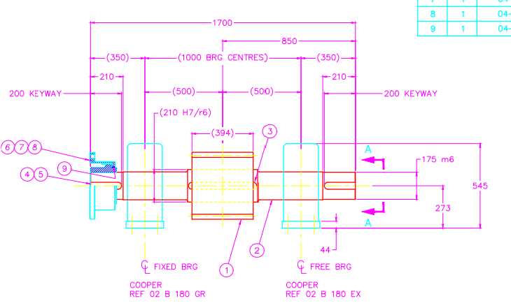
(Dow Ltd, 1998)

(Appendix 2)

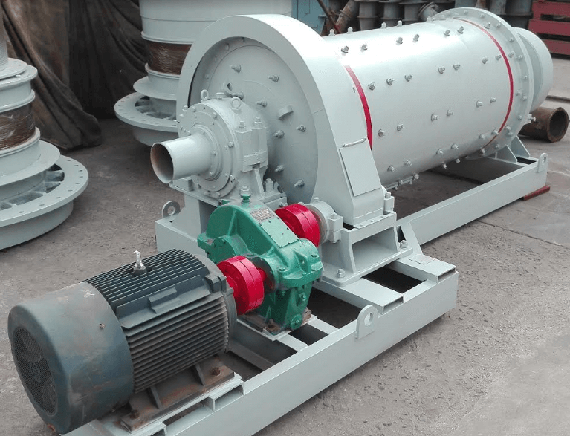
(Anon., n.d.)

(Appendix 3)

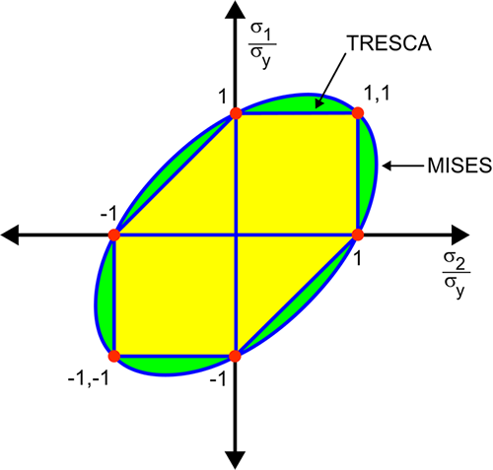

(Anon., n.d.)

