Introduction to web and Database concepts

  - ACCA 4023

Name:Margaret Bisong
StudentID 2523604
Group: 2
Lecturer: Dr Anum Paracha

UNIVERSITY OF WALES, TRINITY SAINT DAVID
London Campus

Contents
Introduction 2
Scenario Analysis 2
Entity Relationship Diagram (ERD) 4
Data Structure Design 5
Normalisation 8
Sample Data 9
Queries 12
Forms and Reports 18
Validation and Testing 19
Reflection 19
Conclusion 20

Introduction
AutoPark currently manages multiple city parking sites using manual logs for entries, slots, customers, and payments. This approach causes:
- Frequent data entry errors and lost records
- Unreliable slot availability tracking
- Inefficient space usage and underreported revenue
- No real-time visibility across sites
- Slow, inconsistent reporting
A database design methodology is explicitly divided into three phases: conceptual, logical, and physical [1.] The new Access-based system will centralise all data, automate workflows, and deliver actionable insights for operational and financial performance.

Scenario Analysis

Entity | Description | Key Attributes | Relationships & Cardinality
Parking Site | A single managed parking location | SiteID (PK), Site name, full address, total slots, opening hours, contact details | 1-to-Many: One site has many parking slots; one slot belongs to only one site
Parking Slot | Individual parking space at a site | SlotID (PK), SiteID (FK), slot number, type (standard / disabled / EV), current status (free / occupied / reserved / out of service) | 1-to-Many: One slot can have many bookings over time; one booking is assigned to only one slot
Customer | Person booking or using parking | CustomerID (PK), full name, phone number, email, address, customer type (casual / regular / corporate), registration date | 1-to-Many: One customer may register many vehicles; one vehicle belongs to only one customer  1-to-Many: One customer may make many bookings; one booking belongs to one customer
Vehicle | Vehicle registered for parking use | VehicleID (PK), CustomerID (FK), UK registration number, type (car / motorbike / van), colour, make/model | 1-to-Many: One vehicle may have many bookings; one booking is linked to one vehicle
Booking | Parking reservation or entry record | BookingID (PK), SiteID (FK), SlotID (FK), CustomerID (FK), VehicleID (FK), start date/time, end date/time, booking type (pre-booked / drive-in), status (active / completed / cancelled / no-show) | 1-to-Many: One booking may have many payment records; one payment relates to only one booking
Payment | Fee settlement record for a booking | PaymentID (PK), BookingID (FK), amount charged, payment date/time, method (cash / card / app), status (paid / pending / refunded) | Linked exclusively to one booking
Tariff | Pricing rules per site/vehicle type | TariffID (PK), SiteID (FK), vehicle type, hourly rate, daily maximum charge, corporate discount rate | Applies to all bookings at the matching site

Entity Relationship Diagram (ERD)

This model incorporates some of the important semantic information about the real world. A special diagrammatic technique is introduced as a tool for database design. The entity-relationship model can be used as a basis for unification of different views of data: the network model, the relational model, and the entity set mode[2].
Fig 1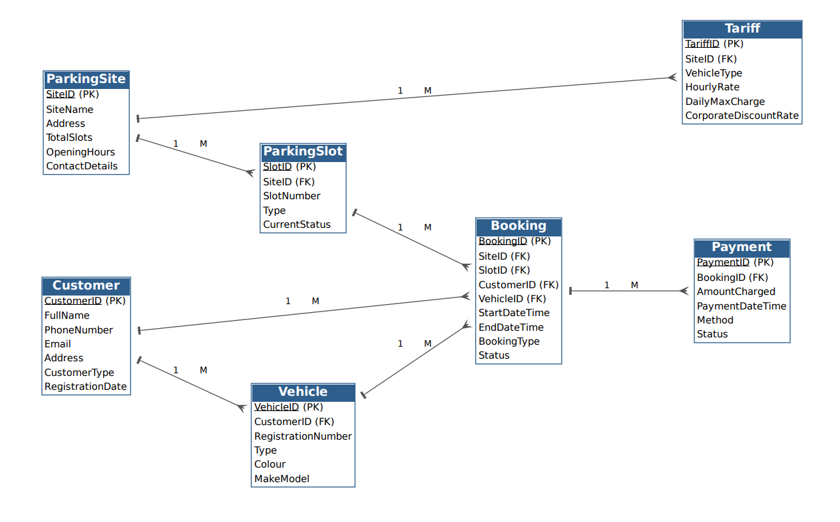
Fig 2
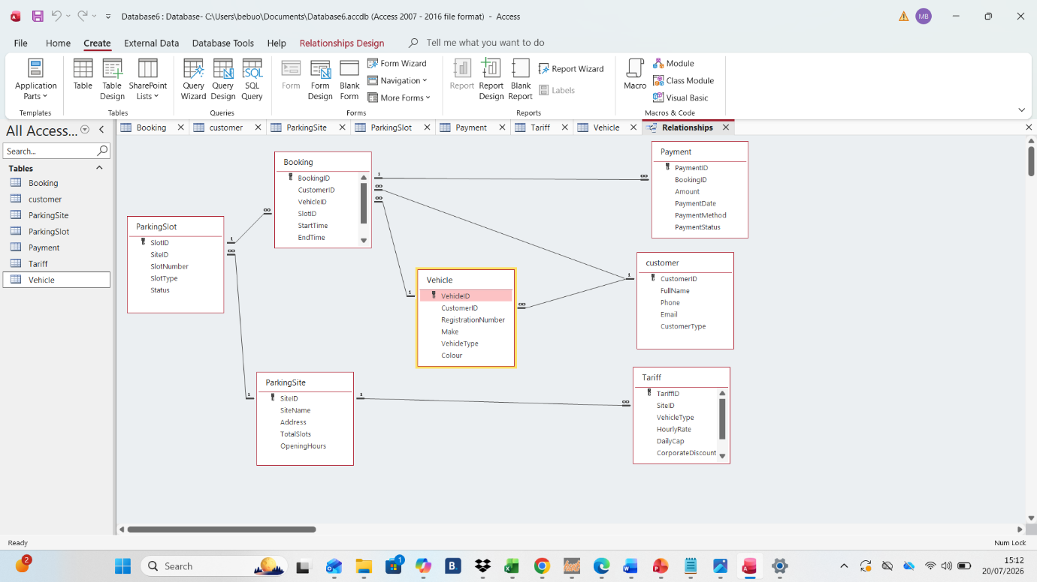

Entity and Attribute Relationship
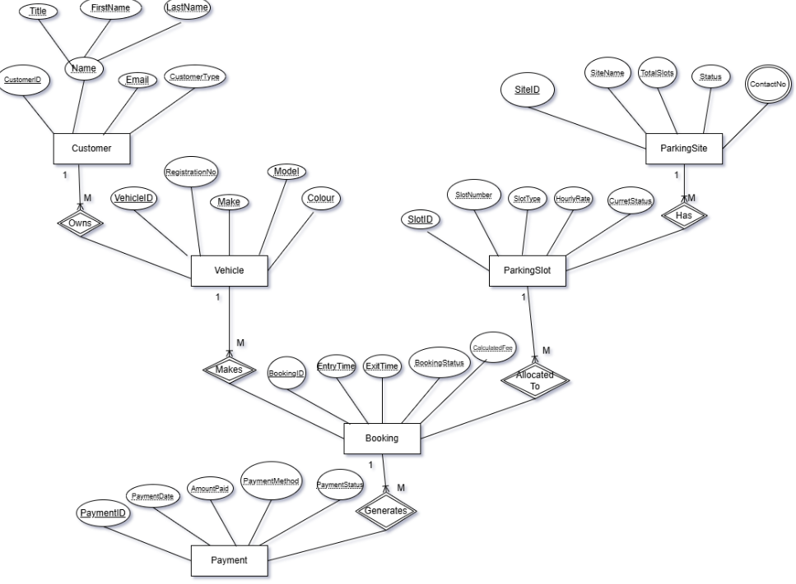

Data Structure Design
Table Name | Field Name | Data Type | Key / Constraint | Validation
ParkingSite | SiteID | AutoNumber | Primary Key | -
 | SiteName | Short Text (50) | Required | Unique values only
 | Address | Short Text (200) | Required | -
 | TotalSlots | Number (Integer) | Required | ≥ 1
 | OpeningHours | Short Text (30) | Required | e.g. "06:00–22:00"
ParkingSlot | SlotID | AutoNumber | Primary Key | -
 | SiteID | Number (Long) | Foreign Key → ParkingSite.SiteID | Enforce referential integrity; cascade updates
 | SlotNumber | Short Text (10) | Required | Unique per site
 | SlotType | Short Text (20) | Required | List: Standard, Disabled, EV, Compact
 | Status | Short Text (20) | Required | List: Free, Occupied, Reserved, Out of Service
Customer | CustomerID | AutoNumber | Primary Key | -
 | FullName | Short Text (100) | Required | -
 | Phone | Short Text (20) | Required | UK format validation
 | Email | Short Text (100) | - | Match email format
 | CustomerType | Short Text (20) | Required | List: Casual, Regular, Corporate
Vehicle | VehicleID | AutoNumber | Primary Key | -
 | CustomerID | Number (Long) | Foreign Key → Customer.CustomerID | Enforce referential integrity
 | RegistrationNo | Short Text (10) | Required | UK format; unique values
 | Make | Short Text (50) | Required | -
 | VehicleType | Short Text (20) | Required | List: Car, Motorbike, Van
Booking | BookingID | AutoNumber | Primary Key | -
 | SiteID | Number (Long) | Foreign Key → ParkingSite.SiteID | -
 | SlotID | Number (Long) | Foreign Key → ParkingSlot.SlotID | -
 | CustomerID | Number (Long) | Foreign Key → Customer.CustomerID | -
 | VehicleID | Number (Long) | Foreign Key → Vehicle.VehicleID | -
 | StartTime | Date/Time | Required | Must be current or future
 | EndTime | Date/Time | Required | > StartTime
 | BookingType | Short Text (20) | Required | Pre-booked, Drive-in
 | Status | Short Text (20) | Required | Active, Completed, Cancelled
Payment | PaymentID | AutoNumber | Primary Key | -
 | BookingID | Number (Long) | Foreign Key → Booking.BookingID | Enforce referential integrity; cascade updates/restrict deletes
 | Amount | Currency | Required | ≥ 0
 | PaymentDate | Date/Time | Required | -
 | PaymentMethod | Short Text (20) | Required | Card, Cash, App
 | PaymentStatus | Short Text (20) | Required | Paid, Pending, Refunded

Normalisation
The design fully meets Third Normal Form (3NF):

- 1NF: All fields contain single atomic values; no repeating groups; every record has a unique primary key.
- 2NF: All non-key fields depend fully on the entire primary key (no partial dependencies). For example, SiteName only appears in ParkingSite, not duplicated in Booking.
- 3NF: No transitive dependencies non-key fields do not depend on other non-key fields. For example, vehicle make/type are stored in Vehicle and not repeated in Booking; customer details are not duplicated in Vehicle.

Benefits: Eliminates data duplication, reduces update/insert/delete errors, and simplifies future changes (e.g. updating a customer’s phone number only needs to happen once). The process focuses on eliminating data repetition and optimizing table structures to enhance performance. Experimental results show that normalization reduces database size by approximately 30%, significantly minimizing redundancy [3]

Sample Data
Parking Site
SiteID | SiteName | Address | TotalSlots | OpeningHours
1 | Solihull Central | 12 High St, Solihull B91 3TB | 120 | 06:00–23:00
2 | Station Approach | Station Rd, Solihull B91 1LG | 75 | 05:00–00:00
3 | Shirley Retail Park | Stratford Rd, Shirley B90 4NZ | 200 | 07:00–21:00

ParkingSlot
SlotID | SiteID | SlotNumber | SlotType | Status
1 | 1 | A01 | Standard | Occupied
2 | 1 | D05 | Disabled | Free
3 | 2 | EV12 | EV Charging | Occupied
4 | 3 | B22 | Standard | Reserved
5 | 1 | C10 | Standard | Out of Service

Customer
CustomerID | FullName | Phone | Email | CustomerType
1 | Emma Clarke | 07700 900123 | e.clarke@example.co.uk | Regular
2 | Raj Patel | 07700 900456 | r.patel@example.co.uk | Casual
3 | Solihull Council | 0121 704 6000 | parking@solihull.gov.uk | Corporate

Vehicle
VehicleID | CustomerID | RegistrationNo | Make | VehicleType
1 | 1 | AB12 XYZ | Vauxhall | Car
2 | 1 | CD34 ABC | Yamaha | Motorbike
3 | 2 | EF56 DEF | Ford | Van
4 | 3 | GH78 GHI | Volkswagen | Car

Booking
BookingID | SiteID | SlotID | CustomerID | VehicleID | StartTime | EndTime | BookingType | Status
1 | 1 | 1 | 1 | 1 | 2026-07-20 08:15 | 2026-07-20 13:45 | Drive-in | Active
2 | 2 | 3 | 2 | 3 | 2026-07-20 09:00 | 2026-07-20 17:00 | Pre-booked | Active
3 | 3 | 4 | 3 | 4 | 2026-07-20 10:30 | 2026-07-20 15:00 | Pre-booked | Active
4 | 1 | 2 | 1 | 2 | 2026-07-19 14:00 | 2026-07-19 16:30 | Drive-in | Completed
5 | 1 | 5 | - | - | - | - | - | Cancelled

Payment
BookingID | SiteID | SlotID | CustomerID | VehicleID | StartTime | EndTime | BookingType | Status
1 | 1 | 1 | 1 | 1 | 2026-07-20 08:15 | 2026-07-20 13:45 | Drive-in | Active
2 | 2 | 3 | 2 | 3 | 2026-07-20 09:00 | 2026-07-20 17:00 | Pre-booked | Active
3 | 3 | 4 | 3 | 4 | 2026-07-20 10:30 | 2026-07-20 15:00 | Pre-booked | Active
4 | 1 | 2 | 1 | 2 | 2026-07-19 14:00 | 2026-07-19 16:30 | Drive-in | Completed
5 | 1 | 5 | - | - | - | - | - | Cancelled

Queries
Query 1 (Test and Result)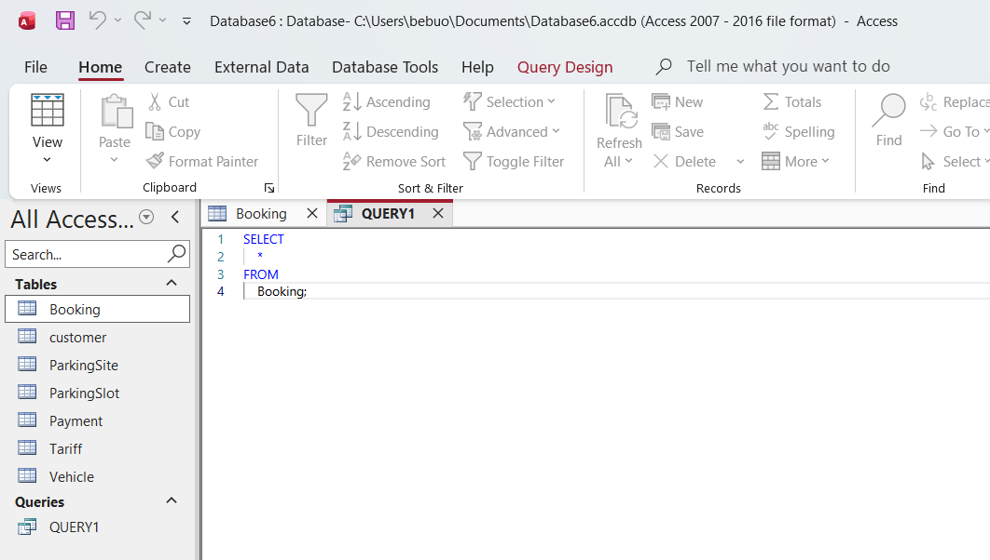 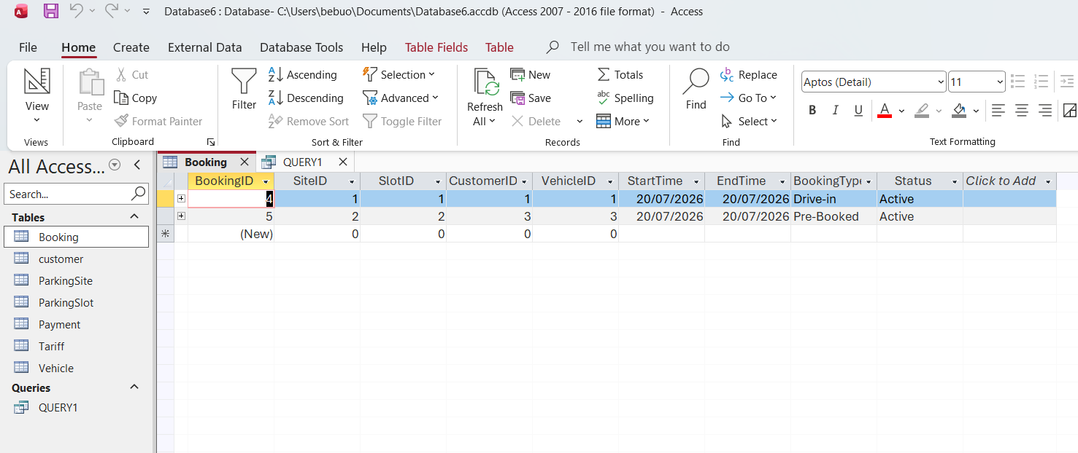

Query 2 (Test and Result)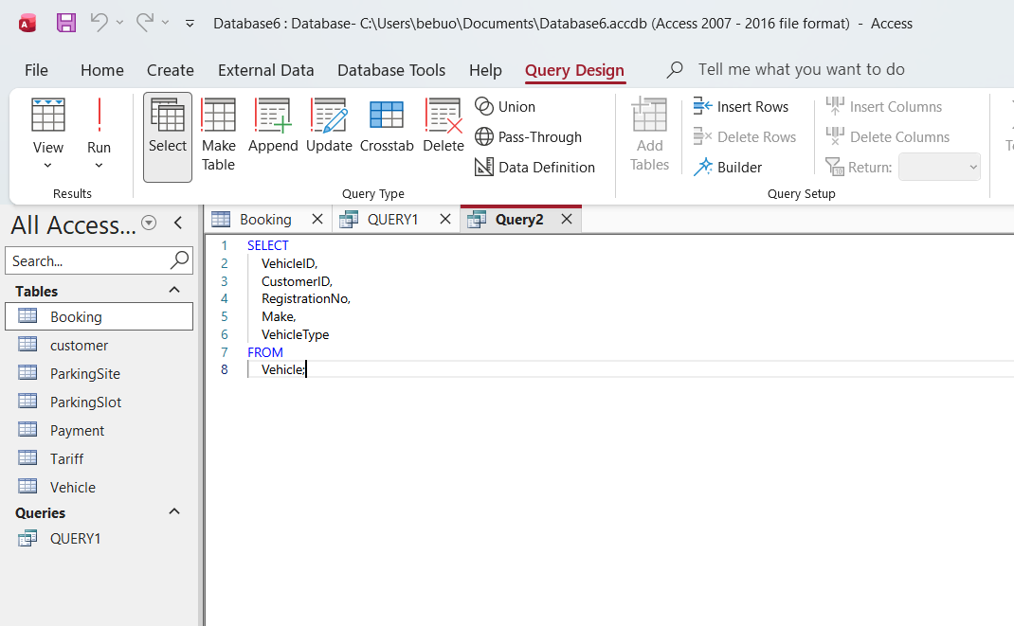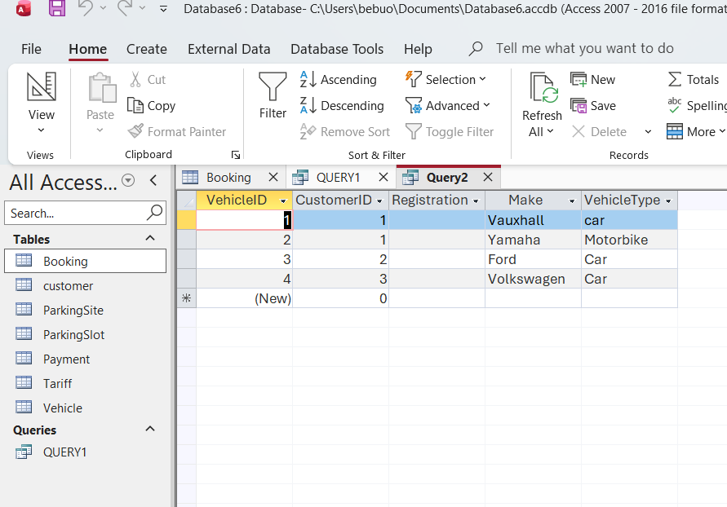

Query 3 (Test and Result)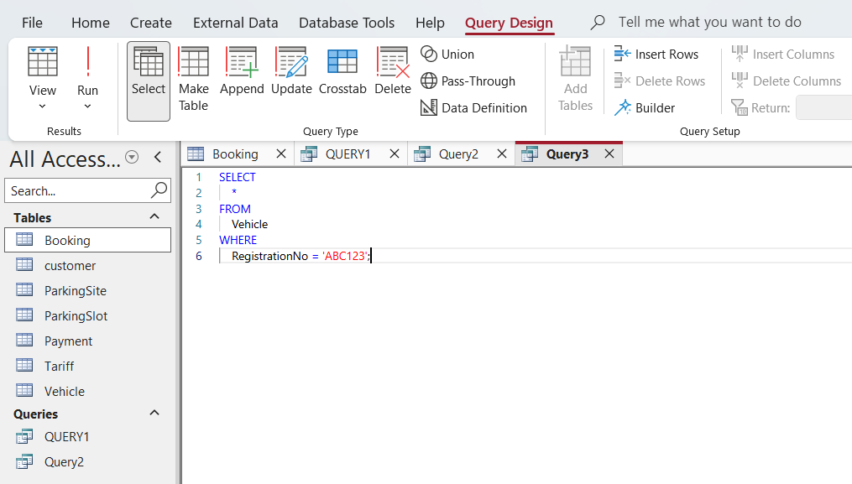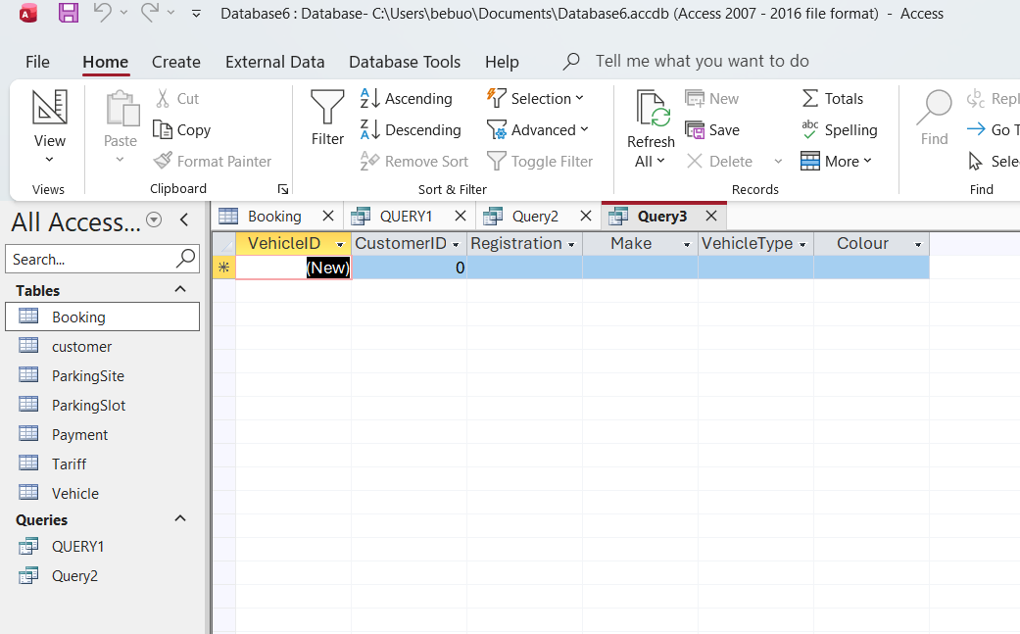

Query 4 (Test and Result)
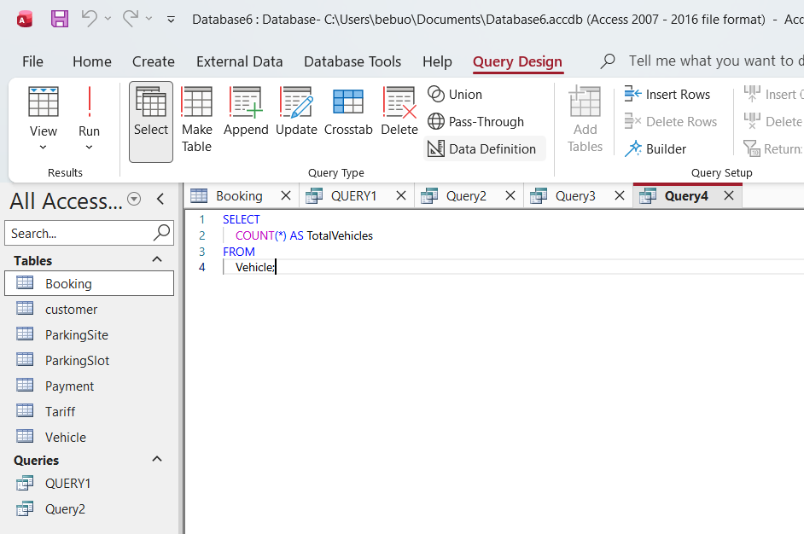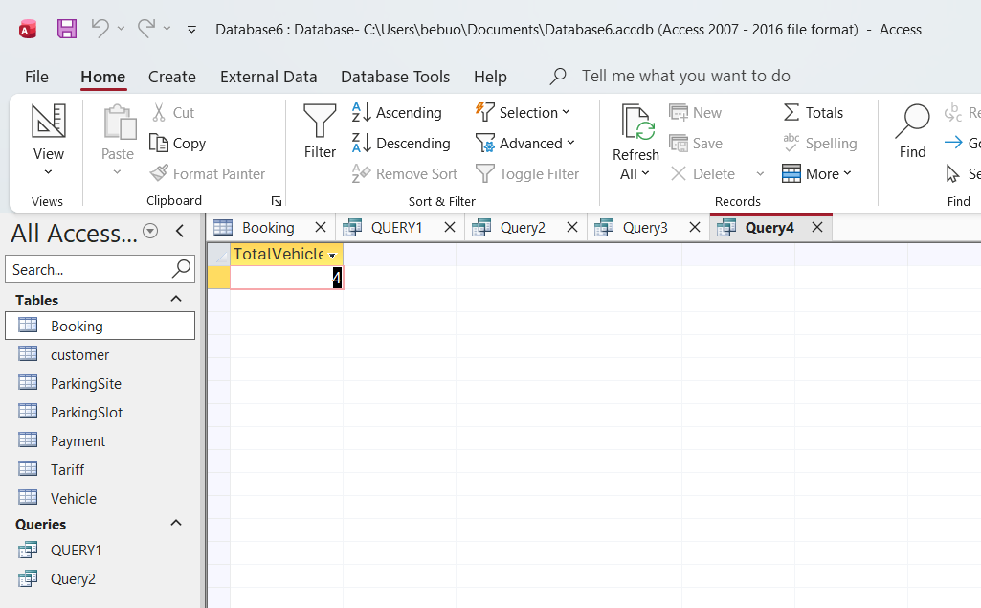

Query 5 (Test and Result)
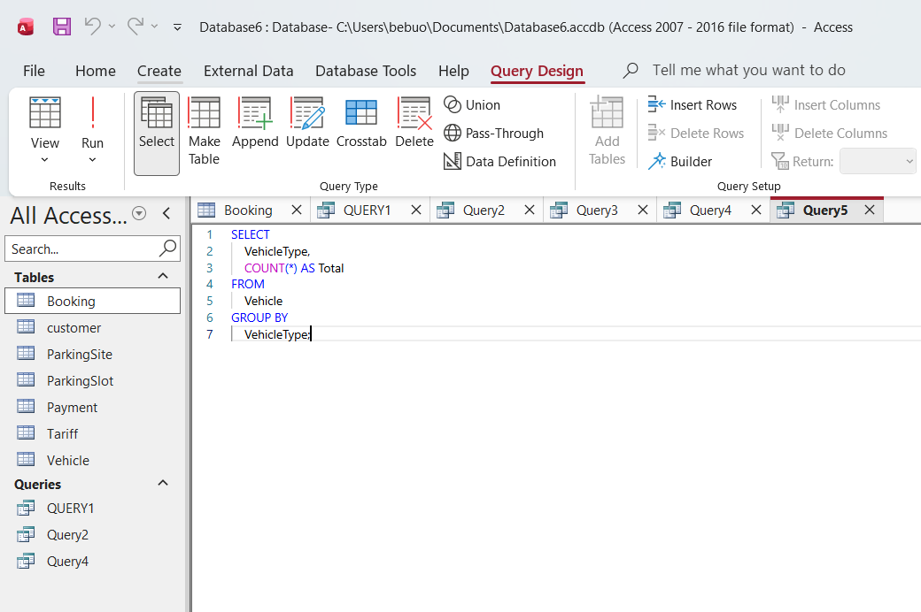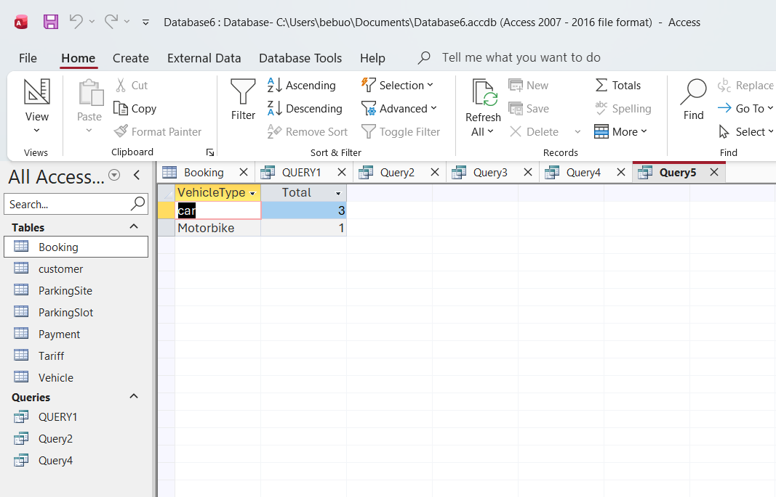

Query 6 (Test and Result)
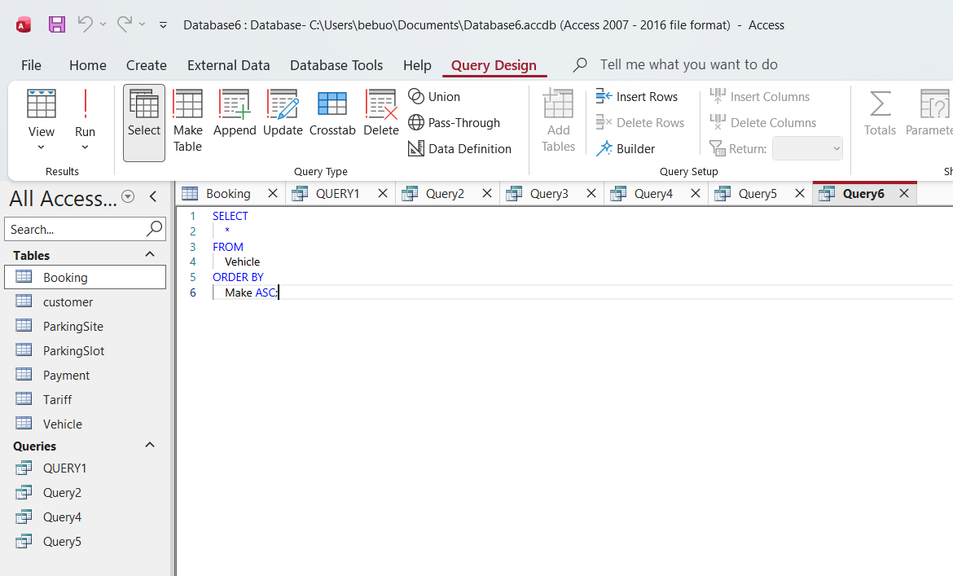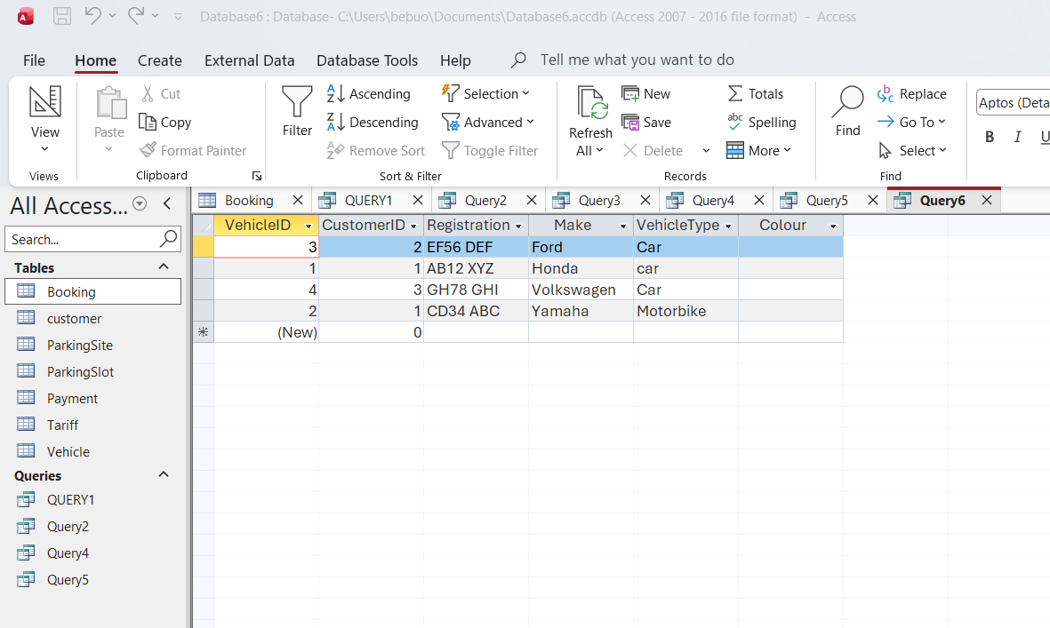

Forms and Reports
ParkingSlot Form
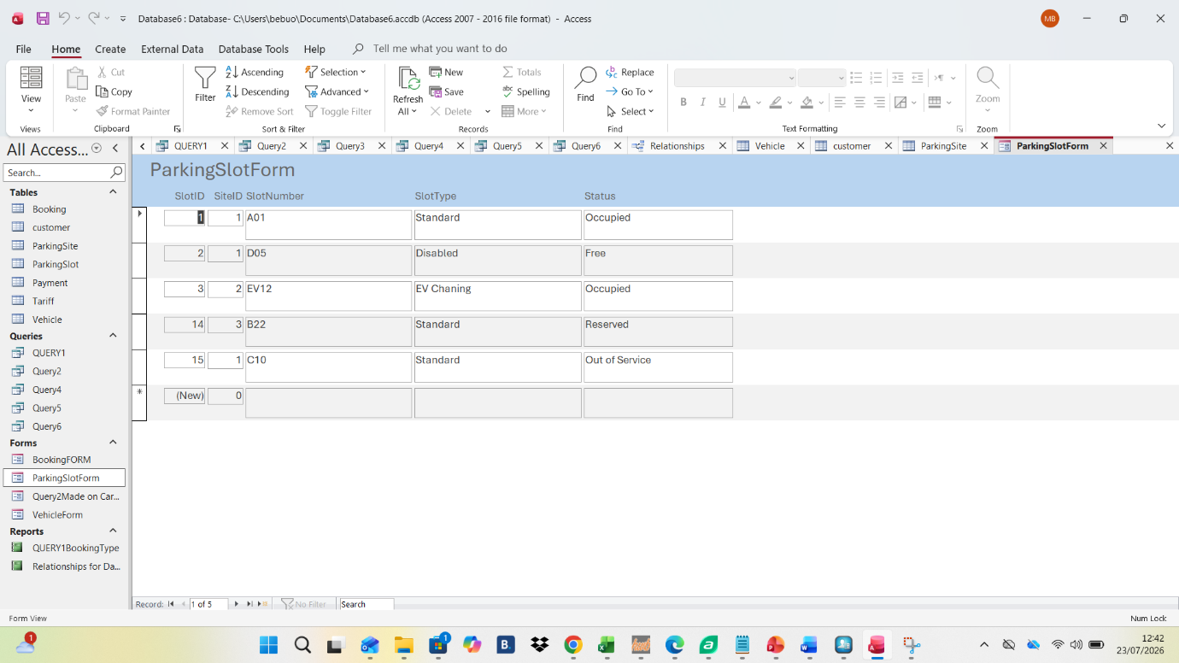

Bookingform

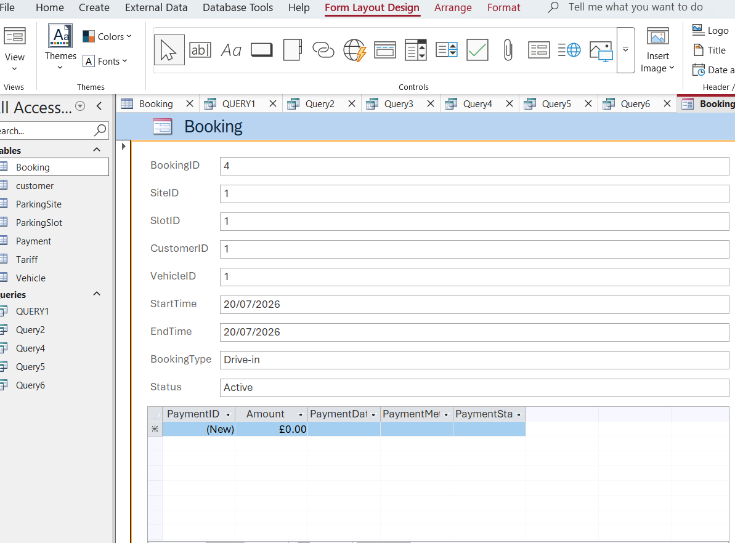

Relationship Report
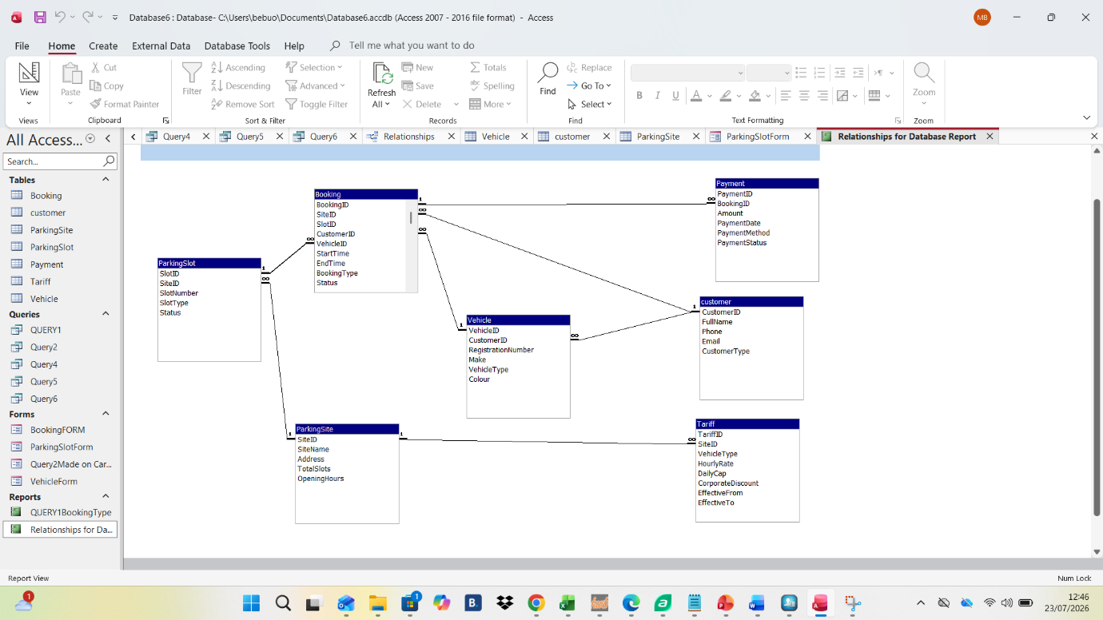

Validation and Testing
The system was evaluated against the original functional requirements by re-entering edge-case scenarios (a slot with no active booking, a booking with a pending payment, a customer with multiple vehicles) and confirming that the relationships, constraints, and queries produced the expected results without orphaned records. Referential integrity was specifically tested by attempting to delete a ParkingSite record with dependent slots and bookings, confirming that Access blocked the deletion as intended. The volume and variety of modern day databases presents a particular challenge to the system testing community. The question is how to go about testing such large collections of various data types ranging from tables to texts and images. To test those applications which use them, these conglomerations of multiple data object types have to be automatically generated and validated. There is no other way but to automate the test process [4]

Reflection
The main technical challenge encountered was an Access error stating that a relationship could not be created because the joined fields did not share the same data type. Investigation showed that a primary key defined as AutoNumber (e.g., ParkingSite.SiteID) had a corresponding foreign key (ParkingSlot.SiteID) typed as Number with a mismatched field size rather than the required Long Integer, which Access requires for an AutoNumber/Number join This was resolved by auditing every FK field against the data type and field size of the PK it references before attempting to draw the relationship, correcting each mismatch to Long Integer, and only then recreating the relationship with referential integrity enforced.
A secondary challenge was managing a table with four separate foreign keys (Booking, referencing Site, Slot, Customer, and Vehicle), which made the Relationships window visually congested and easy to mis-click. This was addressed by adding each relationship one at a time and verifying it in the Edit Relationships dialog before proceeding to the next, rather than attempting to draw all four links in one pass. Together these steps reinforced a general lesson for relational design in Access: schema mismatches between PK and FK fields are the most common blocker when implementing a design that is conceptually correct on the ERD, and disciplined field-by-field verification prevents the bulk of relationship-creation errors.

Conclusion
Database management systems owe much of their usefulness to standardized client interfaces—particularly query languages and call-level interfaces—along with clearly defined atomicity semantics across different configurations. How effective these extensions are depends largely on how well they match real application needs, especially the atomicity guarantees required in distributed environments.
While relaxing atomicity guarantees can improve performance and scalability, stronger guarantees reduce the need for human intervention, making them valuable for building self-managed systems. The right balance ultimately depends on the specific application, which leaves plenty of room for different implementation and configuration choices [5]

References
References
[1] N. Carvalho, A. Correia Jr, J. Pereira, L. E. Rodrigues, R. Oliveira and S. Guedes, "On the Use of a Reflective Architecture to Augment Database Management Systems." vol. 13, no. 8, pp.1110–1135, 2007,
[2] N. Carvalho, A. Correia Jr, J. Pereira, L. E. Rodrigues, R. Oliveira and S. Guedes, "On the Use of a Reflective Architecture to Augment Database Management Systems." vol. 13, no. 8, pp.1110–1135, 2007,
[3] H. M. Sneed and K. Erdoes, "Testing big data (Assuring the quality of large databases)", in 2015 IEEE Eighth International Conference on Software Testing, Verification and Validation Workshops (ICSTW), pp. 1–6.
[4] E. F. Codd, "Further normalization of the data base relational model," vol. 6, no. 1972, pp.33–64, 1972,
[5] P. P. Chen, "The entity-relationship model," vol. 1, pp.1, 1976,
[6] T. M. Connolly and C. E. Begg,Database systems: a practical approach to design, implementation, and management, Pearson Education, 2005.

