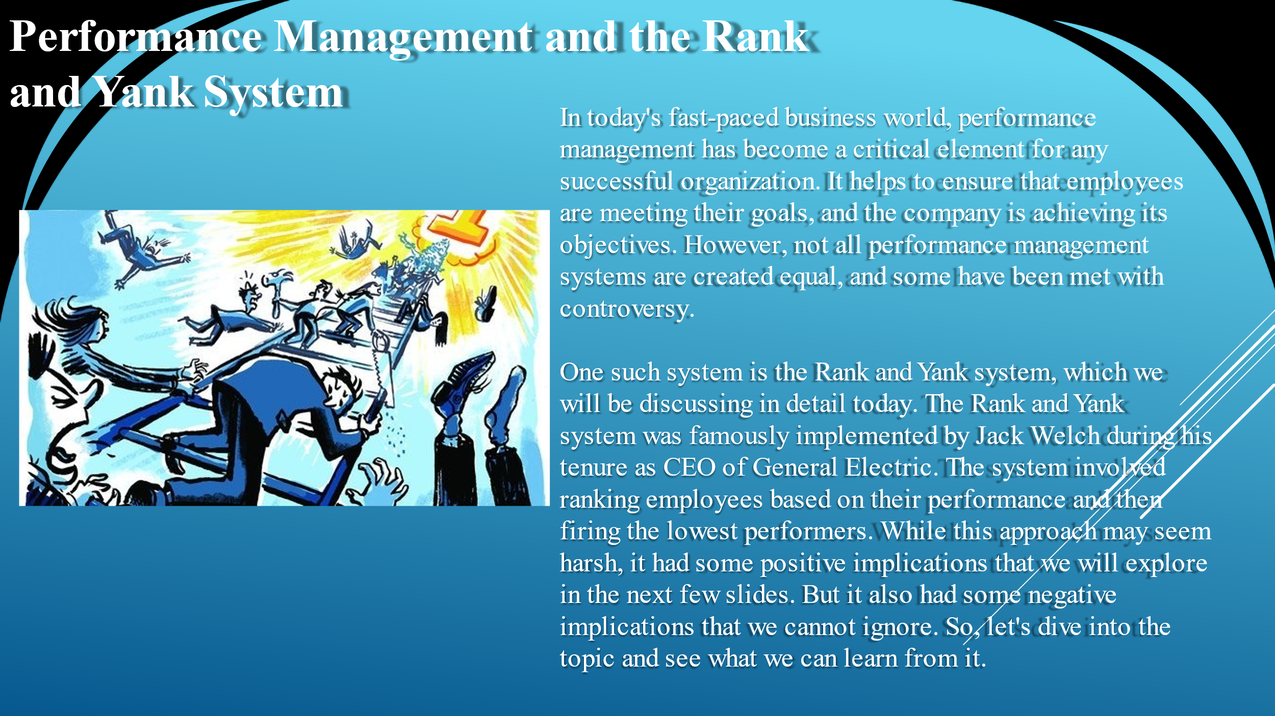
In today's fast-paced business world, performance management has become a critical element for any successful organization. It helps to ensure that employees are meeting their goals, and the company is achieving its objectives. However, not all performance management systems are created equal, and some have been met with controversy.
One such system is the Rank and Yank system, which we will be discussing in detail today. The Rank and Yank system was famously implemented by Jack Welch during his tenure as CEO of General Electric. The system involved ranking employees based on their performance and then firing the lowest performers. While this approach may seem harsh, it had some positive implications that we will explore in the next few slides. But it also had some negative implications that we cannot ignore. So, let's dive into the topic and see what we can learn from it.

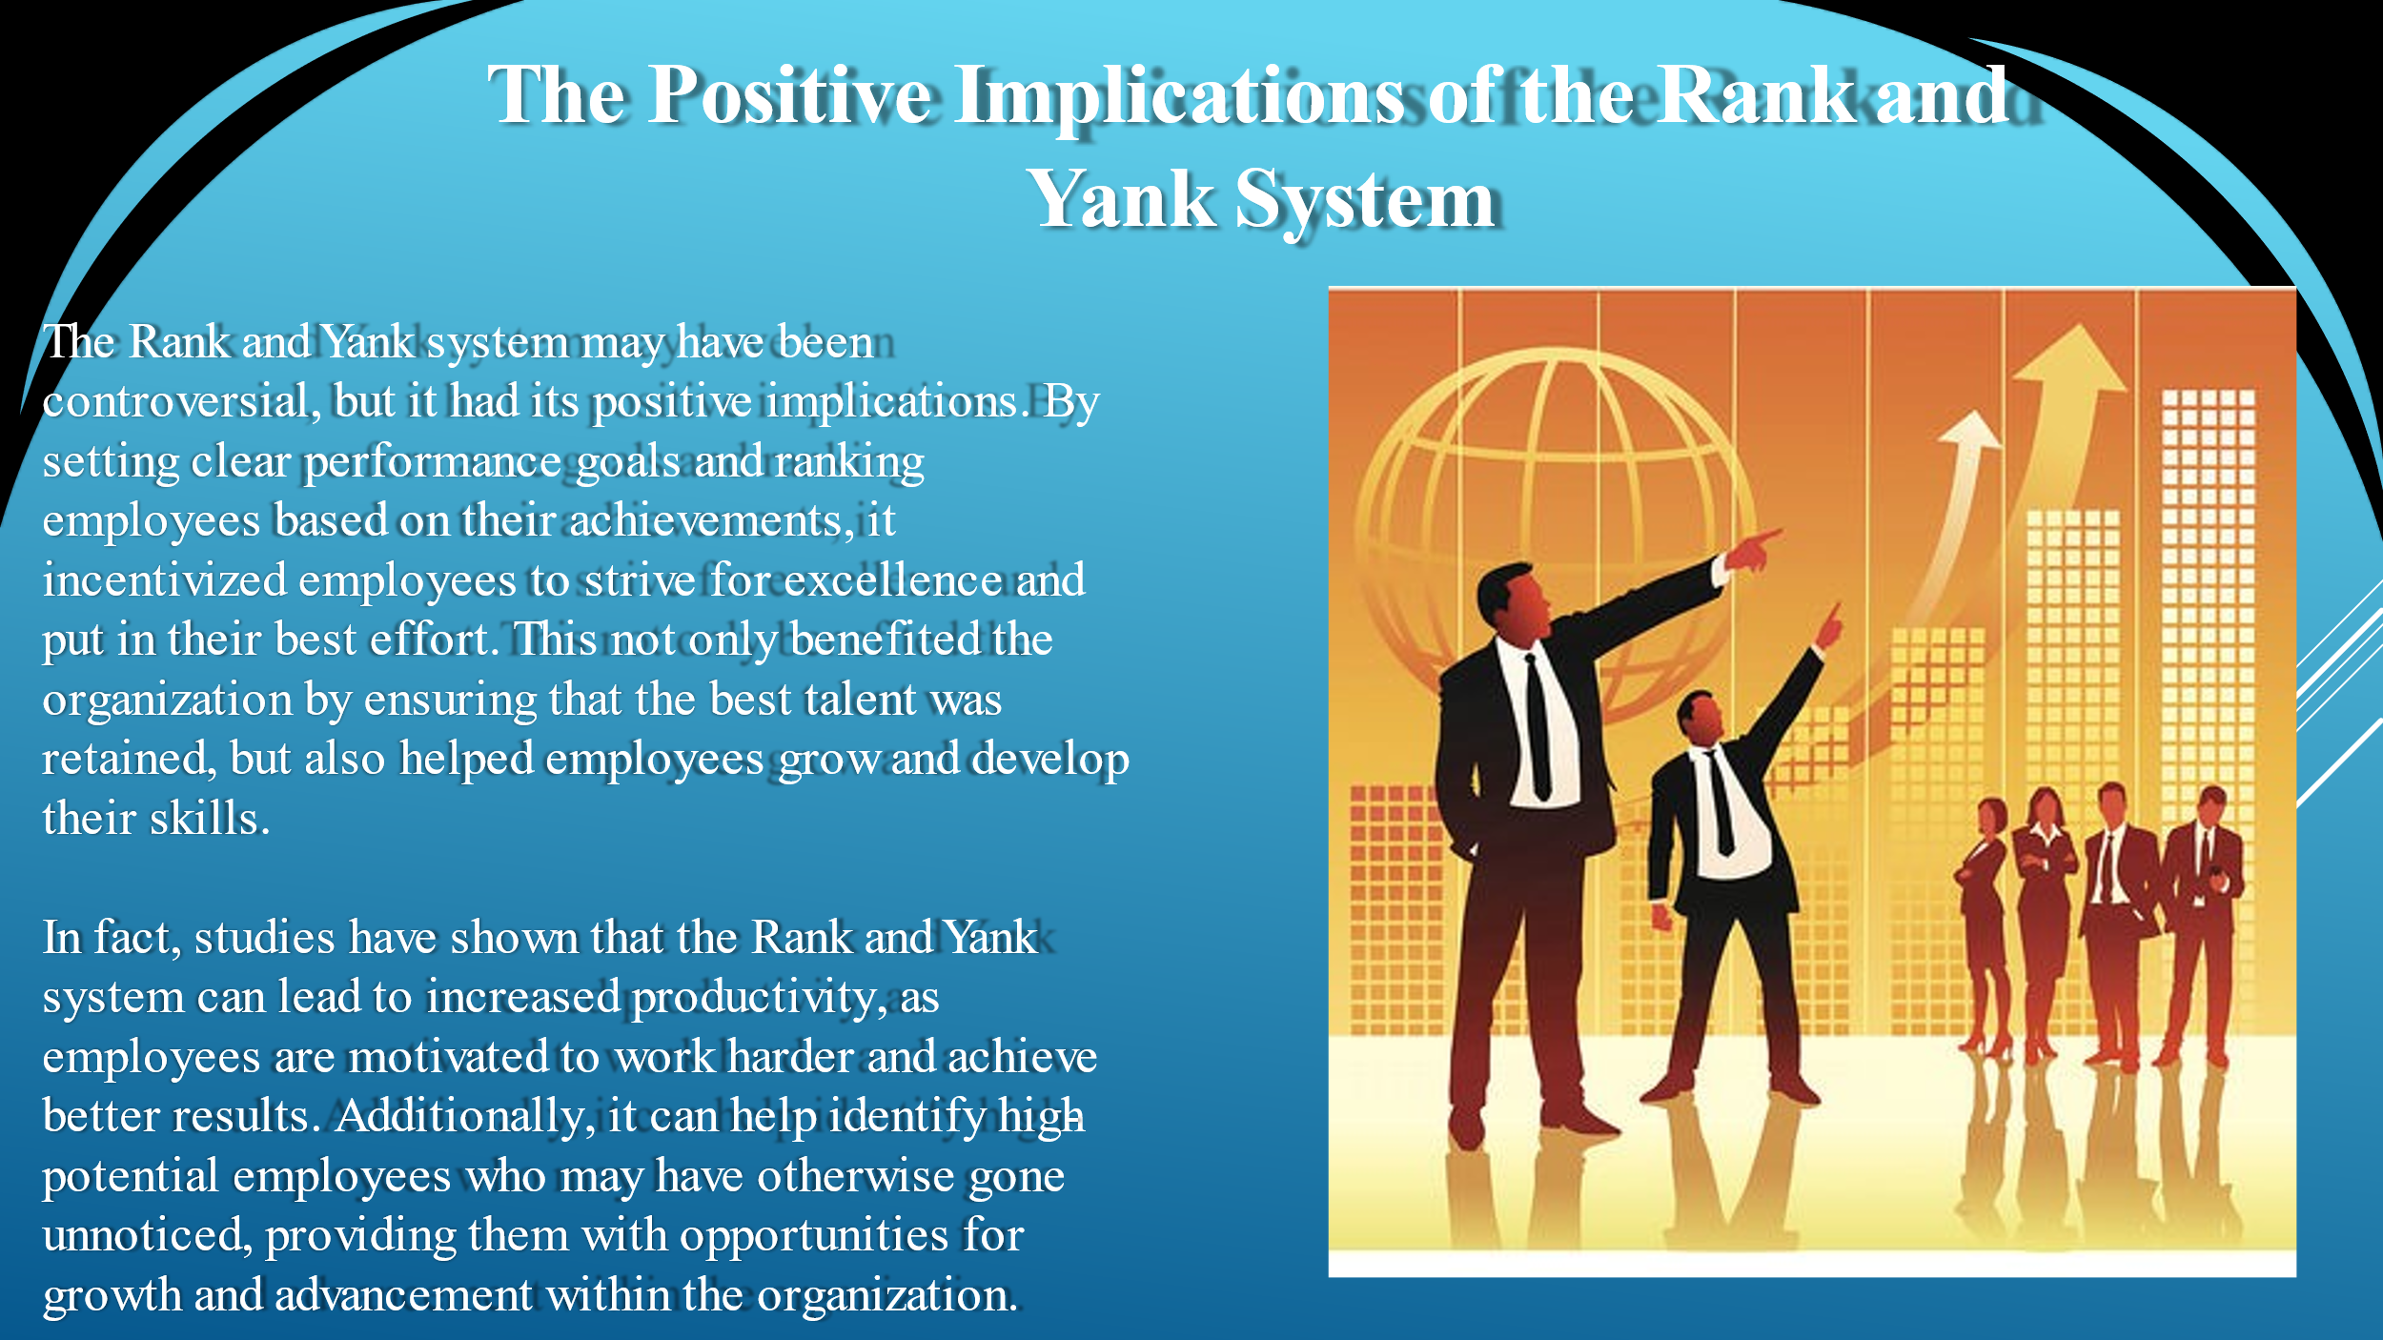
The Rank and Yank system may have been controversial, but it had its positive implications. By setting clear performance goals and ranking employees based on their achievements, it incentivized employees to strive for excellence and put in their best effort. This not only benefited the organization by ensuring that the best talent was retained, but also helped employees grow and develop their skills.
In fact, studies have shown that the Rank and Yank system can lead to increased productivity, as employees are motivated to work harder and achieve better results. Additionally, it can help identify high-potential employees who may have otherwise gone unnoticed, providing them with opportunities for growth and advancement within the organization.

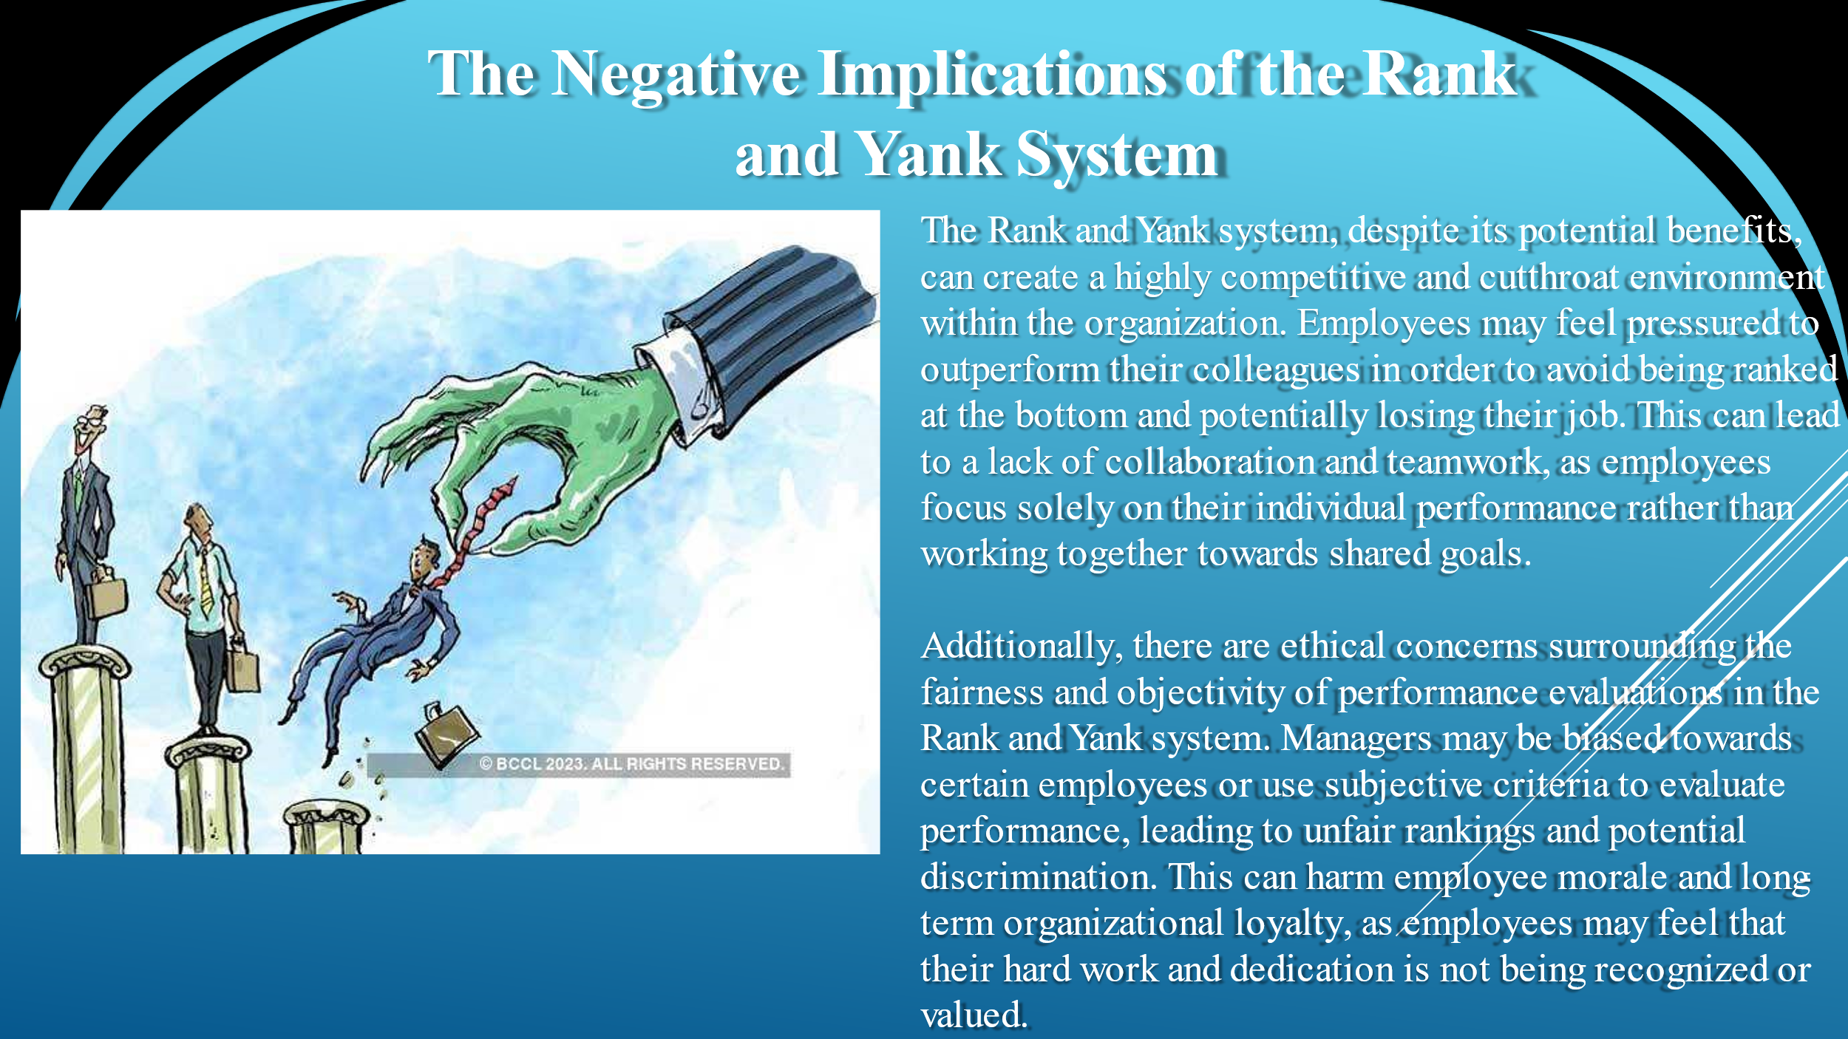
The Rank and Yank system, despite its potential benefits, can create a highly competitive and cutthroat environment within the organization. Employees may feel pressured to outperform their colleagues in order to avoid being ranked at the bottom and potentially losing their job. This can lead to a lack of collaboration and teamwork, as employees focus solely on their individual performance rather than working together towards shared goals.
Additionally, there are ethical concerns surrounding the fairness and objectivity of performance evaluations in the Rank and Yank system. Managers may be biased towards certain employees or use subjective criteria to evaluate performance, leading to unfair rankings and potential discrimination. This can harm employee morale and long-term organizational loyalty, as employees may feel that their hard work and dedication is not being recognized or valued.

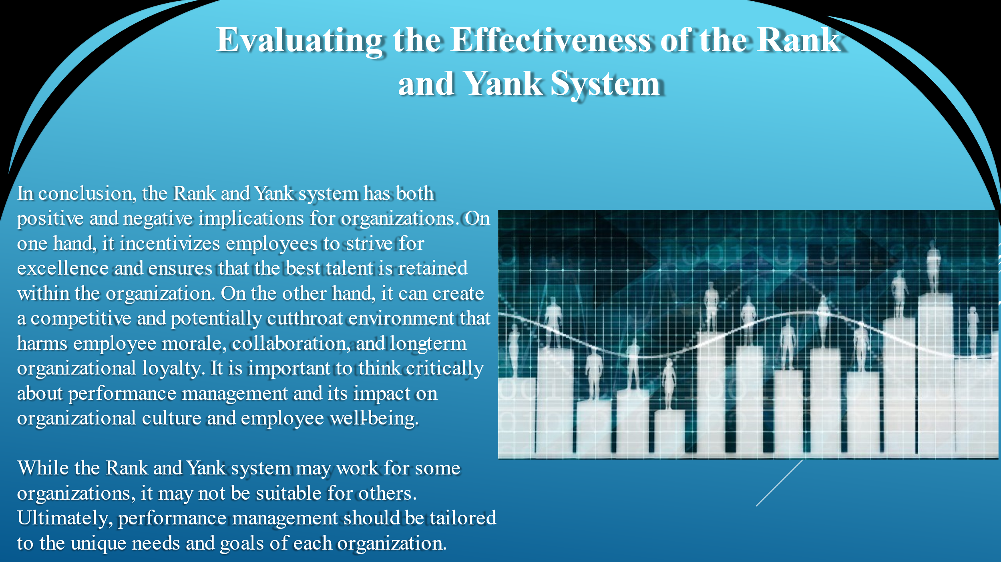
In conclusion, the Rank and Yank system has both positive and negative implications for organizations. On one hand, it incentivizes employees to strive for excellence and ensures that the best talent is retained within the organization. On the other hand, it can create a competitive and potentially cutthroat environment that harms employee morale, collaboration, and long-term organizational loyalty. It is important to think critically about performance management and its impact on organizational culture and employee well-being.
While the Rank and Yank system may work for some organizations, it may not be suitable for others. Ultimately, performance management should be tailored to the unique needs and goals of each organization.

