University of Wales Trinity Saint David
Wales Institute of Science and Art



Motor Vehicle Engineering Science
Energy in a Flywheel
(ACHA4036)

Connor Baldwin
2306099
29/03/2026

Contents

1 Contents i
2 Introduction 1
2.1 Relevance to Industry 1
3 Experimental Procedure 2
3.1 The Process 2
4 Results 4
5 Analysis 5
6 Conclusion 6
7 Evaluation 7
8 Further work 8
9 Bibliography 9

Introduction
This is a technical report detailing the experimental procedure of how to measure energy within a flywheel. In this report it is expected to learn the process of how to measure the energy, what results were collected during the experiment, an analysis of the results but also further work – detailing what improvements can be made to make the experiment more improved.

Relevance to Industry
As per (Euro Tech, 2023) within an automotive vehicle the main purpose of the flywheel is to store and transmit rotational energy from the engine to the transmission, which is then used for the drivetrain to generate motion in the wheels to move the vehicle. It acts in most cases as a buffer, creating smooth and continuous power transfer. Although not it’s primary function the flywheel is used for starting a vehicle, the flywheel’s weight is used to overcome the engine’s initial inertia to start the combustion process. This process is completed with the flywheel being attached to the crankshaft, at the bottom of the engine. With a starter motor directly attached to the flywheel, once moving the flywheel rotates the crankshaft, causing piston rotation and the combustion process begins. The rotational mass of the flywheel also helps it act as a damper to vibration caused from the engine; this reduces stress on components and maintains engine stability.

Experimental Procedure
Using a booklet containing guidance notes by (TecQuipment LTD, 2012), the experiment was conducted in a university laboratory, with the help of two other students to assist with calculations and completion of the experiment. The booklet contains the experimental procedure, which below have been explained.
Figure 1: Shows the equipment used to complete the experiment. It shows the weight hanger, the weights on the hanger, the string connecting the hanger to the pulley shaft. The magnetic ruler is stuck to the work panel, this is to measure $h_{1}$, and $h_{2}$. The flywheel is connected to the pulley shaft via the bearing block, which is one completed unit that is held into the work panel via a screw (held in from the other side).
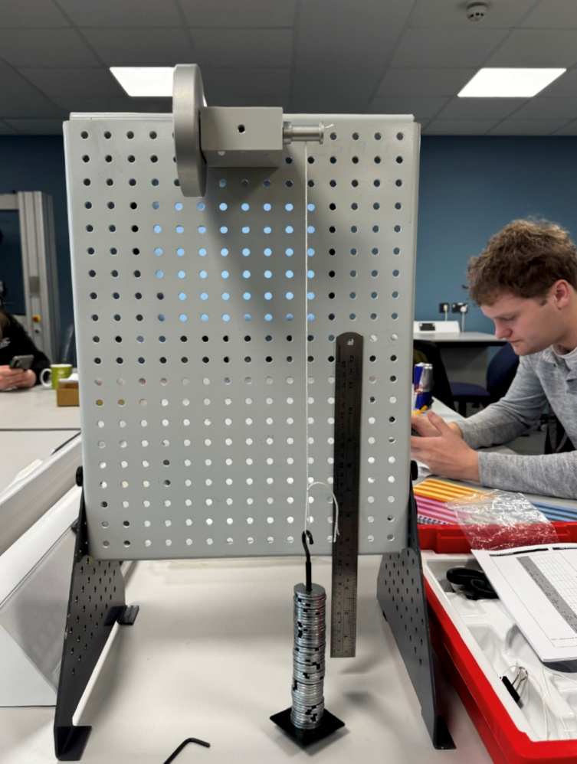
Figure 1 - Photo of experiment whilst in progress, displaying all the equipment used

The Process
The equipment was set up as show in figure 1, however the weight to begin was less due to figure 1 being taken near the end of the experiment. The string specifically should allow the hanger to travel a vertical drop of 0.29m, this is because the starting height of the bottom of the hanger had to be 0.28m (this is the value for $h_{1}$) . With no weight on the hanger, the hanger was allowed to fall to the bottom of its travel, the ruler marking 0m was used to indicate this. The mass of the hanger is 10g, to total 100g for the first mass of the experiment 90g of weights was added to the hanger. Slowly the flywheel was turned, lifting the hanger until the bottom of it was level with 0.28m, using the magnetic ruler to determine this starting position.

Using a starting stopwatch, the time taken for the weight to fall from this starting position, to 0m to then its maximum height (value for $h_{2}$) was then measured. This step was completed 3 times, this meant an average h2 could then be measured, as well as an average time taken.

This process is then repeated for each of the desired masses adding 100g at each point, recording each height change as well as the time taken to complete them.

Using the acquired values, the potential energy, the mass, gravity and PE losses are calculated. The average falling time, acceleration, velocity and (mg-ma)r and a/r values were also then calculated. The equations, how they are used, and the calculation results are explained further on in the analysis section of this report.

Results
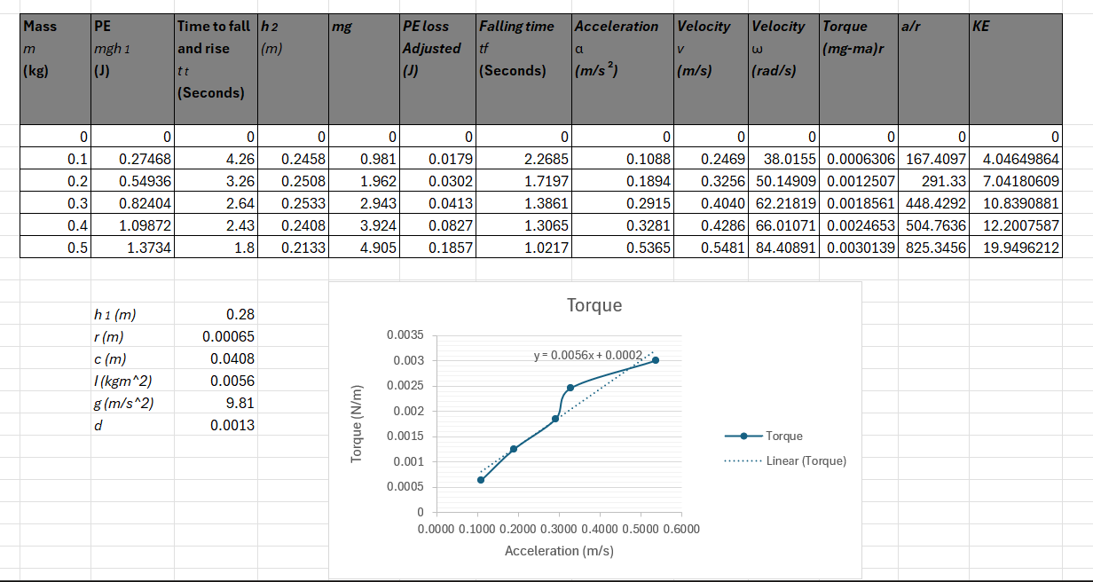
Figure 2 - Table of results and graph displaying torque by acceleration

Analysis
Using (TecQuipment LTD, 2012), the guidance notes explain that kinetic energy can be stored in moving parts of a machine and as explained in the introduction a flywheel is used to store rotational energy. The larger the mass or rotating speed of the object, the more kinetic energy can be stored. This is proven by the results above, as each mass increases so does the kinetic energy.
$$KE=\frac{1}{2}Iw^{2}$$
The moment of inertia is an object’s resistance to a change in rotation. Due to the nature of the experiment the exact inertia of the flywheel and its moving parts is difficult to find, so instead an average value is instead calculated and used to calculate the KE of each mass. Omega is the angular velocity of the flywheel, as the acceleration and mass increases so will the velocity the mass on the hanger falls at.
To complete the table of results, first the PE is calculated, this is simply the mass x gravity x $h_{1}$. The collected values from the experiment are also added, this includes the time taken, mass and $h_{2}$. Column mg is simply mass x gravity. $PE loss= mg (h_{\begin{aligned}1 \\ \end{aligned}}- h_{2}$)
Acceleration becomes a more complicated value to calculate, the equation includes falling time – not to be confused with the time taken which includes falling time from 0.28m to 0m, but also the time taken to reach $h_{2}$ from 0m. To calculate falling time: $T_{f}= t_{t}x\frac{h_{1}}{h_{1}+h_{2}}$
where $t_{t}=$ time taken.
This falling time value can then be used to calculate acceleration:
$$a =\frac{2h_{1}}{t_{f}^{2}}$$
Velocity (V) becomes the acceleration multiplied by the falling time whereas velocity (ω) =$2π×\frac{v}{c}$
The circumference is used as the linear velocity needs to be converted over into angular velocity.

Conclusion
As proved above in the results table, changing the mass on the hanger changes kinetic energy values significantly. The mass also plays a key role in calculating acceleration and velocity, it does also affect the moment of inertia however for this experiment this value was a fixed average value and so no change was calculated. With velocity and acceleration changes the time taken evidently decreases. If the mass returns to $h_{1}$, then the flywheel will have given up all its kinetic energy back to the mass and so PE = KE. However, some energy is lost in the bearings of the bearing block and other factors (like the string) so this is PE loss. This is the total loss through the downward and upward movement of the mass.

Evaluation
One of the most important actions taken when completing the experiment was to repeat the process of each fall 3 times. This way an average can be calculated for the 3 time taken values, and the 3 $h_{2}$ values. Using this method of calculating an average meant that any anomalies in either the time taken or $h_{2}$ would mean the results have minimal irregularities. A way to improve this could be to include a higher number of averages, that way if any anomalies were used within the 3 data collections, then the average balances this out further.

Another way to minimise error was consistently counting the added mass to the hanger. Even when confident that the correct amount of mass was added onto the hanger, the total weight of the hanger was always double checked at every mass change.

The magnetic ruler was to be kept straight throughout the experiment, this meant the angle of the ruler couldn’t change, although the distances wouldn’t be too inaccurate precaution was still taken to ensure the experiment is completed as accurately as possible.

Upon reflection, how time taken was measured was done poorly, it was communicated between one person to another as to when the stopwatch should be stopped, instead the person with the stopwatch watching the experiment takes place and stopping the stopwatch when they see the mass reaches $h_{2}$. Because of this error, $h_{2}$ can be seen as an inaccurate value as well as the time taken, due to one person doing the job of seeing what the $h_{2}$ value is and also communicating when the stopwatch should be stopped.

Further work
Given unlimited time and money the experiment could most definitely be improved. Time management was not needed as such, given the experiment was completed easily within the 2-hour laboratory session provided to complete the experiment. However, the experiment can benefit with the use of technical equipment. I would recommend a high-quality camera to be used to record the experiment. This would eliminate the two main possible inaccuracies - using human eye to gauge the true value of $h_{2}$ but also how the time taken was measured. With a camera recording, the time taken can also be easily measured, given cameras include recording time. However this does become more time consuming, and so accordingly more time is needed to complete the experiment. The experiment becomes longer due to the need to review recorded footage to collect the values for $h_{2}$ and the time taken however these values would become more accurate

Bibliography
Euro Tech. (2023, June 30). Retrieved March 25, 2026, from Euro Tech Auto Service: https://www.eurotechmn.com/blog/what-does-the-flywheel-do
TecQuipment LTD. (2012). Engineering Science Guidance Notes: Potential and Kinetic Energy Kit ES9.

Figure 1 - Photo of experiment whilst in progress, displaying all the equipment used 2
Figure 2 - Table of results and graph displaying torque by acceleration 4

