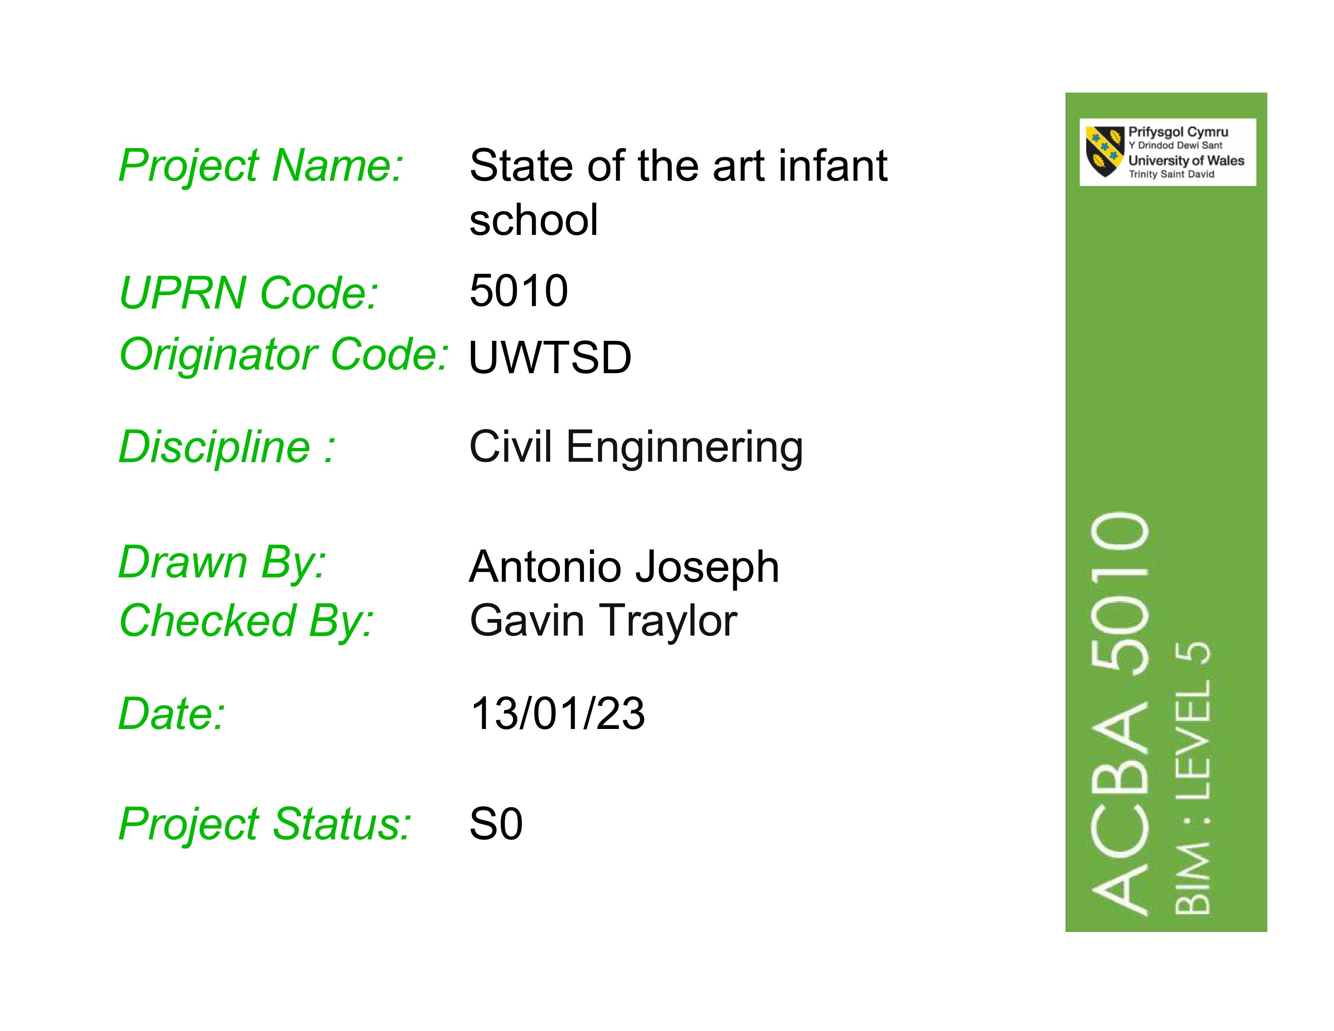

Table of contents

Letter
1 Level of information need…………………………………………………………………………………………………………………….1
  - Level of detail…………………..…………………………………………………………………………………………………………..2
  - Method of demonstrating Level of information need…………………………………………………………………..3

Development across project stages…………………..……………………….……………………………………………………………4

LOD Banding……..…………………………………………………………………………………………………………………………………….5

References………………………………………………………………………………………………………………………………………………6

Antonio Joseph
Coconut Dumplin Construction
College street, Lampeter
Ceredigion, UK, SA48 7Ed
+44 7551 344687

December 21st, 2022

Carmarthenshire County Council
County Hall, Castle Hill
Carmarthen, SA31 1JP
Subject: The explanation of BIM Maturity and how information will be coordinated shared and managed using international standard and the use of BEP.
Dear Sir/Madam
We understand the importance of achieving BIM maturity for this project and the need to ensure that the information is shared, coordinated and managed according to the appropriate international standards. To facilitate this process, we recommend the implementation of a BIM Execution Plan (BEP).
The BIM maturity model defines phases of development in terms of the capacity of the building supply chain to operate and share information. It is a collaborative system that aids industry professionals in the design, delivery, and management of assets across their entire project life cycle. BIM is a method of defining the elements of a structure that allows partners to exchange knowledge from conception through destruction and construction.
There are many levels of collaboration in a construction project. These are known as BIM mature levels. The collaboration between the different stakeholders develops as we advance through the levels. There are presently four distinct levels of BIM maturity.
- Level 0 BIM
Level 0 projects use paper-based 2D CAD drawing techniques and discourages collaboration. The main objective is to produce production Information on paper or digitally. This level is obsolete and no longer in use.
- Level 1 BIM
Level 1 BIM includes the use of both 3D CAD and 2D drawing. While 2D CAD is used to develop production information and legal permission documents, 3D CAD is utilised for conceptual work. At this level, the contractor-managed common data environment (CDE) is utilised for electronic data exchange. The British standard (BS 1192:2007) control CAD standards.

- Level 2 BIM
For public sector projects, the UK government requires Level 2 BIM. This level promotes teamwork by giving each member their own 3D CAD model. All parties work on their own local 3D CAD models, and data is exchanged via a common file format. Combining external data with an organization's own model can result in a federated BIM Model.
- Level 3 BIM
The Level 3 idea allows all participants to work on the same model at the same time, removing the possibility of contradictory information. Level 3 suggests using an integrated solution based on open standards such as IFC (Industry Foundation Classes), with a single server storing all project data.
We will be in cooperating Level 2 BIM in the joint venture with the Welch government in the delivery of a ‘state of the art’ infant school in Carmarthen. Since every new construction development project needs a BIM Execution Plan when working on a project where collaboration is crucial, it becomes much more important. It guarantees that reliable information is available at all times and at all interfaces.
The BIM Execution Plan, also known as BEP or BxP, is created both before and after the contract and is established in direct response to the Employer's Information Requirements (EIR). The project deliverables specified under the contract and the information exchange requirements specified in a BIM protocol will be described in full by BEP.
To achieve BIM compliance, we must meet certain standards before to construction, during the design-build process, and at handover. These standards are briefly explained below.
Pre- Construction stage
- Understanding and following the BIM Protocol
Every government contract includes a legal addendum known as the BIM protocol, which outlines the BIM requirements for that specific project. If one wants to work on that specific project, it must be understood that the requirements described in this protocol and be able to abide by them.
- The creation of a project plan
It is typically better to start from the beginning, which in the case of BIM Level 2 is achieved by responding to the Employer's Information Requirements (EIR). You must construct a BIM Execution Plan (BEP), a Master Information Delivery Plan (MIDP), and a Task Information Delivery Plan (TIDP) to do this (TIDP). These plans will offer a scheme for project deliverables, a work schedule to follow, and everyone's roles and duties at each step of the project.

The design to construct stage
- Collaboration and Coordination
Team members will need to store, manage, and communicate complex information throughout the life cycle of a project; for this, CDE or Common Data Environment is utilized. This is a shared workspace where all project team members may store and manage all project-related data, because this single storage point is intended to help manage the whole project development process.
- Data security
BIM Level 2 includes the PAS 1192-5 standard, which solves all security concerns for securely transmitting project data between the project and the client.
- Using COBie in the project
Construction Operations Building Information Exchange is known by the abbreviation COBie. During the course of the building process, non-graphical data may be kept, shared, and updated on what is frequently portrayed as a central spreadsheet. This may then be given to the client so they can aid in the upkeep and management of the facility. It can also be used to verify that your data fulfils the requirements of the project.
Handing over stage
- Passing on adequate information
Any necessary project data, including an Asset Information Model created throughout each phase of the information delivery cycle will be provided to the client at the conclusion of the construction project. This need to have all the data needed to help staff members in charge of running and maintaining the facility do their duties more efficiently.
- Smooth handovers
A facility operating team must be involved from the start of the project and should receive on going assistance for a predetermined period after handover, according to the UK government's soft landings policy. By incorporating them in the project from the start, they will become familiar with the building inside and out as they will be the ones to administer and maintain it after it is finished.
This is simply a brief overview of BIM maturity requirements, including specifications on how information would be shared, coordinated, and managed with BIM Level 2, as well as what would be required to achieve BIM Compliance and the use of a BEP.
We look forward to working with you to ensure the successful implementation of BIM on this project and to help you realize the full potential of BIM on your project.

……………………………………………………….
Coconut Dumplin Construction

1 Level of information need
The success of every project relies on having the right amount of information available and at the right level of detail. We have to consider the specific objectives of each project to decide what information is necessary, as this can range from geometric data, numerical data, to comprehensive documentation. By following a set of guidelines defined in BS EN ISO 19650:2018, we can make sure we have the right information to deliver successful projects.
To ensure that we are creating the best possible end result with minimal wasted effort, it is important that everyone is on the same page when it comes to the level of detail that is required at each stage of the design process. We need to consider risk, responsibility, delegation, and collaboration in order to make the most out of our efforts.
There are two metrics that are commonly used to measure the amount of information needed in a given situation: Level of Detail (LOD) and Level of Information (LOI). When taken together with the purpose of the information, this forms an overall level of information requirement.
Level of detail (LOD): The digital Plan of Work (dPoW) stages range in graphical detail starting conceptually (LOD2), progressing to generic representations (LOD3), then becoming more specific to match the geometry of an element or product (LOD4), and finally including supporting detail to support construction and installation (LOD5).
Level of Information (LOI): As you progress from initial outline description (LOI2) to performance criteria (LOI3) to specifications of the elements/products (LOI4) to associated (child) products (LOI5), and finally to installation and maintenance information (LOI6), your understanding of the process will become more and more in-depth.

1.1 Level of detail
Planning a project doesn't have to be a daunting task! The Royal Institute of British Architects (RIBA) has created a step-by-step approach to design which can help make the process easier. Their Plan of Work, updated in 2020, breaks projects into 8 stages, such as 'Concept Design', 'Spatial Coordination' and 'Technical Design', so you can make sure you don't miss anything important.
Building projects can be a complex process, but the RIBA Plan of Work helps break it down into easy-to-follow steps. The RIBA Plan of Work is designed to help clients and project team members alike understand the key tasks that need to be completed at each stage of a project, from briefing and design through to construction, handover and use with specific outcomes, tasks and information exchanges for each. In addition to setting out the outcomes of each stage, the Plan of Work also highlights how different priorities (known as Project Strategies) progress through the various RIBA stages. This makes it an essential point of reference throughout the project lifecycle.
As a project develops the information changes and evolves to reflect the design decisions being made. At its most basic, there are two types of information being managed: non-graphical, which includes text data from manufacturers (specification outputs, product content, performance characteristics, etc.) and client requirements; and graphical, which often involves 3D model environments with plans, elevations, sections and detailed drawings. Ultimately, clients will procure a building asset, as well as a wealth of digital information for future use.

1.2 Method of demonstrating levels of information
It's really important to make sure you define the project deliverables accurately, but ten years ago, when UK firms were trying to figure out how much data to include for each stage of the project in their contracts, they had a lot of different methods. They often described their design responsibility matrices with standards from the US, like the AIA E202 BIM Protocol or US BIM Forum Level of Development bands. But these weren't tailored to typical UK projects or procurement. That's why people started to suggest breaking the LOD definitions into two separate bands, one for geometric detail and one for related info.
The platform enables users to record the progress of the project and to indicate what information is necessary for each building system. This allows users to provide feedback on what has been completed and to record the amount of information necessary for each step of the process. This makes it easier for the client and project team to know what has been done and what still needs to be completed.
NBS worked in partnership with industry to create the BIM Toolkit, as part of a project sponsored by Innovate UK. With a clear structure for the data to be documented and shared with other project stakeholders, it is a collaborative platform that enables users to record the current work stage of the project and to indicate the amount of information necessary for each building system. The platform not only allowed users to record that outputs had been given before moving on, but it also allowed the client and project team to specify who was in responsibility of the information. Requirements were recorded at each level, making it easy to keep track of what still needs to be done.
The Toolkit is set up to help recognize the difference between graphical and non-graphical information, providing categories to give an idea of how much data is needed for each step. As you focus on creating a model environment, it is helpful to keep in mind that not all data is contained within the model itself. Much of the non-graphical information related to the model is in the specification, preliminaries or product test reports. By thinking about LOD and LOI together, you can engage more fully with the model and ensure that all relevant information is taken into account.

Development across project stages
As the project progress, the details become more intricate and visually impressive. With a 3D model environment, plans, sections, elevations, images, and details can all be captured and used to generate accurate cost, pricing, and quantity information. Keeping up with the changing requirements, the latest information, and client preferences brings a sense of dynamism to the design work, from the early sketches to the final touches.
The goal is to always give the right level of detail at every stage of the project, based on what is needed and who is responsible for what. Too much detail (for example, a model object made to be fabricated with precision, provided by manufacturers or project teams too early on) can be a waste of time, effort, and computing resources. Just like you wouldn’t expect a complete and specific description at an early stage if only a general overview of performance was needed for a contractor-designed part of the job, each part of the model should be given a level of detail that is appropriate to the stage of the project and how it relates to other systems.
Clients are procuring not only a physical asset but also data, usually in a digital format. As the project progresses, the quantity and detail of data being acquired increases. For example.
There may be a requirement for spaces and activities at an early strategic briefing stage. This will be developed into the design intent of elements/systems to meet the Employer’s Information Requirements (EIR) at concept stage. This is then further developed at design stage when considering the characteristics of each deliverable in terms of performance requirements; this could relate to security requirements of a plant room space, an external wall element or a door set system. At technical design stage, or at least prior to construction, product selection can be determined by the specifier or delegated as ‘contractor’s choice’ based upon generic product performance requirements.

LOD Banding
In order to help the responsible team or organization with their next project, we've prepared a table that outlines the data you'll need at each work stage. This way, you'll always have the information you need to make the best decisions.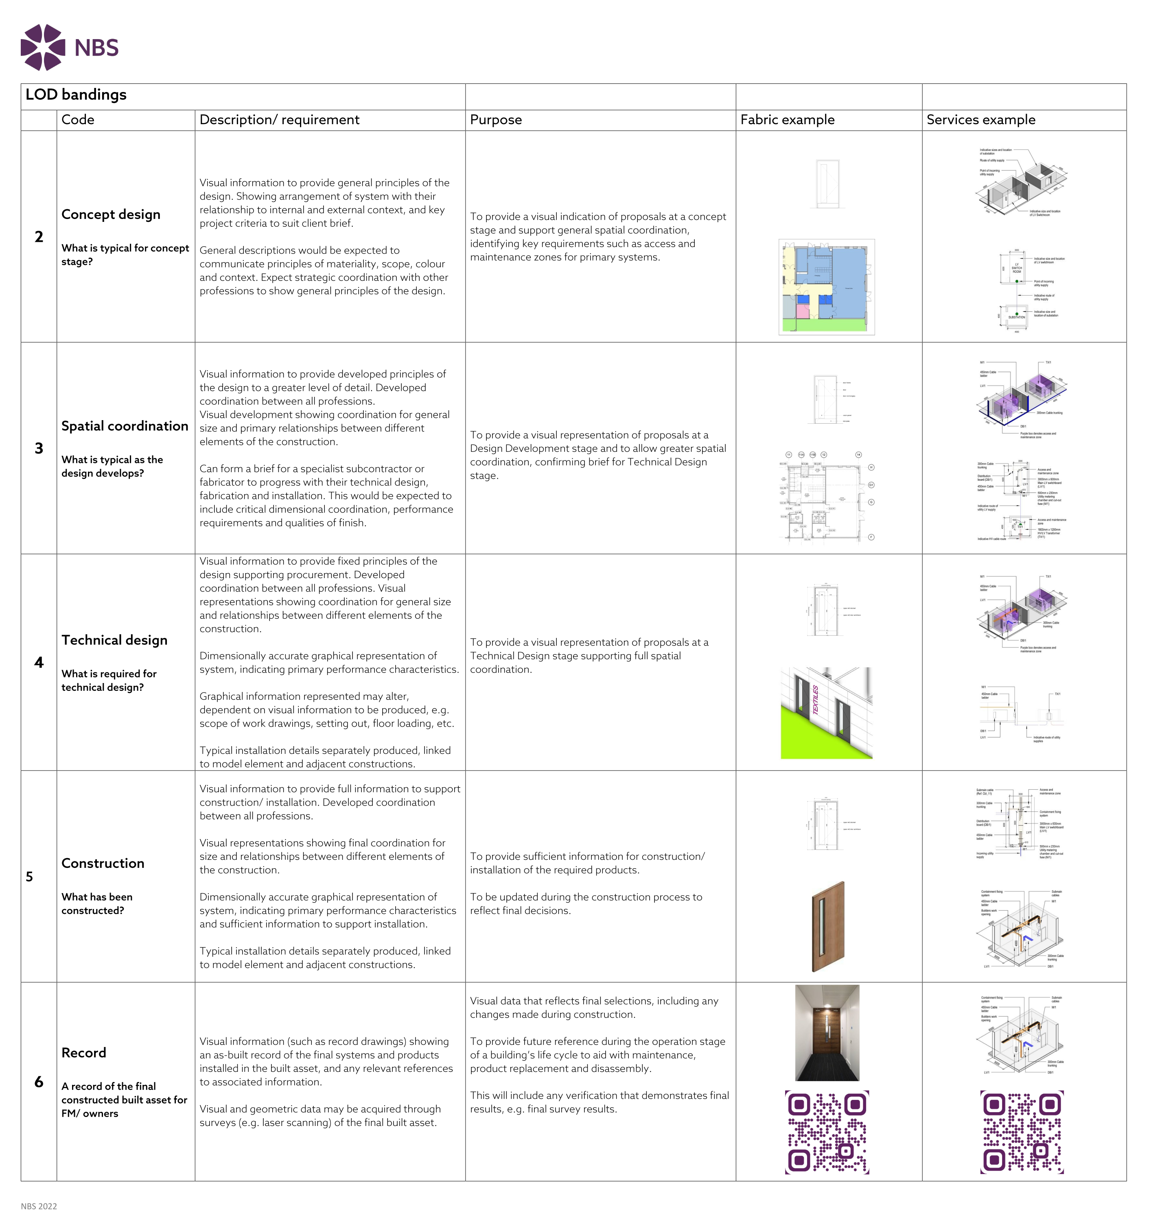
Source: NBS 2022 - https://www.thenbs.com/knowledge/level-of-detail-lod-and-digital-plans-of-work
References
Bahar, U. (2020). How to Use RIBA 2020 Plan of Work: RIBA Design Stages Explained. [online] Urbanist Architecture - London Architects. Available at: https://urbanistarchitecture.co.uk/riba-plan-of-work-stages/ [Accessed 1 Jan. 2023].
Dan (2016). PLQ1.5 – Level of Definition. [online] There’s no BIM like home. Available at: https://bimblog.house/2016/05/09/plq1-5-lod/ [Accessed 12 Jan. 2023].
Marshall, L. (2018). The RIBA Plan of Work: Eight Key Project Stages Explained. [online] NOVO. Available at: https://www.novo.eu.com/post/the-riba-plan-of-work-eight-key-project-stages-explained [Accessed 1 Jan. 2023].
McPartland, R. (2017). What is a BIM Execution Plan (BEP)? [online] NBS. Available at: https://www.thenbs.com/knowledge/what-is-a-bim-execution-plan-bep [Accessed 23 Dec. 2022].
Mordue, S. (2015). BIM Levels of Information. [online] NBS. Available at: https://www.thenbs.com/knowledge/bim-levels-of-information [Accessed 9 Jan. 2023].
RIBA work stages explained — Archisoup | Architecture Guides & Resources (2019). Archisoup | Architecture Guides & Resources. [online] Archisoup | Architecture Guides & Resources. Available at: https://www.archisoup.com/riba-work-stages-explained [Accessed 27 Dec. 2022].
Room, T.C. (2017). BIM Compliance: Are You Ready for BIM Level 2 | BIM Compliance. [online] The CAD Room. Available at: https://www.thecadroom.com/bim-compliance-ready-bim-level-2/ [Accessed 23 Dec. 2022].
Rossana (2017). Maturity Model and BIM Levels. [online] Trace Software. Available at: https://www.trace-software.com/elec-calc-bim-maturity-model-and-bim-levels/#top [Accessed 21 Dec. 2022].
Siresiya, V. (n.d.). BIM Execution Plan (BXP/BEP)- What, Why, When and How | United-BIM. [online] https://www.united-bim.com/bim-execution-plan-bep-guide-for-successful-bep-design-and-execution/. Available at: https://www.united-bim.com/bim-execution-plan-bep-guide-for-successful-bep-design-and-execution/ [Accessed 22 Dec. 2022].
Swaddle, P. (2022). Level of detail (LOD) and digital plans of work. [online] NBS. Available at: https://www.thenbs.com/knowledge/level-of-detail-lod-and-digital-plans-of-work [Accessed 9 Jan. 2023].
United BIM (2019). BIM Maturity Levels Explained- Level 0 | 1 | 2 | 3 | United-BIM. [online] United-BIM. Available at: https://www.united-bim.com/bim-maturity-levels-explained-level-0-1-2-3/ [Accessed 21 Dec. 2022].

