Component 1
RAZIA BEGUM 2217307
Module: Population Health and Digital Health Promotion
Module code: LCHS7009
Lecturer: Dr Besty Jose

2026

Content

Blog 1………………………………………………………………...2-4
Reference list……………………………………………………….5-6
Blog 2………………………………………………………………...7-8-9-10
Reference…………………………………………………………….11-12-13

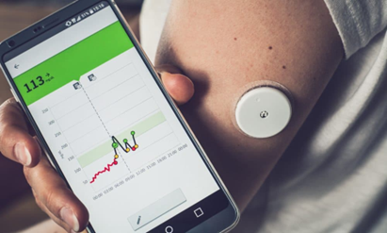(Health Tech World, 2025)
Blog 1
The Impact of Digital Technology

in Diabetes Health Promotion:

A Critical Perspective

🕒 3rd March 2026 📄 Article 1 👁️ Leave a comment 0 Author Razia Begum
Introduction
Digital innovation is reshaping chronic disease prevention, particularly for Type 2 diabetes, which makes up 90% of all diabetes cases. In the UK, over 4.3 million people are affected, putting major strain on NHS services (WHO, 2021; Diabetes UK, 2022) and remain closely linked to obesity, inactivity, and socioeconomic inequality (Diabetes UK, 2022). Wearable and implantable continuous glucose monitoring systems offer real‑time data, trend alerts, and reduced need for finger‑prick testing, supporting earlier behavioural insight and more responsive self‑management (Beck et al., 2017). While these technologies enhance awareness, their benefits depend on equitable access and integration within wider prevention strategies.
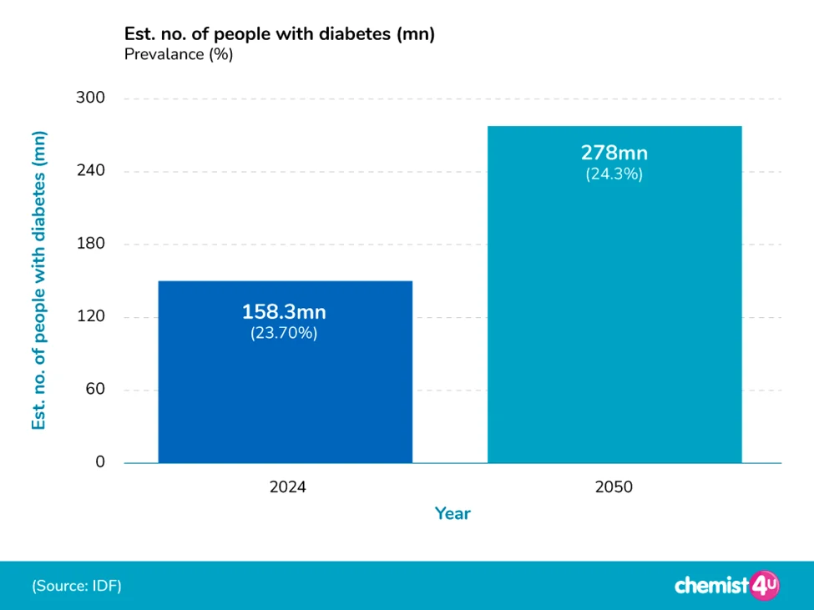 (UK Diabetes Statistics,2026)
CGM and Health Promotion Theory
Continuous glucose monitoring (CGM) devices use wearable sensors and smartphone apps to deliver real‑time glucose feedback, helping users recognise how daily behaviours influence glycaemic control (Barchiesi et al., 2025; Beck et al., 2017). While CGM extends biomedical monitoring, health promotion frameworks such as the Ottawa Charter emphasise empowerment and participation rather than technology alone (WHO, 1986; Greenwood et al., 2017). CGM also aligns with the Health Belief Model, which suggests that behaviour change occurs when individuals perceive risk and recognise the benefits of action (Rosenstock, 1974; Jancev et al., 2024). True empowerment, however, requires equitable access and supportive environments.
I love my CGM for its convenience. I am busy with work during day where I don’t get much time, with a CGM I can monitor my blood sugars more closely (Goddess, 2023).
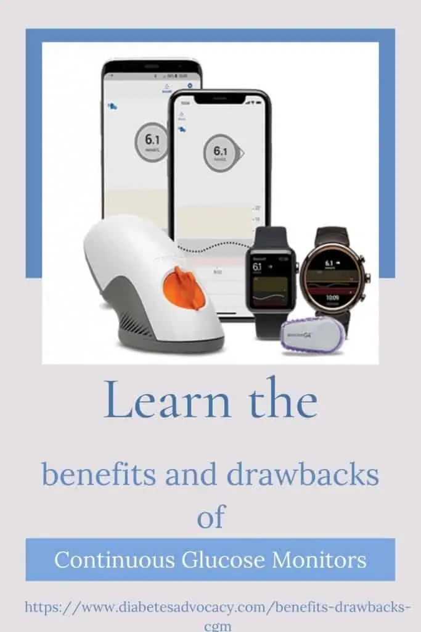

Behaviour Change and Real- World Experience
Sustained change relies on capabilities, opportunities, and motivation shaped by social context. CGM increases awareness but does not address wider determinants such as food access, income, or healthcare support (Greenwood et al., 2017). Patients like Sophie who began using CGM with NHS and telehealth support report better understanding and control. With guidance, she adapted her lifestyle, improved her HbA1c, and gained confidence (see more at: https://www.diabetes.org.uk/your-stories/sophie-cgm-life-changing) (Foster et al., 2019). These outcomes prompt reflection on whether such digital solutions are accessible to all.
Equity and Digital Divide
Equity is crucial: digital literacy, smartphone access, and socioeconomic status, still limit who benefits from CGM and related technologies (Greenwood et al., 2017). Those from disadvantaged communities are most at risk of diabetes-related complications often face the greatest barriers to digital innovation. These risks widen existing health inequalities rather than reducing them. Addressing these issues leads to practical considerations and opportunities for improvement.
Practical Challenges and Opportunities
Self-tracking can cause anxiety or information overload, and its long-term benefits depend on ongoing education and support technology alone is often insufficient to drive meaningful population-level change (Jancev et al., 2024; NHS England, 2021). Professional input remains essential for CGM's effectiveness. These challenges and opportunities shape the future direction of health promotion practice.

(Diabetes in Control, 2025)
Implications for Health Promotion Practice
A critical approach embeds CGM within broader strategies such as culturally tailored education, digital literacy, and telehealth to align with health promotion priorities. Integrating these elements not only supports individual empowerment but also addresses systemic barriers, making digital health more inclusive and sustainable (Greenwood et al., 2017; WHO, 2021).
  Scan for Further Reading

References
Beck, R.W., Riddlesworth, T., Ruedy, K., et al. (2017). Effect of continuous glucose monitoring on glycaemic control in adults with type 1 diabetes using insulin injections: the DIAMOND randomised clinical trial. JAMA, 317(4), pp.371–378. Available at: https://jamanetwork.com/journals/jama/fullarticle/2598770 (Accessed: 27 February 2026).
Diabetes UK (2021). Sophie’s story: my CGM has been life changing. Available at: https://www.diabetes.org.uk/your-stories/sophie-cgm-life-changing (Accessed: 26 February 2026).
Diabetes UK (2022). Diabetes prevalence 2022. Available at: https://www.diabetes.org.uk/professionals/position-statements-reports/statistics/diabetes-prevalence-2022 (Accessed: 26 February 2026).
Diabetes in Control (2025) Digital illustration of a person using a continuous glucose monitor (CGM) with mobile‑supported diabetes self‑management tools. Available at: https://www.diabetesincontrol.com/for-your-practice/for-your-patients/ (Accessed: 25 February 2026).
Barchiesi, M.A., Calabrese, A., Costa, R., Di Pillo, F., D'Uffizi, A., Tiburzi, L. and Zahid, E. (2025) ‘Continuous glucose monitoring in type 2 diabetes: a systematic review of barriers and opportunities for care improvement’, International Journal for Quality in Health Care, 37(3), mzaf046. Available at: https://pubmed.ncbi.nlm.nih.gov/40338639/ (Accessed: 25 February 2026).
Greenwood, D.A., Gee, P.M., Fatkin, K.J. and Peeples, M. (2017). A systematic review of reviews evaluating technology-enabled diabetes self-management education and support. Journal of Diabetes Science and Technology, 11(5), pp.1015–1027. Available at: https://journals.sagepub.com/doi/10.1177/1932296817713506 (Accessed: 25 February 2026).
Goddess (2023) 'Amazing benefits and drawbacks of CGM,' Diabetes Advocacy, 16 October. Available at: https://www.diabetesadvocacy.com/benefits-drawbacks-cgm/ (Accessed: 26 February 2026).
Health Tech World (2025) The role of digital technology in diabetes prevention and management. Available at: https://www.htworld.co.uk/news/medtech/the-role-of-digital-technology-in-diabetes-prevention-and-management/ (Accessed: 24 February 2026).
NHS England (2021). Flash glucose monitoring: National update. Available at: https://www.england.nhs.uk/diabetes/flash-glucose-monitoring/ (Accessed: 26 February 2026).
UK Diabetes Statistics (2026). Available at: https://www.chemist-4-u.com/guides/diabetes/diabetes-statistics/ (Accessed: 26 February 2026).
Jancev, M., Vissers, T. A. C. M., Visseren, F. L. J., van Bon, A. C., Serné, E. H., DeVries, J. H., de Valk, H. W., & van Sloten, T. T. (2024) Continuous glucose monitoring in adults with type 2 diabetes: a systematic review and meta-analysis. Diabetologia, 67(5), 798–810. Available at: https://pmc.ncbi.nlm.nih.gov/articles/PMC10954850/ (Accessed: 28 February 2026).
World Health Organization (WHO) (1986). Ottawa Charter for Health Promotion. Available at: https://www.who.int/teams/health-promotion/enhanced-wellbeing/first-global-conference (Accessed: 26 February 2026).
World Health Organization (WHO) (2021). Diabetes. Available at: https://www.who.int/news-room/fact-sheets/detail/diabetes (Accessed: 26 February 2026).

Blog 2
(Suresh, 2023)
GlucoGuide+: An AI-Driven Continuous Glucose Monitoring Intervention
Introduction: The Public Health Problem

🕒 3rd March 2026 📄 Article 2 👁️ Leave a comment 0 Author Razia Begum

Type 2 diabetes is a leading public health challenge affecting over 422 million people worldwide, with rising prevalence driven by obesity, sedentary lifestyles, and socioeconomic factors (WHO, 2024). In the UK, about 4.6 million people live with diabetes (Diabetes UK, 2023), straining NHS resources and widening health inequalities (NHS England, 2025). Traditional prevention, focused on education and lifestyle advice, often struggles to support lasting behaviour change (Nguyen et al., 2024), underscoring a need for scalable digital interventions.
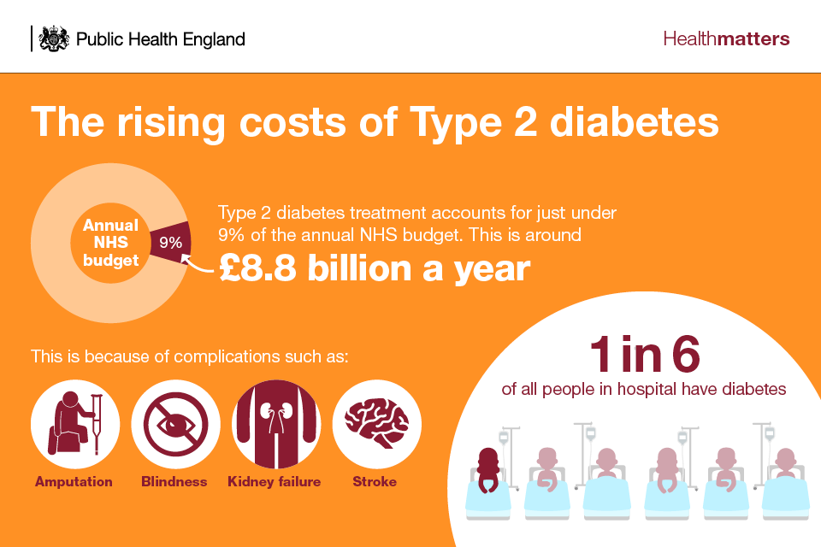
(Health Matters, 2018)

Designed Digital Technology: GlucoGuide+

GlucoGuide+ is a designed digital health promotion intervention that builds upon existing continuous glucose monitoring (CGM) technology by integrating:
- Real-time glucose monitoring
- Artificial intelligence (AI) behavioural coaching
- Culturally tailored lifestyle guidance
- Peer-support communities
- Clinician-linked dashboards
Unlike standard CGM systems, which primarily display glucose data, GlucoGuide+ translates physiological feedback into actionable guidance for health promotion. Similar NHS-supported CGM devices can be explored here: https://www.nhs.uk/tests-and-treatments/cgm-and-hcl-for-diabetes / (NHS, 2025).

Health Promotion Application

GlucoGuide+ lets users take control by managing health through self-management and prevention. Continuous biofeedback links lifestyle choices to glucose, boosting awareness (Turnbull et al., 2020; Welsh et al., 2019). The platform operationalises the COM-B model through clearly aligned features: personalised educational modules within the app directly enhance users’ psychological capability by deepening their understanding of diabetes management; real-time digital access to glucose data, combined with integrated peer support, explicitly increases both physical opportunity (by making relevant information readily available for informed action) and social opportunity (by enabling community engagement); finally, AI-driven coaching modules are designed to deliver tailored motivational prompts, targeting the motivation component essential for encouraging sustained behavioural change (Michie et al., 2011).
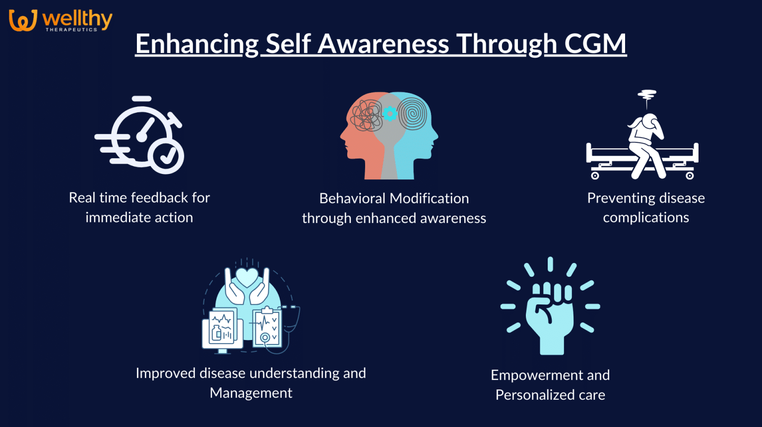
(Pranav, 2024)

Critical Impact: Advantages and Limitations

Digital coaching offers personalised prevention and ongoing support outside clinics. It can scale across NHS populations, improving glycaemic outcomes and physical activity (Hou et al., 2018). However digital inequality restricts access for those lacking digital skills or devices (Greenwood et al., 2017). Over-monitoring can trigger anxiety. Algorithmic bias and poor data controls can undermine ethical standards (NHS Digital, 2021).

Shortfalls

However, limitations remain. Digital interventions risk reinforcing inequalities due to reliance on digital literacy, device access, and internet (Greenwood et al., 2017). Over-monitoring may increase anxiety or shift responsibility to individuals, neglecting structural determinants like food environments and deprivation.

Algorithmic bias could result in less effective advice for some groups, widening health disparities. Data governance concerns include privacy, security, and potential misuse of sensitive information, raising ethical questions about fairness and accountability in AI-driven healthcare (NHS Digital, 2021).

Addressing the Shortfalls

To ensure equitable impact, GlucoGuide+ would incorporate:
- NHS-funded device access for deprived populations.
- Digital literacy training programmes.
- Culturally adapted content design.
- Clinician oversight to prevent over-reliance on automation.
- Transparency auditing of AI algorithms.
Embedding the technology within wider public health strategies ensures digital innovation supports equity-focused health promotion, not just tech-led solutions.
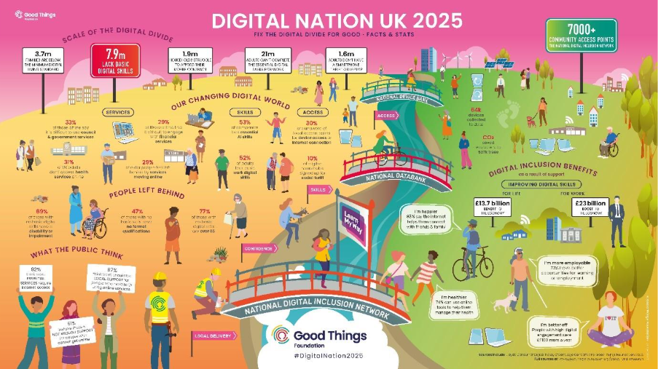
(Digital Nation, 2025)

Conclusion

GlucoGuide+ shows how digital technology can extend diabetes prevention from occasional education to ongoing, personalised support. However, its success relies on ethical use, equitable access, and integration with broader health systems. Digital tools should complement not replace public health approaches.
  Scan for Further Reading
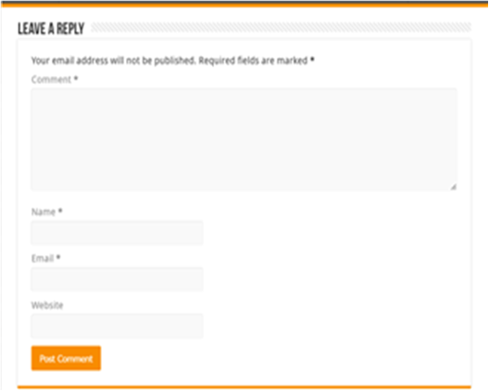

Reference List
Diabetes UK (2023) How many people in the UK have diabetes? Available at: https://www.diabetes.org.uk/about-us/about-the-charity/our-strategy/statistics?gad_campaignid=15219795550&gad_source=1&gbraid=0AAAAAD4IfZUujmZg9Ga0iXHdS3oLKxjVg (Accessed: 25 February 2026).
Digital Nation (2026) The UK’s Digital Divide Good Things Foundation. Available at: https://www.goodthingsfoundation.org/policy-and-research/research-and-evidence/research-2024/digital-nation (Accessed: 23 February 2026).
Turnbull, S., Lucas, P.J., Hay, A.D. and Cabral, C . (2020) 'Digital health interventions for people with type 2 diabetes to develop Self-Care expertise, adapt to identity changes, and influence other’s perception: Qualitative study,' Journal of Medical Internet Research, 22(12), p. e21328. https://doi.org/10.2196/21328 (Accessed: 25 February 2026).
Greenwood, D. A., Gee, P. M., Fatkin, K. J., & Peeples, M. (2017) A Systematic Review of Reviews Evaluating Technology-Enabled Diabetes Self-Management Education and Support. Journal of diabetes science and technology, 11(5), 1015–1027. https://doi.org/10.1177/1932296817713506
Gopinath, N., Sheeba, S., Kariyil, J., Sugathan, N. and Sankar, A. (2024) Evaluation of the antidiabetic activity of Boerhaavia diffusa Q in prediabetic patients: A pilot clinical study, Journal of Complementary Medicine Research, 15(02), pp. 6–10. Available at: https://doi.org/10.5455/jcmr.2024.15.02 (Accessed: 20 February 2026).
Health matters (2018) preventing Type 2 Diabetes. Available at: https://www.gov.uk/government/publications/health-matters-preventing-type-2-diabetes/health-matters-preventing-type-2-diabetes (Accessed: 24 February 2026).
Hou, C, Xu, Q, Diao, S, Hewitt, J, Li, J & Carter, B. (2018) 'Mobile phone applications and self-management of diabetes: A systematic review with meta-analysis, meta-regression of 21 randomized trials and GRADE', Diabetes, Obesity and Metabolism, vol. 20, no. 8, pp. 2009-2013.Available at: https://doi.org/10.1111/dom.13307 (Accessed: 24 February 2026).
Michie, S., Van Stralen, M.M. and West, R. (2011) 'The behaviour change wheel: A new method for characterising and designing behaviour change interventions,' Implementation Science, 6(1), p. 42. Available at: https://pubmed.ncbi.nlm.nih.gov/21513547/ (Accessed: 28 February 2026).
National Health Service (2025) Continuous glucose monitoring and hybrid closed loop for diabetes. Available at: https://www.nhs.uk/tests-and-treatments/cgm-and-hcl-for-diabetes/ (Accessed: 27 February 2026).
National Health Service Digital (2021) Artificial Intelligence: How to Get it Right. Available at: https://digital.nhs.uk/blog/transformation-blog/2020/regulating-ai-in-health-andcare#:~:text=Matthew%20Gould%2C%20CEO%20of%20NHSX,and%20what%20the%20plan%20is.&text=Artificial%20Intelligence%20(AI)%20holds%20enormous,on%20both%20standards%20and%20roles (Accessed: 27 February 2026).
National Health Service England (2025) Healthcare Inequalities Improvement Programme and NHS Race and Health Observatory (RHO): End of year report. Available at: https://www.england.nhs.uk/long-read/healthcare-inequalities-improvement-programme-and-nhs-race-and-health-observatory-rho-end-of-year-report/ (Accessed: 28 February 2026).
Nguyen, V., Ara, P., Simmons, D. and Osuagwu, U.L. (2024) ‘The role of digital health technology interventions in the prevention of type 2 diabetes mellitus: A systematic review’, Clinical Medicine Insights: Endocrinology and Diabetes, 17, pp. 1–11. Available at: https://pubmed.ncbi.nlm.nih.gov/38779330/ (Accessed: 27 February 2026).
Pranav. (2024) The role of continuous glucose monitoring (CGM) in behavioral interventions for diabetes management – Wealthy Therapeutics. Available at: https://www.wellthytherapeutics.com/blog/the-role-of-continuous-glucose-monitoring-cgm-in-behavioral-interventions-for-diabetes-management/ (Accessed: 21 February 2026).
Suresh, D. (2023) Can AI Really Change Daily Life with Diabetes? Available at: https://www.xcode.life/genes-and-ai/ai-diabetes-care-prevention-treatment/ (Accessed: 27 February 2026).
Welsh, J. B., Gao, P., Derdzinski, M., Puhr, S., Johnson, T. K., Walker, T. C., & Graham, C. (2019) Accuracy, Utilization, and Effectiveness Comparisons of Different Continuous Glucose Monitoring Systems. Diabetes technology & therapeutics, 21(3), 128–132. Available at: https://pubmed.ncbi.nlm.nih.gov/30681379/ ( Accessed: 26 February 2026).
World Health Organization: WHO (2024) Diabetes. Available at: https://www.who.int/news-room/fact-sheets/detail/diabetes (Accessed: 27 February 2026).

