CertHE Computing Skills for Workplace
ACCA4026 Software Solutions for Business
Component 1 – Coursework Portfolio
Evaluation and Practical Application of Software Solutions Supporting Modern Business Operations

Student Name: Sozear Kame Ran Rasheed
Student ID: 2541951
Submission Date: 20th July 2026
Table of Contents
Introduction 4
TASK 1: e-Commerce Website Builders / Software Solutions 4
1.1 Introduction to e-Commerce Website Builders 4
1.2 Shopify Analysis 4
1.3 WooCommerce Analysis 5
1.4 Comparison and Evaluation 6
TASK 2: Mind Mapping of Contemporary Software Applications 7
2.1 Understanding Mind Mapping 7
2.2 Benefits of Mind Mapping in Business 7
2.3 Business Software Mind Map 7
TASK 3: Office Applications for Business Operations 9
3.1 Microsoft Word 9
3.2 Microsoft PowerPoint 10
3.3 Microsoft Excel 12
3.4 Microsoft Access 13
3.5 Practical Excel Testing Evidence 14
TASK 4: Communication and Collaboration Applications 22
4.1 Microsoft Teams – Communication Application 22
4.2 Google Workspace – Collaboration Application 23
4.3 Practical Testing Evidence 24
Conclusion 27
References 29

List of Figures
Figure 1: Mind Map 8
Figure 2: Raw employee performance dataset in Microsoft Excel 16
Figure 3: IF Function formula applied in Excel 17
Figure 4: Final employee performance output 17
Figure 5: Retail sales dataset before Pivot Table creation 19
Figure 6: Pivot Table configuration and selected fields 20
Figure 7: Completed Pivot Table showing sales analysis 21
Figure 8: Microsoft Teams meeting creation interface 25
Figure 9: Microsoft Teams chat communication feature 26
Figure 10: Google Docs shared editing feature 27

List of Tables
Table 1: Comparison and Evaluation 6
Table 2: Dataset 15
Table 3: Dataset 18

Introduction
Modern organizations have realised that software solutions have become important entities because they facilitate efficient operations, enhance productivity and facilitate digital transformation. The increased consumption of digital technologies has transformed the systems of information management applied by businesses, methods of communication with the employees and customers and decision-making strategy [1]. This portfolio will evaluate how the operations in the workplace can be conducted using different software applications in order to manage workflows, data, collaboration, and business intelligence. Shopify and WooCommerce have been chosen as e-commerce systems, Microsoft Office as the information-generating and analyzing application, Microsoft Teams as the communication solution, and Google Workspace as a collaboration solution. Nonetheless, with all the advantages, organizations have to pay attention to the challenges, such as the implementation cost, cybersecurity threats, training needs of employees, and interoperability of the systems to ensure success during technology adoption.

TASK 1: e-Commerce Website Builders / Software Solutions

1.1 Introduction to e-Commerce Website Builders
E-commerce site creators are computer-based software systems designed to help companies store, run and operate online stores without necessarily knowing complex programming languages. These platforms are getting more crucial with the emergence of the rising digital marketplaces and emerging consumer buying patterns [2]. They facilitate online selling by allowing online sellers to manage products, process payments, communicate with customers and automate the transactions, thus enhancing efficient operations and enabling the business to access more customers.

1.2 Shopify Analysis
Shopify is an online merchant platform that provides companies with the ability to innovate and run internet stores using a convenient online platform. It works with organizations of all scales, such as small start-ups to large corporations, offering tools that make it easier to develop the site and to manage the online retail without the need to know more than rudimentary coding. Shopify provides pre-professionally designed templates, customization and mobile-friendly layouts that enable businesses to build attractive and easy-to-use online stores. Its business management options encompass product catalogues, inventory management, order management and integrated payment processing that assists in running a business every day efficiently. Also, Shopify gives out analytics services that create sales and customer insights and enable organizations to comprehend purchasing behavior and enhance decisions.
The platform is very advantageous to businesses as it allows a business to reach out into the market within a short time, with less reliance on technical expertise, enhancing the customer experience, and sustaining the business by being scalable [3]. In turn, limitations are recurring subscription fees, discrepant advanced customization with more advanced systems, and reliance on the Shopify ecosystem, which can pose a challenge to companies that need a lot more control and flexibility.

1.3 WooCommerce Analysis
WooCommerce is unpaid e-commerce extension built on WordPress websites that allows companies to convert existing websites to be fully operational online shopping stores. Small and medium-sized enterprises, especially, find it especially attractive because of the affordability, flexibility and the potential to blend with the rest of the WordPress environment [4]. The platform offers critical functionalities such as product management, inventory management, payment, order processing and website customization. Its large ecosystem of plugins has enabled businesses to integrate other features like marketing, customer management or powerful analytics as per their needs.
WooCommerce has good benefits that include high customization, reducing upfront pricing and developers and users have good community support. WooCommerce is, however, not as user-friendly, though more tech-savvy than fully managed platforms where the business holds the responsibility of hosting as well as maintaining, updating and security management of the websites. These roles can pose some difficulties to organizations that have low technical capability.

1.4 Comparison and Evaluation
Table 1: Comparison and Evaluation
Feature | Shopify | WooCommerce
Ease of use | High | Medium
Customisation | Medium | High
Cost | Subscription-based | Hosting-based
Technical skill required | Low | Higher
In general, Shopify is better suited to enterprises that need an easy, scalable system that needs fewer involvement in the technical aspect, whereas WooCommerce is more appropriate to organizations that need to have more control, flexibility, and customization. It will be dependent on the size of the business, the technical capacity and the needs of operations.

TASK 2: Mind Mapping of Contemporary Software Applications

2.1 Understanding Mind Mapping
Mind mapping is a graphical method of structuring information in which ideas, concepts and relationships are depicted in the form of a well-defined diagram. It puts a key issue in the center, and related issues branch off, and they enable information to be comprehended more effectively and efficiently. Mind maps aid the planning process in a business setup as they assist the teams to plan activities, resources and their goals [5]. They promote creativity as employees can create and relate new ideas in new ways, and contribute to strategy development by introducing an alternative evaluation of the business goals. Also, the use of mind mapping leads to knowledge management as it enables organizations to develop, store and share valuable information efficiently with their teams.

2.2 Benefits of Mind Mapping in Business
Mind mapping offers several advantages to the running of a business as it enhances the way information is organized, communicated and analysed. Project managers can also analyze objectives, allocate resources, identify project tasks and track project requirements using mind maps in planning activities. Another way they enhance communication is by formulating the complex ideas in a visual form, whereby the teams can get to know the relationship between different concepts. To make decisions, managers can make comparisons of the available options, assess the outcomes and find solutions systematically. Additionally, mind mapping facilitates the dissemination of knowledge as the employees can record, store and share organizational knowledge, which enhances teamwork and retention of essential business information.

2.3 Business Software Mind Map
Central Topic: Contemporary Business Software Applications
The mind map below illustrates the role of various types of software applications in maintaining the operations of a business in current times. Organizations can now participate in virtual meetings, exchange instant messages, and share files via communication software, which reduces the feeling of being physically present at the workplace, such as Microsoft Teams [6]. The collaboration software, such as Google Workspace, facilitates teamwork using Google Docs, Google Sheets, and Google Drive to facilitate the creation, editing and management of information within a team of employees. Data analysis software, such as Microsoft Excel and Power BI, can help organizations to report, calculate, create a dashboard and visualize the data to enable them to make evidence-based decisions. Trello is a project management tool which helps a team to arrange and coordinate work, track its progress and organize it more efficiently. Finally, CRM software, with Salesforce, enables companies to handle the relationship they have with their customers, as well as monitor their sales efforts and improve communication with customers. Together, these kinds of software demonstrate the contribution of digital resources to productivity, cooperation, and business behavioral strategies.
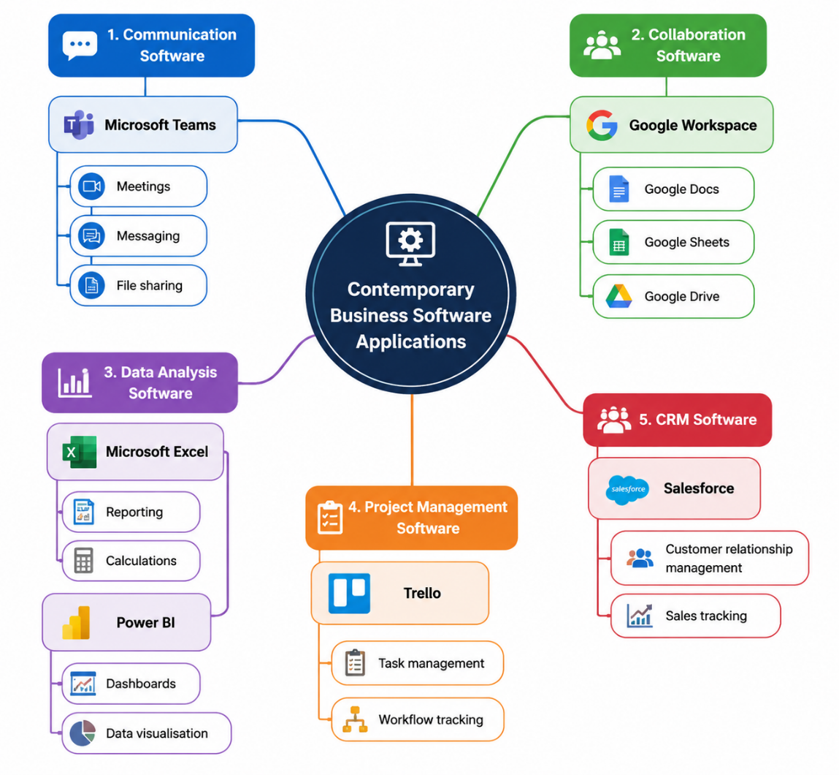
Figure 1: Mind Map

TASK 3: Office Applications for Business Operations

3.1 Microsoft Word
Introduction: Role of Microsoft Word in Business Documentation
One of the applications that many businesses/ organizations use to distribute, create, format and edit professional documents is Microsoft Word [7]. It aids in the communication within the working environment by assisting businesses in generating structured reports, agreements, letters and policies. Its formatting, the presentation of the data and ability to work in collaboration enhance documentation and professional management of the information.
Features of Microsoft Word
Microsoft Word offers numerous features which assist in creating and maintaining business documents efficiently. The formatting tools such as fonts, headings, layouts and styles allow the organizations to create professional and consistent documents. Inimitable in promoting efficiency and savings on time wastage, templates enable the business to develop standardized documents, including reports, letters, invoices and proposals. Tables are used to make structured data, comparisons and schedules more understandable. The mail merge feature allows customized documents by using templates with pre-stored data to communicate with customers and employees.
Business Applications of Microsoft Word
Microsoft Word is applied across various business activities, including:
- Reports: Creating operational reports, research documents, and management summaries.
- Contracts: Preparing formal agreements and business documents.
- Policies: Developing organizational guidelines and procedures [8].
- Letters: Producing professional communication for customers, suppliers, and employees.
Benefits of Microsoft Word
Microsoft Word has some benefits to organizations. It enhances professional communication as it allows businesses to create well-structured documents. Templates and formatting tools are used to attain a standardization that enables consistent branding and presentation. Moreover, Word enhances work efficiency by making it quicker in terms of preparation, editing, and sharing of any document using automatic features and collaboration possibilities.
Limitations of Microsoft Word
Microsoft Word, as beneficial as it may be, is not useful in managing complex databases and large-scale structured information, for which specialized systems prove to be more useful [9]. In addition, a problem of version control can arise whereby numerous users make changes on different copies of a document, leading to confusion and old information. The proper management of documents is thus needed to guarantee precision and uniformity.

3.2 Microsoft PowerPoint
Introduction: Role of Microsoft PowerPoint in Business Presentations
Microsoft PowerPoint is a presentation software tool which allows organizations to create and present information in a structured form, presented in the form of visuals. It assists the business communication process in enabling the users to present ideas, strategies and data to the employees, customers and other stakeholders. PowerPoint is more effective in sharing knowledge; it enhances clarity, engagement and professionalism through the use of text, graphics, charts and multimedia.
Features of Microsoft PowerPoint
Microsoft PowerPoint offers different features that can be used to make good business presentations. Its Slide designing features, including templates, themes and layouts, enable the user to create professional and cohesive presentations, depending on the organization’s branding. Multimedia can be integrated so that it can incorporate images, video and audio to enhance the understanding and interaction between the audiences [10]. Important information might be highlighted by animation and transition effects, and numerical information in a systematic way might be presented by charts and data visualization software to ensure a company can perform an analysis, comparison and make decisions.
Business Uses of Microsoft PowerPoint
Microsoft PowerPoint is used across various business activities, including:
- Training: Organizations use presentations to provide training to their employees, such as workshops and study aids.
- Sales Presentations: Businesses use PowerPoint to present products, services and even proposals to prospective customers.
- Project Updates: Project teams utilize presentations to provide updates to stakeholders on the progress and achievements, challenges and the future.
Benefits of Microsoft PowerPoint
The major strength of PowerPoint is in its enhanced visual communication. The capability to present multifaceted data in terms of images, charts and adequately structured slides can empower businesses to understand others better than using text-related documents alone [11]. It will also enable the presentation to be much more engaging to the audience as it will be more interactive, easier to remember and comprehend. These competencies aid the sharing of knowledge and communication with professionals.
Limitations of Microsoft PowerPoint
Although PowerPoint offers its benefits, it has certain drawbacks also. Inappropriate presentation design, such as too much text, improper graphics or mismatched styles of displaying the message, can lower the effectiveness of communications and have an adverse impact on comprehension by audiences. Moreover, information congestion may arise, where people have utilized excessive content on slides, rendering presentations hard to understand. That is why organizations should pay attention to the definite design principles and selection of the relevant content in order to receive the greatest benefits of PowerPoint presentations.

3.3 Microsoft Excel
Introduction: Role of Microsoft Excel in Business Data Management
Microsoft Excel is a spreadsheet program commonly adopted by organizations to store, manipulate and present business information. It allows calculating and finding the trends, the work of employees and managers, and facilitating decision-making. The analysis capabilities of it enhance efficiency in all finance, operations, marketing and management functions as it can turn raw data into valuable business intelligence.
Features of Microsoft Excel
Microsoft Excel offers very effective and efficient features for managing and analyzing business data. Algorithms facilitate automatic calculations of revenue, cost and performance measures, alleviating the amount of manual work. The functions include SUM, IF and VLOOKUP that assist organizations to analyse data and make precise reports [12]. Charts are used to convert the numerical data into a visual representation so as to be easily interpreted. Pivot Tables are used to summarize extensive volumes of data and determine trends; data analysis tools such as sorting, filtering, and forecasting are used to make evidence-based decisions.
Business Applications of Microsoft Excel
- Financial Analysis: Analyses income, expenses, profitability, and financial performance to support reporting and monitoring.
- Budgeting: Creates budgets, tracks spending, and improves resource allocation.
- Forecasting: Evaluates historical data to predict future trends and demand.
- Performance Tracking: Monitors targets, efficiency, and key performance indicators through dashboards and reports.
Benefits of Microsoft Excel
Microsoft Excel enhances evidence-based decision-making as it enables organizations to familiarise themselves with accurate information and determine insights. Managers can make more informed decisions based on evidence as opposed to assumptions through automated calculations, visual reports and analytical tools. The accuracy of Excel is also enhanced through the minimization of manual calculations and standardization of data processing techniques.
Limitations of Microsoft Excel
Excel has a few limitations in spite of the advantages it possesses. Popular formula errors may arise due to users being wrong in writing the formula or editing complex spreadsheets, which may influence business decisions. Furthermore, Excel can also be restricted by very large datasets since the functionality can slow down, and more powerful database systems can be more appropriate [13]. Hence, organizations should make sure that there are appropriate practices of data management and training of users in case they use Excel to analyze business information.

3.4 Microsoft Access
Introduction: Role of Microsoft Access in Business Data Management
Microsoft Access is an application of database management application that allows organizations to store, organise, manage and search structured information effectively. As opposed to spreadsheet software, Access has support for relational databases, linking various sources of data. It can especially be applied to small and medium-sized companies that need to have organization in record management and enhanced operational effectiveness.
Features of Microsoft Access
Microsoft Access offers some features which assist in the effective management of the database. Tables hold organized data such as customer information, employees and product information and have a connection between various data sets [14]. The queries enable the users to search, filter, analyze and retrieve specific information effectively. Forms are an easy-to-use interface to add and modify data and minimize errors in inputting data. Reports assist organizations in providing reports on database information in a professional style, which they utilize in their decision-making and communication with their stakeholders.
Business Uses of Microsoft Access
The application of Microsoft Access in business has been mainly related to structuring information which is structured.
Customer Databases:
Access is used by businesses in storing and managing the information of the customers, such as their contact details, purchase history and customer interaction. This contributes towards improving customer relations and customer support.
Inventory Records:
Organizations use access databases to trace the products and stock levels, supplier information, as well as inventory movement to help them control inventory better and facilitate efficient operations.
Benefits of Microsoft Access
The major benefit of Microsoft Access is that it has well-structured data management. Businesses are in a position to make proper records and minimize data redundancy by tabulating information related to each other [15]. Access also enhances retrieval of information as users can quickly search, filter and create reports of stored information, aiding in quicker decision-making processes and better control over operations.
Limitations of Microsoft Access
Though Microsoft Access works well with smaller organisations, small businesses find it less scalable than enterprise database systems like Microsoft SQL Server or Oracle Database. Access can potentially be overloaded and less effective with growing data volumes and the number of users. Thus, more complicated database management solutions might be needed in larger organisations, where large amounts of data are needed.

3.5 Practical Excel Testing Evidence
Introduction to Practical Excel Testing
As illustrations of how Excel can be used in business, two functions were put to the test using simulated datasets: the IF Function and the Pivot Table [16]. The tools were chosen because they provide the option to fully automate calculations, performance information analysis with the aid of the identification of trends and can act as evidence-based tools in making decisions, enhancing operational efficiency and decreasing manual data processing.
Feature 1: IF Function – Employee Performance Analysis
Practical Scenario
A scenario of the sales performance of an employee was used to test the IF Function. Enterprises usually require the performance of employees to be determined based on certain targets so that high performers can be identified, and those employees who need more attention can be identified. The IF Function helps Excel to execute logical conditions automatically to come up with results based on agreed-upon criteria.
Table 2: Dataset
Employee | Sales (£) | Result
John | 6000 | Excellent
Sarah | 2500 | Needs Improvement
Formula Applied
The following formula was used:
=IF(B2>5000,"Excellent","Needs Improvement")
This formula makes a valuation of the sales in cell B2. If the sales figure exceeds a figure of £5,000, the Excel will automatically label the employee as an excellence; a situation otherwise the outcome shows on the page as needs improvement.
Screenshot Evidence
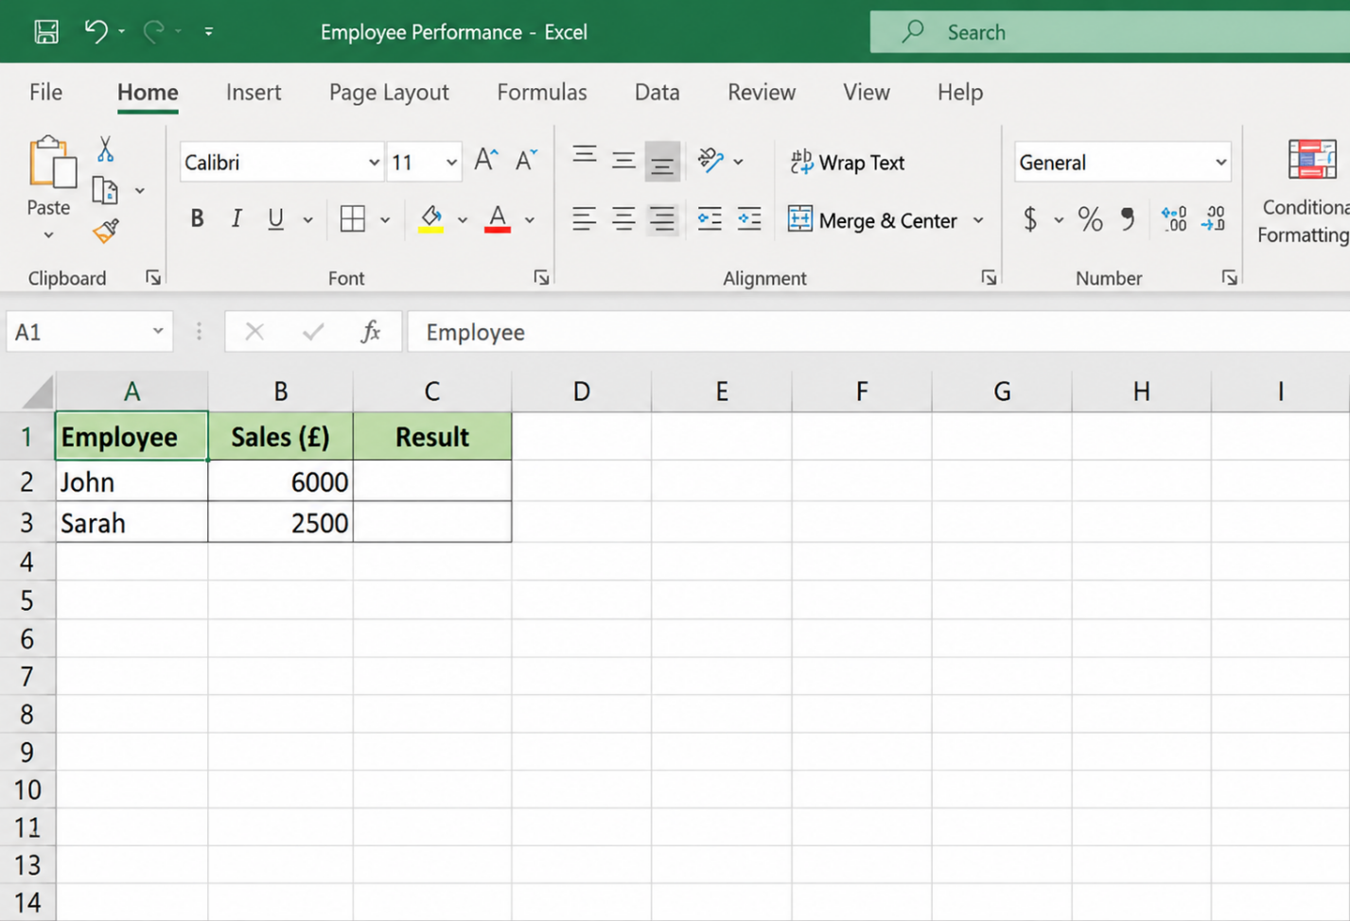
Figure 2: Raw employee performance dataset in Microsoft Excel
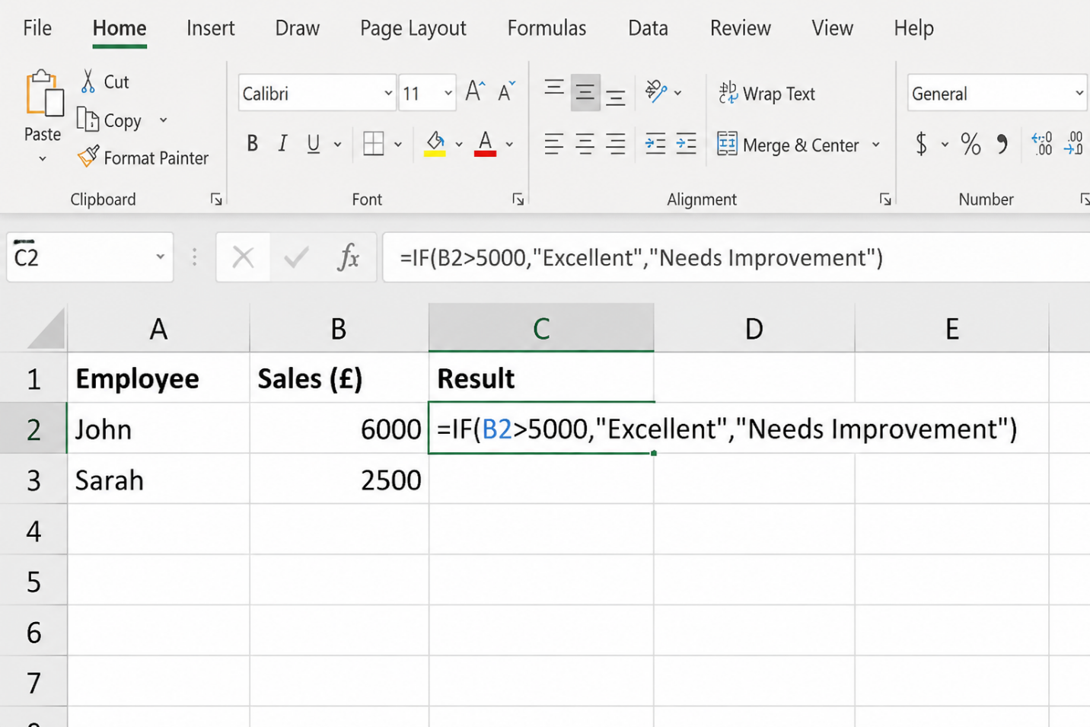
Figure 3: IF Function formula applied in Excel
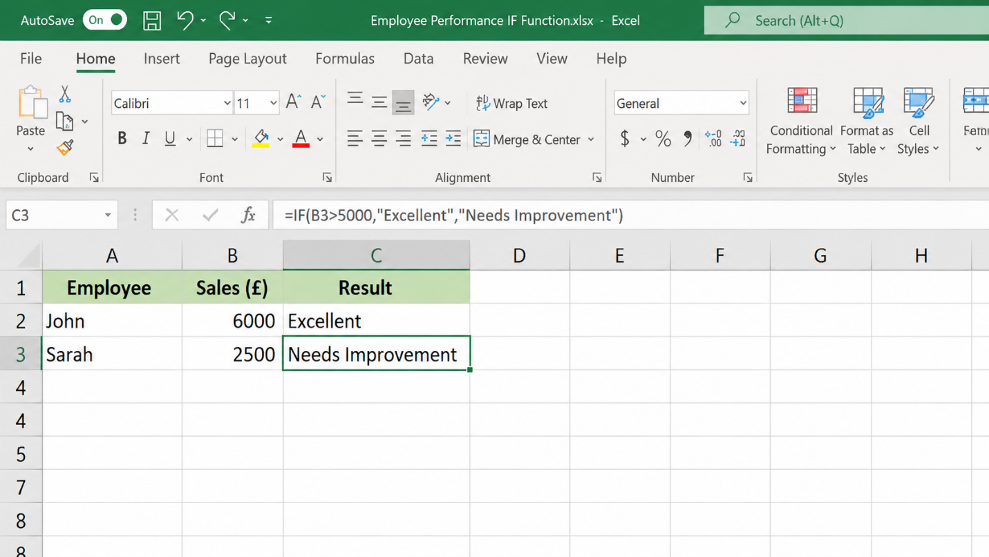
Figure 4: Final employee performance output
Business Value of the IF Function
The IF Function may prove to be of immense help to an organisation in that it makes employee evaluation easier. Instead of making sure that employees go through the records of all employees, record by record, businesses can apply logical rules that can easily analyse the masses of performance data. This enhances efficiency, minimises calculation errors and enables the managers to detect performance problems or reward top-performing employees in more efficient ways [17]. This feature is very handy, especially in sales tracking, employee appraisal schemes and target-based performance schemes.
Feature 2: Pivot Table – Retail Sales Analysis
Practical Scenario
The pivot table feature was tried with a case of retail sales analysis. Companies often receive massive amounts of sales data and need good ways of summarising data, seeing trends, and evaluating performance within various categories.
Dataset Structure
Table 3: Dataset
Product | Region | Sales (£)
Laptop | London | 5000
Phone | Manchester | 3500
Tablet | Birmingham | 2500
Laptop | Manchester | 4000
Pivot Table Analysis
A Pivot Table was created to summarise:
- Total sales by product category
- Regional sales performance
- Comparison of business performance across locations
Screenshot Evidence
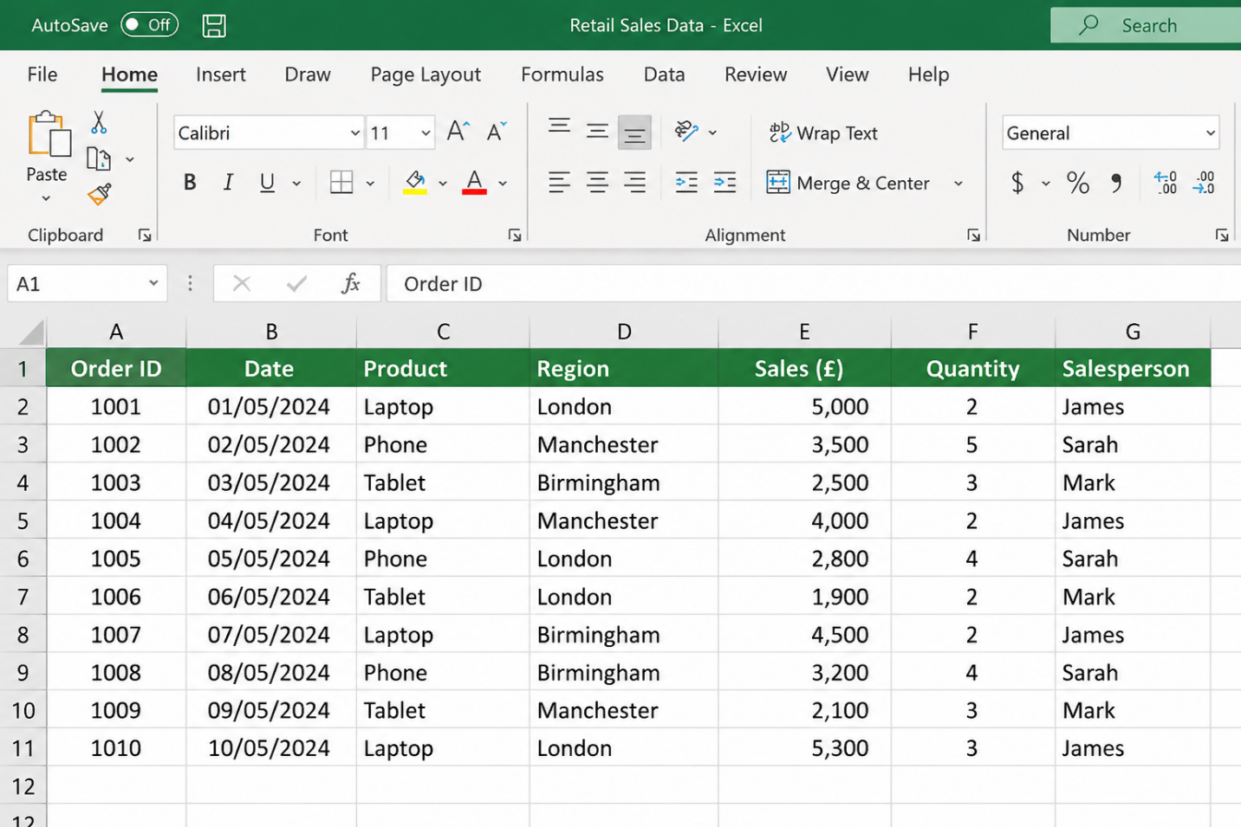
Figure 5: Retail sales dataset before Pivot Table creation
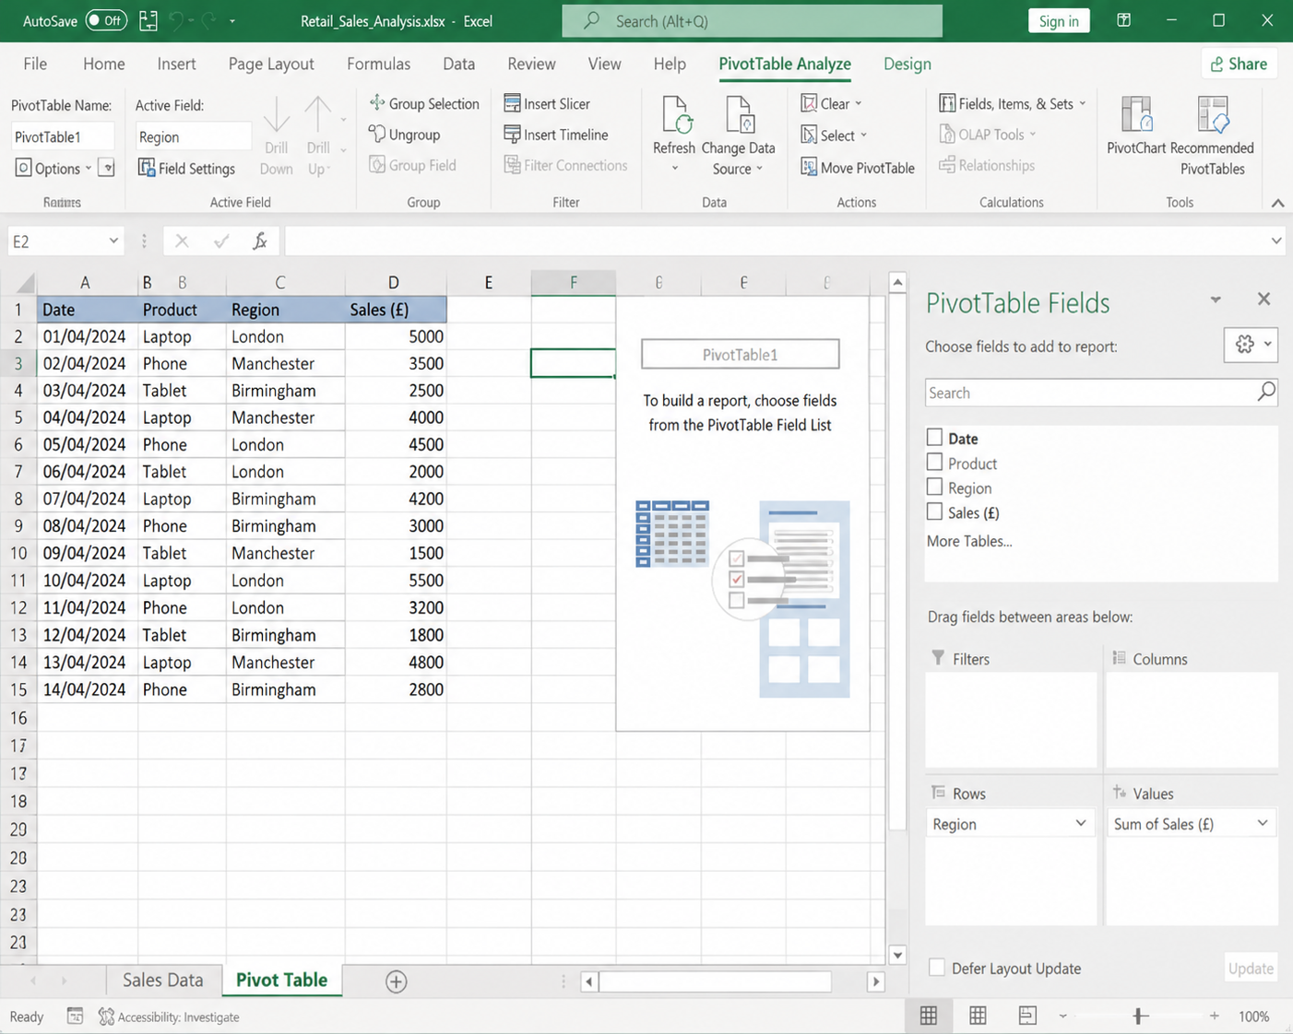
Figure 6: Pivot Table configuration and selected fields
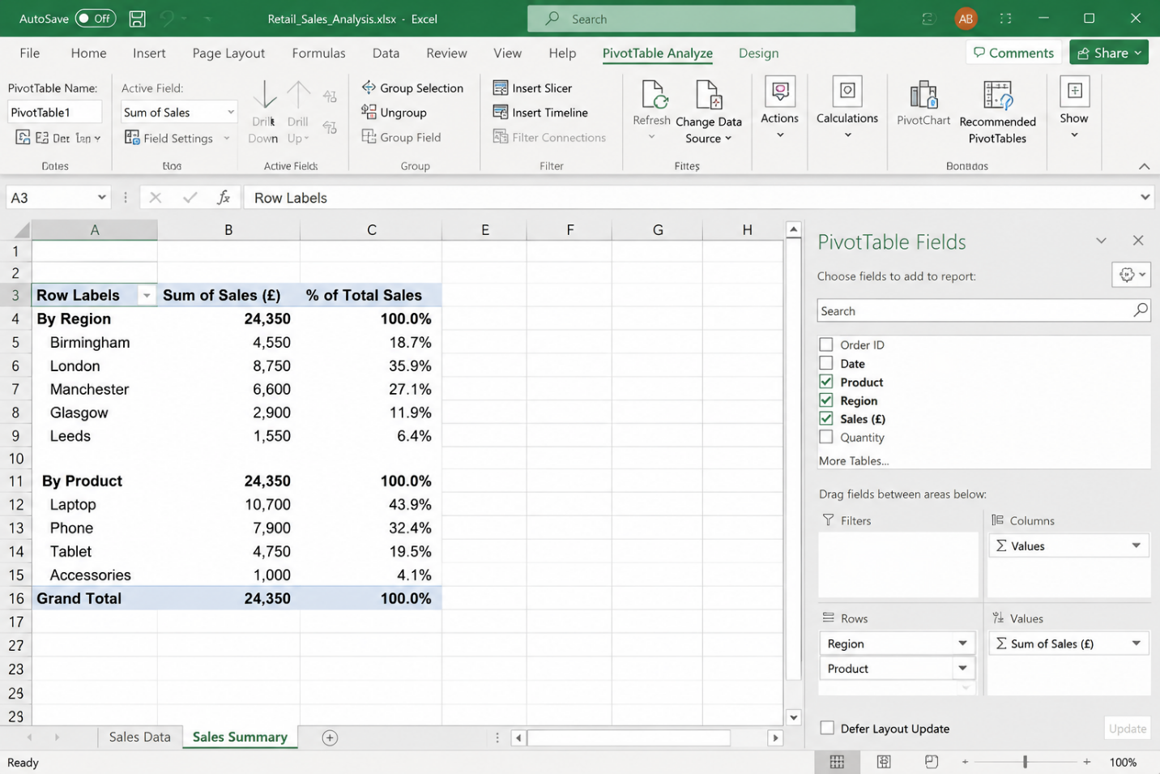
Figure 7: Completed Pivot Table showing sales analysis
Business Value of Pivot Table
Pivot Tables facilitate decision-making in businesses as they help to summarise huge datasets in meaningful and understandable ways. The managers can quickly track sales, monitor the performance across regions and even establish the products that are generating maximum revenue. This helps organisations to make sound decisions on marketing, inventory decisions and resource allocation. As such, Pivot Tables enhance analysis as it enables companies to draw upon useful information of operation data effectively.

TASK 4: Communication and Collaboration Applications

4.1 Microsoft Teams – Communication Application
Introduction: Overview of Microsoft Teams
Microsoft Teams is a communication and collaboration web-based application that enables organisations to bring together employees, teams, and other stakeholders by using one digital platform. Not only does it justify the existing ones in the workplace, such as remote and hybrid work, but it also offers possibilities in the sphere of instant messaging, video conferencing, sharing files and working with teams [18]. The platform is an integration of a series of communication skills in a single platform, which will help businesses optimise communication between themselves and how workflow is organised. Being capable of lowering communication barriers and enabling real-time communication, Microsoft Teams enhances organisational efficiency, fosters teamwork and allows employees to co-operate through collaboration despite the geographical location.
Features of Microsoft Teams
Microsoft Teams offers some applications that favour successful working communication and cooperation. The chat system allows employees to communicate using instant messages, update and solve problems quickly without necessarily depending on mail as the only means of communication. Video meetings enable organisations to hold virtual meetings, presentations, training, and stakeholder meetings, which encourage remote and hybrid working. The sharing of files allows them to post, retrieve and contribute to documents via Microsoft 365 integration, enhancing the sharing of information and collaboration. Channels assist organisations by allowing conversations and resources to be arranged according to a specific team, department or project and enhancing the structure and management of communication and information.
Business Benefits of Microsoft Teams
Microsoft Teams have some benefits to organisations. It also facilitates quicker communication where employees can share messages, information in real-time and enhance the response programs and operational effectiveness. The platform also minimises geographical limits where the employees in various places can work effectively by collaborating in a virtual meeting and accessing inaccessible resources. In addition, Teams enhances teamwork by providing a centralised platform that allows employees to communicate, share knowledge sharing and more easily coordinate their activities.
Limitations of Microsoft Teams
Although Microsoft Teams has many positive features, it has some limitations, such as the overload of information due to a large number of messages and notifications, which can decrease the effectiveness of communication [19]. The system is also reliant on good internet connectivity, and organisations might have to train their employees to facilitate effective adoption. Unless it is well managed, users can find it hard to maximise its superior communication capabilities.

4.2 Google Workspace – Collaboration Application
Introduction: Overview of Google Workspace
Google Workspace is a web-based collaboration and productivity software which helps organisations develop, store, share and handle information, using computer software [20]. It helps in contemporary working environments as it enables the staff to work remotely, ensuring they are able to consult documents and collaborate with colleagues even in distant areas, thereby adapting well to a remote and hybrid work environment. The tools accessible in the platform are Google Docs, Google Sheets, Google Forms, and Google Meet, which offer combined processes of document and data creation, communication, and collaboration. Google Workspace also enables organisations to work more efficiently, streamline their processes and boost workplace productivity by providing greater accessibility and collaboration due to digital transformation.
Features of Google Workspace
Google Workspace is a system that contains many features that allow collaborating with other companies and managing the flow of information. Google Docs is an online word-processing program where users can write, edit and manage their documents online, which include activities like writing reports and business documents. Shared editing is a feature that enables more than one employee to work on the same document at the same time, enhancing organisation and minimising time loss. The comments and feedback option allows the user to provide comments and feedback on documents and propose any changes. Google Drive is a secure cloud storage system which enables organisations to store, manage, access and share files from various locations whilst managing user access.
Business Benefits of Google Workspace
Google Workspace enhances efficiency in organisations by making it easier to collaborate in real-time, where employees can work collectively on the same document and eliminate challenges of managing version control [21]. It improves the productivity level by simplifying the information flow and the means of digital connectivity. Furthermore, its online accessibility enables remote and hybrid work since it is capable of helping employees work efficiently in various places.
Limitations of Google Workspace
Google Workspace has limitations even though it has several advantages. It can also lead to security issues since business data is stored over the cloud and organisational security practices must include stringent access mechanisms, authentication, and protection of data. Also, as one relies on cloud access, internet connectivity is needed to adequately utilise most of its features. Inconvenience of internet services or disconnection can temporarily take a toll on the productivity of employees. Thus, organisations need to take into account cybersecurity and a trustworthy infrastructure when using cloud-based collaboration solutions.

4.3 Practical Testing Evidence
Microsoft Teams Practical Test
Feature Tested: Creating a Meeting and Chat Communication
To establish the capability of Microsoft Teams in communication in the workplace, a practical test was conducted using it. The simulated team meeting was developed, and the chat feature was employed in order to communicate between team members.
Screenshot Evidence:
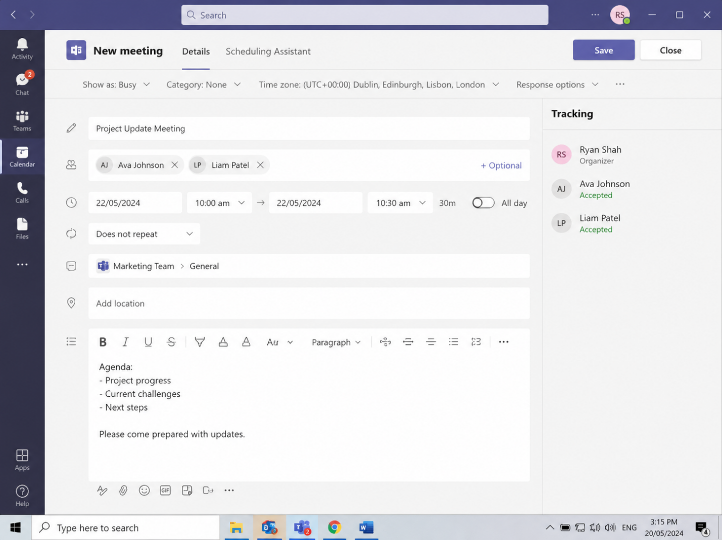
Figure 8: Microsoft Teams meeting creation interface

Figure 9: Microsoft Teams chat communication feature
Microsoft Teams can help the business to communicate, however, by allowing employees to set up virtual meetings, update or collaborate without the need to be physically present in the room. This feature may be applied by organisations to have team discussions, client meetings, staff training, and organise projects, enhancing communication efficiency.
Google Docs Practical Test
Feature Tested: Real-Time Collaboration
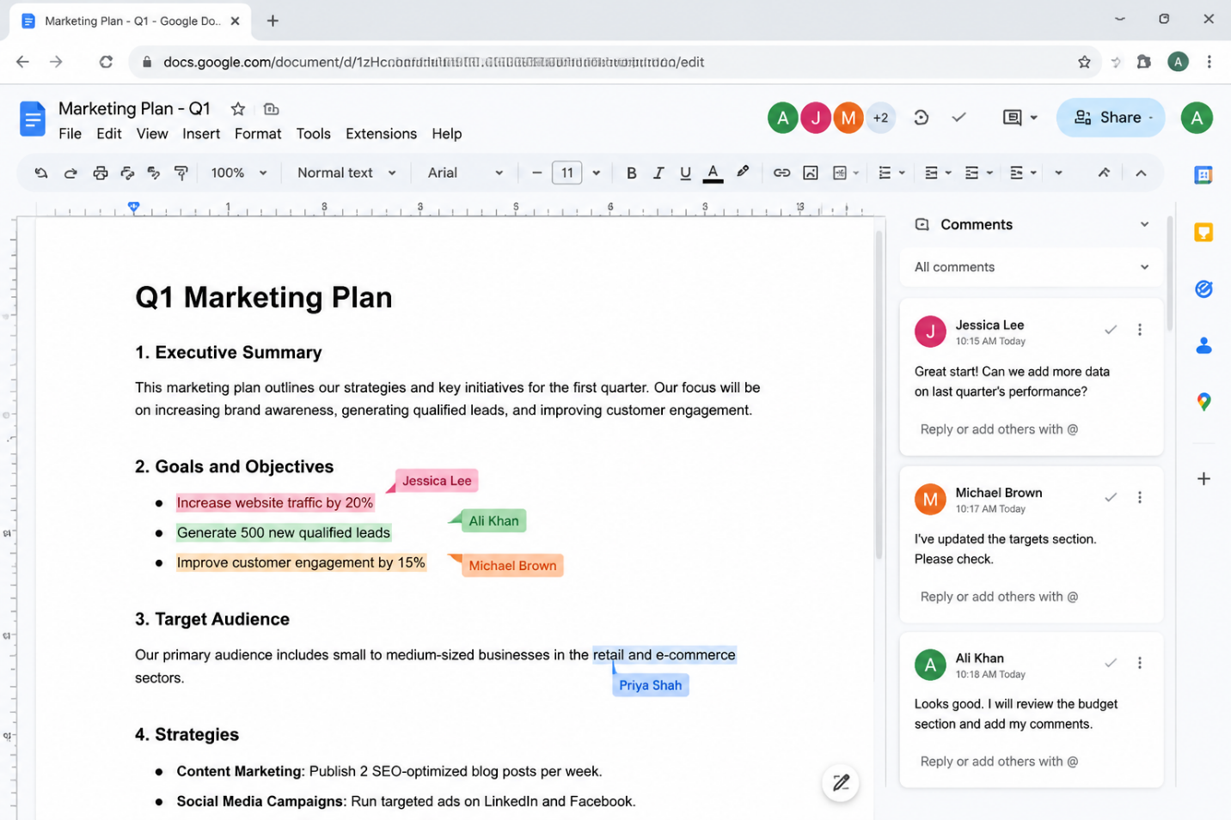
Figure 10: Google Docs shared editing feature
Google Docs enhances collaboration since it enables workers to work together on the same document, make corrections to documents and check revisions in real time. This helps minimise time delays due to transmitting several versions of documents and enables productive interaction of distributed and hybrid teams.

Conclusion
Software applications are important in ensuring better business performance through enhanced productivity, facilitated business processes and aided decision making. There are e-commerce tools like Shopify and WooCommerce that enable an organisation to grow its online sales platforms and enhance customer interaction. Office applications enhance information generation, storage and analysis, and communication and collaboration tools facilitate contemporary working practices, such as remote working and work hybrids. Nonetheless, adoption of software cannot be successful without more than adopting the right technologies; organisations need to do more, such as building the capacity of their employees, upholding a good security culture and ensuring congruency between the software solution and business goals.

References
[1] | H. Li, Z. Yang, C. Jin, and J. Wang, “How an Industrial Internet Platform Empowers the Digital Transformation of SMEs: Theoretical Mechanism and Business Model,” Journal of Knowledge Management, vol. 27, no. 1, Dec. 2022, doi: 10.1108/jkm-09-2022-0757.
[2] | F. K. WAHAB and Tajudeen Idera ABDULMAJEED, “The Rise of E-Commerce and Digital Marketplaces: Implications for Consumer Engagement and Market Efficiency,” ULM Digital Repository, 2025. https://repository.ulm.edu/jbe/vol35/iss1/4/ (accessed July 17, 2026).
[3] | M.-F. de-Lima-Santos, L. Mesquita, J. G. de Melo Peixoto, and I. Camargo, “Digital News Business Models in the Age of Industry 4.0: Digital Brazilian News Players Find in Technology New Ways to Bring Revenue and Competitive Advantage,” Digital Journalism, pp. 1–25, Feb. 2022, doi: 10.1080/21670811.2022.2037444.
[4] | Ariesto Hadi Sutopo, Developing Modern E-Commerce: WooCommerce for Digital Products. Topazart, 2024.
[5] | T. Buzan and D. O’brien, Mind Map Mastery : The Complete Guide to Learning and Using the Most Powerful Thinking Tool in the Universe. London: Watkins, An Imprint Of Watkins Media Limited, 2018.
[6] | S. Agarwal, “International Journal of Embedded Systems & Emerging Technologies Https://Stmjournals.in/International-Journal-Of-Embedded-Systems-And- the Profound Impact of Virtual Communication Technologies on Team Collaboration in the Contemporary Work Environment,” The Profound Impact of Virtual Communication Technologies on Team Collaboration in the Contemporary Work Environment , vol. 10, no. 1, p. 2024, 2024, Accessed: July 17, 2026. [Online]. Available: https://journalspub.com/wp-content/uploads/2024/08/45-60-The-Profound-Impact-of-Virtual-Communication-Technologies-on-Team-Collaboration-in-the-Contemporary-Work-Environment-2.pdf
[7] | J. Lambert, Microsoft Word. Redmond: Microsoft Press, 2022.
[8] | F. S. Steingold, Legal Forms for Starting & Running a Small Business. Berkeley, California: Nolo, 2022.
[9] | T. N. Nguyen, “Developing Health Information Systems in Developing Countries: Lessons Learnt from a Longitudinal Action Research Study in Vietnam,” The Electronic Journal of Information Systems in Developing Countries, Mar. 2023, doi: 10.1002/isd2.12268.
[10] | A. Alzubi, “The Role of Multimedia Tools in Hashemite Kingdom of Jordan Education Classroom Teaching in the Digital Era,” European Journal of Interactive Multimedia and Education, vol. 4, no. 2, p. e02303, July 2023, doi: 10.30935/ejimed/13378.
[11] | S. Das, A. Malik, S. K. Tripathy, and M. Sahoo, “How to Improve the Quality of PowerPoint Presentation to Achieve Maximum Learning,” Research and Reviews in Pediatrics., vol. 26, no. 2, pp. 31–36, May 2025, doi: 10.4103/rrp.rrp_10_24.
[12] | M. Alexander, Microsoft Excel Dashboards & Reports. Hoboken, Nj: John Wiley & Sons, Inc, 2022.
[13] | C. Wang, Z. Li, K.-K. Wong, R. Murch, C.-B. Chae, and S. Jin, “AI-Empowered Fluid Antenna Systems: Opportunities, Challenges, and Future Directions,” IEEE Wireless Communications, vol. 31, no. 5, pp. 34–41, Oct. 2024, doi: 10.1109/mwc.017.2300527.
[14] | Bathini Ravinder, Senthil Kumar Seeni, V. S. Prabhu, P. Asha, S.P. Maniraj, and C. Srinivasan, “Web Data Mining with Organized Contents Using Naive Bayes Algorithm,” pp. 1–6, Feb. 2024, doi: 10.1109/ic457434.2024.10486403.
[15] | Aleksejs Plotnikovs, Data Management Strategy at Microsoft. Packt Publishing Ltd, 2024.
[16] | Bernard Obeng Boateng, Data Modeling with Microsoft Excel. Packt Publishing Ltd, 2023.
[17] | U. Brahmbhatt, “Developing an Action Plan to Increase Employee Efficiency and Improve Operational Streamlining : Adjustments After Changing to a New Digital Performance Monitoring System in Company X,” Theseus.fi, 2025, doi: http://www.theseus.fi/handle/10024/896214.
[18] | R. Melati, “Analysis of the Advantages of Microsoft Teams as a Corporate Communication Tool in Supporting Employee Performance,” Eduvest - Journal of Universal Studies, vol. 5, no. 3, pp. 2893–2899, Mar. 2025, doi: 10.59188/eduvest.v5i3.50900.
[19] | T. K. Frey and B. S. Bloch, “Using Microsoft Teams to Facilitate Asynchronous Online Focus Groups,” International Journal of Qualitative Methods, vol. 22, Jan. 2023, doi: 10.1177/16094069231211251.
[20] | J. M. Lake, “Using Cloud-Based Collaborative Office Productivity Tools (Google Workspace) to Engage Students in Their Learning and Prepare Them for the Workplace,” Innovations in Higher Education Teaching and Learning, pp. 161–179, Aug. 2022, doi: 10.1108/s2055-364120220000045009.
[21] | O. Seri Fasola and M. O. Abimbola, “Collaborative Technology for Information Sharing, Knowledge Creation and Management in Libraries,” Gateway Information Journal, vol. 24, no. 1 & 2, pp. 33–46, 2023, Accessed: July 17, 2026. [Online]. Available: http://gatewayinfojournal.org/gij/article/view/34

