Name: Edward Walden
Student Number: 2203426
Date: 17/03/2023
Module: Motorcycle Technology
Module Code: ACHA4003
Assignment Title: Engine Performance Characteristics


Contents
Introduction…………………………………………………………………..………………..3

Testing Equipment and Method……………………………………………………….4

Raw Data………………………………………………………………………………………….5

Graphical Data………………………………………………………………………………….6

Conclusion……………………………………………………………………………………….9

Evaluation………………………………………………………………………………………10

References List……………………………………………………………………………….11

Introduction:
The primary objective of this technical report is to develop and demonstrate an understanding in knowledge of engine and vehicle technologies, mainly using equipment supplied by the University of Wales Trinity Saint David (UWTSD) in order to collect data, and use said data in order to research different correlations between aforementioned data, explaining why they are correlated as well as explaining what these correlations mean.
The correlations that will be covered in this essay will be the Specific Fuel Consumption (SFC) compared against Engine Speed, the Torque of the engine compared against the Engine Speed, and the Brake Power compared with the Engine Speed, with explanations as to why the engine may be showing these characteristics

Testing Equipment and Method:
The equipment used for this experiment was an engine dynamometer, which was used to collect data of a Honda 16V3 engine, typically found in a commercial Honda Jazz. The way the engine dynamometer was controlled was via two dials, one which controlled the rpm of the engine, and another dial which controlled the load, in Newtons, which was being placed on the engine, with the goal being to find the right combination of engine speed and load in order to hold the engine at a specific RPM, for example 4,500RPM, without the engine stalling or reaching its limiter.
The way this was achieved was by firstly increasing the Engine Speed to a suitable number of RPM. Then, whilst increasing the Engine Speed, increase the Load on the engine with the second dial. If done correctly the RPM of the engine should climb steadily, then eventually it should stay at a certain RPM, which can then be finely adjusted by changing the position of one or both dials.
After the dynamometer experiment was completed, it gave a large spreadsheet of data (See Figure 1) of which, the raw data was used in order to calculate values on Figure 1, for example the Specific Fuel Consumption and the Brake Mean Effective Pressure.

Raw Data:
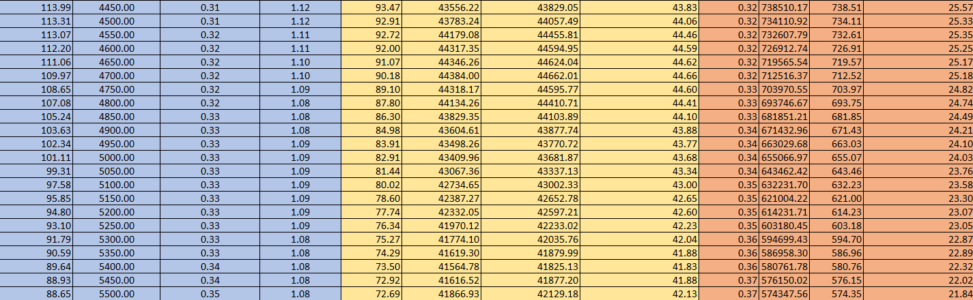
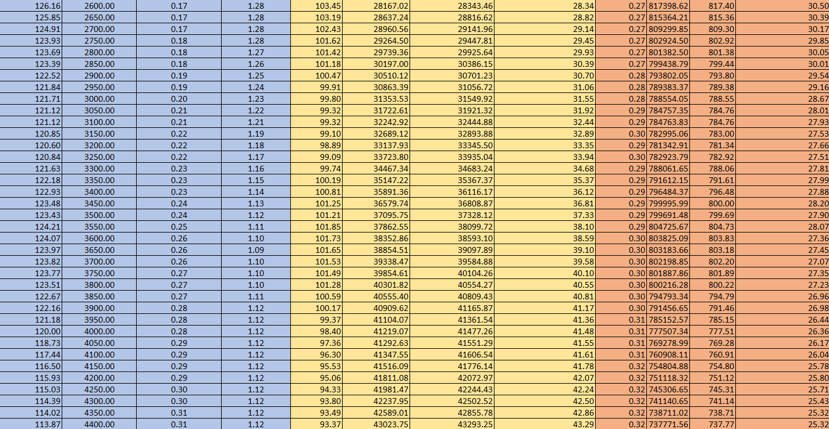
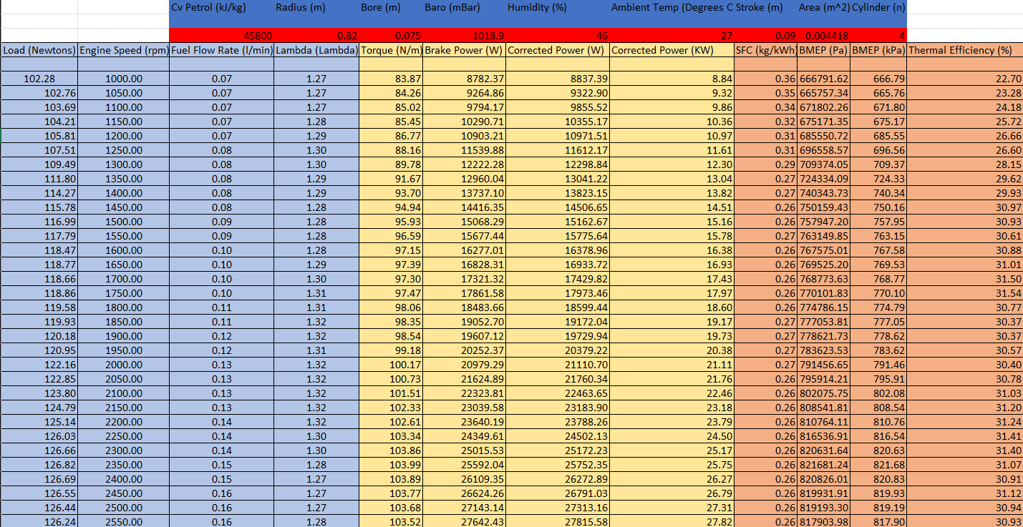
Figure 1: Raw Data Spreadsheet for the Dynamometer Test

Graphical Data:
Below is a graph made to show the correlation between the SFC of the engine and the Engine Speed.

Figure 2: SFC (kg/kWh) Plotted Against Engine Speed (RPM)

As this graph shows, the SFC originally starts off very high, and decreases as the RPM increases, up until around 1400RPM, at which point the SFC slightly increase, then slightly decreases again, until around 2300RPM, at which point the SFC begins to increase again, and does so for the rest of the dynamometer test. This can be explained by the fact that when the engine is at a higher RPM the fuel injector is open for longer, in order to provide the engine with more fuel meaning the engine can reach and maintain a higher RPM. This theory is supported by an article written by Irawan, B., Puspitasari, E., Winoko, Y.A. and Dwiyono, T which states “As the engine speed increases, the injector will be open for longer as a result, the fuel increases” (Analysis of fuel pressure on the performance of motorcycle engine with ethanol fuel (February 2021))

The second comparison looked at was the Torque, plotted against the Engine Speed.
In Figure 2, its shown that when the engine first starts and idles the torque is very low. “This signifies that as the engine’s speed (RPM) increases from a standstill, it also generates more rotational force (Torque), aiding in the vehicle’s acceleration” (Muscad, O. (2022). Torque vs RPM: How RPM Impacts Torque Output). The torque reaches its maximum at approximately 2300RPM before it drops off, until around 3300RPM when it starts to increase again before it steadily decreases after 3800RPM. “This drop-off point is often where the engine operates most efficiently.” (Muscad, O. (2022). Torque vs RPM: How RPM Impacts Torque Output).
Figure 3: Torque (N/m) Plotted Against Engine Speed (RPM)

The final data comparison was Brake Power compared to the engine speed.
As can be seen on this graph, the Brake Power increases with engine speed at a steady rate, up until approximately 4600RPM at which point the Brake Power dips back down, but only from 45000W to 39000W. This could possibly be explained by seeing that the Torque increases with Engine Speed, as seen in Figure 2, which means a greater Braking Power is needed. This data shows the relationship between the Brake Power and Engine Speed and from that, the engines efficiency and power are able to be determined from it. Aswell as this, the relationship shown in Figure 4 also has an effect on other factors like the SFC, as shown in a study done by Rahman, M.M., Mohammed, M.K. and Bakar, R.A. which states that “The decreases of BMEP with increases of engine speed, however, increases the brake specific fuel consumption.” (Trends of Rotational Speed on Engine Performance for Four Cylinder Direct Injection Hydrogen Fuelled Engine. (2009))
Figure 4: Brake Power (W) Plotted Against Engine Speed (RPM)

Conclusion:
In this investigation, the aim was to assess characteristics of an engine when running and under load, and the results found from the engine dynamometer test has allowed us to identify certain characteristics. For example, the data has shown us that Specific Fuel Consumption and Engine Sped both increase with each other, as an engine running at higher RPMs requires the fuel injectors to stay open for longer. Secondly, the results showed the connection between torque and engine speed, allowing a specific point on the RPM range where the engine is most efficient to be identified, meaning that when the engine is in use, the person using it can know what level RPM they should aim to run the engine at to get the best efficiency. And finally, the data from the dynamometer test showed a link between Braking Power and Engine Speed, the link being that they are positively correlated, meaning as the Engine Speed increases, so does the Brake Power, and this is because as previously stated, the torque also increases with engine speed, meaning that there is more pressure required on the power stroke of the engine.

Evaluation:
As a whole, I believed I performed the requirements of the task relatively well, I was able to gain good results from the engine dynamometer by not allowing the engine to stall or reach the limiter. As for the actual results I am happy with how the data and graphs turned out, as when compared to my peers the results were all fairly similar, meaning the trends and characteristics I have identified are not specific to only my results.
Given unlimited time and money for this experiment, it would be ideal to have run the dynamometer test multiple times, in order to compare the data sets from each run and identify any anomalous results within the data, meaning the inferences made from the data would be more accurate and well informed as they can be supported by multiple data sets. Additionally, doing multiple dynamometer tests means that I will undoubtedly become more confident at controlling the machinery, meaning the results will eventually become more accurate as I am able to have a better control over the engine speed and the load being put upon the engine.

References List:
Irawan, B., Puspitasari, E., Winoko, Y.A. and Dwiyono, T. (2021). Analysis of fuel pressure on the performance of motorcycle engine with ethanol fuel. [online] researchgate.net. Available at: https://www.researchgate.net/publication/349656199_Analysis_of_fuel_pressure_on_the_performance_of_motorcycle_engine_with_ethanol_fuel#pf6
Muscad, O. (2022). Torque vs RPM: How RPM Impacts Torque Output. [online] DATAMYTE. Available at: https://datamyte.com/blog/torque-vs-rpm/#:~:text=The%20torque%2DRPM%20curve%20typically
Rahman, M.M., Mohammed, M.K. and Bakar, R.A. (2009) Trends of Rotational Speed on Engine Performance for Four Cylinder Direct Injection Hydrogen Fuelled Engine. Trends in Applied Sciences Research, [online] 4(4), pp.188–199. Available at: https://scialert.net/fulltext/?doi=tasr.2009.188.199#:~:text=The%20obtained%20results%20seen%20that,the%20brake%20specific%20fuel%20consumption.

