SJYW7016 Supervision and Support Skills – Assessment 1

Evaluation of supervision and support provision at Tanyard Youth Project, Pembroke

- Introduction

This report aims to evaluate the supervision and support in place at the writer’s placement setting, which is the Tanyard Youth Project, Pembroke. The Tanyard Youth Project do not have a supervision policy and have stated that they include supervision as a way of work. Other policies are in place at the provider and these are referred to and appended at the end of the document (TanyardYouthProject, 2020).

This report will investigate how an effective supervision policy can enhance the quality of youth work provided in a setting. This will take place by looking at existing policies, examining theory and academic reading and, also align with; the Code of Occupational Ethics for the Youth Service in Wales, (ETS Wales & YMCA Wales Community College, February, 2012), National Youth Service Strategy for Wales 2007 - Young people, youth work, Youth Service, (Welsh Assembly Government, 2007), National Youth Agency, Youth Standards (National Youth Agency, 2014), Youth Work Strategy for Wales, 2019 , (Welsh Assembly Government, 2019 ), and Youth Work in Wales: Principles and Purposes(Youth Work in Wales Review Group, 2018).

Effective youth practice is developed by a process of reflective practice and is aided by a dialogue of mutual respect and problem solving. Supervision can aid the relationship between the young people, the setting and the youth worker. (moodle-University of Wales Trinity St David, 2020) A good explanation of this process is provided by K Sapin below (Sapin, 2013):

Supervision, like youth work, can be a process of dialogue and problem-posing with both parties working together and learning from each other to deepen understanding. A developmental approach based on mutual respect can enable both supervisor and supervisees to learn from each others’ perspectives in a relationship that is both supportive and challenging. Good supervision can provide a structure for professional youth work practice where supervisees reflect on recent work and plan future developments that are consistent with youth work principles (Sapin, 2013).

As the emphasis of youth work is to respect the rights of the young person and encourage practice which protects and helps young people develop in a safe and inclusive way. It is therefore imperative that youth workers and youth settings follow all appropriate guidance and as part of this supervision should be incorporated and given equal importance to safeguarding. The report will therefore make recommendations relating to the introduction of a separate supervision policy and ways of working for the placement.

- Supervision as a function

The concept of supervision as we know it began with psychoanalysts needing to discuss aspects of their work with colleagues, it then became widely accepted that social workers required the need to discuss case work with qualified colleagues. Subsequently, supervision became recognised for group social work and therefore youth work (J. Woods, 2001, p. 250-251).

The function of supervision can be described as managerial or non-managerial supervision. (J. Woods, 2001, p. 250-251). In managerial supervision, which is often used in business or manufacturing, the supervisor would actually be in charge of the supervisee and oversee their work, monitor output and quality. In comparison, with non-managerial supervision where there is a holistic relationship based upon mutual respect. (J. Woods, 2001, p. 250-251).

With regard to youth work which is often unprepared, informal and voluntary in nature the type of supervision should be promoted which reflects the relationship with young people (Sapin, 2013). This is in congruence with Freire’s statement below which illustrates how we learn from each other:

Liberating education consists in acts of cognition, not transferals of information … Through dialogue, the teacher-of-the-students and the students-of-the-teacher cease to exist…The teacher is no longer merely the-one-who-teaches, but one who is himself taught in dialogue with the students, who in turn whilst being taught also teaches. They become jointly responsible for a process in which all grow. In this process, arguments based on ‘authority’ are no longer valid; in order to function, authority must be on the side of freedom, not against it. Here, no one teaches another, nor is anyone self-taught. People teach each other (Freire, 1973:p. 79-80) Sapin,2013).
From this it is apparent that any supervision policy should reflect the values outlined in Youth Work in Wales: Principles and Purposes (Youth Work in Wales Review Group, 2018) as well as Youth Work National Occupational Standards (National Youth Agency, 2014) and the code of ethics for the youth service in wales (ETS Wales & YMCA Wales Community College, February, 2012). Section 5.6 of the code of ethics states that youth workers should: “participate in in-service training, identify training needs and assist where appropriate with the supervision, support, training and placement supervision of other colleagues and students”. (ETS Wales & YMCA Wales Community College, February, 2012) The five pillars of youth work in wales which are, educative, expressive, participative, inclusive and empowering (Youth Work in Wales Review Group, 2018). The pillar: participative illustrates how an encouraging and supportive relationship empowers young people to learn and develop. This value can be transferred to the supervision concept in that youth workers can learn from each other and from the young people within their care (Youth Work in Wales Review Group, 2018).

- Forms of supervision
Kadushin’s portrayal of John Dawson’s (1926) suggested functions are described below: (Kadushin’s (1992) interpretation of Dawson 1926: 293, (infed, 2020)):

Administrative – the promotion and maintenance of good standards of work, co- ordination of practice with policies of administration, the assurance of an efficient and smooth-running office;
- If this model was to be applied within a placement setting you could utilise this section for policies such as supervision, DBS, safeguarding, health and safety, data protection and employment legislation.
Educational – the educational development of each individual worker on the staff in a manner calculated to evoke her fully to realize her possibilities of usefulness;
- This could be an opportunity to discuss skills and offer training and ensure that all appropriate training such as first aid, safeguarding skills are up to date. Thus, giving the supervisee an opportunity to request any further training that may assist development.
Supportive – the maintenance of harmonious working relationships, the cultivation of esprit de corps.
- This would be the part where the supervisee was supported and could talk about difficult situations and off load stress, thus improving morale and therefore enhancing the youth experience.
(Kadushin’s (1992) interpretation of Dawson 1926: 293, (infed, 2020)

Proctor’s (1987) model (moodle-University of Wales Trinity St David, 2020) uses a similar concept which can be aligned to Kadushin’s (Kadushin,1992). Proctor utilises the terms of formative which could also be matched to educational, normative which focuses on administrative tasks and restorative which restores the emotions or supports the supervisee (Proctor, 1987) (moodle-University of Wales Trinity St David, 2020).
A common theme across many models of supervision is the emphasis on development and learning. (Joan Tash,1967) was able to demonstrate successful outcomes which confirmed the significance of supervision as a forum for learning. (Joan Tash, 1967) (moodle-University of Wales Trinity St David, 2020).

The work of Hawkins and Shohet fits in with the concept of educational, supportive and administrative actions and offers congruence with Kadushin and Proctor’s models of supervision (Kadushin’s (1992) of Dawson 1926: 293, (after Hawkins and Shohet 1989; 2007) (infed, 2020)
The primary foci of supervision (after Hawkins and Shohet 1989; 2007) The functions of Kadushin and Proctor have been incorporated in the table to demonstrate how they align
- To provide a regular space for the supervisees to reflect upon the content and process of their work | Proctor | Hawkins and Shohet | Kadushin
 | Formative | Educational | Educational
- To develop understanding and skills within the work | Formative | Educational | Educational
- To receive information and another perspective concerning one’s work | Restorative/  Formative | Supportive/  Educational | Supportive/  Educational
- To receive both content and process feedback | Restorative/  Formative | Supportive/  Educational | Supportive/  Educational
- To be validated and supported both as a person and as a worker | Restorative | Supportive | Supportive
- To ensure that as a person and as a worker one is not left to carry unnecessarily difficulties, problems and projections alone | Restorative | Supportive | Supportive
- To have space to explore and express personal distress, restimulation, transference or counter-transference that may be brought up by the work | Normative | Administrative | Administrative
- To plan and utilize their personal and professional resources better | Normative | Administrative | Administrative
- To be pro-active rather than re-active | Normative | Administrative | Administrative
- To ensure quality of work | Normative/  Restorative | Administrative/  Supportive | Administrative/  Supportive
(Kadushin’s (1992) of Dawson 1926: 293, (after Hawkins and Shohet 1989; 2007) (infed, 2020)
- Current supervision in place

The placement provider; Tanyard Youth Project do not have a specific supervision policy, instead state that they supervise as they work. It could therefore be assumed that a process of ongoing discussion takes place between volunteers, youth workers, managers and trustees. From examination of the code of conduct (appendix a) and induction check list (appendix b) which can be viewed in the appendices at the end of this report, it is clear that a set of procedures and appraisal process is part of the way in which the provider manages employees (TanyardYouthProject, 2020).

Whilst it can be seen from the mention of safeguarding and child protection policies that there is a clear reporting line for any disclosures or concerns regarding the young people, there is a distinct gap in that it is not clear if the code of conduct, appraisal process and assumed supervision apply to volunteers or even temporary employees.

Education, training and career advancement are discussed at induction and during appraisal and supervision reviews are held. However, without a supervision policy it is unclear how supervision takes place, how formal this process is, if it is recorded regular and for all employees and volunteers.

There is the risk that if supervision is carried out as part of day to day management and linked to appraisal systems and possibly performance that there could be an oppressive barrier to effective supervision. Employees and volunteers may not want to show weakness or disclose worries or imagined failures if there is a chance that this could affect their career development. There is also a failure in that who would supervise the manager? Is the person who supervises adequately qualified to do so? (moodle-University of Wales Trinity St David, 2020) (Kadushin’s (1992) of Dawson 1926: 293, (after Hawkins and Shohet 1989; 2007) (infed, 2020)

There is also the question of barriers to supervision. The supervisee may have had a previous bad experience or envisages, supervision as micro-management. Without a relationship based upon mutual respect and a good rapport there is the risk that the supervision session would not flow as it should. A managerial approach to supervision could feel almost like a job interview, care should be taken to relax the supervisee and prompt reflective discussion. (moodle-University of Wales Trinity St David, 2020)(Kadushin’s (1992) of Dawson 1926: 293, (after Hawkins and Shohet 1989; 2007) (infed, 2020)

Certain items that arise in the youth workers practise could evoke emotions or bring up memories of past experiences. The supervisor should take care that whilst counselling skills can be effective, counselling should take place in an appropriate setting and with a qualified counsellor. Perhaps a company referral to a counsellor could be considered if required? (Kadushin’s (1992) of Dawson 1926: 293, (after Hawkins and Shohet 1989; 2007) (infed, 2020)

The supervisor should develop certain qualities to prevent oppressive practices and so that the power relationship is equal and reflective.

Mark Smith suggests in Local Education, community, conversation, praxis that there would be a benefit in an impartial supervisor rather than a manager:

It is just nice to talk to somebody who is not involved, who has not got any responsibility to make you do your work and you can talk to about things you are working on. There is an ongoing need for that. There are some things that you cannot say to a line manager – what you may be thinking
(Smith, 2009, p. 99)

A valid view could be taken to suggest that supervision could be hindered by being supervised by a line manager. Although in contrast it could be said that there is some benefit in discussing legislative issues such as DBS status, first aid and other administrative issues. In this vein it would be appropriate to introduce a supervision policy which takes elements from the ones suggested by Kadushin or Proctor. (Kadushin’s (1992) of Dawson 1926: 293, (after Hawkins and Shohet 1989; 2007) (infed, 2020)

- Proposed supervision structure for placement

In order for a youth provider to demonstrate commitment to young people and continuous development of youth workers a supervision policy should have equal standing to other organisational policies. (moodle-University of Wales Trinity St David, 2020). This will ensure there is no confusion and that employees and prospective employees can be assured that there is a positive and reflective culture within the organisation. Due to the informal setting of youth work and the continual learning on the job, there should be opportunity for reflective practice and adherence to the National Youth Work Occupational Standards (National Youth Agency, 2014) and ETS Wales & YMCA Code of Occupational Ethics (ETS Wales & YMCA Wales Community College, February, 2012) .

K Sapin suggests a planned approach to supervision as demonstrated below: preparing, establishing, and moving on. (Sapin, 2009, p. 191-192)

A planned approach to supervision
Preparing for Supervision | - Understanding the type of supervision required  - Locating self in relation to identity, skills and experience
Establishing the supervision relationship | - Exchanging information about the above  - Making practical arrangements to meet  - Structuring the sessions  - Record-keeping
Examining practice | - Listening and valuing experience  - Providing critical feedback  - Reviewing practice  - Identifying issues
Moving on | - Action planning  - Reviewing what has been achieved  - Identifying learning outcomes  - Allowing the relationship to end
(Sapin, 2009, p. 191-192)

- Boundary management

It would be appropriate to have set meetings, with set times and in a quiet location with no interruptions. An agenda could be set which is provided to both parties beforehand.

Notes should be kept, and a summary agreed between both parties at the end of the supervision session. Active listening, counselling skills and open questions should be used. It is important the supervisee is able to reflect without being led towards conclusions. (Bolton, 2014) (moodle-University of Wales Trinity St David, 2020)

- Conclusion and recommendations

In conclusion, it is clear that a supervision policy is an essential part of the framework of any youth provider. It aligns with the code of ethics, national standards and youth work academic theory. There is also a reputational and cultural requirement to be seen as a provider that follows guidance and understands how reflective practice benefits employees and provides an enhanced service for young people. In an informal education setting, thinking on the job or work in action is often required and thus an opportunity to reflect and discuss is a necessity to continual learning and development. (Bolton, 2014)

I therefore recommend that:

- The Tanyard Youth Project introduces a supervision policy which includes details of how, when and where supervision will take place.

- Consideration should be given to what form of functions should be incorporated. Kadushin’s administrative, educational and supportive would be fitting if a manager was supervising. This would ensure that all administrative policies and legislation was adhered to as part of normal day management. There is the benefit of peer supervision which could be a consideration.

- References

Bolton, G. (2014) Relective Practice Writing and Professional Development. 4th Ed. London: SAGE.

ETS Wales & YMCA Wales Community College. (2012) Code of Occupational Ethics for the Youth Service in Wales. Cardiff: ETS Wales & YMCA Wales.

Infed. (2020). infed. [Online] Available at: https://infed.org/mobi/the-functions-of-supervision/
[Accessed 1 Jan – 14 April, 2020].

moodle-University of Wales Trinity St David, (2020). Moodle. [Online]
Available at: https://moodle.uwtsd.ac.uk/course/view.php?id=3053
[Accessed Jan-April 2020].

National Youth Agency. (2014) Youth Work National Occupational Standards. Leicester: National Youth Agency.

Sapin, K. (2013) Essential Skills for Youth Work Practice. 2nd ed. London: SAGE.
Shohet, R. (2011) Supervision as Transformation: A Passion for Learning. 1st ed. London: Jessica Kingsley Publishers.

Smith, M. K. (2009) Local Education - community, conversation, praxis. 3rd ed. London: Open University Press.

TanyardYouthProject. (2020) Tanyard Youth Project. [Online]
Available at: http://www.tanyardyouthproject.co.uk
[Accessed 3 April 2020].

Welsh Assembly Government. (2007) National Youth Service Strategy for wales, 2007 - Young people, youth work, Youth Service. Cardiff: Welsh Assembly Government.

Welsh Assembly Government, 2019 . Youth Work Strategy for Wales, 2019, Cardiff: Welsh Assembly Government.

J. Woods. (2001) Principles and Practices of Informal Education. in L D Richardson and Wolfe M (eds.)

- Appendices
- Tanyard Youth Project - Code of Conduct
- Tanyard Youth Project – Induction checklist

- Tanyard Youth Project - Code of Conduct

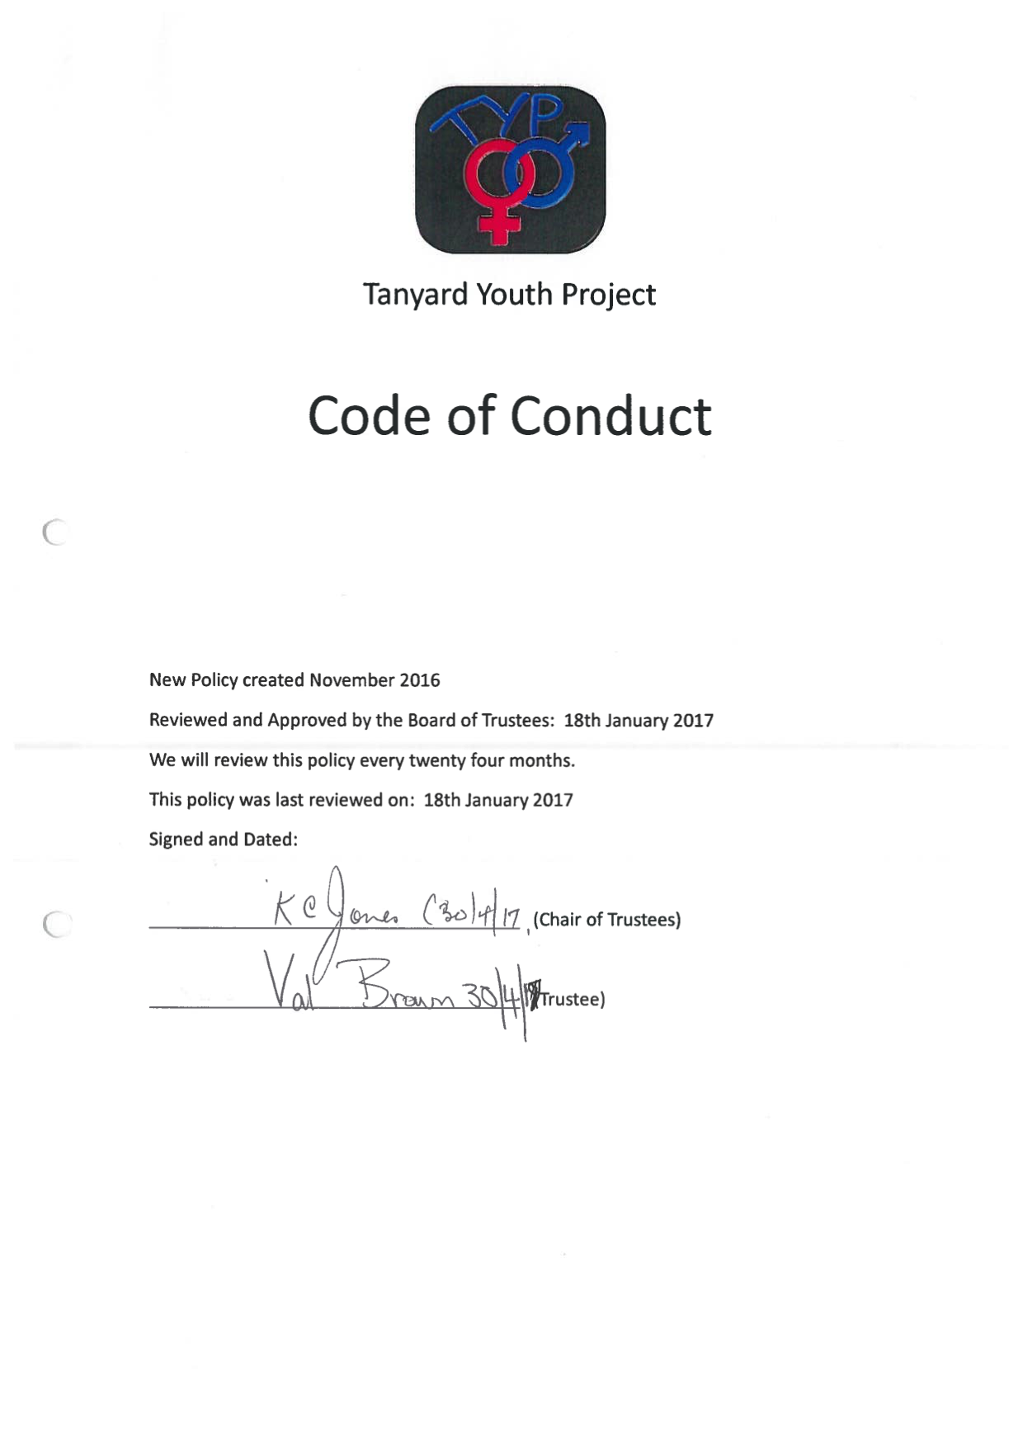

- Tanyard Youth Project – Induction Checklist



INDUCTION CHECKLIST

NAME OF EMPLOYEE ......................................................…………..

JOB TITLE ......................................................................

DATE COMMENCED ......................................................…………..

The Tanyard Youth Project as an organisation | Complete
1. Charitable aims
2. Introduction to colleagues
3. New entrant’s own job
4. Objectives and appraisals
5. General layout - entrances and exits
6. Telephones and contact information
7. Trustees

Conditions of Employment
1. Information on hours of work and overtime
2. Time recording and timesheets
3. Expenses claims & mileage claims
4. Contract of Employment
5. Company Pension scheme and eligibility
6. Reporting in when sick including when on leave
7. Arrangements for requesting leave: annual leave, unpaid leave, compassionate leave
8. Policies
9. DBS disclosure and Tier 1 Safeguarding Training
Safeguarding
1. Certificate copy or book on to Tier 1 Course
2. Child Protection Policy
3. Staff Handbook and Code of Conduct
4. Duty Safeguarding Officers

Health and Safety, Security, Fire
1. Health and Safety policy
2. Issuing of fire instructions and procedure
3. Location of fire-fighting equipment
4. Accident reporting
5. First aid facilities
6. CCTV and policy
7. Security of department/building
8. Arrangements regarding keys, ID Badges etc.
9. Risk Assessments
Conduct
1. Code of Conduct
2. Disciplinary procedures
3. Grievances and Whistle blowing
4. Confidentiality
7. Social Media and Statements to the Press
Facilities
1. Toilets
2. Kitchen
3. Parking
Education, Training, Promotion
1. Means of advancement, promotion opportunities
2. Employee appraisal, review systems
3. Training needs and opportunities
4. Supervision of youth work
Employee Involvement and Communication
1. Facebook page
2. Communication arrangements Email, phone
3. Information sources, e.g. notice boards, staff bulletin etc.
4. One to One meetings with manager
5. Team Days for all staff
6. Senior staff meetings

- I have been informed about and understand the above items.

- Signature:...................................…………………………………………………… Date:..............

- I confirm that the above Induction Checklist has been completed for the above member of staff.

- Signature of Project Manager:...................................………………………… Date:..............

