Competitive Strategy Report of LIDL

Dummy Report for Strategic Management Assignment 1 2019 – Competitive Strategy Report of LIDL



November 2019

MODULE NAME: Strategic Management & Sustainability (M3X9111)
Name: Chuchengsangmu xina
Student Number: 1904305
Table of Contents
Executive Summary 3
1. Introduction 4
1.1 Report Remit 4
1.2 Background of LIDL 4
1.3 Definitions of Major Concepts 5
2. LIDL’s Competitive Strategy 7
2.1 LIDL’s Implementation of Cost Leadership Strategy 7
2.2 Advantages and Disadvantages of the Strategy 9
3. Conclusion and recommendations 10
References 11

Executive Summary
In view of the development of e-commerce and industry technology, the competition of enterprises has become more and more prominent, so the competitive advantage of enterprises has become the core factor of enterprise development. This is also the starting point for this report. The purpose of this report is to study LIDL's cost leadership strategy, analyse its strengths and weaknesses, and finally propose reasonable and feasible recommendations. As the industry's leading retailer, LIDL's competitive advantage strategy reflects its characteristics and professionalism, so the analysis of its strategy can provide a reference for today's highly competitive retail industry. This report finds that LIDL's cost leadership strategy has advantages in price competition, prevention of new entrant threats and market share competition, with disadvantages in in long-term operation and branding effect. Therefore, this report proposes two recommendations from the advantages and disadvantages, including advancing the cost management of the supply chain and increasing the cost of technological innovation.

1. Introduction

1.1 Report Remit
For enterprises, economic adjustment, changes in the industrial environment, and changes in people's willingness to purchase have gradually complicated the problems faced by enterprises (Kamukama et al., 2017), which have brought sustained impact to the competitiveness of enterprises. While the industry is expanding, competition is increasing. As a chain retail supermarket with physical store management as the main profit model, the competition is particularly fierce. In the context of the changes in the social and economic environment and the changes in the industrial environment, how can retailers acquire, maintain and play their own unique competitiveness? This report uses the supermarket chain LIDL as a case study. This paper will analyse LIDL's competitive strategy, evaluate its advantages and limitations, and finally make relevant recommendations. The purpose of this report is to effectively evaluate the company's competitive strategy and provide valuable input to the industry. Given the breadth of the industry as a whole, this report fixes this topic in the retail industry and studies the competitive strategy of a particular company (LIDL).

1.2 Background of LIDL
LIDL was founded in 1973 as a retail store originating in Germany and the original small store with 500 products and 3 employees was the prototype of LIDL. During 1977 to the 1980s, LIDL has expanded its German stores to more than 33 and become famous throughout the country (Thefactsite, 2018). Until 1990, LIDL began to transform into an international retail chain, and began to expand the retail market to France, the United Kingdom, and Italy and other European countries. By 2015, LIDL had established its headquarters in the United States. At this time, LIDL has been successfully ranked into the top five of the world's retailers, with more than 260,000 employees and 10,500 physical stores worldwide (LIDL, 2019). LIDL's mission is to develop into the world's largest retailer through planned and determined efforts, and to provide the best practices for the industry with advanced technology. According to LIDL's latest financial disclosure, LIDL's operating income still maintains strong growth, and the growth rate shows an increasing trend year by year, creating an international turnover of 46.1 billion euros, an increase of 11% (Retaildetail, 2019). But one notable problem is that although LIDL has shown strong ambitions for the international market, its expansion costs have put a lot of pressure on profitability, making the balance sheet unsatisfactory. And in the German domestic market, the industry is particularly competitive, because LIDL's number one competitor, ALDI, continues to increase the number of brands and new stores. This might imply some prone risks in LIDL’s strategy.

1.3 Definitions of Major Concepts
- Strategy
The essence of strategy is to maximize value and determine what kind of company the organization expects to be (Adegoke, 2013). The strategy focuses on the future of the company and is a vision and a forward-looking vision for the future, which can help companies seize the future development opportunities and resources (Mathis and Galloway, 2013). Mintzberg (1998) pointed out that people go through different ways to give different strategic meanings in management and production activities, which shows that they can accept the diversification of strategies at different levels. Therefore, he proposed a strategic SP model in 1998, including five basic strategic elements: plan, ploy, pattern, position and perspective.
- Business level strategy
According to the division of strategic level, the company's strategy can also be subdivided according to different priorities, of which the business level strategy is one. Nandakumar et al. (2010) pointed out that the business level strategy is also called the competitive strategy, and through the use of the company's own core competitiveness, it determines its dominant position in the industry and maintains it.
The competitive strategy was first explained by the American scholar Porter (1982): using offensive or defensive behaviors to build a regressive position in the industry and perfectly solve the five types of competitive forces, in order to obtain more investment profit. Claver-Cortés et al. (2012) considered the company's competitive strategy based on its core competitiveness and continued to gain competitive advantage.
It was pointed out by Oyewobi et al. (2016) that the so-called company competitive strategy refers to the purpose, positioning, planning and strategy of the company's goods or services involved in market competition. Its choice can be regarded as the basis of competition and the key to determining whether the competition is successful.
Linton and Kask (2017) identified that if the competitive strategy is to win, then it is a combination of advantages, which means that the company can continue to have revenue, and more customers willing to choose the company's products and services. Such an "advantageous combination" can also be called value, which is what all companies are actively fighting for, and this value often depends on the customer.
- Porter’s Generic Strategies
Porter's generic strategies are the most representative of the company's competitive strategy. According to Porter's analysis, a company's competitive advantage depends on three basic points, namely differentiation, cost leadership and focus (González-Benito et al., 2010). On this basis, Porter put together these points and put forward the famous general strategy, as shown in the following figure:
Figure 1 Porter’s Generic Strategies Model
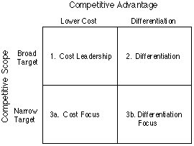
Source: Porter, 1985
Porter's generic strategies model successfully proposes four basic competitive strategies: cost leadership strategy, differentiation strategy, cost focus strategy and differentiated focus strategy. Porter's model takes into account the various possible elements of business competition, so the model has a very high practicality and can be applied to almost every enterprise in all walks of life. But at the same time, it also has some risks. For example, the competitor's imitation of the cost leadership strategy may reduce the profitability of the entire industry, and the technological breakthroughs in the industry can easily destroy the company's cost leadership strategy (Akan et al., 2006).

2. LIDL’s Competitive Strategy
The competitive strategy adopted by LIDL is a cost leadership strategy. According to the Valipour et al. (2012), the cost leadership strategy is to reduce costs as much as possible, minimize and compress product costs to ensure competitive advantage. The key to this strategy is to target price-sensitive customers and bring them standard products at a lower unit cost. This strategy can be divided into two categories, one is the lowest cost, which is to bring products and services to consumers at the lowest market price. The other is the best value, which is to bring services and products to customers at the best market price. The customer groups that these two types face must be a large market.

2.1 LIDL’s Implementation of Cost Leadership Strategy
LIDL’s implementation of cost leadership strategy is identified in the following aspects:
- Commodity outsourcing for variety restrictions
In order to ensure the low price, LIDL does not purchase high-priced brand products, such as Madeleine black truffle chocolate. At the same time, LIDL also created its own low-cost brand (Marketingweek, 2019), because there is no competition between the different brands in the store, and consumers choose to buy very fast, so the sales of single products are very high. LIDL’s product is cheap the quality is not bad. These are all because they find that the fewer types of goods they supply, the more refined they are, the more they can ensure the growth of retail sales and lower operating costs.
- Low advertising cost budget and expenditure
LIDL does not have an external public relations department, does not conduct market research, does not carry out annual plans, and even has little investment in advertising. LIDL does not set up shops in bustling areas like downtown areas and it tends to do the opposite to set up shops in residential areas or in suburban areas (Marketing91, 2019). These lots are not only cheap, but also have ample customer traffic. These all have saved LIDL a lot of fixed assets and management costs, and also saved a lot of training costs.
- Unconditional return
Unconditional return is a requirement to protect the rights and interests of consumers that consumers can make return of goods to the merchant unconditionally within a limited time after purchasing (Main et al., 2018). Like many other competitors, LIDL also adopts an unconditional return policy to enhance its reputation and credibility. In addition to improving its reputation, unconditional returns can effectively avoid additional costs, which can effectively control LIDL's cost of living. Since the unconditional return policy has many of the above benefits, the principle of an unconditional return policy can basically become one of the conditions for a large supermarket to enter the international market. It is self-evident that LIDL chooses this approach in its operations, which is one of the prerequisites for LIDL's cost leadership strategy.
- Frugal corporate culture
LIDL does not pursue a popular and bright sales environment. Its store decoration style is very simple, and the store is also compact. In the specific operation, LIDL has taken many measures to save commodity space. For example, a large number of goods is not necessarily displayed on the display rack, as long as the customer can easily get it. In daily work, LIDL employees also support the concept of cost control, and always implement the spirit of saving first.
- Efficient work team
Human capital plays an important role in enterprises in a highly competitive environment and the cost of human resources is often a high cost item (Niculescu, 2015). Since LIDL uses a cost-leading strategy, the company's labour costs should also be cautious planning. Encouraging all employees to participate in cost savings and exploring the potential of employees is a necessity for this strategy. In order to achieve long-term low-cost operation strategy, LIDL attaches great importance to employee skill training and employee career development planning. Through many trainings, employees can adapt to various positions of the company in a short period of time and effectively improve own capabilities. At the same time, the improvement of the employee competency also corresponds to the high salary and promotion opportunities provided by LIDL.

2.2 Advantages and Disadvantages of the Strategy
Any generic strategy adopted by company can enhance its competitive advantage by exploiting its potential advantages, but at the same time limitations cannot be ignored. One of the advantages of LIDL's cost leadership strategy is that they are dominant in price competition because leaders' investment in efficiency gives them better competitive endurance. In addition to current competitors, the cost leadership strategy also creates revenue relative to new entrants in the industry. Wada’s (2018) explanation for this is that, in general, the cost owner will find a way to stop potential new entrants, because new entrants will often adopt price cuts when entering a new market, which is not conducive to the competition of the existing company. But LIDL's cost-leading strategy can create barriers for entrants to enter the market, thereby protecting them from the threat of new entrants.
Moreover, in most cases, the cost-leading strategy can capture a significant portion of the market share, as it is attractive to potential consumers at a low price in exchange for acceptable-quality services and commodities (Hilman and Kaliappen, 2014). This is true for LIDL. LIDL's need for efficiency lowers the cost-manager's profit margin below the average of other companies, so it can profit from a large number of consumers. This means that LIDL's cost-leading strategy always enjoys an objective total profit. This is also the reason why LIDL's sales are growing year by year (see Figure 2).

Figure 2 LIDL’s International Sales
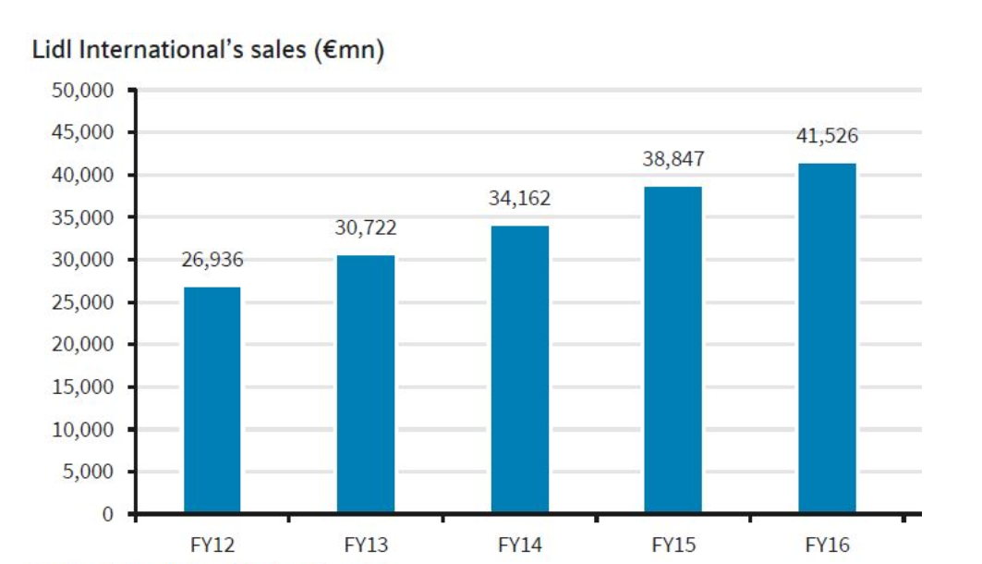
Source: Retaildetail, 2019
As mentioned above, LIDL's cost leadership strategy minimizes the cost of additional expenses such as advertising and R&D, but in the long run it is a disadvantage, as this method can become expensive. The low cost of the research means that LIDL's market research is relatively lacking, which may lead LIDL to be less proficient in environmental monitoring and estimation than other competitors. At the same time, the cost leader's contempt for R&D is a deadly point, because once the market environment changes, their responsiveness will decrease. The end result may result in LIDL's cost leadership not being consistent with market changes. The same is true for advertising investment. Reducing advertising costs is not conducive to the development of the brand effect of LIDL.

3. Conclusion and recommendations
This report believes that the competitive strategy adopted by LIDL is a cost leadership strategy, so this report analyses the implementation of this strategy by LIDL from five aspects. LIDL's cost leadership strategy gives it a leading edge in price competition, and can prevent potential threats for new entrants and help LIDL gain absolute market share. At the same time, however, LIDL's cost leadership may not be conducive to its clear perception of the market and sensitivity to market changes in the long run, and over reducing advertising costs will inhibit the brand effect.
This report proposes recommendations to LIDL from two perspectives. First, in order for LIDL to maintain advantages of its cost leadership strategy, this report suggests that LIDL should expand its business scale in the market, which is to open more new stores. When analysing the strategic advantages of LIDL, it was mentioned that LIDL has an absolute advantage in the market share because of its cost-leading strategy. To maintain this advantage, LIDL needs to consider the market size. According to Rajeev's (2001) research, cost drivers are the focus of cost leadership strategies, of which structural drivers are prerequisites, including the size of the enterprise, the scope of operations and the location of the building. Based on LIDL's strategic perspective, expanding its scale can lay the foundation for the company's implementation of strategy and should be taken seriously.
In order to make up for the advantages of LIDL's cost leadership strategy, this report recommends that LIDL increase R&D costs and actively promote technological innovation. This suggestion is also proposed from the perspective of long-term management. Realizing corporate profits ultimately reflects the value created for the customer, but its value depends on the core competitiveness of the company, which is technological innovation (Leavy, 2018). The investment in technology innovation will temporarily increase the cost range and total cost of LIDL. However, regarding the long-term development of LIDL, the implementation of the cost leadership strategy also adapts to this development need.

References
Adegoke, Y. (2013). STRATEGY. Billboard - The International Newsweekly of Music, Video and Home Entertainment, 125(37), pp.14.

Akan, O., Allen, R., Helms, M., & Spralls, S. (2006). Critical tactics for implementing Porter's generic strategies. Journal of Business Strategy, 27(1), pp.43-53.

Claver-Cortés, E., Pertusa-Ortega, E., & Molina-Azorín, J. (2012). Characteristics of organizational structure relating to hybrid competitive strategy: Implications for performance. Journal of Business Research, 65(7), pp.993-1002.

González-Benito, J., & Suárez-González, I. (2010). A Study of the Role Played by Manufacturing Strategic Objectives and Capabilities in Understanding the Relationship between Porter's Generic Strategies and Business Performance. British Journal of Management, 21(4), pp.1027-1043.

Hilman, H., & Kaliappen, N. (2014). Do Cost Leadership Strategy and Process Innovation Influence the Performance of Malaysia Hotel Industry? Asian Social Science, 10(10), pp.134-141.

Kamukama, N., Kyomuhangi, D., Akisimire, R., & Orobia, L. (2017). Competitive advantage. African Journal of Economic and Management Studies, 8(2), pp.221-234.

Leavy, B. (2018). Cost innovation – a value-creation strategy to transform over-priced industries. Strategy & Leadership, 46(6), pp.3-13.

LIDL. (2019). A Lidl Bit of History. Available at:
https://careers.lidl.com/en/our-history-1305.htm.

Linton, G., & Kask, J. (2017). Configurations of entrepreneurial orientation and competitive strategy for high performance. Journal of Business Research, 70, pp.168-176.

Main, S., Irwin, S., Sanders, D., & Smith, A. (2018). Financialization and the returns to commodity investments. Journal of Commodity Markets, 10, pp.22-28.

Marketing91. (2019). Marketing Strategy of LIDL – LIDL Marketing Strategy. Available at:
https://www.marketing91.com/marketing-strategy-of-lidl/.

Marketingweek. (2019). Lidl on its new marketing campaign: We want to be as famous for quality as we are for price. Available at:
https://www.marketingweek.com/lidl-big-on-quality-advertising/.

Mathis, T. L., & Galloway, S. M. (2013). Strategy. In Steps to Safety Culture Excellence (pp. 1-28). Hoboken, NJ, USA: John Wiley & Sons.

Mintzberg, H. (1998). Strategy safari a guided tour through the wilds of strategic management. Management Services, 48(11), pp.152.

Nandakumar, M., Ghobadian, A., & O'Regan, N. (2010). Business-level strategy and performance. Management Decision, 48(6), pp.907-939.

Niculescu, G. (2015). HUMAN CAPITAL CONCENTRATION. Analele Universitatii "Constantin Brancusi" Din Targu Jiu. Serie Litere Si Stiinte Sociale, (2), pp.9-14.

Oyewobi, L., Windapo, A., Rotimi, J., & Jimoh, R. (2016). Relationship between competitive strategy and construction organisation performance. Management Decision, 54(9), pp.2340-2366.

Porter, M. (1982). Business Level Strategy. Journal of Business Strategy, 3, pp.80-84.

Porter, M. (1985)."Competitive Advantage". Pp.11-15. The Free Press. New York.

Rajeev, K.T. (2001). Cost leadership and pricing. Economics Letters, 72(2), pp.189-193.

Retaildetail. (2019). Strong growth rate affects Lidl's profits. Available at:
https://www.retaildetail.eu/en/news/food/strong-growth-rate-affects-lidls-profits.

Thefactsite. (2018). The History Of Lidl. Available at:
https://www.thefactsite.com/history-of-lidl/.

Valipour, H., Birjandi, H., & Honarbakhsh, S. (2012). The Effects of Cost Leadership Strategy and Product Differentiation Strategy on the Performance of Firms. Journal of Asian Business Strategy, 2(1), pp.14-23.

Wada, T. (2018). Capability-based Cost Leadership Strategy of Japanese Firms. Annals of Business Administrative Science, 17(1), pp.1-10.

