
Module Name: Academic Skills in the Digital Era
Module Code: BMSW4013
Assessment 1: E-Portfolio
Student Name: Igor Geci
Student Number: 2245999
Lecturer: Scott James
Deadline: Friday 21st November 23:59PM

AI Acknowledgement
Examples of statements If you have not used AI
I confirm that I have not presented any AI generated materials as my own work.
I confirm that I have copies of my drafts, notes, and other resources I used, which I may be asked to provide in evidence.

Contents
Component 1 – Research and Planning Template 4
Source Exploration 4
Key Challenge for Students 4
Key Opportunity for Students 4
Planning Your Report 4
Timeline for Component 2 4
Component 2 – Answering the Question 5
Introduction 5
Challenges Students Face 5
Opportunities Digital Tools Provide 5
How Students Can Adapt 5
Conclusion 5
Component 3 – Reflective Presentation 6
Slide 1 (Overview) 6
Slide 2 (Research) 6
Slide 3 (Planning & Writing) 6
Slide 4 (Challenges) 6
Slide 5 (Successes) 6
Reference List 7

Component 1 – Research and Planning Template

Source Exploration
The article that the author has chosen is ‘Technology in the classroom: The pros and cons of using technology in education’ written by Nadine Mohamed and published in March, 2023.
The articles main point is to show how effective it is to use technology while learning as it can give you many recourses in the palm of your hands. At the same time, it gives the author the challenges of using technology while studying for example, you can get distracted easily while using technology.
The author has chosen this source because he has used the CRAAP test to test its reliability and through the CRAAP test it showed him that he can rely on this source because it was recent and it gives him good points on the pros and cons of using technology while studying. It also is easy for students to read because it is in a simple format.
it will help the author answer the question because it gives me various pros and cons of technology for students and goes into detail about that. It is also a reliable article because it was published in 2023 which is in the modern age where technology is used for studying.

Key Challenge for Students
One challenge that students face when using digital tools is that within technology there always will be distractions. Myself as a student I also suffer from this challenge but as I progress academically, I need to learn how to shift my focus to studying and completing tasks.
Many distractions that Mohamed (2023) states are video games, social media and simply internet browsing.
This challenge is important because studies indicate that shifting your attention to the distractions (social media, video games, etc) even for a brief moment can interrupt how a student learns which could result in a lower academic performance. (Mohamed, 2023)

Key Opportunity for Students
One major benefit that digital tools offer students is the extent of information they can gather just by using the internet.
For example, there is no need to go to libraries to look for specific books to help you study. With the internet you can get a variety of online libraries that will have a book that you are looking for. Even if it is not a book that you are looking for there are many articles or websites that give you credible information about anything that you are looking for which I find best when studying and trying to find the correct source for an answer.
The opportunity is valuable to the author because it saves a lot of time trying to find information. The author always relies on the internet to find books or articles to support my work because he is not the type of person to go and look for a book in a library.

Planning Your Report
When planning the report the author will focus more on the opportunities that the digital tools can help students because he thinks going forward academically more and more technology will be used and seeing how everything is now digitalised he believes it should be the main goal to make technology the best resource for students and education.
The specific digital tools the author would want to include in his report would be Office 365 and what this tool has to offer for students.
The way the author would structure his report is by first introducing the topic, following up with the challenges students face when using digital tools and then he would talk about the opportunities that digital tools can provide for students. He would then talk about how students can adapt in a digital learning environment and finally end the report with a conclusion by summarising my main points.

Timeline for Component 2
Task | Date/ Deadline
Finish research | 2nd Nov 2025
Draft first section | 4th Nov 2025
Complete first draft | 15th Nov 2025
Final editing | 18th Nov 2025

Component 2 – Answering the Question

Introduction
In this report the author will be talking about the challenges and opportunities for students in the digital era and how they can adapt to succeed. Theres many benefits that students have when using digital tools but there are also many challenges for students.
It is important that students acknowledge both the opportunities and challenges that come with using digital tools because certain digital tools for example Office 365 can help students stay organised and help them carry out any assignment whether, it is an essay to write or a PowerPoint presentation to make.
The authors report will cover two benefits in using digital tools in education and two key challenges that students face when using digital tools. On the report the author will also go over how students can adapt in using digital tools while studying without it affecting their studies.

Challenges Students Face
One of the major challenges that students face when using digital tools is being easily distracted. It is easy to be distracted because of social media, video games and just using the internet to browse can shift your attention from studying.
From an article that the author has found, the author of the article speaks about how students get distracted, they lose their academic focus due to non-academic content. Martin (2025) also talks about how when connected to the internet there will always by notifications on your phone or laptop that will make you shift your focus.
Another major challenge that students face is the cost of different technology and the cost of the different digital tools that students would need to succeed. In one article it talks about how unfair it can be when some schools can have advanced technology with many availabilities of digital tools where some may not have that capacity to supply for all students. (Mohamed, 2023)
These 2 challenges are unique from each other because the cost of tech and digital tools can stop a student from learning to the best resourceful way as possible whereas, students that get distracted have the opportunity to succeed with using digital tools but they limit themselves by having common distractions in their way.

Opportunities Digital Tools Provide
One of the benefits the author has received as a student in the digital era is how easy it is to get information about anything he wants or needs. All the information that a student requires in their learning is all accessible through the internet. Whether it is videos, books, or articles it is all accessible and most of the times free to use. (Shivam, 2025)
Another benefit the author has found as a student is how fast we can get feedback from our teachers. For example, if I were to complete an assignment, I can send it to my teacher for feedback on where I can improve. Also automated grading systems like ‘turnitin’ let teachers check student progress quickly and give instant feedback and grades which is also a benefit for the teachers as they do not need to go through paperwork as it is all digital. (Acacia University, 2025)
These benefits for students improve learning because without them they would make studying harder and getting feedback harder as well. Some students may not have the funds to buy books or textbooks related to their course but, internet is accessible everywhere now and libraries have free-to-use computers where students can go and study there. Also getting feedback is the best way to improve learning and see where you went wrong. Without feedback a student will not grow academically.

How Students Can Adapt
Students can thrive in a digital learning environment by adapting to these 3 practical suggestions:
- Time Management Tools
Pomodoro apps help students split essays or assignments into manageable chunks. They also break up your work into 25-minute sections with breaks in between them This helps students stay focused and not get distracted while studying. (MMU, 2025)

- Being mindful when using AI tools
AI tools like ChatGPT can help students gather information faster and can be used for explanation on anything. If students rely on AI tools it can prevent students from using critical thinking so you should use it to an extent where you can still use your own knowledge and not fully rely on AI. (Coursera Staff, 2024)

- Accessing support services
Students have access to many online support services to help them with their digital skills. One for example could be the JISC tool. It helps students see their strengths and weaknesses in their digital skills. Another one could be LinkedIn courses. These courses help you use Microsoft Word, PowerPoint, Excel and so on. You also receive badges and certificates on the courses that you have completed.

Conclusion
In conclusion, students face many challenges, mainly being distracted easily by using technology while studying. On the other hand, students benefit from using technology by receiving worldwide information on any topic that they are working on. To adapt and succeed academically, students should manage their time by using pomodoro apps, use AI tools to an extent where they are not fully relying on AI and access support services to help them gain more digital knowledge. By following these points, students can succeed academically and in their future career.

Component 3 – Reflective Presentation

Slide 1 (Overview)
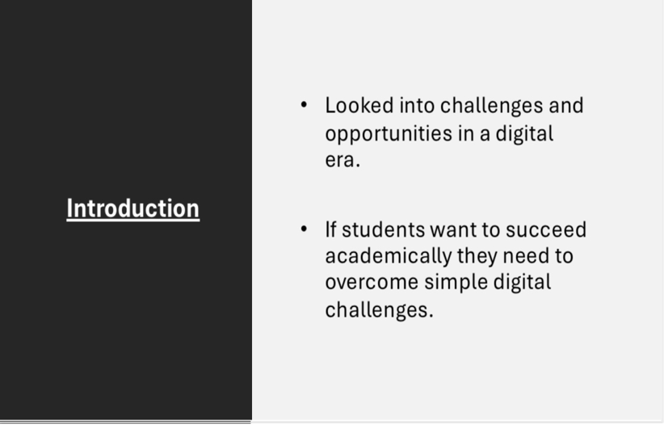

Slide 2 (Research)
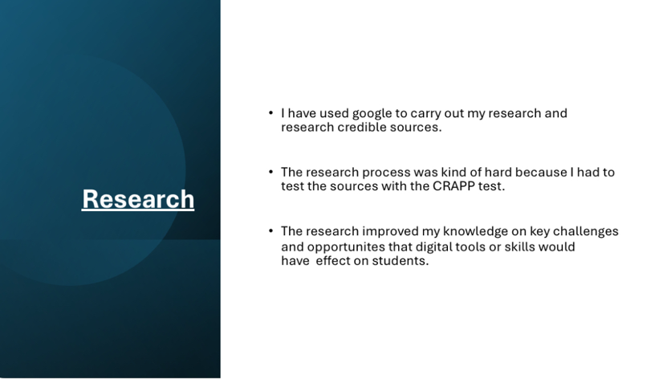

Slide 3 (Planning & Writing)

Slide 4 (Challenges)

Slide 5 (Successes)

Slide 6 (Looking Forward)

Reference List
Mohamed, N. (2023) ‘Technology in the Classroom: The Pros and Cons of Using Technology in Education’, Educatly Blog. Available at: https://www.educatly.com/blog/268/pros-and-cons-of-using-technology-in-education (Accessed: 5th November 2025).
Martin, F., Long, S., Haywood, K. ‘Digital distractions in education: a systematic review of research on causes, consequences, and prevention strategies’. Education Tech Research Dev (2025). https://doi.org/10.1007/s11423-025-10550-6
Kumar, S. (2025) ‘How the Internet is Beneficial to Students’. 21K School. Available at: https://www.21kschool.com/ua/blog/how-the-internet-is-beneficial-to-students/
Acacia University (2025) ‘How can modern educators benefit from classroom technology tools and apps?’Available at: https://acacia.edu/blog/how-can-modern-educators-benefit-from-the-best-classroom-technology-tools-and-apps/ (Accessed 5th November 2025)
Manchester Metropolitan University. (2025) ‘The best time management apps for uni students’. Available at: https://www.mmu.ac.uk/news-and-events/news/story/best-time-management-apps-uni-students (Accessed 5th November 2025)
Coursera Staff (2024) ‘AI in education: approaches and strategies for educators’. Available at: https://www.coursera.org/articles/ai-in-education (Accessed 5th November 2025)

