

Title: The Evolution and Impact of Community Mental Health Services: Challenges, Roles, and Solutions
Student Name: Merveille Baptista
Student ID: 2509566
Module code: LCHS4003
Module name: Introduction to health and social care
Lecture name: Muhammad Aliyu

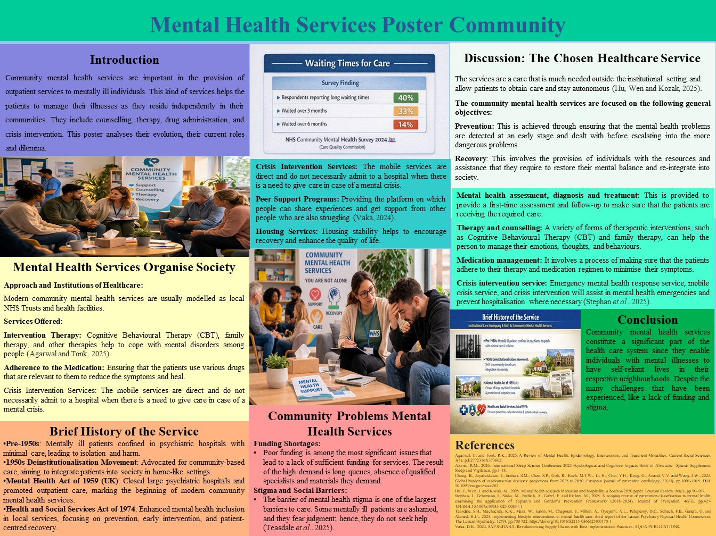

Mental Health Services Poster Community

Introduction
Community mental health services are important in the provision of outpatient services to mentally ill individuals. This kind of services helps the patients to manage their illnesses as they reside independently in their communities. They include counselling, therapy, drug administration, and crisis intervention. This poster analyses their evolution, their current roles and dilemma.

1. Discussion: The Chosen Healthcare Service
Community-based mental health services are needed among mentally ill patients. The services are a care that is much needed outside the institutional setting and allow patients to obtain care and stay autonomous (Hu, Wen and Kozak, 2025). Unlike traditional hospitals, the community mental health service providers focus on outpatient treatment; thus, the individuals can live within the communities, rather than being locked up in long-term care institutions.
The community mental health services are focused on the following general objectives:
Prevention: This is achieved through ensuring that the mental health problems are detected at an early stage and dealt with before escalating into the more dangerous problems.
Recovery: This involves the provision of individuals with the resources and assistance that they require to restore their mental balance and re-integrate into society.
Community Integration: Helping the individuals to become members of their communities and live independently, while being provided with the necessary care and support of the mental health professionals (Chong et al., 2025).
Community mental health services imply a broad range of treatment and support services, and these would include:
Mental health assessment, diagnosis and treatment: This is provided to provide a first-time assessment and follow-up to make sure that the patients are receiving the required care.
Therapy and counselling: A variety of forms of therapeutic interventions, such as Cognitive Behavioural Therapy (CBT) and family therapy, can help the person to manage their emotions, thoughts, and behaviours.
Medication management: It involves a process of making sure that the patients adhere to their therapy and medication regimen to minimise their symptoms.
Crisis intervention service: Emergency mental health response service, mobile crisis service, and crisis intervention will assist in mental health emergencies and prevent hospitalisation where necessary (Stephan et al., 2025).
Mental health services provided in the community are more oriented towards preventive care, under which mental illnesses are detected at the initial stages, and an attempt is made to stem the vice before it turns into an acute condition.

2. Brief History of the Service
It is Institutional Care Inadequacy and Community Mental Health Services Shift.
The mentally ill have been confined in psychiatric hospitals for ages, and the treatment was just the bare minimum, not to mention the isolation of the mentally ill patients. This form of institution was perceived to be unhelpful and harmful towards the long-term well-being of the patients towards the 1950s.
The deinstitutionalisation movement held that there was a need to transition to community-based care, and that patients would be better served in home-like settings, where they would be assimilated into society rather than being isolated.
The move was prescribed by the Mental Health Act of 1959 in the United Kingdom, which closed down large inpatient psychiatric hospitals and promoted outpatient care services (Alomri, 2026). At this point, modern society began its community mental health services. The Health and Social Services Act of 1974 still enhanced the inclusion of mental health care in the local health service and led to the focus on prevention, early intervention, and patient-centred recovery. 3. The Service is currently operated in the following way.

Mental Health Services Organise Society
Approach and Institutions of Healthcare:
Modern community mental health services are usually modelled as local NHS Trusts and health facilities. These services follow a multi-disciplinary model, which entails the treatment of people in a holistic manner, inclusive of psychiatrists, psychological workers, mental health nurses and social workers.
Services Offered:
Intervention Therapy: Cognitive Behavioural Therapy (CBT), family therapy, and other therapies help to cope with mental disorders among people (Agarwal and Tonk, 2025).
Adherence to the Medication: Ensuring that the patients use various drugs that are relevant to them to reduce the symptoms and heal.
Crisis Intervention Services: The mobile services are direct and do not necessarily admit to a hospital when there is a need to give care in case of a mental crisis.
Peer Support Programs: Providing the platform on which people can share experiences and get support from other people who are also struggling (Vaka, 2024).
Housing Services: Housing stability helps to encourage recovery and enhance the quality of life.
Such services can be predicted to be affordable, community-based, and patient-centred, and consider individual abilities and provide the necessary assistance. 4. Two Things the Service Must Struggle with.

Community Problems Mental Health Services
Funding Shortages:
Poor funding is among the most significant issues that lead to a lack of sufficient funding for services. The result of the high demand is long queues, absence of qualified specialists and materials they demand.
Stigma and Social Barriers:
The barrier of mental health stigma is one of the largest barriers to care. Some mentally ill patients are ashamed, and they fear judgment; hence, they do not seek help (Teasdale et al., 2025). This is especially dangerous in the marginalised communities where even the cultural attitudes lead to discrimination.

Conclusion
Community mental health services constitute a significant part of the health care system since they enable individuals with mental illnesses to have self-reliant lives in their respective neighborhoods. Despite the many challenges that have been experienced, like a lack of funding and stigma, such services are on the rise to offer the required services that enhance the recovery and quality of life of the service users.

Task 2: Community Mental Health Services Essays
1. Community Mental health Services: History and Foundational background
The community mental health services are due to the deinstitutionalization movement in the mid-20th century. Mentally ill individuals used to be enclosed in large mental asylum centers where there were minimal attention and care was paid to them, and they were not able to cooperate with other individuals. It was observed by the 1950s that this model was not effective and that patients were not getting proper care and were being deprived of society.
To this, the research works following came up with the postulation that patients can be fit to heal better within less restrictive community-based settings, provided the appropriate support (Hu, Wen and Kozak, 2025). The most significant was the transformation associated with the Mental Health Act of 1959 in the UK, which encouraged the shutdown of large psychiatric facilities and the emergence of outpatient care services. This act enabled patients to be attended to in friendly places that were familiar to them. It was also reinforced by the support of the Health and Social Services Act of 1974, which set up mental healthcare services within the local healthcare systems, and, therefore, it had eased access to services.
The very process of deinstitutionalisation, though expected to enhance care further, had its dark side. There were high cases of psychiatric hospitals closing and leaving behind an insignificant community infrastructure to manage the individuals being released. The products were homelessness, lack of resources, and marginalisation.
2. Critical Assessment of the Service Operation as it Now Looks
Community mental Health Care services, especially the National Health Service (NHS) in the UK, are services that have a wide variety of services such as psychotherapy, drug treatment, crisis management, and peer support in modern society (Kechi et al., 2025). The psychiatrists, psychologists, as well as the social workers, in liaison with the mental health nurses, are the multi-disciplinary teams that participate in the process of this process in order to meet the many needs of the patients. They have been instrumental in enhancing access to care as well as giving individuals sustainable care via the well-known settings.
However, challenges persist. The number of services demanded has increased tremendously in most cases, and it exceeds supply. In the NHS Community Mental Health Survey 2024, he had to wait more than three months to see the first time and over 14 months to see the first time. The other major problem is financial deficit and the workforce in rural settings, where there are insufficient services.
The challenges, however, do not imply that mental health provided within communities is not needed. They have taken precautions by putting the people who provide patients with control over their conditions in their societies (Wu et al., 2025). Nevertheless, underinvestment and lack of human resources still affect the service provision process, and it becomes difficult to meet the increasing demand for mental health support.
3. Significance of Integrated Well-being of Service users
Community-based mental health services are essential towards enhancing the lives of mentally ill individuals. The services allow the affected patients to live a normal life, because they are attended to in their respective homes, which is part of the minimization of isolation. Person-centered care (nursing individualised care) results in holistic care and participatory interactions, which eventually result in optimal recovery.
Early intervention and prevention are important because problems in mental health can be solved at a tender age, thus they can not deteriorate (Shi et al., 2025). The services of peer support also assist in linking people to people, thereby removing loneliness. Nonetheless, these factors, such as unreliable access to the rural setting and stigma, specifically in the marginalised group, may hinder the treatment process and interfere with the healing process.

References
Agarwal, U. and Tonk, R.K., 2025. A Review of Mental Health: Epidemiology, Interventions, and Treatment Modalities. Current Social Sciences, 3(1), p.E2772316X373662.
Alomri, R.M., 2026. International Sleep Science Conference 2025 Psychological and Cognitive Impacts Book of Abstracts—Special Supplement. Sleep and Vigilance, pp.1-18.
Chong, B., Jayabaskaran, J., Jauhari, S.M., Chan, S.P., Goh, R., Kueh, M.T.W., Li, H., Chin, Y.H., Kong, G., Anand, V.V. and Wang, J.W., 2025. Global burden of cardiovascular diseases: projections from 2025 to 2050. European journal of preventive cardiology, 32(11), pp.1001-1015. DOI: 10.1093/eurjpc/zwae281
Hu, F., Wen, J. and Kozak, M., 2025. Mental health research in tourism and hospitality: a Horizon 2050 paper. Tourism Review, 80(1), pp.90-107.
Hu, F., Wen, J. and Kozak, M., 2025. Mental health research in tourism and hospitality: a Horizon 2050 paper. Tourism Review, 80(1), pp.90-107.
Kechi, I.A., Inungu, J., Jayaraman, R. and Mumford, V.E., 2025. Utilisation of mental health services among Black African immigrants in the US: Integrative literature review. Electron J Gen Med. 2025; 22 (5): em685 [online] https://doi.org/10.29333/ejgm/16749
Shi, M., Rostami-Tabar, B. and Gartner, D., 2025. Looking for the crystal ball in unscheduled care: a systematic literature review of the forecasting process: M. Shi et al. Health Care Management Science, 28(3), pp.548-564.
Stephan, J., Gehrmann, J., Sinha, M., Stullich, A., Gabel, F. and Richter, M., 2025. A scoping review of prevention classification in mental health: examining the application of Caplan’s and Gordon’s Prevention Frameworks (2018–2024). Journal of Prevention, 46(3), pp.427-454.DOI:10.1007/s10935-025-00834-1
Teasdale, S.B., Machaczek, K.K., Marx, W., Eaton, M., Chapman, J., Milton, A., Oyeyemi, A.L., Pelupessy, D.C., Schuch, F.B., Gatera, G. and Ahmed, H.U., 2025. Implementing lifestyle interventions in mental health care: third report of the Lancet Psychiatry Physical Health Commission. The Lancet Psychiatry, 12(9), pp.700-722. https://doi.org/10.1016/S2215-0366(25)00170-1
Vaka, D.K., 2024. SAP S/4HANA: Revolutionising Supply Chains with Best Implementation Practices. AQUA PUBLICATIONS.
Wu, S., Falk, K. and Myklebust, T., 2025. Beyond safety: barriers to shared autonomous vehicle utilisation in the post-adoption phase—Evidence from Norway. World Electric Vehicle Journal, 16(3), p.133. https://doi.org/10.3390/wevj16030133

