Ben Rowland-Jones (2213554)
2213554@student.uwtsd.ac.uk
2d diffusion equation model using explicit finite difference method
ACMA6012 Computational Methods

Table of Contents
1.0 Introduction 2
2.0 Main Findings 3
2.1 The Heat Equation 3
2.2 Numerical Method used to Discretise Equation 4
2.2.1 Difference Approximations 4
2.2.2 Explicit Finite Difference Method 6
2.3 Initial and Boundary Conditions and Analytical Solution 8
2.3.1 Initial and Boundary Conditions 8
2.3.2 Analytical Solution 9
2.4 MATLAB Code Structure 10
2.5 Code Validation 14
2.6 Sensitivity Analysis 16
2.7 Limitations 20
2.7.1 Numerical Method Limitations 20
2.7.2 Coding Limitations 21
2.8 Improvements 22
3.0 Conclusion 23
4.0 Bibliography 24
5.0 Appendix 26

1.0 Introduction

This report outlines the use of the Explicit Finite Difference method to be able to model the heat diffusion equation in 2D using MATLAB software. This method turns a complex and continuous problem into a numerical equation, which enables the simulation of the diffusion equation to the desired parameters.
The report will be split into nine sections, each including all elements needed for the MATLAB simulation to function correctly, these sections are:
- Heat equation
- Numerical method
- Conditions and analytical solution
- The code
- Code validation
- Results analysis
- Limitations
- Suggested improvements
- Conclusion
The aims of this project are to successfully model heat diffusion across an aluminium plate with known boundary conditions using a numerical solution of a differential equation in MATLAB. It also aims to check the outcome of the MATLAB code against an analytical solution to be able to discern any and all differences.
The objectives of this project are to write a MATLAB code that works out the thermal diffusivity of aluminium, prompts user inputs for conditions, sets boundaries, creates matrices, runs initial temperatures through the finite difference method (FDM) equation and then display the outcome graphically.

2.0 Main Findings

2.1 The Heat Equation
The heat diffusion equation is as follows:
$$\frac{∂^{2}T}{∂x^{2}}+ \frac{∂^{2}T}{∂y^{2}}= \frac{ρ × c_{p}}{k} × \frac{∂T}{∂t}$$
$\frac{∂^{2}T}{∂x^{2}}$ and $\frac{∂^{2}T}{∂y^{2}}$ are the secondary derivatives of temperature T with respect to x and y respectively, and $\frac{∂T}{∂t}$ is the first derivative of temperature T with respect to time t.
T is the temperature at point x/y and t denotes time. the Greek symbol $ρ$ (rho) is the density of the material, $c_{p}$ is the uniform specific heat and k is the thermal conductivity of the given material. The equation without a heat source:
$$\frac{∂^{2}T}{∂x^{2}}+ \frac{∂^{2}T}{∂y^{2}}= \frac{1}{α} × \frac{∂T}{∂t}$$
$\frac{∂^{2}T}{∂x^{2}}$ and $\frac{∂^{2}T}{∂y^{2}}$ are secondary derivatives of temperature T with respect to x and y and $\frac{∂T}{∂t}$ is the first derivative with respect to time t. Alpha $α$ represents the thermal diffusivity of a given material which can be written as $k ÷(ρ × c_{p})$ or $\frac{ρ × c_{p}}{k}$.

2.2 Numerical Method used to Discretise Equation

2.2.1 Difference Approximations
The Taylor series is a way to denote a mathematical function that uses an infinite amount of terms calculated from values attained using the derivatives at a given point (Hartman, 2024). In some cases, a function $f(x)$ about $x=x_{0}$ can be written as:
$$f\left(x\right)=f\left(x_{0}\right)+f^{'}\left(x_{0}\right).\frac{{(x-x_{0})}^{1}}{1!}+f^{''}\left(x_{0}\right).\frac{{(x-x_{0})}^{2}}{2!}+f^{'''}\left(x_{0}\right).\frac{{(x-x_{0})}^{3}}{3!}+f^{\left(4\right)}\left(x_{0}\right).\frac{{(x-x_{0})}^{4}}{4!}…$$
At $x_{0}=0$, the above equation is known as the Maclaurin series which is a unique case in the Taylor series; this occurs when the expansion is centred about $x= 0$ (Simpson, 2024). Another Taylor series that links the value of point $x_{0}$ to the value of a nearby point $(x_{0}+h)$ is given by:
$$f\left(x_{0}+h\right)=f\left(x_{0}\right)+h.f^{'}\left(x_{0}\right)+\frac{h^{2}}{2!}f^{''}\left(x_{0}\right)+\frac{h^{3}}{3!}f^{\left(3\right)}\left(x_{0}\right)+…$$
Now that some point $h$ has been introduced to the equation, one can now use it to derive the forward difference approximation to $f'(x_{0})$. The equation for the forward difference approximation is below (Kaw, 2024):
$$f^{'}\left(x_{0}\right)≈ \frac{f\left(x_{0}+h\right)-f(x_{0})}{h}$$
This approximation becomes more accurate as $h$ decreases in size, but it is still just an approximation, one that could be made more accurate using the backward difference approximation, which can be written as:
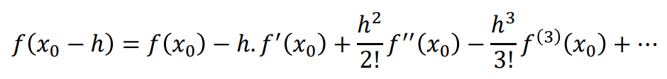
Where the function $h$ is now going in the negative direction as it is the backward approximation, the final form of which is shown below:
$$f^{'}\left(x_{0}\right)≈\frac{f\left(x_{0}\right)-f\left(x_{0}-h\right)}{h}$$

By combining the two equations above:
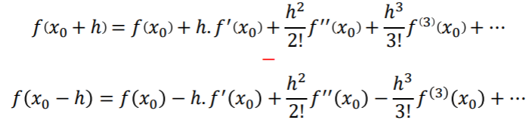
Which gives:
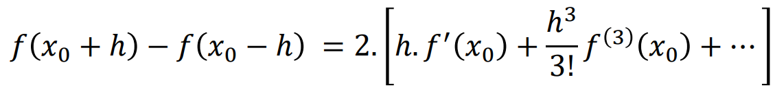
Which would can be rearranged to give the central difference approximation:
$$f'(x_{0})≈\frac{f\left(x_{0}+h\right)-f(x_{0}-h)}{2.h}$$
This approximation is the most accurate of the three as it takes the average of both forward and backward differences in its approximation (Kaw, 2024). A similar process can be followed to derive the central difference approximation to the second order derivatives. By adding the following equations:
$$f\left(x_{0}+h\right)=[f\left(x_{0}\right)+h.f^{'}\left(x_{0}\right)+\frac{h^{2}}{2!}f^{''}\left(x_{0}\right)+\frac{h^{3}}{3!}f^{\left(3\right)}\left(x_{0}\right)+…]$$
and
$$f\left(x_{0}-h\right)=[f\left(x_{0}\right)-h.f^{'}\left(x_{0}\right)+\frac{h^{2}}{2!}f^{''}\left(x_{0}\right)-\frac{h^{3}}{3!}f^{\left(3\right)}\left(x_{0}\right)+…]$$
Rearranged to give:
$$f''(x_{0})≈\frac{f\left(x_{0}+h\right)-2.f\left(x_{0}\right)+f(x_{0}-h)}{h^{2}}$$

2.2.2 Explicit Finite Difference Method
This method was utilised in this report to solve differential equations by approximating derivatives using finite differences (Ramos, 2006).
Using the terms and functions above and the explicit finite difference method, one can replace the temporal first derivative in the heat diffusion equation by utilising the forward difference approximation to give:
$$\frac{∂T}{∂t}=\frac{T_{P}^{t+∆t}-T_{P}^{t}}{∆t}$$
$T_{P}^{t}$ represents the current temperature at location $P$ at time $t$ and $T_{P}^{t+∆t}$ represents the exact same location $P$ but at the next sequential time step. The spatial second derivative terms in the heat diffusion equation can be replaced using the central difference approximation to give the following equations:
$$\frac{∂^{2}T}{∂x^{2}}=\frac{T_{E}^{t}-2.T_{P}^{t}+T_{W}^{t}}{h^{2}}$$
$$\frac{∂^{2}T}{∂y^{2}}=\frac{T_{N}^{t}-2.T_{P}^{t}+T_{S}^{t}}{h^{2}}$$
Where $T_{E}^{t}$, $T_{W}^{t}$, $T_{N}^{t}$, and $T_{S}^{t}$ are temperatures at the East, West, North and South points respectively at time $t$ and $h$ represents the distance between the four points. The discretisation of the spatial domain is done using uniformed grid spacing, denoted by $h$ as above, where the size of $h$ is dictated by the user inputs. The discretisation of the temporal domain is accomplished by dividing the time interval into a set of discrete time steps, denoted by $∆t$ as above. Substituting the above into the heat equation will give the explicit finite difference equation:
$$T_{P}^{t+∆t}=F_{0}(T_{E}^{t}+T_{W}^{t}+T_{N}^{t}+T_{S}^{t}-\left(4-\frac{1}{F_{0}}\right).T_{P}^{t})$$
Where $F_{0}$ is an expression which represents $\frac{α.∆t}{h^{2}}$ and is used as part of a stability criterion limit in the finite difference method. This number is used when adding a check to the code to ensure that the user does not input a timestep that would exceed the stability criterion which, when $α$ and $h$ are fixed it gives the following criterion:
$$0< F_{0} ≤0.25$$

2.3 Initial and Boundary Conditions and Analytical Solution

2.3.1 Initial and Boundary Conditions

2.3.1.1 Initial Condition

The initial domain condition can be denoted by $T\left(x,y,0\right)=0$, which means that at initial time $t$ all points on the plate between $x$ and $y$ are zero; ergo the entire plate starts at 0⁰C.

2.3.1.2 Boundary Conditions

The boundary conditions specify the heat flux set on the eastern and western boundaries over the time period; the eastern and western boundary condition can be given as:
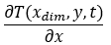
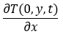
Neither boundary has heat flux across it, meaning the temperature beyond these boundaries does not increase or decrease; ergo both boundaries are perfectly insulated and no heat will transfer. These boundary conditions are in effect from $0<y<Y_{dim}$ and from $0<t<thermal equilibrium$ meaning until the plate reaches thermal equilibrium.
The northern boundary of the plate is fixed at a constant temperature from $0≤x≤X_{dim}$ and $0≤t≤thermal equilibrium$ and is given by:
$$T\left(x,Y_{dim},t\right)=T_{0}$$
This equation states that the temperature $T$ is constant across $x$ and at any time $t$. Similarly, the southern boundary also is a fixed, constant temperature and can be given as:
$$T\left(x,0,t\right)={-T}_{0}$$
This equation is also fixed from $0≤x≤X_{dim}$ and $0≤t≤thermal equilibrium$ and it also explains that the temperature is held at constant temperature $-T$ across $x$ and at any time $t$. The four boundary conditions explained above can be seen graphically using the image below in Figure 1:
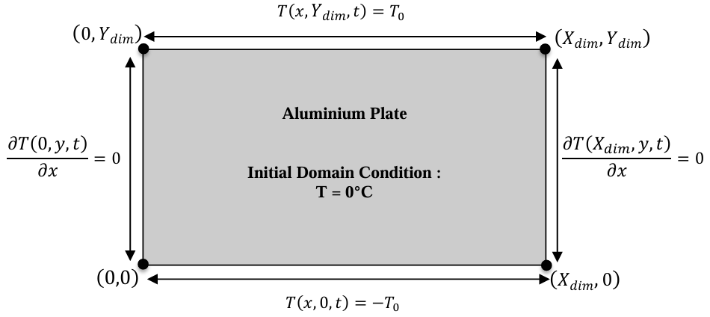
Figure 1, Initial and Boundary Conditions

2.3.2 Analytical Solution

The MATLAB code used to calculate thermal equilibrium is only an approximation and the results must be compared to an analytical solution to check how accurate the numerical solution is. The analytical solution is given by the following equation of temperature at thermal equilibrium (Chang, 2001):
$$T\left(x,y\right)={-T}_{0}+\frac{2.T_{0}}{Y_{dim}}.y+\sum_{k=1}^{∞}{(\frac{1}{{\left(100.k.π\right)}^{2}}.\left[1-{\left(-1\right)}^{k}\right].\frac{\sin\left(\frac{k.π.y}{Y_{dim}}\right)}{\sinh{(\frac{k.π.X_{dim}}{Y_{dim}}}}.[\cosh\left(\frac{k.π.x}{Y_{dim}}\right)-\cosh{(\frac{k.π.\left(x-X_{dim}\right)}{Y_{dim}})])}}$$
The above solution is derived under the assumption that certain conditions are met; conditions like uniform density, no internal heat source and a specific heat. These conditions are also built into the code and numerical solution hence why this particular analytical solution was chosen.

2.4 MATLAB Code Structure

The code used to model heat diffusion started with the calculation of thermal diffusivity of aluminium, which is $α=\frac{k}{ρ.c}$ where $α$ is the thermal conductivity, $k$ is thermal conductivity, $ρ$ is the uniform density and $c$ is the specific heat. The report brief gave the figures for all of these values and they were inputted into the code to give a calculated value of ${6.424×10}^{-5} m^{2}/s$ as shown in Figure 2:
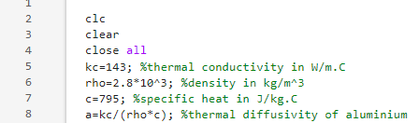

Figure 2, Thermal Diffusivity Calculation
Next, the code asked the user for the dimensions of the plate i.e. Xdim and Ydim. Checks were added to ensure both Xdim and Ydim were more than zero. The user also needs to input the grid spacing across the plate, denoted by $h$, which needed checks in place to ensure that it is more than zero, is divisible by Xdim and Ydim and is also less than Xdim and Ydim; using while loops and if statements (Figure 3):
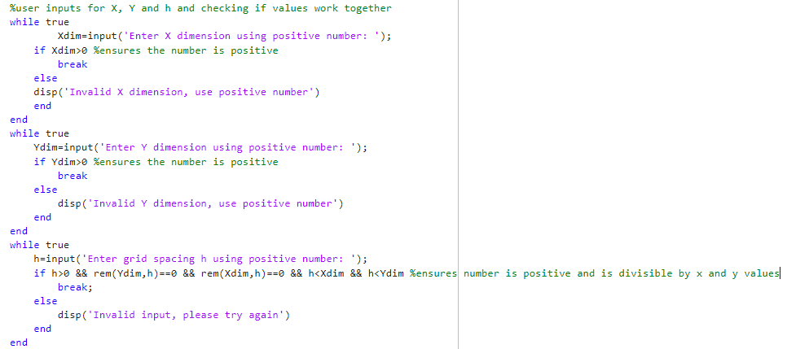

Figure 3, User Inputs for X, Y and h

The next part of the code needed to prompt the user to input the temperature for the northern boundary by using the input function. Then, the code needed to create a matrix, T1, using the inputs for Xdim and Ydim; denoted by numrows and numcols. In order to create a matrix using the user inputs but still taking into account the boundaries, numrows and numcols were created using $X_{dim}÷(h+1)$ and $Y_{dim}÷(h+1)$ respectively.
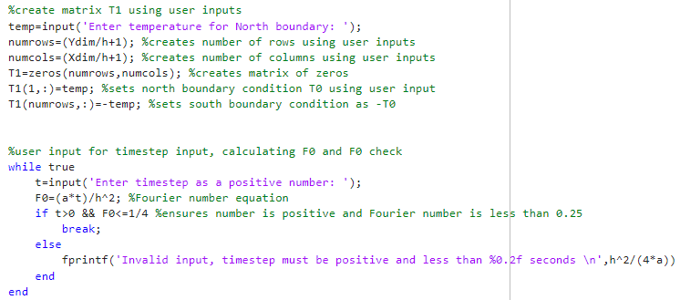
The matrix is initialised using the zeros() function and then the north boundary is set to the user inputted temperature and the reverse for the south boundary. The last part of this section of code is the user input for the timestep, again using while loops and if statements to check if the timestep is more than zero and the Fourier number generated from the timestep is less than 0.25.

Figure 4, T1 Matrix and Timestep Input
Next is the tolerance, error and the creation of T2. T_prev tells the code to not generate great quantities of matrices and ensures that only two matrices exist at any given time whilst modelling the heat diffusion.
The EFDM equation is then introduced three times ; first and second times to ensure the east and west boundaries flux is zero and thirdly for every other point on the plate. The error=max(max(abs(T2-T_prev))) line of code in Figure 5 is written to be able to calculate the maximum error between T2 and T_prev. Lastly, the first temperature map is displayed using functions such as contourf, colormap, colorbar and clim.

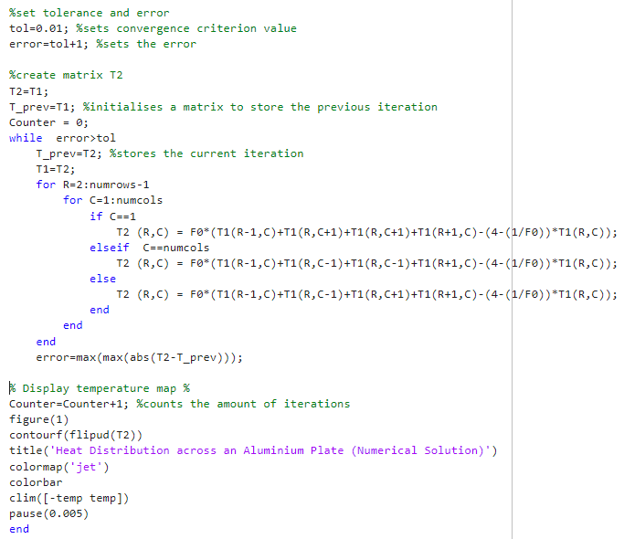

Figure 5, Matrix T2, Tolerances and Error Calculation
The next part of the code ensures that the calculations are done until thermal equilibrium is reached, then uses the fprintf function to display how long in seconds it took. The analytical solution is then introduced by first creating a third matrix TA, from there R and C are created by 1:numrows and 1:numcols respectively. Co-ordinates x and y are then created from R and C using the equations x=(C-1)*h and y=(R-1)*h respectively. The analytical solution is introduced as the variable S and is then used in the bottom line of code in Figure 6 to calculate the analytical solution for each point on the plate.
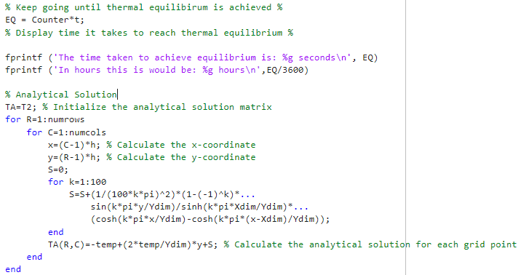
Figure 6, Analytical Solution
Lastly, as shown in figure 7, the T2 and TA matrices are displayed using the disp() function along with the TA colour map and the introduction of TD; which is the difference between the numerical and analytical solutions. This is the last section of the code and can be found below:
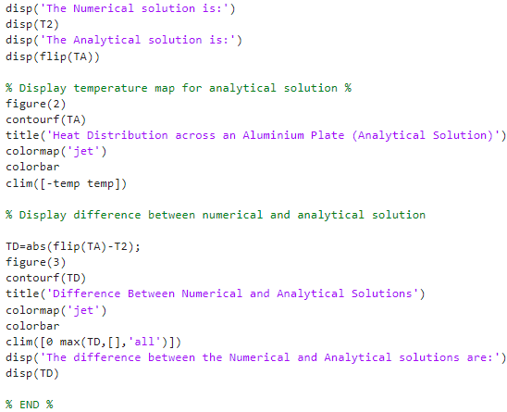
Figure 7, Temperature Maps and Matrix TD

2.5 Code Validation

In order to validate the numerical solution using the analytical equation, matrices TA and TD were created along with their corresponding heat maps. For the comparison, the plate had dimensions of 5x5, a grid spacing of one, a starting temperature of 50⁰C and a timestep of 3600 (1 hour); these parameters gave the following matrices (Figure 8) and heat maps (Figure 9):
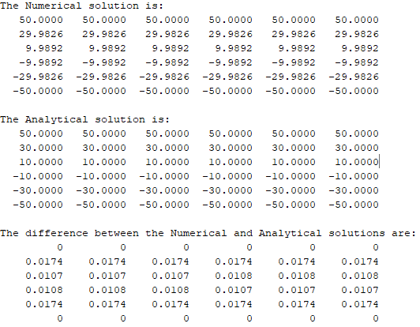

Figure 8, T2, TA and TD Matrices at 50⁰C

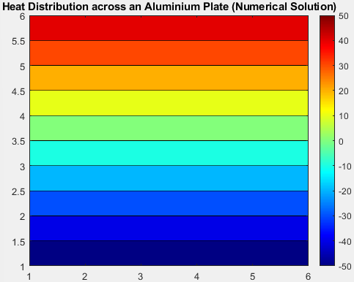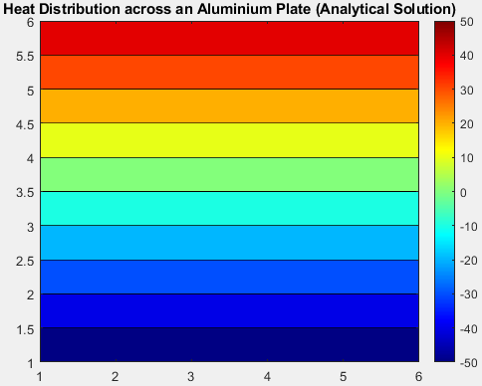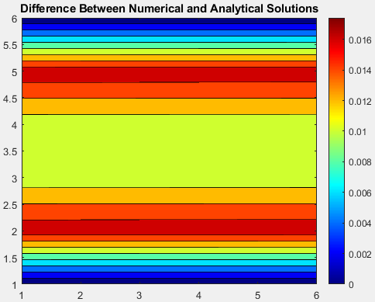
Figure 9, T2, TA and TD Heat Maps at 50⁰C
As shown, the maximum difference between the numerical and analytical solution is 0.0174 or 0.0348%. The differences between the two methods only changes minimally when changing the starting temperature, which one can see below with the matrices (Figure 10) and heat maps (Figure 11) with the starting temperature set to 500⁰C:
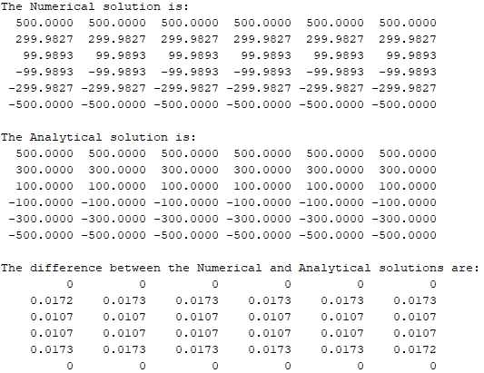
Figure 10, T2, TA and TD Matrices at 500⁰C
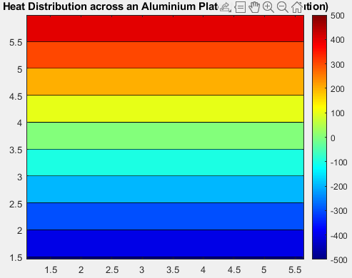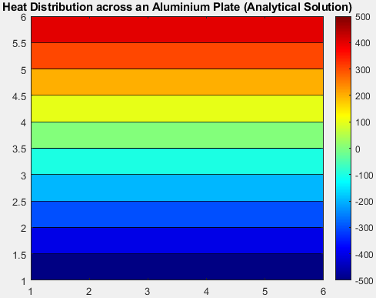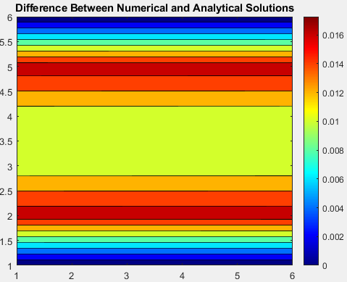
Figure 11, T2, TA and TD Heat Maps at 500⁰C
As shown, the maximum difference with the starting temperature at 500°C is 0.0173 which equates to 0.0346%, so even if the temerature increases by a substantional amount the difference between numerical and analytical is minimal.

2.6 Sensitivity Analysis

All of the following test were carried out with the plate dimensions at 12x12 and a starting temperature of 50⁰C. As the parameters are changed, the time taken to reach thermal equilibrium is recorded. The three parameters used to test sensitivity are:
- Grid spacing ($h$)
- Timestep ($∆t$)
- Tolerance
Below is the data (Figure 12) from the grid spacing sensitivity analysis, where different grid spacing was used through thirteen different test and the thermal equilibrium time was recorded to give the graph (Figure 13):
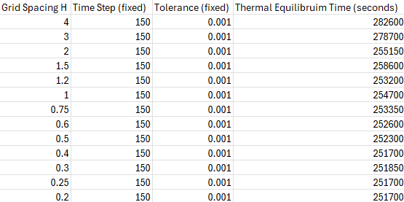
Figure 12, Grid Spacing Data
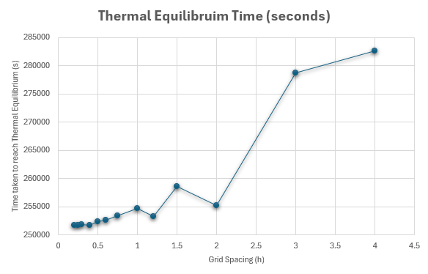
Figure 13, Grid Spacing Graph
As the grid spacing increases, the time taken to reach thermal equilibrium also increases due to the amount of grid points across the plate has decreased, meaning the model is coarser and hence the model becomes more inefficient. Also, as the grid spacing increases, so does the size of any errors.
Next, the timestep was altered in ten iterations from 2000 to 25 seconds; the data and graph can be found in Figures 14 and 15 below:
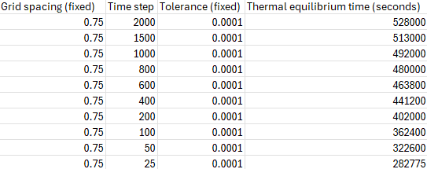
Figure 14, Timestep Data

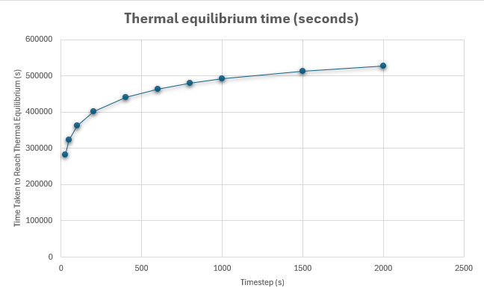
Figure 15, Timestep Graph
As the timestep increases so does the time taken to reach thermal equilibrium but each point is taking less time than the last. Meaning that eventually the time taken to reach thermal equilibrium will be a miniscule value and hence, the larger the timestep, the less stable the numerical solution becomes less stable, ergo the time taken to reach equilibrium takes longer to compensate (Rose, 2025).
Finally, the tolerance was altered from 0.1 down to 0.0000001 and measured against the thermal equilibrium time. The data and graph can be found in Figures 16 and 17 below:
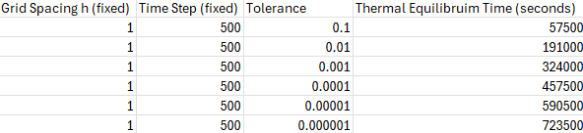
Figure 16, Tolerance Data
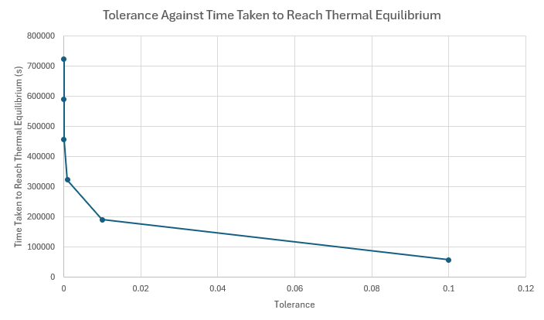
Figure 17, Tolerance Graph
From above, as the tolerance decreases the time taken to reach thermal equilibrium increases exponentially. This is because as the tolerance increases, the model needs to perform more iterations to achieve that level of accuracy. The changes to the tolerance also affect how the convergence criteria is met, as the criteria becomes more strict the model must make more calculations to suit thus slowing down the modelling process.

2.7 Limitations

2.7.1 Numerical Method Limitations

2.7.1.1 Round-off Error

A computer can only approximate numbers to a certain level of accuracy before having to round-off. These round-off errors occur when computers try to calculate a large amount of calculations using arithmetic operators such as division and multiplication. Other functions such as $π$ are also approximated. The results of these calculations are often rounded up or down to reduce the load on a computers CPU and to keep it within the limits of what the computer is capable of (Kaw, Sources of Error, 2022).

2.7.1.2 Truncation Error

Truncation error is when a complex mathematical method which contains an infinite amount of terms is approximated using a finite series, ergo the terms that are not included in the approximation become the truncation error (Kaw, Sources of Error, 2022). In the scenario set out in the report, the truncation error would come from the computers approximation of the Taylor series used in the finite difference methods in section 2.2.

2.7.1.3 Complex Geometry

There are multiple aspects of modelling the heat equation in an object with complex geometry, such as the generation of the grid. If there are extreme features, this will cause the grid to be more complex, and thus having to use more sophisticated techniques or use a more powerful and hence more expensive computer (Toombes, 2011). Complex geometries will also effect the effectiveness of the numerical method; as the non-uniform grid spacing will affect the stability criterion.

2.7.1.4 Stability

As previously mentioned, the stability criterion must be met to ensure the code and model function correctly. The timestep $∆t$ must be small enough to generate a Fourier number that is less than 0.25. The timestep, along with other parameters such as grid spacing $h$ can lead to dynamic instability or chaos if the parameters are altered even slightly (Hrabovsky, 2016). Instability will also amplify any and all errors such as round-off and truncation errors as described above.

2.7.2 Coding Limitations

The way that thermal equilibrium is coded has its limitations, the biggest being how arbitrary certain parameters are such as the tolerance. As per the sensitivity analysis in section 2.6, the time taken to reach thermal equilibrium increases exponentially depending on the tolerance value that is written into the code; which indicates that the code is incredibly sensitive and great care should be taken when defining the tolerance factor.

2.8 Improvements

In order to overcome some of the limitations in section 2.7, some improvements can be made to the numerical method used to discretise the governing equation. One can use the implicit finite difference method to discretise over the explicit version. One benefit of doing this is the unconditional stability that comes with using it, meaning the timestep is not limited by its size and can be larger without effecting the stability, hence improving efficiency (Brunner, 2020).
This added stability also ensures that the modelling of complex geometries is carried out more efficiently as the errors in the calculations are decreased. This is because the added stability allows for a more accurate graphical model of complex geometries with irregular boundaries (Emmanuel, 2012).
There are also alternatives to the finite difference method, such as finite element method (FEM) and finite volume method (FVM). FEM divides a whole geometry into smaller sub-sections and, using a mesh structure, approximates over the entire domain (Papadopoulos, 2015). Advantages of this are a more accurate model of complex geometries and boundary conditions but does require more substantial computing power.
FVM uses volumes in its approximations, rather than triangles like in FEM. FVM converts these volume integrals into surface integrals to be used as fluxes within each control volume (Cardiff, 2021). The advantages of this method are that they give a more accurate model of complex geometries and can work using more unstructured meshes. The main disadvantage is that it is less accurate than FEM.
There are also considerations when choosing the way that thermal equilibrium is modelled, with certain solutions improving on the way it is modelled above. Methods such as multi-scale modelling which includes information at different levels, even extreme levels like atomic and to the macroscale, when modelling thermal equilibrium (Zhabinskaya, 2025).
There are also particle based methods of the aforementioned model, with the Lattice Boltzmann method using lattice grids and particle distribution functions to more accurately model complex heat transfer problems (Zhabinskaya, 2025).

3.0 Conclusion

The MATLAB code that was written for this assignment successfully modelled heat diffusion across an aluminium plate in given boundaries and parameters. The code used the EFDM method to discretise the differential equation to approximate the diffusion.
The code then compared the numerical results with that of an analytical solution to be able to check the accuracy of the code and use it is validation. The code also calculates the thermal diffusivity of aluminium and prompts the user to input the physical boundaries and grid spacing along with the chosen timestep. The code also creates the required matrices and heat maps in order to review and compare the numerical and analytical solution.
The sensitivity analysis showed a comprehensive and sometimes exponential change in results when the timestep, grid spacing and tolerance were altered, meaning that this is a dynamic heat diffusion model. The limitations were also discussed, with recommendations given on how to improve the overall model by using different numerical methods such as FEM and FVM, whilst also considering more robust ways of modelling thermal equilibrium such as multi-scale modelling and the Lattice Boltzmann method.

4.0 Bibliography
Brunner, G. W. (2020). River Analysis System Hydraulic Reference Manual. CA: US ARMY CORPS OF ENGINEERS HYDROLOGIC ENGINEERING CENTER.
Cardiff, P. (2021). Thirty Years of the Finite Volume Method for Solid Mechanics. Archives of Computational Methods in Engineering.
Chang, C.-Y. (2001). Transient thermal conduction analysis of a rectangular plate with multiple insulated cracks by the alternating method. International Journal of Heat and Mass Transfer.
David W. Hahn, M. N. (2012). Heat Conduction, Third Edition. New Jersey: John Wiley & Sons Inc.
Emmanuel, F. S. (2012). On the Stability and Accuracy of Finite Difference Method for Options Pricing. International Institute for Science, Technology and Education.
Hancock, M. J. (2006). The heat and wave equations in 2D and 3D. Cambridge, Massachusetts: MIT.
Hartman, G. (2024). Calculus 3e (Apex). Virginia: Virginia Military Institute.
Hrabovsky, G. E. (2016). Numerical Modeling: Error, Stability, and Chaos. Madison: UW Madison, Department of Physics.
Kaw, A. (2022). Sources of Error. In A. Kaw, Numerical Methods with Applications. Asheville: Welcome Center of North Carolina Arboretum.
Kaw, A. (2024). Numerical Methods and Applications. South Florida: National Science Foundation.
Narasimhan, T. N. (1999). Fourier's Heat Conduction Equation: History, Influence and Connections. Indian Academy of Science.
Papadopoulos, P. (2015). Introduction to the Finite Element Method. California: Panayiotis Papadopoulos.
Ramos, J. I. (2006). Explicit Finite Difference Methods for the EW and RLW Equations. Applied Mathematics and Computation.
Rose, B. E. (2025). Climate Modelling. Albany, USE.
Simpson, R. (2024). Calculus II - Integral Calculus. San Francisco: Cosumnes River College.
Toombes, L. (2011). Numerical Limitations of Hydraulic Models. Brisbane: The University of Queensland, School of Civil Engineering.
Zhabinskaya, D. (2025). Physics 3A. California: UCD.

5.0 Appendix

clc
clear
close all
kc=143; %thermal conductivity in W/m.C
rho=2.8*10^3; %density in kg/m^3
c=795; %specific heat in J/kg.C
a=kc/(rho*c); %thermal diffusivity of aluminium

%user inputs for X, Y and h and checking if values work together
while true
Xdim=input('Enter X dimension using positive number: ');
if Xdim>0 %ensures the number is positive
break
else
disp('Invalid X dimension, use positive number')
end
end
while true
Ydim=input('Enter Y dimension using positive number: ');
if Ydim>0 %ensures the number is positive
break
else
disp('Invalid Y dimension, use positive number')
end
end
while true
h=input('Enter grid spacing h using positive number: ');
if h>0 && rem(Ydim,h)==0 && rem(Xdim,h)==0 && h<Xdim && h<Ydim %ensures number is positive and is divisible by x and y values
break;
else
disp('Invalid input, please try again')
end
end

%create matrix T1 using user inputs
temp=input('Enter temperature for North boundary: ');
numrows=(Ydim/h+1); %creates number of rows using user inputs
numcols=(Xdim/h+1); %creates number of columns using user inputs
T1=zeros(numrows,numcols); %creates matrix of zeros
T1(1,:)=temp; %sets north boundary condition T0 using user input
T1(numrows,:)=-temp; %sets south boundary condition as -T0

%user input for timestep input, calculating F0 and F0 check
while true
t=input('Enter timestep as a positive number: ');
F0=(a*t)/h^2; %Fourier number equation
if t>0 && F0<=1/4 %ensures number is positive and Fourier number is less than 0.25
break;
else
fprintf('Invalid input, timestep must be positive and less than %0.2f seconds \n',h^2/(4*a))
end
end

%set tolerance and error
tol=0.01; %sets convergence criterion value
error=tol+1; %sets the error

%create matrix T2
T2=T1;
T_prev=T1; %initialises a matrix to store the previous iteration
Counter = 0;
while error>tol
T_prev=T2; %stores the current iteration
T1=T2;
for R=2:numrows-1
for C=1:numcols
if C==1
T2 (R,C) = F0*(T1(R-1,C)+T1(R,C+1)+T1(R,C+1)+T1(R+1,C)-(4-(1/F0))*T1(R,C));
elseif C==numcols
T2 (R,C) = F0*(T1(R-1,C)+T1(R,C-1)+T1(R,C-1)+T1(R+1,C)-(4-(1/F0))*T1(R,C));
else
T2 (R,C) = F0*(T1(R-1,C)+T1(R,C-1)+T1(R,C+1)+T1(R+1,C)-(4-(1/F0))*T1(R,C));
end
end
end
error=max(max(abs(T2-T_prev)));

% Display temperature map %
Counter=Counter+1; %counts the amount of iterations
figure(1)
contourf(flipud(T2))
title('Heat Distribution across an Aluminium Plate (Numerical Solution)')
colormap('jet')
colorbar
clim([-temp temp])
pause(0.005)
end

% Keep going until thermal equilibirum is achieved %
EQ = Counter*t;
% Display time it takes to reach thermal equilibrium %

fprintf ('The time taken to achieve equilibrium is: %g seconds\n', EQ)
fprintf ('In hours this is would be: %g hours\n',EQ/3600)

% Analytical Solution
TA=T2; % Initialize the analytical solution matrix
for R=1:numrows
for C=1:numcols
x=(C-1)*h; % Calculate the x-coordinate
y=(R-1)*h; % Calculate the y-coordinate
S=0;
for k=1:100
S=S+(1/(100*k*pi)^2)*(1-(-1)^k)*...
sin(k*pi*y/Ydim)/sinh(k*pi*Xdim/Ydim)*...
(cosh(k*pi*x/Ydim)-cosh(k*pi*(x-Xdim)/Ydim));
end
TA(R,C)=-temp+(2*temp/Ydim)*y+S; % Calculate the analytical solution for each grid point
end
end

disp('The Numerical solution is:')
disp(T2)
disp('The Analytical solution is:')
disp(flip(TA))

% Display temperature map for analytical solution %
figure(2)
contourf(TA)
title('Heat Distribution across an Aluminium Plate (Analytical Solution)')
colormap('jet')
colorbar
clim([-temp temp])

% Display difference between numerical and analytical solution

TD=abs(flip(TA)-T2);
figure(3)
contourf(TD)
title('Difference Between Numerical and Analytical Solutions')
colormap('jet')
colorbar
clim([0 max(TD,[],'all')])
disp('The difference between the Numerical and Analytical solutions are:')
disp(TD)

% END %

