Ellie Morgan
2416694
Placement- culinary skills(BMGM4002)
Lecture name-Jemma smith

I confirm that I have not used any a I tools in the research and creation of this assignment. I confirm that I have not presented any a I generated materials as my own work. I confirm I have copies of my draft notes and other resources I used which I may be asked to Provide in evidence

When I was going to my placement I was nervous as I've never done kitchen before and I'm not very confident in the kitchen either. My culinary skills are not the best I have I cannot cut in a straight line or when I do cut it goes off to a wonky line I'm good at making soups my favourite soup to make is leek and potato as it's a simple soup and the potatoes don't really need to be or even as you blend it after, sources I'm not confident with as I haven't really had the opportunities to make them but I can make a good cheese sauce, when at College that is the only time of ever used kitchen equipment But I've had the opportunity at work to use equipment like a merry chef or the deep fat fryers as majority of the things in work all frozen the only cooked things we could do is burgers, English breakfast and egg on toast or any bacon or egg rolls, but I do have the basic knife skills as in college that's when I used them the most and in work. If I have to say I'm not very confident with any of my skills I do know add as keeping to task be very difficult and also staying focused on a certain task for an significant amount of time, as I struggle with stay in focused or any type of task I need to do I don't stay focused if anyone got enjoy like baking I quite enjoy baking or making some type of soup very happy. The cook and freeze Concept I do understand it as you cook an item of food and then you leave it to cool down to round Eight to 10° us the lower it gets the more chance of bacteria growing but if you cool it down let's say 8 bacteria can still grow but it doesn't grow as fast as uncooked or really room temperature food.
The skills I do have can be used in a kitchen but they just need a little bit more practise and I need more knowledge of our kitchen work or run as I didn't get the opportunities to see a busy kitchen in college as I did my out of front diploma, instead of kitchen.
My general knowledge on health and safety in the kitchen is that the kitchen must be designed I'm built in a way that allows you to keep it clean and hygienic also they must be designed to keep pests out and flies and rats as you don't want them to contaminate the kitchen or the food, also a kitchen must have enough wash basin for the staff to wash hands as you don't want bacteria or any cross contamination to happen from one food to the next.
The safety for allergens is very to say dangerous add as you can have someone who is celiac and they get their food gets cross contaminated with gluten from bread or a cake or even just flour from bread and chicken. Allegiance needs to be the most important thing as it can kill someone, the basic knowledge that I know is if you know you have a allergen in you prepare food that is allergen free so for example they have a shellfish allergy and you know the main course has Ha prawns for example on it, you will have to clean down your station every time you make something with prawns or lobster in it and to keep it away from the main that has no shellfish on it so you know that it's going to be safe for the person who is eating it to eat and you know you won't be killing anyone accidentally because you were silly and put it near the allergen.
The food safety policy is a document that helps restaurants to ensure that food safety followed it also has a goal to prevent foodborne illnesses, The food safety procedures to keep food clean and to keep raw and cooked food Separated in fridges freezers and work surfaces. The knowledge I know for food safety Is The practise of handling, preparing and storing food to reduce the risk of illnesses the ways to stop that is to regularly wash their hands or utensils and work space, also to keep rule food away from cooked food so in the fridge you put the raw food the bottom and cook food at the top because the risk of the raw juices falling onto cooked food is very high, also to chill the food within two hours and the fridge must be set between 4 degrees and six degrees.
Staff training is important in the industry add as it can help improve guest satisfaction, training stuff can provide excellent service also knowledge of how to handle challenges.
The training can improve staff Interactions with customers as they know polite ways to speak and to have the correct attitude and knowledge to help the customers have a better understanding of menus wines and allergen's. There are 4 different ways of training one is customer service training so that helps greetings and interactions with guests ways to handle complaints and resolve conflict and understanding cultural differences and practises with different religion or diets,
Also there's operational training so that is using a point of sale system or a software also knowing protocols and food and beverage service technique so when they're behind bar they knew the correct measurements for drinks correct way to make the drinks and the correct type of drinks there could be, also the most important one is health and safety and hygiene show that knowing food safety emergency response protocols with knowing first aid on fire drills and personal hygiene and cleanliness protocols as you don't want a member of your staff having bad hygiene it can turn customers away and the last one is leadership and management training so with that one you need to know how to resolve situations with customers and also how to run a team, and making big decisions and discussions and the knowledge of financial management budgeting for supervisors. With the knowledge I know based on my experiences Is that well train staff Has the knowledge of how to run a kitchen so they have the basic knife skills and know how to cook, but being in the kitchen also gives you the opportunities to and enhance skills you already know also it can bring knew people into the industry I was like before you start from the bottom and make your way up.
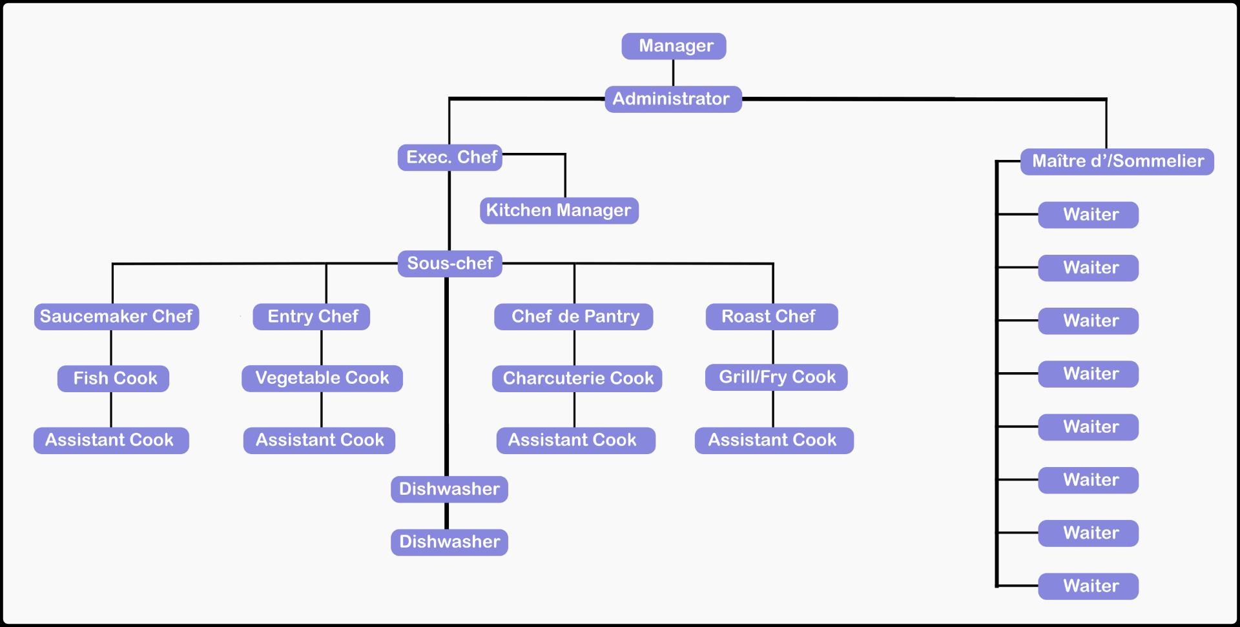
For example in the kitchen you can start from pot wash and after good couple months or even years in pot wash you look at the skills that chefs are doing so you pick up on all the techniques they use, And they also can help you work your way up, Then you can work your way up to a commie chef what they do is the little bits in the kitchen like helping out cut vegetables or making some sauces, after that one you can either go into different sections so a fish cook vegetable or grill or fry cook and you work your way through them types of section after that you could be a sous chef the run the restaurant kitchen when the head chef is not there and their job role is basically half the things that head chef does head chef think of the menu ordering and a lot more things they just pick out how to help the head chef make that great restaurant kitchen.
Delgadilo(2021)
This picture basically shows what stuff all in a restaurant with the manager and admins being the heads to a dishwasher who is starting their career at the very bottom but if they work hard enough you can make your way up to being a manager executive chef the head waiter kitchen manager is basically a head chef but in some places they do call them kitchen managers.

Reference
https://www.waiterio.com/blog/en/restaurant-staff-list/

