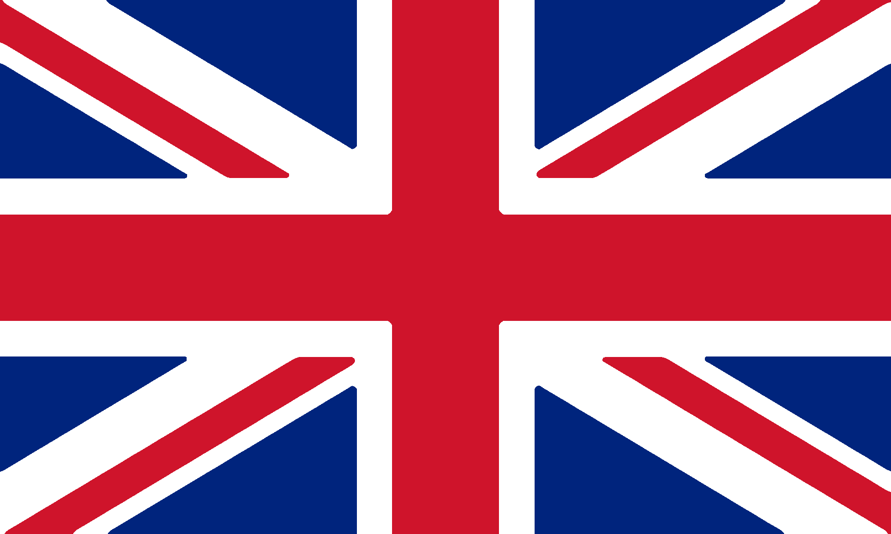
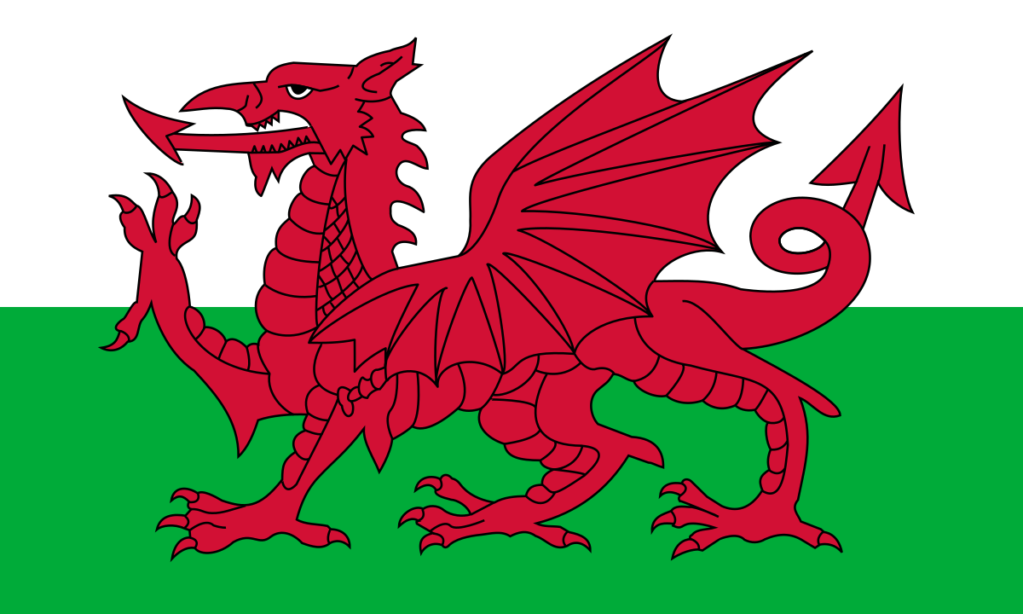
Wikipedia (1959-present)
Wikipedia (n.d)

UK Tourism and Leisure Industry
  - (BMTP4011)
Natalie Morgan | 2000728
This essay will involve a critical review of the provision of the Tourism and Leisure industry within the UK, the focal point will be of the International tourism market, as well as the inbound tourism. The UK is known to be a popular destination for the international tourism market, with figures of attracting 38 million international visitors in 2018 with an expectancy to grow by a quarter by 2025 (Gov.UK 2019). Due to this figure, the UK must continuously change and adapt in order to meet the needs and expectations of the tourism market to remain a word-class destination for visitors, ensuring Maslow’s needs and hierarchy is considered and explained within this submission to support this. Additionally, with a large number of visitors, there is a huge increase in the economy, in 2019 there were 40.9 million overseas visitors who spent £28.4 billion (VisitBritian 2019) and in 2015 inbound visitors spent £15.1 billion (VisitBritian 2015) of which further supports that tourism is one of the country’s most important industries with the input it makes.
Although the UK is made up of Wales, Scotland, Ireland and England, the focus of this paper is on the Tourism and Leisure provisions aimed at the tourism market in Wales. In addition, this essay will show how Wales has adapted to new challenges they have encountered; this includes Coronavirus.
The website “Geography in the news” states that more than one million tourists come to Wales every year, of which contribute £8 million a day during peak seasons, adding up to around £3 billion a year (Geography in the news, n.d). This is a significant amount of money which makes it vital for Wales to have different areas to suit all people’s needs and desires. Wales has various cities and villages that attract the public to visit Wales, for instance Cardiff being the capital of Wales has a Castle of 2,000 years of history, shopping arcades, Mermaid Quay that has waterfront restaurants, sightseeing activities and water sports (Great Britain, n.d). The main attraction in Cardiff being the Principality Stadium that is home to Welsh rugby, attracting an average of 1.3 million visitors per year since opening in 1999 (WRU, n.d), as well as hosting football matches and British Speedway Grand Prix.
Furthermore, Wales has breath-taking beaches with Tenby, situated in Pembrokeshire awarded “Beach of the year” in 2019 by “The Sunday Times”, extraordinary mountains such as Snowdon that people travel thousands of miles to visit, entertainment parks and National Parks, to name a few. Wales has three national parks that cover 4,122 square kilometers, which is equivalent to one fifth of Wales’s land area (UK National Parks, 2012). All three parks provide visitors with different experiences due to their uniqueness and allows them to develop their knowledge on the heritage of Wales as there are many historical and cultural sites along the way, a key tourist attraction for both International and British tourists due to the astonishing scenery.
In terms of visitors, Wales has a large tourist population, this is supported by the figures of 10,698,000 overnight domestic trips of people living in the UK travelling to Wales during 2019, generating an expenditure of £2,003 million (an increase of 6.8% from the year before), however, there was a decrease of 8.8% of day visits as there were 87,300,000 but 95.7 million the previous year, but generated an expenditure of £3,447 million (Welsh Government, 2019). Moreover, international trips to Wales rose to 1,023,000 with £515 million spent from visitors, a huge increase of 18.8% from 2018 (Welsh Government, 2019) showing Wales is a major holiday destination. However, the number of visitors has drastically changed due to the current worldwide pandemic, Covid-19. Due to Wales and different countries being on lockdown, no visitors have been allowed into the country unless it has been an essential. This puts a massive strain on businesses as tourism was their main income and many have gone out of business.
The travel and leisure industry has several stakeholders, the term stakeholders mean “a person, group or organisation is some way involved within a project” (Tourism teacher, 2020). R. Edward Freeman founded the “Stakeholder Theory” which proposes that all stakeholders should be taken into consideration when making a business decision, as well as all suppliers, employees and customers having their wants and needs cared for in order to “yield optimal results” in primary, secondary and external operations (Tourism Teacher, 2020). The three main sectors being private, public, and voluntary, all of which are organisations that work together to achieve a goal. The private sector includes private companies, partnerships, and franchise, of which is linked to inbound, outbound, and domestic tourism. The overall objective for a private sector organisation is to make profit, an example in Wales would be Oakwood in Narberth. The Public sector is government or local government controlled, it teaches, informs, and offers a service to visitors, and voluntary is often a charitable organisation that people willingly join to work that is funded mainly through their members, fundraising and donations. It aims to preserve, protect, and promote its cause.
Due to the worldwide pandemic, Covid-19, it has been crucial for the government to ensure all stakeholders within the tourism industry have special measures put in place so no major damage has/will be caused, this has been done by having restrictions to diminish interference, along with travel bans and both national and local lockdowns.
Visit Wales have put in measures and regulations for Covid-19, this is for pubs, bars, restaurants, and cafes in Wales to close by 6pm, any later than this time will have to be a takeaway, alcohol will also not be allowed to be served at any time. Individuals are not allowed to travel to areas of high prevalence and must follow all regulations when planning to travel, those in the same household are only allowed to travel together or share accommodation. All indoor attractions must close, for example museums and family play zones, however outdoor attractions can remain open with if regulations are followed, like face masks, social distancing, and stricter hygiene.
Those who live outside of Wales are not allowed into the country for any reason, apart from work., especially tier three areas in England, level three and four areas in Scotland and Northern Ireland, it is vital for individuals who live in Wales that have been in different parts of the UK or abroad must follow all regulations
Additionally, there are various impacts that affect the tourism and leisure industry, such as the climate as Wales is usually wet and rainy and sustainability; however, the industry has been heavily affected this year due to the Covid-19 outbreak. A group of Welsh tourism leaders stated that tourism in Wales is on the “brink of collapse” (BBC News, 2020), this is because of the travel ban into the country or out of local areas, during the strict lockdown people were only allowed to leave their homes for exercise or grocery shopping. A survey conducted in April and May found that 71% of businesses said they had to put their staff members on paid leave or furlough (Welsh Government, 2020), this further puts a strain on businesses, as well as being a social impact as these people were not working and not earning their full salary, meaning it add additional stress to the individual. Also, the tourism industry will take longer to develop and make a come back due to decreased staff members.
Maslow’s hierarchy of needs is a theory of five different motivational needs for an individual, often in a hierarchical order (Simply Psychology, 2020) which links to tourism by allowing different places and organisations to adapt their marketplace to suit different peoples likes and interests. The first basic need begins with physiological and safety, which then moves onto psychological needs of love and esteem, followed by self-fulfillment needs of self-actualisation which is the goal of the theory. The needs at the bottom of the five tiers must be satisfied before moving onto the next stage.
For example, the stage of physiological needs is important as individuals must have food and drink regularly, therefore all tourist destinations entail different restaurants and supermarkets to suit these requirements. Reflecting on the capital of Wales, Cardiff, it offers customers restaurants to suit all demands, such as likes, dislikes, allergies, and culture. It enhances the image of a location and increases the number of visitors, however due to Covid-19 many of these places were forced to shut, and some even went out of business, meaning that it limits individuals to certain aspects, resulting in a decrease of figures as their need and desire may not be met.
It is apparent that the tourism industry has been heavily impacted in 2020 due to Covid-19, an industry that was thriving a year ago in Wales is now struggling and unable to develop or maintain its fluidity. Coronavirus is still ongoing, there is not an end it site, excluding a talk about a new vaccine for the older generation, this means it is unknown when the tourism industry will begin to make a comeback. However, people have not been able to travel or visit places so once the restrictions have been lifted and the rate has decreased, tourism is going to rapidly increase, as well as a rise in money and jobs making the industry even stronger and successful than before. Wales, in particular, offers various activities and destinations which will attract all visitors from across the World, accommodating all ages. The website, VisitWales have effectively been trying to create solutions to lower the spread of Covid-19 in Wales and allow the tourism industry to slowly start running again, having rules for individuals is safely allowing them to have a somewhat normal lifestyle whilst preventing close interaction or putting others at risk.

References
Gov.UK (June 2019) Tourism Sector Deal. Available at Tourism Sector Deal - GOV.UK (www.gov.uk) (Assessed 22 November 2020).
Great Britain (n.d) Cardiff at a glance. Available at Cardiff | Attractions & Tourist Information | Visit Britain (Assessed 26 November 2020).
Simply Psychology (March 2020) Maslow’s Hierarchy of Needs. Available at Maslow's Hierarchy of Needs | Simply Psychology (Assessed 2 December 2020).
The Sunday Times (July 2019) Sunday Times Beach of the Year 2019: Tenby Beach. Available at Sunday Times Beach of the Year 2019: Tenby, Wales | Travel | The Sunday Times (thetimes.co.uk) (Assessed 29 November 2020).

Tourism teacher (April 2020) Stakeholders in tourism: Who are they and why do they matter? Available at Stakeholders in tourism: Who are they and why do they matter? - Tourism Teacher (Assessed 30 November 2020).

Umbrella Broker (21 October 2019) Public Sector vs Private Sector: What is the Difference for Contractors? Available at Public vs Private Sector: What’s the Difference for Contractors? (umbrellabroker.com) (Assessed 30 November 2020).

VisitBritain (n.d) Britain’s visitor economy facts. Available at Britain's visitor economy facts | VisitBritain (Assessed 22 November 2020).
Visit Wales (4 December 2020) Coronavirus: advice for visiting Wales. Available at Coronavirus: advice for visiting Wales| Visit Wales (Assessed 4 December 2020)
Welsh Government (14 May 2020) Tourism Barometer (Coronavirus- COVID19 impact survey). Available at Tourism Barometer (Coronavirus (COVID-19) impact survey): wave 3 2020 (summary) | GOV.WALES (Assessed 2 December 2020).

Welsh Government (June 2020) Wales tourism performance: 2019. Available at Wales tourism performance: 2018 | GOV.WALES (Assessed 24 November 2020).
WRU (n.d) Principality Stadium. Available at Welsh Rugby Union | Wales & Regions | Principality Stadium (wru.wales) (Assessed 26 November).
Wikipedia (1959-present) Flag of Wales. Available at 1200px-Flag_of_Wales_(1959–present).svg.png (1200×720) (wikimedia.org) (Assessed 21 November 2020)
Wikipedia (n.d) UK flag official. Available at uk-flag-official-.gif (1800×1080) (trenchlesstechnology.com) (Assessed 21 November 2020)

