Assignment #4 – Image Commentary
Past Peoples, Present Society
Rhiannon Walker

I love food, in fact I’d even say eating is my favourite part of the day. While not everyone shares this passion, there is a collective, shared fascination with food that is seen in societies and cultures across the globe. This collective importance of food can be observed through many different facets of individual societies, both past and present, but most importantly here, is its appearance in visual culture. This paper will focus on a miniature of what appears to be a royal feast in Royal MS. 14 E IV, a medieval manuscript that can be found at the British Library. Dating from c.1470-c.1480, the manuscript is highly decorated and contains the third volume of Jean de Wavrin’s Anciennes et Nouvelles Chroniques D’Angleterre, beginning with the coronation of King Richard II and ending in 1387. The manuscript was commissioned by King Edward IV of England, but the French text was copied and decorated in the south of the Netherlands. Looking specifically at the miniature found at the top of folio 265v, this project will delve into an analysis of medieval visual culture.
To begin, though there were some medieval thinkers who saw art, including manuscript illustrations, as inferior because of its sensory nature, there were others whose appreciation for it outweighed its lack of intellectual stimulation. The appreciation of the arts can be seen in the fact that a rich corpus of visual artefacts survives to this day from the Middle Ages, and from which we have been able to piece together corpus of artistic mediums and traditions. A rather prominent aspect of this culture was its manuscript art. Codices from the Middle Ages would include varying degrees of decoration, ranging from no decoration at all to ones with full-pages resplendent with gold-leaf. They could have designs in the margins or scribes writing the manuscript would have left room in the text that was later to be filled with initials or miniatures. Even within these categories of decoration, they would have been further differentiated based on the size, extent, and effort that was put into the designs. It is then important to note that “the most valued books seem to be the most highly decorated, because of the increased effort in production as well as the aesthetic effect.” These distinctions in the scope of design were then important because they largely dictated the value associated with the manuscripts.
Turning our attention then to Royal MS. 14 E IV, we see a half-page miniature found at the top of folio 265v. Given the manuscript was a project that took years to complete, the artwork has been attributed to the work of different artists. The manuscripts’ decoration and illuminations was likely begun by the Master of the Vienna and Copenhagen Toison d’Or who worked on the text c. 1470 and was finished c.1480 by a collaboration between the Master of the White Inscriptions and the Master of Edward IV, with the border decorations being largely attributed to the Master of the Harley Froissart. It is richly painted on parchment using many different colours, including different shades of blue, yellow, red, silver, white, black, brown, and green, with certain elements illuminated with gold leaf. The scene takes place in a lavish dining hall: the back and right walls are made of a light gray brick and each have a tall glass paned window, while the left wall appears to be an interior wall made of a darker gray brick. The tiled floors are a putrid looking slime-green in the center of which is a table covered by a white sheet with three platters of food (meat?) lined up along the center.
The image positions the viewer as an audience to a dinner scene where eight richly dressed people are sitting around a table laid out for a meal. In front of each person is a flat, empty, rectangular looking platter, with a knife to its left, a cup above to the right, and what I believe is a bread roll to the plate’s right. The figure with his back to those looking at the image is sitting on a backless bench that extends the length of the table while what the person to his right is sitting on is not shown (and that is if he is sitting). Everyone else at the table is seated on a tall, L-shaped banquette, that is covered in a rich blue and gold tapestry. This lavish decoration extends to the room as a whole where a similar blue-gold and red-gold fabric is draped on the wall behind the central figure of the scene, with a crest at the top, and also extends under the trumpets of the trumpeters. In doing all this, the artist has then gone to quite the effort to show the lavish nature of the dinning hall and so the overall societal importance of the people in attendance.
When it comes to the dinner guests, three of them sit on the long edge of the table facing the viewer, two then sit to their right and one is standing to the left on the two shorter ends of the table, with the final person sitting opposite the three figures with his back to the viewer. The artist also placed the dinner guests in such a way that the viewer not only has an unobstructed view of the central figure at the dinner table, but that our gaze is immediately directed towards this figure. While the placement of the figures around the dinner table was likely largely dictated by strict social and hierarchical protocols, the artist also used this as a way of highlighting the importance of this central figure in the scene.
This idea is further emphasized by that fact that he has the attention of all the figures in the room. Aside from the dinner guests, there are two standing figures seeming to simply observe the feast, looking over the shoulders of the three diners facing the viewer. There are also a few other people depicted in the foreground of the image with their backs to those seeing the image. There are two people waiting on and serving those at the table and a guard by the door to the room holding a spear. Once again, the positioning of the figures here holds a lot of significance: the artist purposefully paints them with their backs either mostly or fully to the viewer to combat the importance that might be ascribed to them given their prominent positioning in the foreground of the scene. The inverse of this is seen in the background, where two trumpeters stand by the other entrance to the dinner area, facing the dinner table. Their placement all the way in the background of the image, as well as the fact that they are not directly facing the viewer, marks them as less important, worthy of our attention, and likely their lower placement on the hierarchy.
In contrast to this, the artist establishes the social importance of the central dinner guest through the same techniques. Not only is the central dinner guest at the table the only figure to be fully facing and looking at the viewer of the manuscript image, but all the other people in the scene, be they dinner guests, observers, or servants. have their gazes directed toward the central figure on the far side of the dinner table. The artist uses not only the placement and positioning of the figures in the scene to direct our gaze to and emphasize the importance of the central dinner guest, but also accomplishes this by showing all the other people in the scene doing this as well. These artistic techniques and colourful pigments then speak to the images’ worth and the wealth it ascribes to the manuscript it is housed in – “the higher the status of a manuscript and the richer the patron for whom it was made, the more complex would be the process of its production and the larger the number of techniques and pigments involved.”
The significance of this miniature is then intimately tied to the manuscript it is found in and works with the text as a means of communication. At its most basic level, the image illustrates a scene from the text to tell a story of food in the Middle Ages and the social customs that surround it. That being said, manuscript illustrations elevated a simple text to a work of art that served not only to feast the eyes, but were also used to comment, highlight, and bring to life important, relevant, or memorable elements of the texts they accompanied. Among the many different historical anecdotes and moments presented in the manuscripts’ text, this feast was among the few that were chosen to be illustrated. At a time when page space was at a premium, that this particular scene was designated half of a page shows the importance that it must have had for the person commissioning the manuscript. The miniature not only acts as a symbol of its patron’s wealth and social importance, but also highlighted the importance he put on this scene.
It is also important to note and mention the political nature of this importance. When it came to politics and ideas of power and authority, medieval thinkers “used all the media available to them – manuscripts or printed books, [as well as] visual artefacts (…) in order to put forward their own opinions.” Through these discourses took place in different types of texts from the 12th century onwards, including historical texts such as that seen in Royal MS.14 E IV of the past both far and near, “in all these works, these textual lessons (…) would often be accompanied by visual lessons in the form of either miniatures in a manuscript, woodcuts in the early printed book, or….”. Though illustrating a segment of the text, the image on folio 265v likely also acts as a platform for its patron, King Edward IV, to put forward and communicate his political views. While the text may have been copied, the textual content and historical narrative pre-determined, it is through the illustration that King Edward IV can add his own perspective and put forward his authority and power in society.
The importance of manuscript illustrations in medieval society was more than merely an appreciation of aesthetics: they were an important means of communication in a world where large portions of the population were illiterate. Medieval artists drew on the symbolic and artistic techniques available to them to create complex images whose many individual components worked together to create a visual narrative. This narrative was shaped by the hand that drew it as well as the figure behind its creation and was communicated to its audience. This audience may have been any future readers of the text, whether contemporary with its production or in the years following, but it also included society as a whole. The manuscripts mere existence and creation was a testament to a person’s wealth and standing in society and, in this way, it found a larger audience in the community in which it circulated. This complex creation is then inextricably tied to the society it was created and intended for, but when it comes to this particular image, it is important to ask: to what extent does it portray the court of Richard II as opposed to the agenda of those from the 1470s-1480s. It would be interesting for future research to explore this image through the idea of art historiography: to what extent does the image portray a feast in the court of Richard II as opposed to what those who came a century later saw as the historical feast?

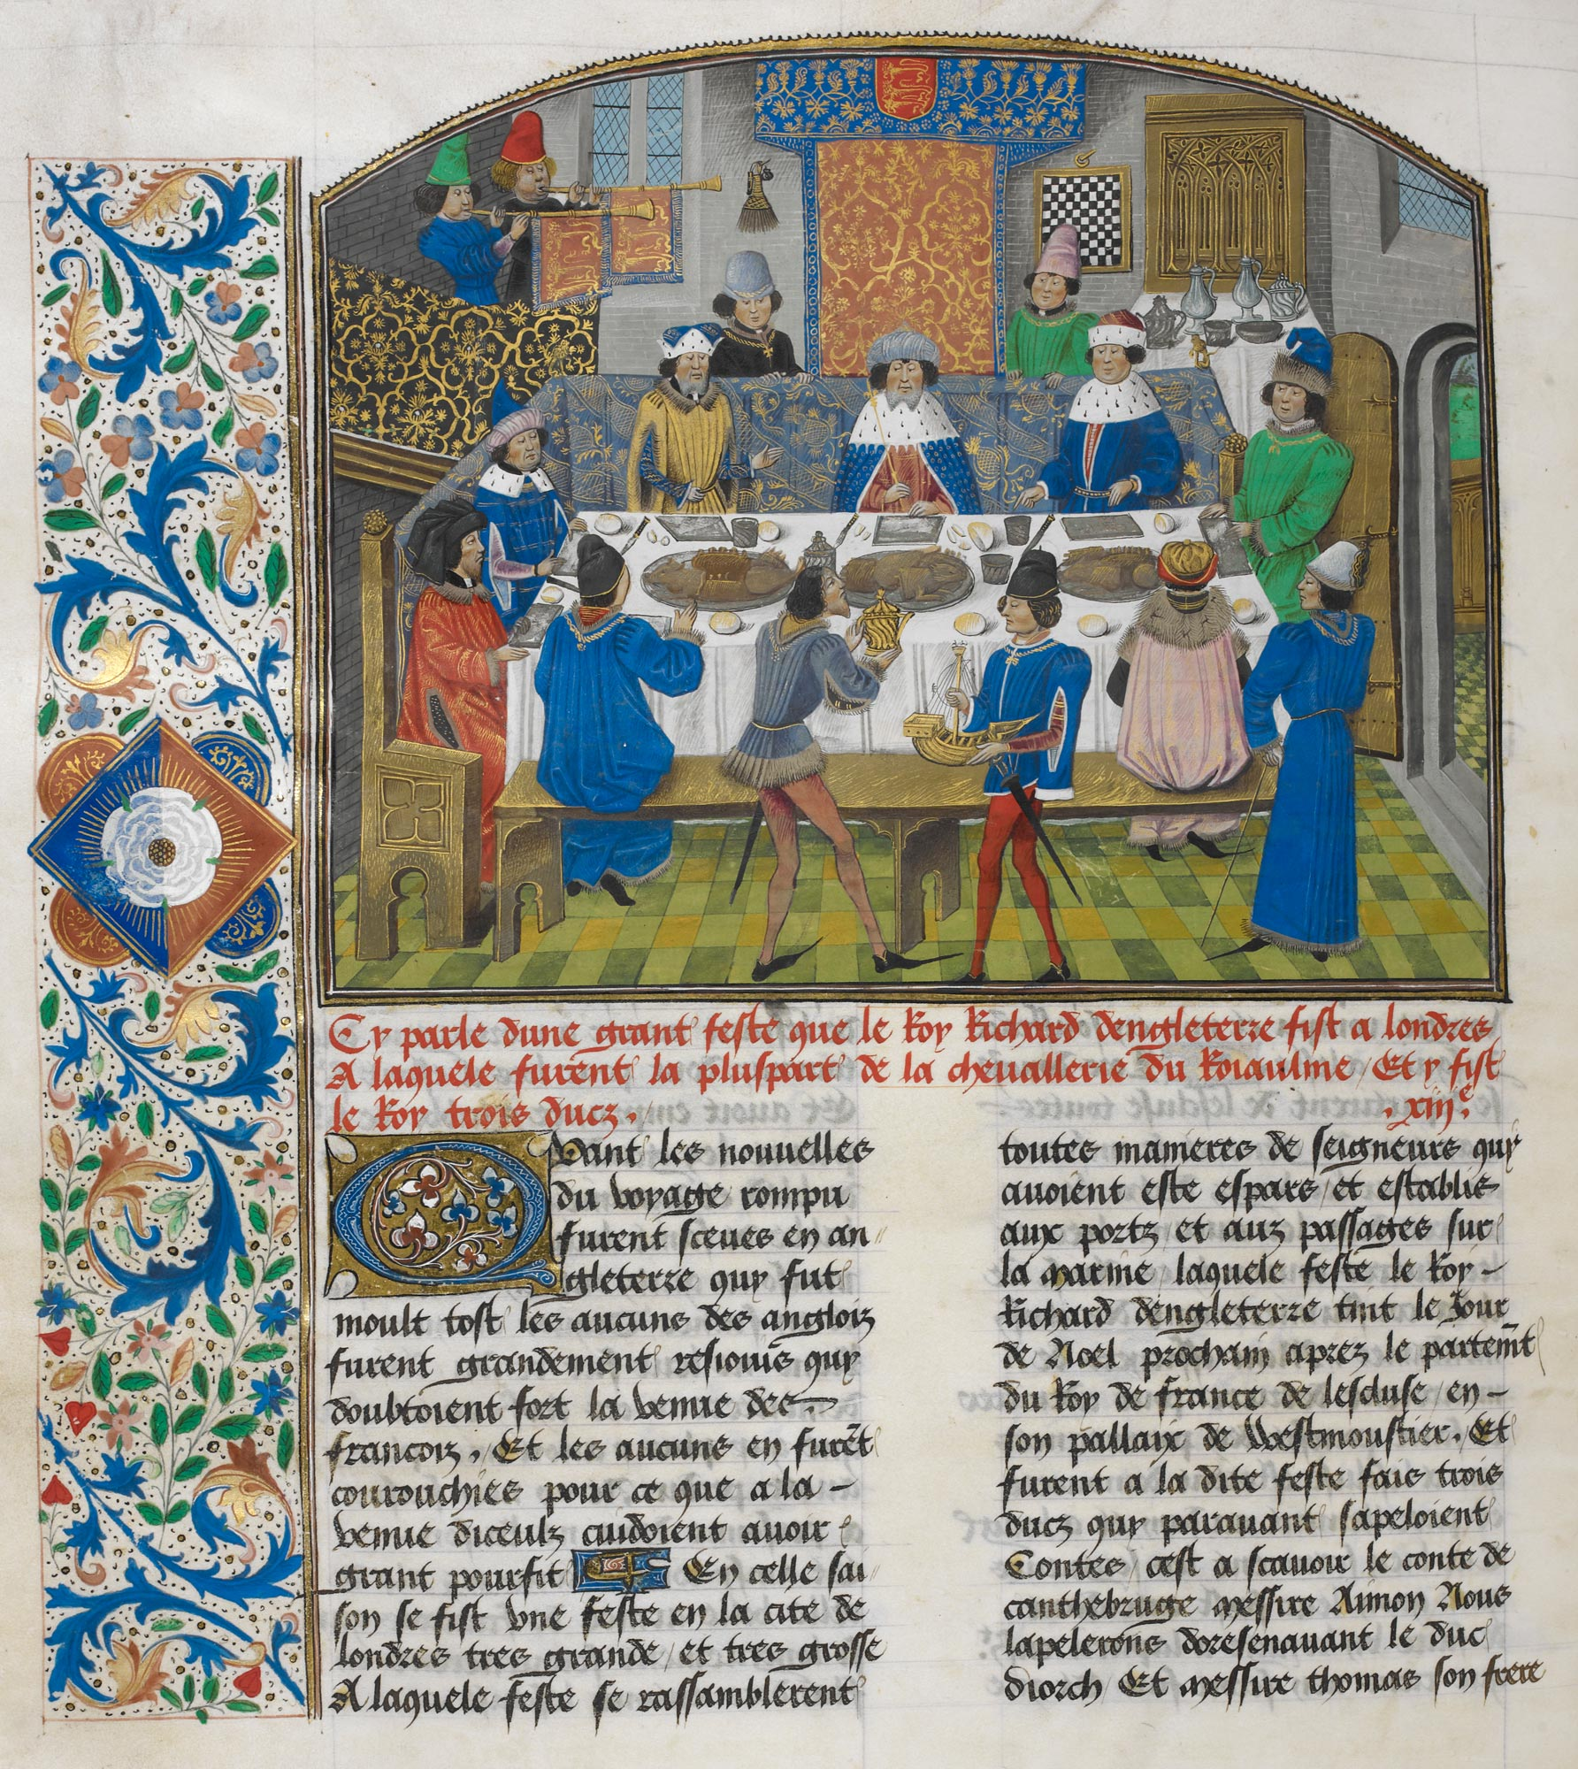

Bibliography

Brown-Grant, Rosalind. “Introduction” in Textual and Visual Representation of Power and Justice in Medieval France, Manuscripts and Early Printed Books. Ed. by Brown-Grant, Rosalind, Ann D. Hedeman, & Bernard Ribemont. Surrey: Ashgate Publishing Company, 2015.
Clemens, Raymond & Timothy Graham. Introduction to Manuscript Studies. Ithaca and London: Cornell University Press, 2007.
London. The British Library (Online). Royal MS. 14 E IV. Ff. 265v. Accessed 29/11/22.
Olsen, Mary C. Fair and Varied Forms: Visual textuality in Medieval Illustrated Manuscripts. New York and London: Routledge, 2003.
Rust, Martha Dana Rust. Imaginary Worlds in Medieval Books: exploring the manuscript matrix. New York: Palgrave MacMillan, 2007.

London. The British Library (Online). Royal MS. 14 E IV. Ff. 265v. Accessed 29/11/22.
London. The British Library (Online). Royal MS. 14 E IV. Ff. 265v. Accessed 29/11/22.
Raymond Clemens & Timothy Graham, Introduction to Manuscript Studies (Ithaca and London: Cornell University Press, 2007), p. 20-21.
Mary C. Olsen, Fair and Varied Forms: Visual textuality in Medieval Illustrated Manuscripts (New York and London: Routledge, 2003), p. 30.
London. The British Library (Online). Royal MS. 14 E IV. Ff. 265v. Accessed 29/11/22.
Raymond Clemens & Timothy Graham, Introduction to Manuscript Studies (Ithaca and London: Cornell University Press, 2007), p. 29.
Martha Dana Rust, Imaginary Worlds in Medieval Books: exploring the manuscript matrix (New York: Palgrave MacMillan, 2007), p. 17-18, 129-132.
Rosalind Brown-Grant, “Introduction” in Textual and Visual Representation of Power and Justice in Medieval France, Manuscripts and Early Printed Books, ed. by Rosalind Brown-Grant, Ann D. Hedeman, & Bernard Ribemont (Surrey: Ashgate Publishing Company, 2015), p. 1.
Rosalind Brown-Grant, “Introduction” in Textual and Visual Representation of Power and Justice in Medieval France, Manuscripts and Early Printed Books, ed. by Rosalind Brown-Grant, Ann D. Hedeman, & Bernard Ribemont (Surrey: Ashgate Publishing Company, 2015), p. 2.

