STUDENT NAME: | AFZAL AHMED
STUDENT NUMBER: | 1806872
LECTURER NAME: | GREGORY COWAN
MODULE TITLE: | Effective teamworking and Communication
MODULE CODE: | BMSK4002

Table of contents:
Introduction……………………………………………………………………………………………………. Page 2
Communication.………………………………………………………………………………………………. Page 2
Description of my workplace (Oxicura)……………………………………………………………. Page 3&4
Communication at my workplace (Case Study) …………………………………………………Page 4
Shannon and weaver model…………………………………………………….………………………. Page 5
Berlo’s model of communication …………………………………………………….………………. Page 6&7
Analyse……………………………………………………………………………………………………………. Page 7&8
Conclusion………………………………………………………………………………………………………. Page 8
References………………………………………………………………………………………………….……Page 9

Introduction:
The purpose of this assignment is to give an example in the workplace and breakdown the different types of communication taking place. Furthermore, it will show an understanding different communication models and approaches such as: The Shannon Weaver mathematical model & Berlo’s model of communication. I Started off with an introduction and a brief explanation of communication. Describe my workplace and the communication at my workplace and end with a conclusion and references.

Communication:
Communication is an exchange of information between two or more people. One is the sender and the other is the receiver, there are many forms of exchanging information such as instructions, thoughts, ideas and emotion (Maund, Schriek and Tinkler 2017).

Everything around us is in constant communication whether it be via verbal or non-verbal methods. This is a requirement whether working as an individual or in a team working environment.

The U.S. Department of Labour has recognized communication and interpersonal skills are essential for future employment. In addition, colleges prepare classes to help students develop these skills via group exercises and projects. Eighty eight percent of employers according to a study in the U.S. now prepare and plan training for all employees in the workplace. Therefore, the significance of communication cannot be over emphasized (Maund, Schriek and Tinkler 2017).

Description of my workplace (Oxicura):
My current workplace is at home, I have an office set up with two screens, web camera and microphone. I communicate in many different ways such as: verbal, nonverbal, written, speaking and listening. The different channels these can be communicated at work are: computer, telephone, voicemail, email, online, letters, web conferencing and social media.
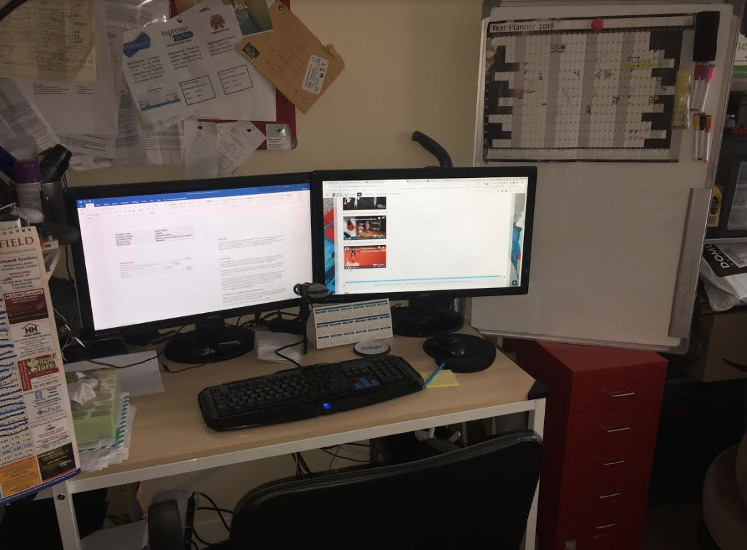

Oxicura is an ecommerce business which supplies wound care treatment for customers in the USA. Products range from bandages, surgical masks and sharps containers. We have customers from an array of backgrounds who suffer from eczema, burn wounds, pain in legs to wrap bandage around and autoimmune conditions. Furthermore, we also serve people who have suffered in natural disasters, supply first aid and CPR training and for animas with wounds.

We only sell via amazons’ website who have performance metrics we must meet. Considering it is a vital component of the business, any complaint can get our seller privileges blocked and causing major problems in the running of operations. The three main indicators monitored are customer service performance, product policy compliance and shipping performance as well as other key metrics shown in image (Amazon.com 2018).
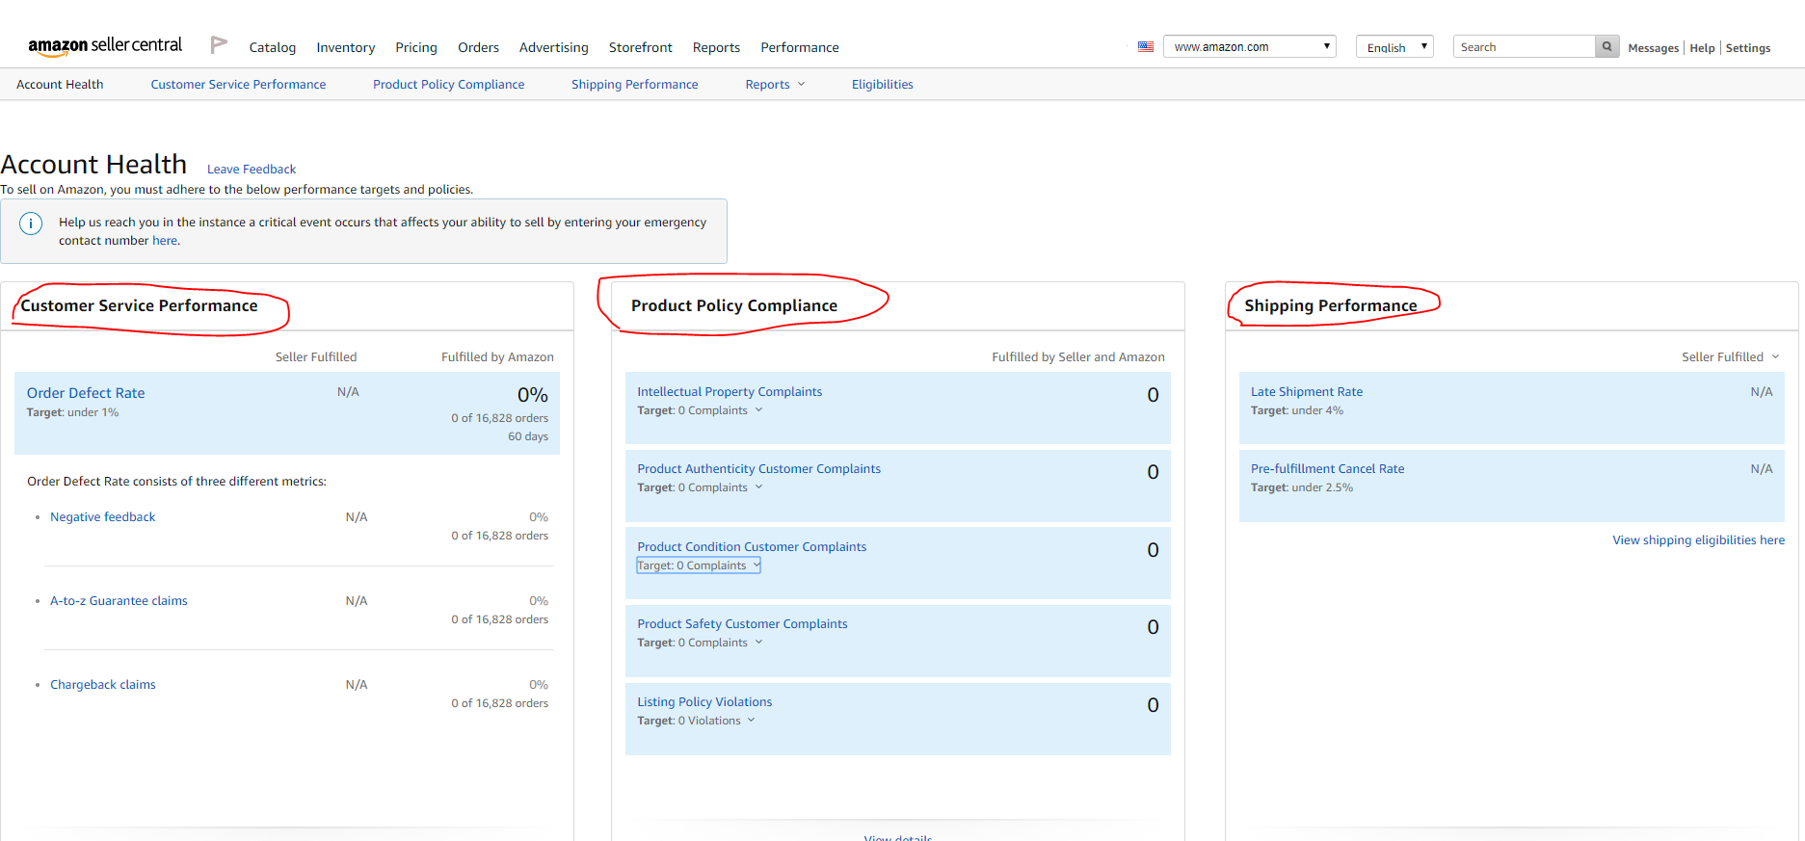

Communication at my workplace (Case Study)
It was 3.55pm on a Saturday, I received a phone call and it was one of our drivers out delivering a parcel. Paul the driver said nervously “Afzal, I can’t find door number 475, help me!”. He was out of breath and his speech was not clear. I then asked him “Paul I need more details mate; what street are you on and what time is delivery due?”. Paul replied in a high-pitched voice “The parcel needs to be delivered by 4pm and you need to get me the address please, I am on Miller street but can’t find number 475, I can see 473 and 477 only”.
I did a quick search on google maps and then told him how to find it, I said hurryingly “Paul, I have just checked quickly on google maps, walk past 473 and go to the back of the building and 475 is situated opposite, hurry up and get it delivered before 4pm or we will get penalised by Amazon!”
I was waiting anxiously for Paul to ring back with confirmation of delivery. At 4.15pm, I received a text from Paul that he delivered on time. I then checked on the system and noticed that Amazon had put a status of ‘late delivery’ next to Pauls delivery number. Paul had lied and did not phone in and tell me the truth.
As Paul was in the USA (as mentioned in description of my workplace) and myself in the UK, I had to conduct a disciplinary meeting via web conference so he could explain to me why he did not tell me the truth and gave him a chance to give his side of the story. Once the meeting was over, as his manager I decided to give him a written warning as it was a serious offence to lie, especially when he already had called in asking for help. Paul was not happy and through the video conference he was regretful he had made a bad decision in the heat of the moment. A couple of days later Paul had sent me another text apologising and never to be dishonest again, as well as thanking me for another opportunity to carry on working at for us. As a company we have always told employees to be open and honest and we can always work things out.

The Shannon – Weaver model:
The Shannon and Weaver method understood communication as a sender who encoded a message, and it was sent out across a medium, sometimes the medium had noise and different types of noises and then went into a decoder and then it was received.

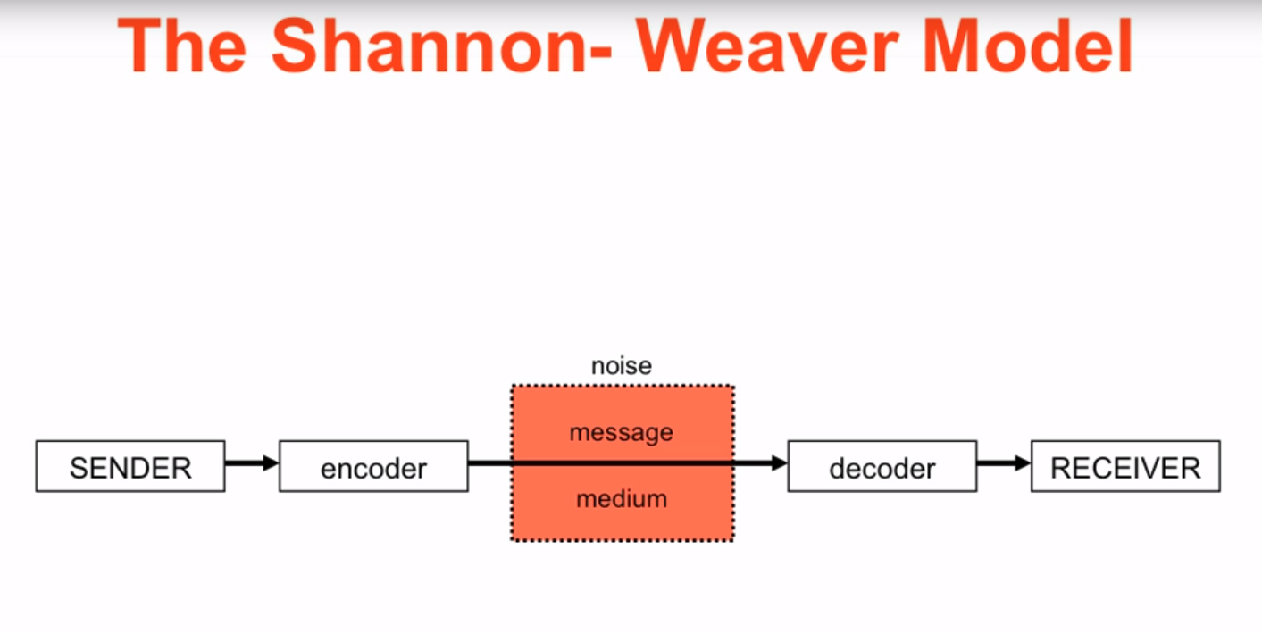
Looking at my example, Paul initially called and also texted me, so that makes him the sender. The message is encoded and sent to the receiver which is Afzal via the phone. The sender converts the message into codes and sent through a medium which is the ‘noise’.
Afzal the receiver has to decode the message to understand it. The phone can also decode and have noise which may cause Afzal to understand Paul clearly. So, for instance, the brain could be the sender, mouth might be the encoder which encodes the accent (even though they are both speaking English, accents can have some noise), and Afzal’s ears and brain can be the decoder and receiver.
Furthermore, if we look at the text message sent to Afzal from Paul, Paul was the sender, the mobile phone provider is the encoder, the noise was the actual message on phone, the decoder is the mobile phone and Afzal the receiver.

Berlo’s model of communication:
Berlo’s Model has four components describing the communication process. They are, sender, message, channel and receiver. Each of the components is affected by many factors.

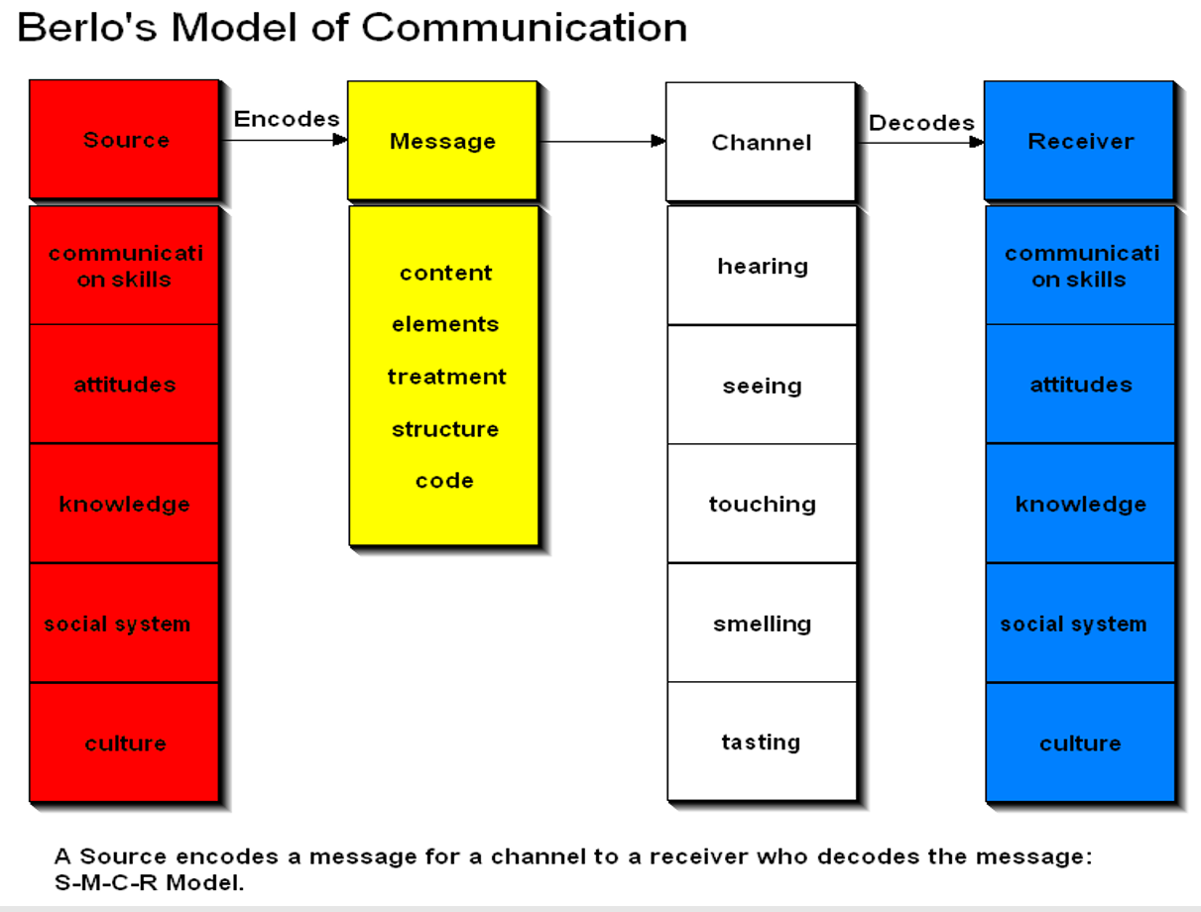

Again, looking at my example, the sender is Paul who is also the source who initiated the call. There are different factors relevant to the scenario for e.g. Communication skills, attitude, knowledge, social systems and culture. Paul communications skill plays a role as his communication will determine whether Afzal understands the message clearly. The attitude of Paul determines the effects of the message, as well as knowledge of the scenario. Paul knew he was running late for delivery but did not have the right attitude but did have the knowledge. He clearly knew how to deliver and knows his job role. Social systems play a part here as morally Paul lied. Finally, culture, even though they both speak English, they do have different accents. But this did not play any part in this scenario.
The message was sent by Paul, he had delivered the content elements, treatment, structure and code. The content was the whole conversation between Paul and Afzal, elements were non-verbal interactions such as: texting. Treatment was in which the message is conveyed to Afzal, in this scenario Paul did lie. The structure of the message was not arranged therefore not effective straight away.
Code is the way the message was sent, in this instance a smartphone was used for calling and texting. Both Paul and Afzal had to make sure messages were accurate or they would both received incorrect information.
Channel is the medium used to deliver the message, as mentioned previously technology may be used but mainly here it is about the five senses of a human being for the channel of communication such as: hearing, seeing, touching, smelling and tasting. Afzal used his ears to listen to Paul, whilst Paul used his eyes to read the messages (MSG, 2019).
The receiver (Afzal) is the person who gets the message sent in the process. This factor will only work if the receiver is on the same level as sender, essentially meaning the sender must also be a good communicator and the receiver have good listening skills (MSG, 2019)

Analyse:
-Active listening:
Looking at the scenario at my workplace there were a few problems which I will explain. Firstly, Paul was wrong to message so close to the deadline and was not clear enough in his question. He did not tell Afzal he was running late straightway so Afzal was not alerted that the delivery is running late. Afzal was using active listening to help make information processing more transparent (Maund, Schriek and Tinkler 2017). “Active listening is the key to accurately understanding what another person is saying. It requires effort and discipline.” (Maund, Schriek and Tinkler 2017, p.52).
- Assertiveness:
Subsequently, even though Paul got the delivery complete he missed the time slot and the company was penalised by Amazon. Paul should have contacted Afzal earlier to report that he could not find the property and was running late. Instead, Paul should have used Assertiveness in delivering his message across to Afzal instead of lying via a text message. If Paul had done this, even though he was late, Afzal may have been more lenient and not issue him a written warning.
Additionally, Afzal did use this method as he was firm and at the same time respectful by acknowledging Paul’s regret. Afzal did not fire him and instead gave him a written warning, in return Paul even texted Afzal after a warning to apologise again and thank him for another opportunity.
“Assertiveness is the ability to express oneself directly and honestly without disrespecting or dishonouring another person.” (Maund, Schriek and Tinkler 2017, p.55).

- Virtual communication:
Virtual communication is the most used form of communication in my workplace. This has allowed me to work remotely from anywhere in the world. This allowed Afzal and Paul communicate instantly and easily even though they were in two different parts of the world. Subsequently, this has allowed both Afzal and Paul to interact without the need for face to face contact, for example, the disciplinary meeting was just as effective as if they were in a room siting directly opposite each other.
Essentially virtual communications such as using a web cam has allowed me to use nonverbal communications in my working environment. For example, by holding the video meeting, Afzal and Paul could both see each other’s body language even though there was a large space between them. However, drawbacks to this is the experience is the proxemics are not the same. Even though Paul faced disciplinary action, Afzal could not achieve the same distance people generally use in communication.
In virtual interaction the lack of face to face interaction sometimes makes it difficult to complete tasks. Therefore, virtual teams struggle to gain a level of trust that maximises group potential (Maund, Schriek and Tinkler 2017).

Conclusion:
In conclusion, this report has described a scenario at my workplace and analysed it in detail using different communication methods. Firstly, I gave a brief definition of communication followed by a detailed description of my workplace. This was important to do so the actual scenario at work was fully understood. I then interpreted how both the Shannon – Weaver model and Berlo’s model of communication work and how it is relevant in my case scenario. I researched concepts and ideas using books, online resources and my own personal experience. I also attempted to analyse some communications relevant to my case study such as: Active listening, Assertiveness and Virtual communication. Essentially, these skills must be implemented in all workplaces, I use these daily to be able to accomplish my goals and grow as a person and employee resulting in a possibility of a promotion or career change and even starting up a business.

References:

Maund, A., Shriek, M. and Tinkler, P. (2017). Certificate in higher education. 1st ed. London: Sage Publication Ltd.

Amazon.com (2018) – Account health [Online]. Available at: https://sellercentral.amazon.com/performance/dashboard?ref=sp_st_nav_sphachlt (Accessed 02 January 2019).

Maund, A., Shriek, M. and Tinkler, P. (2017). Certificate in higher education. 1st ed. London: Sage Publication Ltd.

Maund, A., Shriek, M. and Tinkler, P. (2017). Certificate in higher education. 1st ed. London: Sage Publication Ltd.

MSG Management study guide (2019) - Berlo’s Model of Communication [Online]. Available at: https://www.managementstudyguide.com/berlo-model-of-communication.htm (Accessed 02 January 2019).

