


Computer Forensics (CF)

Lab 4

Faculty of Science and Art
Applied Computing
I.Q Building, Room 205
Swansea
SA1 8EW

Lecturer: Assoc. Professor Carlene Campbell
Email: carlene.campbell@uwtsd.ac.uk
Website: https://www.knowledgewithprofit.com

Exercise 01: Convert Image File from E01 Format to dd Format
Lab Scenario
James, a forensics investigator, is appointed to examine an E01 format forensic image file on a Linux workstation. However, the forensic examination of E01 image file works perfectly only when the forensics workstation is Windows-based, not Linux-based. To examine the E01 file format image file on a Linux workstation, the investigator needs to convert the E01 image file to dd file format.
As a forensics investigator, you should know how to convert the E01 file format to dd file format.

Lab Objectives
E01 and dd are forensic image file formats used to store bit-by-bit copies of storage devices such as hard disks, USB drives, etc.
The objective of this lab is to help you understand how to convert the E01 file format to dd file format using Linux commands.

Lab Environment
To carry out this lab, you need the following:
- Windows Server 2022 virtual machine
- Ubuntu Forensics virtual machine
- Web browsers with an Internet connection
- Administrator privileges to run the tools

Overview of the Lab
This lab familiarizes you with the xmount tool. It helps you understand how to convert an E01 image file to a dd image file on the Linux workstation for further analysis.
Lab Tasks
- Turn on the Ubuntu Forensics virtual machine
- Login into your Ubuntu machine
- Click on the Files icon in the Launcher panel to launch the File Manager.
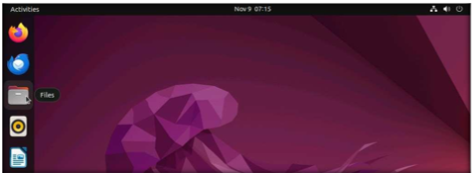

- The File manager window will appear pointing to the Home directory.
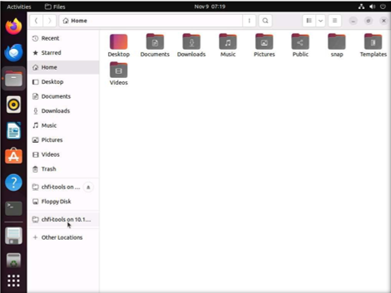

- Next go to the browser Navigate to Forensics tools Evidence File folder Forensic images
- Copy the Windows_Evidence_001.E01 file into the Home directory of Ubuntu.
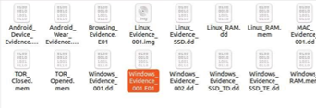
- In this lab, you are going to convert an image file with the E01 file format to the dd file format. To do this, we need to install the xmount tool.
- Click on the Terminal icon from the launcher panel to launch the command line terminal
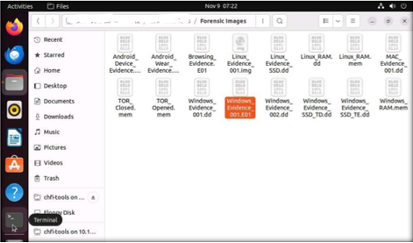
- Command line terminal launches. You require root privileges in the terminal to install an application.
- Type sudo su and press Enter. You will be prompted to enter the password. Type the root password and press Enter.
- Now, you will enter the root terminal as shown in the following screenshot:
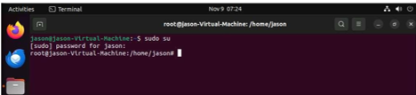
- To install xmount, type the command apt-get install -y xmount and press Enter
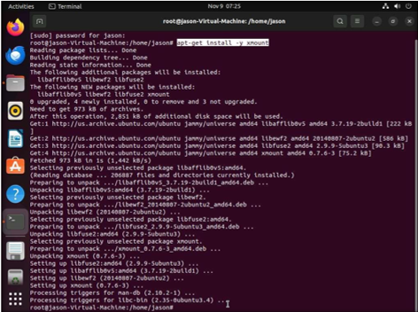
Note: If you face any issues with the internet connectivity, run the commands ifdown - a followed by ifup -a; and then run the command apt-get install -y xmount.
Note: The apt-get install -y xmount command will not execute in case another process is using the apt command. In this scenario, restart the Ubuntu Forensics virtual machine and then run the command for xmount so that it executes successfully as shown in the above screenshot.
- To convert the E01 file using xmount and mount it, execute the command xmount --in ewf Windows_Evidence_001.E01 /home/jason/Documents in the terminal. This command converts the E01 file to a dd file and mounts it onto the Documents folder.
Note: Make sure that the mount directory is empty before executing the command. You may also create a new empty folder and provide the location of the created empty folder for the mount directory.
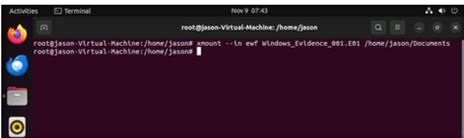
- The mounted drive (here, Documents) will be created on the system.
- Click on the mounted Documents directory to find the Windows_Evidence_001.dd file, as shown in the following screenshot:
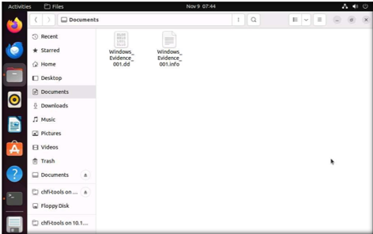
- In this manner, you can convert the E01 file into a dd file format for further examination.
- The next task of an investigator would be to mount this file on the machine and view its contents.
- Close all open windows

Lab Analysis
Analyse and document the results of this lab exercise.
Exercise 02: Mount Images on a Linux Forensic Workstation
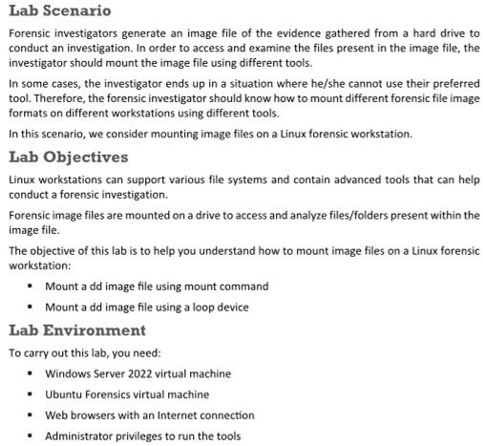
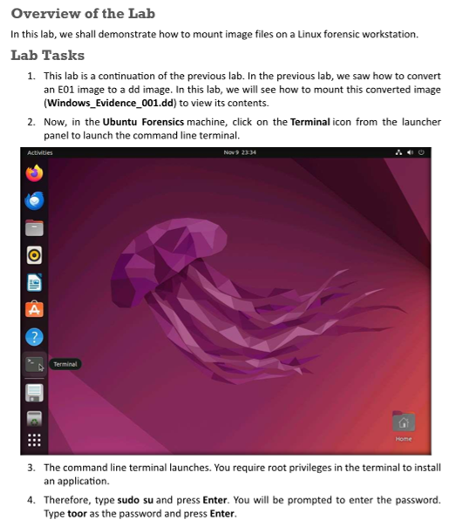
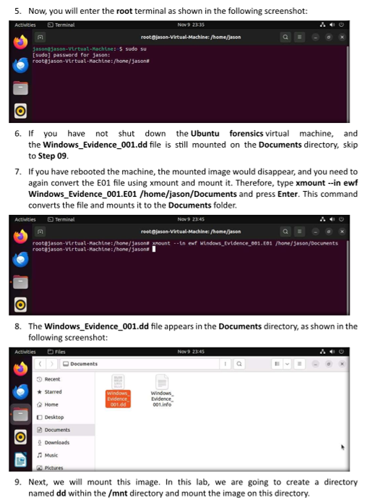
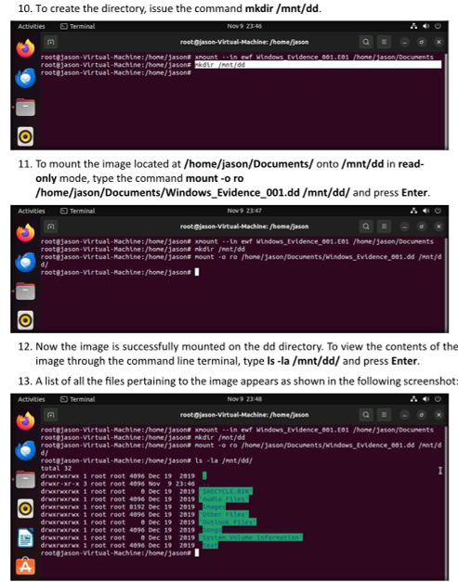
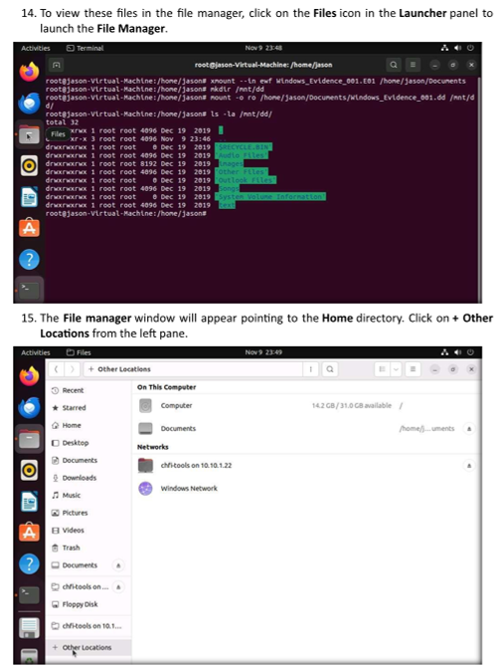
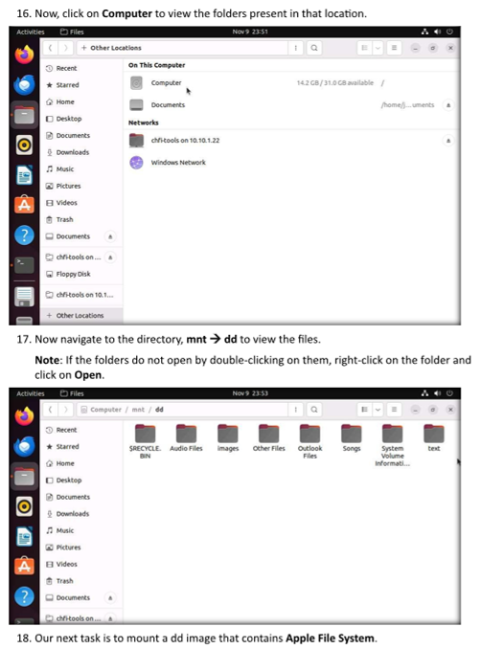
19. Navigate to Forensics tools Evidence File folder Forensic images and copy the MAC_Evidence_001.dd
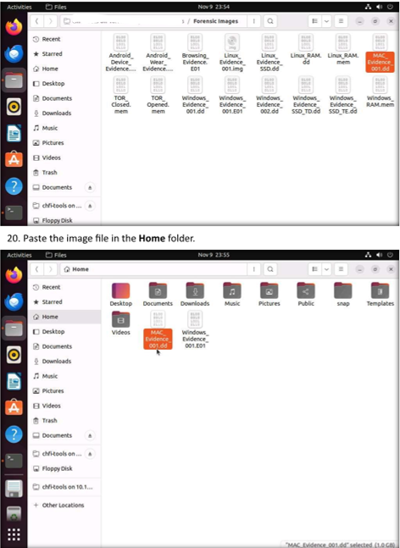
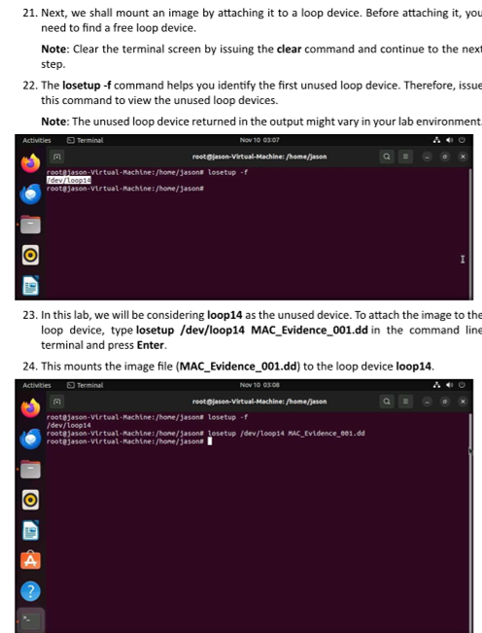
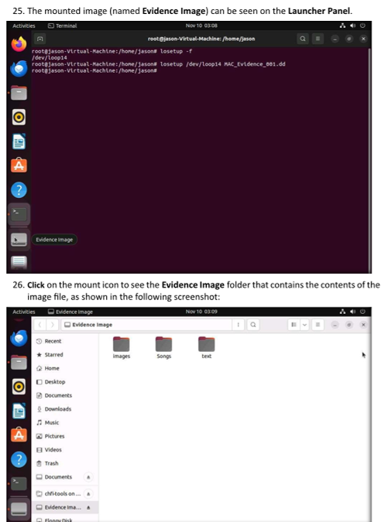
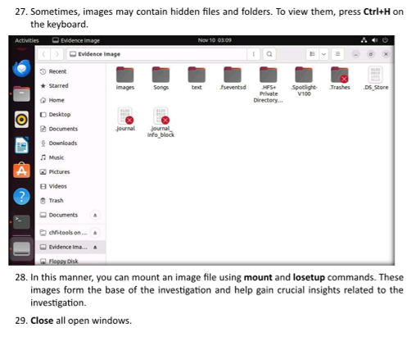
Lab Analysis
Analyse and document the results of this lab exercise.
Using https://tryhackme.com/ website

- Once you have signup go to learn and do one of the Forensics free lab

- Choosing any of the Hands-on activities by going into the Learn menu and search for a Forensics lab of your choice.

- To select a free walk through task, select
  - Go to Walkthroughs as shown below

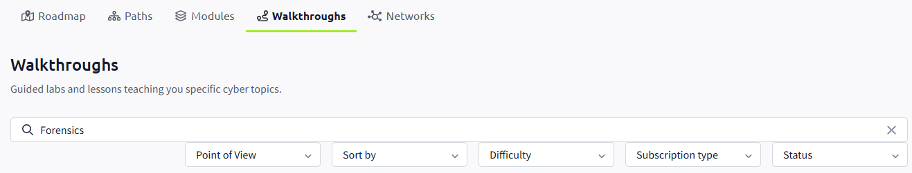
  - Type Forensics

  - In the drop-down menus below the search, select the following in red circle:

  - Choose any of the free walkthrough exercises and give it a go. If you have not done the “Intro to Digital Forensics”, start with that one.
  - Now try to find a lab on how to convert an E01 image file to a dd image file and vice versa.
  - Or choose a forensics lab of your choice.

There are many other similar sites. If you are using a different one, please share it with the class. Do any of the free walkthrough exercise but the option is yours if you want to subscribe (pay).

