WIAV - History of the vocal Repertoire from the Point of View of the Performer
Session 5 – 28 January 2019
Opera seria and opera buffa

As her ‘older sister’, opera buffa is a label used by scholars and musicologists, but very rarely by composers, librettists and other artists involved, who described it using terms such as ‘commedia per musica’, ‘dramma giocoso’, ‘divertimento’, etc.

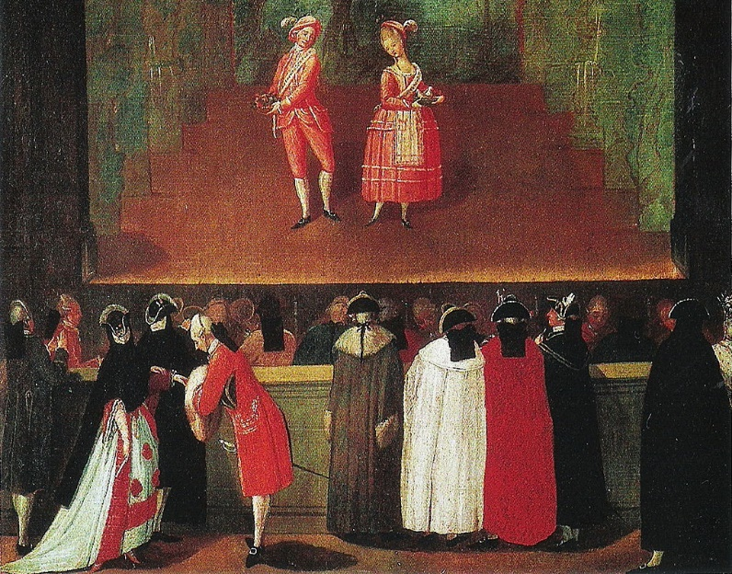
Opera buffa came more than a century later than opera seria, around mid-18th century (1750s): its birthplace and, for many decades, main centre was Naples, rapidly becoming the true operatic capital of the Italian peninsula. Opera buffa can be considered (and is considered by many) as deriving from the so-called intermezzi (sing, intermezzo) i.e. comical interludes performed in between the acts of opera seria. Starting from the beginning of the 18th century, the habit of performing intermezzi had become more and more popular. These were short and comical performances that often mixed spoken theatre, music and dance. Very often in two short acts (to go in between the three acts of an opera seria), they provided comic relief and lightened the atmosphere. They often also contained dialect and a very direct comicality, also involving slapstick elements.

Plots and characters re-employed and revisited features of the so-called ‘commedia dell’arte’, the half-improvised comical theatre performed by troupes of travelling artists throughout Europe since the late Renaissance. Among the most defining features, there were stereotypical characters playing a set role rather than having an individual psychological profile: these characters were often recognizable also by their exterior appearance (costumes and masks), e.g. the servant, the doctor, the old man, the loving maid, the young lover, etc.
As a consequence of these stock characters, plots were also highly stereotyped, and almost revolving around a couple of young lovers whose love was menaced by an old, evil (and dumb) character: thanks to the help of some cunning servants, the old villain usually ended up fooled and love triumphed (rings a bell?).
Example: La bella pescatrice (The fair fisherwoman), libretto by Saverio Zini, music by Pietro Guglielmi, premiered 1789
DORINDA, a fisherman’s daughter, loved by the Count and given by the latter a title so that she can be married to him (S)
CELIDORO, Dorinda’s beloved and a friend of the Count (T)
DON ALFONSO SCUOGLIO, Neapolitan merchant who, after bankrupting, decided to be a dance master
IL CONTE LUMACA, A temperamental man of few words, who loves Dorinda (B)
VESPINA, The Count’s gardener (S)
LISETTA, The Count’s handmaid (S)
MACCABRUNO, The Count’s valet (Ba)
Extras: servants, faker Turks, a fake man from Tyrol.

Within the intermezzi and then in the comic operas, both the stock characters and stereotypical plots were revisited and infused with music very different from that of contemporary opera seria. Instead of the hierarchy of characters dominating over opera seria, in opera buffa the only difference to be found is that between the lovers (usually T and S), the villain(s) (B or Ba) and the helpers, usually cunning servants (usually Ba when males, S when females). In order to represent the low-born, humble characters employed, the comicality, the simple/funny love stories and the light atmosphere required, the voice types and musical forms of opera seria were ineffective (not to mention that the stars of opera seria would have never lowered themselves to intermezzi!).
Es. ‘Stizzoso, mio stizzoso’ from Pergolesi’s La serva padrona (premiered in Naples in 1733 in between the acts of Il prigionier superbo).
Es. 2 ‘La calunnia, mio Signore’ from Paisiello’s Il barbiere di Siviglia
Listen and comment on
- technical skills required?
- other skills required?
Because of its roots in popular theatre, its many characters and the stress on intrigue, misunderstanding, slapstick and comicality, opera buffa privileged and developed ensemble numbers a lot more than opera buffa: not only love duets, but also trios (terzetti), ensemble pieces (quartetti, quintetti, sestetti, etc.) and ensemble finales.
Es. ‘Voi, signor, che giusto siete’, finale Act I from Mozart’s Le nozze di Figaro

Singers of opera buffa, at least until the end of the century, enjoyed a social status and an income not comparable to their counterparts of opera seria. Those who performed in intermezzi were usually not just singers, but rather entertainers, capable of some singing, dancing, acting and instrument playing. As intermezzi evolved into longer and more complex opere serie, the singing component played a progressively more important role, but retained very different features from the opera seria.

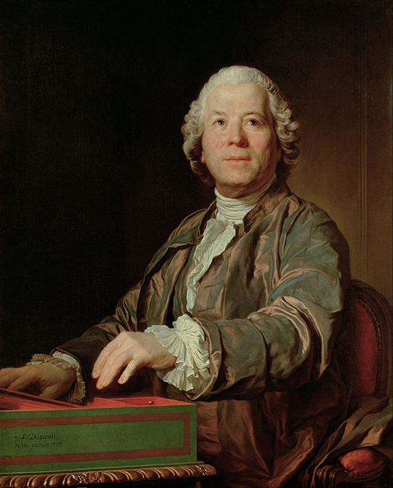
In the second half of the century, the world of Italian theatre (both spoken and musical) was shaken by what can be described as two revolutions, initiated by two very different figures, yet pursuing some similar purposes:
Carlo Goldoni (1707-1793), a Venetian playwright.
Christoph W. Gluck (1714-1787), an Italian composer working at the Habsburg court, and his librettist Ranieri de’ Calzabigi.
Goldoni within the world of comedy, Gluck within the realm of opera seria, denounced the excesses and the negative role of traditions and conventions on the features and quality of theatre. In the world of comedy, stereotypes, low-level comicality and masks had lowered the quality of plays; in the world of opera seria, the singers’ tyranny and the importance of conventions that were detrimental for the quality of drama and music had reduced opera into a terrible state. They proposed:

- Abolition of the masked roles  - More attention to the psychology of the character (commedia di carattere)  - Integration of real life and manners into plots  - Examples (good and bad) rather than theoretical moral precepts  - A lighter and more refined comicality | - Reduction of virtuosity, simpler and more understandable melodic patterns  - Syllabic setting of text  - Abolition of the da capo aria  - Abolition of the secco recitative  - Integration of music into the plot

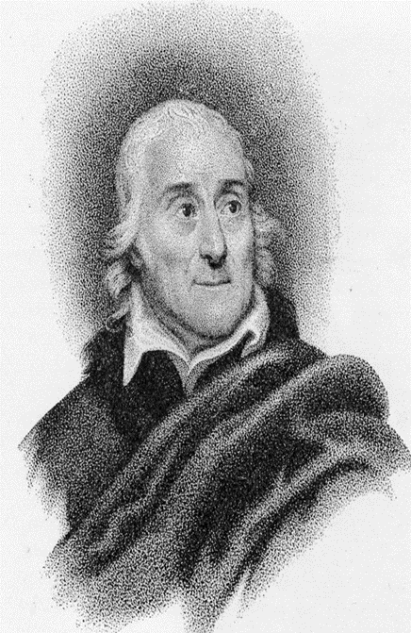
Goldoni’s and Gluck’s legacy, together with the influence of the blooming French theatrical scene, also inspired another paramount playwright and librettist, Lorenzo Da Ponte (1749 – 1838), who worked at the Viennese court in the 1780s having the luck of cooperating with a mature Mozart. Their trilogy (Le nozze di Figaro, Don Giovanni, Cosi fan tutte) can be considered the culmination of eighteenth-century opera buffa thanks to:
- the psychological refinement of the characters, yet retaining some traditional features
- the alteration and complication of the traditional plot, and of the dynamics between characters
- the presence of serious situations and emotions
- the ‘seriousness’ of music, catering seamlessly for a much wider range of emotions
- the high level of musical refinement in all forms and settings
- the perfect interaction between music, word and dramatic effect
- the level of moral reflection and societal critique embedded in the work

What do you think were/are the consequences for singers?

Giocoso: adjective derived from the Italian ‘giocare’, to play.
Divertimento: from the Italian ‘divertirsi’, to have fun.
Scuoglio: similar to ‘scoglio’, a rock, meaning he is stubborn and old-fashioned
Lumaca: in Italian, a snail, meaning he is old, viscid and disgusting
Vespina: similar to ‘vespa’, a wasp, meaning she is very sharp and can become quite mean if her interests/allies are threatened

