DS 1 Template

My Screenshots/Photos
- Please add 4–6 screenshots or photos of your digital life.
- You can use your phone or laptop.
- For each screenshot, write one or two sentences explaining what it shows.

Screenshot/Photo 1
Outlook calendar
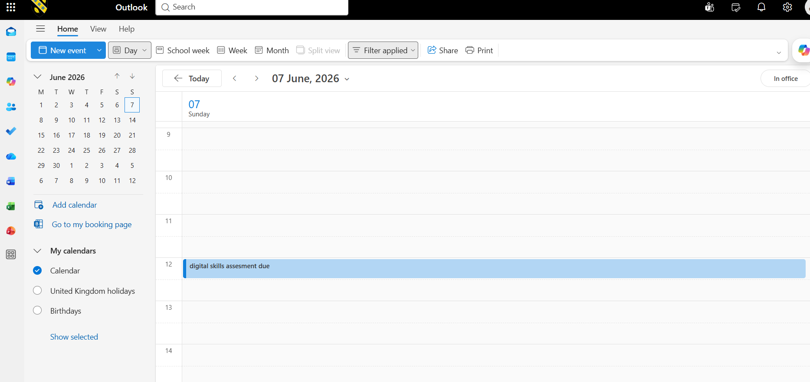By using outlook calendar and saving all dates for my assessments helps me more organised and more confident that I will be able to submit my work on time. I feel confident knowing that I will get notifications about what I have put in my calendar, so I don’t forget anything. I use this tool most days for university and for my children’s school. I make a lot of appointment reminders on here also for doctors, meeting at university. Think this tool will help businesses book appointments and to help them navigate time and dates for colleagues who’s working what days and what times.

Screenshot/Photo 2
Banking
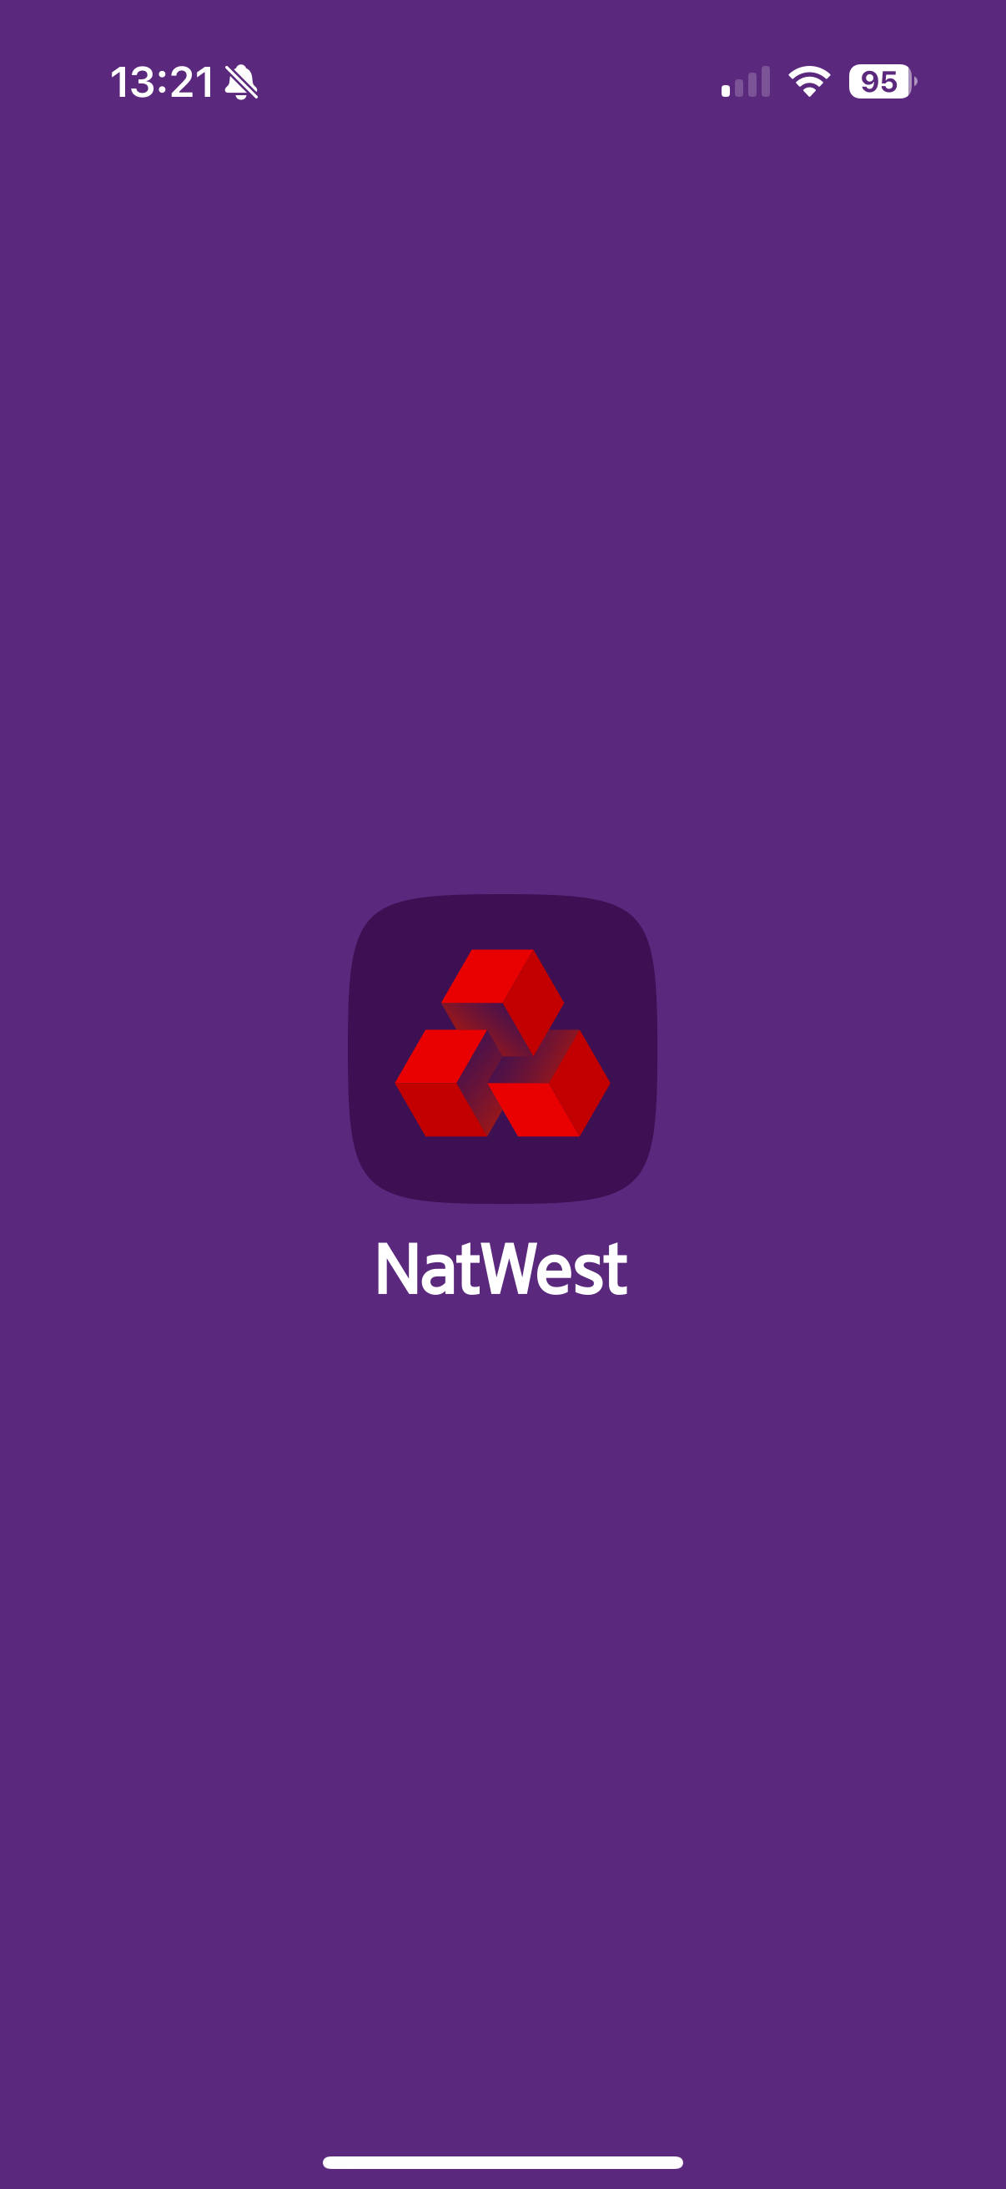 Banking apps are very useful in my life and any kind of business, it helps me manage and spend my money wisely, this app shows me a lot of information how my money is managed and how often I spend my money. It shows me where I shop, what bills are paid and when, money transfers, also shows me how much savings I have, if I need to go into them for a rainy day. I would love to open my own business someday and knowing how to go about banking will help me in the future to sort out expenses in the company, employee wages customer payments, it will help to track my finances and how things are progressing and performing.

Screenshot/Photo 3
WhatsApp
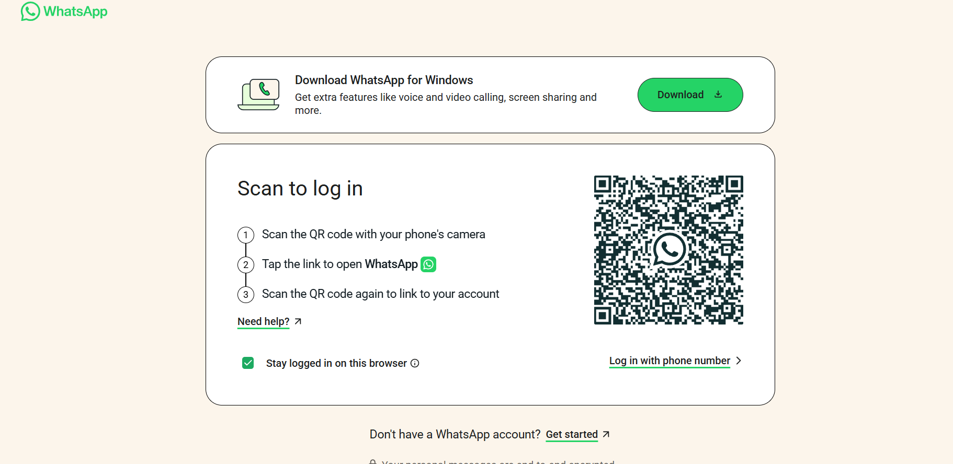 I use WhatsApp every single day without fail, I use it to message friends and family, I use it for group messages so if I need to talk to different people about the same subject then I make group messages, so I don’t have to message each person separately. With WhatsApp people can see who you are by your profile picture and name so it’s very simple to use. WhatsApp allows you to put status up lets you put information about yourself, tells people when you were last active. Business can use this app for updates on orders, messaging clients or customers send photos of their business or products to advertise and promote themselves.

Screenshot/Photo 4
Student Email/Outlook
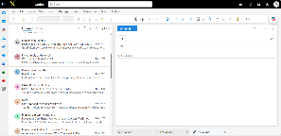 This shows a picture of my student email. emailing helps me stay in touch with tutors with friends from university and helps me keep in check with what’s going on around campus, this is a major way of communicating with important people and a secure way of doing so, this shows my part of my digital life such as online shopping receipts, messages that have been sent and received, calendar and appointment, emailing is great for business as it helps them stay professional and organised, business will use email to send invoices, market information, shipping information, internal communications within the business and create meetings, they could also use email to have conversations with customers if they have any enquires about what they are buying or if they need more information about the company itself.

Screenshot/Photo 5
Amazon/marketplace
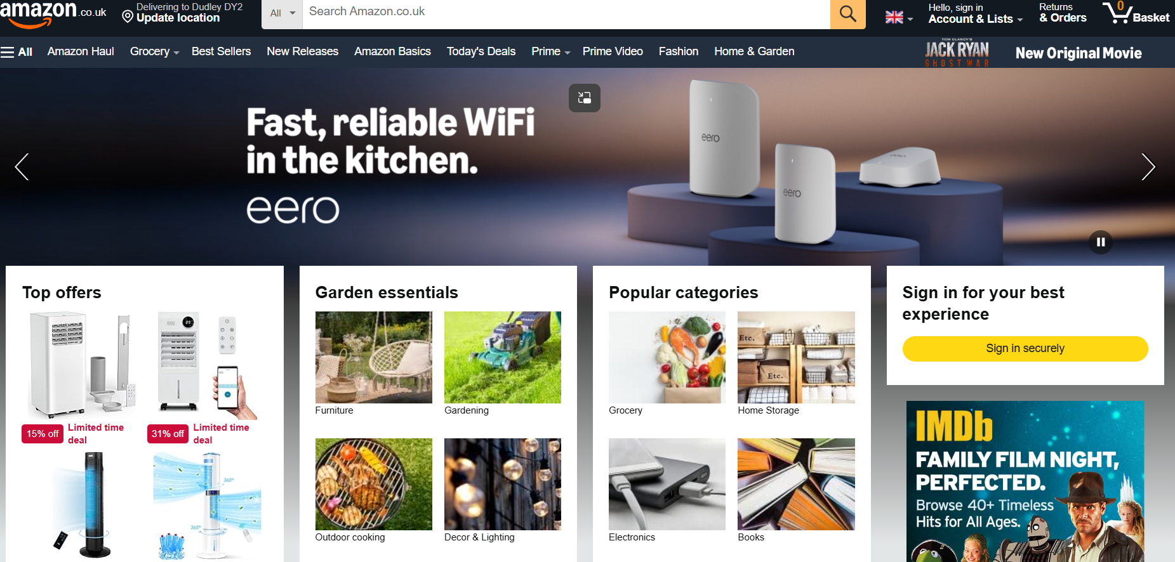 using Amazon helps me and also a lot of people shop a lot easier, this app allows you to shop without even moving of your own sofa, using amazon to purchase important items such a computer for university to notebooks and pens to just day to day living like washing powder or dog food has completely changed my life, people with disabilities like myself or even social anxiety will buy from amazon so they don’t have to leave the house, it’s a great way to buy things in a hurry as they do next day delivery and on some occasions they do same day delivery if you order earlier enough. Amazon is a great marketplace for business to sell their products across the country/worldwide. Businesses can promote, manage deliveries and communicate through customers reviews.

Screenshot/Photo 6
TikTok
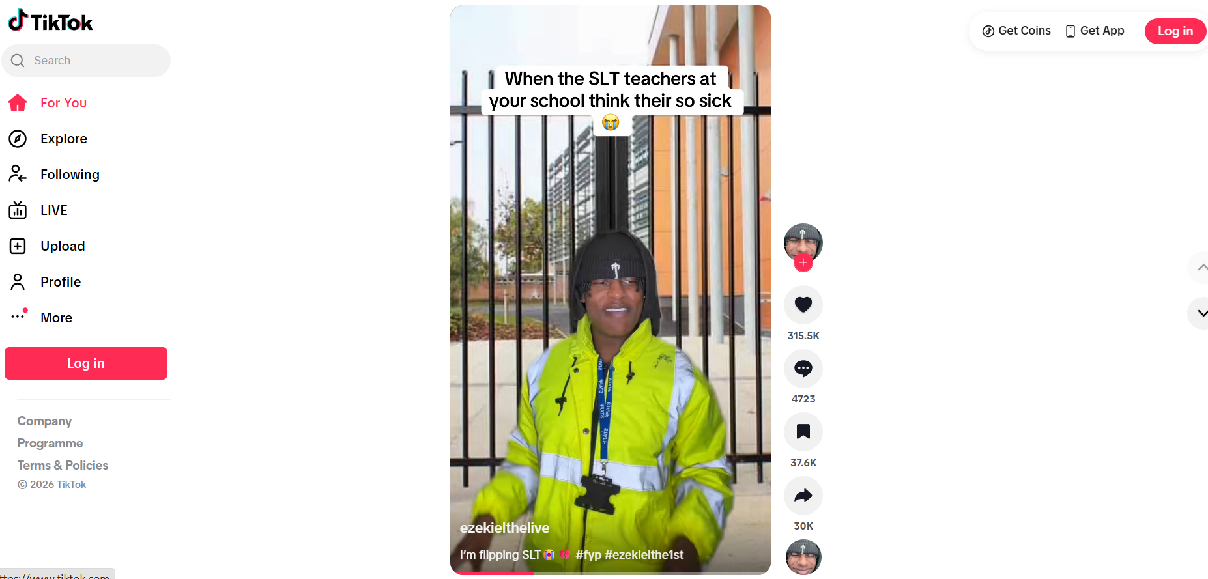 Tik Tok has become of the most stress-free platforms I use in my digital life to sit and relax to have downtime while watching Tik Tok I have come across a lot of businesses and have even purchased from small businesses that are trying to grow their platforms. Tik Tok allows me to create videos lets me like and comment on other people videos helps me purchase items and also teaches me the trends that are going viral. With TikTok it saves my information for example videos that I have liked, search history and accounts that I follow so I can then easily find what I’m looking for later. I think this a great platform for small business to promote their products and business itself, through making videos and interacting with customers all across the country.

My Short Reflection
- Write 5–8 simple sentences about your digital life.
- You can use the sentence starters below if helpful.
My digital life consist of many things it helps me feel more confident in myself helps me communicate and come out of my comfort zone helps me relax, I use digital skills to communicate to friends and family to tutors at university to shop and buy certain things I need, I feel confident when I use these apps because they are teaching me and making me learn new things every day I know that in future these will help me achieve my business goals. The main thing I would like to improve is my online safety skills as I know there are a lot of viruses out there and a lot of people scamming a lot of people so I would like to be aware with what to look out for. When shopping or filling out information online or making any kind of purchases we all use our personal information and this is a very nervous thing for me as I am always very hesitant about putting my personal information on the internet, I am scared that someone will use my information to scam people or hack into banking apps so this worries me a lot and I am always very careful and second guessing. Digital skills are important for me as it helps me grow as an individual helps me learn more new things every day it helps me communicate in ways I didn’t think I could. I know that this module is going to be great for me because it’s going to make me more confident in using technology using the platforms and help me be aware of safety risks.

Sentence starters
- I use digital tools to …
- I feel confident when I …
- I want to improve …
- I often use these tools: …
- I sometimes feel nervous about …
- I hope this module will help me …
- Digital skills are important for me because …
You can write more if you want.

Submission Checklist
Before you submit, please check:
​​​ ☐ I added 4–6 screenshots
☐ I wrote short sentences for each screenshot
☐ I wrote my short reflection
☐ My work is my own
☐ My file opens correctly
​​☐ My file opens correctly

