Chapter 3 – Methodology
Introduction
“Research is the process of inquiry and investigation in a systematic and methodical manner and increases knowledge” (Hussey and Collis, 2014). Academic research is vital in improving awareness, information and knowledge in subjects. “The general purpose of academic research is to investigate a research questions with a view to generating knowledge” (Hussey and Collis, 2014). Bell et al., (2019) further states that “Research has eight distinct characteristics:
1. Research originates with a question or a problem
2. The research goal must be clearly articulated
3. Research follows a specific format
4. Research usually divides the principal problem into more manageable sub-problems
5. Research is guided by the specific research problem, question or hypothesis
6. Research accepts certain critical assumptions and limitations
7. Research requires the collection and interpretation of data
8. Research is, by its nature”
There are two types of research primary research and secondary research. Bouchrika, (2021) defines them as “Primary research refers to research that has involved the collection of original data specific to a particular research project. When doing primary research, the researcher gathers information first-hand rather than relying on available information in databases and other publications. Secondary research involves the summary or synthesis of data and literature that has been organized and published by others. When doing secondary research, researchers use and analyse data from primary research sources”.
This chapter of the dissertation will attempt to answer objective two of the dissertation project which for reference is: “To identify the most suitable research approach required to appropriately conduct the research project and the potentially sensitive topic of County Lines”.

The research onion
One of the most used research methods used in the collection of data and in academic writing is “The research onion” created by Saunders et al., (2015).

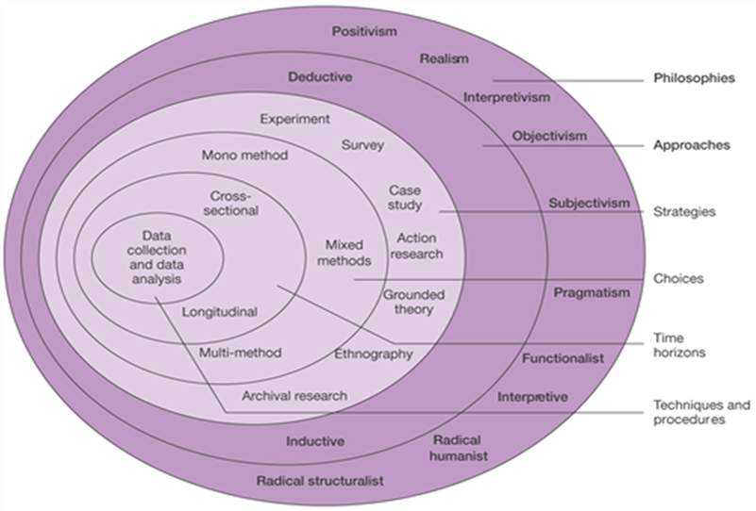

Annotated Diagram – The Research Onion (Source: Saunders et al., 2015) (Figure 3).

The diagram shown shows the ‘research onion’ and the process that will be used for this dissertation with each of the layers on the ‘onion’ showing a specific research technique.

Research Philosophy
The research onion works from the outside in, the first layer of the onion is the ‘Research Philosophies’. “Research philosophy deals with the source, nature and development of knowledge. In simple terms, a research philosophy is belief about the ways in which data about a phenomenon should be collected, analysed and used” (Dudovskiy, 2018).
The subject that I have chosen to research will use the interpretive philosophy, the reason behind this decision is because a different range of answers could come from this research these answers could be subjective and the research requires the opinions of the general public and their views on how police have tackled the problem of county lines across the United Kingdom. Interpretive approach uses a naturalistic approach and the data is collected from such things as interviews, observations and questioners (Dudovskiy, 2018). I will be handing out questionnaires which will be provided to members of the public for their perception of county lines and police forces response.

Approach
As shown in the ‘research onion’ there are two different research approaches available. Streefkerk, (2019) states “The main difference between inductive and deductive reasoning is that inductive reasoning aims at developing a theory while deductive reasoning aims at testing an existing theory. Inductive reasoning moves from specific observations to broad generalizations, and deductive reasoning the other way around”. Due to this statement by Streefkerk an ‘inductive’ approach will be used for this research project.

Strategy
Ibezimako, (2019) states “The Survey strategy is mostly used to observe contributing variables among different data. It permits the collection of vast data that will be used to answer the research question” I will create questionnaires and will be shared via the word publishing document and this will be posted on social media sites, this will allow me to gather a wide range of responses from a number of different members of the public ranging in ages. Questionnaires are a research tool that consist of a number of questions for the purpose of gathering information from different respondents. Questionnaires can be carried out face to face, by telephone computer or post they are relatively cheap can be a quick and efficient way of obtaining large amounts of information. (McLeod, 2018).

Research strategy and choice
As showing in Saunders ‘research onion’ there are there different choices of methods available when conducting research, Mono method, multi method and mixed methods. The method I will be using is mixed methods research (MMR), the mixed methods uses both quantitative and qualitative data. I will be using qualitative data in the form of research that has already been published in journals, governmental documents and research papers conducted by credited researchers, authors and government publicists. These are persons who have conducted research in the topic of county lines and the background of it and any prevention that has already been completed.
I will also be collecting quantitative data, this will be in the form of ‘questionnaires’, these questionnaires will be dispatched across ‘social media’ to members of the public. By using social media to dispatch this questionnaire it will allow me to reach a larger audience in the form of age, location across the United Kingdom gender and sexuality meaning I will get a large sample of different members of the British public.

Time horizons
The final section of Saunders ‘research onion’ is the time horizon, this part of the research onion provides the amount of time that I will allow myself to gather the research (Saunders et al., 2015). Due to my study only taking place over a short period of time, I will be using ‘cross-sectional’ time horizon, this will allow me to collect data and study it over a period of time (Melnikovas, 2018). This method also allows further research to be conducted on this topic should it be required.

Techniques: Data collection and analysis
Data collection:
The findings that I received from the primary data that I collected through questionnaires distributed on social media were inputted in to a software called ‘Microsoft excel’. The results were then displayed in graph form showing the amount of respondents who choose each answer on the survey.
Reliability and validity:
Dudovsky, (2018) defines reliability and validity as “Reliability refers to the extent to which the same answers can be obtained using the same instruments more than one time. Validity of research can be explained as an extent at which requirements of scientific research method have been followed during the process of generating research findings”. There are different ways of validating data, Dudovsky, (2018) states that content validity, criterion-related validity, construct validity, internal validity, external validity, concurrent validity and face validity are all ways of validating data.

Limitations:
There has been limited limitations when conducting this research, however one was reaching a wide age of participants in answering the surveys. Due to social media being limited in the amount of persons it can reach because social media is a way of linking with people from around the word but you must have some sort of connection or know these people in some form for them to be on your social media, resulting in most participants being around the same age category.

Ethical considerations:
A project such as this that is studying county lines it is a sensitive topic due to the age and the vulnerabilities of the persons being used in county lines and a number of persons may be affected by county lines and the details of how county lines happen such as the use of exploiting young persons, violence and illegal drugs involved. Before starting this project a thorough ethics form was submitted to the University detailing each bit of the project, what I would be studying and how I would collecting the research, to ensure that the project was appropriate and approved by the University. Before any participants completed the questionnaires they were all made aware that they were not obligated to complete the questionnaire, they were also made aware of how all answers they provided in the questionnaire would be used. The questionnaires do not require for participants to enter their personal details such as name, date of birth or addresses, it will ask however who the police force of their area is and their age category. Due to there being no personal details requested from participants there is no need for any of the information in the questionnaires to be kept confidential.

Conclusion
To conclude this chapter has successfully identified the methodology most suitable for this dissertation project and allowed me to answer objective two of the project. The next chapter of this dissertation will present and analyse the data that was collected from the questionnaires that were completed by participants.

Bouchrika, I., 2021. Primary Research vs Secondary Research: Definitions, Differences, and Examples. Research.com. https://research.com/research/primary-research-vs-secondary-research
Bryman, A., Bell, E. and Harley, B., 2019. Business research methods. 5th ed.
Collis, J. and Hussey, R., 2014. Business research. Basingstoke: Palgrave Macmillan.
Dudovskiy, J., 2018. The Ultimate Guide to Writing a Dissertation in Business Studies: A Step-by-Step Assistance.
Ibezimako, C., 2019. Analysis of Saunders Research Onion. thisisthemind. https://thesismind.com/analysis-of-saunders-research-onion.
McLeod, S., 2018. Questionnaire: Definition, Examples, Design and Types. Simplypsychology.org. https://www.simplypsychology.org/questionnaires.html
Melnikovas, A., 2018. Towards an Explicit Research Methodology: Adapting Research Onion Model for Futures Studies. Journal of Futures Studies, 23.
Saunders, M., Lewis, P. and Thornhill, A., 2009. Research methods for business students.
Saunders, M., Lewis, P. and Thornhill, A., 2015. Research methods for business students.
Streefkerk., R., 2019. Inductive vs. deductive reasoning. Scribbr. https://www.scribbr.com/methodology/inductive-deductive-reasoning

