
Submission date: 31 July 2023
Ana Maria Elena Stanciu
Student number: 1909958
Lecturer: Dr Diola Bijhout

Population Health and Digital Health Promotion
Module code: LCHS7007

Table of Contents
Part A 2
Blog 1. 2
Blog 2. 3
Figure 1. 6
Part B 7
Poster 7
Reference list: 8

Part A

Blog 1.

The Alpha-Stim AID Treatment for Anxiety

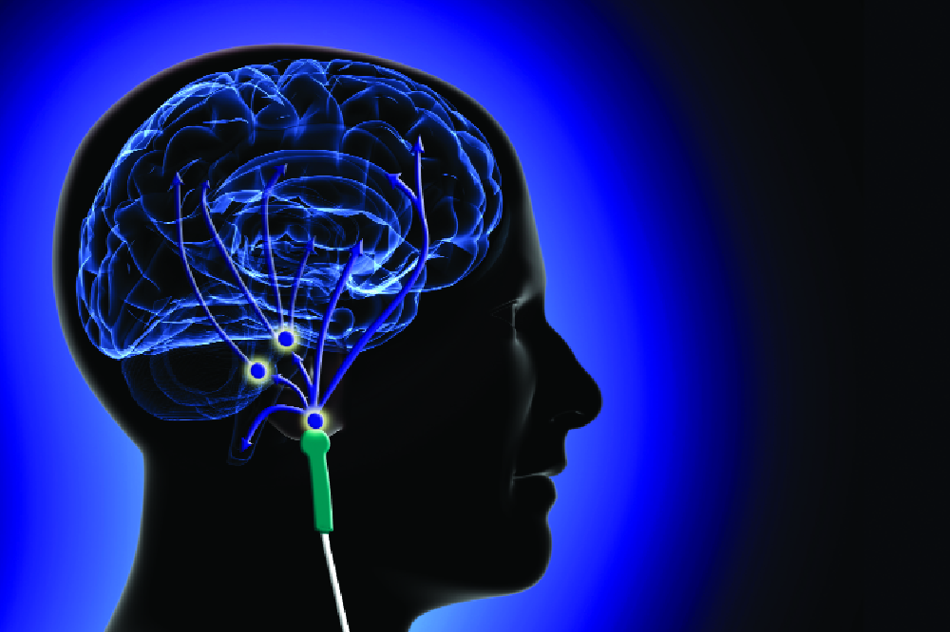

The most commonly occurring mental health illness is anxiety affecting everyone regardless of age, gender, economic and social statute, or ethnicity (Adwas, Jbireal and Azab, 2019). Although anxiety is usually a natural worry, apprehension and/or nervousness of the body as a reaction to a stressful situation it becomes a problem when there is no threat and the body reacts as if there is (Adwas, Jbireal and Azab, 2019). WHO (2022) suggest that in 2019, 301 million people were living with anxiety worldwide including 58 million children and young people, and it has since increased by 25% because of the COVID-19 pandemic (WHO, 2022). In the United Kingdom (UK) anxiety affects 34% of the adult population and 42% of the younger people from the age of 16 to 29 years old (Office of National Statistics, 2021), as well as the rest of the world during the Covid 19 pandemic UK's population has experienced an increase of anxiety disorder from 19% to 39% (Office of National Statistics, 2021).
Alpha-Stim AID is an electrotherapy gadget no larger than a mobile phone, currently used in the United States of America and the UK on private purchases or private practices (NICE, 2020). The device's function is based on stimulating the electric action of the brain's alpha wave through repetitive (0.5 hertz every 10 seconds) use of variable electric microcurrent (NICE, 2020). In the treatment of anxiety, the potency of the electricity can be adapted, and the electricity is furnished through a couple of miniature hooks clamped to the ear's lobes (NICE, 2020). More information about Alpha-Stim AID at: https://www.nice.org.uk/guidance/mtg56/documents/450
The prevalence of anxiety disorder is high both in the UK and around the world and has a negative impact on people’s quality of life, well-being, and capacity to function (Griffiths, et al., 2022). The process of managing anxiety in the UK has three steps that are provided by the National Institute for Health and Care (NICE) guidance including education, monitoring, psychological intervention, and medicated treatment which can be either too lengthy or people can have side effects from medication (Griffiths, et al., 2022).
Alpha-Stim AID is an optimal alternative to all three stages provided by NICE guidelines in anxiety treatment because it can be purchased by everyone at any time without waiting for an appointment for psychological or medicated treatment (Griffiths, et al., 2022). Furthermore, a study conducted by Morriss, et al. (2023) suggests that from 236 participants only nine reported adverse effects and they were mainly headaches that would more likely be from previously medicated treatment, withdrawal. Moreover, Morriss, et al. (2023) found that Alpha-Stim AID can be used to reduce symptoms of anxiety in primary care whereas Griffiths, et al. (2022) suggest that Alpha-Stim AID improves the overall health status by improving anxiety symptoms and it can be both attainable and convenient to patients and professionals.

Introducing Alpha-Stim AID on the NHS as a primary care for anxiety will save time for the health care professionals but more importantly people will not have to wait too long for treatment, therefore, preventing aggravation.

Blog 2.

Mindfulness the anti-depressant



Depression is one of the most common and frequently overlooked mental disorders and can be defined as a low mood in people's everyday lives (Rondon, 2023). Originally coming from the Latin language “depressio” which translates to “sinking”, therefore, a person feels sunk impacting on their reality (Rondon, 2023). According to Tulane University (2021), depression is a concern because the chances of developing a cardiac disease, hypertension, stroke, and diabetes are 40% higher for those with depression and life expectancy can be reduced by approximately 20 years.

WHO (2023) estimates that 5% of the global population is affected whereas in the UK 16% of the adult population was affected, 10% higher than pre-pandemic levels (Office of National Statistics, 2022). There is an effective treatment for depression based on psychological therapy and medicated treatment such as Citalopram, Sertraline, Mirtazapine, and others which can be helpful but more often they can have bad side effects (Mueller, et al., 2017).
One of the major risk factors for developing depression is stress, therefore, lack of sleep (Razzak, Harbi and Ahli, 2019).
There are many studies that supports the effectiveness of practising meditation in reducing symptoms of depression, mindfulness in special. There is no specific way to define mindfulness, it is a “way of being rather” and has three main characteristics (Naik, Harris, and Forthun, 2013).

- Purpose -that refers to purposely directing awareness instead of allowing it to wander.
- Presence -refers to the whole engagement and attention to “the present moment”.
- Acceptance - refers to the way of not being critical of present happenings. For example, any phenomenon, belief, or feeling is not regarded as adequate or wrong; it is thoroughly regarded as happenings.

In a few words, mindfulness-based therapy decreases repetitive negative thoughts and increases the level of happiness (MacKenzie and Lokovski, 2016) More information about Mindfulness effectiveness at: https://www.ncbi.nlm.nih.gov/pmc/articles/PMC4876939/ . And it has been proven to work either on preventing or treating depression. Learn how to practice mindfulness here: https://www.mind.org.uk/media/9587/mindfulness-2021.pdf.
For instance, 80.5% of 457 student participants in mindfulness meditation have reported feeling anxious, unhappy, and having problems sleeping, after 8 weeks of online teaching and meditating once a week for a period between 5-20 minutes, 37% have reported significant changes (Lahtinen and Salmivalli, 2019).
Yet that can be the first step to preventing depression and its great impact on people's well-being.
There are numerous apps, adverts, and signposts about the benefits that mindfulness meditation can bring, however, not many people know about it; what it is, how can be practised, where and most importantly the benefits. Yet, many people know how to use “My GP” apps to book appointments and access their records. Hence, it will bring massive benefits if there will be an icon (please see Figure1.) within the My GP app dedicated to mindfulness called Mindfulness The Anti-depressant.

Figure 1.
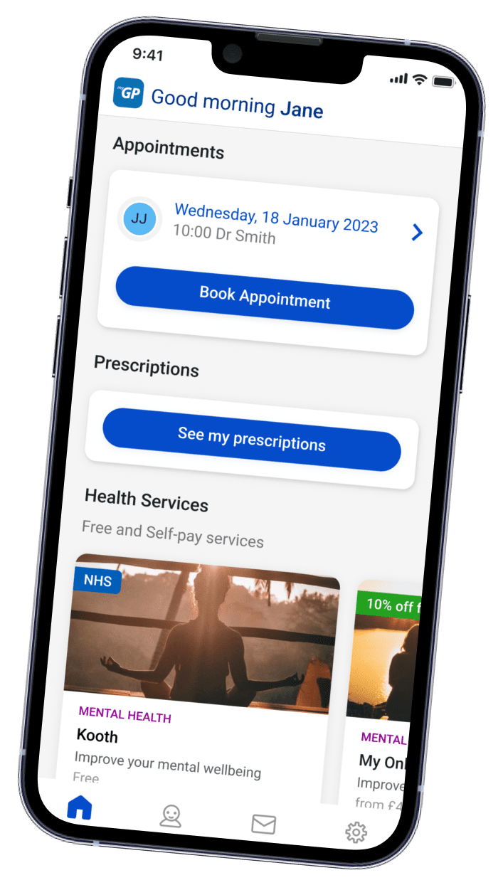
Mindfulness The Anti-depressant icon

The page should contain educational information about what it is and what benefits can bring to people's mental well-being as well as how can be practised.
The benefits of implementing mindfulness within the My GP app will most certainly reduce the number of people accessing primary care, hence, reducing the pressure on healthcare professionals but most importantly will improve the overall quality of life.
On the other hand, it might not be so easy to be accessed by the older generation but that does not mean that they cannot use it. The same information from the app will be sent in the form of a letter if asked for it and of course, it will be verbally promoted by primary care professionals.

Part B

Poster

Reference list:

Akdas, O. and Cismaru, M. (2021) “Promoting mental health during the COVID-19 pandemic: the transtheoretical model of change and social marketing approach”, Int Rev Public Nonprofit Mark, 19(3), pp. 447-474.

Adwas, A.A., Jbireal, J.M., and Azab, A.E. (2019) “Anxiety: Insights into Signs, Symptoms, Etiology, Pathophysiology, and Treatment”, The Journal African of medical science, 2(10), pp. 80-91.
Berging, A.D., et al. (2020) “Preventive digital mental health interventions for children and young people: a review of the design and reporting of research”, npj Digital medicine, 133.

Baker and Kirk-Wade (2023) Mental health statistics: prevalence, services and funding England. [Online]. Available at: https://commonslibrary.parliament.uk/research-briefings/sn06988/ (Accessed: 20 July 2023).

Boston University School of Public Health (2020) The Transtheoretical Model (Stages of Change). [Online]. Available at: https://sphweb.bumc.bu.edu/otlt/mph-modules/sb/behavioralchangetheories/behavioralchangetheories6.html (Accessed: 21 July 2023).
Cole, G. (2022) “The trans-theoretical model for mindful cognitive behavioral therapy a paradigm for systematically advancing evidence-based practice and research”, Cogent Psychology, 9(1).
Griffiths. C., et al. (2022) “Alpha-Stim AID Cranial Electrotherapy Stimulation (CES) for Anxiety Treatment: Outcomes in a Community Healthcare Service”, Open Journal of Depression, 11(04), pp. 80-92.

Lahtinen, O., and Salmivalli, C. (2019) “The relationship between mindfulness meditation and well-being during 8 weeks of ecological momentary assessment”, Mindfulness, 11, pp. 255-263.

Li, J. (2023) “Digital technologies for mental health improvements in the COVID-19 pandemic: a scoping review, BMC Public Health, 413(23).

Morriss. R., et al. (2023) “Clinical effectiveness of active Alpha-Stim AID versus sham Alpha-Stim AID in major depression in primary care in England (Alpha-Stim-D): a multicentre, parallel group, double-blind, randomised controlled trial”, The Lancet Psychiatry, 10(3), pp. 172-183.

Mind (2019) Depression. [Online]. Available at: https://www.mind.org.uk/media-a/2935/depression-2019.pdf (Accessed: 22 July 2023).

Mueller, C., et al. (2017) Mental Health in Older People A Practice Primer. [Online]. Available at: https://www.england.nhs.uk/wp-content/uploads/2017/09/practice-primer.pdf (Accessed: 3 July 2023).

MacKenzie, M.B., and Lokovski, N.L. (2016) “Mindfulness-based cognitive therapy for depression: Trends and developments”, Psychology Research and Behaviour Management, 9(125).
NHS (2022) Protecting patient data. [Online]. Available at: https://digital.nhs.uk/services/national-data-opt-out/understanding-the-national-data-opt-out/protecting-patient-data (Accessed: 20 July 2023).
NICE (2020) Medical technology consultation document Alpha-Stim AID for anxiety disorders. [Online]. Available at: https://www.nice.org.uk/guidance/mtg56/documents/450 (Accessed: 1 July 2023).

Naik, P., Harris, V.W., and Forthun, L.F. (2013) “Mindfulness: An Introduction”, IFAS Extension, 8.

Office of National Statistics (2021) Coronavirus and anxiety, Great Britain: 3 April 2020 to 10 May 2020. [Online]. Available at: https://www.ons.gov.uk/peoplepopulationandcommunity/wellbeing/articles/coronavirusandanxietygreatbritain/3april2020to10may2020 (Accessed: 1 July 2023).

Office of National Statistics (2021) Public opinions and social trends, Great Britain 27 April to 8 May 2022. [Online]. Available at: https://www.ons.gov.uk/peoplepopulationandcommunity/wellbeing/bulletins/publicopinionsandsocialtrendsgreatbritain/27aprilto8may2022 (Accessed: 1 July 2023).

Office of National Statistics (2022) Cost of living and depression in adults, Great Britain: 29 September to 23 October 2022. [Online]. Available at: https://www.ons.gov.uk/peoplepopulationandcommunity/healthandsocialcare/mentalhealth/articles/costoflivinganddepressioninadultsgreatbritain/29septemberto23october2022#:~:text=1.,%2Dpandemic%20levels%20(10%25). (Accessed: 3 July 2023).
OCD (2018) Children & Young People’s Mental Health in the Digital Age. [Online]. Available at: https://www.oecd.org/els/health-systems/Children-and-Young-People-Mental-Health-in-the-Digital-Age.pdf (Accessed: 19 July 2023).

Public Health Register (2017) CORE COMPETENCIES AND PROFESSIONAL STANDARDS FOR HEALTH PROMOTION. [Online]. Available at: http://www.ukphr.org/wp-content/uploads/2017/02/Core_Competencies_Standards_linkE.pdf (Accessed: 21 July 2023).

Paykel, E.S. (2008) “Basic concepts of depression”, Dialogues Clin Neurosci, 10(3), pp. 279-289.

Rondon, J.E. (2023) “Depression: A Review of its Definition”, MOJ Addiction Medicine & Therapy, 5(1).

Qu, M., et al. (2022) “The Impact of School Education on Depressive Symptoms in Chinese Adolescents: a Prospective Longitudinal Study”, International Journal of Mental Health and Addiction. Available at: https://doi.org/10.1007/s11469-022-00944-5 (Accessed: 24 July 2023).
Razzak, H.A., Harbi, A. and Ahli, S. (2019) “Depression: Prevalence and Associated
Risk Factors in the United Arab Emirates”, Oman Medical Journal, 34(4), pp. 274-283.

Svalastog, A.L., et al. (2017) “Concepts and definitions of health and health-related values in the knowledge landscapes of the digital society”, Croatian Medical Journal, 58(6), pp. 431-435.

Tulane University (2021) Understanding Mental Health as a Public Health Issue. [Online]. Available at: https://publichealth.tulane.edu/blog/mental-health-public-health/ (Accessed: 2 July 2023).

Taylor, A. (2020) A Review of Apps and Websites for Promoting Mental Wellbeing: Findings and Initial Recommendations for Design. [Online]. Available at: https://radar.gsa.ac.uk/6220/1/Review_Camera_Ready.pdf (Accessed: 18 July 2023).

University of Alaska (2023) TRANSTHEORETICAL MOdel. [Online]. available at: https://ua.pressbooks.pub/persuasiontheoryinaction/chapter/transtheoretical-model/#:~:text=The%20Transtheoretical%20Model%20indicates%20that,needs%20to%20move%20to%20maintenance. (Accessed: 23 July 2023).

Viswanathan, M., et al. (2020) “Treatment of Depression in Children and Adolescents: A Systematic Review”, Agency for Healthcare Research and Quality, 224.

WHO (2023) Depressive disorder (depression). [Online]. Available at: https://www.who.int/news-room/fact-sheets/detail/depression (Accessed: 3 July 2023).

WHO (2022) Mental disorders. [Online]. Available at: https://www.who.int/news-room/fact-sheets/detail/mental-disorders#:~:text=In%202019%2C%20301%20million%20people,children%20and%20adolescents%20(1). (Accessed: 1 July 2023).

WHO (2022) COVID-19 pandemic triggers 25% increase in prevalence of anxiety and depression worldwide. [Online]. Available at: https://www.who.int/news/item/02-03-2022-covid-19-pandemic-triggers-25-increase-in-prevalence-of-anxiety-and-depression-worldwide (Accessed: 1 July 2023).

WHO (2023) Depressive disorder (depression). [Online]. Available at: https://www.who.int/news-room/fact-sheets/detail/depression ( Accessed: 4July 2023).

WHO (2023) Health Promotion. [Online]. Available at: https://www.who.int/westernpacific/about/how-we-work/programmes/health-promotion#:~:text=Health%20promotion%20is%20the%20process,of%20social%20and%20environmental%20interventions. (Accessed: 19 July 2023).

WHO (2017) Health Promotion: A strategy for the Africa Region. [Online]. Available at: https://www.afro.who.int/sites/default/files/2017-06/hpr%20-%20strategy%20for%20african%20region.pdf (Accessed: 20 July 2023).

