

.

Healthcare on Hand
Providing Healthcare to Adults and Children since
2017
Briefing Paper

Healthcare In Hand is a rapidly growing home healthcare company. Founded in 2017 Healthcare in Hand continues to provide care to adults and children with complex needs in their own home.

The purpose of this document is to outline and introduce the services when meeting with Line Managers that the new team at Healthcare on Hand will provide.

1.1 Explain each stage of the employee lifecycle and the role of the people professionals within it.

The employee journey is delivered by the people professional team by using the 6-stage employee lifecycle, Attraction, Recruitment, Onboarding, Development, Retention and Separation as shown in appendix 1 (Verlinden, 2020). Attraction is the first stage, and our branding needs to be strong and powerful, showing what our organisation stands for and what an employee may expect from us (Waite et al., 2021). The next stage in the employee journey is recruitment, and our People professionals are committed to promoting job vacancies, advertising the variety of roles to the relevant platforms, and ensuring the person we are employing has the relative knowledge and skills required for the role they are being recruited for. The next stage in the employee’s journey is onboarding. Onboarding is a key process and the people professional team play an important role; this is the first introduction to employment with us. Communication and engagement are essential to ensure future employee’s feel valued and are excited about their new role. Induction and development continue the employee journey, and our people professionals will be on hand to encourage, nurture and drive our training programme, encouraging employees to grow and develop. Succession plans and promotion from within is encouraged, rewarding staff for loyalty, and encouraging them on their journey. (Granat, no date). At Healthcare in Hand, it is important for staff to feel valued, our team of people professionals will work on its retention of staff, to build on pay and benefits, providing welfare calls and supporting employees who need advice on matters such as health and well-being while promoting staff recognition and work life balance. Separation is the end of the employee journey, this could be for several reasons, voluntary by means of resignation or retirement or it could be involuntary such as redundancy or dismissal.

1.2 Explain different ways in which you can prepare information for specified roles.

The people professional team will gather and analyse information to prepare for specified roles and can be done in several ways. If the role is currently in operation, the most effective way of obtaining this information would be by asking the current job holders. The team will do this either by interviewing the employees or by sending questionnaires. If the role is a new, then the Line Manager is the best employee to speak with as they and have the knowledge and insight into the role they want to create. (Waite et al., 2021). Once the information has been received the people professionals will analyse this information to create the job description. The document needs to include the person specifications and role profiles and will be designed to show what qualities and skills we are looking for in a future employee. This is split into 2 categories, essential and desirable, essential is the skill or qualification that is specifically required for the role, for example if we are recruiting for a Children’s Nurse, then a degree in Child Nursing is an essential skill needed to undertake this role. However, if we are recruiting for a Support Worker then skills and qualifications in healthcare would be desirable and would provide some evidence that they have the skills needed to be considered. (Methods of recruitment and selection of employees - Recruitment and selection of employees - AQA - GCSE Business Revision - AQA, no date). Appendix 2 shows what needs to be included in the job description (Job description templates | Acas, 2020).

1.3 Explain different recruitment methods and when it is appropriate to use them.

Vacancies at Healthcare in Hand will be advertised both internally and externally. The team will advertise internally within the organisation using our intranet and all vacancies will be available on our website. By advertising internally, we will ensure that all our employees will have the opportunity to grow and develop within our organisation and nurture the skills of our current employees. A recent report found that 28.3% of employees resigned as there were no opportunities for development (Shuster, n.d.). Our people professionals’ team will look to use a variety of platforms to externally recruit our vacancies, these can include social media, attending job fairs, other organisations publications and websites. Job fairs provide a large pool of talent who are all looking for employment and it gives them a change to meet future employees and to discuss our various roles, it will also give any future employees opportunity to ask any questions. Social media sites such as LinkedIn, Instagram and Facebook prove extremely effective, over 80% of job seekers can use social media when seeking employment (Siôn Phillpott, 2019). The nature of the vacancy will determine the platform used, for example if we are looking to recruit a Children’s Nurse then we would look to advertise our vacancy within healthcare professional websites, however if we were looking to recruit administrative staff, then we would look for a platform relative to this role, such as Indeed or LinkedIn.

1.4 Explain factors to consider when deciding on content of copy used in recruitment methods.

To advertise internally the people professionals will draft a document, which needs to include information regarding the role we are recruiting for, for example the salary, hours, and location. It will also include the personal specification outlining the essential and desirable requirements. The document will include our logo and branding, maintaining a professional and corporate image. As this will be targeting our existing employees, information introducing our organisation, our benefits and reward packages are not required, our staff should already be familiar with our organisation and its values. (BBC, 2022). External recruitment needs to create a positive image for maximum attraction and will include our branding and logo reflecting our corporate image to the wider audience outside of the organisation. Included in the job summary will be a paragraph on Healthcare in Hand, what we stand for and will include our values and beliefs. We also need to include details of the role, salary, hours, and location. The people professional team need to determine and include the personal specification and essential and desirable requirements.
The team will also need to consider the advantages and disadvantages to advertising both internally and externally. Internal advertisement is cost effective and promotion from within encourages loyalty. Existing employees already have the knowledge of the organisation and we will already have an understanding of their strengths and weaknesses. It does however have its disadvantages, recruiting internally only gives a limited pool of talent as opposed to external recruitment which reaches a wider range of applicants, and can bring fresh and new ideas. External recruitment can be costly, and lengthy with notice periods (Indeed, 3BC).

2.1 Explain different selection methods and when it is appropriate to use them

The recruiting process starts with the team assessing any applications received, developing long and short lists. Long listing can also be known as screening and scores the candidates against the personal specification on our job description, removing any candidates who do not have the relevant qualifications. Once this process has been completed, we move onto our shortlisting and depending on the number and quality we have received, could be our final list to interview, however if needed we can further assess, reviewing the essential and desirable criteria (Longlisting vs Shortlisting: What’s The Difference?, no date). Once we have our final shortlist, we can begin to arrange the interviews. The team will determine how the interviews will take place either face to face or by telephone or teams, and who will be conducting them. Face to face interviews is popular as they can give you a chance to meet each other and can be easier to communicate, however teams or telephone can be used if the candidate is currently living away and cannot attend in person. The people professional team will then decide on questions for the interview or if any tests are required. Testing may be required if we are recruiting for a more senior role and can be used to assess their skills and knowledge in more depth. The questions need to be relevant to the role we are recruiting for, and testing can include composing an email or compiling a report. They also need to ask open questions such starting with ‘tell me about’ or ‘what would you do’. The interviews are structured and scored to ensure a fair and consistent approach is used, candidates are asked prior to interview if they require any reasonable adjustments ensuring that the whole selection process will be conducted in a clear, unbiased and transparent way to maintain that we are supportive and offer equal opportunities to all to create a diverse and equal organisation (CIPD | Selection Methods, no date).

2.4 Explain the selection records that need to be retained

Any written records need to be retained for both successful and unsuccessful applicants. The records kept need to be accurate and eligible and they need to be recorded at each stage of the process which starts form application to appointment. Application forms or CV’s need to be kept, and long and shortlisting records will need to be retained. The interview notes that have been taken need to be clear and concise showing scores that reflect the written text as taken during the interview also need to be kept. If we have used testing as part of the process these records also need be retained. The selection records are kept ensuring a fair and just process is followed, and should the need arise are used in any claims of discrimination or unfairness can be defended. These selection records need to be kept for a minimum of 6 months however Healthcare in Hand have developed a policy for the retention of these records to be kept for 1 year. In the event of any claim from an applicant who feels that they have not been treated in a fair and just way Healthcare in Hand need to be able to defend decisions that have been made and if we don’t have the records and they have been destroyed we will be unable to prove the rationale behind decisions we make. People Practice, A Complete Guide p131 (Waite et al., 2021).

Total 1630 words

BBC (2022) Internal and external methods of recruitment - Effective recruitment - Edexcel - GCSE Business Revision - Edexcel, BBC Bitesize. Available at: https://www.bbc.co.uk/bitesize/guides/zbwhxyc/revision/3.

CIPD | Selection Methods (no date) CIPD. Available at: https://www.cipd.org/uk/knowledge/factsheets/selection-factsheet/#interviewing.

Granat, J. (no date) Council Post: Four Benefits Of Promoting Talent From Within, Forbes. Available at: https://www.forbes.com/sites/forbesfinancecouncil/2019/11/05/four-benefits-of-promoting-talent-from-within/?sh=762646bd77dd (Accessed: 13 May 2023).

indeed (2019) How to Write a Job Description | Indeed.com, Indeed.com. Edited by B. Sullivan. Available at: https://www.indeed.com/hire/how-to-write-a-job-description.

indeed (3BC). Available at: https://ie.indeed.com/career-advice/career-development/recruitment-methods#:~:text=To%20get%20the%20most%20out%20of%20your%20external,might%20take%20you%20to%20screen%20and%20interview%20recruits . (Accessed: 23 January 2023

Job description templates | Acas (2020) Acas.org.uk. Available at: https://www.acas.org.uk/job-description-templates.

Longlisting vs Shortlisting: What’s The Difference? (no date) Fraser Dove International. Available at: https://www.fraserdove.com/faqs/longlisting-vs-shortlisting/#What%20Is%20A%20Longlist%20in%20Recruitment? (Accessed: 20 May 2023).

Methods of recruitment and selection of employees - Recruitment and selection of employees - AQA - GCSE Business Revision - AQA (no date) BBC Bitesize. Available at: https://www.bbc.co.uk/bitesize/guides/zvfw8xs/revision/2

Shuster, L. (n.d.). Council Post: Why Internal Recruitment Can Be A Smart Strategy For 2023. [online] Forbes. Available at: https://www.forbes.com/sites/forbeshumanresourcescouncil/2023/02/22/why-internal-recruitment-can-be-a-smart-strategy-for-2023/?sh=6de6df5b12b6 [Accessed 8 May 2023].

Siôn Phillpott (2019) 6 External Recruitment Methods and Their Pros and Cons, Careeraddict.com. Available at: https://www.careeraddict.com/external-recruitment-methods.

Verlinden, N. (2020) The Employee Life Cycle: 19 Tips to Get it Right, AIHR. Available at: https://www.aihr.com/blog/employee-life-cycle/.

Waite, K., Beevers, K., Small, N., Tomlinson, K. and Hussain, S. (2021). People practice : a complete guide. London, United Kingdom ; New York, Ny: Kogan Page

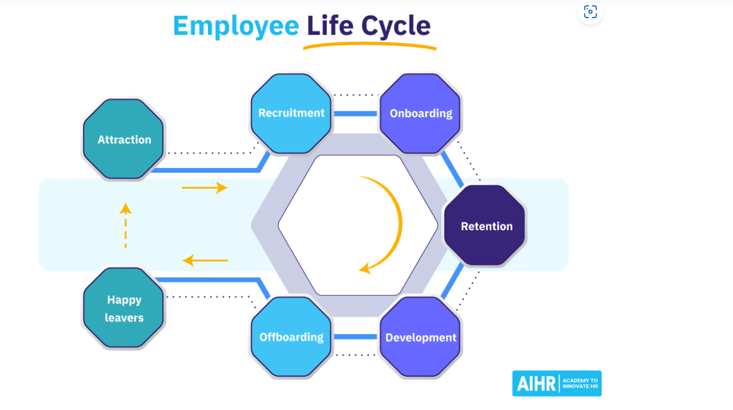Appendix 1.

Outline of a job description

Job title

Department/Section

Main purposes of job
1.

2.

3.

Key tasks
1.

2.

3.

Key results/objectives
1.

2.

3.

Responsible for staff/equipment

Reporting to…
(name and title of line manager)

Appendix 2

Appointment Letter
Healthcare on Hand
Providing Healthcare to
Adults and Children since
2017

Todays date

Applicants name

Applicants Full Address

Dear Name

Re: Appointment of: People Assistant

Further to your interview on date of interview I am delighted to be able to offer you a temporary/permanent part/full-time position of People Assistant.

This offer is conditional upon receipt of two satisfactory references and a satisfactory DBS disclosure. Pending completion of these checks, we have provisionally arranged a start date for 25th June 2023.

Your contracted hours of work will be 30 per week and your salary will be £20,000 per annum. This post is subject to the completion of a Probationary Period with a review at the end of the first 6 months.

In order to proceed I would be grateful if you would confirm acceptance of this post in writing.

I would like to take this opportunity to welcome you to Healthcare in Hand and I hope that you have a happy and successful career with the organisation.

Congratulations and welcome to the team.

Yours sincerely

Name

Job Title

Non Appointment Letter

Healthcare In Hand
Providing Healthcare to
Adults and Children since
2017

Todays date

Applicants name

Applicants Full Address

Dear Name

Re: Unsuccessful Interview

Thank you for attending the interview on date of interview for the above vacancy.

The panel were faced with a very difficult decision on the day and unfortunately, on this occasion, you have been unsuccessful.

If you require feedback on the interview, please contact myself on contact number and I will be happy to discuss this with you.

Once again, thank you for the interest you have shown in Healthcare in Hand, and we wish you every success for the future.

Yours sincerely

Name
Job Title

