Kai Probert 2200897
2200897@student.uwtsd.ac.uk
Data security and compliance - ACCA5034 Kai Probert - 2200897

Task 1 – Research in Data Security and Compliance
Modern security organizations are constantly evolving, thanks in part to the constantly changing and growing security standards. Every company needs to have a strong understanding of what makes their business secure and insecure, to be able to make changes quickly to keep themselves up to standard. Modern organizations require high security standards in the modern day due to the constant threat of hacking and data breaches. Without a good understanding and implementation of security a business will quickly fall victim to the large hacking organizations that try to steal data and money.
I will discuss, explain and review how different security measures work, while also explaining how their affect a business if they are implemented both correctly and incorrectly. I will cover different security examples and show their effectiveness when implemented correctly.
Cryptography
There are multiple forms of cryptography that are used in day-to-day cybersecurity. It is a very strong tool to provide security to hidden texts or data that needs to be encrypted. Cryptography is concealing messages or data within a secret code. Examples of these are ciphers like substitution, permutations, or public / private key cryptography. Typically, either block ciphers, symmetric keys, or public keys for the encryption of the data. Block ciphers requires to make use of multiple keys, as it encrypts the data in blocks. This is usually a defined value of 128/192/256 bits. Triple DES (or 3DES, TDES) is an example of a symmetric block encryption algorithm that which applies a DES encryption to a data block. It does this three times per block, it uses 64-bit blocks which makes it less secure that AES, for that reason. It was recently deprecated due to this reason, as it is susceptible to known plaintext attacks.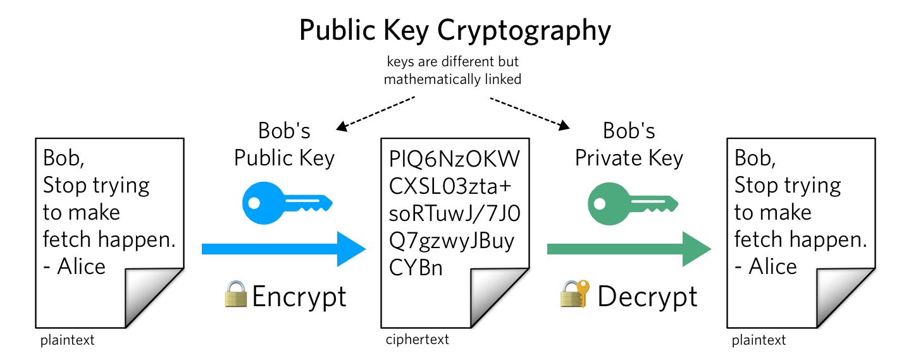
Figure 1 - Public Key Encryption [1]
A symmetric key encryption uses one key that can both encrypt and decrypt data. An example of symmetric key encryption is AES, this can be used in things like zip files to encrypt the data, while requiring the same key to decrypt that data. Public key encryption is used when encrypting data that you typically only want one person to access. This is used in things like email, where person one wants to send an email to person two, while it is encrypted. To do this person one would require person two’s public key, then when the email is sent to person two, they can use their private key to decrypt the email. As the private key should only ever be known by the person who is receiving data. The second a private key is leaked, any data that is sent to that person should be considered as “public” meaning that anyone could read said data / email. 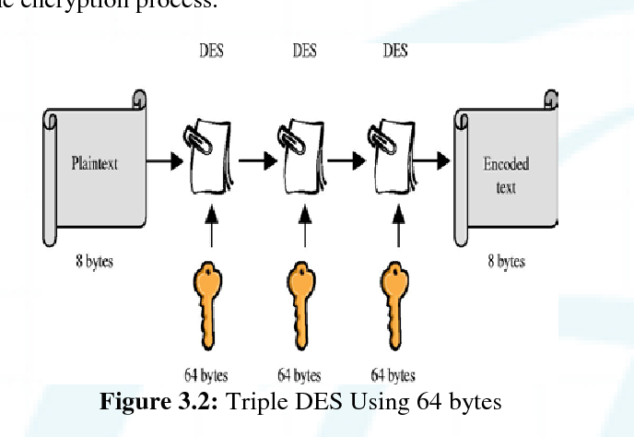
Figure 2 - Triple DES encryption example [2]
Steganography is the practice of hiding a message, not encrypting it. It is different from cryptography due to the way it is used. Steganography is for example hiding a message within another message. This could be done by using each letter of a word to create a message. Other examples of this are using things like invisible ink, requiring a heat, or a chemical to reveal the message. Its drawbacks are that it is a high effort method that if discovered, makes any messages using the method worthless, as the method to understanding the message has been figured out. It is also not high security due to messages being stored in plaintext, meaning that anyone could figure out the method you are using, sometimes by accident.
Cryptanalysis is the process of decryption of encrypted data. This role is done by a cryptanalyst. They use various methods to find and decrypt data that is required to be decrypted. Using a multitude of different attack methods known plaintext for example, allows the cryptanalyst to work towards getting a full decryption of the data. Their role is used in many fields, though typically is used in the security sector (government, police etc). They can also work in public enterprises in decrypting data that was accidentally encrypted, or if someone had lost the key for the data decryption. [3]
Cryptography is an incredibly important implementation for a business as storing data without proper encryption can lead to data leaks by hackers, which can cause irreversible damage to a company’s reputation. It is one of the most important roles that a business should cover in security, as even when a business is hacked, any data that is encrypted will be secure and unreadable from the hackers, making the breach far less severe. This is also why companies should make sure they have SSL certificates on their websites to encrypt the traffic coming from client and server. Using this means that any traffic that comes from the website requires the public key to view, which only the person who is making the transaction, for example, would have access to. Without all of this, businesses become vulnerable to hackers, while also not being compliant. In the UK, without this you could be considered GDPR uncompliant, which could lead to company suspension or fines.

Physical Security
Physical Security is one of the most important measures a business can take to protect itself and its data from breaches. Without any form of physical security, it can lead to break-ins, or non-authorized company personnel accessing data due to improper security measures.
There are many different things a business can do to protect itself with physical security. One of these main things is having a good access policy. Using things like keycards, or more recently biosecurity (facial scanners, fingerprint scanners) it stops bad actors, or unauthorized employees from accessing rooms that they are not meant to be able to. Facial recognition is one of the best options for physical security as it removed the human error (like time recognition systems) and is also far more accurate and harder to bypass.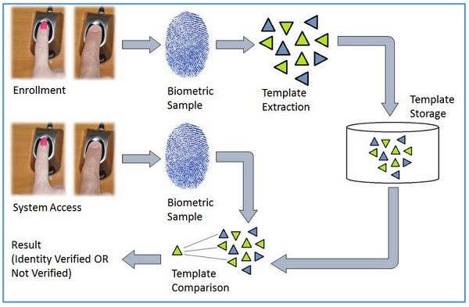
Figure 3 - Biometrics example [4]
Biometric security requires the biometric data to be stored somewhere, although this is typically done locally on the scanner itself or done off-site making it impossible to copy. You would require a physical copy of a fingerprint, or face for the system to be fooled, and this is near impossible to do. Strong staff training also helps with physical security, requiring people to lock any sensitive rooms so to not leave them open for anyone. Doing this alone can help any business be stronger with their security. RFID cards are an excellent example of something that can benefit security thanks to their strong protection. Most high-end RFID cards are possible to copy, but it is exceedingly difficult. All keys also have a unique ID, meaning that someone could not create their own to work on the door / system.
Alarm systems are generally required in basic security. Using an alarm system that can ping someone’s phone to let them know that it has been tripped, can be immensely powerful when paired with Wireless cameras. They both can work together to record, after an alarm has been tripped proving evidence if a break-in were to occur. They are also very low maintenance, meaning that very little upkeep is required to make them work for extended periods of time. Preferably, companies should hire active camera systems that are constantly monitored by a team 24/7.[5] Although this is the best option, this can prove to be expensive and, in some cases, unnecessary, so this is often typically implemented far less than a static system that does not require constant monitoring. Remote monitoring can also remove the need for on location security, massively reducing the cost of overall security. Business can save 80% on security, while maintaining the same level of security.[6]
Although remote monitoring is incredibly useful, there is no true replacement for strong on the ground presence for security. Having guards that monitor the building 24/7 is the perfect solution to high security implementations. A mobile guarding solution is vital when dealing with sensitive data. Combined with an alarm system, they can quickly report to the location and deal with any possible threat. Although security should also be in place during the day, this deters anyone who would want to break in during the day but also can keep guard over staff, meaning no-one can get access to a room they are not meant to be in. Around the clock guards are important, having people who watch doors, to stop possible intruders is a strong way to help prevent this. The presence of a security team can help via intimidation also, a security team that constantly patrols an area (possibly also armed) can instantly deter anyone that was thinking of trying to breach the premises.[7]
Other physical security measures, like using exterior walls, fences and gates are a large visual deterrent, as the security it provides, while being strong, is intimidating to look at and makes the building automatically seem far more secure. While you should not add to many interior gates, as it can slow down business while not increasing security. Barriers also slow down everyone when leaving due to a fire alarm, making everyone scan out of a gate during a fire is incredibly dangerous and therefore the amount should be limited. Gates are important and when used correctly can completely stop people without access. Things like walls fences and gates will not always stop a determined attacker but can slow down the breach enough to allow security to arrive.[8]

Security Technology
Technical controls are incredibly important when enforcing policy. Things like firewalls, access controls are both important things that when configured correctly can help towards making a company’s data easier to access while keeping the data’s security.
Access controls are one of the most important technical controls that a business can implement. Adding these measures stops anyone from accessing information that they are not cleared to use. Using Mandatory Access Controls (MACs) to label and structure this information is very important, if not required. Labels are typically classified in terms of clearance required. For example, no clearance required, class B clearance required, Class C clearance required, secret etc. All of these labels are used in accordance with the company and its staff to allow for certain clearances into rooms. This could be printed on an ID card, so that any guards watching the doors could scan or read the IDs to see if they have the level of clearance required to enter. This can also be done via colour coding, so all classified IDs are red, lower clearances are blue. For higher security, it is possible to use certain identifiers that can be scanned to prove clearance. Random letters or numbers, department numbers for example.
Firewalls are the basis of network security. Without this, your network has no filters, allowing for any untrusted traffic to get through into your network and data. Firewalls do not have to be hosted on any specific piece of hardware; they can be hosted from anywhere within the network. For example, you could setup a firewall from the host pc, or from another separate system, it is also possible to host the firewall using software on a router or switch. Typically, it is hosted on the switch / network, as this is the most time efficient and easiest to configure. Firewalls complete a multitude of jobs to help a network stay secure, some of these are packet filtering, MAC layer firewalls and a proxy. The most common use of firewalls is packet filtering and is used to filter any unrestricted packets and filters through the data packets that are trusted within the network. This is done by reading the IP source address and destination address. It can also be done through TCP or UDP port requests. The proxy firewall is used as both a firewall and an application layer proxy server. These are typically placed in less secure parts of the network but can be more protected by extra packet filtering firewalls. MAC layer firewalls are designed as a sublayer to the network’s data link layer. Any filtering a MAC layer firewall does is based on the host computer, any traffic passing through this firewall layer has been added to an access control list to allow the packets to pass through, any other data from non-access control list systems are blocked. 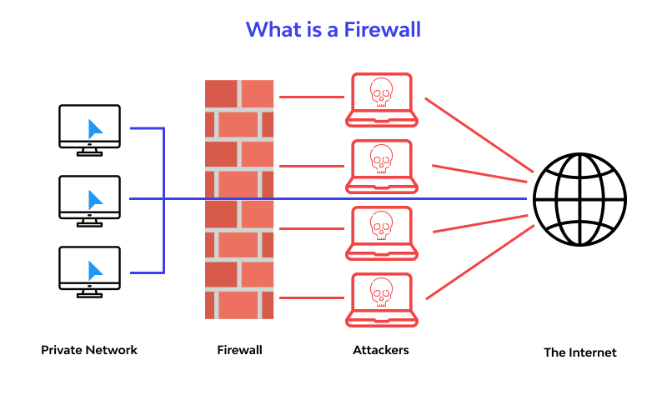
Figure 4 - Firewalls example [9]
All of these systems can be implemented through a hybrid firewall system. This allows the system to make use of any and all of the firewalls to better help protect the network. This is sometimes used when a company wants to expand their firewalls, so they can create a hybrid firewall instead of completely reworking their existing firewall system. More recently, companies have adopted NGFW (Next Gen FireWall), this is far more extensive than a traditional firewall, having many more features than a traditional firewall. For example, the NGFW can block modern threats like malware and application layer attacks, making it incredibly useful in the modern day. It also has integrated threat analysis, meaning that it can constantly search the network for malicious activity and try to prevent it without human intervention. [10]
Firewalls are incredibly important and one of the key factors in securing a network, without it an entire organizations network would be at risk of a breach. With more modern implementations like the NGFW and its ability to cover more ground than a human or a traditional firewall, it can easily stop any malicious software that tries to enter a companies’ network. It is ability to block DDoS attacks, phishing and malware makes it incredibly useful and an absolute requirement for modern day companies.
Task 2 – Case Scenario
StressSolution(SS) is an expanding CyberSec and security consultancy company. Their goal is to provide around the clock security for all of their customers providing active protection against security threats and high-quality consulting services for customers, using proven technology and techniques.
StressSolutions wants to expand and set up a new InfoSec unit (information security unit). To do this they will need to implement some strategies to help aid their solutions. There are many factors that will help towards making the InfoSec unit more efficient and make sure it provides necessary security solutions to companies.
StressSolutions should first implement a structure for employees and their respective divisions to follow. Without these properly implemented, StressSolutions leaves themselves open to insider threats, both malicious and accidental. This structure will allow them to close of certain sections of data and information that certain decisions should not be able to access. For example, StressSolutions would make the security team and the support teams in separate divisions, to make sure that neither division can access data to which they are not authorized. Everyone should be separated into their own departments meaning there is no cross-departmental access unless approved by the director of security.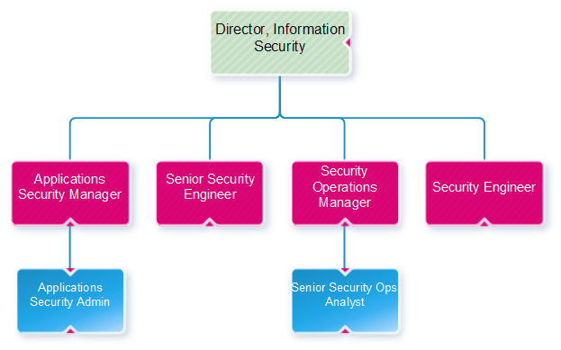
Figure 5 - Infosec example [5]
Doing this also creates multiple lines of defence, making security breaches for more difficult for a threat actor. Making every division sperate from another means that only one sector could be breached at a time, allowing for faster security deployment and less data being taken. The only way to breach the company then would be to hack the director themselves, who has access to the entire InfoSec division. If this would be implemented correctly it would also allow for the individual departments to work just as efficient, as requests should only be made between departments with special requirements, if a department was always requesting access to data, then those departments should be interconnected and allowed to access each other.
Next, StressSolution should work towards making their policies and procedures secure, simple but effective. These are important because it outlines to employees and stakeholders how the security requirements should be met and any responsibilities that the company has. It reduces the ambiguity of information and makes everything that is said clear to everyone and should reduce certain decision making due to the clarity of the rules. There are three objectives an InfoSec company should have when considering their policies and procedures. These are Confidentiality, Integrity, and availability. [12] Confidentiality is the requirement to make sure that any data that can be accessed should only be able to be accessed by the party that is authorised to. Any other access from sources that should not have access to this data would be a failure in the company’s confidentiality policies. Integrity is important as they should be constantly maintaining and improving their security systems so that they are always up-to-date and secure. A failure in integrity would be a big failure in the company as it would not have reliable systems or have systems that are no longer fit for their purpose in the infrastructure. Availability is a requirement of the business structure. The company’s information or policies must be available to access by authorized employees. This is an absolute requirement for the company as without this will lead to data becoming poorly maintained or easily accessed by outsider threats. A strong policy framework will allow everyone in the company to clearly understand the requirements set by them, while also giving everyone a role. A good policy framework that should be implemented by StressSolutions is who is responsible for any policy creation and changes, where does the policy apply to the company, what is the specific information that is being protected by the policies and why should the policy exist. What is the reason for having the policy. This should al be clear and easy to understand otherwise it could lead to confusion and a poor implementation of the policy if no-one understands how they operate. All policies and their respective procedures should majorly consider the interests of the company. What its goals are, is very important to how the policies can be written and maintained. If StressSolution did not consider this, it could possibly lead to policies that do not hold the key interests of the business at heart, leading to a bad work environment or a confusing policy that misrepresents requirements of the company’s structure. StressSolution should consider how it operates as a business and what policies are too enforcing on certain roles and what needs to be improved to make some roles more secure and consistent with the company.
It is pivotal for StressSolution to comply with any laws and regulations, while also keeping a strong ethical standing with governments and enforcing entities. Doing this poorly could lead to the company being liable for misuse of data or increase risk for the company’s standing. To do this they should strongly understand the legal environment that they are required to comply with, make sure their policies and procedures are keeping current with any laws and regulations while also keeping watch on any emerging trends and issues that possibly could arise. StressSolution should also be ethically compliant with social trends, as although this is not enforceable, it is very important to public image and how employable the business could become. In the UK, there are a few important laws pertaining to the use of data and misuse of computer devices. The computer misuse 1990 is still in use today and pertains to the way data is accessed and the intent of the person accessing that data. It is typically enforced when malicious users infiltrate a company’s servers but can also be used in the misuse of systems by employees. If someone were to misuse a company’s system from the inside with malicious intent, this law would be impactful in proving that crime. Another very important law for the company to abide by is GDPR. It is required by British law to deal with personal data in a specific way. Any personal data that StressSolution would oversee would need to abide by seven rules. The data should be purpose limited, meaning that only someone who requires to access that data should have access, the company should be transparent with its data storage. If something is stored, then someone who is using the company legally needs to be informed about what data is being used. Companies should also not store data past the point it is required for use, any data that is being stored that has no requirement by the business to have, should be removed from their databases immediately. These are a few examples of what is required by GDPR. Failing to enforce these policies and laws could lead to sanctions and reprimands like fines from the governing body. Doing this, StressSolution would be compliant with law and on a good ethical standing with the people that would use their business.
Governance and information security planning helps translate the plans of the company into more understandable objectives. Governance is giving a set of objectives to the management board with the goal of providing a more understandable direction, they should also help measure the progress towards any objective that was set, giving a far clearer goal to employees. Doing this also makes sure that any and all risk management practices are clear and appropriate for the department. Doing this planning would help StressSolution, its customers and staff have a clear understanding of the company’s goals and what they plan to do in the future. It helps set goals towards how the company should be aligned and managed, allowing resources to have a clear destination, have lower risks against threats and help measure the company’s performance to the effectiveness of the plans that have been put in place. Having a framework towards these goals gives a clearer scope for employees to understand, while also giving management something to have reference to when discussing progress towards goals. Apart of this is making sure that any policies being enforced remain viable as they can change with a companies plans. It is important for StressSolution to put in place systems that can allow of these to be checked periodically, setting schedules for reviews of policies while also allowing for recommendations towards how some polices are enforced or their goals. Following guidance set by already existing security frameworks (like ISO 27000, NIST and CERT/CC for example) can lead to StressSolution having a far easier time understanding what they require to be secure. ISO 27000 is a framework that guides organizations towards implementations about management, governance, and guidelines to other parts of the organization, like cloud services and importantly network security. The NIST guideline helps companies understand how security services should be implemented, how financing certain elements of security should be managed and prioritizing the scope of how the security ecosystem should be implemented. NIST helps with creating action plans, risk assessments and profiling how the current security systems are implemented. Also included in security planning is the training of all staff that work within the organisation. This is pivotal to avoid any new or long-time staff from making mistakes with configuration and also company security. How rouge USB drives found on premises should be managed, is an example of training that would be expected of a security company. StressSolution should create plans for incident reports. This is used when there are attacks with a likelihood of success or could threaten the integrity of company data. Although this is more reactive than a proactive form of defence, it is required for teams to have a strong understanding that if an incident were to occur, what is everyone’s roles and how they should react to a certain threat. This includes the recovery of data once a threat has been identified and contained and damage assessments to the entire systems. This is why it is important for companies like StressSolution to have backups that are on a different network. This should be practiced by StressSolution so that all employees have a constant understanding and can easily remember what to do during an incident.
Risk management is a requirement in any organization, but it is exceptionally important in a security company. Risk management is when an organization and its board of directors will create a design and implement it which allows the business to operate in a safe environment. Without this, companies can be liable for damages while also not having a understand of what parts of the company are exposed to elevated risk. Risk assessments should be conducted to give an overview of the organizations risk level and what assets the company has that would be considered considerable risk. Any of these risks should be identified and a plan created to both identify the risk, and also manage it reducing it to a far lower level of risk. StressSolutions should know what systems are currently in place to allow for a simpler risk assessment plan to be developed. They should be aware of who the threat actors are, allowing them to plan against their attacks, while also being responsible when a risk is encountered and planning around that scenario. These plans also include any people at the company, not just devices. Procedures should be put in place to prevent new employees from having a certain level of access until they are deemed trusted. Risk assessments also should cover human error or natural damage like floods etc. 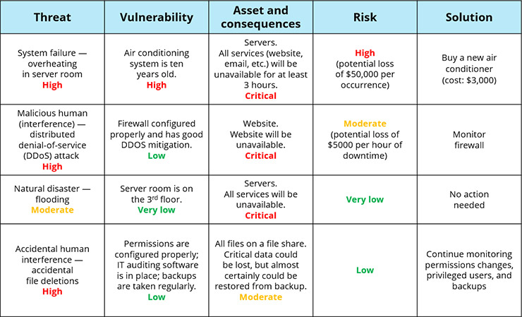
Figure 6 - Risk Assessment chart [13]
StressSolutions should plan and calculate the risk of anything that could go wrong, malicious, or accidental, by comparing the magnitude of data that could be lost in an event. StressSolutions should implement risk assessments into their workflow to both reduce risk and understand what can cause certain risks within their workflow, giving them an advantage with their security and data protection.
Contingency planning is extremely important and works in part with risk assessments. Contingency plans are there to know what to do in the event of an emergency. These risks are things like data loss, breaches in security or human error mistakes. Contingency plans are incredibly important to have, and everyone involved should partake in training to know what their role is during crisis management. All plans should be consolidated into a single document that covers all aspects of a crisis, while also informing everyone who is required what their roles would be in the event of a breach or similar.
There are multiple elements to a contingency plan that makes it work. Awareness training, making sure everyone is aware of the plans and if there are any other plans, reviews, ensuring that the plan is examined often to check if it is still correct with the businesses plans and practices. Constantly revisiting the plans is also important as it can provide any form of improvement deemed necessary that could help in the event of a crisis. The quicker a contingency plan is put into place when an event occurs, the lower the risk of damage to the organization or its employees. The speed of a plan also helps in keeping a stronger financial status, competitive position, and a reputation.
Protection mechanisms are put in place to enforce trust between the different security levels of a device. Typically, this is used to give a hierarchical order to distinct levels of access to the system. Doing this helps protect system processes and its data. In systems, layering is the typical protection mechanism that is used. Implementation of this into a system for StressSolutions could allow for stronger system security. Creating a protection mechanism using encryption is not easy, but it is the strongest protection mechanism that can be used in a system. Thanks to the strong types of encryptions that have been developed encryption can lead to truly secure systems as it is impossible in some cases to decrypt the info without the key. Although encryption of data requires policy additions, legal, management and also usability. Despite its complex nature, it is by far the best option, especially for a security company like StressSolutions. This allows them to keep any data they want secret but requires a deep understanding of not just cryptography but also policies and law, to make sure you allowed to encrypt the data that you are holding. StressSolutions should consider this and make an implementation if it is possible for their business.
In conclusion, StressSolutions new information security unit (InfoSec) has many different approaches to meet their requirements. But, by combining the things mentioned, StressSolutions would be able to operate in a safe environment, that is secure and compliant. The final design path the company goes down should consider these options and what is best for them. Although options like, contingency planning and risk management, are non-negotiable and the organization should implement them immediately.

References

[1]
K. Robinson, “Public Key Encryption Example Image.” Twillio, Sep. 21, 2018, [Online]. Available: https://www.twilio.com/blog/what-is-public-key-cryptography.
[2]
S. Karthik, “TDES encryption image example.” Semantic Scholar, 2014, [Online]. Available: https://www.semanticscholar.org/paper/Data-Encryption-and-Decryption-by-Using-Triple-DES-Karthik/e5754799bc8ae8b3ab8e1bb803c12fba95e38a4a/figure/4.
[3]
P. D. C. Rao, D. A. K. Rath, and D. M. R. Kabat, “CRYPTOGRAPHY AND NETWORK SECURITY LECTURE.” [Online]. Available: https://www.vssut.ac.in/lecture_notes/lecture1428550736.pdf.
[4]
“ Benefits of Face Recognition Technology in the Workplace .” https://www.egress-sys.co.uk/benefits-of-face-recognition-technology-in-the-workplace-2/.
[5]
“Biometrics - Overview .” [Online]. Available: https://www.tutorialspoint.com/biometrics/biometrics_overview.htm.
[6]
“CCTV Monitoring & Monitored CCTV Systems,” 2023. https://safeguardsystems.co.uk/security-systems/commericial-cctv/remote-cctv-monitoring-systems/.
[7]
“What is physical security? 3 measures and best practices you should know,” 2022. https://www.kingdom.co.uk/blog/what-is-physical-security-measures-and-best-practices-you-should-know.
[8]
“Fences and Gates,” Nov. 10, 2020. https://www.npsa.gov.uk/fences-and-gates-0.
[9]
“Firewall definition - Image.” 2023, [Online]. Available: https://www.wallarm.com/what/the-concept-of-a-firewall.

[10]
“What Is a Next-Generation Firewall?,” 2023. https://www.cisco.com/c/en/us/products/security/firewalls/what-is-a-next-generation-firewall.html.
[11]
“ CTS Organizational Chart - image.” [Online]. Available: https://cts.ndus.edu/wp-content/uploads/sites/2/2023/04/DirectorInfoSec.png.
[12]
“What is an Information Security Policy?,” 2022. https://www.isms.online/information-security/policy.

[13]
“Information Security Risk Assessment Checklist,” 2023. https://www.netwrix.com/information_security_risk_assessment_checklist.html.

