

Student: Alayna Zaid
Student No: 2225339
Module: Introduction To Independent Research Skills
Component 2
Module code: BMHP5019

TABLE OF CONTENTS
Introduction 3
Background 4
Methods 5
Results 7
Discussion 10
Conclusion and Recommendation 12
Reference List 14

Introduction
One such critical men health concern of the international scene and one of the largest cancer concerns in the UK is prostate cancer as more than 52,000 cases are new infections each year. It grows in the prostate gland and can grow slowly or aggressively, and the early diagnostics are relevant to enhance the survival. Methods of screening that aim to identify the cancer before it reaches a point when it can have any symptoms include Prostate-Specific Antigen (PSA), multi-parametric MRI (mpMRI) and digital rectal examination (DRE) with the concern that it is not one hundred percent accurate, over diagnoses and has psychological implications to the patient. A scoping review suits best since it maps the various evidence, identifies concept of interest and identifies gaps and cluster of results into major themes.

Rationale
In the UK, the recommendation of universal prostate cancer screening is still absent despite decades of research. PSA test, the most widespread screening test, does not have the ideal specificity and sensitivity, and it results in false positives, false negatives, and the identification of insignificant cancers (Bergez-Hernández et al., 2024). The problems of complications due to the unwarranted biopsies and psychological discomfort also complicate decision-making. MPR has also been recognised to enhance the accuracy of diagnosis and lessen unnecessary processes in the meantime. Nevertheless, disparities in access, cost, and different levels of professional knowledge pose challenges to the consistent incorporation into the clinical paths. Moreover, there are still demographic inequalities, and Black men are in significantly greater danger of developing prostate cancer and have worse outcomes. The combination of these problems suggests the necessity to summarise the current research to assess the effectiveness of screening, difficulties, and consequences of screening on UK health practice.

Review Question
What does the current peer-reviewed literature tell us concerning the efficacy, constraints, and ramifications of prostate cancer screening procedures in enhancing prompt detection and patient outcomes in men?

Objectives
To determine and locate the existing peer-reviewed literature regarding prostate cancer screening.

To investigate the advantages and disadvantages of PSA testing, mpMRI, and integrated screening methods.

To investigate impediments, disparities, and threats to screening attendance and results.

To evaluate the use of evidence to inform the UK clinical practice and policy regarding early detection.

To define the gaps that need additional investigation and suggest future research, policy making, and healthcare practice.

Background
Prostate cancer is a field of clinical concern in the UK. As more and more people become aware of the disease, more effective diagnostic strategies are developed, and the population of persons aged 65 and older grows, the necessity to find effective methods of early detection is more urgent than ever (Tay et al., 2024). There is a high degree of heterogeneity in the disease; there are those tumours that are indolent and others that develop quickly. This biological variability makes it harder to come up with screening strategies that could balance the situations of early detection and the situation of unnecessary overtreatment.
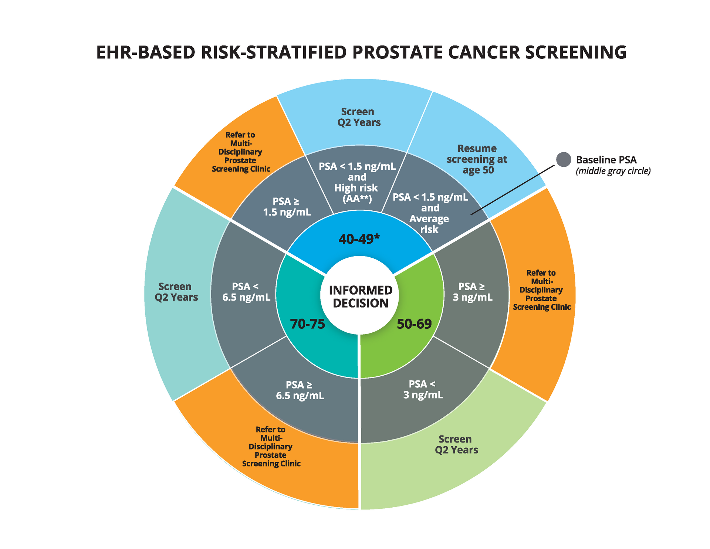
(Source: Dukecancerinstitute.org, 2024)

Policies, Legislation, and UK Guidance
The UK lacks a national prostate cancer screening programme. Rather, the NHS Prostate Cancer Risk Management Programme (PCRMP) informs testing because it assists general practitioners (GPs) in the discussion of the advantages and disadvantages of PSA testing to men aged 50 and above. The “National Institute for Health and Care Excellence (NICE) NG131” guideline offers a wide range of recommendations on the diagnosis and treatment of prostate cancer, with a focus on the application of mpMRI as the initial investigation following an increase in PSA levels.
These are guidelines that embody risk-based, patient-centred as opposed to universal screening. The policymakers are still apprehensive because of contradictory findings about population-wide PSA screening and its effects on mortality rates. The NHS Long Term Plan also promotes the early detection of cancer by enhancing diagnostic capability but does not advocate universal prostate cancer screening yet.

Existing Services and Pathways of Diagnosis
The diagnostic process of suspected prostate cancer usually starts with the primary care, in which men might report urinary symptoms or demand the PSA examination. Men are sent to secondary care to undergo further evaluation in case PSA levels are above age-adjusted levels or in cases of clinical suspicion. The modern diagnostic pathway is now more focused on mpMRI before biopsy, which allows sampling of suspicious areas specifically, eliminating the necessity of systematic biopsy (Boue et al., 2024). Post-diagnosis management options include active surveillance, radiotherapy, radical prostatectomy, hormone therapy, and including less commonly chemotherapy. The determination of treatment choice is based on cancer staging, risk stratification, and patient preference.

Challenges in Contemporary Practice
Overdiagnosis and overtreatment: PSA screening will identify indolent cancers that would never manifest any symptoms.
Inequalities of access: mpMRI is inequitably distributed amongst NHS trusts.
Racial differences: Black men are twice as likely and prone to death than white men (Pennisi et al., 2024).
Sociocultural factors: Stigma, fear, and ignorance lower the screening attendance.
Lack of consistent clinical practice: PSA thresholds and guidelines on referring to the hospital are inconsistent and influence the consistency of the diagnosis.

Methods
A systematic and transparent approach was used in the scoping review, and this ensured the identification of credible, reproducible, and extensive evidence on the topic of prostate cancer screening. The methods were invented based on the accepted principles of scoping review, according to which each step of the study, including the search strategy to analysis, was conducted in a systematic way. The overall approach to the methodology entailed three key components, data collection, data analysis, and ethics.

Data Collection Approach
In an intricate and systematised search, the relevance of peer-reviewed research regarding the study was searched in scholarly databases. The databases identified included “PubMed, CINAHL, Scopus, PsycINFO, and Google Scholar” because they were found to be providing good coverage on the medical science, diagnostic imaging studies, behavioural health, and public health outlook (Li et al., 2024). The studies published after 2014 were taken into consideration only to ensure the availability of the most current evidence, which is the evidence of the progress reached in the field of PSA testing, and the increasing utilisation of multi-parametric MRI (mpMRI) in clinical settings.
Particular keywords and Boolean operators were applied to make sure that as many relevant articles as possible were retrieved. The following were the search terms: prostate cancer, screening, PSA test, diagnostic accuracy, mpMRI, early detection, screening barriers, and men's health. The refinement of the results was performed with the help of the Boolean operators (e.g., prostate cancer AND mpMRI, PSA screening AND limitations).

Inclusion: Peer-reviewed reference or secondary research articles on prostate cancer screening, including adult males, and the screening article language was English and had a direct discussion of the screening effectiveness measure, the diagnostic pathways, or barriers to the screening. The eligible studies were those that utilised quantitative, qualitative, or mixed-method studies, as the scoping review is expected to chart the diversity of evidence forms.

Exclusion: It is used to remove the non-peer-reviewed articles, such as editorials, commentaries, expert opinions, abstracts of conferences, and some research that considers the treatment aspect and not screening or diagnosis. What is more, the studies whose methodology is not clear were filtered to retain quality (Liu et al., 2024).
The titles and abstracts were screened, and possibly relevant articles were accessed to be analysed specifically. The final selection was of the studies that fitted the review question and objectives and rendered them significant and deeply weighty during synthesis.

Data Analysis Approach
The review adopted a thematic analysis approach, which is consistent with the scoping review approach. After the process of selecting the corresponding works, they were all tabulated in the table using systematic information on the significant details: author, year, the purpose of the research, methods, the major findings, and their application to the review question. It was possible to compare studies and to organise the information systematically.
The identification of patterns, repetitive concepts, and significant findings using the included studies was obtained by means of an inductive coding process. Codes were only then grouped into broad categories, and this was reduced to the final themes (Yan et al., 2024). This process enabled the compilation of evidence into rational regions of subjects, such as but not restricted to PSA screening effectiveness, diagnostic advantages of mpMRI, and obstacles to screening among diverse groups, as well as screening dangers or constraints.
They were integrated, and the quantitative and qualitative data were integrated, which contributed to the analysis of providing the statistical information and the patient or community perspective (Gemma et al., 2024). The opposite results were considered critically, where inconsistencies were highlighted and gaps in knowledge were established, where further investigation was intended to be done.

Ethical Considerations
This scoping review was a secondary data review and therefore no ethical consent had to be sought. The studies used were all in the public realm and have already been ethically endorsed by the concerned institutions (Bithi et al., 2025). The ethical requirements were met with the representation of the findings properly, transparency, and appreciation of all the authors, with the help of the right Harvard form of reference. The bias was minimised by employing explicit inclusion criteria and being neutral in interpretation.

Results
The five peer-reviewed articles published in 2024-2025 were incorporated into this scoping review. The subjects of these papers spanned the entire spectrum of screening issues, including genetic testing processes, the rapid diagnosis pathway, volatile urine biomarkers, MRI-targeted biopsy, and disparities in diagnostic pathways. These studies combined to provide information on the emerging technologies in diagnostics, barriers at the system level, and the differences in diagnostic accuracy. A tabular outline was created to make sure that the important features are clearly presented.

Thematic Analysis
Author & Year | Research Objectives | Methods | Key Findings | Relevance to Review Question
Dawson et al. (2024) | To identify based on urinary volatile organic compounds (VOCs). | Systematic Review | Urinary VOCs have potential promises of accuracy, with standardization needed. | Shows potential for non-invasive and early detection.
Falagario et al. (2025) | To make a comparison of MRI-targeted biopsy guiding methodology. | Systematic Review & Meta-analysis | The in-bore MRI guidance was the most accurate, and cognitive fusion was diverse. | Turns out to be evidence-based diagnostic value of MRI-targeted screening.
Jones et al. (2024) | To determine the speed of diagnostic paths of prostate cancer. | Realist Synthesis | One of the reasons is rapid pathways, which are reported to reduce diagnostic delays, but they are variable depending on the regions. | Identifies the system barriers to early diagnosis and the disparities.
Scott & Hoskin (2024) | To examine the disparity in cancer during diagnostics. | Literature Review | However, found significant delays that were related to deprivation, ethnicity, and fragmentation of the system. | Identifies barriers to screening that are population-based.
Tuffaha et al. (2024) | To Survey  the recommendations in the genetic  testing of prostate  cancer internationally. | Scoping Review | Stated Incongruent  Genetic  Testing demands, experienced accumulating evidence  in genetic testing of high-risk men in the germline. | Genetic risk needs to be included in the screening pathways.

Theme 1: Genetic Testing and Risk-Stratified Screening
According to Tuffaha et al. (2024), genetic testing is becoming increasingly significant in the development of individualised strategies to screen prostate cancer. They revisit that BRCA1, BRCA2, ATM, and HOXB13 mutations are highly prone to prostate cancer despite the uneven policy on this case at the global level. Most of the screening programmes do not consider the genetic risk as a routine screening, hence, high-risk men are not detected at an early age. The research claims that the improvement in the precision of the diagnosis would require the introduction of risk-stratified paths which would entail the PSA test when still young and specific MRI on the susceptibility groups of the disease. This can involve genetic profiling to ensure that the screening is more specific, elaborate and fair to the vulnerable populations that are afflicted with more diseases.

Theme 2: Rapid Process of Diagnostic and System Effectiveness
As Jones et al. (2024) have discovered, high-speed diagnostic procedure is considerable and can reduce the time of diagnosis of prostate cancer by incorporating a combination of PSA and MRI with biopsy in a series of clinical procedures. Their derivation of realists implied that the regions were highly different in the level of the pathway performance in the UK to be controlled by the insufficiency of the workforce and low capacity of MRI and lack of uniformity of the communication between the services. Good planning in terms of pathways was also easier to analyse, less anxiety was experienced by the patients and decisions on the treatment became quicker. Conversely, geographical regions that were poor had chronic backlog and delays in diagnosis. The findings state that not only successful screening technologies cause the success of early detection, but the efficiency of delivery of the healthcare services is also effective and well-organised.

Theme 3: Urinary VOCs as a New Non-Invasive Biomarker
As Dawson et al. (2024) prove, urinary volatile organic compounds (VOCs) have a bright future as a non-invasive technique for early detection of prostate cancer. Their systematic review revealed that the VOC profiles between cancer and non-cancer samples are significantly different and that some studies reported a high level of sensitivity and specificity. The procedure is painless and is more acceptable to men who are not keen on carrying out PSA testing or biopsy. Nevertheless, methods of analysis are diverse, and most of the research is only at an initial level, which restricts the ability for clinical use. Nevertheless, VOCs present a considerable potential for improving diagnostic accuracy, minimising the number of unwarranted biopsies, and supplementing existing screening methods with the technology as it is increasingly standardised and validated.

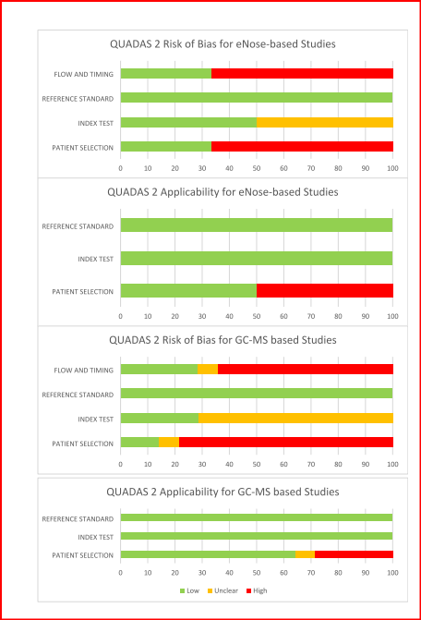
(Source: Dawson et al. 2024)
Theme 4: MRI-Targeted Biopsy Techniques: Accuracy
In the article by Falagario et al. (2025), three methods of the MRI-targeted biopsy, including cognitive fusion, software-assisted fusion, and in-bore guidance, were compared to determine diagnostic accuracy. Their meta-analysis discovered that in-bore MRI-guided biopsy had the highest detection rates of clinically significant prostate cancer and provided a better superiority in terms of precision and reduced operator dependency. Fusion with the help of software demonstrated good results but with greater variability, and cognitive fusion had the least consistency in accordance with dependence on clinical judgement. Such results prove that MRI-targeted biopsies are more reliable in diagnosis than conventional systematic biopsy. Having good quality imaging technology and radiologists who are well-trained is key to establishing equal access to undertake proper diagnosis of prostate cancer at an early stage in healthcare facilities.
Theme 5: Diagnostic Pathway Inequalities and Delays
Scott and Hoskin (2024) mention significant disparities in the diagnosis of prostate cancer in the UK. Their review demonstrates that ethnicity, socioeconomic deprivation, and geographic location are found to have a significant impact on access to screening and early diagnosis. There is reduced screening uptake, wait period, and access to MRI by black men and deprived communities. The inequalities are associated with the delayed diagnosis and worse outcomes. The authors present the idea that to enhance early detection, specific community mobilisation, culture-aware communication, and access to rapid diagnostic routes are necessary. It is important to address structural and social barriers to make sure that screening benefits are accessible to all high-risk groups.

Discussion
This scoping review demonstrates that despite current developments in the field of genetic risk assessment, emerging biomarkers and MRI-targeted biopsy, the system-level and population-level barriers continue to be significant and result in disparities and delays in the early detection and constrain the benefits of new diagnostic methods.

Genetic Testing and Risk-Stratified Screening
According to their review, inherited mutations such as BRCA1 and BRCA2 are strongly related to raising the risk of prostate cancer, and men with a genetic predisposition to an increased risk have a chance to observe the disease progress earlier or more often. Nevertheless, the difference in the global guidelines exists to this day, which makes clinical practice uneven (Tuffaha et al.,2024). This is the lack of connection between the genetic information and application of screening, such that the high-risk groups, in particular, the male population with positive family history or high-risk ethnic groups, will not be diagnosed at an earlier stage. The findings show that it is necessary to have national systems that will integrate genetic testing in the decision-making process in a bid to achieve a more individualised and just screening process.

Rapid Channels of Diagnosis and Service Effectiveness
They can provide a valuable insight into how the organisation of healthcare systems affects the early detection process (Jones et al., 2024). They demonstrate that their synthesis of realists demonstrates that the simplification of the diagnostic process through the use of a rapid diagnostic pathway, simplifying PSA, MRI, and biopsy, has a significant impact on shortening the diagnoses. Regions with good routes offer quicker opinions and fewer anxieties amongst patients. However, geographical inequality is high, and it is linked to the inability of imaging capabilities, manpower, and interservice liaison. This information is congruent with the general data of lagging, which is not only caused by clinical limitations but also structural inefficiency. The process of making a correct diagnosis on time, therefore, requires improved ability to diagnose and avoid a situation where the pathways are not standardised within the NHS.

New Non-invasive Biomarkers (Urinary VOCs)
One possible future screening procedure described is the urinary volatile organic compounds (VOCs). They show high sensitivity and specificity of VOCs to distinguish between cancerous and non-cancerous samples in their systematic review. The VOC analysis method, being a non-invasive test, would potentially reduce the use of PSA testing and unwarranted biopsies, and the method would be more acceptable and comfortable to the patients. However, the current evidence is flawed because of the methodological differences and the current research phases (Dawson et al., 2024). Though VOCs are in their infancy, they remain a promising technical step in terms of screening and an indication of the new direction of prioritising more technologies geared towards a balance between quality and the patient experience.

MRI-Targeted Biopsy Techniques: Accuracy

It indicates a certain difference in accuracy in the MRI-targeted biopsy procedures. Their meta-analysis indicates that in-bore MRI-guided biopsy boasts the highest detection rate of clinically significant prostate cancer and is more effective compared to software-assisted and cognitive fusion techniques (Falagario et al., 2025). This is the basis of increasing application of mpMRI in the diagnosis pathways. However, the issues of operator skill and technology availability are also mentioned in the research as the less developed methods are more changeable. These results prove the thesis of the need to invest in radiological competence and state-of-the-art imaging facilities to ensure the quality of the diagnostic procedures within all healthcare conditions.

Lack of Inequality in Diagnostic Pathways
Inequalities remain alive and have a very significant effect on access to screening and diagnostic services. They also state in their review that Black men and those living in socioeconomically deprived areas have a drop in screening uptake, long wait times, and low access to MRI services (Scott and Hoskin 2024). The result of such inequalities is the consequent diagnoses and poorer clinical outcomes, depicting the trends of cancer inequality in the UK. The findings suggest that technological advancement is not enough to strengthen early diagnosis; one should apply culturally oriented communication, intensive awareness, and adequately distribute the resources so that the positive outcome of screening could be enjoyed by all layers of society, particularly the most vulnerable ones.

Implications
In general, the findings suggest that prostate cancer screening appears to be more precise and personalised. However, the advanced technological improvements are to be supported with the investment and definite action of the state power at the system level and the target intervention of health. The advances of genetic testing, imaging, and the creation of biomarkers will not always guarantee the improvement of the results of all men unless the structural disparities and prolonged diagnostic delays are considered.

Conclusion and Recommendation
This scoping review presented the latest research on the topic of prostate cancer screening, which includes the fact that genetic risk assessment, the accuracy of MRI-targeted biopsy, and new biomarkers like urinary VOCs have been developed. Although technological advances prove their increasing opportunities to enhance the accuracy of diagnostics, as the review indicates, significant system-wide limitations and enduring disparities still predetermine the results of early detection. Black men and those living in deprived communities are at high risk because they are still disproportionately suffering delays and a lack of access to advanced diagnostics. Unstable and inconsistent guidelines and the capability of delivering diagnosis at various spots within the NHS do not contribute to equitable practice. Overall, the results underline that successful early diagnosis involves a holistic strategy, i.e., combining technological development with organisational change, specific outreach, and enhanced accessibility of high-quality diagnostics.

Recommendations
To enhance prostate cancer screening, there should be a combination of genetic risk assessment in the national guidelines so that those carrying BRCA1/2, men of high-risk family history, and high-risk ethnic groups should be screened earliest (Mohammadian-Hafshejani et al., 2024). The rapid diagnostic pathways should be extended to all NHS areas with investments in radiology staff training, MRI availability, and a simplified attitude towards referrals. Diagnostic accuracy should be enhanced by providing equity in access to mpMRI and in-bore MRI-guided biopsy (Zhang et al., 2024). Newer biomarkers, such as urinary VOCs, need additional funding and large-scale validation to advance possible non-invasive screening to come.
There is also a need to use targeted public health interventions to overcome inequalities (Ikhile et al., 2024). Early help-seeking in the high-risk groups can be promoted through culturally sensitive awareness campaigns, community collaboration, and promotion of primary care consultation. Lastly, nationalisation of screening guidelines and nationwide standard data collection will facilitate evidence-based practice and decrease geographic disparity in the diagnosis results.

Reference List
Bergez-Hernández, F., Irigoyen-Arredondo, M. and Martínez-Camberos, A., 2024. A systematic review of mechanisms of PTEN gene down-regulation mediated by miRNA in prostate cancer. Heliyon, 10(15). https://www.cell.com/heliyon/pdf/S2405-8440(24)10981-4.pdf

Bithi, S.A., Al Hasan, M.S., Bhuia, M.S., Mia, E., Yana, N.T., Hasan, A.M.W., Uddin, M.B., Sayeed, M.A., Emon, Y., Hasan, R., and Chowdhury, R., 2025. Botanical sources, biopharmaceutical profile, anticancer effects with mechanistic insight, toxicological and clinical evidence of prunetin: a literature review. Medical oncology, 42(4), p.87.

Boue, A., Joly, F., Lequesne, J., and Lange, M., 2024. Does hormone therapy impact cognition in patients with prostate cancer? A systematic review and meta‐analysis. Cancer, 130(12), pp.2120-2138.

Dawson, J., Green, K., Lazarowicz, H., Cornford, P., and Probert, C., 2024. Analysis of urinary volatile organic compounds for prostate cancer diagnosis: A systematic review. BJUI compass, 5(9), pp.936-947. https://bjui-journals.onlinelibrary.wiley.com/doi/pdfdirect/10.1002/bco2.423

Falagario, U.G., Pellegrino, F., Fanelli, A., Guzzi, F., Bartoletti, R., Cash, H., Pavlovich, C., Emberton, M., Carrieri, G. and Giannarini, G., 2025. Prostate cancer detection and complications of MRI-targeted prostate biopsy using cognitive registration, software-assisted image fusion, or in-bore guidance: a systematic review and meta-analysis of comparative studies. Prostate Cancer and Prostatic Diseases, 28(2), pp.270-279. https://www.nature.com/articles/s41391-024-00827-x.pdf

Gemma, L., Pecoraro, A., Sebastianelli, A., Spatafora, P., Sessa, F., Nicoletti, R., Gravas, S., Campi, R., Serni, S. and Gacci, M., 2024. Impact of minimally invasive surgical procedures for Male Lower Urinary Tract Symptoms due to benign prostatic hyperplasia on ejaculatory function: a systematic review. Prostate Cancer and Prostatic Diseases, 27(3), pp.404-421.

Ikhile, D., Ford, E., Glass, D., Gremesty, G. and van Marwijk, H., 2024. A systematic review of risk factors associated with depression and anxiety in cancer patients. PLoS One, 19(3), p.e0296892.

Jones, K., Chandran, A. and Rance, J., 2024. Rapid diagnostic pathways for prostate cancer: A realist synthesis. Journal of Cancer Policy, 42, p.100514. https://cronfa.swan.ac.uk/Record/cronfa68291/Download/68291__33350__102f34ed81ab4fd0b1cad5a75de02a6a.pdf

Li, J., Deng, Z., Soerensen, S.J.C., Kachuri, L., Cardenas, A., Graff, R.E., Leppert, J.T., Langston, M.E., and Chung, B.I., 2024. Ambient air pollution and urological cancer risk: A systematic review and meta-analysis of epidemiological evidence. Nature Communications, 15(1), p.5116.
Liu, J., Cundy, T.P., Woon, D.T., Desai, N., Palaniswami, M. and Lawrentschuk, N., 2024. A systematic review on artificial intelligence evaluating PSMA PET scan for intraprostatic cancer. BJU international, 134(5), pp.714-722.

Mohammadian-Hafshejani, A., Farahmandian, P., Fadaei, A. and Sadeghi, R., 2024. Investigating the relationship between cadmium exposure and the risk of prostate cancer: a systematic review and dose-response meta-analysis. Iranian Journal of Public Health, 53(3), p.553.

Pennisi, F., Odelli, S., Borlini, S., Morani, F., Signorelli, C., and Renzi, C., 2024. Impact of the COVID-19 pandemic on timely cancer diagnosis across European healthcare settings: A scoping review. Annali di Igiene: Medicina Preventiva e di Comunità (Ann Ig).

Scott, E.C. and Hoskin, P.J., 2024. Health inequalities in cancer care: a literature review of pathways to diagnosis in the United Kingdom. EClinicalmedicine, 76. https://bjui-journals.onlinelibrary.wiley.com/doi/pdfdirect/10.1111/bju.16311

Tay, K.J., Fong, K.Y., Stabile, A., Dominguez-Escrig, J.L., Ukimura, O., Rodriguez-Sanchez, L., Blana, A., Becher, E. and Laguna, M.P., 2024. Established focal therapy—HIFU, IRE, or cryotherapy—where are we now?—a systematic review and meta-analysis. Prostate cancer and prostatic diseases, pp.1-14.

Tuffaha, H., Edmunds, K., Fairbairn, D., Roberts, M.J., Chambers, S., Smith, D.P., Horvath, L., Arora, S., and Scuffham, P., 2024. Guidelines for genetic testing in prostate cancer: a scoping review. Prostate cancer and prostatic diseases, 27(4), pp.594-603. https://www.nature.com/articles/s41391-023-00676-0.pdf

Yan, Y., Zhuo, H., Li, T., Zhang, J., Tan, M. and Chen, Y., 2024. Advancements in PSMA ligand radiolabeling for diagnosis and treatment of prostate cancer: a systematic review. Frontiers in Oncology, 14, p.1373606.

Zhang, Z., Tian, A., Che, J., Miao, Y., Liu, Y., Liu, Y. and Xu, Y., 2024. Application and optimization of prostate-specific antigen screening strategy in the diagnosis of prostate cancer: a systematic review. Frontiers in Oncology, 13, p.1320681.

